Technical Design Document (TDD)

MCP Orchestration Server — MTO-5: Create MCP Tool Orchestration

Document Information
Field | Value
Jira Ticket | MTO-5
Title | Create MCP Tool Orchestration
Author | SA Agent
Version | 1.0
Date | 2026-05-02
Status | Draft
Related BRD | BRD-v2-MTO-5.docx
Related FSD | FSD-v1-MTO-5.docx

Author Tracking
Role | Name - Position | Responsibility
Author | SA Agent – Solution Architect | Create document
Peer Reviewer | Tech Lead – Senior Engineer | Review document

Revision History
Version | Date | Author | Changes
1.0 | 2026-05-02 | SA Agent | Initiate document — auto-generated from BRD and FSD

Sign-Off
Name | Signature and date
 | ☐ I agree and confirm the technical design in this TDD
 | ☐ I agree and confirm the technical design in this TDD

1. Introduction

1.1 Purpose
This TDD specifies the technical architecture and detailed design of the MCP Orchestration Server — a Kotlin/Ktor application that acts as an intelligent proxy between the Kiro AI IDE and multiple upstream MCP (Model Context Protocol) Servers. The server exposes exactly two MCP tools (find_tools and execute_dynamic_tool) to minimize AI context window consumption while providing access to an unlimited number of upstream tools via semantic search and dynamic proxying.
This document translates the functional requirements from the FSD into concrete implementation decisions: system architecture, API contracts, data structures, class design, integration patterns, security controls, and deployment strategy.

1.2 Scope
Technical scope covered: - Kotlin/Ktor application architecture with layered design - MCP Protocol implementation (JSON-RPC 2.0 over stdio/HTTP) - Semantic search pipeline: Embedding generation → Vector DB storage → ANN search - Dynamic proxy execution to upstream MCP servers - Tool registration, indexing, and metadata extraction - Server health monitoring with state machine and auto-reconnect - Configuration management with hot-reload - Fallback strategies (keyword search when Vector DB/Embedding unavailable)
Not covered: - UI/Dashboard (future phase) - IDE plugin development - Production infrastructure provisioning (Kubernetes, cloud)

1.3 Technology Stack
Layer | Technology | Version
Language | Kotlin | 2.3.20
Framework | Ktor | 3.4.0
DI Framework | Koin | 4.1.1
Serialization | kotlinx.serialization | 1.8.1
Coroutines | kotlinx.coroutines | 1.10.2
Date/Time | kotlinx.datetime | 0.6.2
Vector DB (primary) | Qdrant | 1.9+
Vector DB (local fallback) | FAISS (via JNI) | Latest
Embeddings | OpenAI text-embedding-3-small | API v1
Protocol | MCP (JSON-RPC 2.0) | 2024-11-05
Transport | stdio + HTTP/SSE | —
Build Tool | Gradle (Kotlin DSL) | 8.x
Testing | JUnit 5 + Ktor Test Host | 5.11.4 / 3.4.0
Logging | SLF4J + Logback | 1.4.x
HTTP Client | Ktor Client | 3.4.0

1.4 Design Principles
- SOLID — Single Responsibility, Open/Closed, Liskov Substitution, Interface Segregation, Dependency Inversion
- Coroutine-first — All I/O operations are non-blocking, using Kotlin coroutines and structured concurrency
- Fail-safe with graceful degradation — System remains operational even when Vector DB, Embedding service, or upstream servers are unavailable
- Interface-driven — Core services defined as interfaces, enabling testability and swappable implementations
- Configuration over code — All tunable parameters externalized to application.yml
- Transparent proxy — Upstream responses passed through without modification (except metadata enrichment)

1.5 Constraints
- MCP protocol compliance: Must implement JSON-RPC 2.0 as specified by the MCP specification (version 2024-11-05)
- Embedding model dimension: 768 dimensions for text-embedding-3-small (configurable)
- Vector DB must support HNSW index for ANN search
- stdio transport requires single-process model (no horizontal scaling for stdio mode)
- OpenAI API rate limits: 3,000 RPM for embedding requests (batch to mitigate)

1.6 References
Document | Location
BRD | BRD-v2-MTO-5.docx
FSD | FSD-v1-MTO-5.docx
SRS | requirement/mcp_orchestration.md
MCP Specification | https://modelcontextprotocol.io/specification
Ktor Documentation | https://ktor.io/docs/
Qdrant Documentation | https://qdrant.tech/documentation/

2. System Architecture

2.1 Architecture Overview
The MCP Orchestration Server follows a layered architecture with four distinct layers: Transport, Protocol, Orchestration, and Infrastructure. Each layer has a single responsibility and communicates only with adjacent layers through well-defined interfaces.
The system acts as a smart proxy — it sits between the Kiro AI IDE (downstream client) and multiple upstream MCP Servers. Kiro sees only 2 tools; the Orchestrator manages discovery and routing to potentially hundreds of tools across dozens of upstream servers.
graph TB
subgraph "AI IDE Layer"
KIRO["Kiro IDE<br/>(AI Agent)"]
end
subgraph "MCP Orchestration Server"
direction TB
TRANSPORT["Transport Layer<br/>(stdio / HTTP / SSE)"]
PROTOCOL["MCP Protocol Layer<br/>(JSON-RPC Handler)"]
ORCH_LAYER["Orchestration Layer"]
DISCOVERY["ToolDiscoveryService"]
DISPATCHER["ToolExecutionDispatcher"]
INFRA["Infrastructure Layer"]
VDB_CLIENT["VectorDB Client"]
EMB_SVC["Embedding Service"]
USM["UpstreamServerManager"]
CONFIG["ConfigurationManager"]
end
subgraph "External Services"
QDRANT["Qdrant<br/>(Vector DB)"]
OPENAI["OpenAI API<br/>(Embeddings)"]
end
subgraph "Upstream MCP Servers"
MCP1["Jira MCP"]
MCP2["Git MCP"]
MCP3["DB MCP"]
MCPN["... N Servers"]
end
KIRO -->|"MCP JSON-RPC<br/>(stdio/HTTP)"| TRANSPORT
TRANSPORT --> PROTOCOL
PROTOCOL --> ORCH_LAYER
ORCH_LAYER --> DISCOVERY
ORCH_LAYER --> DISPATCHER
DISCOVERY --> VDB_CLIENT
DISCOVERY --> EMB_SVC
DISPATCHER --> USM
USM --> CONFIG
VDB_CLIENT --> QDRANT
EMB_SVC --> OPENAI
USM -->|"JSON-RPC<br/>(stdio/HTTP)"| MCP1
USM -->|"JSON-RPC"| MCP2
USM -->|"JSON-RPC"| MCP3
USM -->|"JSON-RPC"| MCPN
style KIRO fill:#e1f5fe,stroke:#0288d1
style TRANSPORT fill:#fff3e0,stroke:#f57c00
style PROTOCOL fill:#fff3e0,stroke:#f57c00
style DISCOVERY fill:#e8f5e9,stroke:#388e3c
style DISPATCHER fill:#e8f5e9,stroke:#388e3c
style VDB_CLIENT fill:#fce4ec,stroke:#c62828
style EMB_SVC fill:#fce4ec,stroke:#c62828
style USM fill:#fce4ec,stroke:#c62828
style CONFIG fill:#fce4ec,stroke:#c62828
style QDRANT fill:#f3e5f5,stroke:#7b1fa2
style OPENAI fill:#f3e5f5,stroke:#7b1fa2
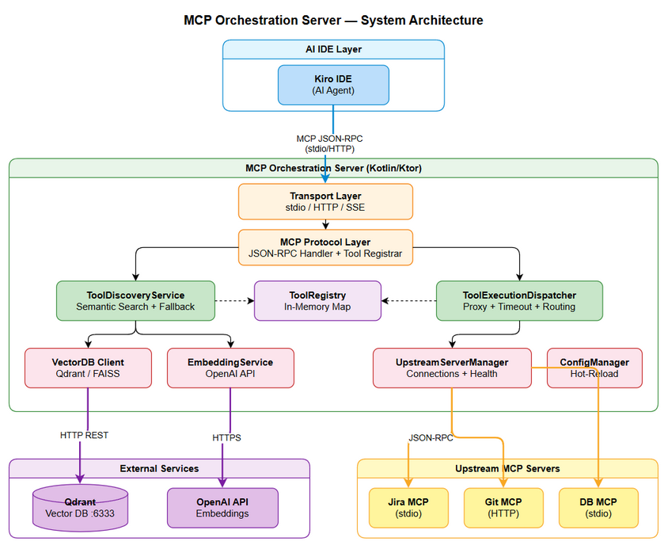
Architecture Diagram

2.2 Component Diagram
graph LR
subgraph "Transport Layer"
STDIO["StdioTransport"]
HTTP["HttpTransport"]
end
subgraph "Protocol Layer"
JSONRPC["JsonRpcHandler"]
TOOLREG["McpToolRegistrar"]
end
subgraph "Orchestration Layer"
TDS["ToolDiscoveryService"]
TED["ToolExecutionDispatcher"]
TR["ToolRegistry"]
TI["ToolIndexer"]
end
subgraph "Infrastructure Layer"
VDB["VectorDbClient"]
QDRANT_IMPL["QdrantClient"]
FAISS_IMPL["FaissClient"]
EMB["EmbeddingService"]
OPENAI_IMPL["OpenAiEmbedding"]
USM["UpstreamServerManager"]
HM["HealthMonitor"]
CM["ConfigurationManager"]
end
STDIO --> JSONRPC
HTTP --> JSONRPC
JSONRPC --> TOOLREG
TOOLREG --> TDS
TOOLREG --> TED
TDS --> VDB
TDS --> EMB
TDS --> TR
TED --> TR
TED --> USM
TI --> EMB
TI --> VDB
TI --> TR
TI --> USM
VDB --> QDRANT_IMPL
VDB --> FAISS_IMPL
EMB --> OPENAI_IMPL
USM --> HM
USM --> CM
style TDS fill:#c8e6c9,stroke:#2e7d32
style TED fill:#c8e6c9,stroke:#2e7d32
style VDB fill:#ffcdd2,stroke:#c62828
style EMB fill:#ffcdd2,stroke:#c62828
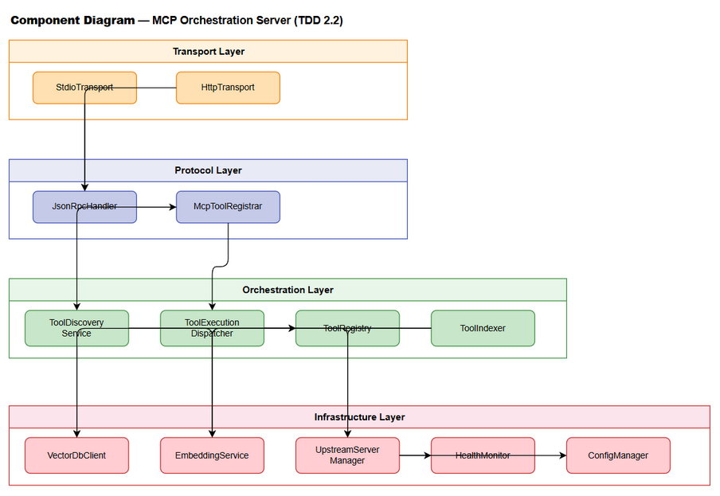
Component Diagram
Component | Responsibility | Technology
StdioTransport | Read/write JSON-RPC messages via stdin/stdout | Kotlin coroutines + System.in/out
HttpTransport | HTTP/SSE endpoint for MCP communication | Ktor Server (Netty)
JsonRpcHandler | Parse JSON-RPC 2.0 requests, dispatch to handlers, format responses | kotlinx.serialization
McpToolRegistrar | Register find_tools and execute_dynamic_tool as MCP tools | MCP protocol
ToolDiscoveryService | Semantic search: query → embedding → vector search → results | Ktor Client, Qdrant
ToolExecutionDispatcher | Route tool calls to correct upstream server, handle timeouts | Kotlin coroutines
ToolRegistry | In-memory tool-to-server mapping, thread-safe concurrent access | ConcurrentHashMap
ToolIndexer | Scan upstream servers, extract tool metadata, generate embeddings, upsert to Vector DB | Batch processing
VectorDbClient | Abstraction over Qdrant/FAISS for vector CRUD and search | Interface + implementations
EmbeddingService | Generate vector embeddings from text via OpenAI API | Ktor HTTP Client
UpstreamServerManager | Manage connections to upstream MCP servers (stdio/HTTP) | Process management, Ktor Client
HealthMonitor | Periodic health checks, state transitions, auto-reconnect | Kotlin coroutines (ticker)
ConfigurationManager | Load, validate, watch, and hot-reload configuration | YAML parser, file watcher

2.3 Deployment Architecture
The MCP Orchestration Server runs as a single JVM process on the developer’s local machine, co-located with the Kiro IDE. In stdio mode, Kiro spawns the Orchestrator as a subprocess. In HTTP mode, it runs as a standalone server.
graph TB
subgraph "Developer Machine"
subgraph "Kiro IDE Process"
KIRO["Kiro AI Agent"]
end
subgraph "MCP Orchestrator Process (JVM)"
APP["Ktor Application"]
HEAP["In-Memory ToolRegistry<br/>≤256 MB heap"]
end
subgraph "Upstream Processes"
P1["npx jira-mcp-server"]
P2["python db-mcp-server"]
P3["node git-mcp-server"]
end
subgraph "Local Services (Docker optional)"
QDRANT["Qdrant Container<br/>:6333"]
end
end
subgraph "Cloud Services"
OPENAI["OpenAI API<br/>api.openai.com"]
end
KIRO -->|"stdio pipe"| APP
APP -->|"stdio pipe"| P1
APP -->|"stdio pipe"| P2
APP -->|"HTTP"| P3
APP -->|"HTTP :6333"| QDRANT
APP -->|"HTTPS"| OPENAI
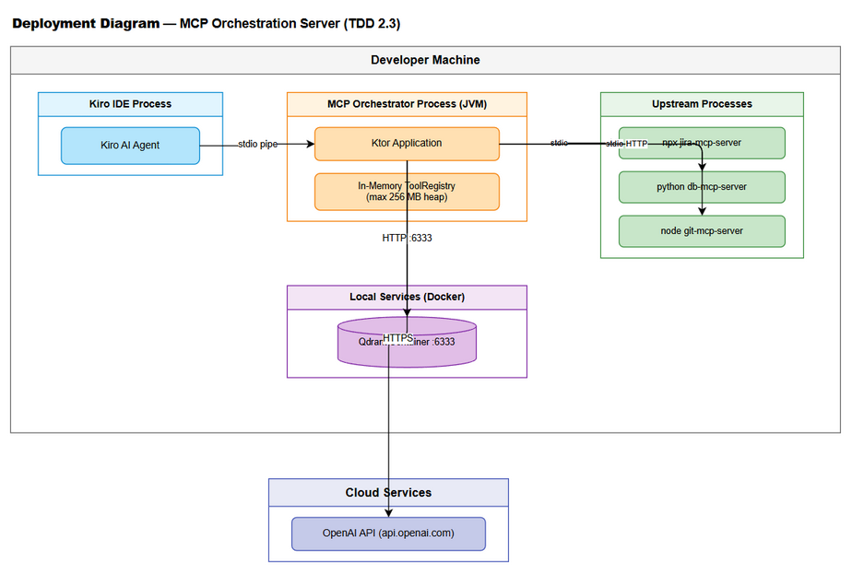
Deployment Diagram

2.4 Communication Patterns
From | To | Protocol | Pattern | Description
Kiro IDE | Orchestrator | MCP/JSON-RPC over stdio | Sync request-response | Tool discovery and execution
Kiro IDE | Orchestrator | MCP/JSON-RPC over HTTP | Sync request-response | Alternative transport
Orchestrator | Qdrant | HTTP REST | Sync request-response | Vector upsert, search, delete
Orchestrator | OpenAI API | HTTPS REST | Sync request-response | Embedding generation
Orchestrator | Upstream (stdio) | JSON-RPC over stdio | Sync request-response | Tool listing and execution
Orchestrator | Upstream (HTTP) | JSON-RPC over HTTP/SSE | Sync request-response | Tool listing and execution
HealthMonitor | Upstream Servers | JSON-RPC ping | Async periodic | Health checks every 30s
ConfigManager | File System | File watch | Async event-driven | Hot-reload on config change

3. API Design

3.1 API Overview
The Orchestrator exposes exactly 2 MCP tools via JSON-RPC 2.0. These are not REST endpoints — they are MCP tool definitions invoked through the MCP protocol.
# | Tool Name | Method | Description | Source
1 | find_tools | tools/call | Semantic search for available tools | UC-01, BR-01..BR-07
2 | execute_dynamic_tool | tools/call | Proxy execution to upstream MCP server | UC-02, BR-08..BR-13
Additionally, the system responds to standard MCP protocol methods:
# | MCP Method | Description | Source
3 | initialize | MCP session handshake | MCP Spec
4 | tools/list | Return the 2 tool definitions | MCP Spec
5 | ping | Health check from IDE | MCP Spec

3.2 Tool: find_tools
Implements: UC-01, BR-01, BR-02, BR-03, BR-04, BR-05, BR-06, BR-07
Attribute | Value
Tool Name | find_tools
Protocol | MCP JSON-RPC 2.0
Transport | stdio / HTTP
Auth | None (local transport)
MCP Tool Definition (registered via tools/list):
{
"name": "find_tools",
"description": "Search for available MCP tools by describing what you want to accomplish. Returns tool definitions with input schemas so you can call them via execute_dynamic_tool.",
"inputSchema": {
"type": "object",
"properties": {
"query": {
"type": "string",
"description": "Natural language description of the action you want to perform",
"maxLength": 2000
},
"top_k": {
"type": "integer",
"description": "Maximum number of results to return (default: 5)",
"default": 5,
"minimum": 1,
"maximum": 20
},
"threshold": {
"type": "number",
"description": "Minimum similarity score threshold (default: 0.7)",
"default": 0.7,
"minimum": 0.0,
"maximum": 1.0
}
},
"required": ["query"]
}
}
JSON-RPC Request Example:
{
"jsonrpc": "2.0",
"id": 1,
"method": "tools/call",
"params": {
"name": "find_tools",
"arguments": {
"query": "check logs and create Jira ticket",
"top_k": 5,
"threshold": 0.7
}
}
}
JSON-RPC Response — Success:
{
"jsonrpc": "2.0",
"id": 1,
"result": {
"content": [
{
"type": "text",
"text": "{\"tools\":[{\"name\":\"read_logs\",\"description\":\"Read application log files\",\"input_schema\":{\"type\":\"object\",\"properties\":{\"path\":{\"type\":\"string\"},\"lines\":{\"type\":\"integer\",\"default\":100}}},\"server_name\":\"log-server\",\"server_status\":\"CONNECTED\",\"similarity_score\":0.92},{\"name\":\"create_jira_issue\",\"description\":\"Create a new Jira issue\",\"input_schema\":{\"type\":\"object\",\"properties\":{\"project_key\":{\"type\":\"string\"},\"summary\":{\"type\":\"string\"},\"issue_type\":{\"type\":\"string\"}}},\"server_name\":\"jira-server\",\"server_status\":\"CONNECTED\",\"similarity_score\":0.87}],\"search_mode\":\"semantic\",\"total_indexed\":150}"
}
]
}
}
JSON-RPC Response — Error:
{
"jsonrpc": "2.0",
"id": 1,
"result": {
"content": [
{
"type": "text",
"text": "{\"error\":{\"code\":\"INVALID_PARAMS\",\"message\":\"Query parameter is required and must be non-empty\"}}"
}
],
"isError": true
}
}
Error Codes:
Code | Message | Condition
INVALID_PARAMS | Query parameter is required and must be non-empty | Empty or null query
INVALID_PARAMS | Query exceeds maximum length of 2000 characters | Query too long
INTERNAL_ERROR | Tool discovery failed. Please retry. | Unrecoverable internal error
Processing Flow:
sequenceDiagram
participant K as Kiro IDE
participant T as Transport Layer
participant P as JsonRpcHandler
participant D as ToolDiscoveryService
participant E as EmbeddingService
participant V as VectorDbClient
participant R as ToolRegistry
K->>T: JSON-RPC tools/call {find_tools}
T->>P: Parse JSON-RPC message
P->>D: findTools(query, topK, threshold)
D->>D: Validate query (non-empty, ≤2000 chars)
D->>E: generateEmbedding(query)
E-->>D: FloatArray[768]
D->>V: search(vector, topK, threshold)
V-->>D: List<ScoredPoint>
D->>R: enrichWithServerStatus(results)
R-->>D: List<ToolResult> with server_status
D-->>P: FindToolsResponse
P-->>T: JSON-RPC result
T-->>K: Response
Note over D,V: Fallback: If E fails → keyword search via R
Note over D,V: Fallback: If V fails → keyword search via R
API Sequence - find_tools
API Sequence - find_tools

3.3 Tool: execute_dynamic_tool
Implements: UC-02, BR-08, BR-09, BR-10, BR-11, BR-12, BR-13
Attribute | Value
Tool Name | execute_dynamic_tool
Protocol | MCP JSON-RPC 2.0
Transport | stdio / HTTP
Auth | None (local transport)
MCP Tool Definition:
{
"name": "execute_dynamic_tool",
"description": "Execute a tool on an upstream MCP server. Use find_tools first to discover available tools and their input schemas.",
"inputSchema": {
"type": "object",
"properties": {
"tool_name": {
"type": "string",
"description": "The exact name of the tool to execute (as returned by find_tools)"
},
"arguments": {
"type": "object",
"description": "Arguments to pass to the tool, conforming to its input_schema",
"additionalProperties": true
}
},
"required": ["tool_name"]
}
}
JSON-RPC Request Example:
{
"jsonrpc": "2.0",
"id": 2,
"method": "tools/call",
"params": {
"name": "execute_dynamic_tool",
"arguments": {
"tool_name": "read_logs",
"arguments": {
"path": "/var/log/app.log",
"lines": 50
}
}
}
}
JSON-RPC Response — Success:
{
"jsonrpc": "2.0",
"id": 2,
"result": {
"content": [
{
"type": "text",
"text": "2026-05-01 10:30:00 INFO Application started\n2026-05-01 10:30:01 INFO Processing request..."
}
],
"_meta": {
"upstream_server": "log-server",
"execution_time_ms": 145
}
}
}
Error Codes:
Code | Message | Condition
TOOL_NOT_FOUND | Tool ‘{name}’ is not registered. Use find_tools to discover available tools. | Tool name not in registry
SERVER_UNAVAILABLE | Server hosting ‘{name}’ is currently unavailable. Status: DISCONNECTED. | Upstream server disconnected
EXECUTION_TIMEOUT | Tool execution timed out after {N}s. | Upstream did not respond in time
INVALID_PARAMS | Argument validation failed: {details} | Arguments don’t match input_schema
UPSTREAM_ERROR | Upstream error: {message} | Error from the upstream MCP server
Processing Flow:
sequenceDiagram
participant K as Kiro IDE
participant P as JsonRpcHandler
participant X as ToolExecutionDispatcher
participant R as ToolRegistry
participant U as UpstreamServerManager
participant M as Upstream MCP Server
K->>P: tools/call {execute_dynamic_tool}
P->>X: execute(toolName, arguments)
X->>R: lookupTool(toolName)
alt Tool not found
R-->>X: null
X-->>P: TOOL_NOT_FOUND error
else Tool found
R-->>X: ToolEntry{serverName, schema}
X->>X: validateArguments(args, schema) [if enabled]
X->>U: getConnection(serverName)
alt Server unavailable
U-->>X: null / DISCONNECTED
X-->>P: SERVER_UNAVAILABLE error
else Server connected
U-->>X: McpConnection
X->>M: JSON-RPC tools/call {toolName, args}
alt Timeout
M--xX: No response within 30s
X-->>P: EXECUTION_TIMEOUT error
else Success
M-->>X: {content: [...]}
X->>X: Add _meta (server, duration)
X-->>P: Result with _meta
end
end
end
P-->>K: JSON-RPC response
API Sequence - execute_dynamic_tool
API Sequence - execute_dynamic_tool

3.4 MCP Protocol Methods

3.4.1 initialize
Standard MCP handshake. The Orchestrator responds with its capabilities.
Request:
{
"jsonrpc": "2.0",
"id": 0,
"method": "initialize",
"params": {
"protocolVersion": "2024-11-05",
"capabilities": {},
"clientInfo": {
"name": "kiro",
"version": "1.0.0"
}
}
}
Response:
{
"jsonrpc": "2.0",
"id": 0,
"result": {
"protocolVersion": "2024-11-05",
"capabilities": {
"tools": {}
},
"serverInfo": {
"name": "mcp-orchestrator",
"version": "1.0.0"
}
}
}

3.4.2 tools/list
Returns the 2 registered tools with their full schemas.
Response:
{
"jsonrpc": "2.0",
"id": 1,
"result": {
"tools": [
{ "name": "find_tools", "description": "...", "inputSchema": { ... } },
{ "name": "execute_dynamic_tool", "description": "...", "inputSchema": { ... } }
]
}
}

4. Database Design

4.1 Schema Overview
This system uses a Vector Database (Qdrant) as its primary data store — not a traditional RDBMS. All persistent data is stored as vector points with payload metadata in Qdrant collections. Volatile runtime state (ToolRegistry, server connections) is held in-memory.
For local development/testing, FAISS serves as a fallback vector store (file-based, no external service required).
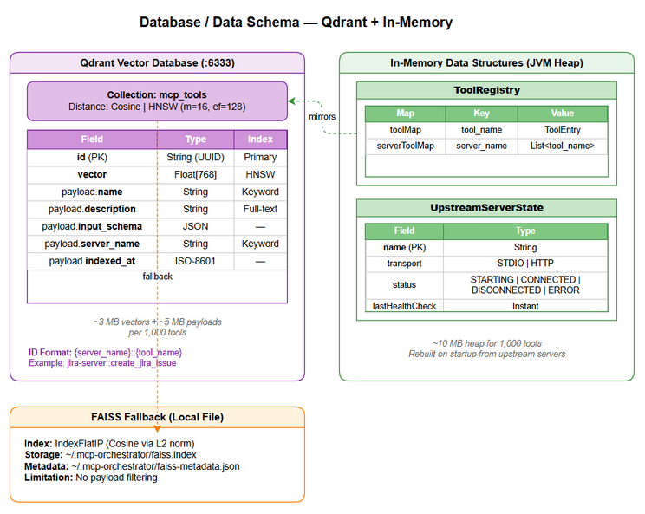
Database Schema
erDiagram
QDRANT_COLLECTION_mcp_tools {
string id PK "UUID: server_name::tool_name"
string name "Tool name"
string description "Tool description"
json input_schema "JSON Schema"
string server_name "Hosting server"
float_768 embedding "Vector embedding"
timestamp indexed_at "Last indexed"
}
IN_MEMORY_ToolRegistry {
map toolMap "tool_name → ToolEntry"
map serverToolMap "server_name → tool_names[]"
}
IN_MEMORY_UpstreamServerState {
string name PK "Server name"
enum transport "STDIO | HTTP"
enum status "STARTING | CONNECTED | DISCONNECTED | ERROR"
instant lastHealthCheck "Last check time"
int reconnectAttempts "Retry count"
}
IN_MEMORY_ToolRegistry ||--o{ QDRANT_COLLECTION_mcp_tools : "mirrors"
IN_MEMORY_UpstreamServerState ||--o{ QDRANT_COLLECTION_mcp_tools : "hosts tools in"

4.2 Qdrant Collection: mcp_tools
Collection Creation:
PUT /collections/mcp_tools
{
"vectors": {
"size": 768,
"distance": "Cosine"
},
"hnsw_config": {
"m": 16,
"ef_construct": 128
},
"optimizers_config": {
"indexing_threshold": 100
}
}
Point Schema:
Field | Type | Indexed | Description
id | String (UUID) | Primary | Composite key: {server_name}::{tool_name}
vector | Float[768] | HNSW vector index | Embedding of tool description
payload.name | String | Keyword index | Tool name as registered in MCP
payload.description | String | Full-text index | Human-readable tool description
payload.input_schema | JSON | Not indexed | Full JSON Schema for tool input
payload.server_name | String | Keyword index (filterable) | Name of the hosting upstream server
payload.indexed_at | String (ISO-8601) | Not indexed | When this tool was last indexed
Payload Index Configuration:
PUT /collections/mcp_tools/index
{
"field_name": "name",
"field_schema": "keyword"
}
PUT /collections/mcp_tools/index
{
"field_name": "server_name",
"field_schema": "keyword"
}
PUT /collections/mcp_tools/index
{
"field_name": "description",
"field_schema": "text"
}
Vector Index Parameters:
Parameter | Value | Rationale
Distance Metric | Cosine | Standard for text embeddings; normalized similarity 0.0–1.0
Dimensions | 768 | text-embedding-3-small output size
Index Type | HNSW | Best balance of speed and recall for <10K vectors
ef_construct | 128 | Higher build quality for small dataset
M | 16 | Standard connectivity for HNSW graph
indexing_threshold | 100 | Start building HNSW index after 100 points

4.3 Upsert Operation
PUT /collections/mcp_tools/points
{
"points": [
{
"id": "jira-server::create_jira_issue",
"vector": [0.0023, -0.0091, ...],
"payload": {
"name": "create_jira_issue",
"description": "Create a new Jira issue with summary, description, and type",
"input_schema": {
"type": "object",
"properties": {
"project_key": { "type": "string" },
"summary": { "type": "string" },
"issue_type": { "type": "string" }
},
"required": ["project_key", "summary", "issue_type"]
},
"server_name": "jira-server",
"indexed_at": "2026-05-02T10:30:00Z"
}
}
]
}

4.4 Search Operation
POST /collections/mcp_tools/points/search
{
"vector": [0.0015, -0.0082, ...],
"limit": 5,
"score_threshold": 0.7,
"with_payload": true
}
Expected Performance: - Search latency: < 10ms for 1,000 vectors (HNSW) - Upsert latency: < 5ms per point - Batch upsert (100 points): < 200ms

4.5 Delete Operation (Server Removal)
POST /collections/mcp_tools/points/delete
{
"filter": {
"must": [
{
"key": "server_name",
"match": { "value": "removed-server" }
}
]
}
}

4.6 FAISS Fallback (Local)
When Qdrant is unavailable, the system falls back to a local FAISS index:
Aspect | FAISS Configuration
Index Type | IndexFlatIP (Inner Product, after L2 normalization = Cosine)
Storage | File-based (~/.mcp-orchestrator/faiss.index)
Metadata | Companion JSON file (~/.mcp-orchestrator/faiss-metadata.json)
Limitations | No payload filtering, full scan for keyword search

4.7 In-Memory Data Structures
These are not persisted — rebuilt on startup from upstream servers.
ToolRegistry:
class ToolRegistry {
// Key: tool_name, Value: ToolEntry
private val toolMap = ConcurrentHashMap<String, ToolEntry>()
// Key: server_name, Value: list of tool_names
private val serverToolMap = ConcurrentHashMap<String, MutableList<String>>()
}
Data Volume Estimates:
Data | Estimated Size | Notes
1,000 tool vectors (768 dim) | ~3 MB in Qdrant | 768 × 4 bytes × 1000
1,000 tool payloads | ~5 MB in Qdrant | ~5 KB avg per tool (schema included)
In-memory ToolRegistry (1,000 tools) | ~10 MB heap | ToolEntry objects + maps
FAISS index (1,000 vectors) | ~3 MB on disk | Same as Qdrant vector size

5. Class / Module Design

5.1 Package Structure
com.orchestrator.mcp/
├── Application.kt # Ktor application entry point
├── config/
│ ├── OrchestratorConfig.kt # @Serializable config data classes
│ ├── ConfigurationManager.kt # Hot-reload, validation, file watching
│ └── ConfigValidator.kt # Config schema validation
├── transport/
│ ├── McpTransport.kt # Interface: send/receive JSON-RPC
│ ├── StdioTransport.kt # stdio implementation
│ └── HttpTransport.kt # HTTP/SSE implementation (Ktor routes)
├── protocol/
│ ├── JsonRpcHandler.kt # JSON-RPC 2.0 message parsing & dispatch
│ ├── McpToolRegistrar.kt # Register find_tools + execute_dynamic_tool
│ ├── McpProtocolHandler.kt # Handle initialize, tools/list, ping
│ └── model/
│ ├── JsonRpcMessage.kt # JSON-RPC request/response/notification
│ ├── McpInitialize.kt # Initialize request/response models
│ └── McpToolCall.kt # tools/call request/response models
├── discovery/
│ ├── ToolDiscoveryService.kt # Interface: findTools(query, topK, threshold)
│ ├── ToolDiscoveryServiceImpl.kt # Semantic + keyword fallback implementation
│ ├── KeywordSearchEngine.kt # In-memory keyword/TF-IDF fallback
│ └── model/
│ ├── FindToolsRequest.kt # Input DTO
│ └── FindToolsResponse.kt # Output DTO with tools array
├── execution/
│ ├── ToolExecutionDispatcher.kt # Interface: execute(toolName, args)
│ ├── ToolExecutionDispatcherImpl.kt # Routing + timeout + error handling
│ └── model/
│ ├── ExecuteToolRequest.kt # Input DTO
│ └── ExecuteToolResponse.kt # Output DTO with content + _meta
├── registry/
│ ├── ToolRegistry.kt # Interface: lookup, register, remove tools
│ ├── ToolRegistryImpl.kt # ConcurrentHashMap-based implementation
│ └── ToolIndexer.kt # Scan servers → embed → upsert → update registry
├── embedding/
│ ├── EmbeddingService.kt # Interface: generateEmbedding(text)
│ ├── OpenAiEmbeddingService.kt # OpenAI API implementation
│ └── model/
│ ├── EmbeddingRequest.kt # OpenAI API request
│ └── EmbeddingResponse.kt # OpenAI API response
├── vectordb/
│ ├── VectorDbClient.kt # Interface: upsert, search, delete
│ ├── QdrantVectorDbClient.kt # Qdrant REST API implementation
│ ├── FaissVectorDbClient.kt # Local FAISS fallback implementation
│ └── model/
│ ├── VectorPoint.kt # Point with vector + payload
│ └── SearchResult.kt # Scored search result
├── upstream/
│ ├── UpstreamServerManager.kt # Interface: connect, disconnect, getConnection
│ ├── UpstreamServerManagerImpl.kt # Connection lifecycle management
│ ├── HealthMonitor.kt # Periodic health checks + auto-reconnect
│ ├── McpConnection.kt # Interface: sendRequest(method, params)
│ ├── StdioMcpConnection.kt # stdio subprocess connection
│ ├── HttpMcpConnection.kt # HTTP connection
│ └── model/
│ ├── ServerState.kt # Enum: STARTING, CONNECTED, DISCONNECTED, ERROR
│ ├── TransportType.kt # Enum: STDIO, HTTP
│ └── UpstreamServerInfo.kt # Runtime server state data class
├── model/
│ ├── ToolDefinition.kt # Core tool data class
│ ├── ToolEntry.kt # Registry entry (tool + server info)
│ └── ErrorCodes.kt # Error code constants
├── di/
│ └── AppModule.kt # Koin module definitions
└── util/
├── JsonRpcUtils.kt # JSON-RPC helper functions
└── RetryUtils.kt # Exponential backoff retry utility

5.2 Key Interfaces
// --- Discovery Layer ---
interface ToolDiscoveryService {
suspend fun findTools(query: String, topK: Int = 5, threshold: Float = 0.7f): FindToolsResponse
}
// --- Execution Layer ---
interface ToolExecutionDispatcher {
suspend fun execute(toolName: String, arguments: JsonObject?): ExecuteToolResponse
}
// --- Registry ---
interface ToolRegistry {
fun lookupTool(toolName: String): ToolEntry?
fun registerTool(entry: ToolEntry)
fun removeTool(toolName: String)
fun removeServerTools(serverName: String)
fun getAllTools(): List<ToolEntry>
fun getToolsByServer(serverName: String): List<ToolEntry>
fun getToolCount(): Int
}
// --- Vector DB ---
interface VectorDbClient {
suspend fun createCollection(name: String, dimensions: Int)
suspend fun upsert(collectionName: String, points: List<VectorPoint>)
suspend fun search(collectionName: String, vector: FloatArray, limit: Int, scoreThreshold: Float): List<SearchResult>
suspend fun delete(collectionName: String, filter: Map<String, String>)
suspend fun isHealthy(): Boolean
}
// --- Embedding ---
interface EmbeddingService {
suspend fun generateEmbedding(text: String): FloatArray
suspend fun generateEmbeddings(texts: List<String>): List<FloatArray>
suspend fun isHealthy(): Boolean
}
// --- Upstream Connection ---
interface McpConnection {
suspend fun sendRequest(method: String, params: JsonObject?): JsonObject
suspend fun close()
fun isActive(): Boolean
}
// --- Upstream Server Manager ---
interface UpstreamServerManager {
suspend fun connectAll()
suspend fun connect(serverName: String)
suspend fun disconnect(serverName: String)
fun getConnection(serverName: String): McpConnection?
fun getServerState(serverName: String): ServerState
fun getAllServerStates(): Map<String, UpstreamServerInfo>
}
// --- Transport ---
interface McpTransport {
suspend fun start()
suspend fun stop()
suspend fun sendMessage(message: String)
fun onMessage(handler: suspend (String) -> String)
}
// --- Configuration ---
interface ConfigurationManager {
fun getConfig(): OrchestratorConfig
fun watchForChanges(onChange: (OrchestratorConfig) -> Unit)
fun reload(): OrchestratorConfig
}

5.3 Class Diagram
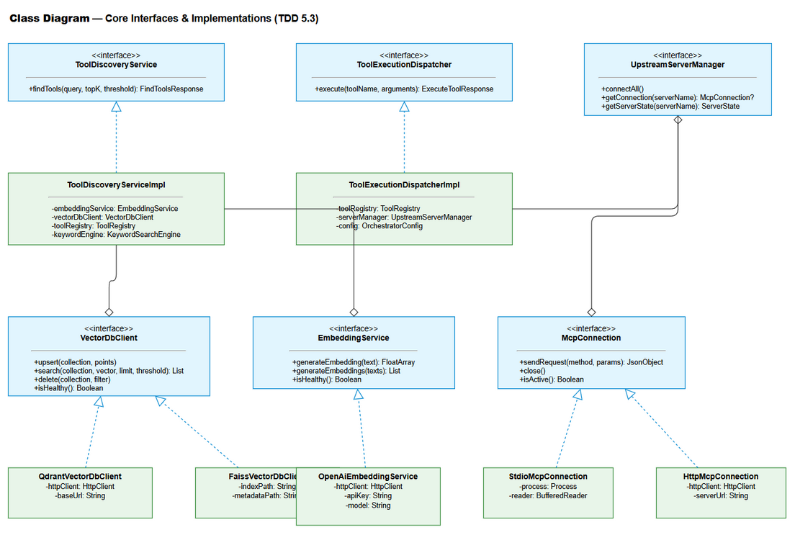
Class Diagram
classDiagram
class ToolDiscoveryService {
<<interface>>
+findTools(query, topK, threshold) FindToolsResponse
}
class ToolDiscoveryServiceImpl {
-embeddingService: EmbeddingService
-vectorDbClient: VectorDbClient
-toolRegistry: ToolRegistry
-keywordEngine: KeywordSearchEngine
+findTools(query, topK, threshold) FindToolsResponse
}
class ToolExecutionDispatcher {
<<interface>>
+execute(toolName, arguments) ExecuteToolResponse
}
class ToolExecutionDispatcherImpl {
-toolRegistry: ToolRegistry
-serverManager: UpstreamServerManager
-config: OrchestratorConfig
+execute(toolName, arguments) ExecuteToolResponse
}
class ToolRegistry {
<<interface>>
+lookupTool(name) ToolEntry?
+registerTool(entry)
+removeTool(name)
+getAllTools() List~ToolEntry~
}
class ToolRegistryImpl {
-toolMap: ConcurrentHashMap
-serverToolMap: ConcurrentHashMap
}
class VectorDbClient {
<<interface>>
+upsert(collection, points)
+search(collection, vector, limit, threshold) List~SearchResult~
+delete(collection, filter)
}
class QdrantVectorDbClient {
-httpClient: HttpClient
-baseUrl: String
}
class FaissVectorDbClient {
-indexPath: String
-metadataPath: String
}
class EmbeddingService {
<<interface>>
+generateEmbedding(text) FloatArray
+generateEmbeddings(texts) List~FloatArray~
}
class OpenAiEmbeddingService {
-httpClient: HttpClient
-apiKey: String
-model: String
}
class UpstreamServerManager {
<<interface>>
+connectAll()
+getConnection(serverName) McpConnection?
+getServerState(serverName) ServerState
}
class McpConnection {
<<interface>>
+sendRequest(method, params) JsonObject
+close()
+isActive() Boolean
}
class StdioMcpConnection {
-process: Process
-reader: BufferedReader
-writer: BufferedWriter
}
class HttpMcpConnection {
-httpClient: HttpClient
-serverUrl: String
}
ToolDiscoveryService <|.. ToolDiscoveryServiceImpl
ToolExecutionDispatcher <|.. ToolExecutionDispatcherImpl
ToolRegistry <|.. ToolRegistryImpl
VectorDbClient <|.. QdrantVectorDbClient
VectorDbClient <|.. FaissVectorDbClient
EmbeddingService <|.. OpenAiEmbeddingService
McpConnection <|.. StdioMcpConnection
McpConnection <|.. HttpMcpConnection
ToolDiscoveryServiceImpl --> EmbeddingService
ToolDiscoveryServiceImpl --> VectorDbClient
ToolDiscoveryServiceImpl --> ToolRegistry
ToolExecutionDispatcherImpl --> ToolRegistry
ToolExecutionDispatcherImpl --> UpstreamServerManager
UpstreamServerManager --> McpConnection

5.4 Design Patterns
Pattern | Where Used | Rationale
Strategy | VectorDbClient (Qdrant vs FAISS), EmbeddingService (OpenAI vs HuggingFace), McpConnection (stdio vs HTTP) | Swappable implementations based on config/availability
Facade | ToolDiscoveryService, ToolExecutionDispatcher | Simplify complex multi-step operations behind a single interface
Registry | ToolRegistry | Central lookup for tool-to-server mapping
Observer | ConfigurationManager (file watcher → onChange callback) | React to config changes without polling
State Machine | UpstreamServerInfo (STARTING → CONNECTED → DISCONNECTED → ERROR) | Manage server lifecycle with well-defined transitions
Proxy | ToolExecutionDispatcher → McpConnection | Transparent forwarding of tool calls to upstream servers
Circuit Breaker | HealthMonitor (max reconnect attempts → ERROR state) | Prevent infinite reconnection loops
Template Method | McpConnection.sendRequest() | Common JSON-RPC framing with transport-specific I/O

5.5 Dependency Injection (Koin)
// di/AppModule.kt
val appModule = module {
// Configuration
single<ConfigurationManager> { ConfigurationManagerImpl(configPath = get()) }
single { get<ConfigurationManager>().getConfig() }
// Embedding
single<EmbeddingService> {
val config = get<OrchestratorConfig>()
when (config.embedding.provider) {
"openai" -> OpenAiEmbeddingService(
httpClient = get(),
apiKey = config.embedding.apiKey,
model = config.embedding.model
)
else -> throw IllegalArgumentException("Unsupported embedding provider")
}
}
// Vector DB
single<VectorDbClient> {
val config = get<OrchestratorConfig>()
when (config.vectorDb.provider) {
"qdrant" -> QdrantVectorDbClient(
httpClient = get(),
baseUrl = "http://${config.vectorDb.host}:${config.vectorDb.port}"
)
"faiss" -> FaissVectorDbClient(indexPath = config.vectorDb.faissPath)
else -> throw IllegalArgumentException("Unsupported vector DB provider")
}
}
// Registry & Indexer
single<ToolRegistry> { ToolRegistryImpl() }
single { ToolIndexer(get(), get(), get(), get()) }
// Upstream
single<UpstreamServerManager> { UpstreamServerManagerImpl(get()) }
single { HealthMonitor(get(), get()) }
// Core Services
single<ToolDiscoveryService> {
ToolDiscoveryServiceImpl(get(), get(), get(), KeywordSearchEngine(get()))
}
single<ToolExecutionDispatcher> {
ToolExecutionDispatcherImpl(get(), get(), get())
}
// HTTP Client (shared)
single {
HttpClient(CIO) {
install(ContentNegotiation) { json() }
install(Logging) { level = LogLevel.INFO }
}
}
}

5.6 Error Handling Strategy
graph TB
A[Exception Thrown] --> B{Exception Type?}
B -->|InvalidParamsException| C[Return INVALID_PARAMS<br/>HTTP-like: 400]
B -->|ToolNotFoundException| D[Return TOOL_NOT_FOUND<br/>HTTP-like: 404]
B -->|ServerUnavailableException| E[Return SERVER_UNAVAILABLE<br/>HTTP-like: 503]
B -->|ExecutionTimeoutException| F[Return EXECUTION_TIMEOUT<br/>HTTP-like: 504]
B -->|UpstreamErrorException| G[Return UPSTREAM_ERROR<br/>Pass-through upstream error]
B -->|VectorDbException| H[Log WARN<br/>Fallback to keyword search]
B -->|EmbeddingException| I[Log WARN<br/>Fallback to keyword search]
B -->|ConfigException| J[Log ERROR<br/>Keep previous config]
B -->|Unexpected Exception| K[Return INTERNAL_ERROR<br/>Log full stack trace]
style C fill:#fff3e0
style D fill:#fff3e0
style E fill:#ffcdd2
style F fill:#ffcdd2
style G fill:#ffcdd2
style H fill:#e8f5e9
style I fill:#e8f5e9
style J fill:#e8f5e9
style K fill:#ffcdd2
Exception Hierarchy:
// Base exception
sealed class McpOrchestratorException(
val errorCode: String,
override val message: String,
override val cause: Throwable? = null
) : Exception(message, cause)
// Client errors (input validation)
class InvalidParamsException(message: String) :
McpOrchestratorException("INVALID_PARAMS", message)
// Tool not found
class ToolNotFoundException(toolName: String) :
McpOrchestratorException("TOOL_NOT_FOUND",
"Tool '$toolName' is not registered. Use find_tools to discover available tools.")
// Server unavailable
class ServerUnavailableException(toolName: String, serverName: String, status: ServerState) :
McpOrchestratorException("SERVER_UNAVAILABLE",
"Server hosting '$toolName' is currently unavailable. Status: $status.")
// Execution timeout
class ExecutionTimeoutException(toolName: String, timeoutSeconds: Int) :
McpOrchestratorException("EXECUTION_TIMEOUT",
"Tool execution timed out after ${timeoutSeconds}s.")
// Upstream error (pass-through)
class UpstreamErrorException(message: String, val upstreamServer: String) :
McpOrchestratorException("UPSTREAM_ERROR", "Upstream error: $message")
// Infrastructure errors (non-fatal, trigger fallback)
class VectorDbUnavailableException(cause: Throwable) :
McpOrchestratorException("VECTOR_DB_UNAVAILABLE",
"Vector DB is unavailable, using keyword fallback", cause)
class EmbeddingServiceException(cause: Throwable) :
McpOrchestratorException("EMBEDDING_SERVICE_ERROR",
"Embedding service unavailable", cause)

6. Integration Design

6.1 External System: Upstream MCP Servers
Attribute | Value
Protocol | MCP (Model Context Protocol) over JSON-RPC 2.0
Transport | stdio (subprocess) or HTTP/SSE
Authentication | Per-server via environment variables (API keys, tokens)
Timeout | 30s (configurable per-server)
Retry Policy | 1 retry for transient errors (configurable)
Circuit Breaker | Max 5 reconnect attempts → ERROR state
Outbound MCP Methods:
Method | Purpose | When Used
initialize | Establish MCP session | On connection
tools/list | Retrieve tool definitions | During indexing
tools/call | Execute a tool | During execute_dynamic_tool
ping | Health check | Periodic monitoring
stdio Connection Lifecycle:
sequenceDiagram
participant O as Orchestrator
participant P as Process (npx/python/node)
O->>P: Spawn subprocess (command + args + env)
O->>P: initialize {protocolVersion, capabilities}
P-->>O: {protocolVersion, capabilities, serverInfo}
O->>P: notifications/initialized
O->>P: tools/list {}
P-->>O: {tools: [{name, description, inputSchema}, ...]}
Note over O,P: Connection established — ready for tool calls
loop Health Check (every 30s)
O->>P: ping {}
P-->>O: {} (pong)
end
loop Tool Execution
O->>P: tools/call {name, arguments}
P-->>O: {content: [...]}
end
O->>P: Close stdin
P->>P: Process exits
HTTP Connection Lifecycle:
sequenceDiagram
participant O as Orchestrator
participant S as HTTP MCP Server
O->>S: POST /mcp — initialize
S-->>O: 200 — {protocolVersion, capabilities}
O->>S: POST /mcp — tools/list
S-->>O: 200 — {tools: [...]}
loop Tool Execution
O->>S: POST /mcp — tools/call {name, arguments}
S-->>O: 200 — {content: [...]}
end

6.2 External System: OpenAI Embedding API
Attribute | Value
Protocol | HTTPS REST
Endpoint | https://api.openai.com/v1/embeddings
Authentication | Bearer token (Authorization: Bearer {OPENAI_API_KEY})
Timeout | 10s
Retry Policy | 2 retries with exponential backoff (1s, 2s)
Rate Limit | 3,000 RPM (batch requests to stay under)
Request:
POST https://api.openai.com/v1/embeddings
Authorization: Bearer sk-...
Content-Type: application/json
{
"model": "text-embedding-3-small",
"input": ["Read application log files and return recent entries", "Create a new Jira issue"],
"dimensions": 768
}
Response:
{
"object": "list",
"data": [
{ "object": "embedding", "index": 0, "embedding": [0.0023, -0.0091, ...] },
{ "object": "embedding", "index": 1, "embedding": [0.0015, -0.0082, ...] }
],
"model": "text-embedding-3-small",
"usage": { "prompt_tokens": 24, "total_tokens": 24 }
}
Batching Strategy: - Batch up to 100 tool descriptions per API call during indexing - Single embedding per call during find_tools (real-time query) - Track token usage for cost monitoring

6.3 External System: Qdrant Vector Database
Attribute | Value
Protocol | HTTP REST (gRPC optional)
Endpoint | http://localhost:6333 (configurable)
Authentication | API Key (optional, header: api-key)
Timeout | 5s
Retry Policy | 1 retry for connection errors
Key API Calls:
Operation | Method | Endpoint | Description
Create Collection | PUT | /collections/mcp_tools | Initialize on first startup
Check Collection | GET | /collections/mcp_tools | Verify collection exists
Upsert Points | PUT | /collections/{name}/points | Add/update tool vectors
Search | POST | /collections/{name}/points/search | ANN similarity search
Delete by Filter | POST | /collections/{name}/points/delete | Remove server’s tools
Health Check | GET | /healthz | Qdrant health status

6.4 External System: Kiro AI IDE (Inbound)
Attribute | Value
Protocol | MCP JSON-RPC 2.0
Transport | stdio (primary), HTTP (alternative)
Direction | Inbound — Kiro calls the Orchestrator
Authentication | None (local transport security)
Exposed MCP Capabilities:
{
"capabilities": {
"tools": {}
},
"serverInfo": {
"name": "mcp-orchestrator",
"version": "1.0.0"
}
}

7. Security Design

7.1 Authentication
Connection | Auth Method | Details
Kiro IDE → Orchestrator | None | Local stdio transport — OS process isolation provides security
Orchestrator → OpenAI API | Bearer Token | Authorization: Bearer {OPENAI_API_KEY} from environment variable
Orchestrator → Qdrant | API Key (optional) | api-key header, from environment variable
Orchestrator → Upstream (stdio) | Per-server env vars | API keys injected via subprocess environment
Orchestrator → Upstream (HTTP) | Per-server headers | Configurable auth headers per server

7.2 Authorization
Since the Orchestrator runs locally as a single-user tool, there is no multi-tenant authorization model. All requests from Kiro IDE have full access to both tools.
Role | Endpoints | Permissions
Kiro IDE (AI Agent) | find_tools, execute_dynamic_tool | Full access
Administrator | Config files, process management | OS-level access

7.3 Data Protection
Data Type | At Rest | In Transit | In Logs
API Keys (OpenAI, Jira, etc.) | Environment variables only — never in config files | TLS 1.2+ (HTTPS) | Excluded — never logged
Upstream server credentials | Environment variable injection to subprocess | TLS for HTTP servers | Excluded
Tool execution arguments | Not persisted | JSON-RPC (local stdio or HTTPS) | Excluded — only tool_name logged
Tool descriptions | Qdrant (plaintext payload) | HTTP to Qdrant (local) | Truncated to 100 chars
Vector embeddings | Qdrant (float arrays) | HTTP to Qdrant (local) | Not logged
Query strings | Not persisted | JSON-RPC (local) | Truncated to 100 chars

7.4 Input Validation
Field | Validation | Sanitization
find_tools.query | Non-empty, max 2000 chars, trimmed | Trim whitespace
find_tools.top_k | Integer, range 1–20 | Clamp to range
find_tools.threshold | Float, range 0.0–1.0 | Clamp to range
execute_dynamic_tool.tool_name | Non-empty string | Exact match (no normalization)
execute_dynamic_tool.arguments | Optional JSON object, validated against tool’s input_schema (if enabled) | Pass-through to upstream
Config file paths | Must be valid YAML/JSON | Reject invalid syntax
Server names in config | Non-empty, alphanumeric + hyphens | Reject invalid characters

7.5 Secrets Management
# application.yml — secrets via environment variable references
orchestrator:
embedding:
api_key: ${OPENAI_API_KEY} # NEVER hardcode
upstream_servers:
- name: jira-server
env:
JIRA_TOKEN: ${JIRA_TOKEN} # Injected to subprocess
Rules: 1. All secrets referenced via ${ENV_VAR} syntax in config files 2. Config files committed to VCS must NOT contain actual secret values 3. Subprocess environment variables are set programmatically, never logged 4. Log sanitization: any string matching sk-*, token=*, key=* patterns is redacted

8. Performance & Scalability

8.1 Caching Strategy
Cache | What | TTL | Eviction | Technology
ToolRegistry | Tool-to-server mapping | Indefinite (updated on index/health) | Manual invalidation on re-index | In-memory ConcurrentHashMap
Embedding Cache | Query → embedding vector | 5 minutes | LRU, max 100 entries | In-memory LinkedHashMap
Connection Pool | Active MCP connections | Session lifetime | On disconnect/error | In-memory map
Embedding Cache Rationale: Repeated identical queries (common in AI agent loops) should not re-call the OpenAI API. A small LRU cache with 5-minute TTL saves API calls and reduces latency.

8.2 Connection Pooling
Resource | Min | Max | Timeout | Idle Timeout
Ktor HTTP Client (shared) | 1 | 10 | 10s connect | 60s
Qdrant connections | 1 | 5 | 5s connect | 30s
OpenAI API connections | 1 | 3 | 10s connect | 30s
Upstream HTTP connections | 1 per server | 1 per server | 5s connect | Session lifetime
Upstream stdio connections | 1 per server | 1 per server | N/A (process) | Session lifetime

8.3 Performance Targets
Operation | Target | Measurement | Source
find_tools end-to-end | < 500ms (p95) | From JSON-RPC request to response | BR-01
find_tools — embedding generation | < 200ms (p95) | OpenAI API call duration | Derived
find_tools — vector search | < 10ms (p95) | Qdrant search duration | Derived
execute_dynamic_tool proxy overhead | < 100ms | Orchestrator processing time (excl. upstream) | BR-08
Tool indexing (100 tools) | < 5s | Full re-index of one server | FSD §8
Startup time (5 servers) | < 10s | Process start to accepting requests | FSD §8
Memory usage (1000 tools) | < 256 MB heap | JVM heap size | FSD §8

8.4 Coroutine Architecture
All I/O operations use Kotlin coroutines for non-blocking execution:
// Structured concurrency for parallel server connections
coroutineScope {
config.upstreamServers.map { serverConfig ->
async(Dispatchers.IO) {
connectToServer(serverConfig)
}
}.awaitAll()
}
// Timeout for tool execution
withTimeout(config.execution.timeoutSeconds * 1000L) {
connection.sendRequest("tools/call", params)
}
// Periodic health checks
val healthJob = launch(Dispatchers.IO) {
while (isActive) {
delay(config.health.checkIntervalSeconds * 1000L)
checkAllServers()
}
}

8.5 Horizontal Scaling
Mode | Scalability | Notes
stdio transport | Single instance only | Kiro spawns one Orchestrator process
HTTP transport | Multiple instances possible | Requires shared Qdrant, stateless design
For the initial release (stdio mode), horizontal scaling is not applicable. The system is designed as a single-process, single-user tool. Future HTTP mode could support multiple instances sharing a Qdrant cluster.

9. Monitoring & Observability

9.1 Logging
Framework: SLF4J + Logback (Kotlin idiomatic)
Log Format:
{timestamp} [{level}] [{coroutine-name}] {logger} - {message}
Log Event | Level | Fields | Destination
Server startup | INFO | version, config_path, servers_count | stdout
Tool discovery request | INFO | query (truncated 100 chars), top_k, threshold | stdout
Tool discovery response | INFO | result_count, search_mode, duration_ms | stdout
Tool execution request | INFO | tool_name, server_name | stdout
Tool execution response | INFO | tool_name, server_name, duration_ms, success | stdout
Server state transition | INFO | server_name, old_state → new_state | stdout
Health check | DEBUG | server_name, status, response_time_ms | stdout
Config reload | INFO | added_servers, removed_servers, changed_settings | stdout
Indexing complete | INFO | server_name, tools_added, tools_removed, duration_ms | stdout
Vector DB fallback | WARN | reason, fallback_mode | stdout + stderr
Embedding fallback | WARN | reason, fallback_mode | stdout + stderr
Server connection failed | ERROR | server_name, error_message | stderr
Unhandled exception | ERROR | exception_class, message, stack_trace | stderr
Logback Configuration (logback.xml):
<configuration>
<appender name="STDOUT" class="ch.qos.logback.core.ConsoleAppender">
<encoder>
<pattern>%d{ISO8601} [%level] [%thread] %logger{36} - %msg%n</pattern>
</encoder>
</appender>
<logger name="com.orchestrator.mcp" level="INFO"/>
<logger name="com.orchestrator.mcp.upstream.HealthMonitor" level="DEBUG"/>
<logger name="io.ktor" level="WARN"/>
<root level="INFO">
<appender-ref ref="STDOUT"/>
</root>
</configuration>

9.2 Metrics
Metric | Type | Description | Alert Threshold
find_tools.latency_ms | Histogram | End-to-end find_tools duration | p95 > 500ms
find_tools.result_count | Histogram | Number of tools returned per query | avg < 1 (poor index)
find_tools.fallback_count | Counter | Times keyword fallback was used | > 10/hour
execute_tool.latency_ms | Histogram | Proxy overhead (excl. upstream) | p95 > 100ms
execute_tool.total_latency_ms | Histogram | Total execution time (incl. upstream) | p95 > 30s
execute_tool.error_count | Counter | Failed executions by error code | > 5/minute
upstream.server_count | Gauge | Number of connected servers | 0 (all disconnected)
upstream.tool_count | Gauge | Total indexed tools | 0 (empty index)
upstream.health_check_failures | Counter | Failed health checks | > 3 consecutive
embedding.latency_ms | Histogram | OpenAI API call duration | p95 > 300ms
embedding.token_usage | Counter | Total tokens consumed | Budget tracking
vectordb.search_latency_ms | Histogram | Qdrant search duration | p95 > 50ms
config.reload_count | Counter | Configuration reloads | Informational
Implementation: Metrics collected via Micrometer (Ktor plugin) and exposed via /metrics endpoint (Prometheus format) when running in HTTP mode. In stdio mode, metrics are logged periodically.

9.3 Health Checks
Endpoint / Method | Checks | Expected Response
MCP ping | Orchestrator process alive | {} (empty result)
Internal health (logged) | Vector DB, Embedding Service, Upstream Servers | Periodic log entry with status summary
Health Summary Log (every 60s):
2026-05-02T10:30:00Z [INFO] [health-summary] HealthMonitor -
Servers: 3/5 CONNECTED, 1 DISCONNECTED, 1 ERROR |
Tools: 150 indexed |
VectorDB: HEALTHY |
Embedding: HEALTHY

10. Deployment Considerations

10.1 Environment Configuration
Property | DEV | PROD
orchestrator.server.transport | stdio | stdio
orchestrator.discovery.top_k | 5 | 5
orchestrator.discovery.similarity_threshold | 0.6 | 0.7
orchestrator.execution.timeout_seconds | 60 | 30
orchestrator.embedding.provider | openai | openai
orchestrator.embedding.model | text-embedding-3-small | text-embedding-3-small
orchestrator.vector_db.provider | faiss | qdrant
orchestrator.vector_db.host | — | localhost
orchestrator.vector_db.port | — | 6333
orchestrator.health.check_interval_seconds | 60 | 30
OPENAI_API_KEY | dev key | prod key

10.2 Feature Flags
Flag | Default | Description
orchestrator.execution.validate_arguments | true | Enable/disable JSON Schema validation of tool arguments
orchestrator.discovery.fallback_to_keyword | true | Enable keyword search fallback when Vector DB is down
orchestrator.health.auto_reconnect | true | Enable automatic reconnection to disconnected servers
orchestrator.embedding.cache_enabled | true | Enable in-memory embedding cache

10.3 Startup Sequence
stateDiagram-v2
[*] --> LoadConfig: Application.main()
LoadConfig --> ValidateConfig
ValidateConfig --> InitVectorDB: Config valid
ValidateConfig --> ExitError: Config invalid
InitVectorDB --> InitEmbedding
InitEmbedding --> ConnectUpstream: Parallel coroutines
ConnectUpstream --> IndexTools: For each connected server
IndexTools --> BuildRegistry
BuildRegistry --> RegisterMcpTools: find_tools + execute_dynamic_tool
RegisterMcpTools --> StartHealthMonitor
StartHealthMonitor --> StartConfigWatcher
StartConfigWatcher --> Ready: Accept MCP requests
Ready --> [*]: Shutdown signal
InitVectorDB --> FallbackInMemory: VDB unavailable
FallbackInMemory --> InitEmbedding
InitEmbedding --> FallbackKeyword: Embedding unavailable
FallbackKeyword --> ConnectUpstream
ConnectUpstream --> MarkError: Server unreachable
MarkError --> IndexTools

10.4 Rollback Strategy
Since this is a greenfield project with no existing data to migrate:
- Binary rollback: Replace the JAR/distribution with the previous version
- Config rollback: Restore previous application.yml from version control
- Vector DB: Qdrant collection is rebuilt on startup — no migration needed
- In-memory state: Rebuilt on startup — no persistence to roll back

10.5 Build & Distribution
// build.gradle.kts
plugins {
kotlin("jvm") version "2.3.20"
kotlin("plugin.serialization") version "2.3.20"
id("io.ktor.plugin") version "3.4.0"
application
}
application {
mainClass.set("com.orchestrator.mcp.ApplicationKt")
}
// Distribution: ./gradlew installDist → build/install/mcp-orchestrator/
// Fat JAR: ./gradlew buildFatJar → build/libs/mcp-orchestrator-all.jar
Kiro IDE Configuration (mcp.json):
{
"mcpServers": {
"mcp-orchestrator": {
"command": "java",
"args": ["-jar", "/path/to/mcp-orchestrator-all.jar"],
"env": {
"OPENAI_API_KEY": "sk-..."
}
}
}
}

11. E2E Test Architecture

11.1 Framework & Language
- Framework: JUnit 5 + Ktor Test Host (for integration tests), manual E2E via MCP client
- Language: Kotlin (matches project’s main language)
- API test client: Ktor HTTP Client (for HTTP transport tests)
- MCP test client: Custom TestMcpClient class that communicates via stdio/HTTP
- Note: E2E tests run against a fully started Orchestrator instance with mock upstream servers

11.2 E2E Test Module Structure
e2e-tests/
├── build.gradle.kts
├── src/test/kotlin/com/orchestrator/mcp/e2e/
│ ├── McpOrchestratorE2ETest.kt # Main E2E test class
│ ├── FindToolsE2ETest.kt # find_tools scenarios
│ ├── ExecuteToolE2ETest.kt # execute_dynamic_tool scenarios
│ ├── HealthMonitorE2ETest.kt # Health check + reconnect scenarios
│ ├── ConfigReloadE2ETest.kt # Hot-reload scenarios
│ ├── support/
│ │ ├── TestMcpClient.kt # MCP client for sending JSON-RPC
│ │ ├── MockUpstreamServer.kt # Mock MCP server (stdio + HTTP)
│ │ ├── TestQdrantContainer.kt # Testcontainers for Qdrant
│ │ └── TestConfig.kt # Test configuration helpers
│ └── fixtures/
│ ├── tool-definitions.json # Sample tool definitions
│ └── test-config.yml # Test application.yml

11.3 Reusable Components
- TestMcpClient: Sends JSON-RPC messages to the Orchestrator via stdio pipe or HTTP. Handles initialize handshake, tools/list, and tools/call methods.
- MockUpstreamServer: Simulates an upstream MCP server. Configurable tool definitions, response delays, and error injection. Supports both stdio and HTTP transport.
- TestQdrantContainer: Testcontainers wrapper for spinning up a real Qdrant instance during E2E tests.
- TestConfig: Generates application.yml with mock server configurations pointing to MockUpstreamServer instances.

11.4 E2E Test Scenarios
ID | Scenario | Description
E2E-01 | Full discovery flow | Start Orchestrator → index mock tools → find_tools query → verify results
E2E-02 | Full execution flow | find_tools → execute_dynamic_tool → verify upstream received correct call
E2E-03 | Keyword fallback | Start without Qdrant → find_tools → verify keyword search works
E2E-04 | Server disconnect/reconnect | Kill mock server → verify DISCONNECTED → restart → verify CONNECTED + re-indexed
E2E-05 | Config hot-reload | Modify config → verify new server connected, removed server disconnected
E2E-06 | Concurrent requests | Send 50 find_tools in parallel → verify all return within 500ms
E2E-07 | Execution timeout | Mock server with 60s delay → verify EXECUTION_TIMEOUT error
E2E-08 | Tool not found | execute_dynamic_tool with nonexistent tool → verify TOOL_NOT_FOUND

12. Appendix

12.1 Glossary
Term | Definition
MCP | Model Context Protocol — open standard for AI tool communication
Orchestrator | The MCP Orchestration Server being designed in this document
Upstream Server | An external MCP Server that hosts actual tools
Tool Definition | Metadata describing a tool: name, description, input_schema
Vector DB | Vector Database for semantic similarity search (Qdrant/FAISS)
Embedding | Dense vector representation of text for semantic search
Top-K | The K most similar results from a vector search
JSON-RPC | JSON Remote Procedure Call — MCP wire protocol
ANN | Approximate Nearest Neighbor — fast vector search algorithm
HNSW | Hierarchical Navigable Small World — graph-based ANN index
Context Window | The limited token budget available to an AI model per request

12.2 FSD Requirement → TDD Design Mapping
FSD Requirement | TDD Section | Design Decision
UC-01: find_tools | §3.2 | Semantic search via Qdrant + keyword fallback
UC-02: execute_dynamic_tool | §3.3 | Proxy via McpConnection interface (stdio/HTTP)
UC-03: Tool Registration | §5.1 (ToolIndexer) | Batch embedding + upsert on startup/config change
UC-04: Configuration | §5.1 (ConfigurationManager) | YAML parsing + file watcher for hot-reload
UC-05: Health Monitoring | §5.1 (HealthMonitor) | Coroutine-based periodic checks + state machine
BR-01: <500ms find_tools | §8.3 | Embedding cache + HNSW index
BR-05: Keyword fallback | §5.2 (KeywordSearchEngine) | In-memory TF-IDF over ToolRegistry
BR-08: <100ms proxy overhead | §8.3 | Direct JSON-RPC forwarding, minimal processing
BR-14: Incremental indexing | §6.2 (Processing Logic) | Diff-based upsert/delete
BR-24: Exponential backoff | §5.1 (HealthMonitor) | 1s, 2s, 4s, 8s… with max attempts
FSD §4: Data Model | §4 | Qdrant collection + in-memory registry
FSD §7: Security | §7 | Env var secrets, no auth for local stdio
FSD §8: NFR | §8 | Coroutine-first, caching, connection pooling
FSD §9: Error Handling | §5.6 | Sealed exception hierarchy with error codes

12.3 Open Questions
# | Question | Status | Answer
1 | Should we support HuggingFace local embeddings in v1.0? | Open | Deferred to v1.1 — OpenAI API is sufficient for initial release
2 | Should Qdrant run as Docker container or embedded? | Resolved | Docker container for prod, FAISS for local dev
3 | Maximum number of upstream servers tested? | Open | Target 50, need load testing to validate
4 | Should we support MCP resources and prompts in addition to tools? | Open | Out of scope for v1.0, tools only
5 | gRPC vs REST for Qdrant communication? | Resolved | REST — simpler, sufficient for <10K vectors

12.4 Diagram Index
# | Diagram | File | Section
1 | Architecture Diagram | architecture.drawio / .png | §2.1
2 | Component Diagram | component.drawio / .png | §2.2
3 | Deployment Diagram | deployment.drawio / .png | §2.3
4 | API Sequence — find_tools | api-sequence-find-tools.drawio / .png | §3.2
5 | API Sequence — execute_dynamic_tool | api-sequence-execute-tool.drawio / .png | §3.3
6 | Database Schema | db-schema.drawio / .png | §4.1
7 | Class Diagram | class-diagram.drawio / .png | §5.3

12.5 NEW Dependencies (Not in Existing Project)
Dependency | Purpose | Justification
io.qdrant:client | Qdrant Java/Kotlin client | Primary vector DB — no existing alternative in project
ch.qos.logback:logback-classic | Logging implementation | Standard SLF4J backend for JVM applications
com.charleskorn.kaml:kaml | YAML parsing for kotlinx.serialization | Config file parsing — kotlinx.serialization doesn’t support YAML natively
org.testcontainers:qdrant | Qdrant container for E2E tests | Integration testing with real Qdrant instance

