Technical Design Document (TDD)

MCPOrchestration — MTO-15: Database Schema & Sync State Management

Document Information
Field | Value
Jira Ticket | MTO-15
Title | Database Schema & Sync State Management
Author | SA Agent
Version | 1.0
Date | 2025-07-14
Status | Draft
Related BRD | BRD-v1-MTO-15.docx
Related FSD | FSD-v1-MTO-15.docx

Author Tracking
Role | Name - Position | Responsibility
Author | SA Agent – Solution Architect | Create document
Peer Reviewer | Tech Lead – Senior Engineer | Review document

Revision History
Version | Date | Author | Changes
1.0 | 2025-07-14 | SA Agent | Initiate document — auto-generated from BRD and FSD

Sign-Off
Name | Signature and date
 | ☐ I agree and confirm the technical design in this TDD
 | ☐ I agree and confirm the technical design in this TDD

1. Introduction
Scope Boundary: This TDD specifies HOW to implement the requirements defined in the FSD. It does NOT repeat functional requirements, business rules, use cases, or UI specifications — refer to the FSD for those. This document focuses on: technology choices, architecture decisions, implementation patterns, and deployment concerns.

1.1 Purpose
This TDD provides the technical design for the Database Schema & Sync State Management module (MTO-15), the foundational persistence layer for the Jira Project Sync Service (MTO-14 epic). It specifies:
- Physical database schema implementation (4 PostgreSQL tables + 8 indexes)
- SyncStateManager class design with state machine and optimistic locking
- JiraSyncDatabaseInitializer migration executor following existing project patterns
- Repository classes for each table with UPSERT and batch operations
- Integration with existing HikariCP, Koin DI, and coroutine infrastructure
- Testing strategy using Kotest + MockK (unit) and Testcontainers (integration)

1.2 Scope
Technical scope: - Package com.orchestrator.mcp.sync/ — all new classes for this feature - Migration script V3__create_jira_sync_tables.sql - Extension of AppModule.kt with new Koin bindings - Unit tests for state machine logic - Integration tests for database operations with Testcontainers PostgreSQL
Out of technical scope: - Jira API client implementation (future MTO-14 stories) - Background job scheduler (future story) - KB ingestion pipeline (future story) - HTTP endpoints (this is internal Kotlin API only)

1.3 Technology Stack
Layer | Technology | Version
Language | Kotlin | 2.3.20
Platform | JVM | 21
Framework | Ktor (Netty) | 3.4.0
DI | Koin | 4.1.1
Database | PostgreSQL | 16+
Connection Pool | HikariCP | 6.2.1
Coroutines | kotlinx.coroutines | 1.10.2
Date/Time | kotlinx.datetime | 0.6.2
Serialization | kotlinx.serialization-json | 1.8.1
Logging | Logback Classic | 1.5.18
Build Tool | Gradle (Kotlin DSL) | 8.x
Testing | Kotest | 5.9.1
Testing | MockK | 1.14.2
Testing | Testcontainers | 1.21.1

1.4 Design Principles
- Interface/Impl Pattern — All services expose an interface for testability and DI (existing project convention)
- Coroutines + Dispatchers.IO — All blocking DB operations wrapped in withContext(Dispatchers.IO) (existing pattern)
- Optimistic Locking — State transitions use WHERE status = :expected to prevent race conditions without pessimistic locks
- Idempotent Migrations — All DDL uses IF NOT EXISTS for safe re-execution
- Immutable Data Classes — Domain models are Kotlin data class with val properties
- Single Responsibility — Each repository handles one table; SyncStateManager handles lifecycle logic only
- SOLID Compliance — Interface segregation (separate repos), dependency inversion (inject via Koin)

1.5 Constraints
- Must integrate with existing HikariDataSource singleton (already in Koin)
- Must follow existing DatabaseInitializer pattern (no Flyway/Liquibase — manual SQL execution)
- No new external dependencies beyond what’s already in build.gradle.kts
- File size limit: each .kt file ≤ 200 lines, each function ≤ 20 lines
- All DB operations must be non-blocking (suspend functions with Dispatchers.IO)
- PostgreSQL-specific features allowed (JSONB, partial indexes, CHECK constraints)

1.6 References
Document | Location
BRD | BRD-v1-MTO-15.docx
FSD | FSD-v1-MTO-15.docx
Existing DatabaseInitializer | orchestrator-client/src/main/kotlin/…/vectordb/DatabaseInitializer.kt
Existing AgentLogService | orchestrator-server/src/main/kotlin/…/logging/AgentLogService.kt
Project Structure | .analysis/code-intelligence/project-structure.md

2. System Architecture

2.1 Architecture Overview
The Database Schema & Sync State Management module is a persistence layer within the orchestrator-server module. It provides internal Kotlin APIs (no HTTP endpoints) for managing Jira synchronization state, ticket caching, relationship graphing, and attachment queuing.
The module follows a layered architecture: - Interface Layer — SyncStateManager interface exposed to upstream consumers (Sync Job Scheduler) - Implementation Layer — SyncStateManagerImpl with state machine logic + 4 Repository classes - Data Layer — PostgreSQL tables accessed via HikariCP JDBC connections - Model Layer — Immutable Kotlin data classes and enums
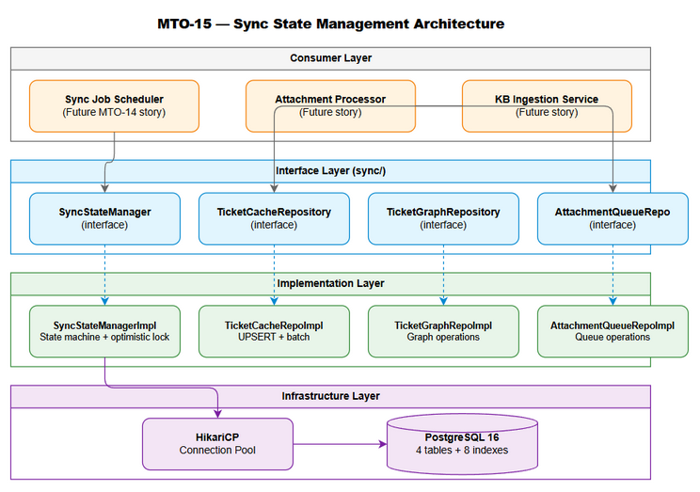
Architecture Diagram

2.2 Component Diagram
The module consists of 6 primary components organized in the com.orchestrator.mcp.sync package:
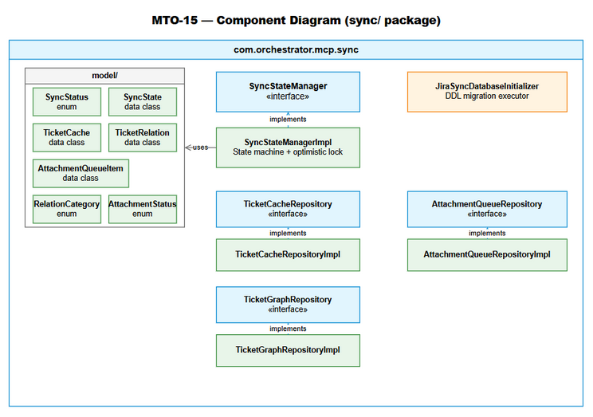
Component Diagram
Component | Responsibility | Technology
SyncStateManager | Lifecycle state machine, optimistic locking, progress tracking | Kotlin coroutines + JDBC
JiraSyncDatabaseInitializer | Execute DDL migration on startup | HikariCP + raw SQL
TicketCacheRepository | CRUD + UPSERT for ticket metadata cache | JDBC PreparedStatement
TicketGraphRepository | Insert/query directed graph edges | JDBC + composite PK
AttachmentQueueRepository | Queue operations (enqueue, poll, status update) | JDBC + partial indexes
Koin Module Extension | DI registration for all sync components | Koin 4.1.1

2.3 Deployment Architecture
This module deploys as part of the existing mcp-orchestrator-all.jar fat JAR. No separate deployment artifact is needed.
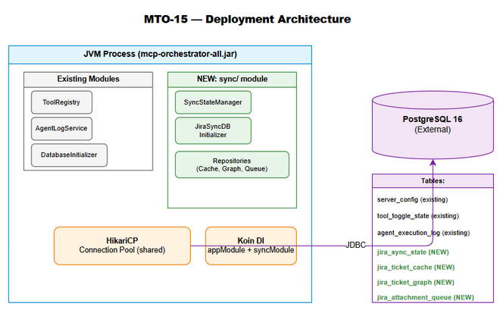
Deployment Diagram
Runtime topology: - Single JVM process (mcp-orchestrator-all.jar) - PostgreSQL database (external, shared with existing tables) - HikariCP connection pool (existing singleton, shared across all DB operations)

2.4 Communication Patterns
From | To | Protocol | Pattern | Description
Sync Job Scheduler | SyncStateManager | Kotlin suspend call | Sync (coroutine) | State transitions and progress updates
SyncStateManager | PostgreSQL | JDBC over TCP | Sync (Dispatchers.IO) | SQL queries via HikariCP
Ticket Fetcher | TicketCacheRepository | Kotlin suspend call | Sync (coroutine) | Batch UPSERT of ticket metadata
Relationship Extractor | TicketGraphRepository | Kotlin suspend call | Sync (coroutine) | Insert graph edges
Attachment Discoverer | AttachmentQueueRepository | Kotlin suspend call | Sync (coroutine) | Enqueue attachments
Attachment Processor | AttachmentQueueRepository | Kotlin suspend call | Sync (coroutine) | Poll + status updates
Application Startup | JiraSyncDatabaseInitializer | Kotlin suspend call | Sync (coroutine) | Execute migration DDL

3. API Design
Note: This module exposes internal Kotlin APIs only (no HTTP endpoints). The “API” here refers to the public interface methods that upstream consumers (Sync Job Scheduler, Attachment Processor) will call via Koin DI injection.

3.1 API Overview
# | Interface | Method | Description | Source
1 | SyncStateManager | getOrCreate(projectKey) | Get or create sync state | UC-01
2 | SyncStateManager | markRunning(projectKey) | Transition to RUNNING | UC-01, UC-05
3 | SyncStateManager | markPaused(projectKey) | Transition to PAUSED | UC-05
4 | SyncStateManager | markCompleted(projectKey) | Transition to COMPLETED | UC-01, UC-05
5 | SyncStateManager | markFailed(projectKey, error) | Transition to FAILED | UC-05
6 | SyncStateManager | updateProgress(projectKey, offset, synced) | Update checkpoint | UC-01
7 | SyncStateManager | getStatus(projectKey) | Query current status | UC-05
8 | TicketCacheRepository | upsert(ticket) | Insert/update single ticket | UC-02
9 | TicketCacheRepository | upsertBatch(tickets) | Batch insert/update | UC-02
10 | TicketCacheRepository | findByProject(projectKey) | Get all tickets for project | UC-02
11 | TicketCacheRepository | findNotIngested(projectKey) | Get un-ingested tickets | UC-02
12 | TicketCacheRepository | markIngested(ticketKey) | Mark ticket as KB-ingested | UC-02
13 | TicketGraphRepository | insertRelation(relation) | Insert graph edge | UC-03
14 | TicketGraphRepository | insertBatch(relations) | Batch insert edges | UC-03
15 | TicketGraphRepository | findOutgoing(sourceKey) | Get outgoing edges | UC-03
16 | TicketGraphRepository | findIncoming(targetKey) | Get incoming edges | UC-03
17 | TicketGraphRepository | deleteBySource(sourceKey) | Delete outgoing edges | UC-03
18 | AttachmentQueueRepository | enqueue(item) | Add to queue | UC-04
19 | AttachmentQueueRepository | enqueueBatch(items) | Batch enqueue | UC-04
20 | AttachmentQueueRepository | pollPending(limit) | Poll oldest PENDING | UC-04
21 | AttachmentQueueRepository | updateStatus(id, status, error) | Update processing status | UC-04
22 | AttachmentQueueRepository | markDone(id) | Mark as DONE | UC-04
23 | AttachmentQueueRepository | incrementRetry(id, error) | Increment retry count | UC-04

3.2 SyncStateManager Interface Contract
Implements: UC-01, UC-05, BR-01 through BR-27
interface SyncStateManager {
/** Get existing sync state or create new with IDLE status. Thread-safe via UPSERT. */
suspend fun getOrCreate(projectKey: String): SyncState
/** Transition to RUNNING. Allowed from: IDLE, PAUSED, FAILED. */
suspend fun markRunning(projectKey: String)
/** Transition to PAUSED. Allowed from: RUNNING only. */
suspend fun markPaused(projectKey: String)
/** Transition to COMPLETED. Allowed from: RUNNING only. Sets last_sync_at. */
suspend fun markCompleted(projectKey: String)
/** Transition to FAILED. Allowed from: RUNNING only. Stores error message. */
suspend fun markFailed(projectKey: String, error: String)
/** Update progress checkpoint atomically. Only when RUNNING. */
suspend fun updateProgress(projectKey: String, offset: Int, synced: Int)
/** Query current status. Returns null if project not tracked. */
suspend fun getStatus(projectKey: String): SyncStatus?
}
Error Contract:
Method | Exception | Condition
All methods | IllegalArgumentException | projectKey is blank or > 50 chars
markRunning | IllegalStateException | Current status not in {IDLE, PAUSED, FAILED}
markPaused | IllegalStateException | Current status ≠ RUNNING
markCompleted | IllegalStateException | Current status ≠ RUNNING
markFailed | IllegalStateException | Current status ≠ RUNNING
updateProgress | IllegalArgumentException | offset < 0 or synced < 0
updateProgress | IllegalStateException | Current status ≠ RUNNING

3.3 Repository Interface Contracts
TicketCacheRepository:
interface TicketCacheRepository {
suspend fun upsert(ticket: TicketCache)
suspend fun upsertBatch(tickets: List<TicketCache>): Int
suspend fun findByProject(projectKey: String): List<TicketCache>
suspend fun findNotIngested(projectKey: String): List<TicketCache>
suspend fun markIngested(ticketKey: String)
suspend fun findByHash(projectKey: String, hash: String): TicketCache?
}
TicketGraphRepository:
interface TicketGraphRepository {
suspend fun insertRelation(relation: TicketRelation)
suspend fun insertBatch(relations: List<TicketRelation>): Int
suspend fun findOutgoing(sourceKey: String): List<TicketRelation>
suspend fun findIncoming(targetKey: String): List<TicketRelation>
suspend fun findAllForProject(projectKey: String): List<TicketRelation>
suspend fun deleteBySource(sourceKey: String): Int
}
AttachmentQueueRepository:
interface AttachmentQueueRepository {
suspend fun enqueue(item: AttachmentQueueItem)
suspend fun enqueueBatch(items: List<AttachmentQueueItem>): Int
suspend fun pollPending(limit: Int): List<AttachmentQueueItem>
suspend fun updateStatus(id: Int, status: AttachmentStatus, error: String? = null)
suspend fun markDone(id: Int)
suspend fun incrementRetry(id: Int, error: String)
suspend fun findByTicket(ticketKey: String): List<AttachmentQueueItem>
suspend fun countByStatus(status: AttachmentStatus): Int
}

4. Database Design
Prerequisite: Logical data model (entities, relationships, business attributes) is defined in FSD §4. This section specifies the physical implementation: DDL scripts, indexes, migration plans, and query performance patterns.

4.1 Schema Overview
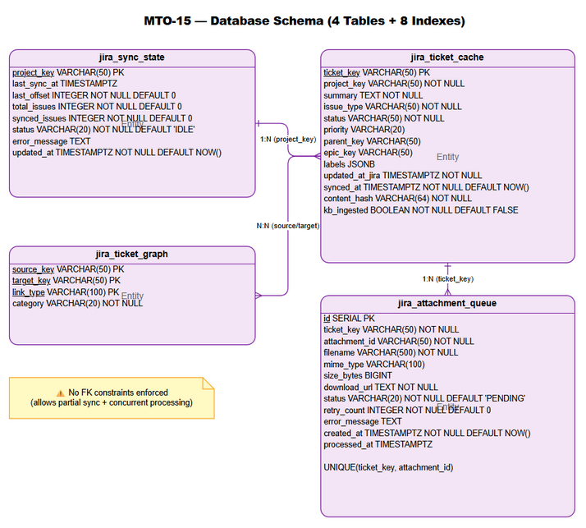
Database Schema
The physical schema consists of 4 tables in the default PostgreSQL schema:
Table | Purpose | PK Type | Estimated Rows
jira_sync_state | One row per project — sync lifecycle tracking | Natural (project_key) | 10-50
jira_ticket_cache | Cached Jira ticket metadata | Natural (ticket_key) | 10,000-100,000
jira_ticket_graph | Directed relationship edges between tickets | Composite (source, target, type) | 50,000-500,000
jira_attachment_queue | Work queue for attachment processing | Surrogate (SERIAL id) | 1,000-50,000

4.2 DDL Scripts

Table: jira_sync_state
CREATE TABLE IF NOT EXISTS jira_sync_state (
project_key VARCHAR(50) PRIMARY KEY,
last_sync_at TIMESTAMPTZ,
last_offset INTEGER NOT NULL DEFAULT 0,
total_issues INTEGER NOT NULL DEFAULT 0,
synced_issues INTEGER NOT NULL DEFAULT 0,
status VARCHAR(20) NOT NULL DEFAULT 'IDLE',
error_message TEXT,
updated_at TIMESTAMPTZ NOT NULL DEFAULT NOW(),
CONSTRAINT chk_sync_status CHECK (status IN ('IDLE', 'RUNNING', 'PAUSED', 'COMPLETED', 'FAILED')),
CONSTRAINT chk_offset_non_negative CHECK (last_offset >= 0),
CONSTRAINT chk_total_non_negative CHECK (total_issues >= 0),
CONSTRAINT chk_synced_non_negative CHECK (synced_issues >= 0)
);
COMMENT ON TABLE jira_sync_state IS 'Tracks synchronization progress per Jira project';
COMMENT ON COLUMN jira_sync_state.project_key IS 'Jira project key (e.g., MTO)';
COMMENT ON COLUMN jira_sync_state.last_offset IS 'Resumable checkpoint — last processed offset';
COMMENT ON COLUMN jira_sync_state.status IS 'Lifecycle state: IDLE, RUNNING, PAUSED, COMPLETED, FAILED';

Table: jira_ticket_cache
CREATE TABLE IF NOT EXISTS jira_ticket_cache (
ticket_key VARCHAR(50) PRIMARY KEY,
project_key VARCHAR(50) NOT NULL,
summary TEXT NOT NULL,
issue_type VARCHAR(50) NOT NULL,
status VARCHAR(50) NOT NULL,
priority VARCHAR(20),
parent_key VARCHAR(50),
epic_key VARCHAR(50),
labels JSONB,
updated_at_jira TIMESTAMPTZ NOT NULL,
synced_at TIMESTAMPTZ NOT NULL DEFAULT NOW(),
content_hash VARCHAR(64) NOT NULL,
kb_ingested BOOLEAN NOT NULL DEFAULT FALSE
);
COMMENT ON TABLE jira_ticket_cache IS 'Local cache of Jira ticket metadata for change detection';
COMMENT ON COLUMN jira_ticket_cache.content_hash IS 'SHA-256 hash of key fields for change detection';
COMMENT ON COLUMN jira_ticket_cache.kb_ingested IS 'Whether ticket has been ingested into Knowledge Base';

Table: jira_ticket_graph
CREATE TABLE IF NOT EXISTS jira_ticket_graph (
source_key VARCHAR(50) NOT NULL,
target_key VARCHAR(50) NOT NULL,
link_type VARCHAR(100) NOT NULL,
category VARCHAR(20) NOT NULL,
PRIMARY KEY (source_key, target_key, link_type),
CONSTRAINT chk_graph_category CHECK (category IN ('INWARD', 'OUTWARD', 'SUBTASK', 'EPIC'))
);
COMMENT ON TABLE jira_ticket_graph IS 'Directed graph of ticket relationships for dependency visualization';
COMMENT ON COLUMN jira_ticket_graph.category IS 'Relationship category: INWARD, OUTWARD, SUBTASK, EPIC';

Table: jira_attachment_queue
CREATE TABLE IF NOT EXISTS jira_attachment_queue (
id SERIAL PRIMARY KEY,
ticket_key VARCHAR(50) NOT NULL,
attachment_id VARCHAR(50) NOT NULL,
filename VARCHAR(500) NOT NULL,
mime_type VARCHAR(100),
size_bytes BIGINT,
download_url TEXT NOT NULL,
status VARCHAR(20) NOT NULL DEFAULT 'PENDING',
retry_count INTEGER NOT NULL DEFAULT 0,
error_message TEXT,
created_at TIMESTAMPTZ NOT NULL DEFAULT NOW(),
processed_at TIMESTAMPTZ,
CONSTRAINT chk_attachment_status CHECK (status IN ('PENDING', 'DOWNLOADING', 'PROCESSING', 'DONE', 'FAILED')),
CONSTRAINT chk_retry_non_negative CHECK (retry_count >= 0),
CONSTRAINT uq_ticket_attachment UNIQUE (ticket_key, attachment_id)
);
COMMENT ON TABLE jira_attachment_queue IS 'Queue for asynchronous attachment download and processing';
COMMENT ON COLUMN jira_attachment_queue.status IS 'Lifecycle: PENDING, DOWNLOADING, PROCESSING, DONE, FAILED';

Indexes
-- jira_ticket_cache indexes
CREATE INDEX IF NOT EXISTS idx_ticket_cache_project ON jira_ticket_cache (project_key);
CREATE INDEX IF NOT EXISTS idx_ticket_cache_updated ON jira_ticket_cache (updated_at_jira);
CREATE INDEX IF NOT EXISTS idx_ticket_cache_not_ingested ON jira_ticket_cache (kb_ingested) WHERE kb_ingested = FALSE;
-- jira_ticket_graph indexes
CREATE INDEX IF NOT EXISTS idx_ticket_graph_source ON jira_ticket_graph (source_key);
CREATE INDEX IF NOT EXISTS idx_ticket_graph_target ON jira_ticket_graph (target_key);
-- jira_attachment_queue indexes
CREATE INDEX IF NOT EXISTS idx_attachment_queue_status ON jira_attachment_queue (status);
CREATE INDEX IF NOT EXISTS idx_attachment_queue_ticket ON jira_attachment_queue (ticket_key);
CREATE INDEX IF NOT EXISTS idx_attachment_queue_pending ON jira_attachment_queue (status, created_at) WHERE status = 'PENDING';

4.3 Migration Plan
Order | Script | Description | Estimated Time | Rollback
1 | V3__create_jira_sync_tables.sql | Create all 4 tables + 8 indexes | < 1 second | DROP TABLE IF EXISTS (reverse order)
Migration execution pattern:
class JiraSyncDatabaseInitializer(private val dataSource: HikariDataSource) {
private val log = LoggerFactory.getLogger(javaClass)
suspend fun initialize() = withContext(Dispatchers.IO) {
log.info("Initializing Jira sync database schema...")
dataSource.connection.use { conn ->
conn.autoCommit = false
try {
conn.createStatement().use { stmt ->
stmt.execute(CREATE_JIRA_SYNC_STATE)
stmt.execute(CREATE_JIRA_TICKET_CACHE)
stmt.execute(CREATE_JIRA_TICKET_GRAPH)
stmt.execute(CREATE_JIRA_ATTACHMENT_QUEUE)
stmt.execute(CREATE_INDEXES)
}
conn.commit()
log.info("Jira sync database schema initialized successfully.")
} catch (e: Exception) {
conn.rollback()
log.error("Failed to initialize Jira sync schema", e)
throw e
}
}
}
}
Rollback script (manual, for emergency use):
-- V3__rollback_jira_sync_tables.sql
DROP TABLE IF EXISTS jira_attachment_queue CASCADE;
DROP TABLE IF EXISTS jira_ticket_graph CASCADE;
DROP TABLE IF EXISTS jira_ticket_cache CASCADE;
DROP TABLE IF EXISTS jira_sync_state CASCADE;

4.4 Query Patterns
Operation | Query Pattern | Expected Performance | Index Used
Get sync state | SELECT * FROM jira_sync_state WHERE project_key = ? | < 1ms (PK lookup) | PK
Update sync status | UPDATE jira_sync_state SET status=? WHERE project_key=? AND status=? | < 5ms | PK
Upsert ticket | INSERT INTO jira_ticket_cache ... ON CONFLICT (ticket_key) DO UPDATE | < 5ms | PK
Batch upsert (100) | Same as above in loop with single transaction | < 100ms | PK
Find tickets by project | SELECT * FROM jira_ticket_cache WHERE project_key = ? | < 50ms (1000 rows) | idx_ticket_cache_project
Find un-ingested | SELECT * FROM jira_ticket_cache WHERE project_key=? AND kb_ingested=FALSE | < 10ms | idx_ticket_cache_not_ingested
Insert graph edge | INSERT INTO jira_ticket_graph ... ON CONFLICT DO NOTHING | < 1ms | PK
Find outgoing edges | SELECT * FROM jira_ticket_graph WHERE source_key = ? | < 5ms | idx_ticket_graph_source
Poll pending attachments | SELECT * FROM jira_attachment_queue WHERE status='PENDING' ORDER BY created_at LIMIT ? | < 10ms | idx_attachment_queue_pending
Count by status | SELECT COUNT(*) FROM jira_attachment_queue WHERE status = ? | < 5ms | idx_attachment_queue_status

5. Class / Module Design

5.1 Package Structure
com.orchestrator.mcp.sync/
├── model/
│ ├── SyncState.kt # Data class — sync state record (≤30 lines)
│ ├── SyncStatus.kt # Enum — IDLE, RUNNING, PAUSED, COMPLETED, FAILED (≤10 lines)
│ ├── TicketCache.kt # Data class — cached ticket metadata (≤30 lines)
│ ├── TicketRelation.kt # Data class — graph edge (≤15 lines)
│ ├── RelationCategory.kt # Enum — INWARD, OUTWARD, SUBTASK, EPIC (≤10 lines)
│ ├── AttachmentQueueItem.kt # Data class — queue entry (≤30 lines)
│ └── AttachmentStatus.kt # Enum — PENDING, DOWNLOADING, PROCESSING, DONE, FAILED (≤10 lines)
├── SyncStateManager.kt # Interface — 7 suspend methods (≤25 lines)
├── SyncStateManagerImpl.kt # Implementation — state machine + optimistic locking (≤180 lines)
├── JiraSyncDatabaseInitializer.kt # Migration executor (≤80 lines)
├── TicketCacheRepository.kt # Interface — 6 methods (≤20 lines)
├── TicketCacheRepositoryImpl.kt # Implementation — UPSERT + batch (≤180 lines)
├── TicketGraphRepository.kt # Interface — 6 methods (≤20 lines)
├── TicketGraphRepositoryImpl.kt # Implementation — graph operations (≤150 lines)
├── AttachmentQueueRepository.kt # Interface — 8 methods (≤25 lines)
└── AttachmentQueueRepositoryImpl.kt # Implementation — queue operations (≤180 lines)
Total new files: 15 (7 model + 4 interfaces + 4 implementations) Estimated total lines: ~800 (all files ≤ 200 lines each)

5.2 Class Diagram
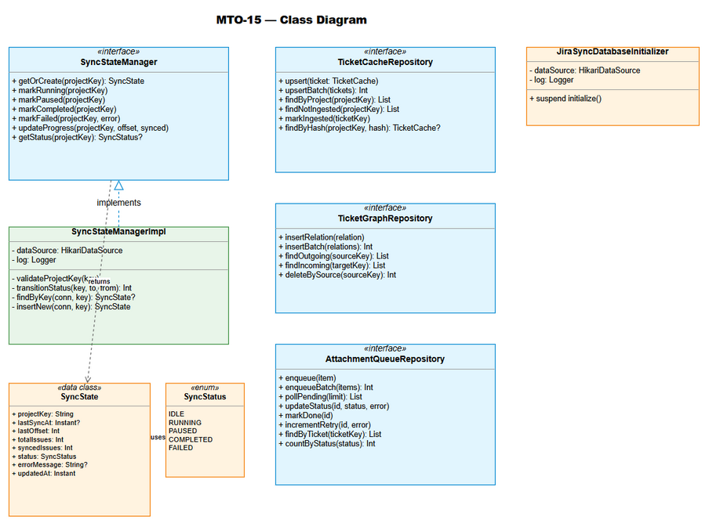
Class Diagram

5.3 Key Interfaces
SyncStateManager (see §3.2 for full contract)
JiraSyncDatabaseInitializer:
class JiraSyncDatabaseInitializer(private val dataSource: HikariDataSource) {
suspend fun initialize() // Execute V3 migration DDL
}

5.4 Implementation Details — SyncStateManagerImpl
class SyncStateManagerImpl(
private val dataSource: HikariDataSource
) : SyncStateManager {
private val log = LoggerFactory.getLogger(javaClass)
override suspend fun getOrCreate(projectKey: String): SyncState =
withContext(Dispatchers.IO) {
validateProjectKey(projectKey)
dataSource.connection.use { conn ->
// Try SELECT first
val existing = findByKey(conn, projectKey)
if (existing != null) return@withContext existing
// INSERT new with IDLE status
insertNew(conn, projectKey)
}
}
override suspend fun markRunning(projectKey: String) =
withContext(Dispatchers.IO) {
validateProjectKey(projectKey)
val allowed = listOf("IDLE", "PAUSED", "FAILED")
val rows = transitionStatus(projectKey, "RUNNING", allowed)
if (rows == 0) throwInvalidTransition(projectKey, "RUNNING")
}
// ... similar for markPaused, markCompleted, markFailed
override suspend fun updateProgress(
projectKey: String, offset: Int, synced: Int
) = withContext(Dispatchers.IO) {
require(offset >= 0) { "Offset must be non-negative" }
require(synced >= 0) { "Synced count must be non-negative" }
val sql = """
UPDATE jira_sync_state
SET last_offset = ?, synced_issues = ?, updated_at = NOW()
WHERE project_key = ? AND status = 'RUNNING'
""".trimIndent()
val rows = dataSource.connection.use { conn ->
conn.prepareStatement(sql).use { stmt ->
stmt.setInt(1, offset)
stmt.setInt(2, synced)
stmt.setString(3, projectKey)
stmt.executeUpdate()
}
}
if (rows == 0) {
throw IllegalStateException(
"Cannot update progress: project $projectKey is not RUNNING"
)
}
}
private fun validateProjectKey(key: String) {
require(key.isNotBlank()) { "Project key must not be blank" }
require(key.length <= 50) { "Project key exceeds 50 characters" }
}
private fun transitionStatus(
projectKey: String, toStatus: String, fromStatuses: List<String>
): Int {
val sql = """
UPDATE jira_sync_state
SET status = ?, updated_at = NOW(), error_message = NULL
WHERE project_key = ? AND status = ANY(?)
""".trimIndent()
return dataSource.connection.use { conn ->
conn.prepareStatement(sql).use { stmt ->
stmt.setString(1, toStatus)
stmt.setString(2, projectKey)
stmt.setArray(3, conn.createArrayOf("VARCHAR", fromStatuses.toTypedArray()))
stmt.executeUpdate()
}
}
}
private fun throwInvalidTransition(projectKey: String, target: String) {
val current = runBlocking { getStatus(projectKey) }
throw IllegalStateException(
"Cannot transition to $target from $current for project $projectKey"
)
}
}

5.5 Design Patterns
Pattern | Where Used | Rationale
Interface/Impl | All services and repositories | Testability via MockK; Koin DI binding
Optimistic Locking | SyncStateManagerImpl transitions | Prevent race conditions without DB-level locks
Repository | TicketCache/Graph/AttachmentQueue | Separation of concerns — each repo handles one table
Template Method | JiraSyncDatabaseInitializer.initialize() | Same pattern as existing DatabaseInitializer
UPSERT (Idempotent Write) | TicketCacheRepository, TicketGraphRepository | Safe re-execution, no duplicate errors
Work Queue | AttachmentQueueRepository | Persistent FIFO queue with status lifecycle

5.6 Error Handling
Exception | Context | When Thrown | Recovery
IllegalArgumentException | Input validation | Blank/oversized projectKey, negative offset | Caller fixes input (programming error)
IllegalStateException | State machine | Invalid transition or concurrent modification | Caller logs warning, skips or retries once
SQLException | Database operations | Connection failure, constraint violation | Propagates to caller; RetryUtils handles
DataIntegrityViolationException | JSONB validation | Invalid labels JSON in ticket cache | Skip single ticket, log error, continue batch

5.7 Koin DI Registration
// Extension to existing AppModule.kt
val syncModule = module {
single { JiraSyncDatabaseInitializer(get()) }
single<SyncStateManager> { SyncStateManagerImpl(get()) }
single<TicketCacheRepository> { TicketCacheRepositoryImpl(get()) }
single<TicketGraphRepository> { TicketGraphRepositoryImpl(get()) }
single<AttachmentQueueRepository> { AttachmentQueueRepositoryImpl(get()) }
}
Startup initialization order: 1. HikariDataSource created (existing) 2. JiraSyncDatabaseInitializer.initialize() called (new — after existing DatabaseInitializer) 3. All repository singletons available via Koin

6. Integration Design
Prerequisite: Business integration requirements are defined in FSD §5. This section specifies the technical implementation.

6.1 External System: PostgreSQL Database
Attribute | Value
Protocol | JDBC (PostgreSQL driver)
Connection | Via HikariCP pool (existing singleton)
Authentication | Username/password from application.yml
Timeout | Connection acquire: 30s (HikariCP default)
Retry Policy | No retry at repository level — caller uses RetryUtils
Circuit Breaker | Not applicable (single DB, HikariCP handles pool exhaustion)
Connection Configuration (existing in application.yml):
orchestrator:
database:
url: "jdbc:postgresql://localhost:5432/mcp_orchestrator"
username: "${DB_USERNAME:postgres}"
password: "${DB_PASSWORD:postgres}"
pool:
maximum_pool_size: 10
minimum_idle: 2
idle_timeout_ms: 600000
connection_timeout_ms: 30000
Data Mapping (Kotlin ↔ PostgreSQL):
Kotlin Type | PostgreSQL Type | Transformation
String | VARCHAR(N) | Direct mapping
Int | INTEGER | Direct mapping
Long | BIGINT | Direct mapping
Boolean | BOOLEAN | Direct mapping
Instant (kotlinx.datetime) | TIMESTAMPTZ | Timestamp.from(instant.toJavaInstant())
List<String>? | JSONB | Json.encodeToString(list) / Json.decodeFromString(jsonStr)
SyncStatus (enum) | VARCHAR(20) | .name / SyncStatus.valueOf(str)
RelationCategory (enum) | VARCHAR(20) | .name / RelationCategory.valueOf(str)
AttachmentStatus (enum) | VARCHAR(20) | .name / AttachmentStatus.valueOf(str)

6.2 External System: HikariCP Connection Pool
Attribute | Value
Protocol | In-process (JVM library)
Integration | Koin DI injection of HikariDataSource
Pattern | dataSource.connection.use { conn -> ... } (auto-close)
Threading | All DB calls wrapped in withContext(Dispatchers.IO)
Sequence Diagram — Sync State Transition:
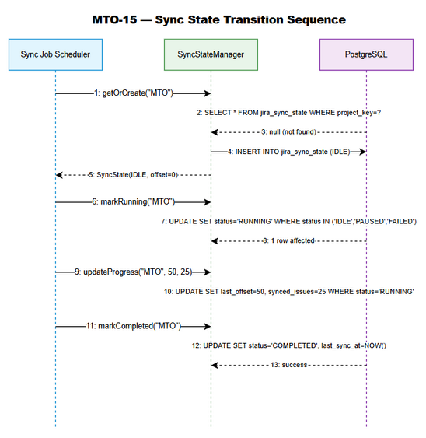
API Sequence

6.3 External System: Koin DI Framework
Attribute | Value
Protocol | In-process (JVM library)
Integration | Module registration at startup
Pattern | single<Interface> { Impl(get()) }
Registration sequence: 1. Application.kt → startKoin { modules(appModule, syncModule) } 2. Koin resolves HikariDataSource (existing binding) 3. Koin creates JiraSyncDatabaseInitializer(dataSource) singleton 4. Application calls get<JiraSyncDatabaseInitializer>().initialize() 5. Koin creates repository singletons on first access

7. Security Design
Prerequisite: Business security requirements are defined in FSD §7.

7.1 Authentication
This module is an internal service — no external authentication. Access is controlled at the application level: - Only Koin-registered services can obtain repository instances - No HTTP endpoints exposed (internal Kotlin API only) - Database credentials managed via environment variables (DB_USERNAME, DB_PASSWORD)

7.2 Authorization
Role | Access | Enforcement
Sync Job Scheduler | Full CRUD on all tables | Application-level (Koin DI injection)
Attachment Processor | Read/Write attachment queue | Application-level
KB Ingestion Service | Read ticket cache, write kb_ingested | Application-level
External users | No access | No HTTP endpoints

7.3 Data Protection
Data Type | At Rest | In Transit | In Logs
Jira ticket metadata | Plain (PostgreSQL) | TLS (if remote DB) | Allowed (internal data)
Attachment download URLs | Plain (PostgreSQL) | TLS | EXCLUDED (contains auth tokens)
Sync error messages | Plain (PostgreSQL) | TLS | Allowed (debugging)
Content hashes (SHA-256) | Plain | TLS | Allowed (non-reversible)
Database credentials | Environment variables | N/A | EXCLUDED

7.4 Input Validation
Field | Validation | Enforcement
projectKey | Non-blank, ≤50 chars, pattern [A-Z]+ | validateProjectKey() in SyncStateManagerImpl
ticketKey | Non-blank, ≤50 chars, pattern [A-Z]+-\d+ | Repository-level validation
contentHash | Exactly 64 hex characters | require(hash.length == 64)
offset | ≥ 0 | require(offset >= 0)
synced | ≥ 0 | require(synced >= 0)
labels (JSONB) | Valid JSON array or null | PostgreSQL JSONB type enforcement
category | One of: INWARD, OUTWARD, SUBTASK, EPIC | Kotlin enum + CHECK constraint
status | One of: IDLE, RUNNING, PAUSED, COMPLETED, FAILED | Kotlin enum + CHECK constraint

8. Performance & Scalability
Prerequisite: Business NFR targets are defined in FSD §8.

8.1 Caching Strategy
Cache | What | TTL | Eviction | Technology
N/A | No application-level caching needed | — | — | —
Rationale: All queries are simple PK lookups or indexed queries with < 10ms response time. Adding a cache layer would introduce complexity (invalidation, consistency) without meaningful performance gain for this workload.

8.2 Connection Pooling
Resource | Min | Max | Timeout | Idle Timeout
PostgreSQL (HikariCP) | 2 | 10 | 30,000ms | 600,000ms
Shared pool: The sync module shares the existing HikariCP pool with other modules (tool registry, agent logging). The pool size of 10 is sufficient for: - 1-2 concurrent sync jobs (each holds connection briefly per operation) - Background attachment processor (1 connection per poll cycle) - Existing modules (tool toggle, agent log)

8.3 Performance Targets
Operation | Target (p99) | Measurement | Bottleneck
Single sync state update | < 5ms | JDBC round-trip | Network latency to DB
Batch UPSERT (100 tickets) | < 200ms | Single transaction | Sequential PreparedStatement execution
Attachment queue poll | < 10ms | Partial index scan | Index on (status, created_at)
Graph edge insert (single) | < 2ms | PK lookup + insert | Composite PK check
Migration execution (cold start) | < 500ms | DDL execution | Table creation (one-time)

8.4 Scalability Considerations
Dimension | Current Design | Future Scaling Path
Projects | 50 concurrent (one row each) | No change needed — PK lookup is O(1)
Tickets per project | 100,000 | Partition by project_key if > 1M
Graph edges | 500,000 | Partition by source_key prefix if > 5M
Attachment queue | 50,000 active | Archive DONE entries to separate table if > 100K
Concurrent sync jobs | 1 per project (optimistic lock) | No change — lock prevents concurrent runs

9. Monitoring & Observability

9.1 Logging
Log Event | Level | Fields | Destination
Schema initialization start | INFO | — | Logback (stdout + file)
Schema initialization success | INFO | — | Logback
Schema initialization failure | ERROR | exception, SQL context | Logback
State transition | INFO | projectKey, fromStatus, toStatus | Logback
Invalid state transition | WARN | projectKey, currentStatus, attemptedTarget | Logback
Concurrent modification detected | WARN | projectKey, targetStatus | Logback
Batch UPSERT completed | DEBUG | projectKey, count, durationMs | Logback
Attachment queue poll | DEBUG | pendingCount, polledCount | Logback
Attachment processing failure | WARN | ticketKey, attachmentId, error, retryCount | Logback

9.2 Metrics
Metric | Type | Description | Alert Threshold
sync.state.transitions.total | Counter | Total state transitions (by project, from, to) | —
sync.state.failures.total | Counter | Failed transitions (invalid state) | > 10/minute
sync.tickets.upserted.total | Counter | Tickets upserted (by project) | —
sync.tickets.batch.duration_ms | Histogram | Batch UPSERT duration | p99 > 500ms
sync.attachments.pending | Gauge | Current PENDING attachment count | > 1000
sync.attachments.failed | Counter | Failed attachment processing | > 50/hour
sync.db.connection.acquire_ms | Histogram | HikariCP connection acquire time | p99 > 5000ms
Note: Metrics are emitted via SLF4J structured logging (existing pattern). Future story may add Micrometer/Prometheus integration.

9.3 Health Checks
Check | Method | Expected Response | Failure Action
Database connectivity | SELECT 1 via HikariCP | Success within 5s | Log ERROR, retry
Sync tables exist | SELECT COUNT(*) FROM jira_sync_state | No exception | Re-run migration

10. Deployment Considerations

10.1 Environment Configuration
Property | DEV | SIT | UAT | PROD
DB URL | localhost:5432 | sit-db:5432 | uat-db:5432 | prod-db:5432
DB Pool Max | 5 | 10 | 10 | 20
DB Pool Min | 1 | 2 | 2 | 5
Log Level (sync) | DEBUG | INFO | INFO | INFO

10.2 Feature Flags
Flag | Default | Description
sync.enabled | true | Master switch for sync module initialization
sync.attachment_processing.enabled | true | Enable/disable attachment queue processing
Implementation: Feature flags are read from application.yml at startup. If sync.enabled = false, the JiraSyncDatabaseInitializer is not called and sync repositories are not registered in Koin.

10.3 Rollback Strategy
Scenario | Rollback Action | Data Impact
Bug in SyncStateManager logic | Redeploy previous JAR version | No data loss — tables remain
Schema migration issue | Run rollback SQL (DROP tables) | Data loss — all sync state lost
Performance regression | Redeploy previous JAR + keep tables | No data loss
Rollback procedure: 1. Stop application 2. If schema rollback needed: execute V3__rollback_jira_sync_tables.sql 3. Deploy previous JAR version 4. Start application (previous version won’t call V3 migration)

10.4 Backward Compatibility
- Database: New tables only — no modification to existing tables. Fully backward-compatible.
- Code: New package sync/ — no modification to existing classes. Fully backward-compatible.
- Configuration: New optional section in application.yml. Missing section = sync disabled.
- Startup: New initialization step added AFTER existing DatabaseInitializer. If it fails, application logs error but existing functionality is unaffected (sync module simply unavailable).

11. Testing Strategy

11.1 Test Architecture
Level | Framework | Scope | Mocking
Unit Tests | Kotest 5.9.1 + MockK 1.14.2 | SyncStateManagerImpl logic | Mock HikariDataSource, Connection, PreparedStatement
Integration Tests | Kotest + Testcontainers 1.21.1 | Full DB operations | Real PostgreSQL container, no mocks

11.2 Unit Test Design — SyncStateManagerImpl
Test class: SyncStateManagerImplTest.kt
Test Case | Input | Expected | BR
getOrCreate — new project | “MTO” (not in DB) | INSERT + return SyncState(IDLE) | BR-01
getOrCreate — existing project | “MTO” (exists) | Return existing record | BR-01
markRunning — from IDLE | status=IDLE | UPDATE to RUNNING | BR-21
markRunning — from PAUSED | status=PAUSED | UPDATE to RUNNING | BR-21
markRunning — from FAILED | status=FAILED | UPDATE to RUNNING | BR-21
markRunning — from COMPLETED | status=COMPLETED | IllegalStateException | BR-21
markPaused — from RUNNING | status=RUNNING | UPDATE to PAUSED | BR-22
markPaused — from IDLE | status=IDLE | IllegalStateException | BR-22
markCompleted — from RUNNING | status=RUNNING | UPDATE to COMPLETED + set last_sync_at | BR-23
markFailed — from RUNNING | status=RUNNING | UPDATE to FAILED + store error | BR-24
updateProgress — valid | offset=100, synced=50 | UPDATE offset and synced | BR-03, BR-04
updateProgress — negative offset | offset=-1 | IllegalArgumentException | BR-03
updateProgress — not RUNNING | status=IDLE | IllegalStateException | —
validateProjectKey — blank | "" | IllegalArgumentException | —
validateProjectKey — too long | 51 chars | IllegalArgumentException | —
concurrent modification | 0 rows affected | IllegalStateException | BR-26
Mocking strategy:
class SyncStateManagerImplTest : FunSpec({
val dataSource = mockk<HikariDataSource>()
val connection = mockk<Connection>()
val statement = mockk<PreparedStatement>()
val manager = SyncStateManagerImpl(dataSource)
beforeEach {
every { dataSource.connection } returns connection
every { connection.prepareStatement(any()) } returns statement
every { connection.close() } just Runs
}
})

11.3 Integration Test Design — Database Operations
Test class: JiraSyncDatabaseIntegrationTest.kt
Infrastructure: Testcontainers PostgreSQL 16
class JiraSyncDatabaseIntegrationTest : FunSpec({
val postgres = PostgreSQLContainer("postgres:16-alpine")
lateinit var dataSource: HikariDataSource
beforeSpec {
postgres.start()
dataSource = HikariDataSource().apply {
jdbcUrl = postgres.jdbcUrl
username = postgres.username
password = postgres.password
}
// Run migration
JiraSyncDatabaseInitializer(dataSource).initialize()
}
afterSpec {
dataSource.close()
postgres.stop()
}
})
Test Case | Scope | Validates
Migration creates all 4 tables | DDL | Tables exist after initialize()
Migration is idempotent | DDL | Second initialize() doesn’t throw
UPSERT inserts new ticket | TicketCacheRepo | Row created with correct values
UPSERT updates existing ticket | TicketCacheRepo | Row updated, synced_at refreshed
Batch UPSERT (100 tickets) | TicketCacheRepo | All 100 rows created, < 1s
Graph edge insert + duplicate | TicketGraphRepo | First succeeds, second is no-op
Self-referencing edge rejected | TicketGraphRepo | IllegalArgumentException
Attachment enqueue + poll | AttachmentQueueRepo | FIFO ordering by created_at
State transition full lifecycle | SyncStateManager | IDLE→RUNNING→COMPLETED
Concurrent modification | SyncStateManager | Second thread gets IllegalStateException
Partial index used for poll | EXPLAIN ANALYZE | idx_attachment_queue_pending in plan
CHECK constraint enforcement | DDL | Invalid status INSERT throws

11.4 Test Data
Fixtures: - TestFixtures.kt — factory methods for creating test data classes - No CSV files needed (data classes are simple, created inline)

12. Implementation Checklist

12.1 Files to Create
# | File Path | Type | Lines (est.) | Priority
1 | sync/model/SyncStatus.kt | Enum | 10 | P0
2 | sync/model/SyncState.kt | Data class | 25 | P0
3 | sync/model/AttachmentStatus.kt | Enum | 10 | P0
4 | sync/model/AttachmentQueueItem.kt | Data class | 30 | P0
5 | sync/model/RelationCategory.kt | Enum | 10 | P0
6 | sync/model/TicketRelation.kt | Data class | 15 | P0
7 | sync/model/TicketCache.kt | Data class | 30 | P0
8 | sync/SyncStateManager.kt | Interface | 25 | P0
9 | sync/SyncStateManagerImpl.kt | Implementation | 180 | P0
10 | sync/JiraSyncDatabaseInitializer.kt | Migration | 80 | P0
11 | sync/TicketCacheRepository.kt | Interface | 20 | P1
12 | sync/TicketCacheRepositoryImpl.kt | Implementation | 180 | P1
13 | sync/TicketGraphRepository.kt | Interface | 20 | P1
14 | sync/TicketGraphRepositoryImpl.kt | Implementation | 150 | P1
15 | sync/AttachmentQueueRepository.kt | Interface | 25 | P1
16 | sync/AttachmentQueueRepositoryImpl.kt | Implementation | 180 | P1
Base path: orchestrator-server/src/main/kotlin/com/orchestrator/mcp/

12.2 Files to Modify
# | File Path | Change | Impact
1 | di/AppModule.kt | Add syncModule import and include | Low — additive only
2 | Application.kt | Call JiraSyncDatabaseInitializer.initialize() after existing init | Low — additive only

12.3 Test Files to Create
# | File Path | Type | Lines (est.)
1 | sync/SyncStateManagerImplTest.kt | Unit test | 150
2 | sync/JiraSyncDatabaseIntegrationTest.kt | Integration test | 180
3 | sync/TicketCacheRepositoryImplTest.kt | Integration test | 120
4 | sync/TicketGraphRepositoryImplTest.kt | Integration test | 100
5 | sync/AttachmentQueueRepositoryImplTest.kt | Integration test | 130
Base path: orchestrator-server/src/test/kotlin/com/orchestrator/mcp/

12.4 Implementation Order
Phase 1 (Foundation):
1. Model classes (all 7 files) — no dependencies
2. JiraSyncDatabaseInitializer — depends on HikariDataSource only
3. SyncStateManager interface + impl — depends on models + HikariDataSource
Phase 2 (Repositories):
4. TicketCacheRepository interface + impl
5. TicketGraphRepository interface + impl
6. AttachmentQueueRepository interface + impl
Phase 3 (Integration):
7. Koin module extension (syncModule)
8. Application.kt startup integration
Phase 4 (Testing):
9. Unit tests for SyncStateManagerImpl
10. Integration tests with Testcontainers

13. Appendix

13.1 Glossary
Term | Definition
Optimistic Locking | Concurrency control using WHERE clause on expected state — no DB-level locks
UPSERT | INSERT … ON CONFLICT … DO UPDATE — atomic insert-or-update
Partial Index | PostgreSQL index with WHERE clause — indexes only matching rows
Composite PK | Primary key consisting of multiple columns
HikariCP | High-performance JDBC connection pool library
Dispatchers.IO | Kotlin coroutine dispatcher optimized for blocking I/O operations
Testcontainers | Library that provides throwaway Docker containers for integration testing

13.2 Open Questions
# | Question | Status | Answer
1 | Should COMPLETED state allow transition back to IDLE for re-sync? | Open | Future story may add reset() method
2 | Should attachment queue have a dead-letter mechanism? | Open | Current design: FAILED items stay in table. Future story may archive.
3 | Should we add a created_at column to jira_sync_state? | Resolved | No — updated_at with DEFAULT NOW() serves as creation timestamp for new rows

13.3 Diagram Index
# | Diagram | Image | Source (editable)
1 | Architecture Overview | tdd-architecture.png | tdd-architecture.drawio
2 | Component Diagram | tdd-component.png | tdd-component.drawio
3 | Class Diagram | tdd-class-diagram.png | tdd-class-diagram.drawio
4 | Database Schema | tdd-db-schema.png | tdd-db-schema.drawio
5 | API Sequence | tdd-api-sequence.png | tdd-api-sequence.drawio
6 | Deployment Diagram | tdd-deployment.png | tdd-deployment.drawio

End of Document

