Business Requirements Document (BRD)

Jira Project Sync Service — MTO-16: Jira REST Client — Direct API Integration

Document Information
Field | Value
Jira Ticket | MTO-16
Title | Jira REST Client — Direct API Integration
Author | BA Agent
Version | 1.0
Date | 2025-07-14
Status | Draft
Parent Epic | MTO-14 — Jira Project Sync Service: Background Job for Automated KB Ingestion

Author Tracking
Role | Name - Position | Responsibility
Author | BA Agent – Business Analyst | Create document
Peer Reviewer | SA Agent – Solution Architect | Review document

Revision History
Version | Date | Author | Changes
1.0 | 2025-07-14 | BA Agent | Initiate document — auto-generated from Jira ticket MTO-16 and epic MTO-14 context

Sign-Off
Name | Signature and date
 | ☐ I agree and confirm all criteria on this BRD as expected requirements
 | ☐ I agree and confirm all criteria on this BRD as expected requirements

1. Introduction

1.1 Scope
This document defines the business requirements for building a dedicated Jira REST API client that communicates directly with Jira Cloud/Server APIs. This client bypasses the MCP Atlassian connector to provide efficient, high-throughput access for the background sync job (Epic MTO-14).
The scope includes:
- Ktor HTTP Client with JSON serialization (kotlinx.serialization), Basic Auth, configurable base URL, connection pooling, and timeout management
- 4 API endpoint methods: searchIssues, getIssue, getAttachments, downloadAttachment
- Rate limiting via token bucket algorithm (10 requests/second default) with 429 response handling
- Retry logic with exponential backoff (1s initial, 30s max, 3 retries max) for transient failures
- Custom error handling with typed exceptions and structured error parsing
- Environment-based configuration for all connection parameters
This is a foundation story — it provides the HTTP communication layer that the sync job orchestrator and ticket fetcher depend on.

1.2 Out of Scope
- Jira webhook integration (push-based notifications)
- OAuth 2.0 authentication (only Basic Auth with API token is in scope)
- Jira write operations (create/update/delete issues)
- Jira Cloud-specific features (Connect apps, Forge apps)
- Caching of API responses (handled by MTO-15 ticket cache layer)
- Background job scheduling and orchestration (separate story under MTO-14)
- Knowledge Base ingestion pipeline (separate story under MTO-14)
- UI/dashboard for monitoring API health

1.3 Preliminary Requirement
- Ktor Client library (CIO engine) is available in the project (already declared in orchestrator-server/build.gradle.kts)
- kotlinx.serialization is available for JSON parsing (already in project dependencies)
- Jira Cloud/Server instance is accessible with valid API credentials
- Environment variables for Jira connection can be configured in deployment environment
- PostgreSQL database is available for sync state tracking (MTO-15 dependency)

2. Business Requirements

2.1 High Level Process Map
The Jira REST Client provides a reliable, rate-limited HTTP communication layer between the MCP Orchestration system and Jira’s REST API. It serves as the data acquisition component for the broader Jira Project Sync Service.
flowchart TB
subgraph "MCP Orchestration System"
A[Sync Job Scheduler] --> B[Jira REST Client]
B --> C[Rate Limiter<br/>Token Bucket]
B --> D[Retry Handler<br/>Exponential Backoff]
B --> E[Error Handler<br/>Custom Exceptions]
end
subgraph "External"
F[Jira REST API v3]
end
C --> F
D --> C
F -->|200 OK| B
F -->|429 Rate Limited| D
F -->|5xx Server Error| D
F -->|4xx Client Error| E
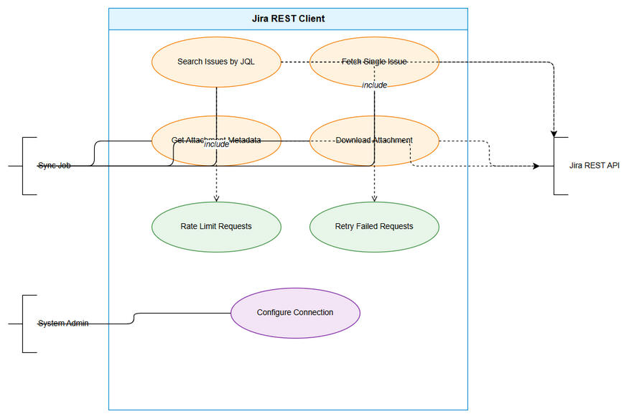 Edit in draw.io
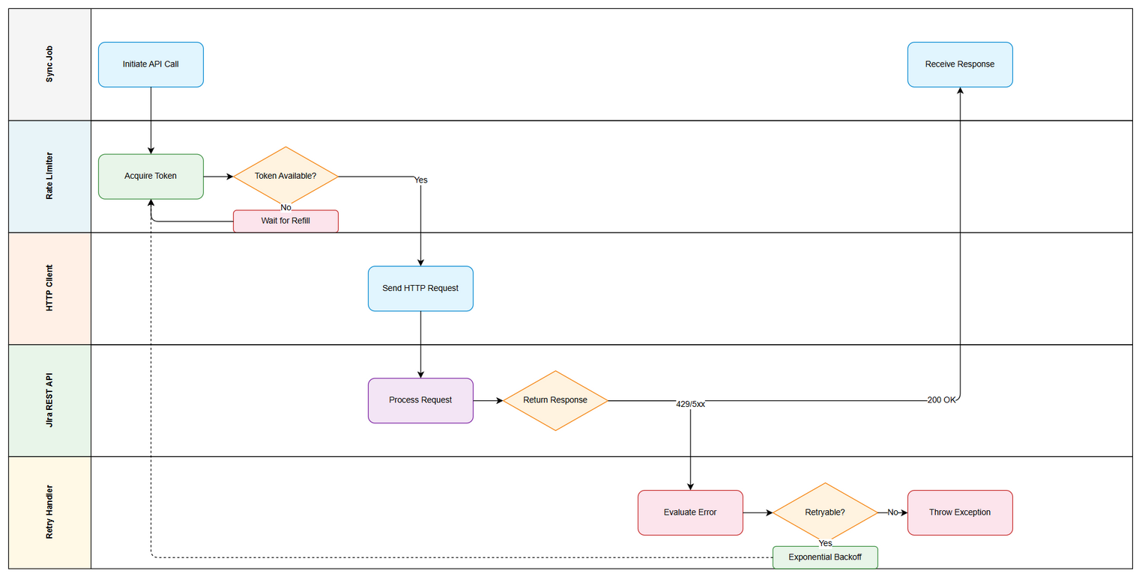 Edit in draw.io

2.2 List of User Stories / Use Cases
# | Story / Use Case | Priority | Source Ticket
1 | As a sync job, I want to search Jira issues by JQL so that I can discover tickets to sync | MUST HAVE | MTO-16
2 | As a sync job, I want to fetch a single Jira issue with full details so that I can cache its data locally | MUST HAVE | MTO-16
3 | As a sync job, I want to retrieve attachment metadata for an issue so that I can queue attachments for download | MUST HAVE | MTO-16
4 | As a sync job, I want to download attachment binary content so that I can store and process attachments | MUST HAVE | MTO-16
5 | As a sync job, I want the client to respect Jira’s rate limits so that the system does not get blocked | MUST HAVE | MTO-16
6 | As a sync job, I want failed requests to be retried with exponential backoff so that transient failures are handled gracefully | MUST HAVE | MTO-16
7 | As a system administrator, I want to configure Jira connection parameters via environment variables so that deployment is flexible | MUST HAVE | MTO-16

2.3 Details of User Stories

Business Flow
The Jira REST Client operates as follows:
Step 1: Sync Job Scheduler triggers a sync cycle and calls the Jira REST Client methods
Step 2: Client checks the token bucket rate limiter — if tokens available, proceed; otherwise wait until a token is available
Step 3: Client constructs the HTTP request with Basic Auth headers and JSON body (if POST)
Step 4: Client sends the request to Jira REST API via Ktor HTTP Client
Step 5: If response is 200 OK — deserialize JSON response and return typed result
Step 6: If response is 429 Too Many Requests — extract Retry-After header, wait the specified duration, then retry (up to max retries)
Step 7: If response is 5xx Server Error — apply exponential backoff and retry (up to max retries)
Step 8: If response is 4xx Client Error (not 429) — throw appropriate custom exception immediately (no retry)
Step 9: If max retries exhausted — throw exception with full context (correlation ID, attempt count, last error)
Note: All API calls are coroutine-based (suspend functions) to support non-blocking I/O within the Ktor framework.
sequenceDiagram
participant SJ as Sync Job
participant JC as Jira REST Client
participant RL as Rate Limiter
participant RH as Retry Handler
participant API as Jira REST API
SJ->>JC: searchIssues(jql, fields)
JC->>RL: acquireToken()
RL-->>JC: token granted
JC->>API: POST /rest/api/3/search
alt 200 OK
API-->>JC: JSON response
JC-->>SJ: List<JiraIssue>
else 429 Rate Limited
API-->>JC: 429 + Retry-After header
JC->>RH: handleRateLimit(retryAfter)
RH-->>JC: wait complete
JC->>RL: acquireToken()
JC->>API: POST /rest/api/3/search (retry)
API-->>JC: JSON response
JC-->>SJ: List<JiraIssue>
else 5xx Server Error
API-->>JC: 500/502/503
JC->>RH: exponentialBackoff(attempt)
RH-->>JC: wait complete
JC->>API: POST /rest/api/3/search (retry)
API-->>JC: JSON response
JC-->>SJ: List<JiraIssue>
else 4xx Client Error
API-->>JC: 401/403/404
JC-->>SJ: throw JiraException
end

STORY 1: Search Jira Issues by JQL
As a sync job, I want to search Jira issues by JQL so that I can discover tickets to sync.
Requirement Details:
- Implement searchIssues(jql: String, fields: List<String>, startAt: Int, maxResults: Int) method
- Use Jira REST API v3 endpoint: POST /rest/api/3/search
- Support pagination via startAt and maxResults parameters
- Allow field selection to minimize response payload size
- Return deserialized response containing issues list, total count, and pagination metadata
- Request body must be JSON with jql, fields, startAt, maxResults properties
Data Fields:
Field | Type | Required | Description | Example
jql | String | Yes | JQL query string | "project = CRP AND updated >= -1d"
fields | List<String> | No | Fields to return (empty = all) | ["summary", "status", "assignee"]
startAt | Int | No | Pagination offset (default: 0) | 0
maxResults | Int | No | Page size (default: 50, max: 100) | 50
Response Data:
Field | Type | Description
issues | List<JiraIssue> | List of matching issues
total | Int | Total number of matching issues
startAt | Int | Current offset
maxResults | Int | Requested page size
Acceptance Criteria:
- Given a valid JQL query, when searchIssues is called, then it returns a paginated list of issues matching the query
- Given startAt=0 and maxResults=50, when there are 120 matching issues, then the response contains 50 issues with total=120
- Given specific fields are requested, when the API responds, then only those fields are present in the response
- Given an invalid JQL query, when the API returns 400, then a JiraClientException is thrown with the error message from Jira
- Given the API returns 429, when the client receives the response, then it waits for Retry-After duration and retries
Validation Rules:
- jql must not be blank/empty
- maxResults must be between 1 and 100 (Jira API limit)
- startAt must be >= 0
- fields list items must not contain empty strings
Error Handling:
- 400 Bad Request (invalid JQL): Throw JiraClientException with Jira’s error messages
- 401 Unauthorized: Throw JiraAuthException indicating invalid credentials
- 403 Forbidden: Throw JiraAuthException indicating insufficient permissions
- 429 Too Many Requests: Retry after Retry-After header value
- 5xx Server Error: Retry with exponential backoff

STORY 2: Fetch Single Jira Issue
As a sync job, I want to fetch a single Jira issue with full details so that I can cache its data locally.
Requirement Details:
- Implement getIssue(issueKey: String, fields: List<String>, expand: List<String>) method
- Use Jira REST API v3 endpoint: GET /rest/api/3/issue/{issueKey}
- Support field selection via fields query parameter
- Support expand parameter for additional data (changelog, renderedFields, transitions)
- Return fully deserialized JiraIssue object with all requested fields
Data Fields:
Field | Type | Required | Description | Example
issueKey | String | Yes | Jira issue key | "MTO-16"
fields | List<String> | No | Fields to return | ["summary", "description", "status"]
expand | List<String> | No | Sections to expand | ["changelog", "renderedFields"]
Acceptance Criteria:
- Given a valid issue key, when getIssue is called, then it returns the full issue data with requested fields
- Given expand=["changelog"], when the API responds, then the changelog section is included in the response
- Given a non-existent issue key, when the API returns 404, then a JiraNotFoundException is thrown
- Given the issue key format is invalid, when validation runs, then a JiraClientException is thrown before making the API call
Validation Rules:
- issueKey must match pattern [A-Z]+-\d+ (e.g., MTO-16, CRP-84)
- fields list items must not contain empty strings
- expand values must be from allowed set: changelog, renderedFields, transitions, operations, editmeta
Error Handling:
- 404 Not Found: Throw JiraNotFoundException with the issue key
- 401/403: Throw JiraAuthException
- 429: Retry with rate limit handling
- 5xx: Retry with exponential backoff

STORY 3: Retrieve Attachment Metadata
As a sync job, I want to retrieve attachment metadata for an issue so that I can queue attachments for download.
Requirement Details:
- Implement getAttachments(issueKey: String) method
- Use Jira REST API v3 endpoint: GET /rest/api/3/issue/{issueKey}?fields=attachment
- Return list of attachment metadata objects (filename, size, MIME type, download URL, author, created date)
- This is a specialized variant of getIssue that only fetches the attachment field for efficiency
Data Fields (Response):
Field | Type | Description | Example
id | String | Attachment ID | "10001"
filename | String | Original filename | "screenshot.png"
mimeType | String | MIME type | "image/png"
size | Long | File size in bytes | 245760
content | String | Download URL | "https://jira.example.com/secure/attachment/10001/screenshot.png"
author | JiraUser | Who uploaded | {displayName: "John Doe"}
created | String | ISO 8601 timestamp | "2025-07-10T14:30:00.000+0000"
Acceptance Criteria:
- Given an issue with 3 attachments, when getAttachments is called, then it returns a list of 3 attachment metadata objects
- Given an issue with no attachments, when getAttachments is called, then it returns an empty list
- Given a non-existent issue key, when the API returns 404, then a JiraNotFoundException is thrown
- Each attachment metadata must include: id, filename, mimeType, size, content URL, author, created date
Validation Rules:
- issueKey must match pattern [A-Z]+-\d+
- Response attachment objects must have non-null content URL for download
Error Handling:
- 404 Not Found: Throw JiraNotFoundException
- 401/403: Throw JiraAuthException
- 429/5xx: Standard retry logic applies

STORY 4: Download Attachment Binary Content
As a sync job, I want to download attachment binary content so that I can store and process attachments.
Requirement Details:
- Implement downloadAttachment(url: String) method
- Perform HTTP GET on the attachment content URL (provided by getAttachments response)
- Return binary content as ByteArray or streaming ByteReadChannel
- Support large file downloads without loading entire content into memory
- Include Basic Auth headers on download requests (Jira requires authentication for attachment downloads)
Data Fields:
Field | Type | Required | Description | Example
url | String | Yes | Full attachment download URL | "https://jira.example.com/secure/attachment/10001/file.pdf"
Acceptance Criteria:
- Given a valid attachment URL, when downloadAttachment is called, then it returns the binary content of the attachment
- Given the attachment URL is inaccessible (404), when the download fails, then a JiraNotFoundException is thrown
- Given a large attachment (>10MB), when downloading, then the client streams the content without buffering the entire file in memory
- Given the download URL requires authentication, when the request is made, then Basic Auth headers are included
Validation Rules:
- url must be a valid HTTP/HTTPS URL
- url must belong to the configured Jira base URL domain (security check to prevent SSRF)
Error Handling:
- 404 Not Found: Throw JiraNotFoundException with the URL
- 401/403: Throw JiraAuthException
- Connection timeout: Throw JiraTimeoutException
- 429/5xx: Standard retry logic applies

STORY 5: Rate Limiting (Token Bucket)
As a sync job, I want the client to respect Jira’s rate limits so that the system does not get blocked.
Requirement Details:
- Implement token bucket rate limiter with configurable rate (default: 10 requests/second)
- Each API call must acquire a token before executing
- If no tokens available, the caller suspends (coroutine-friendly) until a token is replenished
- When Jira responds with 429, extract Retry-After header and pause all requests for that duration
- Rate limiter must be thread-safe for concurrent coroutine access
- Token bucket refills at a constant rate (e.g., 10 tokens/second = 1 token every 100ms)
Data Fields (Configuration):
Field | Type | Required | Description | Default
JIRA_RATE_LIMIT | Int | No | Max requests per second | 10
burstCapacity | Int | No | Max burst tokens | 10
refillRate | Double | No | Tokens added per second | 10.0
Acceptance Criteria:
- Given rate limit is 10 req/s, when 15 requests are submitted simultaneously, then only 10 execute immediately and 5 wait for token replenishment
- Given Jira returns 429 with Retry-After: 5, when the response is received, then all subsequent requests are paused for 5 seconds
- Given the rate limiter is idle for 2 seconds, when a burst of 10 requests arrives, then all 10 execute immediately (bucket is full)
- Given concurrent coroutines call the rate limiter, when tokens are limited, then access is fair and thread-safe (no race conditions)
Validation Rules:
- JIRA_RATE_LIMIT must be > 0
- Retry-After header value must be parsed as seconds (integer) or HTTP-date format
- Burst capacity must be >= 1
Error Handling:
- If Retry-After header is missing on 429 response: Use default backoff of 60 seconds
- If Retry-After value is unparseable: Use default backoff of 60 seconds

STORY 6: Retry Logic with Exponential Backoff
As a sync job, I want failed requests to be retried with exponential backoff so that transient failures are handled gracefully.
Requirement Details:
- Implement retry wrapper with exponential backoff strategy
- Initial delay: 1 second, multiplied by 2 on each retry
- Maximum delay cap: 30 seconds (prevents excessively long waits)
- Maximum retry attempts: 3 (configurable via JIRA_MAX_RETRIES)
- Retry on: HTTP 429 (rate limited) and 5xx (server errors)
- Do NOT retry on: 4xx client errors (except 429) — these indicate permanent failures
- Add jitter (±20%) to backoff delay to prevent thundering herd
- Log each retry attempt with correlation ID, attempt number, and delay duration
Data Fields (Configuration):
Field | Type | Required | Description | Default
JIRA_MAX_RETRIES | Int | No | Maximum retry attempts | 3
initialDelay | Long | No | Initial backoff delay (ms) | 1000
maxDelay | Long | No | Maximum backoff delay (ms) | 30000
multiplier | Double | No | Backoff multiplier | 2.0
jitterFactor | Double | No | Jitter range (±%) | 0.2
Acceptance Criteria:
- Given a 503 response on first attempt, when retry logic executes, then the request is retried after ~1 second
- Given 3 consecutive 503 responses, when all retries are exhausted, then the original exception is thrown with retry context
- Given a 404 response, when the error handler evaluates, then no retry is attempted and the exception is thrown immediately
- Given a 429 response with Retry-After: 10, when retry logic executes, then the retry waits 10 seconds (not exponential backoff)
- Given retry delays of 1s, 2s, 4s, when jitter is applied, then actual delays are within ±20% of those values
- Given JIRA_MAX_RETRIES=0, when a retryable error occurs, then no retry is attempted
Validation Rules:
- JIRA_MAX_RETRIES must be >= 0
- initialDelay must be > 0
- maxDelay must be >= initialDelay
- multiplier must be > 1.0
Error Handling:
- After max retries exhausted: Throw the last exception wrapped with retry metadata (attempt count, total elapsed time)
- Retry timeout (total time > configured timeout): Abort retries and throw JiraTimeoutException

STORY 7: Environment-Based Configuration
As a system administrator, I want to configure Jira connection parameters via environment variables so that deployment is flexible.
Requirement Details:
- All Jira client configuration must be loadable from environment variables
- Provide sensible defaults for optional parameters
- Validate configuration at startup — fail fast if required values are missing
- Support the existing project pattern of YAML config with env var resolution (e.g., ${JIRA_BASE_URL})
- Configuration class must be immutable after initialization (data class)
Data Fields (Configuration):
Field | Env Variable | Type | Required | Description | Default
baseUrl | JIRA_BASE_URL | String | Yes | Jira instance URL | —
email | JIRA_EMAIL | String | Yes | Authentication email | —
apiToken | JIRA_API_TOKEN | String | Yes | Jira API token | —
rateLimit | JIRA_RATE_LIMIT | Int | No | Max requests/second | 10
timeoutMs | JIRA_TIMEOUT_MS | Long | No | Request timeout (ms) | 30000
maxRetries | JIRA_MAX_RETRIES | Int | No | Max retry attempts | 3
connectTimeoutMs | JIRA_CONNECT_TIMEOUT_MS | Long | No | Connection timeout (ms) | 10000
socketTimeoutMs | JIRA_SOCKET_TIMEOUT_MS | Long | No | Socket timeout (ms) | 30000
Acceptance Criteria:
- Given JIRA_BASE_URL, JIRA_EMAIL, and JIRA_API_TOKEN are set, when the client initializes, then it connects successfully
- Given JIRA_BASE_URL is not set, when the client initializes, then it throws a ConfigException with a clear error message
- Given JIRA_RATE_LIMIT=5, when the client initializes, then the rate limiter is configured for 5 requests/second
- Given JIRA_TIMEOUT_MS=60000, when a request takes longer than 60 seconds, then it times out
- Given no optional env vars are set, when the client initializes, then default values are used for all optional parameters
Validation Rules:
- JIRA_BASE_URL must be a valid URL starting with http:// or https://
- JIRA_BASE_URL must not have a trailing slash
- JIRA_EMAIL must be a valid email format
- JIRA_API_TOKEN must not be empty
- JIRA_RATE_LIMIT must be between 1 and 100
- JIRA_TIMEOUT_MS must be between 1000 and 300000 (1s to 5min)
- JIRA_MAX_RETRIES must be between 0 and 10
Error Handling:
- Missing required env var: Throw ConfigException listing all missing variables
- Invalid value format: Throw ConfigException with the variable name and expected format
- URL validation failure: Throw ConfigException with specific URL format guidance

3. Dependencies
Dependency | Type | Related Ticket | Description
Ktor Client (CIO) | System | N/A | HTTP client library — already in project dependencies
kotlinx.serialization | System | N/A | JSON serialization — already in project dependencies
kotlinx.coroutines | System | N/A | Async/suspend function support — already in project dependencies
Jira REST API v3 | External | N/A | Jira Cloud/Server REST API endpoint
MTO-15 (Sync State DB) | Story | MTO-15 | Provides sync state persistence — client status tracking
MTO-14 (Epic) | Epic | MTO-14 | Parent epic — Jira Project Sync Service
Jira API Credentials | Infrastructure | N/A | Valid Jira email + API token must be provisioned

4. Stakeholders
Role | Name / Team | Responsibility | Source
Developer | Development Team | Implement the Jira REST Client | Ticket assignee
Solution Architect | SA Agent | Review technical design and integration patterns | Peer reviewer
DevOps | DevOps Team | Configure environment variables in deployment | Infrastructure
QA | QA Agent | Validate retry logic, rate limiting, error handling | Testing

5. Risks and Assumptions

5.1 Risks
Risk | Impact | Likelihood | Mitigation
Jira API rate limits are stricter than expected | High | Medium | Make rate limit configurable; implement adaptive rate limiting based on 429 responses
Jira API v3 schema changes without notice | Medium | Low | Use lenient JSON parsing (ignoreUnknownKeys); version-pin API calls
Network instability causes frequent timeouts | Medium | Medium | Exponential backoff with jitter; configurable timeout values
API token rotation causes auth failures during sync | High | Low | Log clear auth error messages; support runtime credential refresh in future iteration
Large attachment downloads consume excessive memory | High | Medium | Stream downloads instead of buffering; implement size limits

5.2 Assumptions
- Jira Cloud REST API v3 is the target API version (not v2)
- Basic Auth with email + API token is sufficient for all required operations
- The Jira instance allows programmatic access via API tokens
- Rate limit of 10 requests/second is within Jira’s allowed limits for the account tier
- Attachment downloads are authenticated with the same credentials as API calls
- The sync job runs as a single instance (no distributed rate limiting needed)
- kotlinx.serialization can handle all Jira API response formats (including ADF — Atlassian Document Format)

6. Non-Functional Requirements
Category | Requirement | Details
Performance | Request throughput | Support up to 10 requests/second sustained throughput (configurable)
Performance | Response timeout | Default 30s per request; configurable via JIRA_TIMEOUT_MS
Performance | Connection pooling | Reuse HTTP connections via Ktor CIO engine connection pool
Reliability | Retry on transient failures | Exponential backoff (1s, 2s, 4s) with max 3 retries on 429/5xx
Reliability | Graceful degradation | Rate limiter suspends callers rather than rejecting requests
Security | Credential storage | API token stored in environment variable, never logged or serialized
Security | SSRF prevention | Attachment download URLs validated against configured base URL domain
Security | TLS | All API communication over HTTPS (TLS 1.2+)
Observability | Structured logging | All requests logged with correlation ID, duration, status code
Observability | Error context | Exceptions include correlation ID, attempt count, endpoint, and error details
Scalability | Configurable limits | Rate limit, timeout, retries all configurable without code changes
Maintainability | Interface/Impl pattern | Client exposed via interface for testability and future alternative implementations

7. Related Tickets
Ticket Key | Summary | Status | Type | Relationship
MTO-16 | Jira REST Client — Direct API Integration | In Progress | Story | Main ticket
MTO-14 | Jira Project Sync Service: Background Job for Automated KB Ingestion | In Progress | Epic | Parent epic
MTO-15 | Database Schema & Sync State Management | To Do | Story | Sibling — provides persistence layer
MTO-17 | Sync Job Orchestrator (assumed) | To Do | Story | Sibling — consumes this client

8. Appendix

Glossary
Term | Definition
JQL | Jira Query Language — SQL-like syntax for searching Jira issues
Token Bucket | Rate limiting algorithm that allows bursts up to bucket capacity, refilling at a constant rate
Exponential Backoff | Retry strategy where delay doubles after each failed attempt
Jitter | Random variation added to backoff delay to prevent synchronized retries (thundering herd)
CIO | Coroutine-based I/O — Ktor’s non-blocking HTTP client engine
ADF | Atlassian Document Format — JSON-based rich text format used in Jira descriptions
Correlation ID | Unique identifier attached to a request for tracing across logs
SSRF | Server-Side Request Forgery — attack where server is tricked into making requests to unintended URLs
Basic Auth | HTTP authentication using Base64-encoded email:token in Authorization header

Reference Documents
Document | Link / Location
Jira REST API v3 Documentation | https://developer.atlassian.com/cloud/jira/platform/rest/v3/
Ktor Client Documentation | https://ktor.io/docs/client-overview.html
MTO-14 Epic (Parent) | Jira: MTO-14
MTO-15 BRD (Database Schema) | documents/MTO-15/BRD.md
Project Structure | .analysis/code-intelligence/project-structure.md

API Endpoint Reference
Method | Endpoint | HTTP Method | Description
searchIssues | /rest/api/3/search | POST | Search issues by JQL with pagination
getIssue | /rest/api/3/issue/{issueKey} | GET | Fetch single issue with field/expand options
getAttachments | /rest/api/3/issue/{issueKey}?fields=attachment | GET | Get attachment metadata for an issue
downloadAttachment | {attachment.content URL} | GET | Download attachment binary content

Custom Exception Hierarchy
JiraClientException (sealed)
├── JiraAuthException — 401/403 authentication/authorization failures
├── JiraRateLimitException — 429 rate limit exceeded (includes retryAfter value)
├── JiraNotFoundException — 404 resource not found
├── JiraTimeoutException — Request/connection timeout
├── JiraServerException — 5xx server-side errors
└── JiraValidationException — Client-side input validation failures

Configuration YAML Example
jira:
base_url: ${JIRA_BASE_URL}
email: ${JIRA_EMAIL}
api_token: ${JIRA_API_TOKEN}
rate_limit: ${JIRA_RATE_LIMIT:-10}
timeout_ms: ${JIRA_TIMEOUT_MS:-30000}
max_retries: ${JIRA_MAX_RETRIES:-3}
connect_timeout_ms: ${JIRA_CONNECT_TIMEOUT_MS:-10000}
socket_timeout_ms: ${JIRA_SOCKET_TIMEOUT_MS:-30000}

