Technical Design Document (TDD)

Jira Project Sync Service — MTO-16: Jira REST Client — Direct API Integration

Document Information
Field | Value
Jira Ticket | MTO-16
Title | Jira REST Client — Direct API Integration
Author | SA Agent
Version | 1.0
Date | 2025-07-14
Status | Draft
Related BRD | BRD-v1-MTO-16.docx
Related FSD | FSD-v1-MTO-16.docx

Author Tracking
Role | Name - Position | Responsibility
Author | SA Agent – Solution Architect | Create document
Peer Reviewer | TA Agent – Technical Architect | Review document

Revision History
Version | Date | Author | Changes
1.0 | 2025-07-14 | SA Agent | Initiate document — auto-generated from BRD and FSD

Sign-Off
Name | Signature and date
 | ☐ I agree and confirm the technical design in this TDD
 | ☐ I agree and confirm the technical design in this TDD

1. Introduction
Scope Boundary: This TDD specifies HOW to implement the requirements defined in the FSD. It does NOT repeat functional requirements, business rules, use cases, or UI specifications — refer to the FSD for those. This document focuses on: technology choices, architecture decisions, implementation patterns, and deployment concerns.

1.1 Purpose
This TDD provides the detailed technical design for the Jira REST Client module (com.orchestrator.mcp.jira), a dedicated HTTP communication layer that integrates directly with Jira Cloud/Server REST API v3. The client provides high-throughput, resilient access for the background sync job (Epic MTO-14), bypassing the MCP Atlassian connector.

1.2 Scope
This document covers the technical implementation of:
- JiraRestClient interface and JiraRestClientImpl — Ktor CIO HttpClient with Basic Auth, JSON serialization
- TokenBucketRateLimiter — coroutine-safe rate limiting with 429 pause support
- RetryHandler — exponential backoff with jitter for transient failure recovery
- JiraClientConfig — environment-based configuration with fail-fast validation
- Sealed exception hierarchy — 7 typed exceptions for structured error handling
- Koin DI integration — singleton registration following existing project patterns

1.3 Technology Stack
Layer | Technology | Version
Language | Kotlin | 2.3.20
Platform | JVM | 21
HTTP Client | Ktor Client (CIO engine) | 3.4.0
Serialization | kotlinx.serialization-json | 1.8.1
YAML Config | kaml | 0.77.0
DI Framework | Koin | 4.1.1
Coroutines | kotlinx.coroutines | 1.10.2
Date/Time | kotlinx.datetime | 0.6.2
Logging | SLF4J + Logback | 1.5.18
Testing | JUnit 5 + Kotest + MockK | 5.11.4 / 5.9.1 / 1.14.2
Integration Testing | Testcontainers + WireMock | 1.21.1
Build Tool | Gradle (Kotlin DSL) | 8.x

1.4 Design Principles
- Interface/Impl Separation: All public components exposed via interfaces for testability and mock injection
- Coroutine-First: All I/O operations are non-blocking suspend functions using Ktor CIO engine
- Fail-Fast Configuration: Invalid config detected at startup, not at first API call
- Structured Error Handling: Sealed exception hierarchy enables exhaustive when matching
- Single Responsibility: Each class has one clear purpose (rate limiting, retry, HTTP, config)
- Immutability: Configuration and response DTOs are immutable data classes
- Defensive Programming: Input validation before API calls, SSRF protection on downloads

1.5 Constraints
- Must use existing Ktor CIO engine (already in project dependencies) — no OkHttp or Apache HttpClient
- Must integrate with existing Koin DI container (AppModule.kt)
- Must follow existing package naming convention: com.orchestrator.mcp.{module}
- Must use kotlinx.serialization (not Jackson/Gson) for JSON — consistent with project
- Rate limiting must be coroutine-safe (no blocking Thread.sleep)
- API token must never appear in logs, exceptions, or serialized output

1.6 References
Document | Location
BRD | BRD-v1-MTO-16.docx
FSD | FSD-v1-MTO-16.docx
Project Structure | .analysis/code-intelligence/project-structure.md
Existing HTTP Pattern | orchestrator-client/…/HttpMcpConnection.kt
Existing Retry Pattern | orchestrator-core/…/RetryUtils.kt
Jira REST API v3 | https://developer.atlassian.com/cloud/jira/platform/rest/v3/

2. System Architecture

2.1 Architecture Overview
The Jira REST Client is a self-contained module within the MCP Orchestration system. It sits between the Sync Job Orchestrator (MTO-17) and the external Jira REST API, encapsulating all HTTP communication concerns.
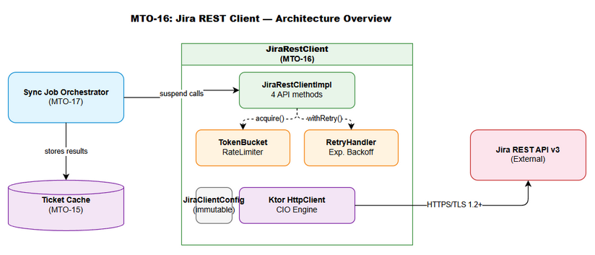
Architecture Diagram
Key architectural decisions:
- Layered design: Config → Client → RateLimiter → RetryHandler → HttpClient → Jira API
- Composition over inheritance: Components are composed via constructor injection, not class hierarchy
- Coroutine suspension for backpressure: Rate limiter suspends callers rather than rejecting — zero request loss
- Single HttpClient instance: Connection pooling via Ktor CIO engine (max 100 connections, 45s keep-alive)

2.2 Component Diagram
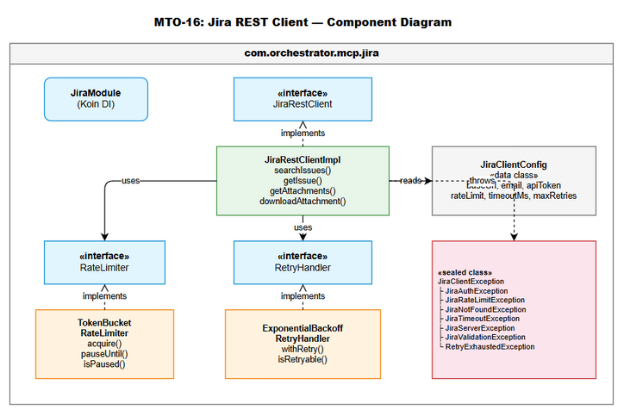
Component Diagram
Component | Responsibility | Technology
JiraRestClientImpl | Orchestrates API calls: validate → rate limit → retry → HTTP → deserialize | Ktor HttpClient, kotlinx.serialization
TokenBucketRateLimiter | Controls request rate, handles 429 pause | Kotlin coroutines, AtomicLong
RetryHandler | Exponential backoff with jitter for transient failures | Kotlin coroutines, kotlin.math
JiraClientConfig | Immutable configuration loaded from YAML/env vars | kaml, data class
JiraExceptions | Sealed exception hierarchy for typed error handling | Kotlin sealed class
JiraModule (Koin) | DI registration of all Jira client components | Koin module DSL

2.3 Deployment Architecture
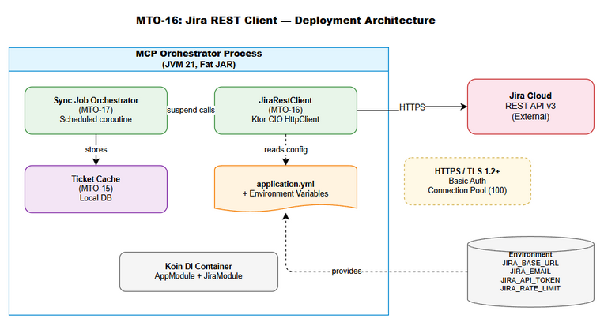
Deployment Diagram
The Jira REST Client deploys as part of the MCP Orchestrator fat JAR (mcp-orchestrator-all.jar). No separate deployment artifact is needed.
Runtime topology:
┌─────────────────────────────────────────────────┐
│ MCP Orchestrator Process (JVM 21) │
│ │
│ ┌─────────────────┐ ┌──────────────────────┐ │
│ │ Sync Job │ │ JiraRestClient │ │
│ │ Orchestrator │──│ (CIO HttpClient) │─┼──→ Jira Cloud API
│ │ (MTO-17) │ │ │ │ (HTTPS/TLS 1.2+)
│ └─────────────────┘ └──────────────────────┘ │
│ │
│ ┌─────────────────┐ │
│ │ Ticket Cache │ │
│ │ (MTO-15) │ │
│ └─────────────────┘ │
└─────────────────────────────────────────────────┘

2.4 Communication Patterns
From | To | Protocol | Pattern | Description
Sync Job Orchestrator | JiraRestClient | In-process | Sync (suspend) | Kotlin suspend function calls
JiraRestClient | Jira REST API | HTTPS | Request/Response | Ktor CIO with connection pooling
JiraRestClient | TokenBucketRateLimiter | In-process | Sync (suspend) | Coroutine suspension for backpressure
JiraRestClient | RetryHandler | In-process | Sync (suspend) | Wraps HTTP calls with retry logic

3. API Design
Prerequisite: Functional API contracts (parameters, business errors, data flows) are defined in FSD §3.1–3.7. This section specifies the technical implementation: HTTP client configuration, request construction, response deserialization, and error code mapping.

3.1 API Overview
# | Method | Jira Endpoint | HTTP Method | Description | Source
1 | searchIssues | /rest/api/3/search | POST | Search issues by JQL with pagination | UC-01
2 | getIssue | /rest/api/3/issue/{key} | GET | Fetch single issue with field selection | UC-02
3 | getAttachments | /rest/api/3/issue/{key}?fields=attachment | GET | Retrieve attachment metadata | UC-03
4 | downloadAttachment | {attachment.content URL} | GET | Download binary attachment content | UC-04

3.2 API: searchIssues
Implements: UC-01, BR-01..BR-08
Attribute | Value
Method | POST
Path | {baseUrl}/rest/api/3/search
Auth | Basic Auth (Base64 email:token)
Content-Type | application/json
Rate Limited | Yes (token bucket)
Retryable | Yes (429, 5xx, timeout)
Request Headers:
Header | Required | Value
Authorization | Yes | Basic {Base64(email:apiToken)}
Content-Type | Yes | application/json
X-Correlation-ID | Yes | UUID generated per request
Request Body (kotlinx.serialization):
@Serializable
data class JiraSearchRequest(
val jql: String,
val fields: List<String> = emptyList(),
val startAt: Int = 0,
val maxResults: Int = 50
)
Response Deserialization:
@Serializable
data class JiraSearchResponse(
val startAt: Int,
val maxResults: Int,
val total: Int,
val issues: List<JiraIssue>
)
Error Mapping:
HTTP Status | Exception | Retryable | Notes
200 | — | — | Success
400 | JiraValidationException | No | Parse errorMessages array from body
401 | JiraAuthException | No | Invalid credentials
403 | JiraAuthException | No | Insufficient permissions
429 | JiraRateLimitException | Yes | Extract Retry-After header
5xx | JiraServerException | Yes | Include status code + body excerpt
Timeout | JiraTimeoutException | Yes | Include timeout duration

3.3 API: getIssue
Implements: UC-02, BR-09..BR-11
Attribute | Value
Method | GET
Path | {baseUrl}/rest/api/3/issue/{issueKey}
Auth | Basic Auth
Rate Limited | Yes
Retryable | Yes (429, 5xx, timeout)
Query Parameters (URL-encoded):
Parameter | Type | Construction
fields | String | fields.joinToString(",")
expand | String | expand.joinToString(",")
Input Validation (before HTTP call):
fun validateIssueKey(key: String) {
require(key.matches(Regex("[A-Z]+-\\d+"))) {
"Invalid issue key format: $key. Expected: PROJECT-123"
}
}
fun validateExpand(expand: List<String>) {
val allowed = setOf("changelog", "renderedFields", "transitions", "operations", "editmeta")
val invalid = expand.filter { it !in allowed }
require(invalid.isEmpty()) { "Invalid expand values: $invalid" }
}
Response Deserialization:
@Serializable
data class JiraIssue(
val id: String,
val key: String,
val self: String,
val fields: JsonObject,
val changelog: JsonObject? = null
)

3.4 API: getAttachments
Implements: UC-03, BR-12..BR-14
Attribute | Value
Method | GET
Path | {baseUrl}/rest/api/3/issue/{issueKey}?fields=attachment
Auth | Basic Auth
Rate Limited | Yes
Retryable | Yes
Response Processing:
// Extract attachment array from nested response
val issueResponse = httpClient.get(url) { ... }
val body = issueResponse.body<JsonObject>()
val attachmentArray = body["fields"]?.jsonObject?.get("attachment")?.jsonArray
?: return emptyList()
// Deserialize and filter (BR-14: skip null content URLs)
return attachmentArray
.map { json.decodeFromJsonElement<JiraAttachment>(it) }
.filter { attachment ->
if (attachment.content.isNullOrBlank()) {
logger.warn("Attachment ${attachment.id} has null content URL — skipping")
false
} else true
}
Response DTO:
@Serializable
data class JiraAttachment(
val id: String,
val filename: String,
val mimeType: String,
val size: Long,
val content: String, // Download URL
val author: JiraUser,
val created: String // ISO 8601
)
@Serializable
data class JiraUser(
val displayName: String,
val emailAddress: String? = null,
val accountId: String
)

3.5 API: downloadAttachment
Implements: UC-04, BR-15..BR-18
Attribute | Value
Method | GET
Path | {attachment.content URL} (full URL from getAttachments)
Auth | Basic Auth
Rate Limited | Yes
Retryable | Yes (timeout, 5xx)
SSRF Validation (BR-16):
fun validateDownloadUrl(url: String, configuredBaseUrl: String) {
val downloadHost = Url(url).host
val configuredHost = Url(configuredBaseUrl).host
require(downloadHost == configuredHost) {
"Download URL domain ($downloadHost) does not match configured Jira base URL ($configuredHost)"
}
}
Response Handling:
suspend fun downloadAttachment(url: String): DownloadResult {
validateDownloadUrl(url, config.baseUrl)
return rateLimiter.acquire().let {
retryHandler.withRetry("downloadAttachment($url)") {
val response = httpClient.get(url) {
header("Authorization", basicAuthHeader())
header("Accept", "*/*")
}
DownloadResult(
content = response.readBytes(),
contentType = response.contentType()?.toString() ?: "application/octet-stream",
contentLength = response.contentLength() ?: 0L
)
}
}
}
data class DownloadResult(
val content: ByteArray,
val contentType: String,
val contentLength: Long
)

4. Database Design
Note: This module does NOT persist data to a database. All data structures are in-memory domain objects for API communication. The downstream Ticket Cache (MTO-15) handles persistence.

4.1 Schema Overview
No database schema required for this module. Data flows:
Jira API → JSON Response → kotlinx.serialization → Data Classes (in-memory) → Caller (Sync Job)

4.2 Data Transfer Objects
All DTOs are defined in Section 3 (API Design). They are: - JiraSearchRequest — outbound request body - JiraSearchResponse — search result container - JiraIssue — single issue representation - JiraAttachment — attachment metadata - JiraUser — user reference - DownloadResult — binary download response

4.3 Serialization Strategy
Concern | Decision | Rationale
JSON library | kotlinx.serialization | Project standard, compile-time safe
Unknown keys | ignoreUnknownKeys = true | Forward compatibility with Jira API changes
Null handling | Explicit nullable types | Kotlin null safety, no runtime surprises
Date format | ISO 8601 strings | Jira API native format, parse on demand
Enum handling | Not used (JsonObject for dynamic fields) | Jira fields are dynamic, not fixed enum

5. Class / Module Design

5.1 Package Structure
com.orchestrator.mcp.jira/
├── JiraRestClient.kt # Interface — 4 public API methods
├── JiraRestClientImpl.kt # Implementation — HTTP orchestration
├── config/
│ └── JiraClientConfig.kt # Immutable config data class + validation
├── ratelimit/
│ ├── RateLimiter.kt # Interface
│ └── TokenBucketRateLimiter.kt # Coroutine-safe token bucket implementation
├── retry/
│ ├── RetryHandler.kt # Interface
│ └── ExponentialBackoffRetryHandler.kt # Backoff + jitter implementation
├── model/
│ ├── JiraSearchRequest.kt # Request DTO
│ ├── JiraSearchResponse.kt # Response DTO
│ ├── JiraIssue.kt # Issue DTO
│ ├── JiraAttachment.kt # Attachment metadata DTO
│ ├── JiraUser.kt # User reference DTO
│ └── DownloadResult.kt # Binary download result
├── exception/
│ ├── JiraClientException.kt # Sealed base class
│ ├── JiraAuthException.kt # 401/403
│ ├── JiraRateLimitException.kt # 429
│ ├── JiraNotFoundException.kt # 404
│ ├── JiraTimeoutException.kt # Timeout
│ ├── JiraServerException.kt # 5xx
│ ├── JiraValidationException.kt # Input validation
│ └── RetryExhaustedException.kt # All retries failed
└── di/
└── JiraModule.kt # Koin module registration

5.2 Key Interfaces
/**
* Jira REST API client interface.
* All methods are suspend functions for non-blocking I/O.
* Thread-safe for concurrent coroutine access.
*/
interface JiraRestClient {
/**
* Search issues by JQL with pagination.
* @throws JiraValidationException if jql is blank or maxResults out of range
* @throws JiraAuthException if credentials are invalid
* @throws RetryExhaustedException if all retries fail
*/
suspend fun searchIssues(
jql: String,
fields: List<String> = emptyList(),
startAt: Int = 0,
maxResults: Int = 50
): JiraSearchResponse
/**
* Fetch a single issue by key.
* @throws JiraValidationException if issueKey format is invalid
* @throws JiraNotFoundException if issue does not exist
*/
suspend fun getIssue(
issueKey: String,
fields: List<String> = emptyList(),
expand: List<String> = emptyList()
): JiraIssue
/**
* Retrieve attachment metadata for an issue.
* @throws JiraValidationException if issueKey format is invalid
* @throws JiraNotFoundException if issue does not exist
*/
suspend fun getAttachments(issueKey: String): List<JiraAttachment>
/**
* Download attachment binary content.
* @throws JiraValidationException if URL domain doesn't match configured base URL (SSRF)
* @throws JiraNotFoundException if attachment not found
*/
suspend fun downloadAttachment(url: String): DownloadResult
}
/**
* Coroutine-safe rate limiter interface.
*/
interface RateLimiter {
/** Acquire a token. Suspends if no tokens available. */
suspend fun acquire()
/** Pause all requests until the specified instant (from 429 Retry-After). */
fun pauseUntil(resumeAt: Long)
/** Check if rate limiter is currently paused. */
fun isPaused(): Boolean
}
/**
* Retry handler interface for transient failure recovery.
*/
interface RetryHandler {
/**
* Execute block with retry logic.
* @param context Descriptive context for logging
* @param block The suspend function to execute and potentially retry
* @return Result of successful block execution
* @throws JiraClientException if all retries exhausted or non-retryable error
*/
suspend fun <T> withRetry(context: String, block: suspend () -> T): T
}

5.3 Class Diagram
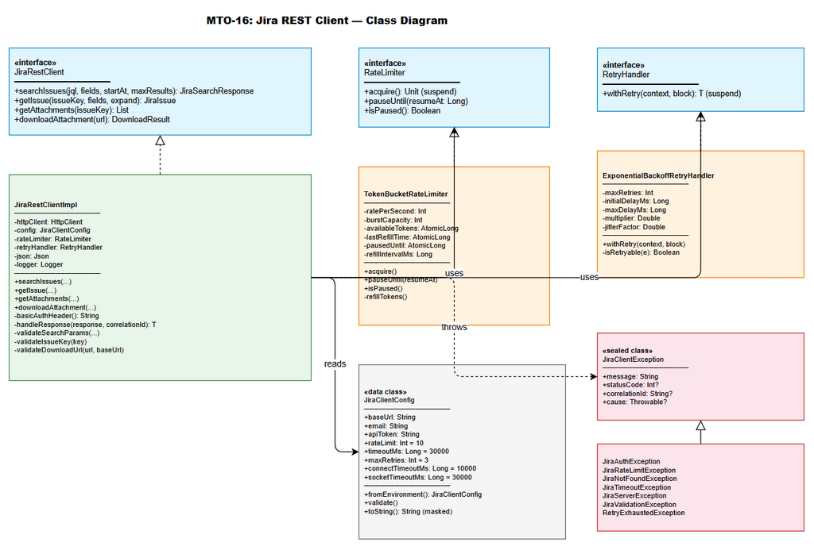
Class Diagram

5.4 Design Patterns
Pattern | Where Used | Rationale
Interface/Impl | JiraRestClient, RateLimiter, RetryHandler | Testability, mock injection, SRP
Strategy | RetryHandler (pluggable retry strategies) | Different retry policies for different contexts
Template Method | withRetry wraps arbitrary suspend blocks | Reusable retry logic across all API methods
Token Bucket | TokenBucketRateLimiter | Industry-standard rate limiting with burst support
Sealed Class | JiraClientException hierarchy | Exhaustive error handling via when expressions
Builder | Ktor HttpClient configuration | Fluent, readable client setup
Composition | JiraRestClientImpl composes RateLimiter + RetryHandler | Loose coupling, independent testing

5.5 Error Handling
Exception | HTTP Status | Error Code | When Thrown
JiraValidationException | 400 / pre-call | JIRA_VALIDATION | Input validation fails (blank JQL, invalid key format, SSRF)
JiraAuthException | 401, 403 | JIRA_AUTH | Invalid credentials or insufficient permissions
JiraNotFoundException | 404 | JIRA_NOT_FOUND | Issue or attachment does not exist
JiraRateLimitException | 429 | JIRA_RATE_LIMIT | Rate limit exceeded (after retries exhausted)
JiraServerException | 5xx | JIRA_SERVER | Jira server error (after retries exhausted)
JiraTimeoutException | — | JIRA_TIMEOUT | Connection or socket timeout (after retries exhausted)
RetryExhaustedException | varies | JIRA_RETRY_EXHAUSTED | All retry attempts failed

5.6 Implementation Details — JiraRestClientImpl
class JiraRestClientImpl(
private val httpClient: HttpClient,
private val config: JiraClientConfig,
private val rateLimiter: RateLimiter,
private val retryHandler: RetryHandler
) : JiraRestClient {
private val logger = LoggerFactory.getLogger(JiraRestClientImpl::class.java)
private val json = Json { ignoreUnknownKeys = true; encodeDefaults = true }
override suspend fun searchIssues(
jql: String,
fields: List<String>,
startAt: Int,
maxResults: Int
): JiraSearchResponse {
// Validate inputs (BR-01..BR-04)
validateSearchParams(jql, fields, startAt, maxResults)
val correlationId = UUID.randomUUID().toString()
val startTime = System.currentTimeMillis()
return rateLimiter.acquire().let {
retryHandler.withRetry("searchIssues(jql=${jql.take(50)})") {
val response = httpClient.post("${config.baseUrl}/rest/api/3/search") {
header("Authorization", basicAuthHeader())
header("X-Correlation-ID", correlationId)
contentType(ContentType.Application.Json)
setBody(json.encodeToString(
JiraSearchRequest.serializer(),
JiraSearchRequest(jql, fields, startAt, maxResults)
))
}
handleResponse(response, correlationId)
}
}.also {
logger.info("searchIssues completed [correlationId=$correlationId, duration=${System.currentTimeMillis() - startTime}ms, total=${it.total}]")
}
}
private fun basicAuthHeader(): String {
val credentials = "${config.email}:${config.apiToken}"
return "Basic ${Base64.getEncoder().encodeToString(credentials.toByteArray())}"
}
private suspend inline fun <reified T> handleResponse(
response: HttpResponse,
correlationId: String
): T {
return when (response.status.value) {
in 200..299 -> json.decodeFromString(response.bodyAsText())
400 -> throw parseValidationError(response, correlationId)
401 -> throw JiraAuthException("Invalid credentials", 401, correlationId)
403 -> throw JiraAuthException("Insufficient permissions", 403, correlationId)
404 -> throw JiraNotFoundException("Resource not found", correlationId)
429 -> {
val retryAfter = response.headers["Retry-After"]?.toLongOrNull() ?: 60
rateLimiter.pauseUntil(System.currentTimeMillis() + retryAfter * 1000)
throw JiraRateLimitException("Rate limited", retryAfter, correlationId)
}
in 500..599 -> throw JiraServerException(
"Server error: ${response.status}", response.status.value, correlationId
)
else -> throw JiraServerException(
"Unexpected status: ${response.status}", response.status.value, correlationId
)
}
}
}

6. Integration Design
Prerequisite: Business integration requirements are defined in FSD §5. This section specifies the technical implementation: protocols, timeouts, retry policies, connection pooling, and sequence diagrams.

6.1 External System: Jira REST API v3
Attribute | Value
Protocol | HTTPS (TLS 1.2+)
Base URL | Configurable via JIRA_BASE_URL env var
Authentication | Basic Auth (Base64 email:apiToken)
Content-Type | application/json (requests), varies (downloads)
Connection Timeout | 10,000ms (configurable: JIRA_CONNECT_TIMEOUT_MS)
Socket Timeout | 30,000ms (configurable: JIRA_SOCKET_TIMEOUT_MS)
Request Timeout | 30,000ms (configurable: JIRA_TIMEOUT_MS)
Retry Policy | Max 3 retries, exponential backoff 1s→2s→4s, max 30s, ±20% jitter
Rate Limit | 10 req/s default (configurable: JIRA_RATE_LIMIT)
Connection Pool | Max 100 connections, 45s keep-alive, 5s idle timeout
Ktor HttpClient Configuration:
val httpClient = HttpClient(CIO) {
engine {
maxConnectionsCount = 100
endpoint {
connectTimeout = config.connectTimeoutMs
socketTimeout = config.socketTimeoutMs
keepAliveTime = 45_000
connectAttempts = 1 // Retry handled by RetryHandler, not engine
}
}
install(HttpTimeout) {
requestTimeoutMillis = config.timeoutMs
connectTimeoutMillis = config.connectTimeoutMs
socketTimeoutMillis = config.socketTimeoutMs
}
install(ContentNegotiation) {
json(Json {
ignoreUnknownKeys = true
encodeDefaults = true
isLenient = false
})
}
install(Logging) {
logger = Logger.DEFAULT
level = LogLevel.INFO // Log request/response metadata, not bodies
sanitizeHeader { header -> header == "Authorization" }
}
}

6.2 Sequence Diagram — API Request with Rate Limiting and Retry
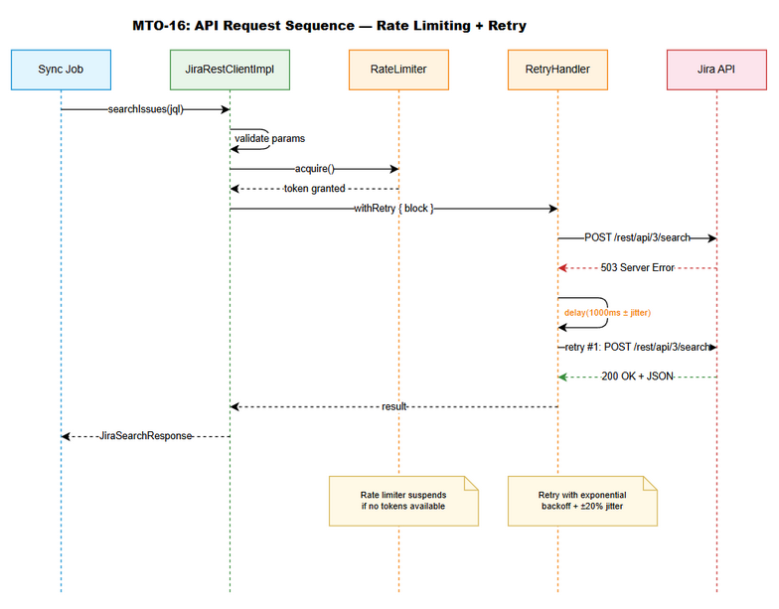
API Sequence Diagram
Flow description:
- Caller invokes searchIssues(jql, fields, startAt, maxResults)
- JiraRestClientImpl validates input parameters
- Acquires rate limiter token (may suspend if bucket empty)
- Wraps HTTP call in retryHandler.withRetry { ... }
- Constructs and sends HTTP request via Ktor CIO
- On success (2xx): deserializes response, returns to caller
- On retryable error (429/5xx/timeout): RetryHandler calculates backoff, suspends, retries
- On non-retryable error (4xx except 429): throws typed exception immediately
- On retry exhaustion: throws RetryExhaustedException with context

6.3 Internal Integration: Koin DI Module
val jiraModule = module {
// Configuration — loaded once at startup
single<JiraClientConfig> {
JiraClientConfig.fromEnvironment()
}
// Rate limiter — singleton shared across all requests
single<RateLimiter> {
TokenBucketRateLimiter(
ratePerSecond = get<JiraClientConfig>().rateLimit,
burstCapacity = get<JiraClientConfig>().rateLimit
)
}
// Retry handler — singleton with config-driven parameters
single<RetryHandler> {
ExponentialBackoffRetryHandler(
maxRetries = get<JiraClientConfig>().maxRetries,
initialDelayMs = 1000L,
maxDelayMs = 30_000L,
multiplier = 2.0,
jitterFactor = 0.2
)
}
// HTTP Client — singleton with connection pooling
single<HttpClient> {
createJiraHttpClient(get<JiraClientConfig>())
}
// Jira REST Client — main entry point
single<JiraRestClient> {
JiraRestClientImpl(
httpClient = get(),
config = get(),
rateLimiter = get(),
retryHandler = get()
)
}
}
Registration in AppModule.kt:
// In existing AppModule.kt, add:
val appModule = module {
includes(jiraModule) // Add Jira client module
// ... existing modules
}

7. Security Design
Prerequisite: Business security requirements are defined in FSD §7. This section specifies the technical implementation.

7.1 Authentication
Aspect | Implementation
Mechanism | HTTP Basic Auth
Header Format | Authorization: Basic {Base64(email:apiToken)}
Credential Source | Environment variables (JIRA_EMAIL, JIRA_API_TOKEN)
Credential Lifecycle | Loaded at startup, held in memory (JiraClientConfig), never serialized
Header Construction | Computed per-request from config (not cached as string)

7.2 Authorization
Role | Access | Jira Permissions Required
Sync Job (service account) | Read issues, Read attachments | Browse Projects, Read Issues
System Administrator | Configure credentials | Environment variable access

7.3 Data Protection
Data Type | At Rest | In Transit | In Logs | In Exceptions
API Token | Memory only (JiraClientConfig) | TLS 1.2+ (Basic Auth header) | ❌ NEVER logged | ❌ NEVER included
Email | Memory only | TLS 1.2+ (Basic Auth header) | ❌ Not logged | ❌ Not included
Issue content | Not persisted by this module | TLS 1.2+ | Summary only (first 50 chars) | Not included
Attachment binary | Not persisted by this module | TLS 1.2+ | Filename + size only | Not included
Credential Protection Implementation:
// In JiraClientConfig — override toString to mask sensitive fields
data class JiraClientConfig(
val baseUrl: String,
val email: String,
val apiToken: String,
// ... other fields
) {
override fun toString(): String = "JiraClientConfig(baseUrl=$baseUrl, email=***@***, apiToken=***)"
}
// In Ktor Logging plugin — sanitize Authorization header
install(Logging) {
sanitizeHeader { header -> header == "Authorization" }
}

7.4 Input Validation & SSRF Prevention
Validation | Implementation | Business Rule
JQL not blank | require(jql.isNotBlank()) | BR-01
maxResults range | require(maxResults in 1..100) | BR-02
Issue key format | require(key.matches(Regex("[A-Z]+-\\d+"))) | BR-09
Download URL domain | require(Url(url).host == Url(config.baseUrl).host) | BR-16
URL scheme | require(url.startsWith("http://") \|\| url.startsWith("https://")) | BR-15

8. Performance & Scalability
Prerequisite: Business NFR targets are defined in FSD §8. This section specifies how to achieve those targets.

8.1 Connection Pooling
Resource | Min | Max | Keep-Alive | Idle Timeout
Ktor CIO connections | 0 (on-demand) | 100 | 45,000ms | 5,000ms
Rationale: CIO engine manages connection pool automatically. Max 100 connections supports 10 req/s with headroom for concurrent retries and burst traffic.

8.2 Rate Limiting Performance
Metric | Target | Implementation
Token acquisition latency | < 1ms (when tokens available) | AtomicLong CAS operation
Suspension overhead | < 100ms (one refill interval) | delay(refillRateMs)
Burst handling | 10 immediate requests | Full bucket = rateLimit tokens
429 pause accuracy | ±100ms of Retry-After | delay(retryAfterMs)

8.3 Retry Performance Impact
Scenario | Worst-Case Latency | Calculation
Success on 1st attempt | < 30s (timeout) | Single request
Success on 2nd attempt | ~31s | 1st attempt + 1s backoff + 2nd attempt
Success on 3rd attempt | ~33s | 1st + 1s + 2nd + 2s + 3rd
All retries exhausted | ~37s | 1st + 1s + 2nd + 2s + 3rd + 4s + final

8.4 Performance Targets
Operation | Target | Measurement
searchIssues (happy path) | < 2s p95 | Ktor request duration metric
getIssue (happy path) | < 1s p95 | Ktor request duration metric
getAttachments (happy path) | < 1s p95 | Ktor request duration metric
downloadAttachment (< 1MB) | < 5s p95 | Ktor request duration metric
Rate limiter acquire (tokens available) | < 1ms | AtomicLong CAS timing
Config validation at startup | < 100ms | Startup log timing

9. Monitoring & Observability

9.1 Logging
Log Event | Level | Fields | Example
API request start | DEBUG | correlationId, method, endpoint | [cid=abc123] POST /rest/api/3/search
API request success | INFO | correlationId, method, duration, statusCode, resultSize | [cid=abc123] 200 OK in 450ms (120 issues)
API request failure | WARN | correlationId, method, statusCode, errorMessage | [cid=abc123] 429 Rate Limited (Retry-After: 5s)
Retry attempt | WARN | correlationId, attempt, maxRetries, delay, statusCode | [cid=abc123] Retry 1/3 after 1200ms (status=503)
Retry exhausted | ERROR | correlationId, attempts, totalElapsed, lastStatus | [cid=abc123] All 3 retries exhausted after 7200ms
Rate limiter paused | WARN | retryAfterSeconds, pauseUntil | Rate limiter paused for 5s (429 received)
Rate limiter resumed | INFO | pauseDuration | Rate limiter resumed after 5s pause
Config loaded | INFO | baseUrl, rateLimit, timeout (NO credentials) | Jira config: url=https://jira.example.com, rate=10/s
Config validation failed | ERROR | missingVars, invalidVars | Missing: JIRA_BASE_URL, JIRA_API_TOKEN

9.2 Metrics (Future — when metrics infrastructure available)
Metric | Type | Description | Alert Threshold
jira.requests.total | Counter | Total API requests by method and status | —
jira.requests.duration | Histogram | Request duration in ms | p95 > 5000ms
jira.retries.total | Counter | Total retry attempts | > 10/min
jira.ratelimit.pauses | Counter | Number of 429-triggered pauses | > 5/hour
jira.ratelimit.tokens | Gauge | Available tokens in bucket | < 2
jira.errors.total | Counter | Errors by exception type | auth > 0

9.3 Health Checks
Check | Implementation | Expected Response
Jira connectivity | GET {baseUrl}/rest/api/3/serverInfo | 200 OK with version info
Rate limiter status | rateLimiter.isPaused() | false (not paused)
Config validity | config.isValid() | true

10. Deployment Considerations

10.1 Environment Configuration
Property | DEV | SIT | UAT | PROD
JIRA_BASE_URL | https://dev-jira.example.com | https://sit-jira.example.com | https://uat-jira.example.com | https://jira.example.com
JIRA_EMAIL | sync-dev@example.com | sync-sit@example.com | sync-uat@example.com | sync-prod@example.com
JIRA_API_TOKEN | (dev token) | (sit token) | (uat token) | (prod token)
JIRA_RATE_LIMIT | 10 | 10 | 10 | 10
JIRA_TIMEOUT_MS | 30000 | 30000 | 30000 | 30000
JIRA_MAX_RETRIES | 3 | 3 | 3 | 3
JIRA_CONNECT_TIMEOUT_MS | 10000 | 10000 | 10000 | 10000
JIRA_SOCKET_TIMEOUT_MS | 30000 | 30000 | 30000 | 30000

10.2 YAML Configuration (application.yml)
jira:
base_url: ${JIRA_BASE_URL}
email: ${JIRA_EMAIL}
api_token: ${JIRA_API_TOKEN}
rate_limit: ${JIRA_RATE_LIMIT:10}
timeout_ms: ${JIRA_TIMEOUT_MS:30000}
max_retries: ${JIRA_MAX_RETRIES:3}
connect_timeout_ms: ${JIRA_CONNECT_TIMEOUT_MS:10000}
socket_timeout_ms: ${JIRA_SOCKET_TIMEOUT_MS:30000}

10.3 Feature Flags
Flag | Default | Description
jira.client.enabled | true | Enable/disable Jira client (for graceful degradation)
jira.client.retry.enabled | true | Enable/disable retry logic (useful for debugging)
jira.client.ratelimit.enabled | true | Enable/disable rate limiting (useful for load testing)

10.4 Rollback Strategy
This module is a library component within the fat JAR. Rollback = redeploy previous JAR version.
Rollback triggers: - Authentication failures in production (wrong credentials configured) - Rate limiting causing sync job timeouts - Unexpected Jira API changes breaking deserialization
Rollback steps: 1. Redeploy previous mcp-orchestrator-all.jar version 2. Verify sync job resumes with previous Jira client behavior 3. Investigate root cause before re-deploying new version

10.5 Dependencies & Build
New dependencies to add to build.gradle.kts:
// No new dependencies needed — all already in project:
// - io.ktor:ktor-client-cio (existing)
// - io.ktor:ktor-client-content-negotiation (existing)
// - io.ktor:ktor-serialization-kotlinx-json (existing)
// - io.ktor:ktor-client-logging (existing)
// - org.jetbrains.kotlinx:kotlinx-serialization-json (existing)
// - com.charleskorn.kaml:kaml (existing)
// - io.insert-koin:koin-core (existing)
// Test dependencies (existing):
// - io.ktor:ktor-client-mock (for unit tests)
// - org.wiremock:wiremock (for integration tests)
// - org.testcontainers:testcontainers (for IT infrastructure)

11. Appendix

11.1 Implementation Checklist
# | Task | Package/File | Priority | Estimated Effort
1 | Create JiraClientConfig data class + validation | config/JiraClientConfig.kt | High | 2h
2 | Create sealed exception hierarchy (7 classes) | exception/*.kt | High | 1h
3 | Create DTO models (6 data classes) | model/*.kt | High | 1h
4 | Implement TokenBucketRateLimiter | ratelimit/TokenBucketRateLimiter.kt | High | 3h
5 | Implement ExponentialBackoffRetryHandler | retry/ExponentialBackoffRetryHandler.kt | High | 2h
6 | Implement JiraRestClientImpl (4 API methods) | JiraRestClientImpl.kt | High | 4h
7 | Create Koin module (JiraModule.kt) | di/JiraModule.kt | Medium | 1h
8 | Add YAML config section to application.yml | resources/application.yml | Medium | 0.5h
9 | Unit tests — config validation | test/.../config/ | High | 2h
10 | Unit tests — rate limiter | test/.../ratelimit/ | High | 3h
11 | Unit tests — retry handler | test/.../retry/ | High | 2h
12 | Unit tests — client (Ktor mock) | test/.../ | High | 3h
13 | Integration tests — WireMock | test/.../integration/ | High | 4h
14 | Update AppModule.kt to include jiraModule | AppModule.kt | Medium | 0.5h
 | Total |  |  | ~29h

11.2 State Diagram — Retry Handler
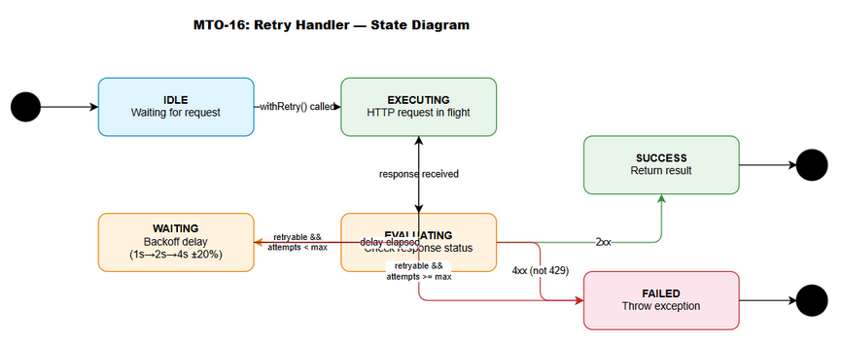
State Diagram — Retry Logic
States:
State | Description
IDLE | Waiting for next request
EXECUTING | HTTP request in flight
EVALUATING | Checking response status
WAITING | Backoff delay before retry
SUCCESS | Request completed successfully
FAILED | All retries exhausted
Transitions:
From | To | Trigger
IDLE | EXECUTING | withRetry() called
EXECUTING | EVALUATING | Response received or timeout
EVALUATING | SUCCESS | 2xx response
EVALUATING | FAILED | Non-retryable error (4xx except 429)
EVALUATING | WAITING | Retryable error AND attempts < max
EVALUATING | FAILED | Retryable error AND attempts >= max
WAITING | EXECUTING | Backoff delay elapsed

11.3 TokenBucketRateLimiter Implementation Detail
class TokenBucketRateLimiter(
private val ratePerSecond: Int,
private val burstCapacity: Int = ratePerSecond
) : RateLimiter {
private val availableTokens = AtomicLong(burstCapacity.toLong())
private val lastRefillTime = AtomicLong(System.currentTimeMillis())
private val pausedUntil = AtomicLong(0L)
private val refillIntervalMs = 1000L / ratePerSecond
private val logger = LoggerFactory.getLogger(TokenBucketRateLimiter::class.java)
override suspend fun acquire() {
while (true) {
// Check global pause (429 backoff)
val pauseEnd = pausedUntil.get()
val now = System.currentTimeMillis()
if (pauseEnd > now) {
logger.debug("Rate limiter paused, waiting ${pauseEnd - now}ms")
delay(pauseEnd - now)
continue
}
// Refill tokens based on elapsed time
refillTokens()
// Try to acquire token (CAS)
val current = availableTokens.get()
if (current > 0 && availableTokens.compareAndSet(current, current - 1)) {
return // Token acquired
}
// No token — wait for next refill
delay(refillIntervalMs)
}
}
private fun refillTokens() {
val now = System.currentTimeMillis()
val lastRefill = lastRefillTime.get()
val elapsed = now - lastRefill
val tokensToAdd = elapsed / refillIntervalMs
if (tokensToAdd > 0 && lastRefillTime.compareAndSet(lastRefill, now)) {
val newTokens = minOf(
availableTokens.get() + tokensToAdd,
burstCapacity.toLong()
)
availableTokens.set(newTokens)
}
}
override fun pauseUntil(resumeAt: Long) {
logger.warn("Rate limiter paused until ${Instant.fromEpochMilliseconds(resumeAt)}")
pausedUntil.set(resumeAt)
}
override fun isPaused(): Boolean = pausedUntil.get() > System.currentTimeMillis()
}

11.4 ExponentialBackoffRetryHandler Implementation Detail
class ExponentialBackoffRetryHandler(
private val maxRetries: Int = 3,
private val initialDelayMs: Long = 1000L,
private val maxDelayMs: Long = 30_000L,
private val multiplier: Double = 2.0,
private val jitterFactor: Double = 0.2
) : RetryHandler {
private val logger = LoggerFactory.getLogger(ExponentialBackoffRetryHandler::class.java)
private val random = java.util.Random()
override suspend fun <T> withRetry(context: String, block: suspend () -> T): T {
var attempt = 0
var lastException: JiraClientException? = null
val startTime = System.currentTimeMillis()
while (attempt <= maxRetries) {
try {
return block()
} catch (e: JiraClientException) {
if (!isRetryable(e)) throw e
lastException = e
attempt++
if (attempt > maxRetries) break
val baseDelay = minOf(
initialDelayMs * multiplier.pow((attempt - 1).toDouble()),
maxDelayMs.toDouble()
).toLong()
val jitter = (baseDelay * jitterFactor * (random.nextDouble() * 2 - 1)).toLong()
val actualDelay = (baseDelay + jitter).coerceAtLeast(0L)
logger.warn(
"Retry {}/{} for {} after {}ms [status={}, correlationId={}]",
attempt, maxRetries, context, actualDelay,
e.statusCode, e.correlationId
)
delay(actualDelay)
}
}
throw RetryExhaustedException(
cause = lastException!!,
attempts = attempt,
elapsedMs = System.currentTimeMillis() - startTime
)
}
private fun isRetryable(e: JiraClientException): Boolean = when (e) {
is JiraRateLimitException -> true // 429
is JiraServerException -> true // 5xx
is JiraTimeoutException -> true // timeout
else -> false // 4xx (auth, not found, validation)
}
}

11.5 Glossary
Term | Definition
CIO | Coroutine-based I/O — Ktor’s non-blocking HTTP client engine
Token Bucket | Rate limiting algorithm: tokens refill at constant rate, requests consume tokens
Exponential Backoff | Retry delay doubles after each attempt (1s → 2s → 4s)
Jitter | Random ±20% variation on backoff delay to prevent thundering herd
SSRF | Server-Side Request Forgery — prevented by URL domain validation
Correlation ID | UUID attached to each request for distributed tracing
CAS | Compare-And-Swap — atomic operation for lock-free concurrency

11.6 Open Questions
# | Question | Status | Answer
1 | Should rate limiter be shared across multiple JiraRestClient instances? | Resolved | Yes — singleton via Koin DI
2 | Should we support OAuth 2.0 in addition to Basic Auth? | Deferred | Out of scope per BRD — future enhancement
3 | Should download streaming use ByteReadChannel for very large files? | Resolved | Return ByteArray for simplicity; streaming is internal implementation detail
4 | Should we add circuit breaker pattern? | Deferred | Not in scope — rate limiter + retry provides sufficient resilience

⛔ MANDATORY: Diagram Requirements

Required draw.io Diagrams
# | Diagram | File | Section | Status
1 | Architecture Overview | diagrams/tdd-architecture.drawio + .png | §2.1 | ✅
2 | Component Diagram | diagrams/tdd-component.drawio + .png | §2.2 | ✅
3 | Deployment Diagram | diagrams/tdd-deployment.drawio + .png | §2.3 | ✅
4 | API Sequence (rate limit + retry) | diagrams/tdd-sequence-api.drawio + .png | §6.2 | ✅
5 | Class Diagram | diagrams/tdd-class-diagram.drawio + .png | §5.3 | ✅
6 | State Diagram (retry handler) | diagrams/tdd-state-retry.drawio + .png | §11.2 | ✅

Diagram Index
# | Diagram | Image | Source (editable)
1 | Architecture Overview | tdd-architecture.png | tdd-architecture.drawio
2 | Component Diagram | tdd-component.png | tdd-component.drawio
3 | Deployment Diagram | tdd-deployment.png | tdd-deployment.drawio
4 | API Sequence | tdd-sequence-api.png | tdd-sequence-api.drawio
5 | Class Diagram | tdd-class-diagram.png | tdd-class-diagram.drawio
6 | State — Retry Handler | tdd-state-retry.png | tdd-state-retry.drawio

