Business Requirements Document (BRD)

MCPOrchestration — MTO-13: Add HTTP Streamable Transport Mode Support

Document Information
Field | Value
Jira Ticket | MTO-13
Title | Add HTTP Streamable Transport Mode Support
Author | BA Agent
Version | 1.0
Date | 2026-05-06
Status | Draft

Author Tracking
Role | Name - Position | Responsibility
Author | BA Agent – Business Analyst | Create document
Peer Reviewer | Duc Nguyen – Project Lead | Review document

Revision History
Version | Date | Author | Changes
1.0 | 2026-05-06 | BA Agent | Initiate document — auto-generated from Jira ticket MTO-13 and linked tickets

Sign-Off
Name | Signature and date
 | ☐ I agree and confirm all criteria on this BRD as expected requirements
 | ☐ I agree and confirm all criteria on this BRD as expected requirements

1. Introduction

1.1 Scope
This change request covers a major enhancement to the MCP Orchestrator system, introducing HTTP Streamable transport mode support per MCP specification 2025-03-26, along with supporting infrastructure changes. The scope includes 7 parts:
- Part A — HTTP Streamable Transport (AC #1-7): Add a new transport mode (httpstreamable) to the MCP Orchestrator server.
- Part B — Hidden Utility Tools (AC #8-9): Implement get_drawio_reference and export_drawio hidden tools.
- Part C — Gradle Multi-Module Refactor (AC #10-14): Restructure into orchestrator-core/server/client/bridge.
- Part D — MCP Client Bridge (Kotlin) (AC #15-22): Kotlin-based stdio-to-HTTP-Streamable bridge.
- Part E — MCP Client Bridge (Node.js) (AC #23-30): TypeScript/Node.js bridge implementation.
- Part F — Smart Tool Promotion (AC #31-41): Progressive tool exposure reducing token usage by 73-80%.
- Part G — Stream Write Tool (AC #42-50): Direct-to-disk file write tool (stream_write_file).

1.2 Out of Scope
- Migration of existing upstream MCP server configurations
- UI/frontend changes to IDE plugins (Kiro, Cursor)
- Authentication/authorization for HTTP Streamable endpoints
- Load balancing or horizontal scaling of the Orchestrator

1.3 Preliminary Requirements
- MTO-10 (Base Orchestrator) must be deployed
- MTO-12 (Auto File Proxy) should be in progress or completed
- JDK 21 runtime environment
- Node.js 20+ runtime
- draw.io desktop app installed
- Ktor 3.4.0 framework already in use

2. Business Requirements

2.1 High Level Process Map
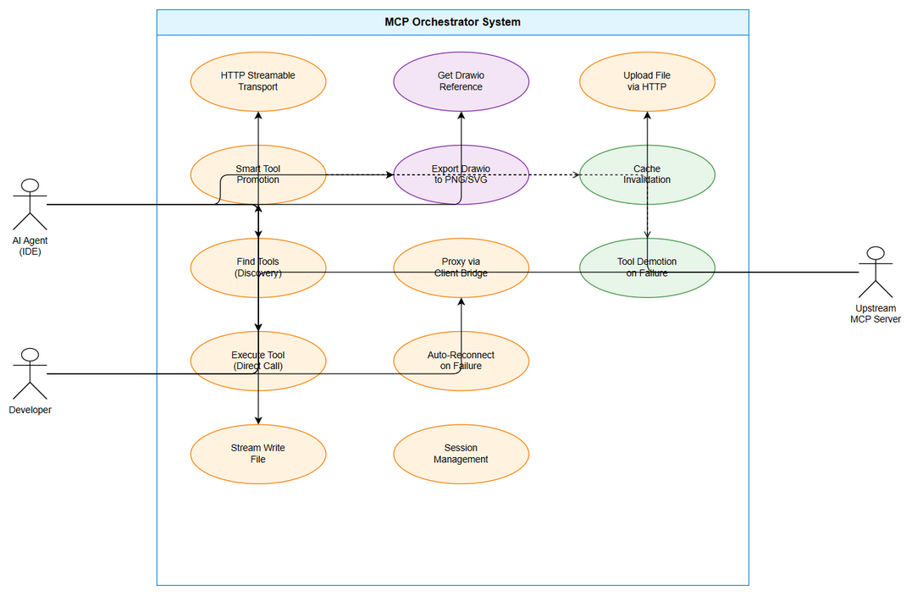
Use Case Diagram
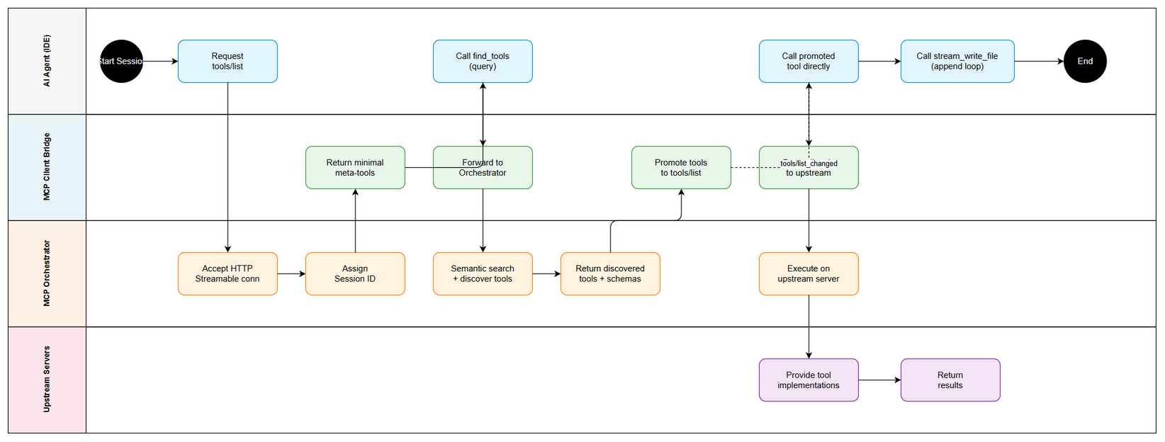
Business Flow

2.2 List of User Stories / Use Cases
# | Story / Use Case | Priority | Source Ticket
1 | HTTP Streamable Transport | MUST HAVE | MTO-13 (Part A)
2 | Hidden Utility Tools | SHOULD HAVE | MTO-13 (Part B)
3 | Gradle Multi-Module Refactor | MUST HAVE | MTO-13 (Part C)
4 | MCP Client Bridge Kotlin | MUST HAVE | MTO-13 (Part D)
5 | MCP Client Bridge Node.js | SHOULD HAVE | MTO-13 (Part E)
6 | Smart Tool Promotion | MUST HAVE | MTO-13 (Part F)
7 | Stream Write Tool | MUST HAVE | MTO-13 (Part G)

2.3 Details of User Stories

STORY 1: HTTP Streamable Transport (Part A)
As a developer, I want the MCP Orchestrator to support HTTP Streamable transport so that I can connect to it over the network instead of only via stdio.
Acceptance Criteria:
- Server supports transport: httpstreamable config option
- Single POST endpoint /mcp receives JSON-RPC requests
- Server responds with application/json (single) or text/event-stream (streaming)
- Support Mcp-Session-Id header for session management
- Support Last-Event-ID for stream resumability
- Backward compatible — existing stdio and sse modes still work
- upload_file tool works over HTTP Streamable

STORY 2: Hidden Utility Tools (Part B)
As a developer, I want hidden utility tools so that AI agents can generate and export diagrams without cluttering the tool list.
Acceptance Criteria:
- get_drawio_reference — Hidden tool returns drawio XML reference. Only discoverable via find_tools.
- export_drawio — Hidden tool accepts file_path and format, calls draw.io CLI, returns {output_path, bytes_written}.

STORY 3: Gradle Multi-Module Refactor (Part C)
As a developer, I want the project refactored into Gradle multi-module for better organization.
Acceptance Criteria:
- Refactor into multi-module: orchestrator-core, orchestrator-server, orchestrator-client, orchestrator-bridge
- Shared models/interfaces in orchestrator-core
- Server logic in orchestrator-server
- Upstream client logic in orchestrator-client
- Existing tests still pass after refactor

STORY 4: MCP Client Bridge — Kotlin (Part D)
As a developer, I want a Kotlin MCP Client Bridge for stdio-to-HTTP-Streamable proxying.
Acceptance Criteria:
- Kotlin MCP server runs stdio (module orchestrator-bridge)
- Connects to Orchestrator via HTTP Streamable client
- File content transmitted via HTTP binary (not base64 over stdio)
- Proxy find_tools and execute_dynamic_tool via HTTP Streamable
- Token optimization (see Part F)
- Configurable Orchestrator URL: http://localhost:8080/mcp
- Auto-reconnect when Orchestrator restarts
- Fat JAR: mcp-bridge-all.jar

STORY 5: MCP Client Bridge — Node.js (Part E)
As a developer, I want a Node.js MCP Client Bridge as a lightweight alternative.
Acceptance Criteria:
- Node.js MCP server runs stdio
- Connects to Orchestrator via HTTP Streamable
- File content transmitted via HTTP binary
- Proxy find_tools and execute_dynamic_tool
- Token optimization (see Part F)
- Configurable URL via env var ORCHESTRATOR_URL
- Auto-reconnect
- Packaging: npx runnable

STORY 6: Smart Tool Promotion (Part F)
As a developer, I want Smart Tool Promotion to reduce token usage by 73-80%.
Acceptance Criteria:
- Orchestrator stdio mode: Start with 6 meta-tools, promote after find_tools
- Bridge: Start with 2 meta-tools, promote after find_tools
- First find_tools call — cache and promote tools into tools/list
- Send notifications/tools/list_changed to IDE
- From second call: AI calls tool directly — 0 tokens for discovery
- Tool list grows incrementally based on need
- Promoted tools have compact schema
- Cache invalidation: restart, reset_tools, TTL 5 minutes
- Fallback: promoted tool fails — auto demote and retry
- Promoted tool succeeds — route directly to upstream
- Config: smart-promotion.enabled: true (default)

STORY 7: Stream Write Tool (Part G)
As a developer, I want stream_write_file for large file generation without RAM buffering.
Acceptance Criteria:
- Tool name: stream_write_file — writes content directly to disk, NO RAM buffer
- Available on BOTH Orchestrator (built-in tool) AND Bridge (local tool)
- Input: file_path (absolute), content (text), mode (“write” | “append”), encoding (utf-8 default)
- Writes each chunk immediately — does not accumulate content in memory
- Supports append mode — agent calls multiple times in loop
- Response: {file_path, bytes_written, total_size, mode}
- Path validation: absolute path required, no traversal, parent dir must exist
- Error handling: INVALID_PATH, OUTPUT_DIR_NOT_FOUND, OUTPUT_NOT_WRITABLE, WRITE_FAILED
- Primary use case: Agent generates large file in loop — each iteration appends 1 section

3. Dependencies
Dependency | Type | Related Ticket | Description
MTO-10 Base Orchestrator | System | MTO-10 | Foundation must be deployed
MTO-12 Auto File Proxy | System | MTO-12 | File proxy wrapper — in progress
Ktor 3.4.0 | Infrastructure | N/A | HTTP server framework
MCP Kotlin SDK 0.12.0 | Infrastructure | N/A | MCP protocol implementation
JDK 21 | Infrastructure | N/A | Kotlin runtime
Node.js 20+ | Infrastructure | N/A | Node.js bridge runtime
draw.io Desktop | External | N/A | CLI for export_drawio tool

4. Stakeholders
Role | Name / Team | Responsibility | Source
Project Lead | Duc Nguyen | Requirements, architecture, review | MTO-13 Reporter
Development Team | Unassigned | Implementation | MTO-13 Assignee
QA Team | TBD | Testing 50 ACs | To be assigned

5. Risks and Assumptions

5.1 Risks
Risk | Impact | Likelihood | Mitigation
Gradle refactor breaks functionality | High | Medium | Comprehensive test suite
HTTP latency vs stdio | Medium | Low | Benchmark; stdio remains for local
Cache invalidation stale tools | Medium | Medium | TTL + manual reset + auto-demote
Bridge divergence (Kotlin vs Node.js) | Medium | Medium | Shared ACs + integration tests
Path traversal vulnerability | High | Low | Strict validation

5.2 Assumptions
- MCP spec 2025-03-26 is stable
- IDEs support notifications/tools/list_changed
- Ktor/Netty handles HTTP Streamable without major changes
- 73-80% token reduction estimate is based on typical patterns

6. Non-Functional Requirements
Category | Requirement | Details
Performance | HTTP Streamable latency | < 100ms (excluding upstream)
Performance | Token reduction | 73-80% via Smart Tool Promotion
Scalability | Concurrent sessions | 10+ simultaneous clients
Reliability | Auto-reconnect | Within 15 seconds
Compatibility | Backward compatible | stdio and SSE unchanged
Security | Path validation | No traversal, absolute paths only

7. Related Tickets
Ticket Key | Summary | Status | Type | Relationship
MTO-13 | Add HTTP Streamable transport mode support | Docs Review | Story | Main ticket
MTO-10 | Upgrade MCP Orchestrator | Ready for Product | Story | Dependency
MTO-12 | Auto File Proxy | Docs Review | Story | Dependency

8. Appendix

Glossary
Term | Definition
MCP | Model Context Protocol
HTTP Streamable | Transport mode per MCP spec 2025-03-26
stdio | Standard input/output transport
SSE | Server-Sent Events
Smart Tool Promotion | Progressive tool exposure mechanism
Bridge | Protocol translator (stdio to HTTP Streamable)
Fat JAR | Self-contained JAR with all dependencies

Reference Documents
Document | Link / Location
MCP Spec 2025-03-26 | https://modelcontextprotocol.io/specification/2025-03-26/basic/transports#streamable-http
MTO-10 BRD | documents/MTO-10/BRD.md
Project Structure | .analysis/code-intelligence/project-structure.md

