Business Requirements Document (BRD)

SDLC Agents 4 Enterprise — SA4E-193: Create Config Commands — /create-new-agent, hook, steering, skill

Document Information
Field | Value
Jira Ticket | SA4E-193
Title | Create Config Commands — /create-new-agent, hook, steering, skill
Parent Epic | SA4E-181 — Chat Module — OpenCode Parity + Agentic Config System
Author | BA Agent
Version | 2.0
Date | 2026-08-23
Status | In Review
Source System | Jira (jiraassist.atlassian.net)

Revision History
Version | Date | Author | Changes
1.0 | 2026-08-19 | BA Agent | Initial draft auto-generated from Jira ticket SA4E-193
2.0 | 2026-08-23 | BA Agent | Complete rewrite — full requirements captured from updated ticket description (CMD1–CMD4 commands table, 8-step flow, acceptance criteria), dependency details refreshed from SA4E-189 and SA4E-190; supersedes v1.0 entirely

Sign-Off
Name | Signature and date
Duc Nguyen Minh – Product Owner / Reporter | ☐ I agree and confirm all criteria on this BRD as expected requirements
 | ☐ I agree and confirm all criteria on this BRD as expected requirements

Executive Summary
SA4E-193 delivers 4 slash commands (/create-new-agent, /create-new-hook, /create-new-steering, /create-new-skill) in the Chat module of the SDLC Agents 4 Enterprise VS Code extension ("Kiro"). Each command lets a user type a natural-language description of the configuration they want (an agent role, a hook trigger/action, a steering rule, or a skill purpose) and have an LLM generate a complete, schema-valid config file directly into the correct .code-intel/{agents,hooks,steering,skills}/ location.
After generation, the system writes the file to disk, opens it in the dual-tab custom editor (Form + Text) provided by SA4E-190 for review/editing, and the Hot-Reload system from SA4E-189 picks up the new file so the UI reflects it without restarting the extension.
This closes Gap Reference CMD1 + CMD2 + CMD3 + CMD4 (Section 11) of the agentic config system, removing the need for users to hand-write YAML frontmatter, JSON schemas, or markdown boilerplate.

Business Objectives
# | Objective | Measure of Success
BO-1 | Reduce time to create valid agentic config files from minutes/hours of manual authoring to under one minute via natural language | Time-to-created-config per command < 60s excluding user typing time
BO-2 | Eliminate syntax/schema errors in hand-written agent, hook, steering, and skill files by generating them from Section 7 field-spec templates | 100% of generated files pass schema validation
BO-3 | Provide a consistent create → review → save workflow across all four config types using chat slash commands as single entry point | All 4 commands follow identical flow pattern
BO-4 | Integrate seamlessly with existing editor (dual-tab Form+Text) and hot-reload infrastructure so new configs are immediately visible and editable | Generated files open in editor; UI list updates without extension restart

1. Introduction

1.1 Scope
In scope (from ticket SA4E-193 description):
- Four chat slash commands that use LLM to generate config files from natural language description:
Command | Input | Output | Location
/create-new-agent | Agent role description | .md with YAML frontmatter + system prompt | .code-intel/agents/{name}.md
/create-new-hook | Hook trigger/action description | .json following hook schema | .code-intel/hooks/{name}.json
/create-new-steering | Rule description | .md with optional frontmatter + body | .code-intel/steering/{name}.md
/create-new-skill | Skill purpose description | Folder + SKILL.md | .code-intel/skills/{name}/SKILL.md
- Chat-driven prompt/response loop: command triggers a chat prompt asking the user to describe what they want; user's reply is used as LLM input.
- LLM generation guided by templates: LLM prompt includes Section 7 field specs as template guide.
- File writing to the correct .code-intel/ sub-directory with schema validation before write.
- Post-write integration: generated file opens in dual-tab custom editor (Form + Text); hot-reload detects the new file automatically.

1.2 Out of Scope
The following are explicitly excluded (based on ticket scope statements of SA4E-193 and dependency tickets):
- Editing/deleting existing config files — covered separately by the Custom Dual-Tab Editors story (SA4E-190) and Sidebar TreeView CRUD (UI5).
- LLM reactive system prompt rebuild on config change — explicitly out of scope of SA4E-189 hot-reload; no backend LLM prompt rebuild when configs change.
- hookEngine.reload() auto-trigger for runtime behavior — not part of hot-reload scope (SA4E-189).
- Graph recompile on config change — out of scope (SA4E-189).
- Bulk import/export or migration of existing configs — not mentioned in any ticket; To be confirmed with stakeholders.
- Non-English description input handling guarantees — LLM output language behavior is not specified in tickets; To be confirmed with stakeholders.

1.3 Preliminary Requirement
Prerequisites before implementation/use:
- Hot-Reload System (SA4E-189) — must be available so newly written config files are detected automatically (FileSystemWatcher with 300ms debounce watching .code-intel/agents/*.md, .code-intel/steering/*.md, .code-intel/hooks/*.md, .code-intel/skills/*.md). Status: Done (resolved 2026-08-23).
- Custom Dual-Tab Editors (SA4E-190) — required for "opens file in Form + Text editor after generation" acceptance criterion. Status: To Do at time of BRD v2 creation; until delivered, files open in standard text editor (per implementation comment on SA4E-193).
- Working LLM connection in the Chat module (existing infrastructure of the Kiro extension).
- .code-intel/ directory convention present in workspace (directories created on demand if missing).

2. Business Requirements

2.1 High Level Process Map
The end-to-end business process is identical in shape for all four commands:
- User types a slash command (/create-new-*) in the chat input.
- Chat prompts the user for a natural-language description of the desired config.
- User submits the description.
- LLM generates the complete config content following the relevant template specs (Section 7 field specs).
- System validates the generated content against the target schema.
- System writes the validated file to the correct location under .code-intel/.
- System opens the generated file in the dual-tab editor (Form + Text) for review.
- User reviews/edits and saves; hot-reload picks up the new file and updates the UI automatically — no restart needed.
A visual business flow diagram is provided in the Diagrams section below (business-flow.png).

2.2 List of User Stories / Use Cases
# | Story / Use Case | Priority | Source Ticket
1 | As a developer using the Kiro chat, I want /create-new-agent to generate a complete agent .md config from my role description so that I can onboard new specialized agents without memorizing frontmatter fields. (CMD1) | MUST HAVE | SA4E-193
2 | As a developer, I want /create-new-hook to generate a hook .json matching the hook schema from my trigger/action description so that automation hooks are consistent and error-free. (CMD2) | MUST HAVE | SA4E-193
3 | As a developer, I want /create-new-steering to generate a steering rule .md from my rule description so that I can steer agent behavior declaratively without hand-writing markdown structure. (CMD3) | MUST HAVE | SA4E-193
4 | As a developer, I want /create-new-skill to create a skill folder with SKILL.md from my purpose description so that reusable skills follow the standard folder layout automatically. (CMD4) | MUST HAVE | SA4E-193

2.3 Details of User Stories

Business Flow (End-to-End, applies to all four commands)
Step 1: User types /create-new-agent (or /create-new-hook, /create-new-steering, /create-new-skill) in the chat input.
Step 2: Chat shows an input prompt, e.g. "Describe the agent you want" (adapted per command).
Step 3: User enters a natural-language description of the desired configuration.
Step 4: LLM generates the complete file content following Section 7 template specs (YAML frontmatter fields, hook JSON schema, markdown structure) as template guide in the prompt.
Step 5: System validates the generated output against the target schema and writes the file to the correct location (.code-intel/agents/{name}.md, .code-intel/hooks/{name}.json, .code-intel/steering/{name}.md, or .code-intel/skills/{name}/SKILL.md with folder creation).
Step 6: System opens the newly created file in the dual-tab custom editor (Form + Text tabs) — depends on SA4E-190; falls back to standard text editor while SA4E-190 is pending.
Step 7: User reviews/edits the file and saves.
Step 8: Hot-reload FileSystemWatcher detects the new/changed file (300ms debounce) and updates agents/hooks/steering/skills UI automatically — no extension restart required — depends on SA4E-189.
Note: Steps are identical across all four commands except for the prompt text, LLM template guide, output format (.md vs .json vs folder+SKILL.md), and target directory. Source: SA4E-193 description "Flow" section.

STORY 1 (CMD1): Create Agent Config via /create-new-agent
As a developer using the Kiro chat, I want /create-new-agent to generate a complete agent .md config from my role description so that I can onboard new specialized agents without memorizing frontmatter fields.
Requirement Details:
- Slash command /create-new-agent is registered in the command registrar and appears in the slash menu.
- Chat prompts: "Describe the agent you want"; user's reply is sent as generation instruction.
- LLM prompt includes Section 7 field specs so the agent .md contains all required YAML frontmatter fields + system prompt body.
- Generated agent name is sanitized to {name}.md filename; file written to .code-intel/agents/.
Data Fields (generated agent .md frontmatter):
Field | Type | Required | Description | Example
name | string | Yes | Unique agent identifier (kebab-case) used as filename | code-reviewer
label | string | No | Human-readable display label | Code Reviewer
phase | string | Yes | Lifecycle phase the agent operates in | development
tools | list[string] | No | Tool allow-list for the agent | [read, grep]
model | string | No | LLM model override | claude-sonnet-4
outputDoc | string | No | Output document type produced by agent | review-report
(body) | markdown | Yes | Agent system prompt | "You are a senior reviewer..."
Acceptance Criteria:
- CMD1: /create-new-agent generates a valid agent .md with all required frontmatter fields present.
- LLM prompt includes Section 7 field specs as template guide.
- Generated file passes schema validation before write.
- File is written to .code-intel/agents/{name}.md.
- After write, file opens in the editor (custom dual-tab when SA4E-190 available).
- Hot-reload detects the new agent file without restart (SA4E-189).
Validation Rules:
- Required frontmatter fields must exist after generation; missing required fields → regeneration/error path.
- name must be filesystem-safe; invalid characters stripped/replaced before writing.
Error Handling:
- LLM returns malformed/incomplete frontmatter: system reports failure in chat; file is not written; user may retry.
- Target file already exists: overwrite requires confirmation or auto-rename — To be confirmed with stakeholders (not specified in ticket).

STORY 2 (CMD2): Create Hook Config via /create-new-hook
As a developer, I want /create-new-hook to generate a hook .json matching the hook schema from my trigger/action description so that automation hooks are consistent and error-free.
Requirement Details:
- Slash command /create-new-hook triggers chat prompt describing trigger/action of the desired hook.
- LLM generates a complete hook definition as JSON strictly following the hook schema (event types, patterns/toolTypes conditionals, action type radio between prompt/command).
- File written to .code-intel/hooks/{name}.json.
Data Fields (generated hook .json):
Field | Type | Required | Description | Example
name | string | Yes | Unique hook identifier / filename base | pre-commit-guard
version | string | Yes | Schema version | 1.0.0
enabled | boolean | Yes | Whether hook is active | true
eventType | enum | Yes | Trigger event type | before-prompt-submit
patterns / toolTypes | conditional | Conditional | Present depending on event type | ["*.ts"]
action.type | enum (prompt/command) | Yes | Action kind selected via radio semantics | prompt
action.prompt | textarea content | Conditional | Required when type = prompt | "Check for TODOs..."
action.command | shell command | Conditional | Required when type = command | npm run lint
Acceptance Criteria:
- CMD2: /create-new-hook generates valid hook .json matching the hook schema.
- Generated file passes schema validation (JSON parse + field checks) before write.
- Conditional fields (patterns/toolTypes, prompt/command) consistent with event/action selection.
- File written to .code-intel/hooks/{name}.json; opens in editor after write; hot-reload picks it up.
Validation Rules:
- JSON must parse cleanly; unknown top-level keys rejected.
- Exactly one of action.prompt / action.command present according to action.type.
Error Handling:
- Invalid JSON from LLM: not written; error surfaced in chat with retry guidance.

STORY 3 (CMD3): Create Steering Config via /create-new-steering
As a developer, I want /create-new-steering to generate a steering rule .md from my rule description so that I can steer agent behavior declaratively without hand-writing markdown structure.
Requirement Details:
- Slash command /create-new-steering prompts for a rule description.
- LLM generates steering markdown with optional YAML frontmatter + body per Section 7 specs.
- File written to .code-intel/steering/{name}.md.
Data Fields (generated steering .md):
Field | Type | Required | Description | Example
inclusion | enum (always / fileMatch / manual) | No | When rule is included in context | always
description | string | No | Short purpose summary | Enforce REST API conventions
fileMatchPattern | glob | Conditional | Required when inclusion = fileMatch | src/api/**.ts
(body) | markdown | Yes | Rule instructions given to agents | "Always use DTO mapping..."
Acceptance Criteria:
- CMD3: /create-new-steering generates a valid steering .md.
- Frontmatter optional but, when present, fields follow spec; body always present.
- File passes schema validation; written to .code-intel/steering/{name}.md.
- Opens in dual-tab editor after write; hot-reload reflects new steering rule immediately.
Validation Rules:
- If inclusion: fileMatch, fileMatchPattern must be non-empty.
- Body must contain at least one non-empty line of instructions.
Error Handling:
- Missing body or contradictory conditional fields: validation fails; nothing written; error shown in chat.

STORY 4 (CMD4): Create Skill Config via /create-new-skill
As a developer, I want /create-new-skill to create a skill folder with SKILL.md from my purpose description so that reusable skills follow the standard folder layout automatically.
Requirement Details:
- Slash command /create-new-skill prompts for the purpose of the skill.
- LLM generates SKILL.md with required frontmatter (name, description, metadata); system creates the containing folder if absent.
- Resulting layout: .code-intel/skills/{name}/SKILL.md.
Data Fields (generated SKILL.md frontmatter):
Field | Type | Required | Description | Example
name | string | Yes | Skill identifier, also folder name | release-versioning
description | string | Yes | What the skill does and when to use it | Git release process steps
metadata | object | No | Extra key/value metadata | {author: "..."}
(body) | markdown | Yes | Instructions/resources of the skill | Step-by-step procedure
Acceptance Criteria:
- CMD4: /create-new-skill creates folder + SKILL.md with frontmatter.
- Folder .code-intel/skills/{name}/ is created on demand; no collision errors on fresh workspace.
- SKILL.md passes schema validation; opens in editor after write; hot-reload registers the new skill.
Validation Rules:
- Folder name equals sanitized name from frontmatter.
- Required frontmatter (name, description) must be present.
Error Handling:
- Existing skill folder with same name: write blocked or confirmed — To be confirmed with stakeholders (not specified in ticket).
- Folder creation permission failure: error surfaced in chat; partial artifacts cleaned up.

3. Dependencies
Dependency | Type | Related Ticket | Description | Status
Hot-Reload System — FileSystemWatcher | System | SA4E-189 | Watches .code-intel/agents/*.md, .code-intel/steering/*.md, .code-intel/hooks/*.md, .code-intel/skills/*.md with 300ms debounce; reloads UI lists via postMessage without extension restart. Required for AC "Hot-reload detects new file". | Done (resolved 2026-08-23)
Custom Dual-Tab Editors — Form + Text | System | SA4E-190 | VS Code CustomEditorProvider editors for .code-intel/agents/*.md, hooks .json, steering .md, SKILL.md; Form and Text tabs sync bidirectionally. Required for AC "file opens in custom editor". | To Do
LLM Chat Infrastructure | Infrastructure | Epic SA4E-181 | Existing chat/LLM pipeline used to run generation prompts. | Available

4. Stakeholders
Role | Name / Team | Responsibility | Source
Reporter / Product Owner | Duc Nguyen Minh | Owns requirements, reviews BRD, signs off | SA4E-193 reporter/creator/watcher
Developer | Extension team (implementation by Duc Nguyen Minh per commit comment) | Implements ConfigCommands, templates, slash menu integration | SA4E-193 comment 2026-08-23
BA | BA Agent | Requirements documentation (this BRD) | Pipeline role
End Users | Developers using Kiro extension in enterprise workspaces | Use slash commands to create configs | Derived from product context

5. Non-Functional Requirements
Category | Requirement | Details
Performance | Generation round-trip should feel instant within chat UX | Target < 60s end-to-end per command excluding user typing time; hot-reload debounce fixed at 300ms (from SA4E-189)
Usability | Single entry point via slash menu; guided prompt flow | Commands discoverable in slash menu (SlashMenuItems.ts); prompt text adapts per config type
Reliability | No invalid file ever written to disk | Schema validation gate before write; failures reported in chat without partial artifacts
Consistency | Identical flow pattern across all 4 commands | Shared command handler architecture (ConfigCommands.ts, shared template registry)
Compatibility | Works with existing editor fallback | If SA4E-190 dual-tab editor unavailable, file opens in standard text editor without breaking the flow (per implementation comment on SA4E-193)
Maintainability | Templates centralized | Section 7 field specs maintained as templates in extension/src/commands/config-templates/ so spec changes don't require code rewrites of handlers
Additional quantified targets (e.g., exact latency budgets, concurrency limits) were not specified in the tickets. To be confirmed with technical team.

6. Success Metrics
# | Metric | Target | Measurement Method
SM-1 | Command success rate | ≥ 95% of invocations produce a valid written file | Telemetry/logs of command runs vs validation failures
SM-2 | Schema validation pass rate | 100% of written files valid at write time | Validation gate results
SM-3 | Time-to-config | Median < 60s from description submit to file written | Timestamped logs (submit → write)
SM-4 | Hot-reload pickup | New file reflected in UI ≤ 1s after write (300ms debounce + refresh) | Manual/E2E verification per SA4E-189 behavior
SM-5 | Adoption | All four commands used at least once per active workspace within first week of release | Usage counters
SM-6 | Rework reduction | Reduction in manually-authored config files with schema errors vs baseline | Git history audit pre/post release

7. Risks and Assumptions

7.1 Risks
Risk | Impact | Likelihood | Mitigation
LLM generates frontmatter/JSON that fails schema validation intermittently | Medium | Medium | Validation gate before write; retry loop; error surfaced in chat with actionable message; Section 7 specs embedded in prompt reduce drift
SA4E-190 dual-tab editor not yet delivered → "opens in custom editor" AC unmet | Medium | High (SA4E-190 status: To Do) | Graceful fallback to standard text editor (already implemented per ticket comment); track SA4E-190 to completion
Name collisions with existing config files cause silent overwrite or confusing duplicates | Medium | Low/Medium | Collision policy to be confirmed (confirm-or-rename); until then, surface clear chat warning when target exists
Hot-reload only updates UI lists, not runtime hook engine or LLM system prompt (scope limit of SA4E-189) | Low | Certain by design | Document expectation clearly: new configs appear in UI immediately; runtime behavior rebuilds are separate scope
User provides vague description → low-quality generated config | Medium | Medium | Prompt guidance in chat ("Describe the agent you want"); users review in editor before relying on the config

7.2 Assumptions
- The workspace follows the .code-intel/ directory convention; directories are created on demand.
- LLM connectivity is available whenever slash commands are invoked.
- Section 7 field-spec templates remain the single source of truth for generation prompts.
- Generated filenames derive from sanitized user/intent-provided names ({name} placeholder).
- SA4E-189 hot-reload behavior (300ms debounce, UI-only refresh) is stable and released (extension v1.33.0+).

8. Related Tickets
Ticket Key | Summary | Status | Type | Relationship
SA4E-193 | Create Config Commands — /create-new-agent, hook, steering, skill | In Review | Story | Main ticket
SA4E-181 | Chat Module — OpenCode Parity + Agentic Config System | Done | Epic | Parent epic
SA4E-189 | Hot-Reload System — FileSystemWatcher reactive prompt rebuild | Done | Story | Dependency (hot-reload picks up new files)
SA4E-190 | Custom Dual-Tab Editors — Form+Text editors for agent/hook/steering/skill | To Do | Story | Dependency (post-write editor experience)

9. Appendix

Glossary
Term | Definition
Kiro | VS Code–based AI coding assistant extension developed in this project (SDLC Agents 4 Enterprise)
Agent | An LLM persona defined by a markdown file with YAML frontmatter + system prompt, stored under .code-intel/agents/
Hook | Automation triggered on events, defined as JSON under .code-intel/hooks/ following the hook schema
Steering | A rule guiding agent behavior, defined as markdown (optional frontmatter) under .code-intel/steering/
Skill | A reusable capability packaged as folder + SKILL.md under .code-intel/skills/
CMD1–CMD4 | Gap-reference IDs for the four create-config commands (Section 11 of gap analysis)
Section 7 field specs | Template specification source used to instruct the LLM during generation
Dual-Tab Editor | Custom VS Code editor offering Form tab and Text tab for the same config file (SA4E-190)
Hot-Reload | Automatic UI refresh on config file changes via FileSystemWatcher with 300ms debounce (SA4E-189)
Slash command | Chat input command beginning with "/" registered in the slash menu

Reference Documents
Document | Link / Location
Jira ticket SA4E-193 | https://jiraassist.atlassian.net/browse/SA4E-193
Jira epic SA4E-181 | https://jiraassist.atlassian.net/browse/SA4E-181
Jira dependency SA4E-189 | https://jiraassist.atlassian.net/browse/SA4E-189
Jira dependency SA4E-190 | https://jiraassist.atlassian.net/browse/SA4E-190
UG.md (User Guide attachment on SA4E-193) | Jira attachment id 11191
Repository | https://github.com/dnguyenminh/SDLC-Agents-4-Enteprise.git

Implementation Traceability (from ticket comments)
Per DEV comment on SA4E-193 (2026-08-23): implementation complete with files extension/src/commands/ConfigCommands.ts, extension/src/commands/config-templates/ (4 templates), extension/src/commands/CommandRegistrar.ts, extension/src/webview/slash-menu/SlashMenuItems.ts, extension/src/webview/input/InputAreaIntegration.ts; all tests pass; branch SA4E-193 pushed.

Diagrams

Diagram Index
# | Diagram | PNG (embedded below) | Editable Source
1 | Use Case Diagram — Actor & 4 create-config use cases | diagrams/use-case.png | diagrams/use-case.drawio
2 | Business Flow — Slash command → LLM generation → validate → write → editor → hot-reload | diagrams/business-flow.png | diagrams/business-flow.drawio

Use Case Diagram
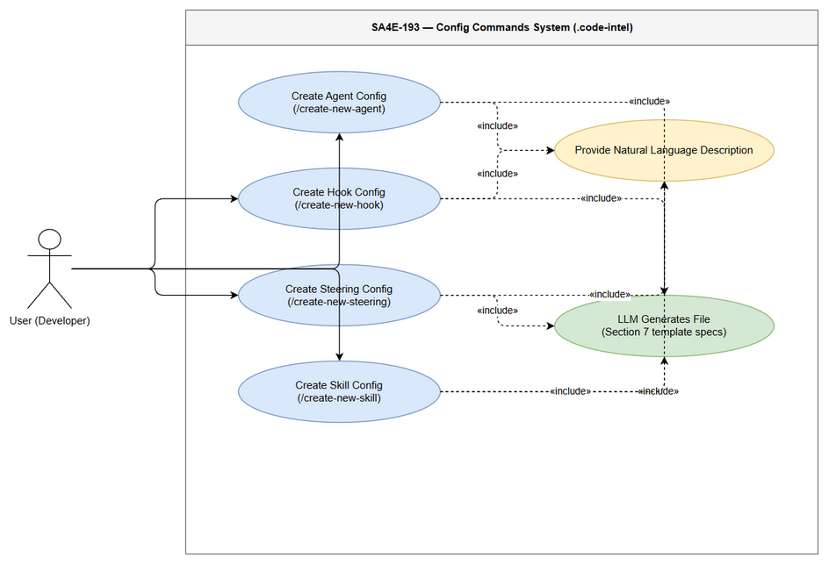
Edit in draw.io

Business Flow Diagram
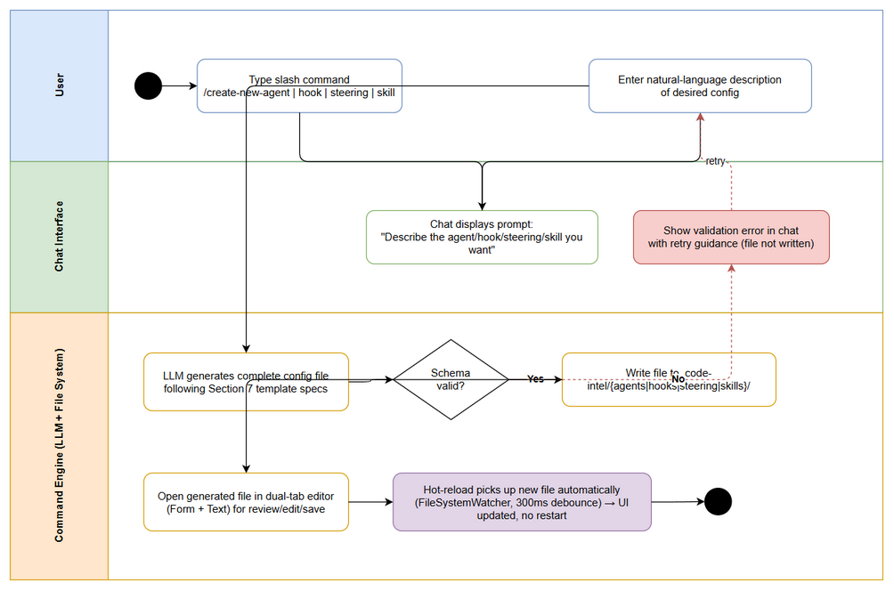
Edit in draw.io

