Deployment Guide (DPG)

SDLC Agents 4 Enterprise (Kiro Extension) — SA4E-193: Config Commands with ValidationGate

Document Information
Field | Value
Jira Ticket | SA4E-193
Title | Config Commands with ValidationGate — /create-new-agent, /create-new-hook, /create-new-steering, /create-new-skill
Parent Epic | SA4E-181 — Chat Module — OpenCode Parity + Agentic Config System
Release Version | v1.35.0 (covers SA4E-190 + SA4E-193)
Author | DevOps Agent
Version | 1.1
Date | 2026-08-24
Status | Released (post-merge documentation of record)
Related TDD | TDD.md v2.0 (documents/SA4E-193/TDD.md)
Related Reports | TEST-REPORT.md v3.0 (SUITE GREEN), UG.md v2

Revision History
Version | Date | Author | Changes
1.0 | 2026-08-24 | DevOps Agent | Initiate document — auto-generated from TDD v2.0, BRD v2.0, TEST-REPORT v3.0; release merged to main (default branch)
1.1 | 2026-08-24 | DevOps Agent | Release version correction v1.36.0 → v1.35.0 per PO decision (v1.35.0 was never released; SA4E-193 ships as official v1.35.0)

Sign-Off
Name | Role | Signature and date
Duc Nguyen Minh | Dev Lead / Product Owner | ☐ Approved for deployment
QA Lead | QA Lead | ☐ Testing completed (TEST-REPORT v3.0 — SUITE GREEN)
Ops Lead | Ops Lead | ☐ Infrastructure ready

1. Overview

1.1 Feature Summary
SA4E-193 delivers 4 chat slash commands in the Kiro VS Code extension that generate complete, schema-valid agentic config files from a natural-language description:
Command | Output Artifact | Target Path
/create-new-agent | Markdown + YAML frontmatter + system prompt body | .code-intel/agents/{name}.md
/create-new-hook | Strict-schema JSON (canonical serialization) | .code-intel/hooks/{name}.json
/create-new-steering | Markdown ± optional frontmatter | .code-intel/steering/{name}.md
/create-new-skill | Skill folder + SKILL.md | .code-intel/skills/{name}/SKILL.md
Key engineering guarantees introduced by this release:
- ValidationGate — a mandatory validate-before-write gate closes GAP-01 and fixes production defects D-1..D-7 (frontmatter dedup, strict hook schema, empty-stream handling, skill name forcing, canonical serialization).
- Template fallback — deterministic scaffolds when the LLM is unavailable; creation is never blocked by LLM outage (offline-safe).
- Hot-reload integration — written files are picked up by the SA4E-189 watcher (300 ms debounce) with no extension restart.

1.2 Release & Git Facts
Item | Value
Default branch | main
Merge commit into main | 3d924ca — “Merge branch ‘SA4E-193’ — Config Commands with ValidationGate (fixes D-1..D-7)” (parents d4836f3 + 3a3b6c4)
Version commit (tag target) | f9c64a8 — “set official release version to 1.35.0”: all 3 package.json corrected 1.36.0 → 1.35.0 (correction commit) + README changelog consolidated into a single ### v1.35.0 (2026-08-24) entry covering SA4E-190 + SA4E-193
Annotated tag | v1.35.0 → points to f9c64a8 (pushed to origin; verified git ls-remote: v1.35.0^{commit} = f9c64a8)
Superseded history (record only) | Intermediate bump cb83296 (all 3 package.json 1.35.0 → 1.36.0) and its annotated tag v1.36.0 (→ cb83296) were reverted/deleted local + remote after PO confirmed the 1.35 line had never been released; README changelog commits c492837 superseded by f9c64a8
Tag hygiene precedent | Stale tag v1.34.0 deleted local+remote earlier (had pointed at wrong commit 1a7a800 of SA4E-206); interim tag v1.36.0 deleted on this correction — official tag is now v1.35.0
Release coverage | v1.35.0 covers SA4E-190 + SA4E-193 — first tagged release of the 1.35 line; last valid released baseline remains v1.33.0
Final refactor included | a618e0b — ConfigCommands.ts 593 → 195 lines (thin orchestrators) + 8 new modules + 64 ValidationGate regression tests

1.3 Deployment Scope
Item | Type | Description
Extension module (extension/) | Modified + New | Refactored ConfigCommands.ts (593 → 195 lines, thin orchestrators); NEW modules: validation-gate.ts, hook-gate.ts, llm-prompts.ts, template-provider.ts, frontmatter-utils.ts, file-writer.ts, config-command-specs.ts, name-extractor.ts; NEW templates under extension/src/commands/config-templates/
Backend (backend/) | None (functional) | No functional change from SA4E-193; version corrected to 1.35.0 in lockstep (f9c64a8); full suite re-run green (2,621 tests) as regression proof
Admin UI (admin-ui/) | None (functional) | Version bump only
Database | N/A | Feature persists plain files under <workspace>/.code-intel/; no database, no migration
Configuration | None | No new environment variables, properties, or feature flags required
Infrastructure | None | No servers/containers changed; distribution is via extension package (VSIX / marketplace publish)

1.4 Target Environments
The product is a VS Code extension monorepo; “environments” map to build/distribution channels:
Environment | Channel | Deploy Order | Approval Required
DEV | Local dev build (esbuild-watch + F5 launch) | 1st | No
SIT | Side-loaded debug VSIX (package:debug) on QA machines | 2nd | No
UAT | Side-loaded prod VSIX (package:prod) on business validators | 3rd | QA Sign-off
PROD | Marketplace publish (vsce publish 1.35.0) or enterprise VSIX distribution | 4th | PO + Dev Lead Sign-off

2. Prerequisites

2.1 Infrastructure
Requirement | Status | Notes
Build machine with npm workspaces support | Ready | Monorepo root scripts: npm run build --workspaces, npm run test --workspaces
Node.js ≥ 18.14.1 | Ready | Required by backend test setup (vitest v4.x) and vsce packaging
VS Code engine ≥ 1.85.0 on target workstations | Ready | extension/package.json engines constraint
GitHub Copilot LLM availability (end users) | Ready | Generation uses vscode.lm.selectChatModels({ vendor: "copilot" }); outage degrades gracefully to template fallback
Release archive of previous VSIX (v1.33.x) | Required | MUST exist before PROD rollout — rollback artifact per Section 8 (v1.33.0 is the last valid released baseline)

2.2 Software Dependencies
Dependency | Version | Status
Node.js runtime | ≥ 18.14.1 | Installed on build machine
TypeScript | ^5.4.0 | Locked via extension/package.json
esbuild bundler | ^0.21.0 | npm run esbuild-production
@vscode/vsce packager | current | vsce package --no-dependencies
Vitest | ^4.1.x | Test gate runner (extension + backend suites)
Git | ≥ 2.x | Tag verification (v1.35.0 → f9c64a8)

2.3 Access Requirements
Access | Type | Who Needs It
Repository read at tag v1.35.0 | Git clone/pull | Build engineer
Marketplace publisher account (dnguyenminh) | Credentials/PAT | Release manager (PROD only)
VS Code CLI on target machines | Local admin/user | QA + end users (VSIX side-load)
Jira project access | Service account | SM attaches DPG/RLN artifacts

2.4 Backup Requirements
- ☐ Previous release artifact archived: sdlc-agents-4-enterprise-1.33.x.vsix (v1.33.0) stored in release archive (rollback prerequisite — last stable released line before v1.35.0)
- ☐ Database backup: N/A — no database involved in this feature
- ☐ Configuration backup: N/A — no deploy-time configuration changes; user workspace files under .code-intel/ are user-owned and untouched by install/uninstall
- ☒ Git state backup: tag v1.35.0 → f9c64a8 + merge commit 3d924ca pushed to origin (verified)
## 3. Pre-Deployment Checklist
All items below were verified for release v1.35.0 on 2026-08-24:
| # | Item | Responsible | Status | |—|——|————-|——–| | 1 | Code merged to main (merge commit 3d924ca) | Developer | ✅ | | 2 | Extension unit tests passed — 1,621/1,621 (+64 ValidationGate regression tests D-1..D-7, 0 regression vs 1,557 baseline) | Developer | ✅ | | 3 | Backend unit/integration/E2E-API tests passed — 2,621/2,621 full green (13 prior E2E-API failures resolved by refactor a618e0b) | QA | ✅ | | 4 | QA sign-off obtained — TEST-REPORT v3.0 verdict SUITE GREEN | QA | ✅ | | 5 | Database backup completed | DBA | ✅ N/A — no database in scope | | 6 | Configuration files prepared | DevOps | ✅ N/A — no deploy-time config changes | | 7 | Feature flags configured | Developer | ✅ N/A — no feature flags in this release | | 8 | Monitoring/alerting configured | DevOps | ✅ N/A server-side; success-metrics audit plan defined (§7.4) | | 9 | Rollback plan reviewed (Section 8 + rollback-flow diagram) | Team | ✅ | | 10 | Release window confirmed — 2026-08-24 | PM | ✅ |

4. Database Migration
Not applicable. SA4E-193 introduces no database schema changes and no data migration:
- Persistence is plain UTF-8 files under the end-user workspace: .code-intel/{agents,hooks,steering,skills}/.
- Directories are created on demand at first write (writeFileWithMkdir()); fresh workspaces are safe.
- Artifacts written by v1.35.0 remain valid when the extension is downgraded (older versions simply ignore the new files; formats follow the pre-existing .code-intel convention).

4.1 Verification Instead of Migration Queries
Post-install file-integrity spot checks (run inside any test workspace):
# After creating an agent via /create-new-agent
Get-Content .code-intel/agents/<name>.md -TotalCount 2 # must start with '---' frontmatter block
# After creating a hook via /create-new-hook
node -e "JSON.parse(require('fs').readFileSync('.code-intel/hooks/<name>.json','utf8')); console.log('valid JSON')"

4.2 Rollback of Data
No database rollback exists or is needed. Generated workspace files may optionally be removed by the user (git clean inside their repo if tracked); the uninstaller never touches user workspaces.

5. Application Deployment

5.1 Deployment Architecture
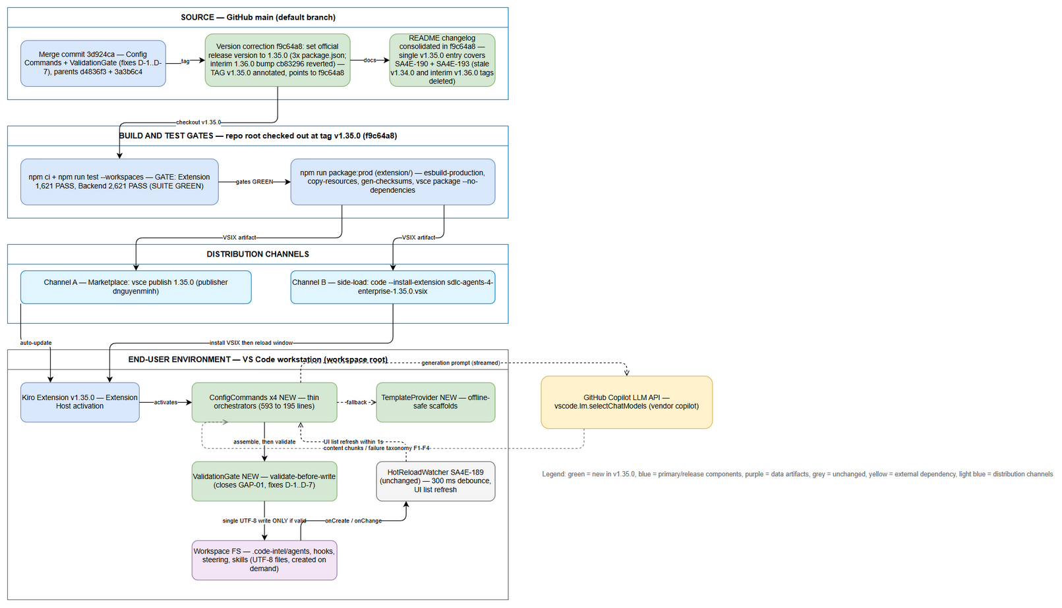
Deployment Architecture
Edit in draw.io
The pipeline is: Source (main @ merge 3d924ca + version commit f9c64a8, tag v1.35.0) → Build & Test gates → VSIX package → Distribution (marketplace / side-load) → End-user VS Code workstation where the extension host runs the new command modules, writes validated configs to .code-intel/, and hands off to the pre-existing hot-reload watcher.

5.2 Build & Package Steps
Execute from repository root at tag v1.35.0:
Step | Action | Command | Verification
1 | Checkout release state | git fetch --tags && git checkout v1.35.0 | git describe --tags → v1.35.0; git rev-parse v1.35.0^{commit} → f9c64a8…
2 | Verify merge lineage | git log --oneline -3 main | Contains 3d924ca merge commit
3 | Install dependencies (all workspaces) | npm ci | Clean install, no errors
4 | Extension test gate | npm run test --workspace=extension | Expected: 1,621 passed / 0 failed (~80s)
5 | Backend regression gate | npm run test --workspace=backend && npm run test:e2e-api --workspace=backend | Expected: 2,621 passed / 0 failed (~180s)
6 | Package production VSIX | cd extension && npm run package:prod | Artifact extension/sdlc-agents-4-enterprise-1.35.0.vsix created (esbuild-production + copy-resources + gen-checksums + vsce package --no-dependencies)
7 | Record checksums | Get-FileHash extension\sdlc-agents-4-enterprise-1.35.0.vsix -Algorithm SHA256 | Hash recorded in release notes/receipt

5.3 Distribution & Install Steps
PROD channel A — Marketplace publish (release manager):
cd extension
npx @vscode/vsce publish 1.35.0 # publishes dnguyenminh.sdlc-agents-4-enterprise v1.35.0
PROD channel B — Enterprise VSIX side-load (per workstation):
code --install-extension .\sdlc-agents-4-enterprise-1.35.0.vsix
SIT/UAT channels: same side-load command using the debug/prod VSIX built per §5.2 step 6 (package:debug for SIT).
Step | Action | Command | Verification
1 | Install/side-load VSIX | code --install-extension sdlc-agents-4-enterprise-1.35.0.vsix | CLI exits 0: “Extension ‘sdlc-agents-4-enterprise’ v1.35.0 was successfully installed.”
2 | Reload window | Command Palette → “Developer: Reload Window” | Extension Host restarts without errors
3 | Version check | Extensions view → search “SDLC Agents” | Shows 1.35.0, no reload prompt pending
Docker deployment is not applicable — this release ships as a VSIX, not a container image. No docker-compose changes are included.
## 6. Configuration Changes
None required. This release requires zero deploy-time configuration:
### 6.1 New Environment Variables
| Variable | Description | DEV | SIT | UAT | PROD | |———-|————-|—–|—–|—–|——| | (none) | No new environment variables introduced | — | — | — | — |
### 6.2 Application Properties Changes
| Property | Old Value | New Value | File | |———-|———–|———–|——| | version (extension/package.json) | 1.36.0 (interim bump cb83296, never released) | 1.35.0 (correction commit f9c64a8) | extension/package.json (baked into VSIX at build) | | version (backend/package.json) | 1.36.0 (interim bump cb83296, never released) | 1.35.0 (correction commit f9c64a8) | backend/package.json | | version (root/admin-ui package.json) | 1.36.0 (interim bump cb83296, never released) | 1.35.0 (correction commit f9c64a8) | lockstep correction commit f9c64a8 |
Runtime behavior notes:
- LLM access uses the built-in Copilot model selection (vscode.lm.selectChatModels({ vendor: "copilot" })) — no keys or endpoints to configure. - Hot-reload watcher globs and 300 ms debounce are unchanged from SA4E-189 (already active since v1.33.0+). - Templates are bundled inside the VSIX (config-templates/ via copy-resources) — no external template hosting.
### 6.3 Feature Flags
| Flag | DEV | SIT | UAT | PROD | |——|—–|—–|—–|——| | (none — feature is always-on once v1.35.0 installed) | — | — | — | — |

7. Post-Deployment Verification

7.1 Health Checks
This is a client-side extension; “health” = clean activation and command registration on a representative workstation.
Check | Endpoint/Command | Expected Result | Timeout
Extension activation | Open workspace → Output panel → “Extension Host” | No activation errors; extension activates silently | 30s
Installed version | Extensions view → “SDLC Agents 4 Enterprise” | Version reads 1.35.0 | 10s
Command registration | Chat slash menu / Command Palette → type /create-new- | All 4 commands listed: agent, hook, steering, skill | 10s
Backend unaffected (if backend deployed alongside) | npm run test:e2e-api --workspace=backend in CI | 2,621 passed | 300s

7.2 Smoke Tests
Run each scenario in a scratch workspace after install:
# | Scenario | Steps | Expected Result
1 | Create agent | /create-new-agent → describe role → confirm kebab-case name | .code-intel/agents/{name}.md written with frontmatter (name, label, phase, tools) + body; file auto-opens in editor; success toast
2 | Create hook | /create-new-hook → describe trigger/action | Valid {name}.json written; parses cleanly; only allowed top-level keys present
3 | Create steering | /create-new-steering → describe rule | .code-intel/steering/{name}.md written; body non-empty
4 | Create skill | /create-new-skill → describe purpose | .code-intel/skills/{name}/SKILL.md created; frontmatter name equals folder name exactly
5 | Gate rejection (GAP-01 proof) | Force invalid generation (e.g., malformed JSON hook via prompt manipulation) | Error toast “Failed to create …: {reason}”; no file written to target dir
6 | Offline fallback | Disconnect Copilot LLM (or simulate failure) → run any command | Deterministic template scaffold written instead of failing; flow completes
7 | Hot-reload pickup | After any successful write | New config appears in UI list within ≤ 1s without window reload

7.3 Log Verification
Log Entry | Level | Expected | Location
[ConfigCommands] … fallback diagnostics | DEBUG (console.debug) | Only when LLM unavailable/failure taxonomy F1–F4 triggers | Developer Tools console
Validation rejections | Toast + session log | Reason text surfaced; nothing persisted | Developer Tools console
Unhandled exceptions | ERROR | Must be absent during smoke scenarios | Developer Tools console / Extension Host output

7.4 Monitoring Dashboard
No server dashboards exist for this release. Post-release audit per BRD success metrics:
- ☐ SM-1 command success rate ≥ 95% of invocations produce a valid file (session-log audit, first week)
- ☐ SM-2 schema validation pass rate = 100% at write time (by construction — gate blocks otherwise)
- ☐ SM-3 median time-to-config < 60s excluding typing
- ☐ SM-4 hot-reload pickup ≤ 1s after write
- ☐ No unexpected user reports of blocked writes (gate false-positives) — would trigger §8.2 criteria

8. Rollback Plan

8.1 Rollback Flow
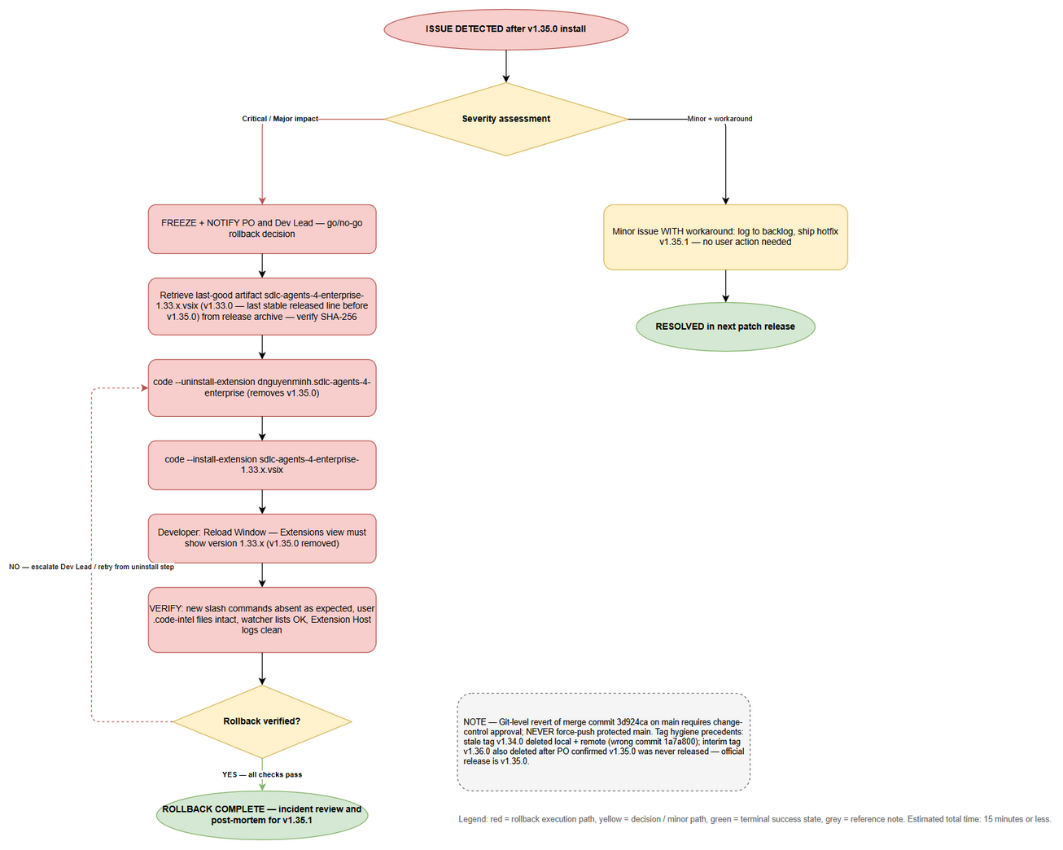
Rollback Flow
Edit in draw.io

8.2 Rollback Decision Criteria
Condition | Action
Commands fail to register / extension fails to activate on PROD workstations | Immediate rollback to v1.33.x VSIX (last stable released line)
ValidationGate false-negatives block valid writes at scale (> 5% of invocations report “Failed to create…”) | Immediate rollback
Data integrity concern — invalid file ever observed on disk post-write (should be impossible by design) | Immediate rollback + engineering investigation
Generated-file corruption reported | Immediate rollback + investigate affected workspaces
Minor UI/cosmetic issue with available workaround | No rollback — schedule hotfix v1.35.1
Single-user local issue (workspace-specific) | Troubleshoot locally — no global rollback

8.3 Rollback Steps
Rollback is an artifact downgrade — no database, no configuration, no server state.
Step | Action | Command | Verification
1 | Freeze & notify | Notify PO + Dev Lead (decision gate per diagram) | Acknowledgment recorded
2 | Acquire last-good artifact | Retrieve sdlc-agents-4-enterprise-1.33.x.vsix (v1.33.0) from release archive | File hash matches archive record
3 | Uninstall current version | code --uninstall-extension dnguyenminh.sdlc-agents-4-enterprise | CLI confirms removal of v1.35.0
4 | Install previous version | code --install-extension sdlc-agents-4-enterprise-1.33.x.vsix | CLI: “was successfully installed.”
5 | Reload window | Command Palette → “Developer: Reload Window” | Extension Host restarts clean
6 | Verify rollback | Extensions view shows 1.33.x; /create-new-* commands absent (expected); existing .code-intel/ files intact and still listed by watcher | Smoke §7.2 #7 passes
7 | Post-mortem input | Capture incident details for fix release v1.35.1 | Ticket created
Notes:
- User data safety: uninstalling never deletes workspace files under .code-intel/; artifacts produced by v1.35.0 stay valid under older versions.
- Git-level rollback (exceptional): reverting merge commit 3d924ca on main is NOT automatic and requires change-control approval; if executed, delete the release tag local+remote following the same procedure used for the stale v1.34.0 cleanup and the interim v1.36.0 removal. Never force-push protected main.
- Marketplace rollback: if channel A was used, unpublish/mark v1.35.0 deprecated in publisher portal while side-loading v1.33.x internally.

8.4 Rollback Time Estimate
Action | Estimated Time
Decision & notification | 5 min
Artifact retrieval + uninstall/install per workstation | 5 min
Verification (§8.3 steps 5–6) | 5 min
Total | ≤ 15 min

## 9. Environment-Specific Notes
### 9.1 DEV
- Build locally: npm run esbuild-watch --workspace=extension + F5 launch (Extension Development Host). - No tagging/publishing; test against working tree. - ValidationGate unit tests: npm run test --workspace=extension — 1,621 expected green.
### 9.2 SIT
- Side-load debug VSIX: cd extension && npm run package:debug then code --install-extension sdlc-agents-4-enterprise-1.35.0.vsix. - QA validates all 7 smoke scenarios (§7.2) including gate-rejection and offline-fallback paths. - Backend E2E-API suite must be green in CI before UAT promotion.
### 9.3 UAT
- Side-load prod VSIX (package:prod) on validator machines. - Business validation focuses on BO-1..BO-4 (BRD): time-to-config < 60s, zero schema errors, consistent flow across 4 commands, hot-reload visibility. - QA sign-off required before PROD promotion.
### 9.4 PROD
- Deployment Window: 2026-08-24 (release executed post-merge of 3d924ca; official release tag v1.35.0 cut at version commit f9c64a8) - Approval Required From: Product Owner (Duc Nguyen Minh) + Dev Lead - Communication Plan: announce in team channel with RLN link; SM attaches DPG/RLN to Jira SA4E-193 - On-Call Contact: DevOps rotation (per team roster) - Special note — release version correction: interim tag v1.36.0 (→ cb83296) was deleted local+remote after the PO confirmed v1.35.0 had never been released. SA4E-193 therefore ships as the official release v1.35.0, which covers both SA4E-190 (Pipeline Autonomy L3 Reset & Rebuild) and SA4E-193 (Config Commands with ValidationGate). Precedent retained: legacy tag v1.34.0 (wrong commit 1a7a800, SA4E-206 work) was also deleted local+remote during this release — do not re-create it. Next tags: hotfix ≥ v1.35.1, next minor ≥ v1.36.0.

10. Appendix

Contacts
Role | Name | Contact
Release Manager / DevOps Lead | (team roster) | on-call channel
Product Owner / Reporter | Duc Nguyen Minh | via Jira SA4E-193
On-Call Dev | Extension team rotation | on-call channel

Related Tickets
Ticket | Summary | Relationship
SA4E-193 | Config Commands with ValidationGate | Main ticket (this release)
SA4E-181 | Chat Module — OpenCode Parity + Agentic Config System | Parent epic
SA4E-189 | Hot-Reload System — FileSystemWatcher (300 ms debounce) | Dependency — Done, ships since v1.33.0+
SA4E-190 | Custom Dual-Tab Editors — Form+Text | Dependency — To Do; graceful text-editor fallback active

Diagram Index
# | Diagram | Image | Source (editable)
1 | Deployment Architecture — release pipeline from source to end-user workstation |  | deployment-architecture.drawio
2 | Rollback Flow — issue detection, severity decision, downgrade steps, verification loop |  | rollback-flow.drawio
Related diagrams maintained in TDD.md: architecture.png, component.png, class-diagram.png.

DPG v1.1 — DevOps Agent, 2026-08-24. Sources: TDD.md v2.0, BRD.md v2.0, TEST-REPORT.md v3.0, verified git state of main @ merge 3d924ca / version commit & tag f9c64a8 (v1.35.0). v1.1: release version corrected v1.36.0 → v1.35.0 per PO decision.

