Release Notes (RLN)

SDLC Agents 4 Enterprise (Kiro Extension) — SA4E-193: Config Commands with ValidationGate

Release Information
Field | Value
Release Version | v1.36.0
Release Date | 2026-08-24
Jira Ticket | SA4E-193
Parent Epic | SA4E-181 — Chat Module — OpenCode Parity + Agentic Config System
Environment | PROD (released on default branch main)
Git Tag | v1.36.0 (annotated, → cb83296)
Author | DevOps Agent
Status | Released

Revision History
Version | Date | Author | Changes
1.0 | 2026-08-24 | DevOps Agent | Initiate document for release v1.36.0

Git Release Record
Item | Value
Merge commit into main | 3d924ca — “Merge branch ‘SA4E-193’ — Config Commands with ValidationGate (fixes D-1..D-7)” (parents d4836f3 + 3a3b6c4)
Final feature commit lineage includes | a618e0b — ConfigCommands refactor (593 → 195 lines) + ValidationGate modules + 64 regression tests; 6a6b42e — phase docs sync
Version-bump commit | cb83296 — all 3 package.json: 1.35.0 → 1.36.0 (tag target)
README changelog commit | c492837
Tag hygiene | Stale tag v1.34.0 deleted local+remote (had pointed at wrong commit 1a7a800 of SA4E-206)

1. What’s New

1.1 Feature Summary
Kiro chat giờ có 4 lệnh slash mới giúp lập trình viên tạo cấu hình agent/hook/steering/skill chỉ bằng cách mô tả bằng ngôn ngữ tự nhiên — không cần nhớ cú pháp YAML frontmatter hay JSON schema. Hệ thống dùng LLM để sinh file cấu hình hoàn chỉnh, kiểm tra tính hợp lệ theo schema (ValidationGate) trước khi ghi xuống workspace, rồi mở file trong editor và cập nhật UI tự động qua hot-reload.
Nếu LLM không khả dụng, hệ thống tự động sinh bộ khung chuẩn từ template — việc tạo cấu hình không bao giờ bị chặn.

1.2 User-Facing Changes
# | Change | Description | Impact
1 | /create-new-agent | Mô tả vai trò agent bằng tiếng thường → nhận file .md hoàn chỉnh (frontmatter + system prompt) tại .code-intel/agents/ | High
2 | /create-new-hook | Mô tả trigger/action → nhận hook .json đúng hook schema tại .code-intel/hooks/ | High
3 | /create-new-steering | Mô tả rule → nhận steering .md tại .code-intel/steering/ | High
4 | /create-new-skill | Mô tả mục đích → nhận folder skill + SKILL.md chuẩn tại .code-intel/skills/{name}/ | High
5 | Validate-before-write | File lỗi schema không bao giờ được ghi ra disk; lỗi hiển thị rõ lý do kèm hướng dẫn retry | Medium
6 | Offline-safe fallback | Khi Copilot/LLM lỗi hoặc mất kết nối → sinh scaffold từ template thay vì báo lỗi | Medium
7 | Hot-reload pickup | File mới xuất hiện trong UI list trong ≤ 1 giây, không cần restart extension | Low

1.3 Screenshots
See UG.md v2 (documents/SA4E-193/UG.md) for command walkthroughs and example outputs.

2. Technical Changes

2.1 API Changes
None — no HTTP/API surface changes. The change is extension-host internal:
Type | Surface | Description
New | VS Code commands create-new-agent, create-new-hook, create-new-steering, create-new-skill (slash-menu wired) | Registered via registerConfigCommands(); skipped when no workspace root

2.2 Database Changes
None — persistence is plain files under the user workspace (.code-intel/), created on demand. No migration required.
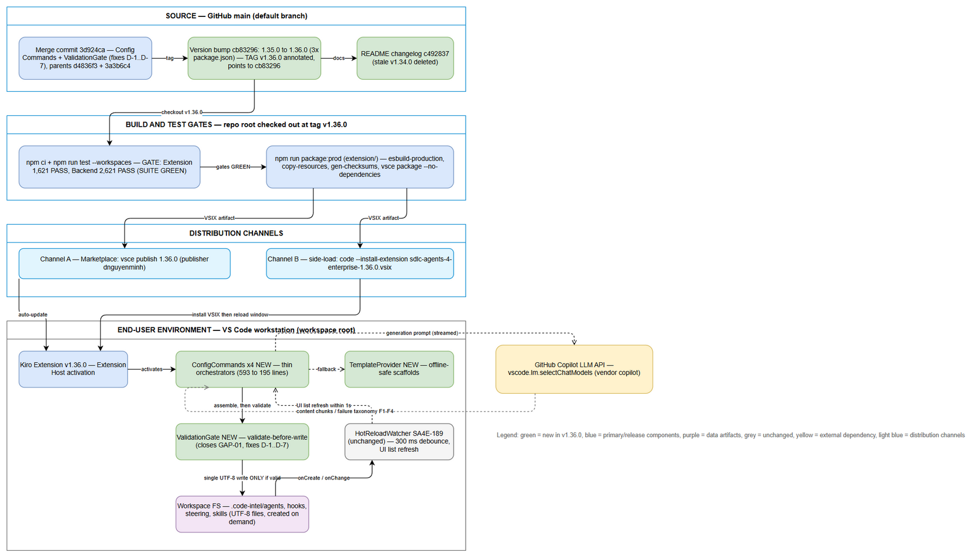
Deployment Architecture
Edit in draw.io

2.3 Configuration Changes
Property | Change Type | Description
version ×3 package.json | Modified | 1.35.0 → 1.36.0 (commit cb83296)
(runtime config) | None added | LLM via built-in vscode.lm.selectChatModels({vendor:"copilot"}); hot-reload globs unchanged from SA4E-189

2.4 Infrastructure / Code Structure Changes
Component | Change | Description
extension/src/commands/ConfigCommands.ts | Refactored | 593 → 195 lines — thin per-type orchestrators sharing one 8-step pipeline
validation-gate.ts ★ new | Added | Pure validate-before-write gate: normalize (strip fences/echoed frontmatter/empty) + per-type schema validation + canonical hook serialization — closes GAP-01/GAP-02, fixes D-1/D-2/D-4/D-5/D-7
hook-gate.ts, llm-prompts.ts, template-provider.ts, frontmatter-utils.ts, file-writer.ts, config-command-specs.ts, name-extractor.ts ★ new | Added | Single-source-of-truth templates & prompts (fixes D-6), safe path-confined writer, kebab-case name extraction (BR-04)
config-templates/ | Added | Per-command field-spec templates bundled in VSIX (offline fallback source)
Distribution artifact | Unchanged model | VSIX package via vsce package --no-dependencies; no servers/containers affected

## 3. Bug Fixes
| # | Defect | Summary | Severity | |—|——–|———|———-| | 1 | D-1 | Agent path echoed its own frontmatter block → duplicated --- header; gate now strips ONE leading frontmatter before canonical prepend (GAP-02) | Major | | 2 | D-2 | No schema validation before write — invalid JSON/markdown could be persisted; ValidationGate now blocks persistence with reason (GAP-01) | Critical | | 3 | D-3 | Editor-open failure misclassified the whole command as failed; post-write steps isolated as warn-only — success toast preserved | Major | | 4 | D-4 | Empty LLM stream treated as success → empty file; empty stream now promotes to template fallback | Major | | 5 | D-5 | Skill fallback scaffold ignored confirmed name; scaffolds are now confirmedName-aware and gate forces skill name = folder name | Minor | | 6 | D-6 | Dead-artifact drift between inline constants and config-templates/; TemplateProvider is now the single accessor | Minor | | 7 | D-7 | Hook serialization emitted inconsistent empty action fields; canonical serializer omits them deterministically | Minor | | 8 | E2E-API ×13 | 13 backend E2E-API failures (hardcoded port, missing JWT auth on /mcp/tools/list, wrong complexity_analysis assertion, harness limitations) resolved by refactor a618e0b — full green | Major |

4. Known Issues & Limitations
# | Issue | Impact | Workaround | Target Fix
1 | E2E-UI tests not configured (no Playwright config in repo) | No browser-level E2E coverage for extension webviews | Manual smoke matrix per DPG §7.2 | Backlog (Dev + QA)
2 | admin-ui.e2e.test.ts and lod-collapse.e2e.test.ts excluded from E2E suite | Admin UI & LOD collapse lack automated E2E coverage | Run manually when touching those areas | Backlog
3 | STP.md / STC.md remain template placeholders | Test documentation incomplete for audit trail | TEST-REPORT v3.0 carries execution evidence | Before UAT of next epic
4 | Dual-tab Form+Text editor not yet available (SA4E-190 To Do) | Generated files open in standard text editor instead of custom editor | None needed — flow completes normally; editor upgrade lands with SA4E-190 | SA4E-190
5 | Target-file collision policy unconfirmed (OI-01/GAP-05) | Existing target surfaces a warning; silent overwrite forbidden until policy decided | Choose a different kebab-case name | Backlog decision
6 | Hot-reload refreshes UI lists only — no hookEngine.reload() / system-prompt rebuild / graph recompile (SA4E-189 scope) | New hook rules affect UI immediately; runtime engine behavior picks up per existing reload semantics | Restart window if immediate runtime pickup is required | By design
7 | Non-English description handling unguaranteed (OI-09) | LLM output language may vary for non-English input | Use English descriptions for deterministic results | TBD with PO

5. Dependencies

5.1 Pre-requisite Releases
Release | Version | Status | Required Before
SA4E-189 Hot-Reload System | v1.33.0+ | ✅ Deployed | This release (file pickup)

5.2 External System Changes
System | Change Required | Status | Contact
GitHub Copilot LLM (vscode.lm) | Active Copilot subscription on user machines | ✅ Available | Platform owner
SA4E-190 Dual-Tab Editors | Optional future enhancement (graceful fallback active) | ⏳ To Do | Epic SA4E-181

6. Migration Notes

6.1 Data Migration
None. Workspace files under .code-intel/ are untouched by install/upgrade/uninstall; new sub-directories are created on demand.

6.2 Breaking Changes
No breaking changes in this release. Fully backward compatible.

6.3 Backward Compatibility
Fully compatible: v1.36.0 only adds commands and modules; no existing command, config format, or watcher behavior changed. Files generated by v1.36.0 remain readable by older versions (standard .code-intel conventions). Rollback to v1.35.0 requires no user data action.

7. Testing Summary
Source: TEST-REPORT.md v3.0 (Phase 6 re-test on refactor commit a618e0b, 2026-08-24) — verdict SUITE GREEN.
Test Level | Total | Passed | Failed | Blocked | Pass Rate
Extension Suite (unit + regression) | 1,621 (+64 new ValidationGate tests) | 1,621 | 0 | 0 | 100% (~78.5s)
Backend Suite (unit + integration + E2E-API) | 2,621 | 2,621 | 0 | 0 | 100% (~179.6s)
E2E-UI (Playwright) | — | — | — | — | Not configured (known issue #1)
Defect summary: production defects D-1..D-7 fixed and locked by 64 new regression tests (0 regression vs 1,557-test baseline); all 13 historical E2E-API failures resolved; 4 test-side defects found during v2.0 run also closed.
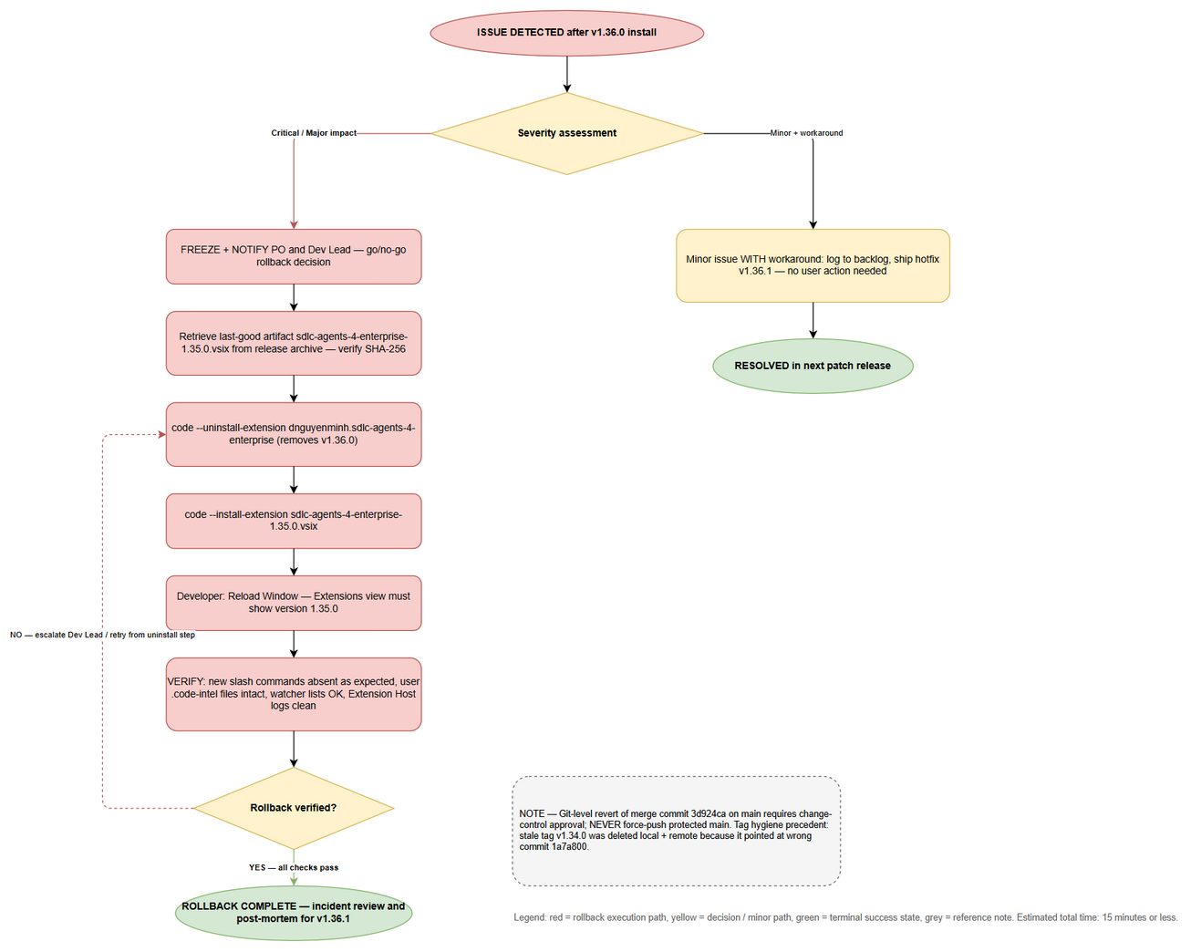
Rollback Flow
Edit in draw.io

8. Deployment Instructions
See the full Deployment Guide: DPG.md
Quick reference:
Step | Action | Estimated Time
1 | Checkout tag v1.36.0 + verify lineage (3d924ca) | 2 min
2 | Test gates (extension 1,621 · backend 2,621) | ~5 min
3 | Package VSIX (npm run package:prod) | 2 min
4 | Publish/side-load + reload window | 3 min
5 | Smoke verification (7 scenarios) | 10 min
Total |  | ~22 min

9. Rollback Plan
Full procedure with diagram: DPG Section 8 (rollback-flow).
Rollback Decision Criteria: - Commands fail to register / activation errors on PROD workstations → rollback immediately - ValidationGate false-negatives block > 5% of valid invocations → rollback immediately - Invalid file ever observed on disk post-write → rollback immediately + investigate - Minor cosmetic issue with workaround → hotfix v1.36.1, no rollback
Estimated Rollback Time: ≤ 15 minutes (VSIX downgrade to archived v1.35.0; user workspace data unaffected).

10. Contacts
Role | Name | Contact | Responsibility
Product Owner / Reporter | Duc Nguyen Minh | via Jira | Business sign-off
Dev Lead | Extension team lead | via Jira | Technical issues
QA Lead | QA team | via Jira | Testing sign-off
DevOps / Release Manager | DevOps rotation | on-call channel | Deployment execution
Scrum Master | SM agent pipeline | via Jira | Release coordination

11. Approval
Role | Name | Date | Signature
Dev Lead | Duc Nguyen Minh | 2026-08-24 | ☐ Approved
QA Lead | (QA Agent — TEST-REPORT v3.0 SUITE GREEN) | 2026-08-24 | ☐ Approved
Business Owner | Duc Nguyen Minh |  | ☐ Approved
Release Manager | (DevOps Agent) | 2026-08-24 | ☐ Approved

RLN v1.0 — DevOps Agent, 2026-08-24. Release v1.36.0 · merge 3d924ca · tag v1.36.0 → cb83296. Sources: BRD v2.0, TDD v2.0, TEST-REPORT v3.0.

