Technical Design Document (TDD)

SDLC Agents 4 Enterprise — SA4E-193: Create Config Commands — /create-new-agent, /create-new-hook, /create-new-steering, /create-new-skill

Document Information
Field | Value
Jira Ticket | SA4E-193
Title | Create Config Commands — /create-new-agent, hook, steering, skill
Parent Epic | SA4E-181 — Chat Module — OpenCode Parity + Agentic Config System
Author | SA Agent
Version | 2.0
Date | 2026-08-23
Status | Draft for Review
Input Documents | FSD v2.1 (documents/SA4E-193/FSD.md), BRD v2.0 (documents/SA4E-193/BRD.md)
Code Baseline | extension/src/commands/ConfigCommands.ts (593 lines), extension/src/commands/config-templates/*, verified via grep against actual source
Dependencies | SA4E-189 Hot-Reload Watcher (Done), SA4E-190 Dual-Tab Editors (To Do)
Related | FSD Discrepancy Register D-1..D-7, Gap Register GAP-01..GAP-06

Revision History
Version | Date | Author | Changes
1.0 | 2026-08-22 | SA Agent | Initial draft alongside first implementation pass of ConfigCommands.ts
2.0 | 2026-08-23 | SA Agent | Complete rewrite aligned to FSD v2.1: introduces ValidationGate as a new dedicated component to close GAP-01; formalizes the shared 8-step pipeline; component/data/error/security designs mapped to ERR-CMD-01..09 and BR-01..BR-20; implementation checklist for refactoring ConfigCommands.ts into testable modules; traceability matrix UC-01..UC-04 → components

1. Introduction

1.1 Purpose
This Technical Design Document defines HOW the four configuration-creation slash commands are engineered inside the Kiro VS Code extension. It translates FSD v2.1 functional requirements (FR-CMD-01..04, FR-COMMON-01..05, UC-01..UC-04) into a concrete component design, data contracts, error-handling strategy, security controls, and an implementation checklist that closes the documented gaps — most critically GAP-01 (missing schema validation gate before file write) and its companion defects D-1..D-5.

1.2 Scope
In scope: command registration, guided input flow, LLM generation with template-guided prompts, deterministic fallback, new ValidationGate component, file persistence under .code-intel/, editor integration with graceful degradation, hot-reload interplay contract.
Out of scope (inherits FSD §1.2): editing/deleting existing configs (SA4E-190/UI5), reactive system-prompt rebuild, hookEngine.reload() auto-trigger, graph recompile, bulk import/export, guaranteed non-English description handling (OI-09).

1.3 Technology Stack (verified against repository)
Layer | Technology | Evidence
Language | TypeScript ^5.4.0 | extension/package.json devDependencies
Runtime | VS Code Extension Host (engine ^1.85.0), Node.js node:fs/promises | extension/package.json engines
LLM access | vscode.lm.selectChatModels({ vendor: "copilot" }) → LanguageModelChatMessage.User streaming | ConfigCommands.ts generateWithLLM() L485–514
Bundler | esbuild ^0.21.0 (npm run esbuild) | extension/package.json scripts
Testing | Vitest ^4.1.8 (+ mocha ^10.7.3 legacy harness present) | extension/package.json devDependencies
Persistence | Plain files under <workspace>/.code-intel/ — no database | FSD §4

1.4 Design Principles & Constraints
# | Principle | Source
P1 | Shared-pipeline rule — one code path parameterized by type; per-type differences limited to prompt string, template spec, output format, target dir. Duplication prohibited | BR-15, FR-COMMON-01
P2 | Fallback-first resilience — LLM outage never blocks creation; deterministic scaffolds always available | FR-COMMON-02
P3 | Validate-before-write — nothing invalid is ever persisted; gate runs after assembly, before disk I/O | BR-07, GAP-01 closure
P4 | Path confinement — writes restricted to exactly four BR-05 path families; kebab-case name doubles as filesystem-safety guarantee | BR-03, BR-05, §6 Security
P5 | Graceful editor degradation — dual-tab editor when SA4E-190 ships; standard text editor meanwhile; flow must not break | FR-COMMON-03, BR-13, GAP-06
P6 | One-way hot-reload contract — this feature only writes complete files at watched paths; refresh timing belongs to SA4E-189 (300 ms debounce) | BR-17, PL-4
P7 | UTF-8 everywhere; single complete write call so the watcher debounce never observes partial content | BR-16, §6.6.3

2. Architecture Overview

2.1 Pipeline Architecture
All logic executes in the extension host process. The runtime pipeline is:
Command Registry → ConfigCommandHandler ×4 → LLMService → ValidationGate (NEW — closes GAP-01)
→ FileWriter → EditorService
The HotReloadWatcher (SA4E-189) independently observes .code-intel/{agents,hooks,steering}/*.md and .code-intel/skills/*/SKILL.md; this feature has no watcher API dependency (one-way file-drop integration).
graph TB
subgraph ExtensionHost["VS Code Extension Host"]
CR["Command Registrar<br/>registerConfigCommands()"]
subgraph Handlers["ConfigCommandHandler ×4"]
H1["handleCreateNewAgent"]
H2["handleCreateNewHook"]
H3["handleCreateNewSteering"]
H4["handleCreateNewSkill"]
end
LLM["LLMService<br/>generateWithLLM() + template fallback"]
VG["ValidationGate ★NEW<br/>validate(type, raw, name, desc)<br/>closes GAP-01"]
FW["FileWriter<br/>writeFileWithMkdir()"]
ES["EditorService<br/>openTextDocument + showTextDocument"]
end
User(["Developer"]) -->|"slash + rawArgs"| CUI["Chat UI<br/>SlashMenuItems + InputAreaIntegration"]
CUI --> CR --> Handlers
H1 & H2 & H3 & H4 --> LLM --> VG --> FW
FW -->|".code-intel/<br/>UTF-8 single write"| FS[("Workspace FS")]
FW -.->|"open doc ≤1s"| ES
FS -.->|"onCreate/onChange"| HR["HotReloadWatcher SA4E-189<br/>300 ms debounce"]
HR -.->|"postMessage refresh"| CUI
style VG fill:#ffe6cc,stroke:#d79b00,stroke-width:3px
style HR fill:#e1d5e7,stroke:#9673a6,stroke-dasharray:5 5
★ = new component introduced by TDD v2.0.

2.2 Request Flow — Sequence (representative: UC-01 /create-new-agent)
sequenceDiagram
actor U as Developer
participant CUI as Chat UI (Slash Menu)
participant H as Agent Handler
participant LLM as LLMService
participant G as ValidationGate ★
participant W as FileWriter
participant E as EditorService
participant HW as HotReload (SA4E-189)
U->>CUI: /create-new-agent [description?]
CUI->>H: dispatch create-new-agent + rawArgs
alt rawArgs empty
H->>U: InputBox "Describe the agent…" (BR-02)
U-->>H: description (empty/Esc ⇒ silent abort EF-01)
end
H->>H: extractNameFromDescription(desc,"agent") (BR-04)
H->>U: InputBox "Agent name (kebab-case)" pre-filled
U-->>H: confirmedName (regex ^[a-z][a-z0-9-]*$ ⇒ EF-02 retry)
H->>LLM: AGENT_LLM_PROMPT + description (streamed)
LLM-->>H: content chunks concatenated
Note over LLM: any failure/empty ⇒ generateFromTemplate() scaffold (FR-COMMON-02, AF-04)
H->>G: validate("agent", raw, confirmedName, desc)
G->>G: NORMALIZE strip fences · strip echoed frontmatter (ERR-CMD-09/GAP-02)
alt invalid
G-->>H: {ok:false, reason}
H-->>U: ❌ "Failed to create agent: reason" — nothing written (EF-03)
else valid
G-->>H: {ok:true, normalized}
H->>W: writeFileWithMkdir(.code-intel/agents/{name}.md)
W-->>HW: file event → 300 ms debounce → UI list refresh
H->>E: open document (dual-tab if SA4E-190 else text)
H-->>U: ✅ toast success (FR-COMMON-04)
end

2.3 Component Responsibilities (runtime view)
Component | Location (target) | Responsibility
Slash Command Dispatcher | webview/slash-menu/SlashMenuItems.ts, webview/input/InputAreaIntegration.ts | Menu entries /create-new-*; maps to command IDs; forwards trailing text as rawArgs
Command Registrar | commands/CommandRegistrar.ts → registerConfigCommands(context, workspaceRoot) | Registers 4 commands into vscode.commands; refuses registration when no workspace root (FSD §7.1)
ConfigCommandHandler ×4 | commands/ConfigCommands.ts (to be refactored, §7) | Shared 8-step pipeline PL-1: description → name → generate → assemble → validate → write → open → notify
LLM Service | generateWithLLM() | Copilot model selection, streamed completion, failure taxonomy F1–F4, silent template fallback
ValidationGate ★NEW | commands/validation-gate.ts (new module) | Normalize (strip fences/echoed frontmatter/empty), schema validation per type (§3.7 FSD), canonical serialization; closes GAP-01, fixes D-1/D-2/D-4/D-5
File Writer | writeFileWithMkdir() | mkdir recursive + single UTF-8 write; fresh-workspace safe (BR-06/BR-16)
Editor Opener | vscode.workspace.openTextDocument/showTextDocument | Post-write open; standard editor while SA4E-190 pending (BR-13)
HotReloadWatcher (SA4E-189) | existing watcher module | Observes BR-05 globs; 300 ms debounce; postMessage list refresh (FR-COMMON-05)
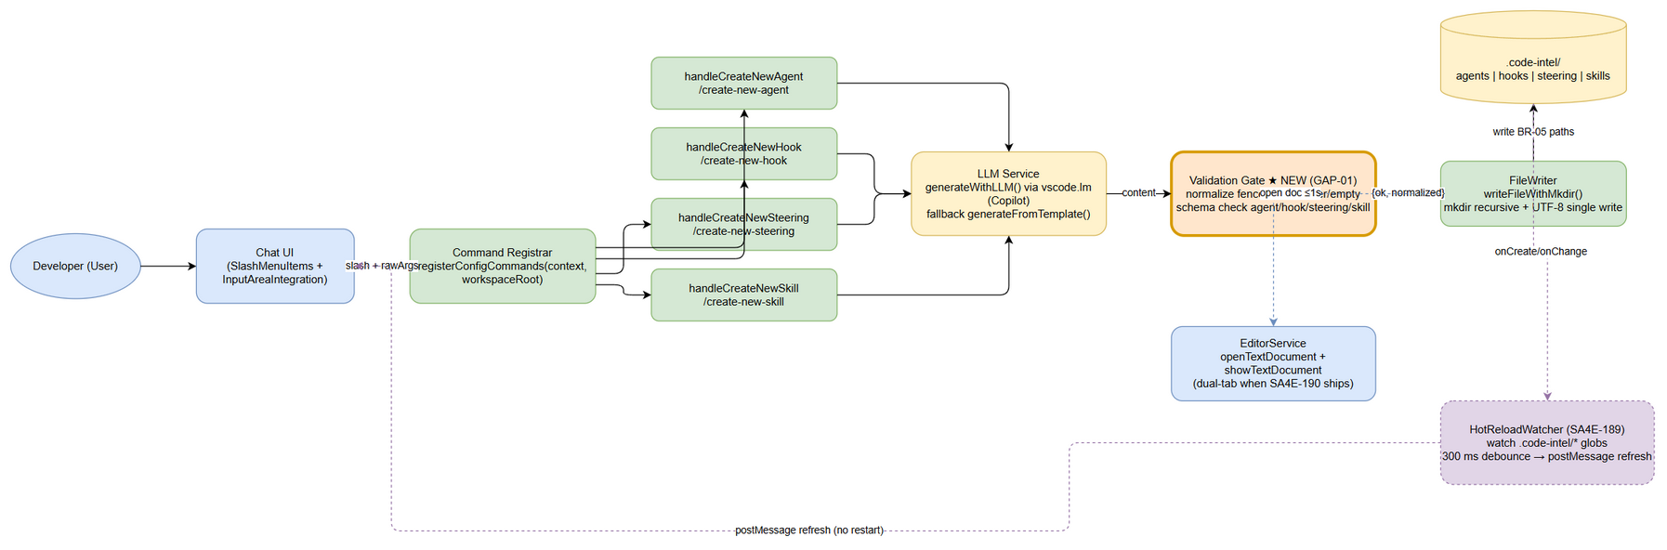 Edit in draw.io

3. Component Design

3.1 Component Catalogue
Component | Responsibility | Inputs | Outputs | Dependencies
ConfigCommandHandler | Execute shared pipeline PL-1 per config type; own dialogs (description BR-02, kebab-case name BR-03); orchestrate generate→validate→write→open→notify; map outcomes to ERR-CMD codes | rawArgs?: string; TypeConfig (prompt, placeholder, prefix, targetDir, extension/format); user input via InputBox | Written artifact at BR-05 path; toast notifications; opened document | TemplateProvider, NameExtractor, LLMServiceAdapter, ValidationGate, FileWriter, EditorService, vscode.window/workspace
TemplateProvider | Single source of truth for per-type assets: LLM system prompts (AGENT/HOOK/STEERING/SKILL_LLM_PROMPT), fallback scaffolds, field-spec templates from config-templates/*.template | ConfigType discriminator | System prompt string; fallback scaffold string (with [placeholder] markers); template spec text | fs read of config-templates/ (resolves OI-08 dead-artifact drift D-6) or inlined constants behind one facade
ValidationGate ★NEW | Mandatory pre-write gate (BR-07): NORMALIZE (strip markdown fences AF-13/AF-24, strip one echoed frontmatter block ERR-CMD-09/GAP-02, reject empty AF-04/D-4) then type-specific schema validation per FSD §3.7; force skill frontmatter name := confirmedName (D-5); canonical JSON serialization omitting empty action fields (D-7) | type, rawContent, confirmedName, description | { ok: boolean, reason?, normalized } — normalized content is the ONLY bytes eligible for disk | none (pure functions; unit-testable without vscode mock)
NameExtractor | Derive kebab-case suggestion per BR-04 algorithm (lowercase → strip non-alphanumerics → filter len>2 → first 3 → join -; fallback {prefix}-new) | description, prefix ∈ agent/hook/rule/skill | suggestedName (may still fail final regex — e.g., digit-leading token; handler validator catches) | none (pure function, ≤5 ms NFR-P2)
LLMServiceAdapter | Wrap vscode.lm.selectChatModels({vendor:"copilot"}); send two User-role messages; concatenate stream; enforce failure taxonomy F1–F4 (empty stream = failure, fixing D-4); optional parameter envelope temperature/token-cap/60 s timeout-promotion (OI-06) | systemPrompt, description, fileType, CancellationTokenSource | generated content string (never throws — returns "" only on hard failure which gate then promotes to fallback) | vscode.lm API; TemplateProvider (for fallback scaffold)

3.2 Class Design (key interfaces & relationships)
classDiagram
class ConfigType {
<<enumeration>>
AGENT
HOOK
STEERING
SKILL
}
class ValidationResult {
+ok: boolean
+reason?: string
+normalized: string
}
class ValidationGate {
<<interface IValidator>>
+validate(type, rawContent, confirmedName, description) ValidationResult
-normalize(rawContent) string
-stripCodeFences(content) string
-stripEchoedFrontmatter(content) string
-validateAgent(doc, name, desc) string~
-validateHook(jsonText) string~
-validateSteering(md) string~
-validateSkill(md, confirmedName) string~
}
class NameExtractor {
<<pure functions>>
+extractNameFromDescription(description, prefix) string
}
class TemplateProvider {
<<interface>>
+getLlmPrompt(type) string
+getFallbackScaffold(type, name, description) string
+getTemplateSpec(type) string
}
class LLMServiceAdapter {
<<interface ILlmService>>
+generate(systemPrompt, description, fileType, token) Promise~string~
-selectModel() Model?
-isFailureTaxonomy(err) boolean
}
class ConfigCommandHandler {
-type: ConfigType
-config: TypeConfig
+handle(rawArgs?) Promise~void~
-promptDescription() Promise~string|undefined~
-confirmName(suggestion) Promise~string|undefined~
-assembleAndPersist(name, desc) Promise~void~
}
class FileWriter {
+writeFileWithMkdir(path, content) Promise~void~
}
class EditorService {
+openGeneratedFile(path) Promise~void~
}
ConfigCommandHandler --> ConfigType
ConfigCommandHandler --> NameExtractor : suggests name
ConfigCommandHandler --> LLMServiceAdapter : generate()
ConfigCommandHandler --> ValidationGate : validate() BEFORE write
ConfigCommandHandler --> TemplateProvider : prompts/scaffolds
ConfigCommandHandler --> FileWriter : persist
ConfigCommandHandler --> EditorService : post-write open
LLMServiceAdapter --> TemplateProvider : fallback scaffold (FR-COMMON-02)
ValidationGate ..> ValidationResult : returns
Design notes:
- ValidationGate is pure — no vscode.* imports — enabling fast unit tests (TC-10/11/16/17/18/19/21) without host mocking.
- Handler depends on abstractions (IValidator, ILlmService) so DEV can inject mocks; concrete adapters stay thin.
- TemplateProvider resolves the D-6 single-source-of-truth drift by becoming the ONLY accessor for prompts/templates.
- Result object pattern (not exceptions) for gate outcome — mirrors FSD §6.6.2 signature → { ok, reason?, normalized }.
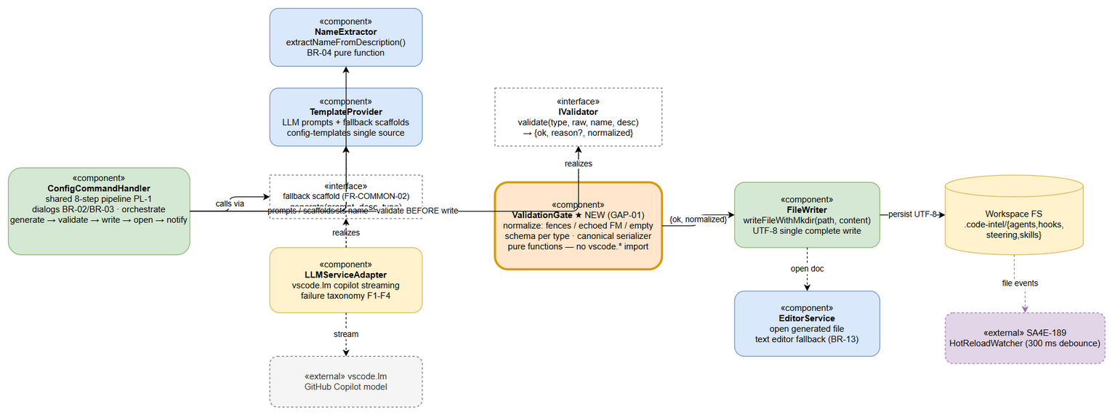 Edit in draw.io
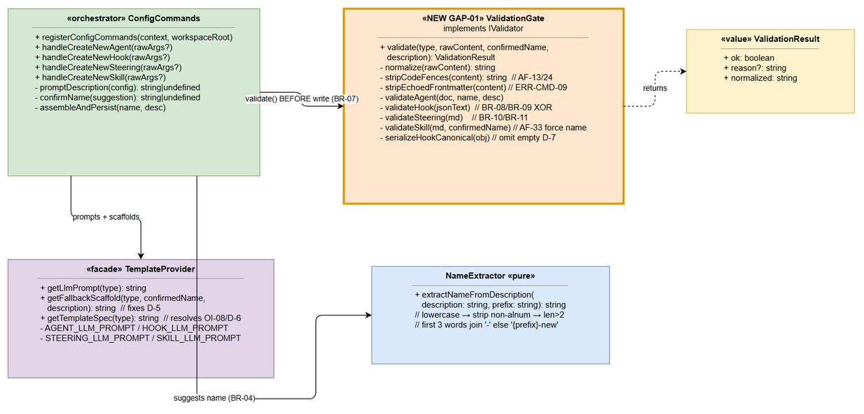 Edit in draw.io

4. Data Design
Storage is file-based under the workspace — no database. Physical layout is contractual (consumed by SA4E-189 watcher patterns).

4.1 Output Path Matrix (BR-05 — exhaustive; nothing else writable)
Command | Artifact | Absolute Path Pattern | Format | Encoding | Created On Demand
/create-new-agent | Agent config | .code-intel/agents/{name}.md | Markdown + YAML frontmatter (name, label, description, phase, tools) | UTF-8 | parent dir agents/
/create-new-hook | Hook config | .code-intel/hooks/{name}.json | JSON object (hook schema, 2-space indent, empty action fields omitted) | UTF-8 | parent dir hooks/
/create-new-steering | Steering rule | .code-intel/steering/{name}.md | Markdown ± optional YAML frontmatter (inclusion enum, description) | UTF-8 | parent dir steering/
/create-new-skill | Skill package | .code-intel/skills/{name}/SKILL.md | Folder + SKILL.md (frontmatter name/description + sections When to Use, Workflow, Tools & Resources, Examples) | UTF-8 | skill folder {name}/ recursive
Directory layout:
.code-intel/
├── agents/ {name}.md # AgentConfig — frontmatter + system prompt body
├── hooks/ {name}.json # HookConfig — strict-schema JSON
├── steering/ {name}.md # SteeringConfig — optional frontmatter + rule body
└── skills/ {name}/SKILL.md # SkillConfig — folder identity = frontmatter name

4.2 Format Specifications (authoritative per FSD §3.7)
Agent {name}.md — canonical frontmatter assembled deterministically by buildAgentFrontmatter(confirmedName, description); LLM supplies body only:
---
name: code-reviewer # REQUIRED, kebab-case, = filename base
label: Code Reviewer # derived Title Case from name (BR-19)
description: > # folded scalar, user's description
Reviews code changes…
phase: implementation # default (BR-18)
tools: ["read", "write", "shell", "@mcp"] # default (BR-18)
---
<system prompt body — ≥1 non-empty line (BR-11)>
Hook {name}.json — allowed top-level keys ⊆ {enabled, name, description, version, when, then}; conditionals per BR-08/BR-09 (patterns only for file* events; prompt iff askAgent XOR command iff runCommand); defaults enabled=true, version="1" (BR-20):
{
"enabled": true,
"name": "Pre-commit Guard",
"description": "What this hook does",
"version": "1",
"when": { "type": "fileEdited", "patterns": ["*.ts"] },
"then": { "type": "askAgent", "prompt": "Check for TODOs" }
}
Steering {name}.md — frontmatter OPTIONAL; if present inclusion ∈ {auto, manual, always} (BR-10; fileMatch variant pending OI-02/GAP-03); body ≥1 non-empty line (BR-11):
---
inclusion: auto
description: Enforce REST API conventions
---
# Rule title
Actionable rules, examples, Do's & Don'ts
Skill {name}/SKILL.md — frontmatter REQUIRED (name kebab-case FORCED = folder name by gate — AF-33/D-5; description non-empty); metadata optional pending OI-03/GAP-04:
---
name: release-versioning
description: Git release process steps
---
## When to Use …
## Workflow …
## Tools and resources …
## Examples …

4.3 State Model — Config File Lifecycle
stateDiagram-v2
[*] --> NotExists
NotExists --> Generating : command invoked, desc+name confirmed
Generating --> Validating : content received (LLM stream or fallback)
Validating --> Validating : NORMALIZE fences/frontmatter/empty (gate)
Validating --> Written : schema valid (BR-07) — atomic-ish single write
Validating --> Failed : invalid (EF-03/13/23/33) — NOTHING persisted
Generating --> Failed : LLM failed AND fallback failed (rare)
Failed --> Generating : user retries
Written --> OpenInEditor : auto-open ≤1s (FR-COMMON-03)
Written --> HotReloaded : watcher fires (300 ms debounce)
OpenInEditor --> HotReloaded : save re-triggers watcher
HotReloaded --> [*] : visible in UI lists

4.4 Data Volume & Size Envelopes (NFR-P7)
Artifact | Size envelope | Rationale
Hook JSON | ≤ 8 KB | Compact schema, bounded fields
Agent / Steering / SKILL.md | ≤ 16 KB (~4k tokens) | Prompt-contract output ceiling; gate warns/refuses beyond
No growth-management concern: artifacts are human-scale, one file per config, workspace-scoped.

5. Error Handling Design
Strategy layers: L-Input (InputBox validators, silent abort on cancel), L-Gen (LLM adapter — never throws, promotes fallback), L-Gate (ValidationGate — Result object, blocks persistence), L-IO (FileWriter try/catch → OS message), L-Post (editor/toast — warn-only, must not flip success to failure; fixes D-3).
Code | Scenario | Severity | Layer | Strategy
ERR-CMD-01 | Description empty/cancelled | Info | L-Input | Silent abort — no file, no toast, return to chat (EF-01 family)
ERR-CMD-02 | Name violates ^[a-z][a-z0-9-]*$ | Warning | L-Input | Inline InputBox validation message ("Name must be kebab-case (e.g., my-{type})"); retry loop; Esc ⇒ silent abort
ERR-CMD-03 | LLM unavailable / no copilot model / request error (taxonomy F1–F3) | Info | L-Gen | console.debug("[ConfigCommands] …") + transparent generateFromTemplate() scaffold; flow completes (FR-COMMON-02)
ERR-CMD-04 | Gate rejects content (invalid JSON, missing fields, bad enum, empty body, empty stream F4) | Error | L-Gate | Return {ok:false, reason}; nothing written; error toast Failed to create {type}: {reason}; retry guidance (closes GAP-01, fixes D-2/D-4)
ERR-CMD-05 | File write failure (EACCES/ENOSPC/path) | Error | L-IO | Toast Failed to create {type}: {os message}; no partial file beyond possibly-created directories
ERR-CMD-06 | Target collision (file/folder exists) | Warning | L-Gate/L-IO boundary | Pre-write existence check; surface warning per BR-12; silent overwrite forbidden until policy confirmed (GAP-05/OI-01)
ERR-CMD-07 | Skill folder creation mid-flow failure | Error | L-IO | Toast with message; best-effort cleanup of partial artifacts (OI-05 orphan-folder note EF-35)
ERR-CMD-08 | Editor open failure AFTER successful write | Warning | L-Post | Isolated try around open only; non-blocking notice; success toast preserved; hot-reload still fires (fixes D-3 misclassification)
ERR-CMD-09 | Duplicated frontmatter risk (agent path echoes its own --- block) | Warning | L-Gate | NORMALIZE strips ONE leading frontmatter block before canonical prepend (fixes GAP-02/D-1; TC-16/TC-17)
Cross-cutting rule (FR-COMMON-04): every terminal outcome notifies except deliberate cancellation; fixed message templates per FSD §3.8.4.

6. Security Design

6.1 Kebab-case Enforcement as Path-Traversal Control
The single strongest injection control is BR-03: {name} MUST match ^[a-z][a-z0-9-]*$. This regex admits ONLY lowercase letters, digits, hyphens — therefore it structurally forbids:
Attack vector | Blocked because
Path traversal ../, ..\\ | . and \ / not in charset
Absolute paths C:\…, /etc/… | : / \ not in charset
Null-byte / control chars | not in charset
Hidden files, dotfiles (.git overwrite) | leading char MUST be [a-z] letter
Unicode homoglyphs / diacritics smuggling | ASCII-only charset
Defense-in-depth rules enforced in addition to the dialog regex:
- Re-validate server-side-of-the-handler: the gate re-checks confirmedName against the same regex immediately before path construction (never trust earlier-passed state).
- Path allowlist composition (BR-05): target path built ONLY as path.join(workspaceRoot, ".code-intel", typeDir, fileName) from constants — never from raw user strings; after join, assert resolved path startsWith resolved .code-intel root (belt-and-braces containment check).
- Skill folder invariant: folder name = sanitized frontmatter name forced by gate (AF-33) — no second user-controlled path segment.
- NameExtractor output is advisory-only: suggestion like digit-leading tokens may fail final regex; the InputBox validator is the enforcement point, the gate re-verifies (TC-20 non-Latin case degrades safely to {prefix}-new).
- Description handling: descriptions are embedded into LLM prompt strings and file CONTENTS, never into paths; JSON serialization uses safe stringify; markdown written verbatim as user-owned workspace artifact.

6.2 Workspace Trust & Authorization
Control | Design
Workspace Trust | Commands operate within VS Code's trust model; handlers resolve workspaceRoot via registrar; no workspace folder ⇒ commands not registered / no-op (FSD §7.1)
Role model | Developer (workspace user) may create configs only under .code-intel/ of the open workspace; extension runtime confined to BR-05 paths
LLM data exposure | Natural-language descriptions transit to configured GitHub Copilot model — standard enterprise Copilot handling applies; no additional local prompt persistence
Secrets | Templates/scaffolds contain NO secrets; generated review-style bodies actively discourage hardcoded secrets
Audit trail | console.debug on LLM fallback (type, error); success provenance via toast + git history; failures logged with type + reason (session logs)

7. Implementation Checklist

7.1 Files to Create
# | File | Content | Traces to
C1 | extension/src/commands/validation-gate.ts ★ | IValidator interface + pure ValidationGate: normalize(), per-type validators (agent/hook/steering/skill), canonical hook serializer (omit empty action fields), result type {ok, reason?, normalized} | GAP-01, GAP-02, D-1/D-2/D-4/D-5/D-7, BR-07..BR-11
C2 | extension/src/commands/template-provider.ts | Facade over *_LLM_PROMPT constants + fallback scaffold builders (accepting confirmedName — fixes D-5) + optional runtime import of config-templates/*.template (resolves OI-08/D-6) | FR-COMMON-02, BR-15, D-5/D-6
C3 | extension/src/commands/name-extractor.ts | Extracted extractNameFromDescription() verbatim algorithm (FSD §6.6.1) | BR-04, NFR-P2
C4 | extension/src/commands/file-writer.ts | Extracted writeFileWithMkdir(); optional tmp+rename atomicity hardening (OI-04) | BR-06/BR-16, PL-4 property 2
C5 | extension/src/test/validation-gate.test.ts | Unit tests: TC-10, TC-11, TC-16, TC-17, TC-18, TC-19, TC-21 + fence/empty/enum/XOR edge cases | §10 FSD
C6 | extension/src/test/name-extractor.test.ts | BR-04 cases incl. hyphenated input, digit-leading, non-Latin fallback (AF-05/TC-20) | §6.6.1 FSD

7.2 Files to Modify
# | File | Change | Notes
M1 | extension/src/commands/ConfigCommands.ts | Refactor 593-line monolith: keep 4 exported handlers as thin orchestrators delegating to C1–C4 modules; insert gate call between assembly and write; move editor-open+success-toast OUT of write try-block (D-3); add pre-write collision check stub (ERR-CMD-06, policy per OI-01); pass confirmedName into fallback builders (D-5) | Preserve exact dialog strings & toast templates (FSD §3.8)
M2 | extension/src/commands/CommandRegistrar.ts | No behavioural change expected — verify registerConfigCommands(context, workspaceRoot) wiring still holds after refactor; guard remains: undefined root ⇒ skip registration | FSD §7.1
M3 | extension/src/commands/config-templates/* | Keep as spec source; either consumed by TemplateProvider or marked deprecated pending OI-08 decision | D-6
M4 | extension/package.json | Add "test" script wiring for vitest suite if not already covering src/test/** | Vitest ^4.1.8 present

7.3 Task Order (DEV-ready)
- C1 validation-gate.ts + C5 tests (pure, zero-risk first) → green.
- C3 name-extractor.ts + C6 tests → green.
- C4 file-writer.ts extraction.
- C2 template-provider.ts (with confirmedName-aware scaffolds).
- M1 ConfigCommands.ts refactor wiring all modules + gate insertion + D-3 fix + collision check.
- Manual regression: TC-01..TC-15 happy/degradation matrix; verify hot-reload pickup (TC-14) unchanged.
- Optional hardening (separate commit): atomic write tmp+rename, concurrent-invocation serialization (NFR-R1), 60 s timeout promotion (OI-06).
Definition of Done: all TC-01..TC-21 pass or have documented disposition; GAP-01/GAP-02 closed; D-1..D-5 addressed; no regression in SA4E-189 pickup timing (≤1 s, TC-14).

8. Traceability Matrix — FSD Use Cases → Components
FSD Requirement / UC | ConfigCommandHandler | TemplateProvider | ValidationGate ★ | NameExtractor | LLMServiceAdapter | FileWriter | EditorService | HotReload (SA4E-189)
UC-01 Create Agent (FR-CMD-01) | ● orchestrate | ● AGENT_LLM_PROMPT + scaffold | ● agent branch (FM dedupe, BR-11) | ● prefix "agent" | ● stream/fallback | ● agents/{name}.md | ● open | ● pickup
UC-02 Create Hook (FR-CMD-02) | ● | ● HOOK_LLM_PROMPT | ● JSON strict parse, keys ⊆ set, BR-08/09 conditionals, canonical serialize | ● prefix "hook" | ● | ● hooks/{name}.json | ● | ●
UC-03 Create Steering (FR-CMD-03) | ● | ● STEERING_LLM_PROMPT | ● inclusion enum (if FM), body ≥1 line, fence strip | ● prefix "rule" | ● | ● steering/{name}.md | ● | ●
UC-04 Create Skill (FR-CMD-04) | ● | ● SKILL_LLM_PROMPT | ● required FM, force name=folder (AF-33), body check | ● prefix "skill" | ● | ● skills/{name}/SKILL.md | ● | ●
FR-COMMON-01 shared pipeline | ● single code path | – | – | – | – | – | – | –
FR-COMMON-02 offline fallback | ● continue flow | ● scaffolds | – | – | ● taxonomy F1–F4 | ● | – | –
FR-COMMON-03 editor open | ● invoke | – | – | – | – | – | ● degrade gracefully | –
FR-COMMON-04 notify all outcomes | ● toasts | – | ● reason text | – | – | ● IO errors | ● warn-only | –
FR-COMMON-05 hot-reload ≤1 s | – | – | – | – | – | ● complete writes at BR-05 paths | – | ● debounce 300 ms
BR-07 validate-before-write (GAP-01) | ● placement step 5 | – | ● THE control | – | – | ● only-after-ok | – | –
BR-12 collision (GAP-05/OI-01) | ● check + warn | – | – | – | – | ● exists-check | – | –
ERR-CMD-01..09 | ● mapping | – | ● 04/06/09 | ● 02 input | ● 03 | ● 05/07 | ● 08 | –
Legend: ● = primary responsibility; – = not involved.

9. Diagram Index
# | Diagram | Image (PNG) | Source (editable draw.io)
1 | Architecture Overview — runtime pipeline + hot-reload interplay |  | architecture.drawio
2 | Component Diagram — components & interfaces |  | component.drawio
3 | Class Diagram — key classes & methods |  | class-diagram.drawio
(placeholder) | Sequence — full 4-command flows (future rev) | TBD | TBD
(placeholder) | State — detailed lifecycle w/ collision branch (future rev) | TBD | TBD
Inline Mermaid diagrams (§2.1 graph TB, §2.2 sequence, §3.2 class, §4.3 state) are authoritative companions of the PNG exports above.

TDD v2.0 — SA Agent, 2026-08-23. Ground truth: FSD v2.1 (TA-verified against ConfigCommands.ts L14–593) + live grep of extension/src/commands/* + extension/package.json.

