Functional Specification Document (FSD)

SDLC Agents 4 Enterprise — SA4E-205: Parallel Phase Execution in SDLC Pipeline Graph

Document Information
Field | Value
Jira Ticket | SA4E-205
Title | Parallel Phase Execution in SDLC Pipeline Graph
Author | BA Agent
Version | 1.0
Date | 2026-08-22
Status | Draft
Related BRD | documents/SA4E-205/BRD.md

Revision History
Version | Date | Author | Changes
1.0 | 2026-08-22 | BA Agent | Initiate document — auto-generated from BRD and Jira tickets

1. Introduction

1.1 Purpose
This FSD defines the functional specifications for enabling concurrent execution of independent SDLC phases using LangGraph fan-out/fan-in patterns within the SDLC Pipeline Graph. It details use cases, business rules, data specifications, integration points, processing logic, and error handling required to implement SA4E-205.

1.2 Scope
Reference BRD scope: Enable concurrent execution of independent SDLC phases using LangGraph fan-out/fan-in within SDLC Pipeline Graph, introducing state merge strategy, join nodes, and per-branch error handling.
Technical scope clarifications: - Implementation limited to pipeline graph orchestration layer; no UI changes per BRD. - State merge strategy and dependency detection algorithm to be defined by System Architect. - Integration with existing LangGraph runtime and SA4E-204 parallel tool execution benefits.

1.3 Definitions & Acronyms
Term | Definition
Fan-out/Fan-in | Pattern where work is distributed to parallel branches then joined
Join Node | LangGraph node that waits for multiple incoming branches
State Merge | Combining state objects from parallel branches into one
SDLC Pipeline Graph | LangGraph workflow representing SDLC phases

1.4 References
Document | Location
BRD | documents/SA4E-205/BRD.md
Epic Discussion | documents/CHAT-MODULE-PARITY-DISCUSSION.md (referenced in SA4E-181)

2. System Overview

2.1 System Context Diagram
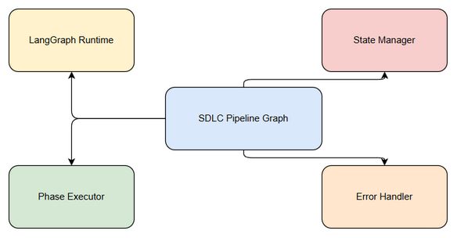
System Context
Edit in draw.io
The SDLC Pipeline Graph interacts with LangGraph Runtime for orchestration, Phase Executor for concurrent phase runs, State Manager for merge strategy, and Error Handler for per-branch isolation. External inputs are SDLC jobs with dependency graphs.
graph TB
subgraph System
Pipeline[SDLC Pipeline Graph]
Runtime[LangGraph Runtime]
Executor[Phase Executor]
StateMgr[State Manager]
ErrHandler[Error Handler]
end
Job[SDLC Job]
Job --> Pipeline
Pipeline --> Runtime
Runtime --> Executor
Executor --> StateMgr
Executor --> ErrHandler
StateMgr --> Pipeline

2.2 System Architecture
High-level architecture comprises: - Orchestration Layer: LangGraph-based pipeline graph with fan-out/fan-in nodes. - Phase Identification Service: Detects independent phases from dependency graph. - Parallel Executor: Executes eligible phases concurrently using LangGraph. - State Merge Service: Implements merge strategies for join nodes. - Error Isolation Service: Captures per-branch errors and applies join policies.
Existing codebase modules relevant to orchestration are in backend/modules/ and extension langgraph/core/. Data persistence via Knowledge Module SQLite.

3. Functional Requirements

3.1 Feature: Parallel Phase Execution for Throughput
Source: BRD Story 1 — As a SDLC Pipeline Engineer…

3.1.1 Description
Enable LangGraph fan-out/fan-in pattern to identify independent SDLC phases at runtime and execute them concurrently.

3.1.2 Use Case
Use Case ID: UC-1 Actor: SDLC Pipeline Engineer Preconditions: SDLC job with phase dependency graph is submitted; LangGraph runtime supports fan-out/fan-in. Postconditions: Independent phases are executed concurrently; pipeline state reflects merged results.
Main Flow:
Step | Actor | System | Description
1 | Engineer |  | Submits SDLC job
2 |  | System | Parses dependency graph
3 |  | System | Identifies phases with no unresolved dependencies
4 |  | System | Fan-out state to parallel branches
5 |  | System | Executes branches concurrently
6 |  | System | Join node waits for completion
7 |  | System | Continues to next phase
Alternative Flows: | ID | Condition | Steps | |—-|———–|——-| | AF-1 | No independent phases | Skip fan-out, continue sequential |
Exception Flows: | ID | Condition | Steps | |—-|———–|——-| | EF-1 | Dependency detection fails | Log error, fallback to sequential execution |

3.1.3 Business Rules
Rule ID | Rule | Source
BR-1 | Only phases with can_parallelize=true and zero unresolved dependencies may be fanned out | BRD Story 1
BR-2 | Fan-out must preserve immutable state snapshot per branch | BRD Risks

3.1.4 Data Specifications
Input Data:
Field | Type | Required | Validation | Description
phase_id | string | Y | Non-empty | Unique identifier
dependencies | array | Y | Array of strings | Phase IDs this phase depends on
can_parallelize | boolean | Y | true/false | Flag for parallel eligibility
Output Data:
Field | Type | Description
execution_time_ms | number | Duration of parallel execution
branches_executed | number | Count of parallel branches

3.1.5 UI Specifications
No UI per BRD.

3.1.6 API Contract (Functional View)
Endpoint: POST /api/v1/pipeline/execute Purpose: Trigger pipeline with parallel execution enabled.
Input Parameters: | Parameter | Type | Required | Business Rule | Description | |———–|——|———-|—————|————-| | job_id | string | Y | BR-1 | Pipeline job identifier | | enable_parallel | boolean | Y | | Toggle parallel execution |
Business Error Scenarios: | Scenario | User Message | Trigger Condition | |———-|————-|——————-| | Dependency cycle detected | Cannot execute pipeline with cyclic dependencies | Graph validation fails |

3.2 Feature: State Merge Strategy for Fan-In Join Nodes
Source: BRD Story 2

3.2.1 Description
Implement deterministic state merge strategy for joining parallel branch outputs without data loss.

3.2.2 Use Case
Use Case ID: UC-2 Actor: System Architect Preconditions: Parallel branches have completed execution. Postconditions: Unified state contains all branch outputs.
Main Flow: …
Main Flow:
Step | Actor | System | Description
1 |  | System | Join node receives branch results
2 |  | System | Apply merge_strategy to combine states
3 |  | System | Resolve conflicts per strategy
4 |  | System | Produce merged state
Alternative Flows: | ID | Condition | Steps | |—-|———–|——-| | AF-1 | Conflict keys present | Apply conflict resolution rule |
Exception Flows: | ID | Condition | Steps | |—-|———–|——-| | EF-1 | Merge conflict unresolvable | Log warning, apply default last-write-wins |

3.2.3 Business Rules
Rule ID | Rule | Source
BR-3 | Merge operation must be idempotent | BRD Story 2
BR-4 | Conflict resolution follows configured merge_strategy | BRD Story 2

3.2.4 Data Specifications
Input Data:
Field | Type | Required | Validation | Description
merge_strategy | string | Y | enum | e.g., merge-deep, last-write-wins
conflict_keys | array | N |  | Keys with conflicts
Output Data:
Field | Type | Description
merged_state | object | Unified state after merge
conflicts_resolved | number | Count of conflicts handled

3.3 Feature: Per-Branch Error Handling
Source: BRD Story 3

3.3.1 Description
Implement per-branch error capture and join node policy for partial failures.

3.3.2 Use Case
Use Case ID: UC-3 Actor: QA Engineer Preconditions: Parallel execution in progress. Postconditions: Errors isolated per branch; pipeline policy applied.
Main Flow:
Step | Actor | System | Description
1 |  | System | Branch execution fails
2 |  | System | Capture error_code, error_message, branch_id
3 |  | System | Continue other branches
4 |  | System | Join node evaluates policy
Exception Flows: | ID | Condition | Steps | |—-|———–|——-| | EF-1 | Critical branch fails | Pipeline fails per policy |

3.3.3 Business Rules
Rule ID | Rule | Source
BR-5 | Errors in one branch must not block others unless policy requires | BRD Story 3
BR-6 | Error details logged with traceability | BRD Story 3

3.3.4 Data Specifications
Input Data:
Field | Type | Required | Validation | Description
branch_id | string | Y | Non-empty | Identifier
error_code | string | N |  | Error code
error_message | string | N |  | Human readable

4. Data Model

4.1 Entity Relationship Diagram
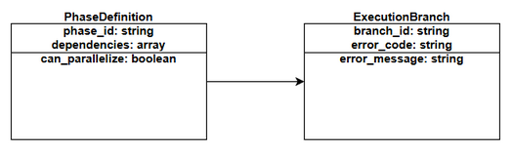
ER Diagram
Edit in draw.io

4.2 Logical Entities

Entity: PhaseDefinition
Attribute | Type | Required | Business Rule | Description
phase_id | string | Y | BR-1 | Unique identifier
dependencies | array | Y |  | Dependent phase IDs
can_parallelize | boolean | Y |  | Parallel eligibility
Relationships: | From Entity | To Entity | Cardinality | Description | |————-|———–|————-|————-| | PhaseDefinition | ExecutionBranch | 1:N | One phase may spawn multiple branches |

Entity: ExecutionBranch
Attribute | Type | Required | Business Rule | Description
branch_id | string | Y |  | Branch identifier
error_code | string | N | BR-6 | Error if failed
error_message | string | N |  | Error details

5. Integration Specifications

5.1 External System: LangGraph Runtime
Attribute | Value
Purpose | Orchestrate fan-out/fan-in execution
Direction | Bidirectional
Data Format | JSON
Frequency | Real-time
Data Exchange: | Our Data | External Data | Direction | Business Rule | |———-|————–|———–|—————| | phase state | execution result | Send/Receive | BR-1, BR-3 |

6. Processing Logic

6.1 Parallel Phase Execution Process
Trigger: SDLC job submission with enable_parallel=true Schedule: On-demand Input: Phase dependency graph Output: Merged state
Processing Steps:
Step | Description | Error Handling
1 | Identify independent phases | Log and fallback to sequential
2 | Fan-out state | Validate snapshot immutability
3 | Execute concurrently | Per-branch error capture
4 | Join & merge | Apply merge strategy, log conflicts
Activity Diagram:
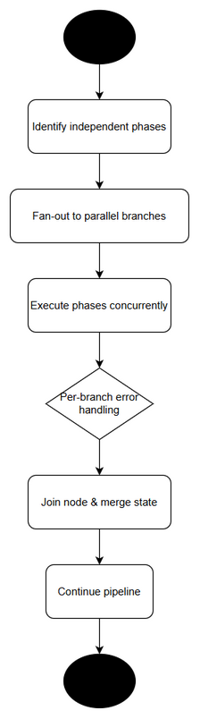
Activity - Parallel Execution
Edit in draw.io
sequenceDiagram
participant Client
participant Pipeline
participant Runtime
participant Executor
participant StateMgr
Client->>Pipeline: Execute job
Pipeline->>Runtime: Fan-out branches
Runtime->>Executor: Execute phase A
Runtime->>Executor: Execute phase B
Executor-->>Runtime: Results / Errors
Runtime->>StateMgr: Merge states
StateMgr-->>Pipeline: Merged state
Pipeline-->>Client: Completion

7. Security Requirements
No specific security requirements identified from tickets. To be confirmed with technical team.

8. Non-Functional Requirements
Category | Business Requirement | Acceptance Criteria
Performance | Throughput improvement target not specified | To be defined
Availability | No specific targets | To be confirmed
Scalability | Concurrency limits not defined | To be defined

9. Error Handling (User-Facing)

9.1 Error Scenarios
Scenario | Severity | User Message | Expected Behavior
Branch timeout | Warning | Phase execution timed out | Log error, continue if policy allows
Merge conflict | Warning | State merge conflict detected | Apply resolution strategy, log

10. Testing Considerations

10.1 Test Scenarios
ID | Scenario | Input | Expected Output | Priority
TC-1 | Independent phases execute concurrently | Graph with 2 independent phases | Both execute in parallel | High
TC-2 | State merge combines outputs | Two branches with overlapping keys | Merged state without loss | High
TC-3 | Branch failure isolation | One branch fails | Other branches complete, error logged | High

11. Appendix

Diagrams
Diagram | File
System Context | system-context.png
Activity - Parallel Execution | activity-parallel-execution.png
ER Diagram | er-diagram.png
Business Flow | business-flow.png
Use Case | use-case.png

Change Log from BRD
FSD expands BRD stories into use cases, business rules, data specifications, and processing logic. No deviations from BRD scope.
stateDiagram-v2
[*] --> Identified
Identified --> FanOut : independent phases found
FanOut --> Executing : branches created
Executing --> Error : branch fails
Executing --> Completed : success
Error --> Join : per-branch handling
Completed --> Join
Join --> Merged : state merged
Merged --> [*]

