Business Requirements Document (BRD)

SA4E — SA4E-101: [Indexing] Persistent multi-tenant index status + auto-reconnect on extension reload

Document Information
Field | Value
Jira Ticket | SA4E-101
Title | Persistent multi-tenant index status + auto-reconnect on extension reload
Author | BA Agent
Version | 1.0
Date | 2026-08-11
Status | Draft

Author Tracking
Role | Name - Position | Responsibility
Author | BA Agent – Business Analyst | Create document
Peer Reviewer | TA Agent – Technical Architect | Review document

Revision History
Version | Date | Author | Changes
1.0 | 2026-08-11 | BA Agent | Initiate document — auto-generated from Jira ticket SA4E-101 and linked tickets

Sign-Off
Name | Signature and date
 | ☐ I agree and confirm all criteria on this BRD as expected requirements
 | ☐ I agree and confirm all criteria on this BRD as expected requirements

1. Introduction

1.1 Scope
SA4E-99 implemented an ephemeral (in-memory) indexing progress status bar in the VS Code extension. When the extension reloads, the backend restarts, or the user reconnects, all progress state is lost — the user has no visibility into an ongoing index operation.
This change request introduces persistent multi-tenant index status stored in PostgreSQL and auto-reconnect logic in the extension’s activate() lifecycle hook. The goal is to ensure that indexing progress survives backend restarts and extension reloads, and that each tenant (userId + projectId) sees only their own progress.

1.2 Out of Scope
- Modifying the indexing algorithm itself (scan, parse, batch logic)
- Changing the AbortController-based cancellation mechanism
- SSE (Server-Sent Events) streaming — polling remains the transport
- Dashboard or admin-level view of all tenants’ indexing status
- Notifications/push to extension (extension polls, not subscribes)

1.3 Preliminary Requirement
- SA4E-99 (Indexing Progress Status Bar) must be complete — provides the in-memory IndexOperationManager and pollIndexProgress() foundation
- SA4E-78 (Async Indexing Engine) must be complete — provides IndexingEngine, AbortController, and batch progress events
- PostgreSQL database available with migration tooling in place
- Authentication/session management operational (requireAuth, JWT, X-Project-Id header)

2. Business Requirements

2.1 High Level Process Map
The system persists index operation state per tenant in PostgreSQL. On extension activate, the extension polls the backend for any active operations. If an operation is running or was interrupted, the status bar reappears with the correct state. Completed operations are automatically cleaned up after 1 hour.
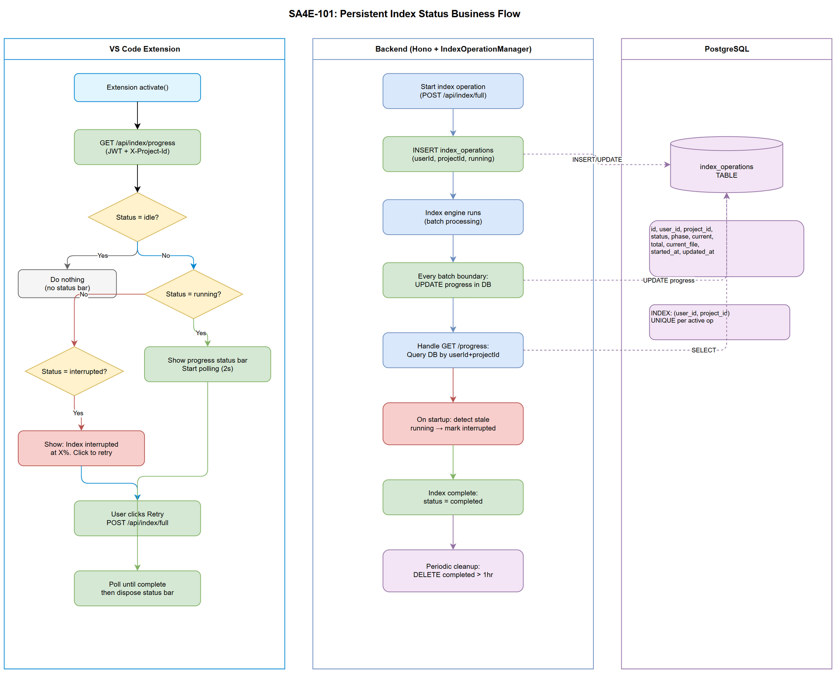
Business Flow

2.2 List of User Stories / Use Cases
# | Story / Use Case / Epic | Priority | Source Ticket
1 | As a developer, I want my indexing progress to survive extension reload so that I can see current progress without losing context | MUST HAVE | SA4E-101
2 | As a developer, I want my indexing progress to survive backend restart so that I know if my index was interrupted and can retry | MUST HAVE | SA4E-101
3 | As a developer working in a multi-tenant environment, I want to see only my own project’s indexing progress so that I’m not confused by other users’ operations | MUST HAVE | SA4E-101
4 | As a system operator, I want completed index statuses to be automatically cleaned up after 1 hour so that the database stays lean | SHOULD HAVE | SA4E-101
5 | As a developer, I want to be prompted to retry when my index was interrupted by a backend restart so that I can resume quickly | SHOULD HAVE | SA4E-101

2.3 Details of User Stories

Business Flow
Step 1: User triggers a full index operation (existing SA4E-78 flow)
Step 2: Backend creates an index_operations record in PostgreSQL with status running, tied to the authenticated userId and projectId
Step 3: Backend updates the DB record at batch boundaries (phase, current, total, current_file, updated_at)
Step 4: Extension polls GET /api/index/progress — backend queries the DB by auth session userId + X-Project-Id header and returns current state
Step 5: If backend restarts mid-index, the DB record remains with status running but updated_at is stale — backend detects this on startup and marks it as interrupted
Step 6: Extension on activate() calls GET /api/index/progress — if status is not idle, the status bar auto-appears with correct progress or the “interrupted, retry?” prompt
Step 7: Completed operations (status = completed, cancelled, failed) older than 1 hour are deleted by a periodic cleanup job
Note: The in-memory IndexOperationManager Map continues to exist for fast hot-path access. The DB serves as the persistence layer that survives restarts.

STORY 1: Index Progress Survives Extension Reload
As a developer, I want my indexing progress to survive extension reload so that I can see current progress without losing context.
Requirement Details:
- Extension activate() must call GET /api/index/progress immediately on startup
- If the response indicates an active operation (status ≠ idle), the extension auto-shows the progress status bar
- The status bar displays the same information as during a normal indexing session: phase, percentage, current file, elapsed time
- Polling resumes at 2-second intervals until the operation completes
Acceptance Criteria:
- User reloads extension (Ctrl+Shift+P → Reload Window) while backend is actively indexing → status bar re-appears within 4 seconds with correct progress percentage
- Status bar shows phase, current/total files, percentage — matching the actual backend state
- No duplicate status bars created on repeated reloads

STORY 2: Index Progress Survives Backend Restart
As a developer, I want my indexing progress to survive backend restart so that I know if my index was interrupted and can retry.
Requirement Details:
- Backend persists index operation state to PostgreSQL table index_operations on every batch boundary update
- On backend startup, check for any index_operations records with status running where updated_at is older than a staleness threshold (e.g., 60 seconds) — mark them as interrupted
- When the extension polls and receives status interrupted, show a status bar message: “Index interrupted. Retry?”
- Clicking the status bar item triggers a new full index operation
Data Fields:
Field | Type | Required | Description | Example
id | UUID | Yes | Primary key | idx-a1b2c3d4
user_id | VARCHAR(255) | Yes | Authenticated user identifier | user@company.com
project_id | VARCHAR(255) | Yes | Tenant project identifier | my-project
status | VARCHAR(20) | Yes | Operation status enum | running
phase | VARCHAR(20) | Yes | Current indexing phase | indexing
current | INTEGER | Yes | Files processed so far | 150
total | INTEGER | Yes | Total files to process | 500
current_file | TEXT | No | Currently processing file path | src/index.ts
started_at | TIMESTAMP | Yes | When operation started | 2026-08-11T10:00:00Z
updated_at | TIMESTAMP | Yes | Last progress update | 2026-08-11T10:01:30Z
Acceptance Criteria:
- Backend restarts mid-index → on next extension poll, response shows status interrupted with last known progress
- Extension displays “Index interrupted at 45%. Retry?” in the status bar
- User clicks retry → new full index operation starts from scratch
- DB record for the interrupted operation is updated to interrupted, not deleted

STORY 3: Multi-Tenant Isolation
As a developer working in a multi-tenant environment, I want to see only my own project’s indexing progress so that I’m not confused by other users’ operations.
Requirement Details:
- GET /api/index/progress queries the index_operations table filtered by the authenticated session’s userId AND the X-Project-Id header
- Each user+project combination can have at most one active operation
- User A cannot see or affect User B’s indexing progress, even on the same project
- The existing requireAuth + requireProjectId middleware handles extraction of userId and projectId
Acceptance Criteria:
- User A starts indexing project “alpha” → User B polling project “alpha” sees idle (different userId)
- User A indexing project “alpha” → User A polling project “beta” sees idle (different projectId)
- User A indexing project “alpha” → User A polling project “alpha” sees actual progress
- Two users indexing different projects simultaneously → each sees only their own progress

STORY 4: Automatic Cleanup of Completed Operations
As a system operator, I want completed index statuses to be automatically cleaned up after 1 hour so that the database stays lean.
Requirement Details:
- A periodic cleanup mechanism removes index_operations records where status is completed, cancelled, or failed AND updated_at is older than 1 hour
- Cleanup runs on a timer (every 10 minutes) or can be triggered lazily on read
- Records with status running or interrupted are never automatically deleted
Acceptance Criteria:
- Completed index operation record exists → after 1 hour, it is no longer returned by the progress endpoint and is deleted from the database
- Running operations are never cleaned up regardless of age
- Interrupted operations are never cleaned up automatically (require user action)

STORY 5: Interrupted Index Retry UX
As a developer, I want to be prompted to retry when my index was interrupted by a backend restart so that I can resume quickly.
Requirement Details:
- When extension polls and receives interrupted status, display a clickable status bar item
- The status bar shows: “$(warning) Index interrupted at {percentage}%. Click to retry”
- On click, fire POST /api/index/full to start a new full index operation
- The interrupted record is updated to superseded or deleted before starting the new operation
Acceptance Criteria:
- Status bar shows warning icon + “Index interrupted at X%” message
- Clicking the status bar successfully triggers a new index operation
- The new operation replaces the interrupted record in the database
- If the backend is unreachable, the extension shows “Backend unavailable” and retries on next poll cycle

3. Dependencies
Dependency | Type | Related Ticket | Description
SA4E-99 | System | SA4E-99 | Provides in-memory IndexOperationManager + pollIndexProgress() in extension
SA4E-78 | System | SA4E-78 | Provides IndexingEngine with async batch indexing, AbortController, progress events
PostgreSQL | Infrastructure | N/A | Database for persisting index_operations table
Auth/Session | System | N/A | JWT auth + X-Project-Id header extraction for multi-tenant isolation

4. Stakeholders
Role | Name / Team | Responsibility | Source
Developer | Engineering Team | Primary users of the indexing feature | Users
DevOps | Platform Team | PostgreSQL infrastructure, migrations | Operations
BA | BA Agent | Requirements definition | Author
Architect | SA Agent | Technical design | Reviewer

5. Risks and Assumptions

5.1 Risks
Risk | Impact | Likelihood | Mitigation
DB writes at batch boundaries add latency to indexing | Medium | Low | Use async fire-and-forget writes; batch update every 50 files (not every file)
Stale detection false positive — backend briefly paused (GC) triggers incorrect “interrupted” | Medium | Low | Use generous staleness threshold (60s); only mark interrupted on server startup, not continuously
Extension polls too frequently, adding DB load | Low | Low | 2-second polling interval is acceptable; progress endpoint is a simple PK lookup
Migration failure on existing databases | High | Low | Test migration on staging; provide rollback script

5.2 Assumptions
- PostgreSQL is the primary database for the backend (confirmed by tech stack)
- The existing requireAuth middleware correctly extracts userId from JWT claims
- The existing X-Project-Id header is always sent by the extension (confirmed by buildHeaders())
- Backend startup hook exists or can be added to detect and mark interrupted operations
- The index_operations table is low-volume (at most 1 active record per user per project)

6. Non-Functional Requirements
Category | Requirement | Details
Performance | Progress endpoint responds within 50ms | Simple indexed query by (user_id, project_id)
Performance | DB write at batch boundary adds <10ms overhead | Async upsert, non-blocking to indexing
Reliability | Status survives backend restart | PostgreSQL persistence guarantees durability
Scalability | Support 100+ concurrent tenants | Each tenant has at most 1 active row; table stays small
Security | Multi-tenant isolation enforced at query level | WHERE user_id = :userId AND project_id = :projectId on every query
Availability | Extension tolerates backend unavailability | Graceful degradation — status bar shows “Backend unavailable”, retries on next poll

7. Related Tickets
Ticket Key | Summary | Status | Type | Relationship
SA4E-101 | Persistent multi-tenant index status + auto-reconnect on extension reload | To Do | Story | Main ticket
SA4E-99 | Indexing progress status bar (ephemeral/in-memory) | Done | Story | Prerequisite — provides foundation
SA4E-78 | Async Indexing Engine with cancellation | Done | Story | Prerequisite — provides IndexingEngine

8. Appendix

Glossary
Term | Definition
Index Operation | A single full-index run for a specific user+project, tracked from start to completion/cancellation/failure
Tenant | A unique combination of userId + projectId representing one user’s workspace
Interrupted | An index operation that was running when the backend restarted — status is stale and operation did not complete
Staleness Threshold | Time after which a running operation with no updates is considered interrupted (default: 60 seconds)
Cleanup | Automatic removal of terminal-state operations older than 1 hour

Reference Documents
Document | Link / Location
SA4E-78 TDD | documents/SA4E-78/TDD.md
IndexOperationManager source | backend/src/engine/indexer/index-operation-manager.ts
IndexerHttpClient source | extension/src/services/IndexerHttpClient.ts

Diagram Index
# | Diagram | Image | Source (editable)
1 | Use Case Diagram | use-case.png | use-case.drawio
2 | Business Flow Diagram | business-flow.png | business-flow.drawio

