Technical Design Document (TDD)

Code Intelligence KB — SA4E-121: Instincts and Confidence Scoring System

Document Information
Field | Value
Jira Ticket | SA4E-121
Title | [KB] Instincts and Confidence Scoring System
Epic | SA4E-119 (ECC Feature Parity)
Author | SA Agent
Version | 1.0
Date | 2025-07-20
Status | Draft
Related BRD | documents/SA4E-121/BRD.md
Related FSD | documents/SA4E-121/FSD.md
Architecture Pattern | ai-agent

Revision History
Version | Date | Author | Changes
1.0 | 2025-07-20 | SA Agent | Initial TDD from FSD v1.0

1. Architecture Overview

1.1 System Architecture
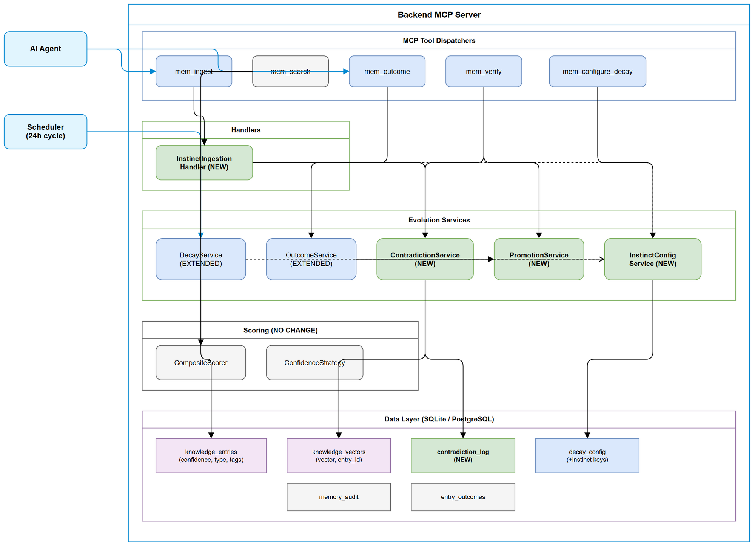
Architecture Overview
The Instincts and Confidence Scoring System extends the existing KB Memory module within the backend MCP server. It introduces two new services (ContradictionService, PromotionService) and extends two existing services (DecayService, OutcomeService) while preserving backward compatibility.

1.2 Design Principles
Principle | Application
Open/Closed | Extend existing services via configuration, not modification of core logic
Single Responsibility | New services (Contradiction, Promotion) handle distinct lifecycle phases
Strategy Pattern | Existing CompositeScorer strategies unchanged — confidence already flows through
Dependency Inversion | All services depend on DatabaseAdapter interface, not concrete implementations
Graceful Degradation | Embedding unavailability does not block ingestion — contradiction detection skipped

1.3 Key Design Decisions
# | Decision | Rationale
1 | No schema migration for knowledge_entries | Existing confidence, type, tags columns sufficient
2 | New contradiction_log table | Separate concern; avoid polluting existing tables
3 | Config stored in existing decay_config key-value table | Reuse infrastructure; per-project isolation via project_id
4 | Instinct detection via type="INSTINCT" OR tags LIKE '%instinct%' | Support both explicit type and flag-based identification
5 | Contradiction detection is async (post-ingest) | Do not block ingestion on potentially slow vector comparisons
6 | Promotion is irreversible | Once at 1.0, entry follows standard knowledge lifecycle

2. Component Design
Component Diagram
Component Diagram

2.1 Component Inventory
Component | Type | Status | Location
InstinctIngestionHandler | New handler | Create | memory/handlers/InstinctIngestionHandler.ts
ContradictionService | New service | Create | memory/evolution/ContradictionService.ts
PromotionService | New service | Create | memory/evolution/PromotionService.ts
InstinctConfigService | New service | Create | memory/evolution/InstinctConfigService.ts
DecayService | Existing | Extend | memory/evolution/DecayService.ts
OutcomeService | Existing | Extend | memory/evolution/OutcomeService.ts
CompositeScorer | Existing | No change | memory/evolution/CompositeScorer.ts
ConfidenceStrategy | Existing | No change | memory/evolution/strategies/ConfidenceStrategy.ts
mem_ingest dispatcher | Existing | Extend | memory/dispatchers/ingest.ts
mem_outcome dispatcher | Existing | Extend | memory/dispatchers/outcome.ts
mem_verify dispatcher | Existing | Extend | memory/dispatchers/verify.ts
mem_search dispatcher | Existing | Minor extend | memory/dispatchers/search.ts

2.2 Dependency Graph
mem_ingest dispatcher
-> InstinctIngestionHandler
-> InstinctConfigService (read config)
-> ContradictionService (detect contradictions)
mem_outcome dispatcher
-> OutcomeService (extended)
-> InstinctConfigService (read ceiling/floor)
-> PromotionService (check promotion)
mem_verify dispatcher
-> ContradictionService (resolve)
-> PromotionService (manual promote)
Scheduler
-> DecayService (extended)
-> InstinctConfigService (read instinct decay params)
mem_search dispatcher
-> CompositeScorer (unchanged)
-> ConfidenceStrategy (unchanged — reads entry.confidence)
-> ContradictionService.getWarnings(entryIds)

3. API Design

3.1 Extended mem_ingest Input Schema (Zod)
const InstinctIngestSchema = z.object({
content: z.string().min(1),
type: z.string().optional(),
instinct: z.boolean().optional(),
confidence: z.number().min(0).max(1).optional(),
source: z.string().optional(),
tags: z.string().optional(),
scope: z.enum(['USER', 'PROJECT', 'GLOBAL']).optional(),
});
Instinct detection logic:
const isInstinct = args.type === 'INSTINCT' || args.instinct === true;
Confidence assignment:
if (isInstinct) {
const config = await configService.getInstinctConfig();
let confidence = args.confidence ?? config.instinct_initial_confidence;
confidence = Math.max(config.instinct_confidence_floor,
Math.min(config.instinct_confidence_ceiling, confidence));
}

3.2 Extended mem_outcome Response
interface OutcomeResult {
recorded: boolean;
new_confidence: number;
new_outcome_factor: number;
total_outcomes: number;
promoted: boolean; // NEW
}

3.3 Extended mem_verify Actions
type VerifyAction = 'resolve' | 'promote';
interface ResolveInput {
action: 'resolve';
contradiction_id?: number;
entry_id_a?: number;
entry_id_b?: number;
resolution: 'resolve_keep_new' | 'resolve_keep_old' | 'resolve_merge' | 'resolve_both';
}
interface PromoteInput {
action: 'promote';
entry_id: number;
}

3.4 Extended mem_configure_decay Schema
const InstinctConfigSchema = z.object({
action: z.enum(['get_config', 'set_config']),
instinct_initial_confidence: z.number().min(0.1).max(0.9).optional(),
instinct_confidence_floor: z.number().min(0.1).max(0.5).optional(),
instinct_confidence_ceiling: z.number().min(0.5).max(1.0).optional(),
instinct_decay_rate: z.number().min(0.01).max(0.5).optional(),
instinct_boost_factor: z.number().min(1.01).max(2.0).optional(),
instinct_fail_factor: z.number().min(0.5).max(0.99).optional(),
instinct_access_threshold_days: z.number().int().min(1).max(365).optional(),
instinct_promotion_threshold: z.number().int().min(1).max(100).optional(),
contradiction_similarity_threshold: z.number().min(0.5).max(0.99).optional(),
});

3.5 Extended mem_search Response (per entry)
interface SearchResultEntry {
// ... existing fields
confidence: number;
is_instinct: boolean;
has_contradiction: boolean;
contradiction_warning?: string;
}

4. Class/Module Design
Class Diagram
Class Diagram

4.1 InstinctConfigService
/**
* InstinctConfigService — reads/writes instinct-specific configuration
* from decay_config table. Provides typed access to all 9 instinct parameters.
*/
export interface InstinctConfig {
instinct_initial_confidence: number; // default 0.5
instinct_confidence_floor: number; // default 0.3
instinct_confidence_ceiling: number; // default 0.9
instinct_decay_rate: number; // default 0.08
instinct_boost_factor: number; // default 1.1
instinct_fail_factor: number; // default 0.9
instinct_access_threshold_days: number; // default 14
instinct_promotion_threshold: number; // default 3
contradiction_similarity_threshold: number; // default 0.85
}
export class InstinctConfigService {
constructor(private readonly adapter: DatabaseAdapter) {}
async getInstinctConfig(): Promise<InstinctConfig>;
async setInstinctConfig(updates: Partial<InstinctConfig>): Promise<InstinctConfig>;
async seedDefaults(): Promise<void>;
}

4.2 ContradictionService
/**
* ContradictionService — detects semantic contradictions between KB entries
* using cosine similarity on embedding vectors. Logs contradictions and
* provides resolution workflows.
*/
export interface ContradictionReport {
contradictions: ContradictionEntry[];
supplements: number;
superseded: number;
}
export interface ContradictionEntry {
id: number;
entry_id_a: number;
entry_id_b: number;
similarity: number;
classification: 'CONTRADICTION' | 'SUPPLEMENT' | 'SUPERSEDE';
status: 'unresolved' | 'resolved' | 'stale';
}
export interface ResolutionResult {
resolved: boolean;
strategy: string;
affected_entries: number[];
}
export class ContradictionService {
constructor(
private readonly adapter: DatabaseAdapter,
private readonly configService: InstinctConfigService,
private readonly logger: Logger,
) {}
async detectContradictions(entryId: number, projectId?: string): Promise<ContradictionReport>;
async resolveContradiction(contradictionId: number, resolution: string, resolvedBy?: string): Promise<ResolutionResult>;
async getWarnings(entryIds: number[]): Promise<Map<number, string>>;
private async classifyRelationship(entryA: { id: number; content: string }, entryB: { id: number; content: string }, similarity: number): Promise<'CONTRADICTION' | 'SUPPLEMENT' | 'SUPERSEDE'>;
private cosineSimilarity(vecA: Float32Array, vecB: Float32Array): number;
}

4.3 PromotionService
/**
* PromotionService — handles instinct-to-knowledge promotion.
* Checks criteria (confidence >= ceiling AND outcomes >= threshold)
* and performs irreversible promotion.
*/
export interface PromotionResult {
promoted: boolean;
entry_id: number;
new_confidence?: number;
reason?: string;
}
export class PromotionService {
constructor(
private readonly adapter: DatabaseAdapter,
private readonly configService: InstinctConfigService,
private readonly logger: Logger,
) {}
async checkAndPromote(entryId: number): Promise<PromotionResult>;
async manualPromote(entryId: number): Promise<PromotionResult>;
private async meetsCriteria(entryId: number): Promise<boolean>;
private async executePromotion(entryId: number): Promise<void>;
}

4.4 DecayService Extension
// Add instinct-specific decay to existing DecayService
private async executeInstinctDecay(): Promise<number> {
const config = await this.instinctConfig.getInstinctConfig();
const threshold = new Date(
Date.now() - config.instinct_access_threshold_days * 86_400_000
).toISOString();
const entries = await this.adapter.allAsync<{ id: number; confidence: number }>(`
SELECT id, confidence FROM knowledge_entries
WHERE (type = 'INSTINCT' OR tags LIKE '%instinct%')
AND pinned = 0 AND archived = 0
AND confidence > ?
AND (last_accessed_at < ? OR last_accessed_at IS NULL)
ORDER BY id
`, [config.instinct_confidence_floor, threshold]);
let decayed = 0;
for (const entry of entries) {
const newConf = Math.max(
entry.confidence * (1 - config.instinct_decay_rate),
config.instinct_confidence_floor,
);
if (newConf < entry.confidence) {
await this.adapter.runAsync(
`UPDATE knowledge_entries SET confidence = ?, updated_at = ${this.dialect.now()} WHERE id = ?`,
[newConf, entry.id],
);
await this.auditConfidenceChange(entry.id, entry.confidence, newConf, 'decay');
decayed++;
}
}
return decayed;
}

4.5 OutcomeService Extension
// Extended applyInstinctConfidenceChange method
private async applyInstinctConfidenceChange(
entryId: number,
currentConfidence: number,
outcome: string,
): Promise<void> {
const config = await this.instinctConfig.getInstinctConfig();
let newConfidence: number;
switch (outcome) {
case 'success':
newConfidence = Math.min(
currentConfidence * config.instinct_boost_factor,
config.instinct_confidence_ceiling,
);
break;
case 'partial':
newConfidence = Math.min(currentConfidence * 1.05, config.instinct_confidence_ceiling);
break;
case 'fail':
newConfidence = Math.max(
currentConfidence * config.instinct_fail_factor,
config.instinct_confidence_floor,
);
break;
default:
return;
}
await this.adapter.runAsync(
`UPDATE knowledge_entries SET confidence = ?, updated_at = ${this.dialect.now()} WHERE id = ?`,
[newConfidence, entryId],
);
await this.auditConfidenceChange(entryId, currentConfidence, newConfidence, outcome);
}

4.6 InstinctIngestionHandler
/**
* InstinctIngestionHandler — orchestrates instinct-specific ingestion logic.
* Called by mem_ingest dispatcher when instinct indicators detected.
*/
export class InstinctIngestionHandler {
constructor(
private readonly configService: InstinctConfigService,
private readonly contradictionService: ContradictionService,
private readonly logger: Logger,
) {}
async computeInitialConfidence(args: IngestArgs): Promise<number>;
applyInstinctTags(existingTags: string): string;
async runContradictionDetection(entryId: number, projectId?: string): Promise<ContradictionReport | null>;
}

5. Database Design

5.1 New Table: contradiction_log
CREATE TABLE IF NOT EXISTS contradiction_log (
id INTEGER PRIMARY KEY AUTOINCREMENT,
entry_id_a INTEGER NOT NULL,
entry_id_b INTEGER NOT NULL,
similarity REAL NOT NULL,
classification TEXT NOT NULL CHECK (classification IN ('CONTRADICTION', 'SUPPLEMENT', 'SUPERSEDE')),
status TEXT NOT NULL DEFAULT 'unresolved' CHECK (status IN ('unresolved', 'resolved', 'stale')),
resolution TEXT DEFAULT NULL,
resolved_by TEXT DEFAULT NULL,
detected_at TEXT NOT NULL DEFAULT (datetime('now')),
resolved_at TEXT DEFAULT NULL,
project_id TEXT DEFAULT NULL,
FOREIGN KEY (entry_id_a) REFERENCES knowledge_entries(id) ON DELETE CASCADE,
FOREIGN KEY (entry_id_b) REFERENCES knowledge_entries(id) ON DELETE CASCADE
);
CREATE INDEX IF NOT EXISTS idx_cl_status ON contradiction_log(status);
CREATE INDEX IF NOT EXISTS idx_cl_entry_a ON contradiction_log(entry_id_a);
CREATE INDEX IF NOT EXISTS idx_cl_entry_b ON contradiction_log(entry_id_b);
CREATE INDEX IF NOT EXISTS idx_cl_project ON contradiction_log(project_id);

5.2 Seed Data: decay_config
INSERT OR IGNORE INTO decay_config (key, value, updated_at) VALUES
('instinct_initial_confidence', '0.5', datetime('now')),
('instinct_confidence_floor', '0.3', datetime('now')),
('instinct_confidence_ceiling', '0.9', datetime('now')),
('instinct_decay_rate', '0.08', datetime('now')),
('instinct_boost_factor', '1.1', datetime('now')),
('instinct_fail_factor', '0.9', datetime('now')),
('instinct_access_threshold_days', '14', datetime('now')),
('instinct_promotion_threshold', '3', datetime('now')),
('contradiction_similarity_threshold', '0.85', datetime('now'));

5.3 Migration Strategy
- Migration file: backend/src/modules/memory/migrations/003-add-instinct-tables.ts
- Approach: Additive only — no ALTER on existing tables
- Steps: CREATE contradiction_log + indexes, INSERT seed data into decay_config
- Rollback: DROP contradiction_log; DELETE seed rows from decay_config

6. Error Handling
Error Code | Layer | Trigger | Recovery
INVALID_CONTENT | Dispatcher | Empty content | Return 400
ENTRY_NOT_FOUND | Service | Invalid entry_id | Return 404
INVALID_OUTCOME | Service | Unknown outcome value | Return 400
JOB_IN_PROGRESS | DecayService | Concurrent cycle | Return 409
ALREADY_RESOLVED | ContradictionService | Double-resolve | Return 409
INVALID_RESOLUTION | ContradictionService | Unknown strategy | Return 400
CRITERIA_NOT_MET | PromotionService | Preconditions not met | Return 422
CONFIDENCE_CLAMPED | Ingestion | Out-of-bounds value | Clamp + 200 with warning
EMBEDDINGS_UNAVAILABLE | ContradictionService | ONNX not loaded | Skip + 200 degraded

7. Security Design

7.1 Input Validation
All inputs validated via Zod schemas. Confidence bounded [0.3, 0.9] for instincts. Resolution strategies enum-validated. Entry IDs checked for existence.

7.2 Data Isolation
- contradiction_log.project_id ensures cross-project isolation
- Config stored per-project in existing decay_config pattern
- No PII in contradiction_log — only entry IDs and metadata

7.3 No New Attack Surface
- No new external API endpoints — extends existing MCP tools
- No new authentication — inherits existing session context
- All parameters validated via Zod before processing

8. Performance Considerations
Operation | Target | Strategy
Confidence scoring | < 0.005ms/entry | Direct field read O(1)
Decay cycle (10k entries) | < 5s | Batch 100/batch
Contradiction detection | < 50ms/entry | Project-scoped + LIMIT 50 candidates
Search overhead | < 5ms/1000 entries | No additional queries

9. Implementation Checklist

Phase 1: Foundation
- Create InstinctConfigService with read/write/seed
- Create migration 003-add-instinct-tables.ts
- Unit tests for InstinctConfigService

Phase 2: Ingestion
- Create InstinctIngestionHandler
- Extend mem_ingest dispatcher
- Unit + integration tests

Phase 3: Decay Extension
- Extend DecayService with executeInstinctDecay()
- Inject InstinctConfigService dependency
- Unit + integration tests

Phase 4: Outcome + Promotion
- Create PromotionService
- Extend OutcomeService with instinct-aware logic
- Unit + integration tests

Phase 5: Contradiction Detection
- Create ContradictionService
- Wire into ingestion flow (async post-ingest)
- Extend mem_verify dispatcher with resolve action
- Unit + integration tests

Phase 6: Search Enhancement
- Extend mem_search response with instinct/contradiction fields
- Wire ContradictionService.getWarnings()
- Integration tests

Phase 7: Configuration
- Extend mem_configure_decay dispatcher
- Integration test: config change -> behavior change

10. File Structure
backend/src/modules/memory/
evolution/
DecayService.ts (EXTEND)
OutcomeService.ts (EXTEND)
CompositeScorer.ts (NO CHANGE)
ContradictionService.ts (NEW)
PromotionService.ts (NEW)
InstinctConfigService.ts (NEW)
models.ts (EXTEND)
strategies/
ConfidenceStrategy.ts (NO CHANGE)
handlers/
InstinctIngestionHandler.ts (NEW)
dispatchers/
ingest.ts (EXTEND)
outcome.ts (EXTEND)
verify.ts (EXTEND)
search.ts (MINOR EXTEND)
migrations/
003-add-instinct-tables.ts (NEW)
schema/
tables.ts (NO CHANGE)

11. Appendix

Diagram Index
# | Diagram | Image | Source (editable)
1 | Architecture Overview | architecture.png | architecture.drawio
2 | Component Diagram | component.png | component.drawio
3 | Class Diagram | class-instinct.png | class-instinct.drawio

Reference Documents
Document | Location
BRD | documents/SA4E-121/BRD.md
FSD | documents/SA4E-121/FSD.md
DecayService | backend/src/modules/memory/evolution/DecayService.ts
OutcomeService | backend/src/modules/memory/evolution/OutcomeService.ts
CompositeScorer | backend/src/modules/memory/evolution/CompositeScorer.ts
Schema (tables) | backend/src/modules/memory/schema/tables.ts

