Software Test Plan (STP)

SDLC-Agents-4-Enterprise — SA4E-185: LSP Diagnostics Feed — Realtime errors into agent loop

Document Information
Field | Value
Jira Ticket | SA4E-185
Title | LSP Diagnostics Feed — Realtime errors into agent loop
Author | QA Agent
Version | 1.0
Date | 2026-08-20
Status | Draft
Related BRD | BRD-v1-SA4E-185.docx
Related FSD | FSD-v1-SA4E-185.docx
Related TDD | TDD-v1-SA4E-185.docx
Related Security Review | SECURITY-DESIGN-REVIEW-SA4E-185.docx

Author Tracking
Role | Name - Position | Responsibility
Author | QA Agent – QA Engineer | Create document
Peer Reviewer | DEV Agent – Developer | Review document for technical feasibility

Revision History
Version | Date | Author | Changes
1.0 | 2026-08-20 | QA Agent | Initiate document — auto-generated from BRD, FSD (incl. TA §10), TDD, and SECURITY-DESIGN-REVIEW; 78 test cases across 6 levels

Sign-Off
Name | Signature and date
 | ☐ I agree and confirm the test plan in this STP
 | ☐ I agree and confirm the test plan in this STP

1. Introduction

1.1 Purpose
This test plan defines the testing strategy, scope, resources, and schedule for SA4E-185 (LSP Diagnostics Feed). The feature adds a push-based DiagnosticsFeedService to the Kiro VS Code extension that subscribes to vscode.languages.onDidChangeDiagnostics, debounces batches with a 300 ms quiet window, filters diagnostics down to agent-touched files, builds a bounded summary (≤ ~8000 chars / ~2000 tokens), and injects it into the LangGraph chat loop via a new diagnosticsContext channel on the next agent turn (consume-once). When the summary contains ≥ 1 error entry, an advisory auto-fix directive is added to the system prompt, bounded by MAX_AGENT_ITERATIONS = 12.
Testing must verify: subscription & batching (UC-01, BR-1..3), filtering/summary/injection (UC-02, BR-4..7), user toggle (UC-03, BR-8..10), auto-fix integration (UC-04, BR-11..13), race-condition safety (RC-1..6), the two open-issue resolutions (OI-1 write_file classification, OI-2 channel-authoritative injection), and the security review conditions C-1 (prompt-injection fence), C-2 (approval-gate enforcement), C-3 (path containment) plus non-blocking C-4..C-8.

1.2 Test Objectives
- Verify all 4 use cases (UC-01..UC-04) from FSD including alternative (AF) and exception (EF) flows.
- Validate all 13 business rules (BR-1..BR-13) are enforced.
- Confirm all 7 BRD acceptance criteria (AC-1..AC-7) are satisfied by automated tests.
- Verify race-condition mitigations RC-1..RC-6 (epoch guard, single-writer channel, read-once buffer).
- Confirm OI-1 regression (classifyTool("write_file") === "write" + allowlist fallback) and OI-2 (channel-authoritative injection; feed never flows via injectedPrompts).
- Prove security conditions C-1, C-2, C-3 are closed with adversarial tests (prompt-injection fence, approval-gate enforcement, path containment).
- Confirm non-functional targets: 300 ms ± 10 ms debounce, inject overhead ≤ 500 ms, summary ≤ 8000 chars, no per-event LLM round-trip.
- Verify no regression on KSA-178 diagnostics-provider.ts and the pull-based get_diagnostics tool.

1.3 References
Document | Location
BRD | documents/SA4E-185/BRD.md (BRD-v1-SA4E-185.docx)
FSD (incl. TA §10) | documents/SA4E-185/FSD.md (FSD-v1-SA4E-185.docx)
TDD | documents/SA4E-185/TDD.md (TDD-v1-SA4E-185.docx)
Security Design Review | documents/SA4E-185/SECURITY-DESIGN-REVIEW.md
STP Template | documents/templates/STP-TEMPLATE.md
Reference STP/STC (same pattern) | documents/SA4E-182/STP.md, documents/SA4E-182/STC.md

2. Test Strategy

2.1 Test Levels (6 Levels — Kiro spec workflow)
The feature is a VS Code extension with no HTTP endpoints. Test levels are mapped to that reality: E2E-API = agent-tool / graph-integration API level (full chat subgraph invoked with a wired feed, mocked LLM at the network layer); E2E-UI = VS Code Extension Host level (VS Code Extension Development Host + settings UI + real editor diagnostics).
Level | ID | Scope | Automation | Tools
Property-Based Testing | PBT | Invariant verification on buildSummary, filter, sanitizeMessage, toWorkspaceRelative (budget, caps, dedupe, containment) | Automated | Vitest + fast-check
Unit Testing | UT | DiagnosticsFeedService methods, inject_diagnostics node, channel reducer, setting/toggle logic | Automated | Vitest + vi.mock + vi.useFakeTimers()
Integration Testing | IT | HookEngine ↔ feed, executeSingleTool → markTouchedFromTool, state channel read-once, graph topology (both variants) | Automated | Vitest + real buildChatSubgraph + mocked LlmProvider
E2E-API Testing | E2E-API | Full pipeline end-to-end at the agent-tool/graph API level: write → LSP event → debounce → filter → inject → next-turn prompt → auto-fix → bound | Automated | Vitest + Hono-style in-process graph invoke (TDD §11.4)
E2E-UI Testing | E2E-UI | VS Code Extension Host level: setting registration/UI, toggle reactivity, real editor diagnostics reaching agent context | Automated | Playwright / @vscode/test-electron (Extension Development Host)
System Integration Testing | SIT | Manual exploratory: visual formatting, latency perception, workspace-trust decision, cross-platform, memory stability | Manual | Browser + Extension Host, screenshots

2.2 Test Types
Type | Description | Applicable
Functional Testing | Verify UC-01..UC-04 main/alt/exception flows per FSD | Yes
Business Rule Testing | Validate BR-1..BR-13 enforcement | Yes
Security Testing | Prompt-injection fence (C-1), approval gate (C-2), path containment (C-3), secret shielding (C-5), buffer caps (C-4) | Yes
Race-Condition Testing | RC-1..RC-6 (epoch guard, single-writer, read-once, last-write-wins) | Yes
Performance Testing | Debounce 300 ms ± 10 ms, inject overhead ≤ 500 ms, filter+buildSummary ≤ 5 ms/100 entries, summary ≤ 8000 chars | Yes
Regression Testing | KSA-178 provider, get_diagnostics tool, hook suite after DR-1 (C-8) | Yes
Configuration Testing | kiroSdlc.enableDiagnosticsFeed schema, headless default disabled, live toggle | Yes
Compatibility Testing | Windows/macOS extension host | Yes (SIT)
Usability/UX Testing | Summary format readability, optional panel indicator | Yes (SIT)

2.3 Test Approach
Risk-based prioritization: Security conditions C-1/C-2/C-3 and data-integrity (consume-once BR-7, epoch RC-1) are highest priority; functional happy paths next; then edge/negative.
Automation first: PBT, UT, IT, E2E-API and E2E-UI are fully automated in CI (Vitest + fast-check + Playwright). SIT is limited to manual/visual workloads that cannot be automated deterministically (format readability, latency perception, trust-state UX, cross-platform look-and-feel) — 71/78 (91%) automated.
Test file layout (matches TDD §11 / TA §10.6 — colocated __tests__/):
New test file | Level(s)
extension/src/langgraph/diagnostics/__tests__/diagnostics-feed-service.test.ts | PBT, UT
extension/src/langgraph/diagnostics/__tests__/diagnostics-feed-config.test.ts | UT
extension/src/langgraph/diagnostics/__tests__/inject-diagnostics-node.test.ts | UT
extension/src/langgraph/__tests__/diagnostics-state-channel.test.ts | UT, IT
extension/src/langgraph/__tests__/chat-graph-diagnostics.integration.test.ts | IT, E2E-API
extension/src/langgraph/__tests__/feed-extension-host.e2e.test.ts | E2E-UI

2.4 Entry Criteria
Level | Entry Criteria
PBT | Types (DiagnosticsBatchEntry, DiagnosticsFeedConfig, FeedSummary) and pure functions (buildSummary, filter, sanitizeMessage, toWorkspaceRelative) implemented
UT | DiagnosticsFeedService class + inject_diagnostics node + diagnosticsContext channel implemented; code compiles
IT | All UT pass ≥ 95%; executeSingleTool wired with markTouchedFromTool; HookEngine classification fixed (DR-1)
E2E-API | Graph integration tests pass; buildChatSubgraph accepts optional diagnosticsFeed (backward compatible)
E2E-UI | Extension packaged for Extension Development Host; setting schema registered; feed wired at activate()
SIT | All automated levels green (0 Critical, ≤ 1 Major open); VSIX packaged on Windows + macOS

2.5 Exit Criteria
Level | Exit Criteria
PBT | All PBT properties pass with ≥ 200 test runs each; 0 invariant violations
UT | 100% UT pass; ≥ 90% branch coverage on DiagnosticsFeedService (incl. epoch, read-once, caps, budget)
IT | All IT scenarios pass; consume-once and loop-re-entry verified on both graph variants
E2E-API | Full pipeline + auto-fix bound + toggle + security conditions verified end-to-end
E2E-UI | Setting/toggle/diagnostics-reach verified in Extension Host; no reload required for toggle
SIT | 0 Critical, ≤ 1 Major defects; visual/UX and workspace-trust decision approved

2.6 E2E Automation Coverage (SIT minimization)
Scenario Type | Classified As | Rationale
Subscription/debounce/filter/summarize | PBT + UT | Deterministic, fake timers
HookEngine ↔ feed wiring | IT | In-process components
Consume-once, loop re-entry, auto-fix, bound | IT + E2E-API | Graph-level, deterministic with mocked LLM
Toggle on/off/discard | UT + E2E-API + E2E-UI | Setting → service → graph
Prompt-injection fence (C-1) | PBT + UT + E2E-API | Assert rendered prompt delimiters
Approval-gate enforcement (C-2) | E2E-API | API-level check sufficient; requires wired gate
Path containment (C-3) | PBT + E2E-API | Pure function + end-to-end traversal
Summary format readability | SIT (manual) | Needs human eyes (layout)
Latency perception / trust UX / cross-platform | SIT (manual) | Visual/timing judgment

2.7 Test Cases Summary
Level | Count | Automated | Manual
PBT | 8 | 8 | 0
UT | 29 | 29 | 0
IT | 16 | 16 | 0
E2E-API | 12 | 12 | 0
E2E-UI | 6 | 6 | 0
SIT | 7 | 0 | 7
Total | 78 | 71 (91%) | 7 (9%)

2.8 Security Conditions → Test Cases (MANDATORY)
The Security Design Review approved the design with conditions. Every condition is mapped to at least one automated test case:
Cond | Finding | Condition | Test Cases
C-1 | F-01 (Major) | Fence + sanitize diagnostics block in system prompt; tighten auto-fix trigger to severity token; adversarial tests | STC-06, STC-32, STC-33, STC-60
C-2 | F-02 (Major) | Wire ToolApprovalGate at production call site; add fs_write/str_replace/fs_append to DANGEROUS_TOOL_PATTERNS | STC-61, STC-62
C-3 | F-03 (Major) | Ship + unit-test total workspace-containment helper with traversal/Windows/UNC cases | STC-07, STC-63
C-4 | F-05 | Buffer caps on pendingUris/touchedFiles | STC-35
C-5 | F-04 | Secret-pattern shielding in buildSummary | STC-36
C-6 | F-06 | Product-security decision on default-on + workspace-trust gating | SIT-76 (manual review)
C-7 | F-07 | Per-tab scoping of touchedFiles | STC-37
C-8 | F-08 | Run full hook suite after DR-1; confirm no command hooks auto-fire on write_file | STC-53, STC-38

3. Test Scope

3.1 Features In Scope
# | Feature / Story | Priority | FSD Reference | Test Levels
1 | Subscribe & batch LSP diagnostics (debounce 300 ms) | High | UC-01, BR-1..3, AC-1/AC-5, TC-01..04 | PBT, UT, IT, E2E-API, E2E-UI
2 | Filter (touched files) & inject bounded summary | High | UC-02, BR-4..7, AC-2/AC-3/AC-4, TC-05..09 | PBT, UT, IT, E2E-API
3 | Auto-fix advisory + iteration bound (12) | High | UC-04, BR-11..13, AC-7, TC-14..17 | IT, E2E-API, E2E-UI
4 | User toggle kiroSdlc.enableDiagnosticsFeed | High | UC-03, BR-8..10, AC-6, TC-10..13, TC-19 | UT, E2E-API, E2E-UI
5 | Touch-set population incl. write_file (OI-1) | High | BR-5, DR-1, TC-06 | UT, IT
6 | Channel-authoritative injection (OI-2, dedupe rule) | High | BR-7, DR-2, RC-2 | UT, IT
7 | Race conditions RC-1..RC-6 | High | TDD §10.5 / §4.4 | UT, IT, E2E-API
8 | Security: C-1 prompt-injection fence | High | SECURITY-REVIEW F-01 | PBT, UT, E2E-API
9 | Security: C-2 approval-gate enforcement | High | SECURITY-REVIEW F-02; BR-13; TC-17 | E2E-API
10 | Security: C-3 path containment | High | SECURITY-REVIEW F-03 | PBT, E2E-API
11 | Security: C-4..C-8 (buffers, secrets, trust, tabs, hooks) | Medium | SECURITY-REVIEW F-04..F-08 | UT, IT, SIT
12 | No regression: KSA-178 + get_diagnostics | Medium | TC-18 | IT (regression), SIT
13 | Non-functional: budget ≤ 8000 chars, ≤ 500 ms overhead, no per-event LLM | Medium | FSD §8, TDD §8.3 | PBT, UT, E2E-API, SIT
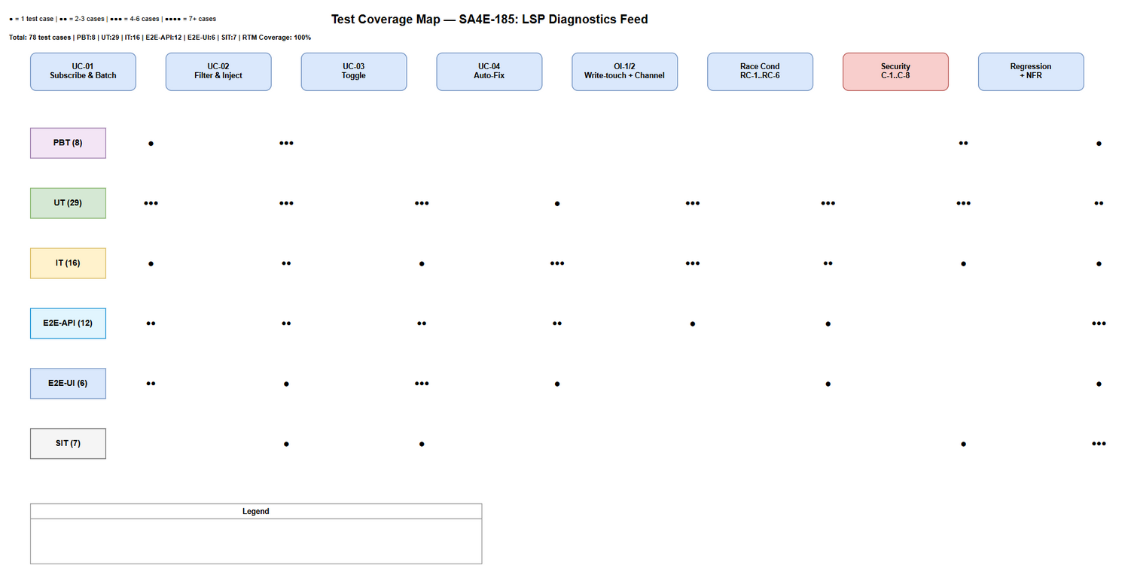
Test Coverage

3.2 Features Out of Scope
# | Feature | Reason
1 | KSA-178 diagnostics-provider.ts (save-triggered code_search diagnostics + CodeActions) | Existing, distinct mechanism — untouched (TC-18 regression watch only)
2 | Pull-based get_diagnostics tool | Existing fallback — unchanged
3 | Generic LSP quick-fix CodeActions | Native VS Code/LSP capability
4 | Persistence of feed state across sessions | In-memory per-session by design (BRD §1.2)
5 | Non-LSP diagnostic sources (task output, test runners) | Out of scope per BRD §1.2
6 | SDLC pipeline graphs (docs/sdlc/hotfix) | Interactive chat loop only
7 | New dedicated UI surfaces / Chat Panel indicator (v1) | Deferred nice-to-have (FSD §3.3.5); SIT-74 explores it only if implemented
8 | LLM model quality of auto-fix decisions | External; we test contract (directive present/absent, tool gates, bounds) not model judgment

4. Test Environment

4.1 Environment Requirements
Environment | Setup | Purpose
PBT/UT | Vitest in-memory, vscode.languages mocked as tiny Emitter, vi.useFakeTimers() | Algorithmic + service-level tests
IT | Real buildChatSubgraph with mocked LlmProvider + dummy wsRoot + mcpBridge=undefined | Component interaction + graph topology
E2E-API | Full graph invoke with wired feed; network-layer mocked LLM | End-to-end pipeline
E2E-UI | VS Code Extension Development Host + Playwright (@vscode/test-electron) | Settings UI + real editor diagnostics
SIT | Packaged VSIX on Windows 11 + macOS 13+ | Manual exploratory + UX

4.2 Platform Requirements
Platform | Version | Required
VS Code | 1.85+ | Yes
Node.js | 20 LTS | Yes
Windows | 10/11 | Yes
macOS | 13+ | Yes
Vitest | ^4.1.8 (extension/package.json) | Yes

4.3 Test Data Requirements
Data Type | Description | Source | Preparation
Workspace fixtures | Temp workspace with TS/ESLint files producing known diagnostics | Generated per test | pre-seeded-data.csv
Diagnostics batches | Entries (file,line,severity,message,code,source) incl. dupes, clamps, storms | Fixture CSV | diagnostics-batch-testdata.csv
Write-tool args | toolName + args incl. write_file (OI-1), non-write, traversal paths | Fixture CSV | write-tool-args-testdata.csv, path-containment-testdata.csv
Toggle values | true/false + event sequences + headless config throw | Fixture CSV | toggle-testdata.csv
Hostile messages | Prompt-injection payloads, control chars, directive tokens | Fixture CSV | prompt-injection-testdata.csv
Auto-fix scenarios | Summary content (error/warning/mixed), iteration counts | Fixture CSV | auto-fix-testdata.csv

4.4 External Dependencies
System | Dependency | Mock/Stub Available
VS Code LSP (onDidChangeDiagnostics, getDiagnostics) | Push events + snapshot pull | Yes — tiny Emitter + configurable map
LLM Provider (chatWithTools) | Model calls in graph | Yes — mocked LlmProvider at network layer
HookEngine + hook-tool-matcher | Write classification + file hooks | Real instance + temp workspace hooks dir
ToolApprovalGate | Permission gate for auto-fix write tools | Requires real wiring (C-2) — E2E-API-008 exercises it
debug-logger.ts | [DD-FEED] structured logs | Yes — spied

5. Test Schedule
Phase | Start Date | End Date | Duration | Milestone
Test Planning | 2026-08-20 | 2026-08-20 | 1 day | STP + STC approved
Test Data Preparation | 2026-08-21 | 2026-08-21 | 1 day | Fixture CSVs ready in testdata/
PBT + UT Development | 2026-08-22 | 2026-08-24 | 3 days | PBT (8) + UT (29) green, coverage ≥ 90%
IT Development | 2026-08-25 | 2026-08-26 | 2 days | IT (16) pass, both graph variants
E2E-API Execution | 2026-08-27 | 2026-08-28 | 2 days | E2E-API (12) incl. C-1/C-2/C-3
E2E-UI Execution | 2026-08-29 | 2026-08-30 | 2 days | E2E-UI (6) in Extension Host
SIT Execution | 2026-08-31 | 2026-08-31 | 1 day | SIT (7) manual sign-off
Defect Fix & Retest | 2026-09-01 | 2026-09-02 | 2 days | 0 Critical, ≤ 1 Major

6. Resources & Responsibilities
Role | Name | Responsibility
Test Lead | QA Agent | Test planning, coordination, reporting
QA Engineer | QA Agent | Test case design, execution, defect reporting
Developer | DEV Agent | Implementation per TDD §12, unit tests, bug fixing
SA | SA Agent | Architecture clarification for IT/E2E scenarios
Security | Security Agent | Verify C-1/C-2/C-3 closure evidence
DevOps | DevOps Agent | CI pipeline for automated test levels

7. Risk & Mitigation
# | Risk | Impact | Likelihood | Mitigation
1 | C-1 fencing not implemented by DEV before QA → prompt-injection tests fail | High | Medium | E2E-API-007/STC-60 raised as blocking; escalate to Security Agent
2 | C-2 approval gate still unwired at production call site (router-graph.ts:80) | High | Medium | E2E-API-008/009 verify production wiring; defect → DEV (Major)
3 | C-3 toWorkspaceRelative implemented naively (prefix check) → traversal bypass | High | Low | PBT-07 + E2E-API-010 adversarial cases; Windows/UNC cases in CSV
4 | Flaky fake-timer assertions around 300 ms debounce | Medium | Medium | vi.useFakeTimers() with exact advance; tolerance ± 10 ms
5 | E2E-UI (Extension Host) instability in Playwright | Medium | High | Retry logic, stable selectors, wait strategies
6 | Race tests for RC-1..RC-6 hard to reproduce deterministically | Medium | Medium | Controllable timers + injected epoch transitions
7 | Requirement change on default-on (C-6 product decision) | Medium | Low | Keep toggle tests parameterizable; decision documented in SIT-76

8. Defect Management

8.1 Severity Levels
Severity | Definition | Example
Critical | Security breach (injection succeeds past fence), loop corruption, context leak across tabs | C-1 fails; diagnostics summary leaks to wrong tab
Major | Feature not working or security control missing | Toggle doesn’t disable; approval gate unwired (C-2); touched filter wrong
Minor | Works with workaround; degraded UX | Cap marker wording; log noise
Trivial | Cosmetic/formatting | Summary alignment in chat

8.2 Priority Levels
Priority | Definition | SLA (Fix Time)
P1 | Security or data-integrity issue (C-1..C-3 failures) | 4 hours
P2 | Core feature broken (feed never injects, loop unbounded) | 1 business day
P3 | Enhancement/minor | 3 business days
P4 | Cosmetic | Next release

8.3 Defect Lifecycle
New → Open → In Progress → Fixed → Ready for Retest → Verified → Closed
→ Reopened → In Progress

9. Test Metrics & Reporting

9.1 Metrics
Metric | Formula | Target
Test Execution Rate | Executed / Total × 100% | 100%
Pass Rate | Passed / Executed × 100% | ≥ 95%
Defect Density | Defects / Test Cases | ≤ 0.05
Critical Defect Count | Count of Critical severity | 0
Security Test Pass Rate | Sec tests passed / Total sec tests × 100% | 100% (C-1..C-3)
Code Coverage (DiagnosticsFeedService) | Branch coverage | ≥ 90%
Automation Ratio | Automated / Total | ≥ 90% (target 91%)

9.2 Reporting Schedule
Report | Frequency | Audience
Daily Test Status | Daily during execution | Project team
Defect Summary | Daily | Dev team
Security Conditions Closure Report | End of E2E-API phase | Security + Arch team
Test Completion Report | End of SIT | All stakeholders

10. Test Execution Flow
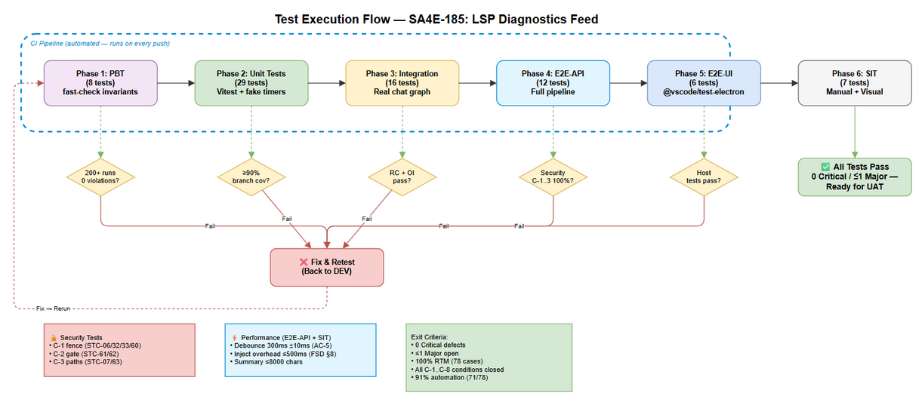
Test Execution Flow
Pipeline: PBT → UT → IT → E2E-API → E2E-UI → SIT. Each level gates the next; RC/epsec-branch defect feedback loops return to DEV (fix → re-run affected level).

11. Appendix

Glossary
Term | Definition
PBT | Property-Based Testing — random inputs verify invariants (fast-check)
UT | Unit Testing — isolated class/function tests with mocked vscode APIs
IT | Integration Testing — real component interactions, partial mocking
E2E-API | End-to-End at agent-tool/graph API level — full subgraph with wired feed, mocked LLM
E2E-UI | End-to-End UI — VS Code Extension Host level (settings UI + real diagnostics)
SIT | System Integration Testing — full packaged extension, visual/UX review
diagnosticsContext | New PipelineAnnotation channel (single-writer: inject_diagnostics)
epoch | Generation counter discarding stale flush callbacks (RC-1/RC-5)
consume-once | BR-7 semantics — summary injected once per turn, cleared after

Assumptions
- DEV implements TDD §12 including DR-1 (OI-1), DR-2 (OI-2) and security conditions C-1..C-3 before QA sign-off.
- The feed setting defaults to true per BRD (C-6 decision documented; tests parameterized).
- Auto-fix quality is not tested (external model) — only the advisory contract, tool gates, and bounds.
- LangGraph version pinned per existing package.json; graph invoked in-process with mocked LLM.

Diagram Index
# | Diagram | Image | Source (editable)
1 | Test Coverage | test-coverage.png | test-coverage.drawio
2 | Test Execution Flow | test-execution-flow.png | test-execution-flow.drawio

