Technical Design Document (TDD)

SDLC-Agents-4-Enterprise — SA4E-185: LSP Diagnostics Feed — Realtime errors into agent loop

Document Information
Field | Value
Jira Ticket | SA4E-185
Title | LSP Diagnostics Feed — Realtime errors into agent loop
Author | SA Agent
Version | 1.0
Date | 2026-08-20
Status | Draft
Related BRD | documents/SA4E-185/BRD.md (BRD-v1-SA4E-185.docx)
Related FSD | documents/SA4E-185/FSD.md (FSD-v1-SA4E-185.docx, incl. TA Enrichment §10)

Author Tracking
Role | Name - Position | Responsibility
Author | SA Agent – Solution Architect | Create document
Peer Reviewer | BA Agent – Business Analyst | Review for BRD/FSD alignment

Revision History
Version | Date | Author | Changes
1.0 | 2026-08-20 | SA Agent | Initiate document — verified against extension/src (chat-graph.ts, state.ts, hook-engine.ts, hook-tool-matcher.ts, chat-graph-nodes.ts, config-watcher.ts, extension.ts, package.json, diagnostics-provider.ts, router-graph.ts, graph-builder.ts, langgraph-engine.ts, debug-logger.ts)

Sign-Off
Name | Signature and date
 | ☐ I agree and confirm the technical design in this TDD
 | ☐ I agree and confirm the technical design in this TDD

1. Introduction
Scope Boundary: This TDD specifies HOW to implement the requirements defined in the FSD (SA4E-185 v1.1, incl. TA Enrichment §10). It does NOT repeat functional requirements, business rules, use cases, or UI specifications — refer to the FSD for those. This document focuses on: technology choices, architecture decisions, implementation patterns, and deployment concerns.

1.1 Purpose
This TDD defines the technical architecture for the LSP Diagnostics Feed in the Kiro VS Code extension: a push-based pipeline that streams realtime language-server diagnostics (vscode.languages.onDidChangeDiagnostics) for agent-touched files into the interactive LangGraph agent loop, enabling agent self-correction (advisory auto-fix) while working in the workspace. It validates and resolves the TA open issues OI-1 (write_file missing from TOOL_CATEGORIES) and OI-2 (injectedPrompts discarded at chat-graph-nodes.ts:334), and confirms the injection-channel decision (new diagnosticsContext channel).
The design implements FSD use cases UC-01 → UC-04 and business rules BR-1 → BR-13.

1.2 Scope
In scope (technical):
- NEW DiagnosticsFeedService — LSP event subscription, 300 ms debounce batching, workspace/file-scheme scoping, touched-files filtering, severity filter, dedupe, caps (20/file, 50 total), bounded summary build (≤ ~8000 chars), read-once pendingSummary buffer, epoch race guard.
- NEW inject_diagnostics LangGraph node (single-writer of the new diagnosticsContext channel) + state.ts channel declaration.
- MODIFY chat-graph.ts (both graph variants: node/edge wiring, routeAfterToolExec re-entry, buildFinalSystemPrompt merge + auto-fix advisory), chat-graph-nodes.ts (agent_step clear-after-turn; executeSingleTool → markTouchedFromTool), hook-tool-matcher.ts (OI-1 fix), extension/package.json (setting), extension.ts (activation + live toggle watcher), langgraph-engine.ts / graph-builder.ts / router-graph.ts (feed instance plumbing).
- NEW settings key kiroSdlc.enableDiagnosticsFeed (boolean, default true) — VS Code Settings UI.
- Unit + integration tests (Vitest) per FSD §10.6.
Out of scope (unchanged):
- extension/src/diagnostics-provider.ts (KSA-178) — save-triggered code_search diagnostics + CodeActions, kept separate, no changes (verified: diagnostics-provider.ts:37-50).
- get_diagnostics pull tool (vscode-tools.ts:126-142) — unchanged, remains available.
- No persistence (feed state is in-memory, session-scoped — BRD §1.2).
- No SDLC pipeline graphs (docs/sdlc/hotfix) — interactive chat subgraph only.
- No new network egress; all processing local to the Extension Host.
- No new UI surfaces (optional Chat Panel indicator deferred as nice-to-have).

1.3 Technology Stack
Layer | Technology | Version | Evidence
Language | TypeScript | 5.x | extension/package.json
Extension Host | VS Code Extension API | ^1.85.0 | package.json:14
State Machine | LangGraph (@langchain/langgraph) | 0.0.x | chat-graph.ts:12
Graph Runtime | LSP push events | VS Code API | vscode.languages.onDidChangeDiagnostics
Config | VS Code contributes.configuration | kiroSdlc.* | package.json:217-221 pattern
Logging | debug-logger.ts (debugLog/debugError) | existing | extension/src/debug-logger.ts
Testing | Vitest | ^4.1.8 | package.json:387,413
No new runtime libraries. All dependencies are existing VS Code APIs and in-repo modules (hook-tool-matcher, debug-logger). No new NPM package.

1.4 Design Principles
- Channel-authoritative + single-writer — the new diagnosticsContext channel is the ONLY transport for feed summaries; the inject_diagnostics node is the only writer. postToolUse → injectedPrompts never carries feed content (dedupe rule, FSD §3.2 AF-04) → consume-once is provable.
- Read-once at the source — takePendingSummary() returns-and-clears the buffer; the graph node merely transports the outcome. The service never writes graph state directly (eliminates feed↔graph races at the source).
- Condition in data, not topology — no conditional edges for “has diagnostics”; the graph topology is fixed; emptiness (no injectable summary) is expressed as {} (no channel churn).
- Backward compatibility — diagnosticsFeed is an optional parameter at every call-site layer; when undefined, the node no-ops and the loop runs exactly as today. Old test call sites keep working.
- Match existing patterns — optional-param closure injection (SA4E-186), onDidChangeConfiguration + affectsConfiguration for settings (extension.ts:307), [MODULE] key=value debug logging, colocated Vitest __tests__/.
- Fail-safe defaults — settings read in non-VS Code/headless context is treated as disabled (EF-01); every failure path is non-fatal to the loop.

1.5 Constraints
- Extension Host is single-threaded — all feed processing must be synchronous or non-blocking async; debounce uses setTimeout (no worker).
- LangGraph StateGraph is compiled once — nodes/edges cannot change at runtime; the feed node re-enters per iteration via the routeAfterToolExec conditional edge mapping (static topology).
- Both chat-graph variants (RAG-graded and standard, chat-graph.ts:269-305) MUST receive identical changes (V14).
- MAX_AGENT_ITERATIONS = 12 (chat-graph.ts:33) bounds auto-fix cycles — no new loop guard (BR-12).
- The ConfigWatcher class (config-watcher.ts) watches ONLY .kiro/settings/mcp.json — the feed setting must use onDidChangeConfiguration (extension.ts:307-313 pattern), NOT ConfigWatcher (V8).
- write_file currently classifies as "other" (hook-tool-matcher.ts:8-16) — the BR-5 touched-set path must not depend solely on TOOL_CATEGORIES (OI-1).
- firePostToolUse return value is currently discarded (chat-graph-nodes.ts:334) — feed must not depend on injectedPrompts (OI-2).

1.6 References
Document | Location
BRD SA4E-185 | documents/SA4E-185/BRD.md
FSD SA4E-185 (BA + TA §10) | documents/SA4E-185/FSD.md
TDD SA4E-186 (same epic, reference) | documents/SA4E-186/TDD.md
Agent loop / chat subgraph | extension/src/langgraph/subgraphs/chat-graph.ts
Node implementations | extension/src/langgraph/subgraphs/chat-graph-nodes.ts
Pipeline state definition | extension/src/langgraph/core/state.ts
Hook engine + matcher | extension/src/langgraph/hooks/hook-engine.ts, hook-tool-matcher.ts
Router / graph builder / engine | extension/src/langgraph/router/router-graph.ts, subgraphs/graph-builder.ts, engine/langgraph-engine.ts
Extension activation + settings | extension/src/extension.ts, extension/package.json
KSA-178 provider (distinct) | extension/src/diagnostics-provider.ts
Debug logger | extension/src/debug-logger.ts

2. System Architecture

2.1 Architecture Overview
The feature runs entirely inside the VS Code Extension Host process. No new services, containers, or external systems are introduced. The architecture adds one service (DiagnosticsFeedService) and one LangGraph node (inject_diagnostics) into the existing interactive chat pipeline, and one new state channel (diagnosticsContext) to PipelineAnnotation.
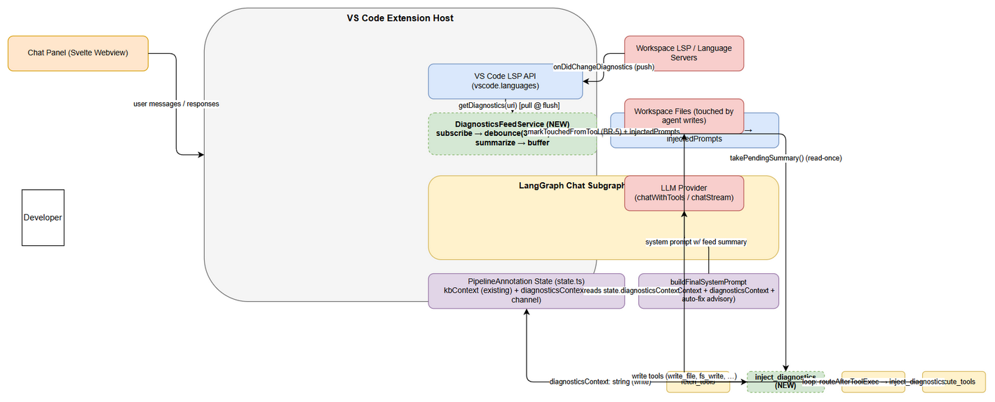 Edit in draw.io
Key data flow (implements FSD §2.1, §6.1; UC-01 → UC-04):
- Push: workspace language servers publish changes → VS Code fires vscode.languages.onDidChangeDiagnostics(uris).
- Batch: DiagnosticsFeedService checks the toggle (BR-8); filters URIs to file:// inside the workspace (BR-3); accumulates them; resets a 300 ms debounce timer (BR-2).
- Flush: on 300 ms quiet, the service reads the current snapshot via vscode.languages.getDiagnostics(uri) per pending URI, then filter() (touched files BR-4 + severity default + dedupe + line clamp) and buildSummary() (caps 20/50 + ≤8000-char budget), storing the result in pendingSummary (BR-6, BR-7).
- Inject: on the next graph pass, the inject_diagnostics node (re-entered at every loop iteration after execute_tools) pulls takePendingSummary() (read-once at source) and writes the only non-empty value into the diagnosticsContext channel.
- Consume: buildFinalSystemPrompt(state) appends the channel after kbContext and, when the summary contains ≥1 error entry, adds the advisory auto-fix directive (BR-11). agent_step clears the channel to "" in its payload (BR-7 consume-once).
- Self-correct: the LLM may issue write tool calls (write_file, fs_write, …); executeSingleTool (a) refreshes the touched-files set via markTouchedFromTool (BR-5), (b) fires existing HookEngine hooks, and the changed file re-triggers step 1. The loop is bounded by MAX_AGENT_ITERATIONS = 12 via routeAfterToolExec (BR-12).

2.2 Component Diagram
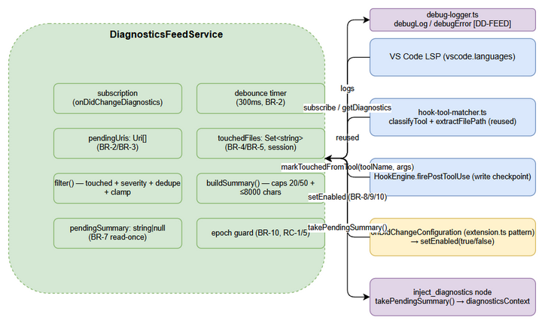 Edit in draw.io
Component | Responsibility | Technology / Source | Status
VS Code LSP API (vscode.languages) | Push event channel + diagnostic snapshot pull | VS Code API (onDidChangeDiagnostics, getDiagnostics) | External
DiagnosticsFeedService | subscribe → debounce(300 ms) → scope → filter → summarize → buffer (BR-1…BR-10) | NEW — extension/src/langgraph/diagnostics/diagnostics-feed-service.ts | NEW
hook-tool-matcher | classifyTool() + extractFilePath() reused for BR-5 (with OI-1 fix) | extension/src/langgraph/hooks/hook-tool-matcher.ts | Existing (1-line change)
HookEngine | firePostToolUse / fireFileHooks write checkpoint; injectedPrompts NOT used for feed (dedupe rule) | extension/src/langgraph/hooks/hook-engine.ts | Existing (unchanged logic)
LangGraph Chat Subgraph | agent loop; inject_diagnostics node inserted between fetch_tools→agent_step and re-entered per iteration | extension/src/langgraph/subgraphs/chat-graph.ts | Existing (modified)
PipelineAnnotation state | holds kbContext (existing) + diagnosticsContext (NEW channel) | extension/src/langgraph/core/state.ts | Existing (extended)
buildFinalSystemPrompt | merges kbContext + diagnosticsContext + auto-fix advisory (BR-11) | chat-graph.ts:221-248 | Existing (modified)
agent_step node | consumes channel; returns diagnosticsContext: "" on all paths (BR-7) | extension/src/langgraph/subgraphs/chat-graph-nodes.ts | Existing (modified)
executeSingleTool | write checkpoint → markTouchedFromTool (BR-5) + existing hooks | chat-graph-nodes.ts:287-345 | Existing (modified)
debug-logger | [DD-FEED] structured logs, debugError | extension/src/debug-logger.ts | Existing
KSA-178 diagnostics-provider.ts | save-triggered code_search diagnostics + CodeActions (kept separate) | extension/src/diagnostics-provider.ts | Existing (untouched)
get_diagnostics tool | pull-based fallback (unchanged) | extension/src/langgraph/vscode/vscode-tools.ts | Existing (untouched)

2.3 Deployment Architecture
The feature ships inside the existing extension bundle — there is no separate deployment topology.
Artifact | Deployment Target | Change
Extension bundle (.vsix via vsce package) | VS Code Marketplace / local install | New code + new setting only
Webview bundle (Svelte) | Embedded in extension assets | None (no UI change in v1)
LangGraph graph | In-memory, per Extension Host session | New node/edges compiled at build time
Feed state (touchedFiles, pendingSummary, …) | In-memory, session-scoped | Cleared at extension deactivate / new chat session
No database, no server, no container changes. extension/package.json contributes.configuration is the only packaging-level change (a settings schema addition).

2.4 Communication Patterns
From | To | Protocol | Pattern | Description
Workspace LSP / Language Server | DiagnosticsFeedService | VS Code event (onDidChangeDiagnostics) | Async push (event) | Changed-URI notifications (UC-01)
DiagnosticsFeedService | VS Code LSP API | VS Code API (getDiagnostics(uri)) | Sync pull (at flush) | Snapshot read at debounce quiet (BR-2)
DiagnosticsFeedService | inject_diagnostics node | In-process call (takePendingSummary()) | Sync pull, read-once | Buffer drained at source (BR-7)
inject_diagnostics node | PipelineAnnotation | Channel write (diagnosticsContext) | Sync state write | Single-writer rule (§10.2 FSD)
Graph → LLM Provider | buildFinalSystemPrompt → chatWithTools/chatStream | In-process + HTTPS | Async request-response | Summary merged in system prompt
executeSingleTool | DiagnosticsFeedService | In-process call (markTouchedFromTool) | Sync | Touched-set refresh (BR-5)
VS Code Settings | DiagnosticsFeedService | onDidChangeConfiguration (event) | Async push | Live toggle (BR-9)

3. API / Interface Design
Prerequisite: Functional contracts (parameters, business errors, data flows) are defined in FSD §3.1–§3.4 (§3.x.6). This feature introduces no HTTP/REST endpoints — it is extension-internal. This section specifies the technical interfaces: TypeScript signatures, the state-channel contract, the VS Code settings JSON schema, and the LangGraph topology change that transports the feed.

3.1 Interface Overview
# | Interface | Kind | Consumed By | Implements
1 | DiagnosticsFeedService (class) | In-process class API | graph node, extension.ts, engine | UC-01, UC-02, UC-03
2 | createInjectDiagnosticsNode(feed) | Factory function → graph node | chat-graph.ts (both variants) | UC-02 (BR-7)
3 | diagnosticsContext channel | PipelineAnnotation channel | buildFinalSystemPrompt, agent_step | UC-02 (BR-7), UC-04 (BR-11)
4 | kiroSdlc.enableDiagnosticsFeed | VS Code configuration (JSON schema) | settings UI + feed service | UC-03 (BR-8/9/10)
5 | LSP event + query | VS Code API | feed service | UC-01 (BR-1/2/3)
6 | Graph topology (routeAfterToolExec map) | LangGraph wiring | chat subgraph | UC-02 (BR-7), UC-04 (BR-12)
7 | VS Code tool write_file classification | TOOL_CATEGORIES entry | hook engine + markTouchedFromTool | BR-5 (OI-1 fix)

3.2 Interface 1 — DiagnosticsFeedService
Implements: UC-01, UC-02, UC-03 — BR-1 … BR-10. File (NEW): extension/src/langgraph/diagnostics/diagnostics-feed-service.ts
Constructor: new DiagnosticsFeedService(workspaceRoot: string, getConfig?: () => vscode.WorkspaceConfiguration)
The getConfig function is injectable for tests/headless; default = () => vscode.workspace.getConfiguration("kiroSdlc"). On construction the service reads the toggle (enableDiagnosticsFeed, default true — headless-safe: read failure → disabled, FSD UC-03 EF-01) and calls start().
Public methods (schema):
export class DiagnosticsFeedService implements vscode.Disposable {
start(): vscode.Disposable; // BR-1 subscribe onDidChangeDiagnostics; register while enabled
stop(): void; // BR-1/10 unsubscribe + clear timer/buffer
dispose(): void; // UC-01 EF-03 detach subscription, clear state
onDiagnosticsChanged(uris: readonly vscode.Uri[]): void; // BR-2/3 handler (registered via onDidChangeDiagnostics)
flush(myEpoch: number): void; // BR-2/6 quiet-window flush: getDiagnostics → filter → buildSummary
filter(entries: DiagnosticsBatchEntry[]): DiagnosticsBatchEntry[]; // BR-4/6 touched + severity + dedupe + clamp
buildSummary(kept: DiagnosticsBatchEntry[]): string; // BR-6 caps 20/50 + budget ≤ 8000 chars (§3.7)
takePendingSummary(): string | null; // BR-7 read-once at source (returns & clears buffer)
markTouchedFromTool(toolName: string, args: Record<string, unknown>): void; // BR-5 (handles write_file — OI-1)
setEnabled(value: boolean): void; // BR-8/9/10 live toggle; epoch++ + discard on false
clearSession(): void; // BR-5 session start: reset touchedFiles/pending/epoch
get isEnabled(): boolean; // BR-8 (observability / optional UI mirror)
}
Method behavior contract:
Method | Precondition | Behavior | Error handling (E-x of FSD §10.5)
start() | workspace open | pushes subscription to disposables; returns the Disposable | E-1 (handler throw → debugError, non-fatal)
onDiagnosticsChanged | enabled === true | workspace/file filter (BR-3) → accumulate pendingUris → reset 300 ms timer with captured myEpoch | E-2/E-3 (per-URI getDiagnostics failures skipped)
flush(myEpoch) | 300 ms quiet | abort if myEpoch !== epoch (E-4); read snapshot; filter(); if empty → return (E-5); else pendingSummary = buildSummary(...) (BR-7) | E-6 (cap log), E-9 (batch persists for next turn)
markTouchedFromTool(name, args) | — | normalize extractFilePath(name, args) to workspace-relative; touchedFiles.add(rel). Write-tool allowlist fallback (see OI-1 resolution) | E-10 (extraction failure/unknown tool → skip)
setEnabled(v) | — | enabled = v; if false: epoch++, clear timer + URIs + pendingSummary (BR-10) | E-12 (settings read fail → disabled)
takePendingSummary() | — | return pendingSummary; set to null (read-once) | E-7 (null when empty)
clearSession() | — | touchedFiles.clear(), pendingUris = [], pendingSummary = null, epoch++ | —

3.3 Interface 2 — createInjectDiagnosticsNode
Implements: UC-02 (BR-7). File (NEW): extension/src/langgraph/diagnostics/inject-diagnostics-node.ts
import { PipelineState } from "../core/state";
import type { DiagnosticsFeedService } from "./diagnostics-feed-service";
// Returns a LangGraph node. When feed is null/undefined (not wired, tests, old call sites)
// the node no-ops — graph behaves exactly as today (backward compatibility).
export function createInjectDiagnosticsNode(feed: DiagnosticsFeedService | null):
(state: PipelineState) => Promise<Partial<PipelineState>> {
return async (_state) => {
if (!feed) return {}; // E-8: not wired → no-op
const summary = feed.takePendingSummary(); // read-once at source (BR-7)
return summary ? { diagnosticsContext: summary } : {}; // {} → no channel churn
};
}
Response payload contract (JS/JSON shape, valid Partial<PipelineState>):
{ "diagnosticsContext": "[Diagnostics feed] (toggle: kiroSdlc.enableDiagnosticsFeed = on)\nsrc/app.ts:12 error TS2339 Property 'ctx' does not exist on type 'App'\n... (3 more diagnostics suppressed)" }
or {} (empty) when nothing pending. The node performs no filtering logic — all conditions (toggle, touched, budget) are evaluated inside the service; the graph carries no conditional branch for “has diagnostics” (condition in data, not topology).

3.4 Interface 3 — diagnosticsContext channel contract
Implements: UC-02 (BR-7), UC-04 (BR-11). File (MODIFY): extension/src/langgraph/core/state.ts — insert immediately after line 65 (kbContext):
// SA4E-185: realtime LSP diagnostics feed summary; consumed once per turn (BR-7)
diagnosticsContext: Annotation<string>({ reducer: (_existing, update) => update, default: () => "" }),
Contract (validated against FSD §10.2):
Aspect | Rule
Type | Annotation<string>, reducer last-write-wins (_e, u) => u, default ""
Writer | Single-writer: only inject_diagnostics node writes non-"" values
Reader | buildFinalSystemPrompt(state) appends after kbContext; conditional auto-fix advisory (§4.5)
Clear | agent_step returns diagnosticsContext: "" in every return payload (success/tool-call/error/no-LLM paths — chat-graph-nodes.ts:120-124, 184, 188, 196-202, 218, 224-229)
Cross-invocation | fresh default: () => "" per graph invoke — stale summaries never leak across chat turns

3.5 Interface 4 — VS Code settings schema
Implements: UC-03 (BR-8/9/10). File (MODIFY): extension/package.json → contributes.configuration.properties, immediately after kiroSdlc.enableMcpServer (currently :217-221), modeled byte-for-byte on that boolean pattern:
{
"kiroSdlc.enableDiagnosticsFeed": {
"type": "boolean",
"default": true,
"description": "Enable the realtime LSP diagnostics feed into the agent loop (batched, agent-touched files only)"
}
}
Read (BR-8, headless-safe EF-01):
const settings = vscode.workspace.getConfiguration("kiroSdlc");
const enabled = settings.get<boolean>("enableDiagnosticsFeed", true); // throw/undefined → treated as disabled
Watch (BR-9 — immediate, no reload). Follow the EXISTING extension.ts:307 pattern (onDidChangeConfiguration + affectsConfiguration) — NOT ConfigWatcher (it only watches .kiro/settings/mcp.json, V8):
// extension.ts — next to the existing mcpServerPort watcher (:307-313)
context.subscriptions.push(vscode.workspace.onDidChangeConfiguration((event) => {
if (!event.affectsConfiguration("kiroSdlc.enableDiagnosticsFeed")) { return; }
const enabled = vscode.workspace.getConfiguration("kiroSdlc")
.get<boolean>("enableDiagnosticsFeed", true);
diagnosticsFeedService.setEnabled(enabled); // live toggle (BR-8/9/10)
}));

3.6 Interface 5 — LSP event + query (VS Code API)
Implements: UC-01 (BR-1/2/3).
API | Direction | Usage | Business rule
vscode.languages.onDidChangeDiagnostics(listener) | push | subscription created in start(), kept while enabled | BR-1
vscode.languages.getDiagnostics(uri): Diagnostic[] | pull | called per pending URI at flush() time | BR-2 (snapshot), BR-3 (scope)
vscode.workspace.asRelativePath(uri) | helper | workspace-relative file field | BR-3, BR-6
vscode.workspace.workspaceFolders | helper | workspace containment check | BR-3
Severity mapping (required by BR-6): DiagnosticSeverity.Error → "error", Warning → "warning", Information → "info", Hint → "hint".

3.7 Injected Summary Format (payload schema)
Built by buildSummary() (BR-6, FSD §3.2.4). One string, ≤ ~8000 chars (≈2000 tokens, V13).
[Diagnostics feed] (toggle: kiroSdlc.enableDiagnosticsFeed = <on/off>)
<file>:<line> <severity> <code> <message> ← one entry per kept diagnostic (BR-6)
... (N more diagnostics suppressed) ← when caps N=20/file or M=50 total hit
Caps/limits (FSD §3.2 Validation Rules): per-file cap N=20; total cap M=50; severity default filter ["error","warning"]; budget guard tokenBudgetChars ≈ 8000 applied via .slice(0, tokenBudgetChars); entries deduplicated on (file, line, code); line clamped to the file’s line count.

3.8 Interface 6 — LangGraph topology change
Implements: UC-02 (BR-7), UC-04 (BR-12). File (MODIFY): extension/src/langgraph/subgraphs/chat-graph.ts — BOTH variants (:269-288 RAG-graded and :291-305 standard, V14).
__start__ → fetch_tools → inject_diagnostics → agent_step ──(routeAgentStep)──→ execute_tools
▲ │
└──────────────────────────────┘
(routeAfterToolExec: continue → "inject_diagnostics" ; failed/>=12 → "synthesize")
verify_response ──(routeAfterVerify)──→ execute_tools | agent_step (retry) | __end__
Changes:
- buildChatSubgraph(...) gains an 8th optional parameter diagnosticsFeed?: DiagnosticsFeedService.
- const injectDiag = createInjectDiagnosticsNode(diagnosticsFeed ?? null);
- .addNode("inject_diagnostics", injectDiag) + .addEdge("fetch_tools", "inject_diagnostics") + .addEdge("inject_diagnostics", "agent_step") in both variants.
- .addConditionalEdges("execute_tools", routeAfterToolExec, { inject_diagnostics: "inject_diagnostics", synthesize: "synthesize" }) — replaces agent_step: "agent_step" entry in the continue branch (verified at chat-graph.ts:282 and :302).
- routeAfterToolExec (chat-graph.ts:167-172) continue branch returns "inject_diagnostics"; pipelineStatus === "failed" and agentIterations >= MAX_AGENT_ITERATIONS branches keep returning "synthesize" (BR-12 untouched).
Every-iteration freshness (BR-7 “next turn”): a batch flushed during execute_tools of turn N is pulled by inject_diagnostics at the top of turn N+1. verify_response(INCOMPLETE) → agent_step retry paths are safe because agent_step already cleared the channel (no repeat), and the buffer still holds any pending batch for the next inject_diagnostics pass.

3.9 Interface 7 — write_file classification (OI-1 fix)
See §4.4. This is a 1-line additive change in extension/src/langgraph/hooks/hook-tool-matcher.ts (TOOL_CATEGORIES) plus a write-tool allowlist fallback inside markTouchedFromTool (defense-in-depth so BR-5 never depends on a single classification path).—

4. Database Design
Prerequisite: FSD §4 defines logical/session entities only (no persistence). This feature introduces NO database.

4.1 Statement — No Database Changes (Explicit)
- There is no backend, no database, and no DDL in this feature. The entire pipeline lives inside the VS Code Extension Host process (extension-only).
- Feed state is in-memory, session-scoped (BRD §1.2, FSD §4.1): touchedFiles, pendingUris, pendingSummary, epoch are module-local service fields, cleared at session start / extension deactivate.
- The only “persistent” artifact is the VS Code settings key kiroSdlc.enableDiagnosticsFeed (stored by VS Code’s own configuration store — managed by VS Code, not by this feature).
- documents/SA4E-185/FSD.md is correct: no ER diagram was produced for good reason — there are no persisted entities.
⚠️ Database sections of the TDD template are N/A. The logical view below documents the in-memory runtime state so DEV can implement it exactly (schema as TypeScript types; “DDL” equivalent is the class-field initialization).

4.2 Logical In-Memory Schema (TypeScript types)
File (NEW): extension/src/langgraph/diagnostics/diagnostics-feed-types.ts
/** One diagnostic that reached the flush stage (FSD §3.1.4 intermediate data). */
export interface DiagnosticsBatchEntry {
file: string; // workspace-relative path (BR-3/BR-6)
line: number; // 1-based; clamped to file line count
severity: "error" | "warning" | "info" | "hint"; // mapped from DiagnosticSeverity (BR-6)
message: string; // non-empty diagnostic message
code: string; // empty string when absent (e.g. TS2339)
source: string; // provider name (e.g. "typescript"); optional
}
export interface DiagnosticsFeedConfig {
debounceMs: number; // 300 (BR-2, fixed in v1)
perFileCap: number; // 20 (§3.2 Validation Rules, N)
totalCap: number; // 50 (§3.2 Validation Rules, M)
severityFilter: ("error" | "warning" | "info" | "hint")[]; // default ["error","warning"]
tokenBudgetChars: number; // ≈8000 (≈2000 tokens, V13)
}
export interface FeedSummary {
header: string; // "[Diagnostics feed] (toggle: ...)"
body: string; // one line per entry (BR-6)
suppressed: number; // count dropped by caps
}

4.3 Runtime State Fields (module-local — the “tables” of this feature)
Field | Type | Init | Business rule | Lifecycle
enabled | boolean | from setting (default true) | BR-8/9/10 | live via setEnabled
subscription | Disposable \| null | null | BR-1 | registered on start(), disposed on stop()
pendingUris | Uri[] | [] | BR-2/3 | accumulate per event; cleared at flush/disable
debounceTimer | NodeJS.Timeout \| null | null | BR-2 | reset per event; cancelled on disable/dispose
touchedFiles | Set<string> | new Set() | BR-4/5 | session-scoped; cleared at session start (clearSession)
pendingSummary | string \| null | null | BR-7 | read-once via takePendingSummary()
epoch | number | 0 | BR-10 | ++ on setEnabled(false)/clearSession(); stale flush aborts (RC-1/RC-5)
config | DiagnosticsFeedConfig | defaults above | §3.2 | immutable in v1
workspaceRoot | string | injected | BR-3 | containment / asRelativePath
disposables | Disposable[] | [] | — | pushed to context.subscriptions

4.4 Runtime State Diagram (feed lifecycle)
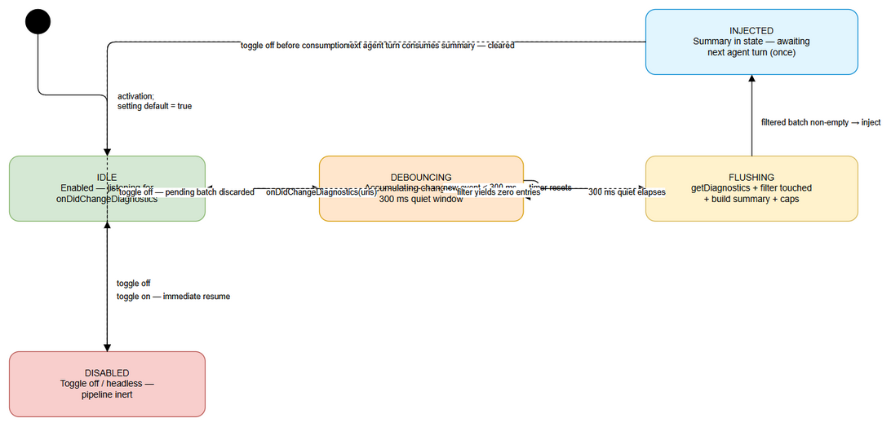 Edit in draw.io
States: DISABLED → IDLE → DEBOUNCING → FLUSHING → INJECTED → IDLE (consume-once), as specified in FSD §6.4. This TDD adds two technical rules to the FSD lifecycle:
- epoch guard: transitions DEBOUNCING/FLUSHING → DISABLED must epoch++ so any in-flight setTimeout(flush, 300) callback aborts (RC-1, E-4).
- INJECTED → IDLE is performed by the graph node consuming the channel, not by the service — the service keeps pendingSummary = null after takePendingSummary() (read-once at source, RC-2/RC-3).

4.5 Data Volume Estimates
Item | Estimate | Rationale
Listener events / flush | 1..N URIs (burst ≤ dozens) | user typing / agent multi-file writes (UC-01 AF-01)
Diagnostics per URI | 0..100s | large-file compile errors
Summary payload | ≤ ~8000 chars (≈2000 tokens) | tokenBudgetChars hard cap (V13)
touchedFiles size | files written in current session (bounded by workspace) | session-scoped, no TTL in v1 (BRD §5.2 Assumption)
Memory footprint | negligible (strings + sets) | no persistence, no growth across sessions

4.6 Query Patterns (N/A — replaced by in-memory operations)
Operation | In-memory equivalent | Cost
“Which pending URIs changed?” | pendingUris array push | O(1) per event
“Is this file agent-touched?” | touchedFiles.has(relPath) | O(1)
“Diagnostics for URI?” | vscode.languages.getDiagnostics(uri) (host-owned) | O(1) per URI call
Dedupe within batch | linear scan on (file,line,code) | O(n) per batch
Cap enforcement | counters per file + total | O(n)

5. Class / Module Design

5.1 Package Structure
extension/src/
├── langgraph/
│ ├── diagnostics/ # **NEW** package (mirrors small-file convention)
│ │ ├── diagnostics-feed-types.ts # DiagnosticsBatchEntry, DiagnosticsFeedConfig, FeedSummary
│ │ ├── diagnostics-feed-service.ts # DiagnosticsFeedService (class)
│ │ ├── inject-diagnostics-node.ts # createInjectDiagnosticsNode(feed)
│ │ └── __tests__/
│ │ ├── diagnostics-feed-service.test.ts
│ │ ├── diagnostics-feed-config.test.ts
│ │ └── inject-diagnostics-node.test.ts
│ ├── core/state.ts # MODIFY — add diagnosticsContext channel (after kbContext, l.65)
│ ├── subgraphs/chat-graph.ts # MODIFY — node/edges (BOTH variants), prompt merge, routeAfterToolExec
│ ├── subgraphs/chat-graph-nodes.ts # MODIFY — agent_step clear-after-turn; executeSingleTool → markTouchedFromTool
│ ├── hooks/hook-tool-matcher.ts # MODIFY — TOOL_CATEGORIES += write_file: "write" (OI-1)
│ ├── router/router-graph.ts # MODIFY — pass diagnosticsFeed to buildChatSubgraph (l.80)
│ ├── subgraphs/graph-builder.ts # MODIFY — optional diagnosticsFeed param (l.37)
│ ├── engine/langgraph-engine.ts # MODIFY — own DiagnosticsFeedService; clearSession() on new session
│ └── __tests__/ # MODIFY/ADD
│ ├── diagnostics-state-channel.test.ts # NEW
│ └── chat-graph-diagnostics.integration.test.ts # NEW
├── extension.ts # MODIFY — activate(): instantiate feed, watch setting, pass to engine
└── debug-logger.ts # (unchanged) debugLog / debugError

5.2 Key Interfaces
The class structure below implements FSD §10.1 Table 1 (class/service design) exactly.
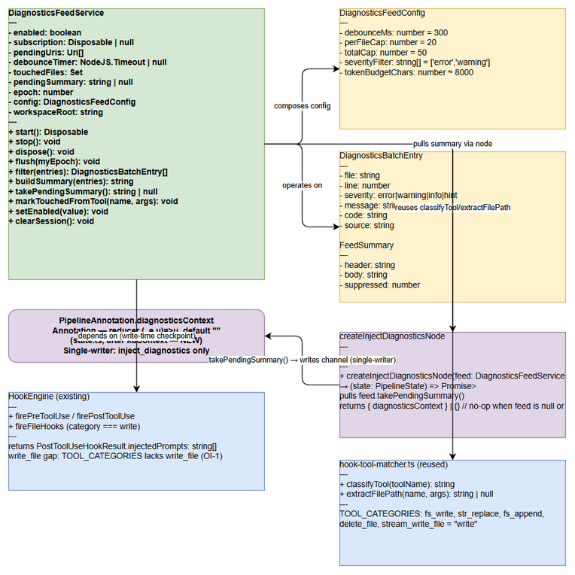 Edit in draw.io
Full class API is specified in §3.2 (DiagnosticsFeedService) and §3.3 (createInjectDiagnosticsNode). Type definitions in §4.2. The design deliberately reuses:
- classifyTool / extractFilePath from hook-tool-matcher.ts (already exported) — no new path-extraction logic.
- debugLog / debugError from debug-logger.ts — no new logger.
- VS Code Disposable pattern for the subscription, pushed to context.subscriptions like every other extension resource.

5.3 Design Patterns
Pattern | Where Used | Rationale
Single-writer (Data-ownership) | inject_diagnostics node ↔ diagnosticsContext channel | Makes consume-once provable; eliminates clear/re-inject races (RC-2)
Read-once at source | takePendingSummary() in service | Service never writes graph state → feed↔graph races eliminated at source (RC-3)
Observer | onDidChangeDiagnostics subscription; onDidChangeConfiguration watcher | Push-based reactive pipeline (BR-1, BR-9)
Debounce/Timer | 300 ms setTimeout + clearTimeout reset | Batching bursts into one flush (BR-2)
Generation/epoch guard (Stale-callback) | epoch counter captured in flush callback | Aborts stale flushes after disable/session changes (RC-1/RC-5)
Closure injection (existing convention) | diagnosticsFeed?: DiagnosticsFeedService param threaded through buildPipelineGraph → buildRouterGraph → buildChatSubgraph | Matches SA4E-186 pattern; optional → backward compatible; node no-ops when absent
Strategy (in-data) | No conditional edges; emptiness expressed as {} | Topology immutable after compile; condition lives in data (V12/V14)
Dependency Inversion | getConfig() injected into service constructor | Testable in headless (Vitest mock of vscode.workspace.getConfiguration)
Flyweight/Set | touchedFiles: Set<string> | O(1) membership; idempotent adds (BR-5)

5.4 Decision Records — Open Issues Resolution (MANDATORY: OI-1, OI-2)

DR-1 (OI-1): write_file missing from TOOL_CATEGORIES
Problem (verified in code): hook-tool-matcher.ts:8-16 maps fs_write, str_replace, fs_append, delete_file, stream_write_file → "write". The primary VS Code write tool write_file (vscode-tool-definitions.ts:24) is NOT mapped → classifyTool("write_file") === "other" → HookEngine.firePostToolUse never calls fireFileHooks, and any fileCreated/fileEdited hooks never fire for it. This would break BR-5 (touched-set population for the primary write tool) if the feed relied only on hook classification.
Decision: two-layer fix (additive + defense-in-depth):
Layer A — classification fix (additive, fixes hook system generally):
// hook-tool-matcher.ts — TOOL_CATEGORIES (1 line added)
const TOOL_CATEGORIES: Record<string, string> = {
readFile: "read", read_file: "read", read_code: "read", read_files: "read",
grep_search: "read", file_search: "read", list_directory: "read",
get_diagnostics: "read", get_process_output: "read",
fs_write: "write", str_replace: "write", fs_append: "write",
delete_file: "write", stream_write_file: "write",
write_file: "write", // ← SA4E-185 OI-1: primary VS Code write tool
execute_pwsh: "shell", control_pwsh_process: "shell",
web_search: "web", fetch_url: "web",
};
Layer B — allowlist fallback inside the feed (BR-5 never depends on a single path):
// diagnostics-feed-service.ts — markTouchedFromTool guard
// Defensive: keep BR-5 working even if TOOL_CATEGORIES drifts again.
// Mirrors hook-engine.ts file-hook event semantics (fs_write/stream_write_file → created; others → edited)
private static readonly WRITE_TOOL_NAMES = new Set([
"write_file", "fs_write", "str_replace", "fs_append", "delete_file", "stream_write_file",
]);
markTouchedFromTool(toolName: string, args: Record<string, unknown>): void {
const isWrite = WRITE_TOOL_NAMES.has(toolName) || classifyTool(toolName) === "write";
if (!isWrite) return; // E-10: non-write tool → skip
const filePath = extractFilePath(toolName, args); // handles args.path (write_file), file_path, targetFile
if (!filePath) return;
const rel = this.toWorkspaceRelative(filePath); // workspace containment (BR-3)
if (rel) this.touchedFiles.add(rel); // Set semantics → idempotent (BR-5)
}
Impact: write_file now classifies as write → fireFileHooks fires for it (existing fileCreated/fileEdited hooks get correct behavior too); the feed’s touched-set is correct even if classification regresses. Safe, additive, backward compatible.

DR-2 (OI-2): firePostToolUse result discarded at chat-graph-nodes.ts:334
Problem (verified in code): executeSingleTool (chat-graph-nodes.ts:332-339) does await hookEngine.firePostToolUse(...) and ignores the returned PostToolUseHookResult.injectedPrompts. The BA FSD §2.2 claim “injectedPrompts merged back into the loop” is therefore false today (V4).
Decision: adopt the channel-authoritative design (FSD §10.3 / §3.5). The feed summary flows exclusively through takePendingSummary() → diagnosticsContext. The postToolUse → injectedPrompts path is not wired for feed content (dedupe rule — RC-2). Code change is a documented comment + the markTouchedFromTool call:
// chat-graph-nodes.ts — executeSingleTool (after firePostToolUse at :334)
if (hookEngine) {
try {
const hookResult = await hookEngine.firePostToolUse(call.name, call.arguments || {}, result, sh, streamId);
// SA4E-185 OI-2: hookResult.injectedPrompts is intentionally NOT replayed into the loop.
// Diagnostics feed is channel-authoritative (diagnosticsContext, single-writer node) to
// guarantee consume-once (BR-7). If askAgent/other hooks later require prompt injection,
// fold ONLY non-feed outputs here — feed summaries must never duplicate (dedupe rule, RC-2).
} catch (hookErr) { debugError(`[chat-graph-nodes] postToolUse hook error for '${call.name}'`, hookErr as Error); }
}
if (diagnosticsFeed) {
diagnosticsFeed.markTouchedFromTool(call.name, call.arguments || {}); // BR-5 (handles write_file — DR-1)
}
executeSingleTool receives diagnosticsFeed via createExecuteToolsNode(mcpBridge, sh, hookEngine, wsRoot, approvalGate, getAgentConfig, diagnosticsFeed?) (new optional 7th param, matching the existing SA4E-186 pattern).
Impact: the feed never double-injects (RC-2); consume-once is enforced by (a) single-writer node, (b) read-once takePendingSummary, (c) agent_step clearing the channel. No regression to the pre-existing (discard) behavior — the semantic is now intentional and documented.

5.5 Error Handling
All feed errors are logged via existing debug-logger.ts primitives (debugLog, debugError) with the [DD-FEED] prefix (FSD §10.5 E-1…E-15). No exception propagates into the agent loop — every path is non-fatal (BR-1, EF-01):
E-ID (FSD §10.5) | Condition | Level | Handling
E-1 | onDidChangeDiagnostics handler throws | ERROR | debugError("[DD-FEED] handler", err); subscription stays
E-2 | getDiagnostics(uri) throws (URI disposed / LSP race) | WARN | skip that URI, continue batch
E-3 | getDiagnostics returns [] | DEBUG | empty batch, no injection
E-4 | stale flush (epoch mismatch) after toggle-off | DEBUG | abort silently; batch already discarded (BR-10)
E-5 | filter() yields 0 entries | DEBUG | no injection; loop unchanged
E-6 | cap overflow | INFO | suppression marker ... (N more diagnostics suppressed); ≤8000 chars
E-7 | takePendingSummary() empty | DEBUG | returns null; node returns {}
E-8 | feed not wired (undefined) | DEBUG | node no-op; graph unchanged
E-9 | injection races a started turn | WARN | batch retained; injected next turn (supersedes “drop” semantics)
E-10 | markTouchedFromTool extraction fails / non-write tool | DEBUG | skip
E-11 | firePostToolUse throws (existing) | ERROR | non-fatal; write result returned
E-12 | settings read throws (headless) | WARN | treated as disabled (safe default)
E-13 | dispose subscription error | WARN | non-fatal; detached
E-14 | auto-fix regex /\berror\b/ false positive on messages | DEBUG | acceptable v1 (severity token precedes message)
E-15 | LLM/tool failure during auto-fix | ERROR | existing pipelineStatus="failed" loop handling (BR-12)

6. Integration Design
Prerequisite: Business-level integration view is in FSD §5. This section specifies the technical implementation: protocols, timeouts, event-ordering guarantees, and the sequence diagram.

6.1 Integration: VS Code LSP / Language Servers (external)
Attribute | Value
Protocol | VS Code API event + method call (in-process)
Endpoint | vscode.languages.onDidChangeDiagnostics (push) / vscode.languages.getDiagnostics(uri) (pull)
Authentication | none (host-internal)
Timeout | none (synchronous host calls)
Retry Policy | none — event-driven; missed batches are re-triggered by the next event (BR-2)
Circuit Breaker | none — single listener; per-URI failure skips only that URI (E-2)
Event ordering | flush reads a fresh snapshot per URI at quiet time → always reflects latest LSP state (BR-2)
Data mapping (Diagnostic → DiagnosticsBatchEntry):
Source (vscode.Diagnostic) | Target (batch entry) | Transformation
range.start.line | line | +1 (1-based); clamped to line count at summary build
severity | severity | Error→error, Warning→warning, Information→info, Hint→hint (BR-6)
message | message | verbatim
code | code | String(d.code ?? "")
source | source | d.source ?? ""
URI → workspace.asRelativePath(uri) | file | workspace-relative (BR-3/BR-6)

6.2 Integration: HookEngine (extension-internal, bidirectional)
Attribute | Value
Protocol | in-process class calls (chat-graph-nodes.ts ⇄ hook-engine.ts)
Data format | PostToolUseHookResult.injectedPrompts: string[]; write-tool event checkpoint
Frequency | per write-tool execution (executeSingleTool)
Data exchange:
Direction | Data | Mechanism | Business rule
receive | tool name + args | firePostToolUse(call.name, call.arguments, …) | write checkpoint; the feed’s markTouchedFromTool runs beside it (BR-5)
receive | injectedPrompts | returned result | intentionally not replayed for feed (DR-2/dedupe rule, RC-2); may carry future non-feed askAgent outputs
receive | file hooks (fileCreated/fileEdited) | fireFileHooks content | fired only when category === "write" — write_file now included after DR-1

6.3 Integration: LangGraph Agent Loop (chat-graph.ts → chat-graph-nodes.ts)
Attribute | Value
Protocol | LangGraph StateGraph channels + node factory parameters
Direction | node ⇄ state (bi); buildChatSubgraph closure
Data format | diagnosticsContext: string; node payloads
Wiring summary (all layers, verified against actual signatures):
Layer | Signature change | Detail
buildChatSubgraph (chat-graph.ts:174) | … agentConfigResolver?, diagnosticsFeed?: DiagnosticsFeedService (8th optional param) | add node/edges in both variants; injectDiag = createInjectDiagnosticsNode(diagnosticsFeed ?? null)
createAgentStepNode (chat-graph-nodes.ts:114) | unchanged signature; return-payload change | every return adds diagnosticsContext: "" (BR-7 clear)
createExecuteToolsNode (chat-graph-nodes.ts:233) | … getAgentConfig?, diagnosticsFeed?: DiagnosticsFeedService (7th optional) | forwards feed to executeSingleTool
executeSingleTool (chat-graph-nodes.ts:287) | … approvalGate?, diagnosticsFeed?: DiagnosticsFeedService | markTouchedFromTool after firePostToolUse (DR-2 code)
buildChatSubgraph prompt builder (chat-graph.ts:221) | modify buildFinalSystemPrompt | append diagnosticsContext after kbContext + auto-fix advisory (below)
routeAfterToolExec (chat-graph.ts:167) | change continue branch | return "inject_diagnostics" instead of "agent_step"
buildRouterGraph (router-graph.ts:12) | … agentConfigResolver?, diagnosticsFeed?: DiagnosticsFeedService (7th optional) | forward to buildChatSubgraph (l.80)
buildPipelineGraph (graph-builder.ts:29) | … agentConfigResolver?, diagnosticsFeed?: DiagnosticsFeedService (7th optional) | forward to buildRouterGraph (l.37)
LangGraphEngine (langgraph-engine.ts) | constructor + field | readonly diagnosticsFeed: DiagnosticsFeedService; passed to buildPipelineGraph; calls clearSession() on new chat session
buildFinalSystemPrompt change (chat-graph.ts, after the existing kbContext block at :244-247):
if (state.diagnosticsContext) {
prompt += `\n\n${state.diagnosticsContext}`; // feed header is inside summary (BR-6)
if (/\berror\b/.test(state.diagnosticsContext)) { // BR-11: ≥1 error entry for a touched file
prompt += `\n\nYou may attempt to fix the errors above using your write tools. This is advisory — decide what to change. Existing approval gates still apply.`;
}
}
Re-entrancy guarantee (BR-7 “next turn”): execute_tools increments agentIterations (chat-graph-nodes.ts:283) and routes back through inject_diagnostics; a batch flushed mid-execution of turn N is pulled at the start of turn N+1. The pipelineStatus === "failed" and agentIterations >= 12 branches still terminate at synthesize (BR-12).
End-to-end sequence (UML — participants: Tool Writer / LSP / DiagnosticsFeedService / Graph / LLM):
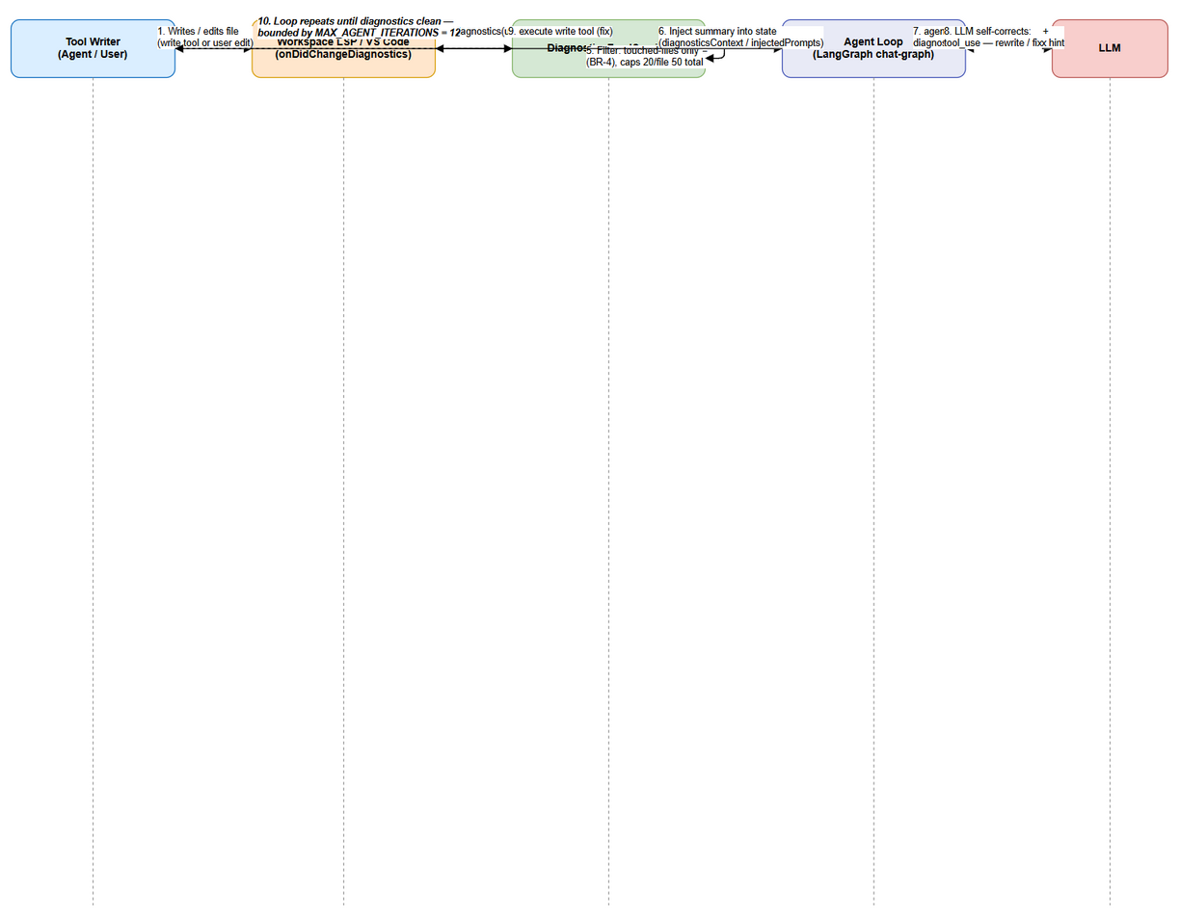 Edit in draw.io

6.4 Integration: VS Code Settings (lifecycle)
Attribute | Value
Protocol | vscode.workspace.onDidChangeConfiguration + affectsConfiguration("kiroSdlc.enableDiagnosticsFeed")
Pattern source | extension/src/extension.ts:307-313 (existing mcpServerPort watcher) — NOT ConfigWatcher (V8)
Apply timing | immediate (no reload) — BR-9
Lifecycle wiring | activate(): instantiate DiagnosticsFeedService(wsRoot); push to context.subscriptions; register config watcher; pass instance into engine before graph build
Toggle behavior contract (maps to FSD §3.3 UC-03):
Value | System behavior
true (default) | UC-01+UC-02 active; batches flow; listener collected
false | setEnabled(false): epoch++, timer cancelled, pendingUris+pendingSummary discarded (BR-10); loop unchanged
false → true mid-session | next event processed immediately (AF-02)
Rapid toggle | epoch++ invalidates in-flight flush → last state wins (UC-03 EF-02)
Headless/non-VS Code read | treated as disabled — no injection (UC-03 EF-01)

6.5 Integration: KSA-178 & get_diagnostics (no-regression guarantee)
System | Guarantee | Evidence
diagnostics-provider.ts (KSA-178) | zero source changes; save-triggered code_search diagnostics + CodeActions keep working | no import, no call-site change
get_diagnostics tool | zero source changes; pull-based fallback remains available | vscode-tools.ts:16 untouched
Separation rationale | KSA-178 = pull/save-triggered; feed = push/realtime; different sources (code_search vs LSP) — must NOT be merged (BRD §1.1 anchor 4, TC-18) | —

7. Security Design
Prerequisite: Business security requirements (roles, classification, audit) are in FSD §7. This section specifies technical implementation. Threat model is minimal: no new network, no external I/O, no new permissions — verified no net-new egress (BRD §6 NFR Security).

7.1 Trust Boundary & Authentication
- No authentication needed: the feed reads diagnostics via VS Code’s own host-internal API (vscode.languages). There is no HTTP endpoint, no token, no new credential.
- Trust boundary: the feed trusts the Extension Host’s LSP channel only. User-controlled input (diagnostic messages) is treated as data, never as instructions — it is embedded in a system-prompt summary but the agent’s tool-permission gates remain authoritative (BR-13).

7.2 Authorization
Role | Permissions | Enforcement
End user (developer) | toggle kiroSdlc.enableDiagnosticsFeed via Settings UI | VS Code configuration schema (boolean only)
Agent (LLM) | may attempt fixes via existing write tools | existing ToolApprovalGate (requiresApproval + requestApproval, chat-graph-nodes.ts:302-315) — not bypassed (BR-13); auto-fix advisory only
Extension Host | subscribe onDidChangeDiagnostics, call getDiagnostics | VS Code API surface; read-only diagnostic data
Hook authors / askAgent hooks | produce injectedPrompts | dedupe rule: feed summaries NEVER flow through injectedPrompts (RC-2)

7.3 Data Protection
Data Type | At Rest | In Transit | In Logs
LSP diagnostics (source-file messages) | in-memory only (no persistence) | N/A (host-internal) | truncated header + counts only; never full messages of large batches
Touched-files set | in-memory Set<string> | N/A | file paths only at DEBUG level
Source code file paths | in-memory / already in workspace | N/A | workspace-relative only
LLM API keys / tokens | VS Code SecretStorage (unchanged) | TLS to provider (unchanged) | never logged
No encryption-at-rest is applicable: the feature persists nothing (BRD §1.2). The extension’s credential handling (VS Code SecretStorage) and network posture are unchanged by this feature.

7.4 Input Validation
Field | Validation | Sanitization
event.uris[] | scheme === "file"; inside active workspace (BR-3) | excluded otherwise
line | positive integer | clamped to file’s line count at summary build
severity | enum mapping from DiagnosticSeverity (BR-6) | invalid/unknown → excluded
message | non-empty string | length-bounded by tokenBudgetChars (≤8000 chars per batch)
code | optional string | String(d.code ?? "")
kiroSdlc.enableDiagnosticsFeed | boolean only (VS Code schema) | read failure → disabled (EF-01)
touchedFiles membership | workspace-relative path containment | paths outside workspace skipped (BR-3)
Prompt-injection surface | diagnostic message text in system prompt | treated as data; tool gates still apply; summary prefix marks it as feed output (BR-6 header)

7.5 Audit Trail (technical)
Event | Logged Fields (debug-logger) | Retention
Batch flushed | uris=N entries=M kept=K truncated=K-M | session log “SDLC Agents Debug”
Toggle change | enabled=<bool> epoch=<n> | session log
Injection consumed | take pending=1 (channel set) | session log
Auto-fix directive added | summary contains ≥1 error line (part of prompt build) | session log (prompt preview)
getDiagnostics failure | [WARN] getDiagnostics failed: <uri> | session log
Structured format | [DD-FEED] <event> key=value [key=value …] | session log (existing convention)

8. Performance & Scalability
Prerequisite: Business NFR targets are in FSD §8. This section specifies how the technical design achieves them.

8.1 Caching Strategy
Cache | What | TTL | Eviction | Technology
enabled setting | mirrored toggle value | until onDidChangeConfiguration | event-invalidated | in-memory field
touchedFiles | session touched paths | session | clearSession() / dispose() | in-memory Set<string>
pendingSummary | latest built summary | until next flush/turn | superseded by newer flush; cleared by takePendingSummary/setEnabled(false) | in-memory string
pendingUris | accumulated URIs | 300 ms window | flush clears | in-memory array
No cache of diagnostics — getDiagnostics(uri) is always read fresh at flush time (BR-2 snapshot semantics). No distributed cache (single-process extension host).

8.2 Connection / Resource Pooling
Resource | Notes
VS Code subscription | exactly ONE onDidChangeDiagnostics listener per service instance; created on start(), disposed on stop()/dispose()
Timers | at most one debounce setTimeout outstanding; always clearTimeout before re-arming (BR-2)
LLM calls | the feed itself performs zero LLM calls — no per-event round-trip (No per-event LLM round-trip invariant, FSD §10.6)

8.3 Performance Targets (measured in Vitest, FSD §10.6)
Operation | Target | Measurement
Debounce latency | flush fires at 300 ms ± 10 ms after last event | vi.useFakeTimers() assertions
filter + buildSummary | ≤ 5 ms per 100-diagnostic batch (p95) | performance.now() loop ×1000
Stable event → pendingSummary set | ≤ 500 ms overhead (NFR) | integration timing test
Context budget | summary ≤ 8000 chars (~2000 tokens) at all times | property test with pathological inputs
LLM involvement | 10 events → 1 flush → 0 LLM calls from the feed | spy on chatWithTools
Memory growth | no growth across sessions (session-scoped state) | service lifecycle assertion

8.4 Scalability & Storm Handling
- Bursts: 300 ms debounce coalesces N events → exactly 1 flush (UC-01 AF-01).
- Storm beyond capacity: caps (20/file, 50 total) + truncation marker bound every batch (EF-02).
- Large workspaces: scoping to workspace + touched-files set keeps the interesting set tiny even in huge repos.
- No per-event LLM round-trip: single flush → single state write → single prompt merge — the agent sees at most one summary per turn (RC-4).

9. Monitoring & Observability
All feed observability reuses the existing debug-logger.ts infrastructure (SDLC Agents Debug output channel) and the existing StreamHandler chat:toolCall events — no new loggers, metrics systems, or event types (FSD §10.5, NFR Observability).

9.1 Logging
Log Event | Level | Fields | When
[DD-FEED] onDidChange | DEBUG | uris=n eligible=m pending=k | event received
[DD-FEED] flush | DEBUG | uris=n entries=m kept=k truncated=t | quiet-window flush
[DD-FEED] take | DEBUG | pending=1 | node consumed buffer
[DD-FEED] enabled | DEBUG | enabled=<bool> epoch=<n> | setEnabled()
[DD-FEED] [WARN] getDiagnostics failed | WARN | <uri> — <msg> | per-URI failure (E-2)
[DD-FEED] [WARN] settings read failed | WARN | — | headless read (E-12)
[chat-graph-nodes] postToolUse hook error | ERROR | tool name, error | existing (E-11, unchanged)
Hook chat:toolCall events | INFO (stream) | toolName, args, status | existing StreamHandler stream; feed work during tool exec visible

9.2 Metrics
Metric | Type | Description | Alert Threshold
no. of flushes / session | Counter (log-derived) | batch count | informational only
entries kept vs dropped | Counter (log-derived) | caps effectiveness | dropped ratio > 0.9 → review caps
injection latency (event → state) | Gauge (integration test) | NFR ≤ 500 ms | > 500 ms
summary size | Gauge | ≤ 8000 chars invariant | > 8000 chars = defect
No external metrics pipeline (OpenTelemetry/Prometheus) is introduced — consistent with the extension-only scope. QA validates via log assertions in Vitest integration tests.

9.3 Health Checks
N/A for an in-process extension service (no HTTP health endpoint). Runtime health proxies:
Check | How | Expected
Feed enabled + listener attached | service introspection / getHookCount-style debug log on start() | subscription registered
Loop unaffected when feed idle | graph integration test asserting identical output with feed disabled | no channel writes
Toggle applies live | config-change unit test | setEnabled reflected without reload

10. Deployment Considerations

10.1 Environment Configuration
No environment matrix exists for an extension-internal feature. The only configuration surface is the VS Code setting (workspace or user scope):
Property | Default | Scope | Behavior
kiroSdlc.enableDiagnosticsFeed | true | user / workspace (VS Code standard resolution) | master switch (BR-8)
debounce (300 ms), caps (20/50), budget (8000) | constants in DEFAULT_CONFIG | code (v1, fixed) | configurability deferred (BRD §5.2)
The existing extension build pipeline (npm run esbuild / esbuild-production, then vsce package) is unchanged — no new build steps, no new bundles.

10.2 Feature Flags
Flag | Default | Description
kiroSdlc.enableDiagnosticsFeed | true | The feed setting doubles as the feature flag: off → the inject_diagnostics node still runs but always returns {} (no channel churn, zero behavior change). Ideal for progressive rollout through VS Code Settings UI / settings.json.
code-level diagnosticsFeed param | undefined (off) | When the engine is constructed without a feed (older call sites/tests), the node no-ops — a second, code-level off-switch (E-8)
Both off-switches are independent and safe: setting off ≠ param undefined. The agent loop runs exactly as today when either is inactive (BR-10).

10.3 Rollback Strategy
- Instant user-level rollback: set kiroSdlc.enableDiagnosticsFeed: false in settings (deleting the key restores the default true, so an explicit false is the off-switch) — no reload, no redeploy (BR-9/BR-10).
- Release rollback: revert the extension version to the pre-SA4E-185 build. The new channel/node are inert without the service; write_file: "write" addition in TOOL_CATEGORIES is additive and harmless to roll back.
- No database migrations, no server changes — rollback is trivially clean.
⚠️ NOTE TO SM/DEV: the TOOL_CATEGORIES write_file mapping (DR-1 Layer A) is the ONLY change that alters pre-existing hook behavior (file hooks will now fire for write_file). This is intended and beneficial, but verify existing hook definitions (hook-loader) remain correct in staging before release.

10.4 Backward Compatibility
Scenario | Behavior
Feed param undefined (tests / old call sites) | node no-ops; graph identical (E-8)
Setting key absent | default true (out of the box, AC-4/Story 3)
Headless / non-VS Code | treated as disabled (EF-01)
No workspace / no LSP provider | no events or empty snapshot → no injection (UC-01 EF-01)
KSA-178 + get_diagnostics | untouched (TC-18)
Both chat-graph variants (RAG/standard) | identical wiring applied (V14)

11. E2E Test Architecture
Knowledge transfer SA → DEV. This section documents the verified test structure of extension/ and specifies exactly which tests to implement for SA4E-185 so DEV can implement E2E coverage without re-analyzing the module. It complements FSD §10.Testing (TC-01…TC-19) and TA §10.6.

11.1 Framework & Language
- Framework: Vitest ^4.1.8 (extension/package.json:387,413) — unit + integration + E2E-API.
- Language: TypeScript (matches the project’s main language; shares types with production code).
- Test commands: npm test (vitest run --exclude '**/*.e2e.test.ts'), npm run test:e2e (targeted E2E files).
- Layout: colocated __tests__/ folders next to source (e.g., extension/src/langgraph/__tests__/chat-graph-agent-step.test.ts, chat-graph-loop.test.ts).
- E2E-UI: Playwright E2E exists for the Chat Panel (__tests__/chat-panel-e2e.test.ts) — the feed adds no new UI, so no new Playwright file is required (optional nice-to-have feeds indicator is deferred).

11.2 Test Structure
Tier | Location | Purpose
Unit | extension/src/langgraph/diagnostics/__tests__/*.test.ts | Feed service / config / node in isolation (mock vscode.languages)
Unit | extension/src/langgraph/__tests__/diagnostics-state-channel.test.ts | channel reducer + consume-once semantics
Integration | extension/src/langgraph/__tests__/chat-graph-diagnostics.integration.test.ts | full buildChatSubgraph with a wired feed (TC-08/14/15/16)
E2E-API | reuse existing chat-panel-e2e.test.ts pattern | end-to-end chat invoke with feed (optional; integration tier covers graph-level)
E2E-UI | none new | no UI surface in v1 (Chat Panel indicator is nice-to-have)

11.3 Reusable Components (existing patterns to reuse)
Component | File (verified) | Reuse
buildChatSubgraph with mocked LlmProvider + dummy wsRoot + mcpBridge=undefined | langgraph/__tests__/chat-graph-agent-step.test.ts | integration tests invoke graph directly; assert LLM-visible prompts via spy
Tiny Emitter stub for onDidChangeDiagnostics; getDiagnostics(uri) as configurable map | mock convention from langgraph/__tests__/ (e.g., mcp-bridge.test.ts) | feed-service unit tests
vi.useFakeTimers() for debounce | standard Vitest | 300 ms assertions (TC-02/03)
debugLog/debugError | src/debug-logger.ts (spied) | assert [DD-FEED] log events
HookEngine real instance with temp workspace hooks dir | langgraph/__tests__/hook-loader.test.ts conventions | write-classification + file-hook integration
classifyTool/extractFilePath | hooks/hook-tool-matcher.ts (direct) | unit tests for markTouchedFromTool incl. write_file (OI-1)

11.4 E2E-API Test Design — chat-graph-diagnostics.integration.test.ts
- File: extension/src/langgraph/__tests__/chat-graph-diagnostics.integration.test.ts
- Auth setup: none required — graph is invoked directly with mocked LlmProvider returning fixed text/tool responses (same as chat-graph-agent-step.test.ts).
- Data cleanup: each test creates a fresh DiagnosticsFeedService with a temp workspaceRoot and clearSession()/dispose() in afterEach; touchedFiles/pendingSummary are per-instance (no shared state).
Test | Scenario | Assert | FSD TC
Consume-once end-to-end | buffer set → invoke graph (text) | prompt turn 1 contains [Diagnostics feed]; turn 2 does not | TC-08
Loop re-entry freshness | buffer flushed during execute_tools (write path) | next agent_step prompt contains the summary | BR-7
Auto-fix directive | summary with ≥1 error line | system prompt includes advisory instruction; warnings-only → none | TC-14 / UC-04 AF-01
Iteration bound | 13 write/fix cycles | graph exits at synthesize when agentIterations >= 12 | TC-16 / BR-12
No-op when disabled | setEnabled(false); events fire | channel never set; loop output identical to baseline | TC-10 / BR-10
No regression | run untouched KSA-178 provider tests + get_diagnostics probes | unchanged | TC-18

11.5 E2E-UI Test Design
None required in v1. If the optional Chat Panel feed indicator (FSD §3.3.5 nice-to-have) is later implemented, it reuses the existing chat-panel-e2e.test.ts Playwright harness and only asserts that the toggle click reflects getConfiguration("kiroSdlc").get("enableDiagnosticsFeed") — the setting remains the source of truth.

11.6 Service Unit Test Matrix (per FSD TA §10.6 — implementer contract)
Test | Input | Assert
Subscription registered/disposed | start() then stop() | listener attached/detached (TC-01)
Debounce merges burst | 10 events < 300 ms | getDiagnostics called exactly once with 10 URIs (TC-02)
No flush before quiet | 1 event, 299 ms | no call; at 300 ms → call (TC-03)
Workspace/file-scheme filter | out-of-workspace + untitled: URIs | excluded (TC-04)
Touched-file filter | A touched, B untouched | only A in summary (TC-05)
markTouchedFromTool population | write_file, fs_write, stream_write_file, str_replace | all added (covers OI-1: classify says “other” → allowlist still adds) (TC-06)
Summary fields | mixed batch | every line file:line severity code message (TC-07)
Dedupe + line clamp | dup (file,line,code); line 9999 | 1 entry; clamped (Validation)
Caps N/M | 100 diagnostics | 20/file + 50 total + marker (TC-09)
Budget guard | pathological messages | output ≤ 8000 chars (V13)
Toggle off/resume/discard | setEnabled(false) mid-window | no flush; takePendingSummary() → null (TC-10/11/12)
Default enabled | config true | starts enabled (TC-13)
Read-once | 2 calls to takePendingSummary | 1st returns, 2nd null (TC-08 unit level)
Headless read | getConfiguration undefined | treated disabled; no throw (TC-19)
write_file classification | classifyTool("write_file") after DR-1 | "write" (OI-1 regression)

12. Implementation Checklist
DEV implementer contract — ordered by dependency. All changes verified against actual source lines on 2026-08-20.

12.1 New Files (4 source + 5 test)
# | Task | File | Priority
1 | Type definitions (DiagnosticsBatchEntry, DiagnosticsFeedConfig, FeedSummary) | extension/src/langgraph/diagnostics/diagnostics-feed-types.ts | P0
2 | DiagnosticsFeedService class (§3.2, §4.3, DR-1 Layer B) | extension/src/langgraph/diagnostics/diagnostics-feed-service.ts | P0
3 | Graph node factory (§3.3) | extension/src/langgraph/diagnostics/inject-diagnostics-node.ts | P0
4 | Service unit tests (matrix §11.6) | extension/src/langgraph/diagnostics/__tests__/diagnostics-feed-service.test.ts | P0
5 | Config/toggle/caps unit tests | extension/src/langgraph/diagnostics/__tests__/diagnostics-feed-config.test.ts | P1
6 | Node no-op/read-once tests | extension/src/langgraph/diagnostics/__tests__/inject-diagnostics-node.test.ts | P1
7 | Channel reducer + consume-once tests | extension/src/langgraph/__tests__/diagnostics-state-channel.test.ts | P1
8 | Graph integration tests (§11.4) | extension/src/langgraph/__tests__/chat-graph-diagnostics.integration.test.ts | P1

12.2 Modified Files (8)
# | Task | File (verified line) | Priority
9 | Add diagnosticsContext channel after kbContext | extension/src/langgraph/core/state.ts:65 | P0
10 | OI-1 fix — add write_file: "write" to TOOL_CATEGORIES | extension/src/langgraph/hooks/hook-tool-matcher.ts:8-16 | P0
11 | Graph wiring: inject_diagnostics node/edges in BOTH variants; routeAfterToolExec → "inject_diagnostics"; buildFinalSystemPrompt append + auto-fix advisory; diagnosticsFeed 8th param | extension/src/langgraph/subgraphs/chat-graph.ts:167-172, 221-248, 269-305 | P0
12 | agent_step returns diagnosticsContext: "" on ALL payload paths; createExecuteToolsNode + executeSingleTool accept diagnosticsFeed and call markTouchedFromTool (DR-2) | extension/src/langgraph/subgraphs/chat-graph-nodes.ts:114-153, 233-285, 332-339 | P0
13 | kiroSdlc.enableDiagnosticsFeed setting schema after enableMcpServer | extension/package.json:217-221 | P0
14 | activate(): instantiate feed, register onDidChangeConfiguration watcher, push to context.subscriptions | extension/src/extension.ts:307-313 (pattern) | P0
15 | Engine: hold readonly diagnosticsFeed, pass to buildPipelineGraph, call clearSession() on new session | extension/src/langgraph/engine/langgraph-engine.ts:60-66 | P1
16 | Plumb optional diagnosticsFeed through buildPipelineGraph + buildRouterGraph → buildChatSubgraph | extension/src/langgraph/subgraphs/graph-builder.ts:37, extension/src/langgraph/router/router-graph.ts:80 | P1

12.3 Traceability (FSD → TDD)
FSD requirement | TDD section | Key design element
UC-01 (BR-1/2/3) | §3.2, §3.6, §6.1 | subscription + 300 ms debounce + URI scoping
UC-02 (BR-4/5/6/7) | §3.2-3.4, §4.2-4.3, §5.4 | touched filter, read-once buffer, channel write/clear
UC-03 (BR-8/9/10) | §3.5, §6.4, §10.2 | settings schema + live watch + discard on disable
UC-04 (BR-11/12/13) | §3.8, §6.3, §7.2 | auto-fix advisory + iteration bound + approval gates
TA §10.1 service design | §3.2, §4.3, §5.2 | file list, fields, methods, skeleton
TA §10.2 channel | §3.4, §5.4 | declaration + single-writer + clear-after-turn
TA §10.3 graph wiring | §3.8, §6.3 | node placement + routeAfterToolExec + call sites
TA §10.4 setting | §3.5, §6.4 | registration + read + watch (NOT ConfigWatcher)
TA §10.5 error matrix | §5.5, §6.1 | E-1…E-15 + [DD-FEED] format
TA §10.6 tests | §11 | full test matrix
OI-1 | §5.4 DR-1 | TOOL_CATEGORIES + allowlist fallback
OI-2 | §5.4 DR-2 | channel-authoritative; documented discard
BRD §1.1 anchor (no contextItems) | §1.4, §3.4 | new diagnosticsContext channel (validates FSD §3.5)
BRD §1.2 out-of-scope | §1.2, §6.5 | KSA-178 + get_diagnostics untouched; no persistence

13. Appendix

13.1 Glossary
Term | Definition
LSP | Language Server Protocol — used by VS Code to surface diagnostics from language servers
onDidChangeDiagnostics | VS Code event fired when language-server diagnostics change
DiagnosticsFeedService | NEW extension service implementing the push-based feed (FSD §10.1)
diagnosticsContext | NEW PipelineAnnotation channel carrying the bounded feed summary (single-writer: inject_diagnostics)
injectedPrompts | string[] from hooks — intentionally NOT used for feed content (DR-2, dedupe rule)
Touched files | files written by agent write tools in the current chat session (BR-5)
epoch guard | generation counter discarding stale async flush callbacks (RC-1/RC-5)
MAX_AGENT_ITERATIONS | 12 — loop guard constant (chat-graph.ts:33)
TOOL_CATEGORIES | hook-tool-matcher.ts classification map; now includes write_file: "write" (OI-1)

13.2 Open Issues / Resolutions
ID | Issue | Status | Decision / Owner
OI-1 | write_file missing from TOOL_CATEGORIES | RESOLVED (this TDD, DR-1) | Two-layer fix: add write_file: "write" + markTouchedFromTool allowlist fallback. Owner: DEV, before code start
OI-2 | firePostToolUse result discarded (chat-graph-nodes.ts:334) | RESOLVED (this TDD, DR-2) | Channel-authoritative design; discard is now intentional + documented; markTouchedFromTool wired beside it. Owner: DEV
OI-3 | chat:toolCall UX visibility per flush (optional) | Deferred (DEV, during DEV) | Optional StreamHandler.emitDirect(...) per flush; no new event types
OI-4 | 2000-token budget enforcement | Resolved in design | 8000-char guard in buildSummary (V13); revisit if per-token estimation is exposed
OI-5 | epoch/single-writer invariants → STC mapping | QA phase | QA maps RC-1…RC-6 rows to STC (FSD §10.6)
OI-6 | FSD §2.2 “injectedPrompts merged into loop” claim false | RESOLVED | Verified V4; documented in §5.4 DR-2 and §13.3 DISC-2
Open | Optional Chat Panel feed indicator UI | Deferred | nice-to-have (FSD §3.3.5); setting remains source of truth

13.3 FSD Discrepancy Summary (FSD vs actual codebase — SA verification)
Per requirements, no separate DISCREPANCY.md file is created; the report is embedded here and in the delivery report. Findings were verified directly against extension/src on 2026-08-20 (supersede any BA-level claims; see FSD TA §10.0 V1–V15).
# | Severity | FSD claim | Actual codebase (verified) | Impact & resolution
DISC-1 | High | Write tools classify as write for BR-5 population (FSD §3.1.1) | write_file is NOT in TOOL_CATEGORIES (hook-tool-matcher.ts:8-16) → classifies "other"; fireFileHooks never fires (V5/OI-1) | Touched-set misses the primary write tool → feed empty for write_file writes. Resolved by DR-1 (§5.4). BA FSD wording acceptable but technically misleading — TA already flagged as V5
DISC-2 | High | FSD §2.2 “injectedPrompts merged back into the loop” | chat-graph-nodes.ts:334 discards the firePostToolUse return value entirely (V4/OI-2) | If the feed had relied on the hook path it would never deliver. Resolved by channel-authoritative design DR-2 (§5.4)
DISC-3 | Low | FSD §3.3 “existing config-watcher” for settings | config-watcher.ts watches ONLY .kiro/settings/mcp.json; real VS Code settings use onDidChangeConfiguration (extension.ts:307-313) (V8) | Using ConfigWatcher would never react to the feed setting. TDD mandates onDidChangeConfiguration + affectsConfiguration (§3.5, §6.4). BA doc wording updated post-hoc by TA
DISC-4 | Low | FSD §4.1 “no ER diagram produced” | Consistent — no persisted entities (BRD §1.2) | No action. TDD §4 confirms no DB/DDL
DISC-5 | Info | contextItems injection (BRD §8.2) | No contextItems channel exists (state.ts:23-66) (V2) | FSD §3.5 already recommended new diagnosticsContext — TDD validates and locks it (§1.4, §3.4)
Severity tally: Critical 0 · High 2 · Low 2 · Info 1. No Critical discrepancies — the feature is implementable as designed following DR-1/DR-2/DR-3.

13.4 Diagram Index
# | Diagram | Image | Source (editable) | Section
1 | Architecture Overview |  | architecture.drawio | §2.1
2 | Component Diagram |  | component.drawio | §2.2
3 | Class Diagram — Diagnostics Feed |  | class-diagnostics.drawio | §5.2
4 | Sequence — Diagnostics Feed (from FSD) |  | sequence-diagnostics-feed.drawio | §6.3
5 | State — Feed Lifecycle (from FSD) |  | state-diagnostics.drawio | §4.4
All 5 PNGs exist. Diagrams 1–3 are new in this TDD; 4–5 were produced by BA/TA (FSD). Every .drawio follows the project draw.io-only convention (no Mermaid) and the validated XML format (expanded edge geometry, no <mxfile> wrapper).

13.5 References (verified code lines)
Reference | Location
MAX_AGENT_ITERATIONS = 12 | extension/src/langgraph/subgraphs/chat-graph.ts:33
routeAfterToolExec | chat-graph.ts:167-172
buildFinalSystemPrompt kbContext merge | chat-graph.ts:244-247
RAG + standard graph variants | chat-graph.ts:269-288, 291-305
kbContext channel | extension/src/langgraph/core/state.ts:65
TOOL_CATEGORIES (write_file gap) | extension/src/langgraph/hooks/hook-tool-matcher.ts:8-16
firePostToolUse + fireFileHooks | extension/src/langgraph/hooks/hook-engine.ts:82-102
firePostToolUse result discarded | extension/src/langgraph/subgraphs/chat-graph-nodes.ts:332-339
execute_tools agentIterations++ | chat-graph-nodes.ts:283
KSA-178 save-triggered provider | extension/src/diagnostics-provider.ts:37-50
ConfigWatcher mcp.json only | extension/src/config-watcher.ts:49-66
onDidChangeConfiguration pattern | extension/src/extension.ts:307-313
enableMcpServer setting template | extension/package.json:217-221
buildChatSubgraph prod call site | extension/src/langgraph/router/router-graph.ts:80
HookEngine ownership | extension/src/langgraph/engine/langgraph-engine.ts:60
buildRouterGraph call | extension/src/langgraph/subgraphs/graph-builder.ts:37
write_file / get_diagnostics tools | extension/src/langgraph/vscode/vscode-tools.ts:15-16
debugLog / debugError | extension/src/debug-logger.ts

End of TDD — SA4E-185 v1.0. Validated against extension source on 2026-08-20.

