Business Requirements Document (BRD)

SDLC Agents 4 Enterprise — SA4E-48: OpenCode v1.17.15 SSE error 405 — WrapperServer missing endpoint event

Document Information
Field | Value
Jira Ticket | SA4E-48
Title | OpenCode v1.17.15 SSE error 405 — WrapperServer missing endpoint event
Author | BA Agent
Version | 1.0
Date | 2026-07-20
Status | Draft

Author Tracking
Role | Name - Position | Responsibility
Author | BA Agent – Business Analyst | Create document
Peer Reviewer | TBD – Technical Lead | Review document

Revision History
Version | Date | Author | Changes
1.0 | 2026-07-20 | BA Agent | Initiate document — auto-generated from Jira ticket SA4E-48

Sign-Off
Name | Signature and date
 | ☐ I agree and confirm all criteria on this BRD as expected requirements
 | ☐ I agree and confirm all criteria on this BRD as expected requirements

1. Introduction

1.1 Scope
This BRD covers the bug fix for the WrapperServer component of the SDLC Agents 4 Enterprise system. The issue is that OpenCode CLI v1.17.15 (a remote MCP client) fails to connect to the WrapperServer running on port 9186, reporting:
"code-intel SSE error: Non-200 status code (405)"
The root cause is two-fold: 1. Stale compiled output: The running extension (Code.exe on port 9186) was using old compiled code where handleMcp() returned HTTP 405 for all non-POST requests. The source code already had a handleMcpGet() method, but the compiled out/services/WrapperServer.js was outdated. 2. Missing SSE endpoint event: The source’s handleMcpGet() implementation sent an event: message with an initialized notification, but did not send the mandatory event: endpoint with data: /mcp as required by the MCP Streamable HTTP transport specification. The SSE client (SSEClientTransport in the MCP SDK) waits for the endpoint event to know where to send JSON-RPC POST requests.
The fix requires: - Adding event: endpoint + data: /mcp to the SSE response in WrapperServer.handleMcpGet() - Recompiling the extension - Updating/adding regression tests to prevent silent regressions - Building a new VSIX and tagging the release

1.2 Out of Scope
- Changes to the MCP JSON-RPC POST handler (handleMcp for POST requests) — this was already working correctly
- Changes to the backend REST API that WrapperServer proxies to
- Changes to the health endpoint (/health)
- Changes to CORS or authentication mechanisms
- Any functional enhancements beyond the SSE connection fix
- Other MCP transport modes (e.g., stdio)

1.3 Preliminary Requirement
- Access to the source code repository at extension/src/services/WrapperServer.ts
- Node.js/npm build environment for recompilation
- VS Code Extension Manager for VSIX packaging and installation
- MCP-compatible client (OpenCode CLI v1.17.15 or later) for verification
- Existing unit test suite must pass (minimum 545 tests)

2. Business Requirements

2.1 High Level Process Map
Diagrams (draw.io): 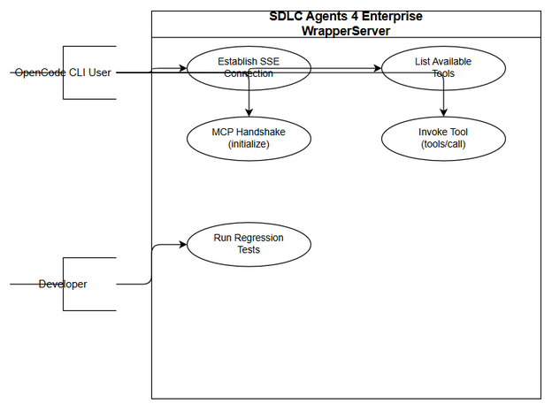 Edit in draw.io
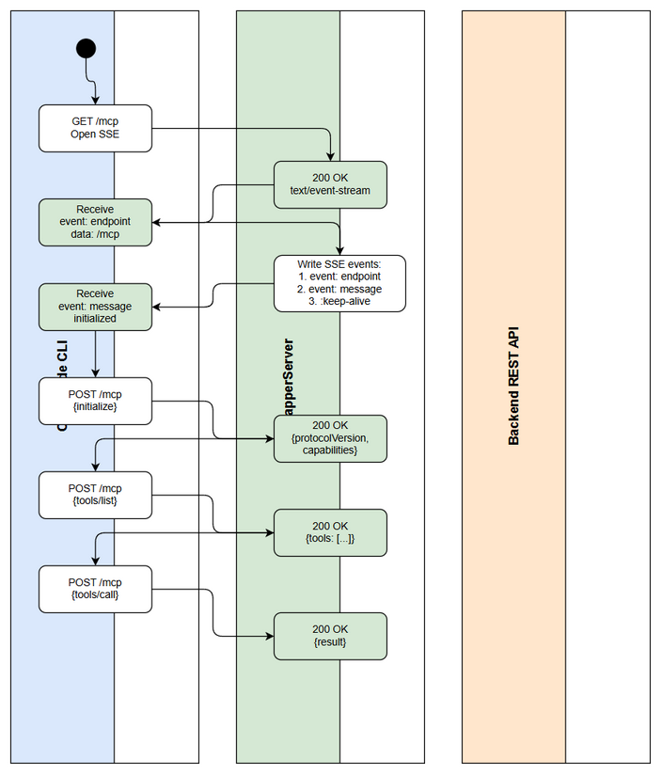 Edit in draw.io
The business process for the MCP connection between OpenCode CLI and the SDLC Agents 4 Enterprise extension follows this flow:
Step 1: OpenCode CLI (MCP client) starts and reads the MCP server configuration pointing to http://localhost:9186/mcp
Step 2: OpenCode CLI opens an SSE connection via GET /mcp to establish a server-sent events channel for receiving unsolicited server messages
Step 3: The WrapperServer must respond with: - HTTP 200 and Content-Type: text/event-stream - An event: endpoint with data: /mcp to tell the client where to send POST requests - An event: message with data: {"jsonrpc":"2.0","method":"initialized"} to signal the server is ready
Step 4: OpenCode CLI reads the endpoint event and starts sending JSON-RPC POST requests to the specified endpoint
Step 5: The WrapperServer processes the MCP handshake (initialize method), negotiates protocol version, and responds with server capabilities
Step 6: After initialization, the client sends tools/list and tools/call requests to invoke available tools
Step 7: If any step in the SSE handshake fails, the OpenCode CLI reports an error and the connection cannot be established
Note: The missing event: endpoint caused the SSE client to never receive the POST URL, resulting in the 405 error when the client sent POST requests to the wrong path or kept waiting forever.
flowchart TD
A[OpenCode CLI starts] --> B[Open SSE connection GET /mcp]
B --> C{WrapperServer responds?}
C -->|200 + SSE events| D[Client receives endpoint event]
C -->|405 or missing endpoint| E[Client error: 'SSE error 405']
D --> F[Client sends JSON-RPC POST to /mcp]
F --> G[MCP Handshake: initialize]
G --> H[Protocol negotiated]
H --> I[Client sends tools/list]
I --> J[Tools returned successfully]
J --> K[Client invokes tools via tools/call]
E --> L[Connection failed - manual fix required]

2.2 List of User Stories / Use Cases
# | Story / Use Case / Epic | Priority | Source Ticket
1 | As an OpenCode CLI user, I want the MCP connection to WrapperServer to succeed without errors so that I can use SDLC Agents tools. | MUST HAVE | SA4E-48
2 | As a developer, I want regression tests that guard against MCP handshake failures so that future changes do not silently break the connection. | MUST HAVE | SA4E-48
3 | As a maintainer, I want the compiled extension output to be in sync with source code so that deployed code always matches the latest fix. | SHOULD HAVE | SA4E-48

2.3 Details of User Stories

Business Flow
sequenceDiagram
participant CLI as OpenCode CLI
participant WS as WrapperServer<br/>port 9186
participant BE as Backend REST API
CLI->>WS: GET /mcp (SSE connect)
WS-->>CLI: 200 OK + Content-Type: text/event-stream
WS-->>CLI: event: endpoint<br/>data: /mcp
WS-->>CLI: event: message<br/>data: {jsonrpc, initialized}
Note over CLI,WS: SSE established ✅
CLI->>WS: POST /mcp (initialize)
WS-->>CLI: 200 {protocolVersion, capabilities}
CLI->>WS: POST /mcp (notifications/initialized)
WS-->>CLI: 202 Accepted
CLI->>WS: POST /mcp (tools/list)
WS->>BE: REST GET tools
BE-->>WS: tool definitions
WS-->>CLI: 200 {tools: [...]}
CLI->>WS: POST /mcp (tools/call)
WS->>BE: REST call tool
BE-->>WS: tool result
WS-->>CLI: 200 {result}
Note: The SSE handshake must include event: endpoint BEFORE event: message. The MCP SDK’s SSEClientTransport blocks on reading the endpoint event to determine the POST URL. Without it, the client never knows where to send JSON-RPC requests and eventually times out or errors.

STORY 1: MCP SSE Connection Handshake
As an OpenCode CLI user, I want the MCP connection to WrapperServer to succeed without errors so that I can use SDLC Agents tools.
Requirement Details:
- The WrapperServer GET /mcp endpoint must return HTTP 200 with Content-Type: text/event-stream
- The SSE stream must include an event: endpoint followed by data: /mcp as the first event
- The SSE stream must include an event: message followed by data: {"jsonrpc":"2.0","method":"initialized"} as a subsequent event
- The SSE stream must include periodic keep-alive comments (: keep-alive\n\n) every 15 seconds
- The WrapperServer POST /mcp endpoint must accept JSON-RPC requests after the SSE client has received the endpoint event
- The WrapperServer must correctly negotiate the MCP protocol version during the initialize handshake
Acceptance Criteria:
- GET /mcp returns HTTP 200 with Content-Type: text/event-stream (not 405)
- SSE stream contains event: endpoint\ndata: /mcp\n\n in the first events
- SSE stream contains event: message\ndata: {"jsonrpc":"2.0","method":"initialized"}\n\n
- POST /mcp returns HTTP 200 for valid JSON-RPC initialize requests with negotiated protocol version
- POST /mcp returns HTTP 202 for notifications/initialized
- POST /mcp returns HTTP 200 for tools/list with a valid tools array
- POST /mcp returns HTTP 200 for ping with empty result {}
- All unit tests pass (minimum 545 tests)

STORY 2: MCP Handshake Regression Tests
As a developer, I want regression tests that guard against MCP handshake failures so that future changes do not silently break the connection.
Requirement Details:
- Create regression test file mcp-handshake.regression.test.ts with 7 test cases
- Test REG-01: initialize method must be implemented (must NOT return -32601 Method not supported)
- Test REG-02: initialize must return protocolVersion, capabilities, and serverInfo
- Test REG-03: Full handshake flow initialize → initialized → tools/list must work end-to-end
- Test REG-04: ping must respond with empty result {}
- Test REG-05: GET /mcp must open an SSE stream (verify Content-Type and event structure)
- Test REG-06: Every required MCP method (initialize, ping, tools/list, tools/call) must not return -32601
- Test REG-07: Unknown/custom methods must still correctly return -32601 Method not supported
Acceptance Criteria:
- All 7 regression tests pass
- Tests guard specifically against the -32601 Method not supported: initialize error that previously broke VS Code connection
- Tests are independent and can run alongside existing wrapper-server tests

STORY 3: Compiled Output Synchronization
As a maintainer, I want the compiled extension output to be in sync with source code so that deployed code always matches the latest fix.
Requirement Details:
- After fixing source code, run npm run compile to recompile TypeScript to JavaScript
- The compiled out/services/WrapperServer.js must include the SSE endpoint fix
- Build VSIX using npm run package:debug
- Tag the release and update changelogs
Acceptance Criteria:
- npm run compile completes without errors
- VSIX file is built successfully
- All 545 tests pass after recompilation
- Release is tagged as v1.14.0

3. Dependencies
Dependency | Type | Related Ticket | Description
WrapperServer.ts source | Code | SA4E-48 | The source file containing the MCP HTTP handler that needs the SSE fix
MCP Streamable HTTP Transport Spec | Protocol | N/A | Specification requirement: SSE stream must include event: endpoint with POST URL
OpenCode CLI v1.17.15 | External | N/A | The MCP client that connects to WrapperServer and triggers the bug
VS Code Extension Runtime | System | N/A | The environment hosting the WrapperServer on port 9186
Node.js / npm | Build | N/A | Build toolchain required to compile TypeScript and package VSIX

4. Stakeholders
Role | Name / Team | Responsibility | Source
Reporter | Duc Nguyen Minh | Identified the bug, provided root cause analysis, implemented fix | Ticket reporter
Developer | Duc Nguyen Minh | Implemented the SSE fix, wrote regression tests, built VSIX | Ticket reporter
User | OpenCode CLI Users | Affected by the connection error, need working MCP connection | Ticket description
QA Engineer | TBD | Verify the fix across different environments | Assumption

5. Risks and Assumptions

5.1 Risks
Risk | Impact | Likelihood | Mitigation
Regression: MCP handshake changes break other MCP clients | High | Low | 7 regression tests guard the exact failure mode; 545 tests total
Stale compiled output after future changes | Medium | Medium | Add build step validation to CI; document compile requirement
Other MCP clients besides OpenCode CLI affected | Medium | Low | Only Streamable HTTP transport is affected; stdio transport is unchanged

5.2 Assumptions
- All MCP clients using the Streamable HTTP transport (not just OpenCode CLI) require the event: endpoint event
- The POST handler (handleMcp for POST) was already functional and needs no changes
- The compiled output mismatch was a one-time issue due to manual build process; CI pipeline will prevent recurrence
- The fix is backward-compatible — existing clients continue to work

6. Non-Functional Requirements
Category | Requirement | Details
Performance | SSE stream must not block the HTTP server | The SSE handler is non-blocking; keep-alive runs on a 15s interval timer
Security | No authentication bypass | The SSE endpoint does not expose sensitive data; authentication is handled at the MCP JSON-RPC layer
Scalability | Single-user local server | WrapperServer is a local-only server (127.0.0.1); no multi-user scaling needed
Availability | Server must restart on VS Code reload | WrapperServer lifecycle is tied to VS Code extension activation
If no non-functional requirements are identified from the tickets, state: “No specific non-functional requirements identified. To be confirmed with technical team.”

7. Related Tickets
Ticket Key | Summary | Status | Type | Relationship
SA4E-48 | OpenCode v1.17.15 SSE error 405 — WrapperServer missing endpoint event | To Do | Bug | Main ticket
No linked issues, subtasks, or epic relationships identified from Jira data.

8. Appendix

Glossary
Term | Definition
MCP | Model Context Protocol — a protocol that enables communication between LLM clients and tool servers
SSE | Server-Sent Events — a standard that allows servers to push events to clients over HTTP
Streamable HTTP | An MCP transport mode using SSE for server-to-client messages and HTTP POST for client-to-server messages
WrapperServer | A local HTTP server in the VS Code extension that bridges MCP JSON-RPC requests to the remote backend
SSEClientTransport | The MCP SDK client-side implementation that consumes SSE streams
JSON-RPC | A lightweight remote procedure call protocol using JSON encoding
VSIX | VS Code Extension package format
405 | HTTP status code “Method Not Allowed”
200 | HTTP status code “OK”

Reference Documents
Document | Link / Location
MCP Streamable HTTP Specification | https://spec.modelcontextprotocol.io/
WrapperServer Source Code | extension/src/services/WrapperServer.ts
Regression Tests | extension/src/tests/mcp-handshake.regression.test.ts
WrapperServer Tests | extension/src/tests/wrapper-server.test.ts

Technical Notes
The MCP Streamable HTTP transport specification requires the following SSE event sequence on GET /mcp:
event: endpoint
data: /mcp
event: message
data: {"jsonrpc":"2.0","method":"initialized"}
: keep-alive
The event: endpoint event is mandatory — it tells the SSE client the URL path where it should send subsequent HTTP POST requests containing JSON-RPC messages. Without this event, the SSEClientTransport in the MCP SDK cannot determine the POST endpoint, causing the connection to fail.
The fix adds exactly two lines to handleMcpGet() in WrapperServer.ts:
res.write("event: endpoint\n");
res.write("data: /mcp\n\n");

