Technical Design Document (TDD)

SDLC Agents 4 Enterprise — SA4E-48: OpenCode v1.17.15 SSE error 405 — WrapperServer missing endpoint event

Document Information
Field | Value
Jira Ticket | SA4E-48
Title | OpenCode v1.17.15 SSE error 405 — WrapperServer missing endpoint event
Author | SA Agent
Version | 1.0
Date | 2026-07-20
Status | Draft
Related BRD | documents/SA4E-48/BRD.md
Related FSD | documents/SA4E-48/FSD.md

Author Tracking
Role | Name - Position | Responsibility
Author | SA Agent – Solution Architect | Create document
Peer Reviewer | TBD – Technical Lead | Review document

Revision History
Version | Date | Author | Changes
1.0 | 2026-07-20 | SA Agent | Initiate document — auto-generated from BRD and FSD

Sign-Off
Name | Signature and date
 | ☐ I agree and confirm the technical design in this TDD
 | ☐ I agree and confirm the technical design in this TDD

1. Introduction
Scope Boundary: This TDD specifies HOW the SSE endpoint event fix is implemented in the WrapperServer component. It does NOT repeat functional requirements, business rules, or use cases — refer to the FSD for those. This document focuses on: module design, internal routing logic, sequence flows, API contracts, and test architecture.

1.1 Purpose
The purpose of this TDD is to document the technical implementation of the WrapperServer SSE endpoint event fix (SA4E-48). The fix ensures compliance with the MCP Streamable HTTP transport specification — specifically, the mandatory event: endpoint SSE event that tells the client where to send JSON-RPC POST requests.

1.2 Scope
This TDD covers the following technical aspects:
- Module Design — Full breakdown of WrapperServer.ts class, methods, and routing logic
- Sequence Flows — SSE handshake, JSON-RPC request lifecycle, error handling
- API Contract — Wire-level specification of SSE events and JSON-RPC request/response formats
- Class/Interface Design — Internal state, dependency injection, interface contracts
- Testing Strategy — Unit, integration, and regression test architecture
- Build & Deployment — Compilation, packaging, release process
Out of scope: - Backend REST API (Code Intelligence MCP Server) — unchanged - Base64ProxyService internals — unchanged - MCP stdio transport — unchanged - Authentication or security mechanisms — unchanged

1.3 Technology Stack
Layer | Technology | Version
Language | TypeScript | 5.x (from project)
Runtime | Node.js (VS Code Extension host) | 20.x
HTTP Server | Node.js native http module | Built-in
Test Framework | Vitest | ^1.x
Build Tool | npm / esbuild (VS Code extension) | —
Packaging | vsce (VS Code Extension Manager) | ^2.x

1.4 Design Principles
- MCP Streamable HTTP Compliance — The SSE stream must strictly follow the MCP specification: event: endpoint MUST precede event: message
- Zero Dependency — The fix uses only Node.js built-in http module; no additional npm dependencies
- Backward Compatibility — Existing JSON-RPC POST handlers remain unchanged; the fix only adds SSE events
- Minimal Change Surface — The fix adds exactly 2 lines of new code (event: endpoint + data: /mcp) to handleMcpGet()

1.5 Constraints
- Server is bound to 127.0.0.1 only — no external network exposure
- Body size is hard-limited to 1 MB (connection destroy on overflow)
- Protocol version list is hardcoded (not configurable) — identified as OI-01 in FSD
- No multi-user scaling — single-user local server

1.6 References
Document | Location
BRD | documents/SA4E-48/BRD.md
FSD | documents/SA4E-48/FSD.md
WrapperServer Source | extension/src/services/WrapperServer.ts
Regression Tests | extension/src/tests/mcp-handshake.regression.test.ts
Integration Tests | extension/src/tests/wrapper-server.test.ts
Test Helpers | extension/src/tests/wrapper-server.helpers.ts
MCP Spec | https://spec.modelcontextprotocol.io/
JSON-RPC 2.0 | https://www.jsonrpc.org/specification

2. System Architecture

2.1 Architecture Overview
The WrapperServer is a lightweight HTTP server embedded inside the VS Code extension process. It acts as a bridge between MCP clients (OpenCode CLI) and the backend Code Intelligence MCP Server.
Key architectural characteristics: - Single-process: Runs inside the VS Code extension host — no separate process - Synchronous routing: Request handler chain is synchronous (no middleware framework) - Stateless: No persistent state between requests (except requestId counter) - Proxy pattern: Most MCP tool calls are proxied to the backend REST API; only stream_write_file and embed_image execute locally
┌─────────────────────────────────────────────────────────────────────┐
│ OpenCode CLI (MCP Client) │
│ ┌──────────────────────────────┐ │
│ │ SSEClientTransport │──GET /mcp──► SSE stream │
│ │ │──POST /mcp──► JSON-RPC │
│ └──────────────────────────────┘ │
└─────────────────────────────────┬───────────────────────────────────┘
│ 127.0.0.1:9186
▼
┌─────────────────────────────────────────────────────────────────────┐
│ VS Code Extension Process │
│ ┌──────────────────────────────────────────────────────────────┐ │
│ │ WrapperServer │ │
│ │ ┌─────────────┐ ┌──────────────────┐ ┌─────────────────┐ │ │
│ │ │ handleReq() │─▶│ handleMcpGet() │ │ handleMcpPost() │ │ │
│ │ │ CORS, Route │ │ SSE stream │ │ JSON-RPC router │ │ │
│ │ └─────────────┘ └──────────────────┘ └────────┬────────┘ │ │
│ │ ┌─────────────────────────────────────────┼────────┐ │ │
│ │ ▼ ▼ │ │ │
│ │ ┌──────────────┐ ┌──────────────┐ ┌──────────────────┐ │ │
│ │ │Local Tools │ │REST Backend │ │Base64ProxyService│ │ │
│ │ └──────────────┘ └──────┬───────┘ └──────────────────┘ │ │
│ └───────────────────────────┼────────────────────────────────┘ │
└──────────────────────────────┼─────────────────────────────────────┘
│ HTTP
▼
┌──────────────────────────────────────┐
│ Code Intelligence MCP Server │
│ (Backend REST API) │
└──────────────────────────────────────┘
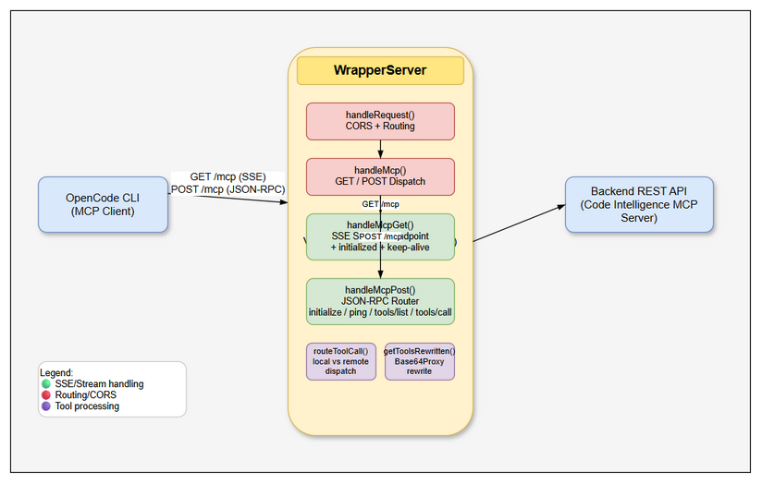 Edit in draw.io

2.2 Component Responsibilities
Component | Responsibility | Technology
handleRequest() | CORS headers, route dispatching (/mcp, /health, 404), error catch-all | Node.js http
handleMcp() | HTTP method dispatch (GET→SSE, POST→JSON-RPC, else→405), Content-Type validation, body reading, JSON-RPC routing | Node.js http
handleMcpGet() | SSE stream setup: headers, event: endpoint, event: message, keep-alive timer, connection cleanup | Node.js http + SSE
getToolsRewritten() | Fetch tools from backend REST, apply Base64ProxyService.rewriteSchemasForLlm() | Base64ProxyService
routeToolCall() | Dispatch to local tool, dynamic tool (with Base64Proxy unwrap), or proxied REST call | Base64ProxyService + executeLocalTool
Base64ProxyService | Schema rewrite (hide content_base64, add output_path), file proxy (read/write Base64) | Injected dependency

2.3 Deployment Architecture
The WrapperServer runs as part of the VS Code extension and has a simplified deployment model:
┌────────────────────────────────────────────────────────┐
│ Developer Workstation │
│ ┌──────────────────────────────────────────────────┐ │
│ │ VS Code (stable / insiders) │ │
│ │ ┌────────────────────────────────────────────┐ │ │
│ │ │ Extension: SDLC Agents 4 Enterprise │ │ │
│ │ │ ┌──────────────────────────────────────┐ │ │ │
│ │ │ │ WrapperServer (127.0.0.1:9186) │ │ │ │
│ │ │ └──────────────────────────────────────┘ │ │ │
│ │ │ ┌──────────────────────────────────────┐ │ │ │
│ │ │ │ OpenCode Extension (MCP v1.17.15+) │ │ │ │
│ │ │ └──────────────────────────────────────┘ │ │ │
│ │ └────────────────────────────────────────────┘ │ │
│ └──────────────────────────────────────────────────┘ │
│ │
│ ┌──────────────────────────────────────────────────┐ │
│ │ Backend Server (remote or localhost) │ │
│ │ Code Intelligence MCP Server │ │
│ └──────────────────────────────────────────────────┘ │
└────────────────────────────────────────────────────────┘
Key deployment points: - No containerization — runs as in-process HTTP server within VS Code - No clustering — one instance per VS Code window (unique port) - Backend REST API may be local or remote depending on configuration

2.4 Communication Patterns
From | To | Protocol | Pattern | Description
OpenCode CLI | WrapperServer | HTTP (SSE + JSON-RPC) | Sync (request-response) + Async (SSE push) | SSE for server→client events; POST for client→server RPC
WrapperServer | Backend REST | HTTP (JSON) | Sync (request-response) | Proxy REST calls for tools/list, tools/call

3. API Design
Prerequisite: Functional API contracts (parameters, business errors, data flows) are defined in FSD §3. This section specifies the technical implementation: wire-level SSE event ordering, JSON-RPC request/response schemas, HTTP status codes, and error code mapping.

3.1 API Overview
# | Endpoint | Method | Description | Source
1 | /mcp | GET | Open SSE stream for server-to-client MCP events | UC-01
2 | /mcp | POST | Handle JSON-RPC 2.0 MCP requests | UC-02
3 | /health | GET | Health check endpoint | —
4 | * | OPTIONS | CORS preflight handler | —

3.2 MCP SSE Event Schema
Implements: UC-01, BR-1, BR-2, BR-3, BR-4, BR-6, BR-9, BR-10
Attribute | Value
Method | GET
Path | /mcp
Auth | None (127.0.0.1 only)
Rate Limit | N/A (local server)
SSE Byte-Level Event Sequence (exact wire format):
event: endpoint\ndata: /mcp\n\n
event: message\ndata: {"jsonrpc":"2.0","method":"initialized"}\n\n
: keep-alive\n\n
(keeps repeating every 15 seconds)
SSE Event Specifications:
Event Type | Field | Value | Purpose
endpoint | event | endpoint | Mandatory per MCP Streamable HTTP spec
 | data | /mcp | URL path for JSON-RPC POST requests
message | event | message | Server-to-client MCP notification
 | data | {"jsonrpc":"2.0","method":"initialized"} | Signals server readiness
(comment) | : keep-alive | (empty line follows) | Prevents proxy/load-balancer timeout
SSE Format Rules:
Aspect | Requirement
Event delimiter | Double newline \n\n (blank line)
Field separator | Single newline \n between event field lines
Data length | data: field = /mcp (4 bytes)
Keep-alive format | SSE comment line (: text) not event format
Content-Type | text/event-stream
Cache-Control | no-cache, no-transform
Connection | keep-alive
Response — SSE Stream (first 2 events are guaranteed before keep-alive starts):
HTTP/1.1 200 OK
Content-Type: text/event-stream
Cache-Control: no-cache, no-transform
Connection: keep-alive
Access-Control-Allow-Origin: *
Access-Control-Allow-Methods: GET, POST, OPTIONS
Access-Control-Allow-Headers: Content-Type
event: endpoint
data: /mcp
event: message
data: {"jsonrpc":"2.0","method":"initialized"}
: keep-alive
Error Responses:
Status | Condition | Description
405 | Non-GET, non-POST to /mcp | {"error":"Method not allowed"}
404 | Unknown path | {"error":"Not found"}
500 | Unhandled exception | {"error":"<message>"} (only if headers not yet sent)

3.3 MCP JSON-RPC POST Handler
Implements: UC-02, BR-11, BR-12, BR-13, BR-14, BR-15, BR-16, BR-20, BR-21, BR-22, BR-25
Attribute | Value
Method | POST
Path | /mcp
Auth | None (127.0.0.1 only)
Max Body Size | 1,048,576 bytes (1 MB)
Content-Type | Must include application/json
Request Headers:
Header | Required | Description
Content-Type | Yes | Must include application/json
Content-Length | Recommended | HTTP/1.1 content length
Request Body (JSON-RPC 2.0):
{
"jsonrpc": "2.0",
"id": 1,
"method": "initialize",
"params": {
"protocolVersion": "2024-11-05",
"capabilities": {},
"clientInfo": { "name": "vscode", "version": "1.128.0" }
}
}
Response — 200 OK (initialize):
{
"jsonrpc": "2.0",
"id": 1,
"result": {
"protocolVersion": "2024-11-05",
"capabilities": {
"tools": { "listChanged": false }
},
"serverInfo": {
"name": "sdlc-agents-4-enterprise",
"version": "1.11.0"
}
}
}
Response — 202 Accepted (notifications/initialized):
HTTP/1.1 202 Accepted
(empty body)
Response — 200 OK (ping):
{
"jsonrpc": "2.0",
"id": 2,
"result": {}
}
Response — 200 OK (tools/list):
{
"jsonrpc": "2.0",
"id": 3,
"result": {
"tools": [
{
"name": "drawio_export_png",
"description": "Export drawio to PNG. Returns output_base64 field.",
"inputSchema": {
"type": "object",
"properties": {
"file_path": { "type": "string" },
"output_path": { "type": "string" }
}
}
}
]
}
}
Error Response — Method not found:
{
"jsonrpc": "2.0",
"id": 4,
"error": {
"code": -32601,
"message": "Method not supported: some_future_method"
}
}
Error Response — Parse error (HTTP 400):
{
"jsonrpc": "2.0",
"id": null,
"error": {
"code": -32700,
"message": "Parse error"
}
}
JSON-RPC Error Code Matrix:
Code | HTTP Status | Meaning | Condition
-32700 | 400 | Parse error | Invalid JSON body or wrong Content-Type
-32601 | 200 | Method not found | Unknown MCP method name
-32603 | 200 | Internal error | Backend REST failure, unexpected exception
(none) | 202 | Accepted | notifications/initialized response
(none) | 405 | Method not allowed | Non-POST to /mcp (except GET)
(none) | 404 | Not found | Unknown URL path
(none) | 500 | Internal error | Unhandled exception before headers sent

4. MCP Routing & Protocol Negotiation

4.1 MCP Method Routing Table
Method | Handler | Response | Notes
initialize | Inline protocol negotiation | protocolVersion, capabilities, serverInfo | Line 107-118
notifications/initialized | Inline | HTTP 202, empty body | Also accepts initialized (defensive)
ping | Inline | {"result":{}} | Line 122
tools/list | getToolsRewritten() | Array of tool definitions (Base64Proxy-rewritten) | Line 123-127
tools/call | routeToolCall() | Varies by tool | Line 128-132
Unknown | — | -32601 Method not supported | Line 133

4.2 Protocol Version Negotiation
flowchart LR
A[Client sends initialize\nwith protocolVersion] --> B{Exact match?}
B -->|Yes| C[Return matched version]
B -->|No| D[Return PROTOCOL_VERSIONS[0]\nnewest: 2025-06-18]
C --> E[Negotiation complete]
D --> E
Supported versions (hardcoded, newest first):
["2025-06-18", "2025-03-26", "2024-11-05"]
Algorithm: 1. Try exact match against supported versions using Array.find() 2. If no match, fall back to PROTOCOL_VERSIONS[0] (newest — 2025-06-18) 3. If client sends undefined (empty params), also falls back to newest

4.3 Tool Routing Logic
flowchart TD
A[tools/call request] --> B{routeToolCall()}
B --> C{Local tool?}
C -->|stream_write_file, embed_image| D[executeLocalTool()]
C -->|execute_dynamic_tool| E[handleDynamic()]
C -->|Other backend tool| F[callWithProxy()]
E --> G{base64Proxy.unwrapDynamicTool}
G -->|find_tools| H[rewriteFindToolsResponse()]
G -->|other dynamic| I[proxyInput → REST → proxyOutput]
D --> J[Return result]
F --> J
H --> J
I --> J

5. Class / Module Design

5.1 Package Structure
The WrapperServer is a single-file module within the extension’s service layer:
extension/src/
├── services/
│ ├── WrapperServer.ts # Main class (233 lines) — THE FIX TARGET
│ ├── Base64ProxyService.ts # Schema rewrite & file proxy (unchanged)
│ └── ...
├── __tests__/
│ ├── wrapper-server.test.ts # Integration + E2E-API tests (263 lines)
│ ├── wrapper-server.helpers.ts # Test utilities — createTestServer, postMcp, openSse
│ └── mcp-handshake.regression.test.ts # 7 regression tests (SA4E-48)
├── backend-local-tools.ts # Local tool executor (stream_write_file, embed_image)
└── ...

5.2 Class Diagram
classDiagram
class WrapperServer {
-server: http.Server | null
-requestId: number
-port: number | null
-deps: WrapperServerDeps
+listeningPort: number | null
+start(requestedPort: number): Promise~void~
+stop(): Promise~void~
-handleRequest(req, res): Promise~void~
-handleMcp(req, res): Promise~void~
-handleMcpGet(res): void
-getToolsRewritten(): Promise~any[]~
+routeToolCall(params): Promise~any~
-handleDynamic(args): Promise~any~
-rewriteFindToolsResponse(result): any
-callWithProxy(name, args): Promise~any~
-readBody(req): Promise~string~
-sendResult(res, id, result): void
-sendError(res, id, code, message): void
-PROTOCOL_VERSIONS: string[]
-LOCAL_TOOLS: Set~string~
-MAX_BODY_SIZE: number
}
class WrapperServerDeps {
+outputChannel: vscode.OutputChannel
+base64Proxy: Base64ProxyService
+restGetTools: () => Promise~any[]~
+restCallTool: (name, args) => Promise~any~
}
class Base64ProxyService {
+detectFromToolList(tools): void
+rewriteSchemasForLlm(tools): any[]
+proxyInput(name, args): Record~string, unknown~
+proxyOutput(name, args, result): any
+wrapDynamicTool(args, proxied): Record~string, unknown~
+unwrapDynamicTool(args): ~toolName, innerArgs~
}
WrapperServer --> WrapperServerDeps : depends on
WrapperServerDeps --> Base64ProxyService : contains

5.3 Key Interfaces
/** Dependency injection contract for WrapperServer */
export interface WrapperServerDeps {
outputChannel: vscode.OutputChannel;
base64Proxy: Base64ProxyService;
restGetTools: () => Promise<any[]>;
restCallTool: (name: string, args: Record<string, unknown>) => Promise<any>;
}

5.4 Design Patterns
Pattern | Where Used | Rationale
Proxy | Base64ProxyService — schema rewrite & file I/O proxy | Transparently intercepts content_base64 fields to read/write files locally
Strategy | routeToolCall() — local vs. remote dispatch | Different execution strategies for local tools, dynamic tools, and backend-proxied tools
Observer | res.on("close") → clearInterval() | Cleanup on SSE connection close prevents timer leaks
Dependency Injection | WrapperServer constructor takes WrapperServerDeps | Testability — mock deps injected in tests

5.5 Error Handling
Condition | Handler | HTTP Status | JSON-RPC Code | Logged?
Invalid JSON body | handleMcp() | 400 | -32700 | No
Wrong Content-Type | handleMcp() | 400 | -32700 | No
Unknown method | handleMcp() | 200 | -32601 | No
Backend call failure | handleMcp() catch | 200 | -32603 | Yes (outputChannel.appendLine)
Non-GET/POST to /mcp | handleMcp() | 405 | — | No
Unknown path | handleRequest() | 404 | — | No
Unhandled exception | handleRequest() catch | 500 | — | No (unless headersSent)
Body > 1MB | readBody() | Connection destroyed | — | No
SSE write after close | handleMcpGet() keepAlive | — | — | Silently caught in try/catch

5.6 Critical Code Path — SSE Handshake (The Fix)
private handleMcpGet(res: http.ServerResponse): void {
// Step 1: SSE response headers
res.writeHead(200, {
"Content-Type": "text/event-stream",
"Cache-Control": "no-cache, no-transform",
Connection: "keep-alive",
});
// Step 2: [THE FIX] Mandatory endpoint event
// MCP SDK SSEClientTransport BLOCKS until this event is received
res.write("event: endpoint\n");
res.write("data: /mcp\n\n"); // Double \n\n = SSE event delimiter
// Step 3: Server ready notification
res.write("event: message\n");
res.write("data: {\"jsonrpc\":\"2.0\",\"method\":\"initialized\"}\n\n");
// Step 4: Keep-alive timer (every 15 seconds)
const keepAlive = setInterval(() => {
try { res.write(": keep-alive\n\n"); } catch { /* ignore */ }
}, 15000);
// Step 5: Cleanup on connection close
res.on("close", () => clearInterval(keepAlive));
}

6. Integration Design
Prerequisite: Business integration requirements are defined in FSD §5. This section specifies the technical integration between WrapperServer and external systems.

6.1 External System: OpenCode CLI (MCP Client)
Attribute | Value
Protocol | HTTP/1.1 + SSE (Streamable HTTP transport)
Endpoint | http://127.0.0.1:9186/mcp
Authentication | None (localhost only)
Timeout | SSE: indefinite (keep-alive every 15s) / POST: inherited from HTTP client
Retry Policy | Client-side (MCP SDK SSEClientTransport handles reconnection)
SSE Handshake Sequence:
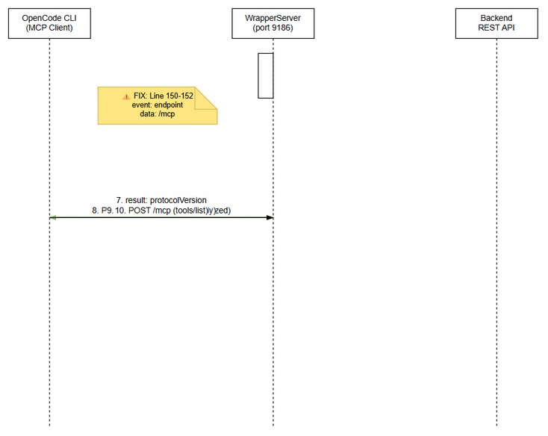 Edit in draw.io
Sequence Steps: 1. Client sends GET /mcp to open SSE stream 2. Server responds with 200 OK + Content-Type: text/event-stream 3. Server writes event: endpoint\ndata: /mcp (THE FIX — was missing) 4. Server writes event: message\ndata: {"jsonrpc":"2.0","method":"initialized"} 5. Server starts keep-alive timer (every 15s) 6. Client receives endpoint event, now knows where to POST 7. Client sends POST /mcp with initialize JSON-RPC request 8. Server responds with negotiated protocol version, capabilities, serverInfo 9. Client sends notifications/initialized → server responds 202 10. Client sends tools/list → server proxies to backend

6.2 External System: Backend REST API
Attribute | Value
Protocol | HTTP (JSON)
Endpoint | Injected via WrapperServerDeps.restGetTools / restCallTool
Authentication | Injected (not handled by WrapperServer)
Timeout | Not configured in WrapperServer (inherited from backend client)
Retry Policy | None (errors bubble to -32603)
Circuit Breaker | None (single-user local server)
Tools/list + tools/call Sequence:
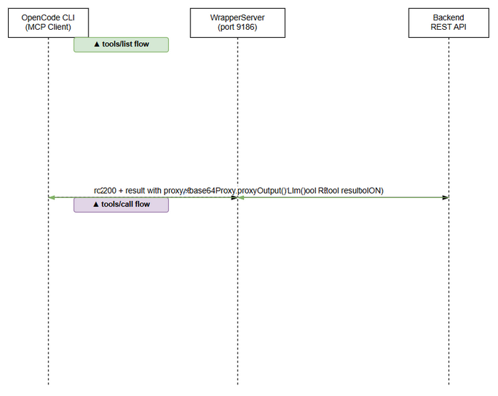 Edit in draw.io
Data Mapping (Base64Proxy):
Source Field | Target Field | Transformation
inputSchema.properties.content_base64 | Removed | Replaced with output_path for LLM-friendly interface
output_base64 (in result) | file_path, size_bytes | Base64 decoded and written to temp file; result rewritten with path
File path (in args) | content_base64 | File read and Base64-encoded before sending to backend

7. Security Design
Prerequisite: Business security requirements are defined in FSD §7. This section specifies the technical implementation.

7.1 Network Security
The WrapperServer binds exclusively to 127.0.0.1 (localhost-only). No TLS, no external network exposure. This is enforced at the server.listen() call:
srv.listen(requestedPort, "127.0.0.1", () => { ... });

7.2 CORS Implementation
CORS headers are set on every HTTP response (including errors) before any routing:
Header | Value | Purpose
Access-Control-Allow-Origin | * | Allow any origin (no CSRF risk on localhost)
Access-Control-Allow-Methods | GET, POST, OPTIONS | Supported methods
Access-Control-Allow-Headers | Content-Type | Required for JSON-RPC POST
OPTIONS preflight: Returns HTTP 204 with CORS headers, empty body.

7.3 Input Validation
Input | Validation | Enforcement
URL path | Match against known routes (/mcp, /health) | Unknown → 404
HTTP method | GET or POST for /mcp | Non-GET/POST → 405
Content-Type | Must include application/json for POST | Non-JSON → 400 (-32700)
JSON body | Parsed via JSON.parse() | Invalid → 400 (-32700)
Body size | Incremental accumulation, check on each chunk | >1MB → req.destroy()

7.4 Audit Trail
Event | Logged Fields | Destination
Server start | Port number | VS Code Output Channel ([WrapperServer])
Server stop | — | VS Code Output Channel (via close callback)
Server error | Error message | VS Code Output Channel ([WrapperServer] Error: ...)
Handler error | Error message | VS Code Output Channel ([WrapperServer] Error: ...)

8. Performance & Scalability
Prerequisite: Business NFR targets are defined in FSD §8.

8.1 Performance Targets
Operation | Target | Measurement
SSE handshake (headers + first event) | < 50ms | res.writeHead to first res.write timestamp
POST /mcp initialize | < 100ms | Request-to-response latency (local)
POST /mcp tools/list | < 500ms p95 | Includes backend REST round-trip
POST /mcp tools/call (local tool) | < 50ms | Local execution only
SSE keep-alive jitter | ±500ms | setInterval drift in Node.js event loop
Memory (baseline) | < 50 MB RSS | Process memory
Memory (per SSE connection) | < 10 KB | Response object + timer

8.2 Connection Lifecycle
sequenceDiagram
participant Client as MCP Client
participant WS as WrapperServer
Note over Client,WS: T=0: SSE connection established
Client->>WS: GET /mcp
WS->>WS: writeHead(200) + write(endpoint) + write(message)
Note over WS: T=0+~1ms: SSE stream active
loop Every 15 seconds
WS->>WS: write(: keep-alive)
Note over WS: T+15s, T+30s, T+45s, ...
end
Note over Client,WS: T+X: Client disconnects
Client-->>WS: connection close
WS->>WS: clearInterval(keepAlive)
Note over WS: T+X+0: No further writes

8.3 Caching Strategy
Cache | What | TTL | Technology
Tool definitions | Fetched from backend on each tools/list call | No caching (always fresh) | In-memory (not cached)
Base64Proxy detection state | Tool schema patterns | Extension session | Base64ProxyService instance state

9. Monitoring & Observability

9.1 Logging
The WrapperServer uses VS Code OutputChannel for diagnostic logging:
Log Event | Level | Fields | Destination
Server listening | INFO | [WrapperServer] Listening on port {port} | Output Channel
Server error | ERROR | [WrapperServer] Error: {message} | Output Channel
Handler error | ERROR | [WrapperServer] Error: {message} + stack | Output Channel
Log format:
[WrapperServer] Listening on port 9186
[WrapperServer] Error: connect ECONNREFUSED
[WrapperServer] Error: TypeError: Cannot read properties of undefined

9.2 Health Check
Endpoint | Response | Purpose
GET /health | {"status":"ok","mode":"wrapper"} | Liveness check for monitoring

9.3 Metrics (Future Enhancement)
No metrics are currently collected. Potential future metrics (identified as OI-03): - SSE connection count (active streams) - Keep-alive write failures - JSON-RPC request latency - Backend REST call latency

10. Deployment Considerations

10.1 Build & Release Process
Step | Command | Expected Result
1. Compile | npm run compile | TypeScript → out/ directory (includes out/services/WrapperServer.js)
2. Run tests | npx vitest run | ≥ 545 tests passing
3. Package VSIX | npm run package:debug | extension/sdlc-agents-4-enterprise-1.14.0.vsix
4. Tag release | git tag v1.14.0 | Release tag created
5. Update docs | Update CHANGELOG.md, README.md | Version references updated

10.2 Environment Configuration
Property | DEV | UAT | PROD
Server port | 9186 (default) | 9186 | 9186
Bind address | 127.0.0.1 | 127.0.0.1 | 127.0.0.1
Backend URL | Configurable via extension settings | Same | Same

10.3 Feature Flags
None required — the SSE endpoint fix is a pure additive change (new events written to the SSE stream). No toggle needed.

10.4 Rollback Strategy
- For VSIX installation: Reinstall previous version of the extension VSIX
- For source: Revert the two lines added to handleMcpGet():
- // res.write("event: endpoint\n");
// res.write("data: /mcp\n\n");
- For compiled output: Run npm run compile to rebuild from reverted source
- Verify: All 545 tests should still pass (tests guard against regression)

10.5 Database Migration
None required. This fix is strictly at the HTTP protocol layer — no database, file format, or persistent state changes.

11. E2E Test Architecture

11.1 Framework & Language
Attribute | Detail
Framework | Vitest (native http requests — no supertest)
Language | TypeScript (matches extension source)
HTTP client | Node.js native http module (for both POST and raw SSE)
Mock strategy | createTestServer() factory with MockDeps
Server lifecycle | beforeAll → server.start(0) on random port → afterAll → server.stop()

11.2 Test Module Structure
extension/src/__tests__/
├── wrapper-server.helpers.ts # Test utilities, server factory, mock deps
├── mcp-handshake.regression.test.ts # 7 regression tests (SA4E-48 fix guard)
├── wrapper-server.test.ts # Integration + E2E-API tests (TC-22 to TC-31)

11.3 Reusable Test Components
Component | File | Purpose
createTestServer() | wrapper-server.helpers.ts | Creates WrapperServer with mocked deps on random port
postMcp(port, body) | wrapper-server.helpers.ts | Send JSON-RPC POST to /mcp, returns {status, body}
postRaw(port, data) | wrapper-server.helpers.ts | Send raw buffer (for oversized body test), returns {status, error}
openSse(port, timeoutMs?) | wrapper-server.helpers.ts | Open GET /mcp SSE, resolve on first event: message
createMockOutputChannel() | wrapper-server.helpers.ts | Minimal vscode.OutputChannel mock
MockDeps | wrapper-server.helpers.ts | Full mock deps with restGetToolsMock and restCallToolMock

11.4 Regression Test Design (SA4E-48)
ID | Test | What it Verifies
REG-01 | initialize is implemented | initialize does NOT return -32601 Method not supported
REG-02 | initialize response structure | Returns protocolVersion, capabilities, serverInfo
REG-03 | Full handshake flow | initialize → notifications/initialized → tools/list works end-to-end
REG-04 | ping response | ping returns {} result
REG-05 | SSE stream | GET /mcp returns 200 + text/event-stream + event: message
REG-06 | All required methods | No required method returns -32601
REG-07 | Unknown method | Unknown method still returns -32601

11.5 Integration Test Design (WrapperServer)
ID | Scenario | Source
TC-22 | tools/call routes file tool through full proxy chain | wrapper-server.test.ts
TC-23 | tools/list returns rewritten schemas via HTTP | wrapper-server.test.ts
TC-24 | execute_dynamic_tool unwraps and proxies via HTTP | wrapper-server.test.ts
TC-25 | Health endpoint returns ok | wrapper-server.test.ts
TC-26 | 404 on unknown path | wrapper-server.test.ts
TC-27 | 405 on non-POST to /mcp | wrapper-server.test.ts
TC-28 | Body too large destroys connection | wrapper-server.test.ts
TC-29 | JSON-RPC parse error returns -32700 | wrapper-server.test.ts
TC-30 | Unknown method returns -32601 | wrapper-server.test.ts
TC-31 | SSE event ordering (endpoint before message) | wrapper-server.test.ts

12. Appendix

12.1 Glossary
Term | Definition
MCP | Model Context Protocol — protocol for LLM ↔ tool server communication
SSE | Server-Sent Events — W3C standard for server push over HTTP
Streamable HTTP | MCP transport: SSE for server→client, HTTP POST for client→server
WrapperServer | Local HTTP server in VS Code extension bridging MCP to backend REST
JSON-RPC 2.0 | Lightweight RPC protocol using JSON encoding
SSEClientTransport | MCP SDK client class that consumes SSE streams
VSIX | VS Code Extension Package format
Base64ProxyService | Service that rewrites tool schemas to hide Base64 encoding from LLM

12.2 Open Issues (from FSD §11)
ID | Issue | Status | Impact on TDD
OI-01 | Protocol version list hardcoded; should be configurable | Open | No action — out of scope
OI-02 | Body size limit enforced via req.destroy() — no graceful 413 | Open | Documented in §5.5
OI-03 | No metric/monitoring for SSE connection count | Open | Documented in §9.3
OI-04 | Server version hardcoded in initialize response | Open | No action — out of scope
OI-05 | No timeout on readBody() | Open | No action — out of scope
OI-06 | SSE keep-alive uses setInterval which accumulates drift | Open | Documented but accepted for simplicity

12.3 File Change Summary
File | Change Type | Lines Changed | Description
extension/src/services/WrapperServer.ts | MODIFY | +2 lines (150-152) | Added event: endpoint\ndata: /mcp\n\n to handleMcpGet()
extension/src/__tests__/mcp-handshake.regression.test.ts | NEW | +115 lines | 7 regression tests guarding MCP handshake
extension/src/__tests__/wrapper-server.test.ts | EXISTING | 0 (unchanged) | Existing 263-line test suite passes without modification
extension/src/__tests__/wrapper-server.helpers.ts | EXISTING | 0 (unchanged) | Test utilities reused by regression tests

⛔ MANDATORY: Diagram Requirements

Required draw.io Diagrams
# | Diagram | File | Section
1 | Component Architecture | diagrams/tdd-component.drawio + .png | §2.1
2 | SSE Handshake Sequence | diagrams/tdd-sequence-handshake.drawio + .png | §6.1
3 | Tools Call Sequence | diagrams/tdd-sequence-toolscall.drawio + .png | §6.2

Inline Mermaid Diagrams
The following Mermaid diagrams are embedded inline in this TDD: - Flowchart — Protocol version negotiation (§4.2) - Flowchart — Tool routing logic (§4.3) - Class diagram — WrapperServer class design (§5.2) - Sequence diagram — Connection lifecycle (§8.2)

