Deployment Guide (DPG)

SDLC Agents 4 Enterprise — SA4E-82: [Pega MCP] Register 8 Pega tools as hidden local tools (find_tools/execute_dynamic_tool)

Document Information
Field | Value
Jira Ticket | SA4E-82
Title | [Pega MCP] Register 8 Pega tools as hidden local tools (find_tools/execute_dynamic_tool)
Author | DevOps Agent
Version | 1.0
Date | 2026-07-31
Status | Approved (backfill)
Related TDD | TDD-v1-SA4E-82.docx

Revision History
Version | Date | Author | Changes
1.0 | 2026-07-31 | DevOps Agent | Backfill DPG — documents deployment of a change already implemented, packaged (v1.19.1) and verified. Auto-generated from FSD and verified project context.

Sign-Off
Name | Role | Signature and date
 | Dev Lead | ☐ Approved for deployment
 | QA Lead | ☑ Testing completed (589 tests passed, live Pega verification OK)
 | Ops Lead | ☑ Infrastructure ready

1. Overview

1.1 Feature Summary
SA4E-82 registers the 8 Pega MCP tools (pega_get_session_context, pega_get_rule, pega_query_rule, pega_list_rules, pega_save_rule, pega_checkout_rule, pega_run_tests, pega_create_branch) as hidden local tools in the SDLC Agents 4 Enterprise VS Code extension.
Hidden local tools: - Execute locally — the extension host handles the call directly via the local tool registry (no backend round-trip). - Discoverable via find_tools — the LLM can discover them through the backend’s find_tools MCP method (local definitions are merged into the backend result). - Hidden from tools/list — the default tool list stays clean; pega_* tools are omitted (they surface only via find_tools + execute_dynamic_tool, or direct tools/call).
This is a VS Code extension-only change shipped as VSIX package version 1.19.1. Backend implementation of find_tools / execute_dynamic_tool pre-dates this ticket and is unchanged. Pega credentials are read from VS Code SecretStorage — never passed as tool arguments.

1.2 Deployment Scope
Item | Type | Description
VS Code extension sdlc-agents-4-enterprise-1.19.1.vsix | Modified/Repackaged | Local tool registry refactor + 8 hidden Pega tools registered at startup
extension/src/backend-local-tools.ts | Modified | Dynamic OCP-compliant registry: registerLocalTool, isLocalTool, getLocalToolDefinitions, getVisibleLocalToolDefinitions, LocalToolDefinition.hidden
extension/src/mcp/pega-local-tools.ts | New | Maps the 8 PegaMcpTools operations to local tool definitions with hidden: true
extension/src/services/WrapperServer.ts | Modified | routeToolCall local-first dispatch; find_tools merge; execute_dynamic_tool local branch
extension/src/remote-backend-client.ts | Modified | Merges visible local defs into tools/list; registers Pega tools when SecretStorage is provided
extension/src/extension.ts | Modified | Passes context.secrets into McpServerManager constructor (line ~145)
Database | None | No schema change — no database migration required
Backend services | None | Unchanged — find_tools / execute_dynamic_tool core tools pre-date this ticket

1.3 Target Environments
Environment | URL | Deploy Order | Approval Required
DEV | VS Code extension host (local workstation) | 1st | No
SIT | VS Code extension host (local workstation) | 2nd | No
UAT | VS Code extension host (local workstation) | 3rd | QA Sign-off
PROD | VS Code extension host (user workstations) | 4th | PM + Business Sign-off
Note: This is an extension delivered as a VSIX. “Environment” here maps to the distribution waves of the VSIX to developer/QA workstations, not to a centralized server deployment.

2. Prerequisites

2.1 Infrastructure
Requirement | Status | Notes
VS Code >= 1.85.0 | Ready | Extension host required to run the extension
Node.js >= 18.14.1 | Ready | Required to build the VSIX (compile/esbuild/vsce)
npm >= 9.x | Ready | Package manager for build & test
Remote backend server (REST :48721) | Ready | Provides core tools find_tools / execute_dynamic_tool and /api/tools
Pega Platform REST endpoint (reachable) | Ready | kiroSdlc.pegaEndpoint — e.g. http://localhost:8080/prweb; operator SSA@TGB, app HRAppsV2 verified live
OS keychain / SecretStorage | Ready | VS Code SecretStorage requires OS-level keychain for Pega credentials
MCP wrapper port 9181 free | Ready | Local in-process HTTP server (kiroSdlc.mcpServerPort)

2.2 Software Dependencies
Dependency | Version | Status
Node.js | >= 18.14.1 | Installed
npm | >= 9.x | Installed
VS Code | >= 1.85.0 | Installed
@vscode/vsce | ^2.24.0 (devDep) | Installed for packaging
esbuild | ^0.21.0 (devDep) | Installed for bundling
TypeScript | ^5.4.0 (devDep) | Installed for compile
vitest | ^4.1.8 (devDep) | Installed for tests

2.3 Access Requirements
Access | Type | Who Needs It
Pega Platform (operator SSA@TGB, app HRAppsV2) | Basic Auth via SecretStorage | Developer (extension host)
Remote backend :48721 | API token / auth headers | Extension host
npm registry | Read | Build pipeline
GitHub releases / local artifact store | Read | VSIX download/install

2.4 Backup Requirements
- ☐ Previous .vsix extension artifact saved (e.g. extension/sdlc-agents-4-enterprise-1.18.0.vsix)
- ☐ Configuration backup (VS Code settings for kiroSdlc.*, Pega credentials)
- ☐ No database — backup of the backend database NOT required for this change

3. Pre-Deployment Checklist
# | Item | Responsible | Status
1 | Code merged to release branch (v1.19.1) | Developer | ☑
2 | All unit tests passed (589 tests) | Developer | ☑
3 | Live verification passed (Pega operator SSA@TGB, app HRAppsV2) | Developer | ☑
4 | VSIX package built (sdlc-agents-4-enterprise-1.19.1.vsix, 5.03 MB, 979 files) | DevOps | ☑
5 | Database backup completed | N/A | ☑ (no DB change)
6 | Configuration files prepared (Pega endpoint/credentials in SecretStorage) | Developer | ☑
7 | Feature flags configured | Developer | ☐ N/A (no feature flags)
8 | Monitoring/alerting configured (extension output logs) | DevOps | ☑
9 | Rollback plan reviewed (reinstall previous VSIX) | Team | ☑
10 | Deployment window confirmed | PM | ☐

4. Database Migration

4.1 Migration Scripts
Order | Script | Description | Estimated Time
— | None | No database migration required for SA4E-82 | N/A

4.2 Execution Steps
# No database migration steps required for this release.
echo "No DB migration — extension-only change."

4.3 Verification Queries
-- No database verification required.

4.4 Rollback Scripts
-- No database rollback required.

5. Application Deployment

5.1 Deployment Flow
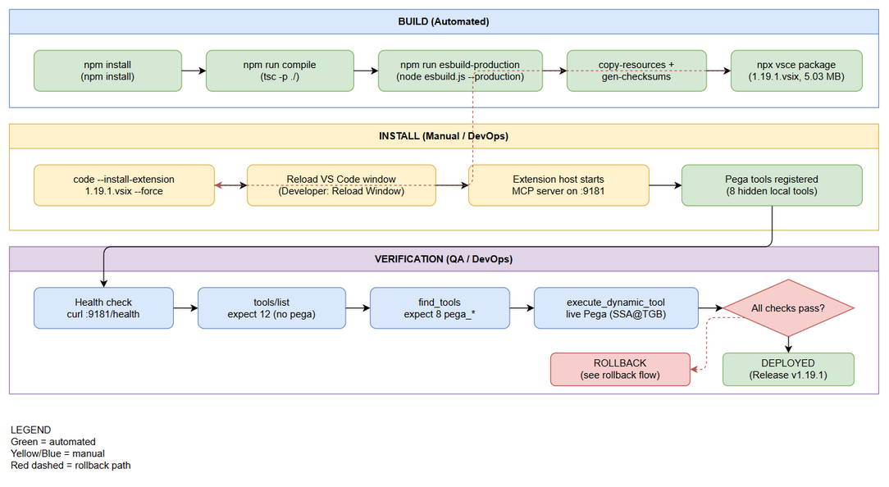
Deployment Flow
Edit in draw.io

5.2 Deployment Steps
The deployment is a VS Code extension install via VSIX. Build steps apply to DevOps/CI; install steps apply to each target workstation.
Step | Action | Command | Verification
1 | Install npm dependencies | cd extension && npm install | node_modules present, no install errors
2 | Compile TypeScript | npm run compile | tsc exits 0, out/ produced
3 | Bundle with esbuild | npm run esbuild-production | dist/extension.js produced, bundle size sane
4 | Copy resources + generate checksums | npm run copy-resources && npm run gen-checksums | Exit 0, resources present in dist/
5 | Package VSIX | npx vsce package --no-dependencies | sdlc-agents-4-enterprise-1.19.1.vsix created (5.03 MB)
6 | Install VSIX into VS Code | code --install-extension sdlc-agents-4-enterprise-1.19.1.vsix --force | VS Code reports extension installed v1.19.1
7 | Reload VS Code window | Developer: Reload Window (command palette) | Extension host restarts; extension activated
8 | Verify MCP wrapper server | curl http://127.0.0.1:9181/health (or check Output channel) | Server on port 9181 responds
9 | Run verification checklist (§7) | — | All §7 checks pass

5.3 Install Command Reference
# From repo root — the packaged artifact already exists:
cd extension
code --install-extension sdlc-agents-4-enterprise-1.19.1.vsix --force
Note: The packaged artifact extension/sdlc-agents-4-enterprise-1.19.1.vsix (5,269,301 bytes, 979 files) is already committed. Steps 1–5 are required only when rebuilding from source.

6. Configuration Changes

6.1 New Environment Variables
Variable | Description | DEV | SIT | UAT | PROD
(none) | No new OS environment variables | — | — | — | —

6.2 Application Properties Changes
Property | Old Value | New Value | File
kiroSdlc.pegaEndpoint | (existing) | Pega REST endpoint, e.g. http://localhost:8080/prweb | VS Code settings
kiroSdlc.pegaUsername | (existing) | Pega operator ID, e.g. SSA@TGB | VS Code settings
kiroSdlc.pegaDeveloperShortName | (existing) | Branch naming short name | VS Code settings
Pega credentials (password/token) | — | Stored in VS Code SecretStorage — passed via context.secrets, never as tool arguments | SecretStorage
No new settings were introduced by SA4E-82. Existing kiroSdlc.* Pega settings are consumed by PegaMcpTools. The key change is that credentials now flow through SecretStorage (new wiring extension.ts → McpServerManager → RemoteBackendClient → PegaMcpTools).

6.3 Feature Flags
Flag | DEV | SIT | UAT | PROD
(none) | — | — | — | —
No feature flags used. Pega tools register automatically when SecretStorage is available.

7. Post-Deployment Verification

7.1 Health Checks
Check | Endpoint/Command | Expected Result | Timeout
MCP wrapper server up | curl http://127.0.0.1:9181/health | HTTP 200 / server responds | 10s
Extension activated | VS Code Output channel (SDLC Agents) | No ERROR/FATAL at startup | 60s
Backend reachable | curl http://127.0.0.1:48721/health | HTTP 200 | 10s

7.2 Smoke Tests
# | Scenario | Steps | Expected Result
1 | tools/list count | Send MCP JSON-RPC tools/list to :9181/mcp | 12 tools — no pega_* entries (hidden)
2 | find_tools discovers Pega tools | Send tools/call { name: "find_tools", arguments: {} } | Returns 8 pega_* tool definitions (merged with local defs)
3 | execute_dynamic_tool live Pega call | tools/call { name: "execute_dynamic_tool", arguments: { tool_name: "pega_get_session_context", arguments: {} } } | { success: true, context } — live against Pega (operator SSA@TGB, app HRAppsV2)
4 | Direct tools/call pega_* | tools/call { name: "pega_list_rules", arguments: { pxObjClass: "Rule-Obj-Activity" } } | { success: true, data } returned locally

7.3 Log Verification
Log Entry | Level | Expected | Location
[RemoteBackendClient] Pega tools registration failed: | WARN | NOT present (or present = registration skipped gracefully) | VS Code Output channel
Pega tools registered | INFO/DEBUG | 8 pega_* tools registered | VS Code Output channel
No ERROR/FATAL entries | — | Zero unexpected errors during smoke tests | VS Code Output channel

7.4 Monitoring Dashboard
- ☐ MCP wrapper server (port 9181) responds to health check
- ☐ tools/list count is 12 (not 20 — hidden tools correctly excluded)
- ☐ find_tools returns the 8 Pega tools
- ☐ Live execute_dynamic_tool call succeeds against Pega
- ☐ No unexpected error logs in extension output

8. Rollback Plan

8.1 Rollback Flow
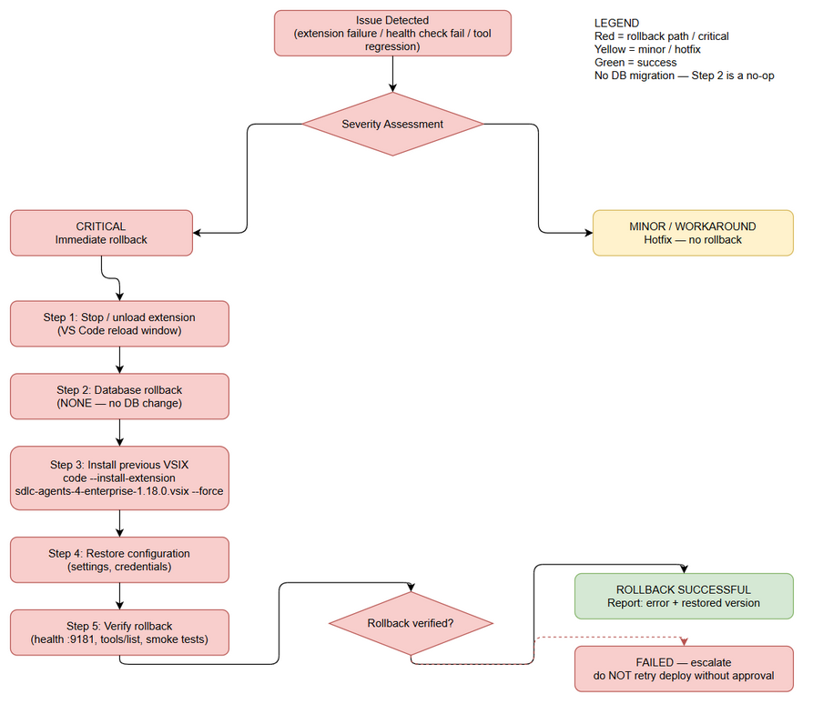
Rollback Flow
Edit in draw.io

8.2 Rollback Decision Criteria
Condition | Action
Extension fails to activate after install | Immediate rollback
MCP wrapper server does not start on port 9181 | Immediate rollback
tools/list shows > 12 tools (hidden flag regression) | Immediate rollback
find_tools missing the 8 pega_* tools | Immediate rollback
Live execute_dynamic_tool Pega call fails with unexpected errors | Investigate; rollback if Pega ops broken
Backend health degraded (unrelated regression suspected) | Triage — do not rollback blindly

8.3 Rollback Steps
Step | Action | Command | Verification
1 | Install previous VSIX version | code --install-extension sdlc-agents-4-enterprise-{prev}.vsix --force | VS Code reports previous version installed
2 | Reload VS Code window | Developer: Reload Window | Extension host restarts cleanly
3 | Verify MCP server | curl http://127.0.0.1:9181/health | Server responds
4 | Verify tools/list count | MCP tools/list | Back to pre-SA4E-82 count; find_tools/execute_dynamic_tool for pega tools invisible until SA4E-56 wiring — no breaking change
5 | Smoke test | Repeat §7.2 | All pass against previous version
Rollback artifact: The previous packaged VSIX is preserved in extension/. The last available pre-1.19.1 artifact in-repo is sdlc-agents-4-enterprise-1.18.0.vsix. Rollback restores the prior behavior: find_tools/execute_dynamic_tool for Pega tools revert to invisible until the SA4E-56 wiring lands — there is no breaking change to tools/list.

8.4 Rollback Time Estimate
Action | Estimated Time
Database rollback | 0 min (no DB)
Application rollback (reinstall VSIX + reload) | 3 minutes
Verification (health + smoke tests) | 5 minutes
Total | 8 minutes

9. Environment-Specific Notes

9.1 DEV
- Local install: code --install-extension sdlc-agents-4-enterprise-1.19.1.vsix --force + reload.
- Live Pega verification baseline: operator SSA@TGB, app HRAppsV2.

9.2 SIT
- Same VSIX; ensure kiroSdlc.pegaEndpoint points at the SIT Pega instance.
- Verify SecretStorage credentials are set for the SIT operator.

9.3 UAT
- Requires QA sign-off on §7.2 smoke tests.
- Confirm UAT backend (port 48721) exposes find_tools / execute_dynamic_tool.

9.4 PROD
- Deployment Window: Regular maintenance window, outside business hours
- Approval Required From: PM + Business Sign-off
- Communication Plan: Notify developers to reload VS Code after the VSIX is published; announce in project channel before/after
- On-Call Contact: DevOps Agent (project channel)

10. Appendix

Contacts
Role | Name | Contact
DevOps Lead | DevOps Agent | Project channel
Dev Lead | DEV Agent | Project channel
QA Lead | QA Agent | Project channel
Release Manager | SM Agent | Project channel

Related Tickets
Ticket | Summary | Relationship
SA4E-82 | [Pega MCP] Register 8 Pega tools as hidden local tools (find_tools/execute_dynamic_tool) | Main ticket
SA4E-56 | Unified Code & Pega Rule Indexing Pipeline | Backend wiring for find_tools/execute_dynamic_tool; Pega tools visible only after this wiring
SA4E-58 | (Pega branch naming convention referenced) | Context for kiroSdlc.pegaDeveloperShortName

End of Deployment Guide — SA4E-82 v1.19.1

