**BÀI TẬP CHƯƠNG K-MAP**

1. Thiết kế một mạch tổ hợp có 3 ngõ vào và một ngõ ra. Ngõ ra bằng logic 1 khi giá trị thập phân ngõ vào nhỏ hơn 3, trong trường hợp còn lại, ngõ ra bằng logic 0

|  |  |  |  |
| --- | --- | --- | --- |
| A | B | C | Q |
| 0 | 0 | 0 | 1 |
| 0 | 0 | 1 | 1 |
| 0 | 1 | 0 | 1 |
| 0 | 1 | 1 | 0 |
| 1 | 0 | 0 | 0 |
| 1 | 0 | 1 | 0 |
| 1 | 1 | 0 | 0 |
| 1 | 1 | 1 | 0 |

=> A’B’C’+A’B’C+A’BC’ = A’B’(C’+C) + A’BC’ = A’B’ + A’BC’ = A’ (B’+BC’ ) = A’(B’+B’C’+BC’)=A’(B’+C’)=A’B’+A’C’

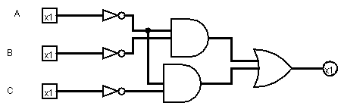

1. Hãy thiết kế một hệ thống có 4 ngõ vào A,B,C,D và một ngõ ra, ngõ ra ở trạng thái 1 chỉ khi A=B=1 hoặc khi C=D=1

|  |  |  |  |  |
| --- | --- | --- | --- | --- |
| A | B | C | D | Q |
| 0 | 0 | 0 | 0 | 0 |
| 0 | 0 | 0 | 1 | 0 |
| 0 | 0 | 1 | 0 | 0 |
| 0 | 0 | 1 | 1 | 1 |
| 0 | 1 | 0 | 0 | 0 |
| 0 | 1 | 0 | 1 | 0 |
| 0 | 1 | 1 | 0 | 0 |
| 0 | 1 | 1 | 1 | 1 |
| 1 | 0 | 0 | 0 | 0 |
| 1 | 0 | 0 | 1 | 0 |
| 1 | 0 | 1 | 0 | 0 |
| 1 | 0 | 1 | 1 | 1 |
| 1 | 1 | 0 | 0 | 1 |
| 1 | 1 | 0 | 1 | 1 |
| 1 | 1 | 1 | 0 | 1 |
| 1 | 1 | 1 | 1 | 1 |

=> A’B’CD + A’BCD+AB’CD+ABC’D’+ABC’D+ABCD’+ABCD = B’CD(A+A’) + ABC’(D’+D) + BCD(A’+A) + ABCD’ = B’CD + BCD + ABC’ + ABCD’ = CD(B+B’) + AB(C’+CD’) = CD + AB(C’+D’) = CD + AB(CD)’ = AB + CD

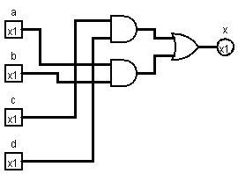

1. Đơn giản hóa các bìa Karnaugh sau:

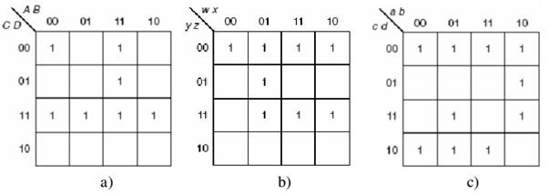

1. F(A,B,C,D)=wpsm(0,3,7,11,12,13,15)

F(A,B,C,D)= A’B’C’D’+ ABC’ + CD

1. F(W,X,Y,Z)=wpsm(0,4,5,7,8,11,12,15)

F(W,X,Y,Z)= Y’Z’+W’XZ+WYZ

1. F(a,b,c,d)= wpsm(0,2,4,6,7,8,9,11,12,14)

F(a,b,c,d)= c’d’ + ab’d+a’d’ + bd’ + a’bc

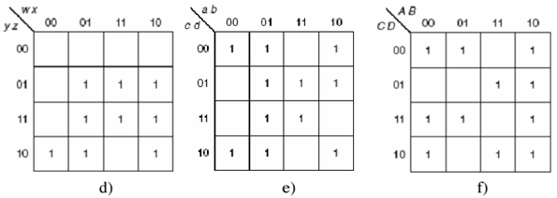

1. F(W,X,Y,Z)= wpsm(2,5,6,7,9,10,11,13,15)

= XZ + WZ+ W’YZ’ + WX’Y

1. F(a,b,c,d)= wpsm(0,2,4,5,6,7,8,9,10,13,15)

= b’d’ + a’b + bd+ab’c’

1. F(A,B,C,D)= wpsm(0,2,3,4,7,8,9,10,11,13,14)

= B’D’ + AB’ + A’C’D’+A’CD+AC’D+ACD’

1. Đơn giản hóa các bìa Karnaugh sau

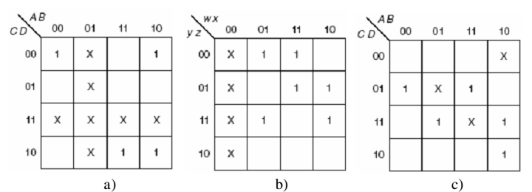

1. F(A,B,C,D)= AC+B’C’D’
2. F(W,X,Y,Z)=X’Z+XY’Z’+WY’Z+W’YZ
3. F(A,B,C,D)=BD+AB’C+A’C’D
4. Tối thiểu các biểu thức sau bằng phương pháp bìa-K  
    a. F(X, Y, Z) = m1 + m2 + m3 + m4 + m6 + m7

X

YZ

00 01 11 10

0

1

1

1

1

|  |  |  |  |
| --- | --- | --- | --- |
|  | 1 | 1 | 1 |
| 1 |  | 1 | 1 |

F= X’Y’Z+X’YZ+X’YZ’+XY’Z’+XYZ+XYZ’ = Y+X’Z+XZ’

b. G(W, X, Y, Z) = M2.M5.M7.M8.M10.M12.M13.M15

YZ

WX

00 01 11 10

00

01

11

10

|  |  |  |  |
| --- | --- | --- | --- |
|  |  | 0 | 0 |
|  | 0 | 0 |  |
|  | 0 | 0 |  |
| 0 |  |  | 0 |

F=(X’+Z’)(W’+Y+Z)(X+Y’+Z)

X’Z’+W’YZ+WX’Z+WYZ’  
 c. H(A,B,C,D) = m0+m6+m8+m9+m10 +m11+m13 +m14 +m15 (2 lời giải)

Cách 1:

CD

AB

00 01 11 10

00

01

11

10

|  |  |  |  |
| --- | --- | --- | --- |
| 1 |  |  | 1 |
|  |  | 1 | 1 |
|  |  | 1 | 1 |
|  | 1 | 1 | 1 |

H= B’C’D’+AC+AD+BCD’

Cách 2:

CD

AB

00 01 11 10

00

01

11

10

|  |  |  |  |
| --- | --- | --- | --- |
| 0 |  |  | 0 |
|  |  | 0 | 0 |
|  |  | 0 | 0 |
|  | 0 | 0 | 0 |

H=(B+C+D)(A’+D’)(A’+C’)(B’+C’+D)

H’=((B+C+D)(A’+D’)(A’+C’)(B’+C’+D))’

H’=B’C’D’+AD+AC+BCD’

1. Tối thiểu các biểu thức sau bằng phương pháp bìa-K:  
    a. F(x,y,z) = xy + xz’ + yz + xyz

= xy(z+z’) + xz’(y+y’) + yz(x+x’) +xyz

= xyz+xyz’ + xyz’ + xy’z’ + xyz +x’yz +xyz+xyz

=xyz+xy’z’+x’yz+xyz’

X

YZ

00 01 11 10

0

1

1

1

|  |  |  |  |
| --- | --- | --- | --- |
|  |  | 1 |  |
| 1 |  | 1 | 1 |

F= yz+xz’

b.

G(a,b,c,d) = abc + ab’d + bc + a’bd + acd’

= abc(d+d’) + ab’d(c+c’) + bc(a+a’)(d+d’)+ a’bd(c+c’) +acd’(b+b’)

= abcd + abcd’ + ab’cd+ ab’c’d + abcd+ abcd’ + a’bcd+a’bcd’ + a’bcd + a’bc’d + abcd’ + ab’cd’

= abcd + ab’cd+ ab’c’d + abcd’ + a’bcd’ + a’bc’d +ab’cd’+a’bcd

CD

AB

00 01 11 10

00

01

11

10

|  |  |  |  |
| --- | --- | --- | --- |
|  |  |  |  |
|  | 1 |  | 1 |
|  | 1 | 1 | 1 |
|  | 1 | 1 | 1 |

G= bc+ac+a’bd+ab’d

c. H(w,x,y,z) = (w’ + x).(w+x+y).z’

= xz’w’ + z’w’y + z’xw + z’x +z’xy+wxz’

= xz’w’(y+y’) + z’w’y(x+x’) + z’xw(y+y’) + xz’(y+y’)(w+w’) + z’xy(w+w’) + wxz’(y+y’)

= w’xyz’+w’xy’z’+w’x’yz’+wxyz’+wxy’z’

yz

wx

00 01 11 10

00

01

11

10

|  |  |  |  |
| --- | --- | --- | --- |
|  | 1 | 1 |  |
|  |  |  |  |
|  |  |  |  |
| 1 | 1 | 1 |  |

h= xz’+w’yz’

1. Tối thiểu các biểu thức sau theo dạng:

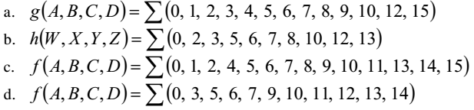

CD

AB

00 01 11 10

00

01

11

10

|  |  |  |  |
| --- | --- | --- | --- |
| 1 | 1 | 1 | 1 |
| 1 | 1 |  | 1 |
| 1 | 1 | 1 |  |
| 1 | 1 |  | 1 |

G(A,B,C,D)=wps(0,1,2,3,4,5,6,7,8,9,10,12,15)

= A’ + B’D’+C’D’+B’C’+BCD

YZ

WX

00 01 11 10

00

01

11

10

|  |  |  |  |
| --- | --- | --- | --- |
| 1 |  | 1 | 1 |
|  | 1 | 1 |  |
| 1 | 1 |  |  |
| 1 | 1 |  | 1 |

H(W,X,Y,Z)=wps(0,2,3,5,6,7,8,10,12,13)

= X’Z’ + W’Y+WXY’+XY’Z

CD

AB

00 01 11 10

00

01

11

10

|  |  |  |  |
| --- | --- | --- | --- |
| 1 | 1 |  | 1 |
| 1 | 1 | 1 | 1 |
|  | 1 | 1 | 1 |
| 1 | 1 | 1 | 1 |

F(A,B,C,D)=wps(0,1,2,4,5,6,7,8,9,10,11,13,14,15)

=B’D’ + A’B+C’D+AC

CD

AB

00 01 11 10

00

01

11

10

|  |  |  |  |
| --- | --- | --- | --- |
| 1 |  | 1 |  |
|  | 1 | 1 | 1 |
| 1 | 1 |  | 1 |
|  | 1 | 1 | 1 |

F(A,B,C,D)=wps(0,3,5,6,7,9,10,11,12,13,14)

= A’B’C’D’ + ABC’+BC’D+A’CD+A’BC+AB’D+ACD’

1. Tối thiểu các biểu thức sau theo dạng SoP hay PoS :



YZ

WX

00 01 11 10

00

01

11

10

|  |  |  |  |
| --- | --- | --- | --- |
| 1 |  |  | 1 |
|  | 1 | 1 |  |
|  | 1 | 1 |  |
| 1 |  |  | 1 |

F= X’Z’+XZ

b.

CD

AB

00 01 11 10

00

01

11

10

|  |  |  |  |
| --- | --- | --- | --- |
| 1 | 1 | 1 | 1 |
| 0 | 1 | 0 | 0 |
| 1 | 0 | 0 | 1 |
| 1 | 1 | 1 | 1 |

F=(B’+C’+D’)(A’+C+D’)(B+C+D’)

=D’+A’BC’+B’C

|  |  |  |  |
| --- | --- | --- | --- |
|  | 1 | 1 |  |
| 1 | 1 | 1 |  |
|  |  |  | 1 |
|  | 1 | 1 |  |

c.

YZ

WX

00 01 11 10

00

01

11

10

F=XY’+XZ’ + W’Y’Z+WX’YZ

d.

CD

AB

00 01 11 10

00

01

11

10

|  |  |  |  |
| --- | --- | --- | --- |
|  | 0 | 0 |  |
| 0 | 0 | 0 | 0 |
| 0 | 0 |  |  |
|  | 0 | 0 |  |

F(A,B,C,D)= (C+D’)(A+D’)(B’+D)

1. Tối thiểu các biểu thức sau theo dạng SoP hay PoS:



a.

|  |  |  |  |
| --- | --- | --- | --- |
| 1 |  |  | x |
| 1 | 1 |  |  |
| 1 |  | x |  |
|  |  | 1 |  |

YZ

WX

00 01 11 10

00

01

11

10

F(W,X,Y,Z)= X’Y’Z’+W’Y’Z+W’X’Z+WXY

|  |  |  |  |
| --- | --- | --- | --- |
| 1 |  |  | 1 |
| 1 |  |  | x |
| x |  | x | 1 |
| 1 |  |  |  |

YZ

WX

00 01 11 10

00

01

11

10

F= W’X’+X’Y’+X’Z

|  |  |  |  |
| --- | --- | --- | --- |
|  | X | X |  |
| X | 1 |  | 1 |
| 1 |  | X |  |
| X |  | 1 |  |

C.

YZ

WX

00 01 11 10

00

01

11

10

F(W,X,Y,Z)=wps(3,5,9,14) + d(1,2,4,12,15)

=W’XY’+X’Y’Z+W’X’Y+WXY

CD

AB

00 01 11 10

00

01

11

10

|  |  |  |  |
| --- | --- | --- | --- |
|  | X |  |  |
| 0 | 0 | 0 | 0 |
|  | 0 | X |  |
|  | 0 |  |  |

F=(A+B’)(C+D’)

|  |  |  |  |
| --- | --- | --- | --- |
|  |  |  |  |
|  | 0 |  | 0 |
| 0 |  | 0 | X |
|  |  | 0 |  |

CD

AB

00 01 11 10

00

01

11

10

F=(A+B’+C+D’)(B+C’+D’)(A’+B’+C’)(A’+B+D’)

1. Tối thiểu các biểu thức sau:

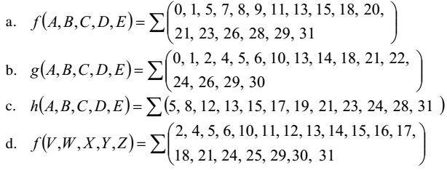

a.

E’

AB

CD

E

AB

CD

|  |  |  |  |  |
| --- | --- | --- | --- | --- |
|  | 00 | 01 | 11 | 10 |
| 00 | 1 |  |  | 1 |
| 01 | 1 | 1 | 1 | 1 |
| 11 |  | 1 | 1 | 1 |
| 10 |  |  |  |  |

|  |  |  |  |  |
| --- | --- | --- | --- | --- |
|  | 00 | 01 | 11 | 10 |
| 00 |  | 1 | 1 |  |
| 01 |  | 1 | 1 |  |
| 11 |  | 1 | 1 |  |
| 10 | 1 |  |  | 1 |

F(A,B,C,D,E)= B’C’E+BDE+ADE+BC’E’+BDE’+B’CD’E’

= BD+B’C’E+ADE+BC’E’+B’CD’E’

E’

AB

CD

b.

E

AB

CD

|  |  |  |  |  |
| --- | --- | --- | --- | --- |
|  | 00 | 01 | 11 | 10 |
| 00 | 1 | 1 |  |  |
| 01 | 1 | 1 | 1 |  |
| 11 |  |  |  |  |
| 10 | 1 | 1 | 1 | 1 |

|  |  |  |  |  |
| --- | --- | --- | --- | --- |
|  | 00 | 01 | 11 | 10 |
| 00 |  |  |  | 1 |
| 01 |  | 1 | 1 |  |
| 11 |  |  |  |  |
| 10 | 1 | 1 | 1 | 1 |

g(A,B,C,D,E)= A’C’E+BC’DE+CD’E +CD’E’+ AB’D’E’+BC’DE’

= A’C’E+BC’D(E+E’)+CD’(E+E’)+AB’D’E’

= A’C’E+BC’D+CD’+AB’D’E’

C.

|  |  |  |  |  |
| --- | --- | --- | --- | --- |
|  | 00 | 01 | 11 | 10 |
| 00 |  |  | 1 | 1 |
| 01 |  | 1 | 1 |  |
| 11 |  |  | 1 |  |
| 10 |  |  |  |  |

|  |  |  |  |  |
| --- | --- | --- | --- | --- |
|  | 00 | 01 | 11 | 10 |
| 00 |  |  | 1 | 1 |
| 01 | 1 | 1 |  |  |
| 11 | 1 | 1 | 1 |  |
| 10 |  |  |  |  |

E’

AB

CD

E

AB

CD

H(A,B,C,D,E)= AC’D’+A’DE’+BC’DE+ABCD

D.

V’

WX

YZ

V

WX

YZ

|  |  |  |  |  |
| --- | --- | --- | --- | --- |
|  | 00 | 01 | 11 | 10 |
| 00 |  | 1 | 1 |  |
| 01 |  | 1 | 1 |  |
| 11 |  |  | 1 | 1 |
| 10 | 1 | 1 | 1 | 1 |

|  |  |  |  |  |
| --- | --- | --- | --- | --- |
|  | 00 | 01 | 11 | 10 |
| 00 | 1 |  |  | 1 |
| 01 | 1 | 1 | 1 | 1 |
| 11 |  |  | 1 |  |
| 10 | 1 |  | 1 |  |

F= XY’V+WYV+YZ’V+Y’ZV’+X’Y’Z’V’+WXYV’+W’X’Z’V’

1. Tối thiểu các biểu thức sau:



|  |  |  |  |  |
| --- | --- | --- | --- | --- |
|  | 00 | 01 | 11 | 10 |
| 00 |  |  |  |  |
| 01 |  | 1 | 1 |  |
| 11 |  | 1 | 1 |  |
| 10 |  |  |  |  |

T’

WX

YZ

T

WX

YZ

|  |  |  |  |  |
| --- | --- | --- | --- | --- |
|  | 00 | 01 | 11 | 10 |
| 00 | 1 | 1 |  |  |
| 01 |  |  | 1 | 1 |
| 11 |  |  | 1 | 1 |
| 10 |  |  |  |  |

F= XZT + W’Y’Z’T’ + WZT’

b.

|  |  |  |  |  |
| --- | --- | --- | --- | --- |
|  | 00 | 01 | 11 | 10 |
| 00 | 1 |  |  |  |
| 01 |  |  |  |  |
| 11 |  | 1 | 1 |  |
| 10 |  | 1 | 1 |  |

T

WX

YZ

T’

WX

YZ

|  |  |  |  |  |
| --- | --- | --- | --- | --- |
|  | 00 | 01 | 11 | 10 |
| 00 | 1 |  | 1 | 1 |
| 01 |  |  | 1 | 1 |
| 11 |  | 1 | 1 |  |
| 10 |  |  |  |  |

F= W’X’Y’Z’ + WY’T+XYZT+XYT’



T’

WX

YZ

T

WX

YZ

|  |  |  |  |  |
| --- | --- | --- | --- | --- |
|  | 00 | 01 | 11 | 10 |
| 00 | 1 | 1 |  |  |
| 01 | 1 | 1 |  |  |
| 11 | 1 |  |  | 1 |
| 10 | 1 |  | 1 | 1 |

|  |  |  |  |  |
| --- | --- | --- | --- | --- |
|  | 00 | 01 | 11 | 10 |
| 00 |  | 1 | 1 | 1 |
| 01 |  | 1 | 1 | 1 |
| 11 |  |  |  | 1 |
| 10 |  |  | 1 | 1 |

F= W’Y’T+W’X’T+WX’YT+WYZ’T+XY’T’+WX’T’+WYZ’T’

=W’Y’T+W’X’T+WX’YT+WYZ’+XY’T’+WX’T’

d.

T’

WX

YZ

T

WX

YZ

|  |  |  |  |  |
| --- | --- | --- | --- | --- |
|  | 00 | 01 | 11 | 10 |
| 00 | 1 | 1 | 1 | 1 |
| 01 |  |  | 1 |  |
| 11 |  | 1 |  | 1 |
| 10 | 1 | 1 | 1 | 1 |

|  |  |  |  |  |
| --- | --- | --- | --- | --- |
|  | 00 | 01 | 11 | 10 |
| 00 | 1 |  |  |  |
| 01 |  |  | 1 |  |
| 11 | 1 |  |  |  |
| 10 | 1 |  | 1 |  |

F= W’X’Y’Z’ + WXY’Z + WXYZ’ + Y’Z’T + Y’ZT + W’XYT + WX’YT + W’X’YT’

|  |  |  |  |  |
| --- | --- | --- | --- | --- |
|  | 00 | 01 | 11 | 10 |
| 00 | 0 |  |  |  |
| 01 | 0 | 0 | 0 | 0 |
| 11 |  |  |  | 0 |
| 10 |  |  |  | 0 |

e.

T’

WX

YZ

T

WX

YZ

|  |  |  |  |  |
| --- | --- | --- | --- | --- |
|  | 00 | 01 | 11 | 10 |
| 00 |  | 0 | 0 |  |
| 01 |  | 0 | 0 |  |
| 11 |  |  |  |  |
| 10 |  |  |  | 0 |

F= (X’+Y+T)(Y+Z’+T’)(W+X+Y+T’)(W’+X+Z’+T’)(W’+X+Y’+Z)

|  |  |  |  |  |
| --- | --- | --- | --- | --- |
|  | 00 | 01 | 11 | 10 |
| 00 |  | 1 | 1 |  |
| 01 | x | x | 1 | 1 |
| 11 |  | 1 | 1 | 1 |
| 10 |  | 1 | 1 |  |

f.

T

WX

YZ

T

WX

YZ

|  |  |  |  |  |
| --- | --- | --- | --- | --- |
|  | 00 | 01 | 11 | 10 |
| 00 |  | 1 | 1 |  |
| 01 |  |  | x | 1 |
| 11 |  |  | x | 1 |
| 10 |  | 1 | 1 |  |

F= XT+WZT+WXT’+WZT’+W’XZ’T’ = XT+WZ +WZT’ + W’XZ’T’