**Bài tập chương 6**

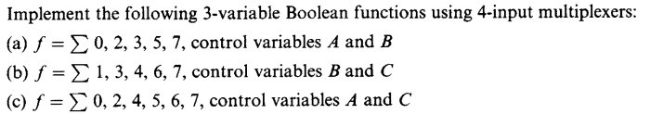Bài 1:

A)

|  |  |  |  |
| --- | --- | --- | --- |
| A | B | C | F |
| 0 | 0 | 0 | 1 I0=C’ AB=00  C  1  F  MUX 4X1  0  I0  I1  I2  I3 |
| 0 | 0 | 1 |
| 0 | 1 | 0 | 1 I1=1 AB=01  1 |
| 0 | 1 | 1 |
| 1 | 0 | 0 | 0 I2=C AB=10  A B  1 |
| 1 | 0 | 1 |
| 1 | 1 | 0 | 0 I3=C AB=11  1 |
| 1 | 1 | 1 |

b)

|  |  |  |  |
| --- | --- | --- | --- |
| A | B | C | F |
| 0 | 0 | 0 | 0 I0=A BC=00  A  MUX 4X1  1  I0  I1  I2  I3 |
| 1 | 0 | 0 |
| 0 | 0 | 1 | 1 I1=A’ BC=01  F  0 |
| 1 | 0 | 1 |
| 0 | 1 | 0 | 0 I2=A BC=10  B C  1  1 |
| 1 | 1 | 0 |
| 0 | 1 | 1 | 1 I3=1 BC=11  1 |
| 1 | 1 | 1 |

|  |  |  |  |
| --- | --- | --- | --- |
| A | B | C | F |
| 0 | 0 | 0 | 1 I0=1 AC=00  1  MUX 4X1  1  I0  I1  I2  I3 |
| 0 | 1 | 0 |
| 0 | 0 | 1 | 0 I1=0 AC=01  F  1  0 |
| 0 | 1 | 1 |
| 1 | 0 | 0 | 1 I2=1 AC=10  A C  1 |
| 1 | 1 | 0 |
| 1 | 0 | 1 | 1 I3=1 AC=11  1 |
| 1 | 1 | 1 |

Bài 2: 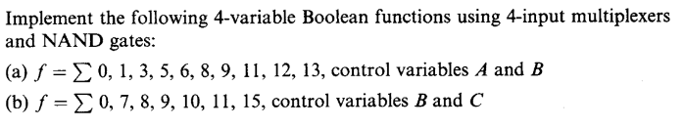



|  |  |  |  |  |
| --- | --- | --- | --- | --- |
| A | B | C | d | F |
| 0 | 0 | 0 | 0 | 1 I0=C’+D AB=00  0  1 |
| 0 | 0 | 0 | 1 |
| 0 | 0 | 1 | 0 |
| 0 | 0 | 1 | 1 |
| 0 | 1 | 0 | 0 | 0 I1=C’D+CD’ AB=01  1  1  0 |
| 0 | 1 | 0 | 1 |
| 0 | 1 | 1 | 0 |
| 0 | 1 | 1 | 1 |
| 1 | 0 | 0 | 0 | 1 I2=C’+D AB=10  1  0  1 |
| 1 | 0 | 0 | 1 |
| 1 | 0 | 1 | 0 |
| 1 | 0 | 1 | 1 |
| 1 | 1 | 0 | 0 | 1 I4=C’ AB=11  1  0  0 |
| 1 | 1 | 0 | 1 |
| 1 | 1 | 1 | 0 |
| 1 | 1 | 1 | 1 |

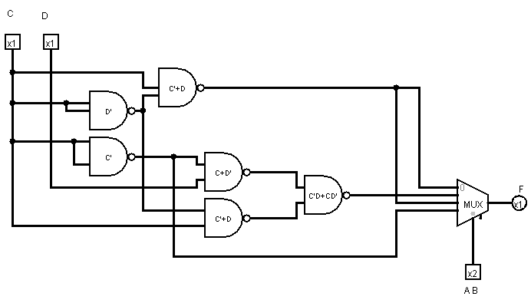

B)

|  |  |  |  |  |
| --- | --- | --- | --- | --- |
| A | B | C | D | F |
| 0 | 0 | 0 | 0 | 1 I0=A+D BC=00  0  1  1 |
| 0 | 0 | 0 | 1 |
| 1 | 0 | 0 | 0 |
| 1 | 0 | 0 | 1 |
| 0 | 0 | 1 | 0 | 0 I1=A’ BC=01  0  1  1 |
| 0 | 0 | 1 | 1 |
| 1 | 0 | 1 | 0 |
| 1 | 0 | 1 | 1 |
| 0 | 1 | 0 | 0 | 0 I2=0 BC=10  0  0  0 |
| 0 | 1 | 0 | 1 |
| 1 | 1 | 0 | 0 |
| 1 | 1 | 0 | 1 |
| 0 | 1 | 1 | 0 | 0 I4=D BC=11  1  0  1 |
| 0 | 1 | 1 | 1 |
| 1 | 1 | 1 | 0 |
| 1 | 1 | 1 | 1 |

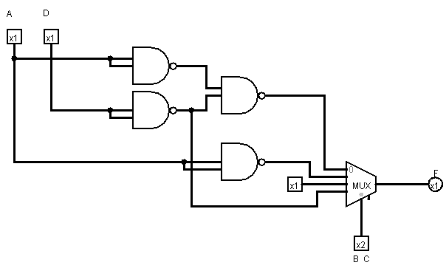

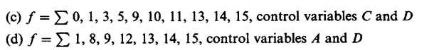

|  |  |  |  |  |
| --- | --- | --- | --- | --- |
| A | B | C | D | F |
| 0 | 0 | 0 | 0 | 1 I0=A’B’ CD=00  0  0  0 |
| 0 | 1 | 0 | 0 |
| 1 | 0 | 0 | 0 |
| 1 | 1 | 0 | 0 |
| 0 | 0 | 0 | 1 | 1 I1=1 CD=01  1  1  1 |
| 0 | 1 | 0 | 1 |
| 1 | 0 | 0 | 1 |
| 1 | 1 | 0 | 1 |
| 0 | 0 | 1 | 0 | 0 I2=A CD=10  0  1  1 |
| 0 | 1 | 1 | 0 |
| 1 | 0 | 1 | 0 |
| 1 | 1 | 1 | 0 |
| 0 | 0 | 1 | 1 | 1 I3=A+B’ CD=11  0  1  1 |
| 0 | 1 | 1 | 1 |
| 1 | 0 | 1 | 1 |
| 1 | 1 | 1 | 1 |

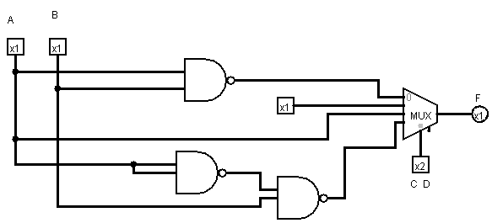

|  |  |  |  |  |
| --- | --- | --- | --- | --- |
| A | B | C | D | F |
| 0 | 0 | 0 | 0 | 1 I0=B’C’ AD=00  0  0  0 |
| 0 | 0 | 1 | 0 |
| 0 | 1 | 0 | 0 |
| 0 | 1 | 1 | 0 |
| 0 | 0 | 0 | 1 | 0 I1=BC AD=01  0  0  1 |
| 0 | 0 | 1 | 1 |
| 0 | 1 | 0 | 1 |
| 0 | 1 | 1 | 1 |
| 1 | 0 | 0 | 0 | 1 I2=B’ AD=10  1  0  0 |
| 1 | 0 | 1 | 0 |
| 1 | 1 | 0 | 0 |
| 1 | 1 | 1 | 0 |
| 1 | 0 | 0 | 1 | 1 I3=B’+C AD=11  1  0  1 |
| 1 | 0 | 1 | 1 |
| 1 | 1 | 0 | 1 |
| 1 | 1 | 1 | 1 |

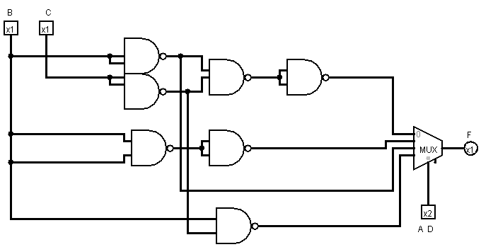

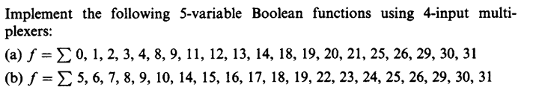Bài 3:

A)

|  |  |  |  |  |  |  |
| --- | --- | --- | --- | --- | --- | --- |
| A | B | C | D | E | F | Input |
| 0 | 0 | 0 | 0 | 0 | 1 | I0=C’+CD’E’  AB=00 |
| 0 | 0 | 0 | 0 | 1 | 1 |
| 0 | 0 | 0 | 1 | 0 | 1 |
| 0 | 0 | 0 | 1 | 1 | 1 |
| 0 | 0 | 1 | 0 | 0 | 1 |
| 0 | 0 | 1 | 0 | 1 | 0 |
| 0 | 0 | 1 | 1 | 0 | 0 |
| 0 | 0 | 1 | 1 | 1 | 0 |
| 0 | 1 | 0 | 0 | 0 | 1 | I1=C’(D’+E)+C(D’+E’)  =C’D’+C’E+CD’+CE’  =D’+(C’ꚚE)  AB=01 |
| 0 | 1 | 0 | 0 | 1 | 1 |
| 0 | 1 | 0 | 1 | 0 | 0 |
| 0 | 1 | 0 | 1 | 1 | 1 |
| 0 | 1 | 1 | 0 | 0 | 1 |
| 0 | 1 | 1 | 0 | 1 | 1 |
| 0 | 1 | 1 | 1 | 0 | 1 |
| 0 | 1 | 1 | 1 | 1 | 0 |
| 1 | 0 | 0 | 0 | 0 | 0 | I2=C’D+DC’  =CꚚD  AB=10 |
| 1 | 0 | 0 | 0 | 1 | 0 |
| 1 | 0 | 0 | 1 | 0 | 1 |
| 1 | 0 | 0 | 1 | 1 | 1 |
| 1 | 0 | 1 | 0 | 0 | 1 |
| 1 | 0 | 1 | 0 | 1 | 1 |
| 1 | 0 | 1 | 1 | 0 | 0 |
| 1 | 0 | 1 | 1 | 1 | 0 |
| 1 | 1 | 0 | 0 | 0 | 0 | I3=C’D’E+C’DE’+CD’E+ CD  =D’E + C’DE’+ CD  =D’E+ D(C+E’)  =DC + (DꚚE)  AB=11 |
| 1 | 1 | 0 | 0 | 1 | 1 |
| 1 | 1 | 0 | 1 | 0 | 1 |
| 1 | 1 | 0 | 1 | 1 | 0 |
| 1 | 1 | 1 | 0 | 0 | 0 |
| 1 | 1 | 1 | 0 | 1 | 1 |
| 1 | 1 | 1 | 1 | 0 | 1 |
| 1 | 1 | 1 | 1 | 1 | 1 |

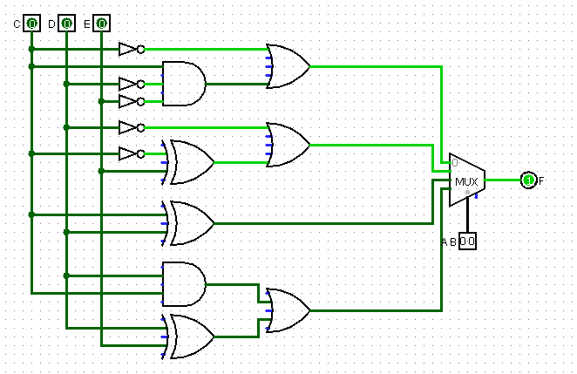

|  |  |  |  |  |  |  |
| --- | --- | --- | --- | --- | --- | --- |
| A | B | C | D | E | F | Input |
| 0 | 0 | 0 | 0 | 0 | 0 | I0=CD’E+CD  =C(D+E)  AB=00 |
| 0 | 0 | 0 | 0 | 1 | 0 |
| 0 | 0 | 0 | 1 | 0 | 0 |
| 0 | 0 | 0 | 1 | 1 | 0 |
| 0 | 0 | 1 | 0 | 0 | 0 |
| 0 | 0 | 1 | 0 | 1 | 1 |
| 0 | 0 | 1 | 1 | 0 | 1 |
| 0 | 0 | 1 | 1 | 1 | 1 |
| 0 | 1 | 0 | 0 | 0 | 1 | I1=C’D’+C’DE’+CD  =C’(D’+E’)+CD  =C’D’+C’E’+CD  =C’E’+ (CʘD)  AB=01 |
| 0 | 1 | 0 | 0 | 1 | 1 |
| 0 | 1 | 0 | 1 | 0 | 1 |
| 0 | 1 | 0 | 1 | 1 | 0 |
| 0 | 1 | 1 | 0 | 0 | 0 |
| 0 | 1 | 1 | 0 | 1 | 0 |
| 0 | 1 | 1 | 1 | 0 | 1 |
| 0 | 1 | 1 | 1 | 1 | 1 |
| 1 | 0 | 0 | 0 | 0 | 1 | I2=C’D’+C’D+CD  =C’+CD  =C’+D  AB=10 |
| 1 | 0 | 0 | 0 | 1 | 1 |
| 1 | 0 | 0 | 1 | 0 | 1 |
| 1 | 0 | 0 | 1 | 1 | 1 |
| 1 | 0 | 1 | 0 | 0 | 0 |
| 1 | 0 | 1 | 0 | 1 | 0 |
| 1 | 0 | 1 | 1 | 0 | 1 |
| 1 | 0 | 1 | 1 | 1 | 1 |
| 1 | 1 | 0 | 0 | 0 | 1 | I3=C’D’+C’DE’+CD’E+CD  =C’(D’+E’)+C(D+E)  =C’D’+C’E’+CD+CE  =(C ʘ D)+(C ʘ E)  AB=11 |
| 1 | 1 | 0 | 0 | 1 | 1 |
| 1 | 1 | 0 | 1 | 0 | 1 |
| 1 | 1 | 0 | 1 | 1 | 0 |
| 1 | 1 | 1 | 0 | 0 | 0 |
| 1 | 1 | 1 | 0 | 1 | 1 |
| 1 | 1 | 1 | 1 | 0 | 1 |
| 1 | 1 | 1 | 1 | 1 | 1 |

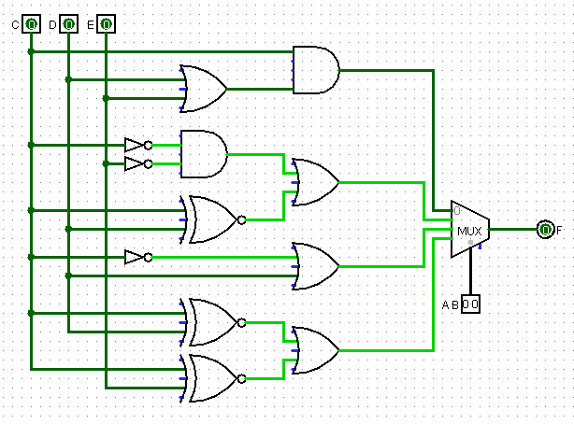

Bài 4:

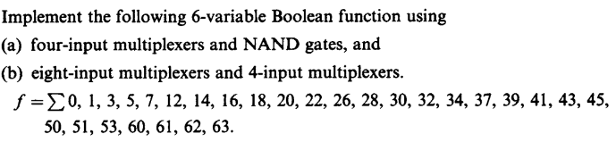

|  |  |  |  |  |  |  |  |
| --- | --- | --- | --- | --- | --- | --- | --- |
| A | B | C | D | E | F | G | Input |
| 0 | 0 | 0 | 0 | 0 | 0 | 1 | I0=C’D’E’+C’D’EF+C’DE’F+C’DEF  +CDE’F’+CDEF’  =C’D’E’+C’D’F+C’DF+CDF’  =C’D’E’+C’F+CDF’  AB=00 |
| 0 | 0 | 0 | 0 | 0 | 1 | 1 |
| 0 | 0 | 0 | 0 | 1 | 0 | 0 |
| 0 | 0 | 0 | 0 | 1 | 1 | 1 |
| 0 | 0 | 0 | 1 | 0 | 0 | 0 |
| 0 | 0 | 0 | 1 | 0 | 1 | 1 |
| 0 | 0 | 0 | 1 | 1 | 0 | 0 |
| 0 | 0 | 0 | 1 | 1 | 1 | 1 |
| 0 | 0 | 1 | 0 | 0 | 0 | 0 |
| 0 | 0 | 1 | 0 | 0 | 1 | 0 |
| 0 | 0 | 1 | 0 | 1 | 0 | 0 |
| 0 | 0 | 1 | 0 | 1 | 1 | 0 |
| 0 | 0 | 1 | 1 | 0 | 0 | 1 |
| 0 | 0 | 1 | 1 | 0 | 1 | 0 |
| 0 | 0 | 1 | 1 | 1 | 0 | 1 |
| 0 | 0 | 1 | 1 | 1 | 1 | 0 |
| 0 | 1 | 0 | 0 | 0 | 0 | 1 | I1=C’D’E’F’+C’D’EF’+C’DE’F’+  C’DEF’+CD’EF’+CDE’F’+CDEF’  =C’D’F’+C’DF’+CEF’+CDE’F’  =C’F’+CF’(E+DE’)  =C’F’+CF’(E+D)  AB=01 |
| 0 | 1 | 0 | 0 | 0 | 1 | 0 |
| 0 | 1 | 0 | 0 | 1 | 0 | 1 |
| 0 | 1 | 0 | 0 | 1 | 1 | 0 |
| 0 | 1 | 0 | 1 | 0 | 0 | 1 |
| 0 | 1 | 0 | 1 | 0 | 1 | 0 |
| 0 | 1 | 0 | 1 | 1 | 0 | 1 |
| 0 | 1 | 0 | 1 | 1 | 1 | 0 |
| 0 | 1 | 1 | 0 | 0 | 0 | 0 |
| 0 | 1 | 1 | 0 | 0 | 1 | 0 |
| 0 | 1 | 1 | 0 | 1 | 0 | 1 |
| 0 | 1 | 1 | 0 | 1 | 1 | 0 |
| 0 | 1 | 1 | 1 | 0 | 0 | 1 |
| 0 | 1 | 1 | 1 | 0 | 1 | 0 |
| 0 | 1 | 1 | 1 | 1 | 0 | 1 |
| 0 | 1 | 1 | 1 | 1 | 1 | 0 |
| 1 | 0 | 0 | 0 | 0 | 0 | 1 | I2=C’D’E’F’+C’D’EF’+C’DE’F+  C’DEF+CD’E’F+CD’EF+CDE’F  =C’D’F’+C’DF+CD’F+CDE’F  =C’D’F’+CD’F+DF(C’+CE’)  =C’D’F’+CD’F+DF(C’+E’)  =D’(C’F’+CF)+DF(C’+E’)  =D’(C ʘ F) + DF(C’+E’)  AB=10 |
| 1 | 0 | 0 | 0 | 0 | 1 | 0 |
| 1 | 0 | 0 | 0 | 1 | 0 | 1 |
| 1 | 0 | 0 | 0 | 1 | 1 | 0 |
| 1 | 0 | 0 | 1 | 0 | 0 | 0 |
| 1 | 0 | 0 | 1 | 0 | 1 | 1 |
| 1 | 0 | 0 | 1 | 1 | 0 | 0 |
| 1 | 0 | 0 | 1 | 1 | 1 | 1 |
| 1 | 0 | 1 | 0 | 0 | 0 | 0 |
| 1 | 0 | 1 | 0 | 0 | 1 | 1 |
| 1 | 0 | 1 | 0 | 1 | 0 | 0 |
| 1 | 0 | 1 | 0 | 1 | 1 | 1 |
| 1 | 0 | 1 | 1 | 0 | 0 | 0 |
| 1 | 0 | 1 | 1 | 0 | 1 | 1 |
| 1 | 0 | 1 | 1 | 1 | 0 | 0 |
| 1 | 0 | 1 | 1 | 1 | 1 | 0 |
| 1 | 1 | 0 | 0 | 0 | 0 | 0 | I3=C’D’EF’+C’D’EF+C’DE’F+  CDE’+CDE  =C’D’E+CD+C’DE’F  AB=11 |
| 1 | 1 | 0 | 0 | 0 | 1 | 0 |
| 1 | 1 | 0 | 0 | 1 | 0 | 1 |
| 1 | 1 | 0 | 0 | 1 | 1 | 1 |
| 1 | 1 | 0 | 1 | 0 | 0 | 0 |
| 1 | 1 | 0 | 1 | 0 | 1 | 1 |
| 1 | 1 | 0 | 1 | 1 | 0 | 0 |
| 1 | 1 | 0 | 1 | 1 | 1 | 0 |
| 1 | 1 | 1 | 0 | 0 | 0 | 0 |
| 1 | 1 | 1 | 0 | 0 | 1 | 0 |
| 1 | 1 | 1 | 0 | 1 | 0 | 0 |
| 1 | 1 | 1 | 0 | 1 | 1 | 0 |
| 1 | 1 | 1 | 1 | 0 | 0 | 1 |
| 1 | 1 | 1 | 1 | 0 | 1 | 1 |
| 1 | 1 | 1 | 1 | 1 | 0 | 1 |
| 1 | 1 | 1 | 1 | 1 | 1 | 1 |

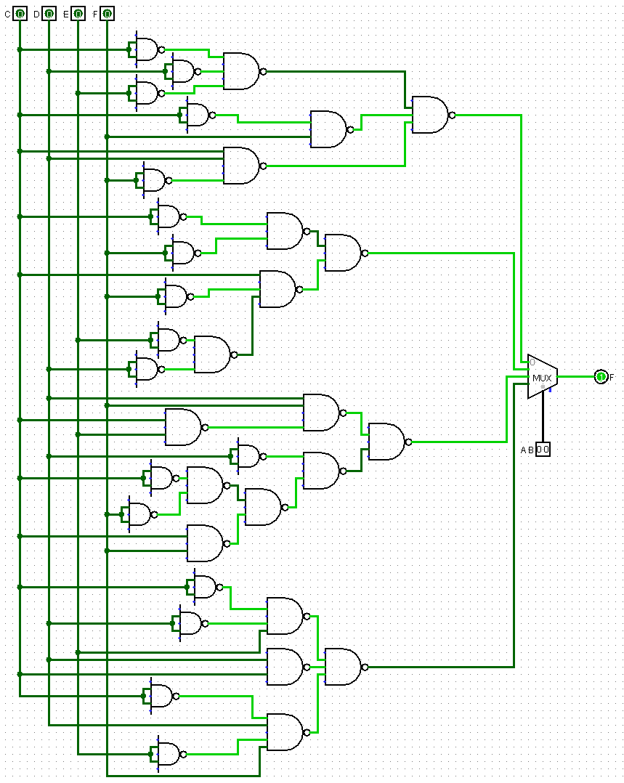

|  |  |  |  |  |  |  |  |
| --- | --- | --- | --- | --- | --- | --- | --- |
| A | B | C | D | E | F | G | Input |
| 0 | 0 | 0 | 0 | 0 | 0 | 1 | I0=D’E’+D’EF+DE’F+DEF  =D’E’+D’F+DE’F+DEF  =E’(D’+F)+F(D’+E)  =D’E’+E’F + D’F + EF  =D’E’+F  ABC=000 |
| 0 | 0 | 0 | 0 | 0 | 1 | 1 |
| 0 | 0 | 0 | 0 | 1 | 0 | 0 |
| 0 | 0 | 0 | 0 | 1 | 1 | 1 |
| 0 | 0 | 0 | 1 | 0 | 0 | 0 |
| 0 | 0 | 0 | 1 | 0 | 1 | 1 |
| 0 | 0 | 0 | 1 | 1 | 0 | 0 |
| 0 | 0 | 0 | 1 | 1 | 1 | 1 |
| 0 | 0 | 1 | 0 | 0 | 0 | 0 | I1=DE’F’+DEF’  =DF’  ABC=001 |
| 0 | 0 | 1 | 0 | 0 | 1 | 0 |
| 0 | 0 | 1 | 0 | 1 | 0 | 0 |
| 0 | 0 | 1 | 0 | 1 | 1 | 0 |
| 0 | 0 | 1 | 1 | 0 | 0 | 1 |
| 0 | 0 | 1 | 1 | 0 | 1 | 0 |
| 0 | 0 | 1 | 1 | 1 | 0 | 1 |
| 0 | 0 | 1 | 1 | 1 | 1 | 0 |
| 0 | 1 | 0 | 0 | 0 | 0 | 1 | I2=D’E’F’+D’EF’+DE’F’+DEF’  =D’F’+DF’  =F’  ABC=010 |
| 0 | 1 | 0 | 0 | 0 | 1 | 0 |
| 0 | 1 | 0 | 0 | 1 | 0 | 1 |
| 0 | 1 | 0 | 0 | 1 | 1 | 0 |
| 0 | 1 | 0 | 1 | 0 | 0 | 1 |
| 0 | 1 | 0 | 1 | 0 | 1 | 0 |
| 0 | 1 | 0 | 1 | 1 | 0 | 1 |
| 0 | 1 | 0 | 1 | 1 | 1 | 0 |
| 0 | 1 | 1 | 0 | 0 | 0 | 0 | I3=D’EF’+DE’F’+DEF’  =D’EF’+DF’  =F’(D+E)  ABC=011 |
| 0 | 1 | 1 | 0 | 0 | 1 | 0 |
| 0 | 1 | 1 | 0 | 1 | 0 | 1 |
| 0 | 1 | 1 | 0 | 1 | 1 | 0 |
| 0 | 1 | 1 | 1 | 0 | 0 | 1 |
| 0 | 1 | 1 | 1 | 0 | 1 | 0 |
| 0 | 1 | 1 | 1 | 1 | 0 | 1 |
| 0 | 1 | 1 | 1 | 1 | 1 | 0 |
| 1 | 0 | 0 | 0 | 0 | 0 | 1 | I4=D’E’F’+D’EF’+DE’F+DEF  =D’F’+DF  =D ʘ F  ABC=100 |
| 1 | 0 | 0 | 0 | 0 | 1 | 0 |
| 1 | 0 | 0 | 0 | 1 | 0 | 1 |
| 1 | 0 | 0 | 0 | 1 | 1 | 0 |
| 1 | 0 | 0 | 1 | 0 | 0 | 0 |
| 1 | 0 | 0 | 1 | 0 | 1 | 1 |
| 1 | 0 | 0 | 1 | 1 | 0 | 0 |
| 1 | 0 | 0 | 1 | 1 | 1 | 1 |
| 1 | 0 | 1 | 0 | 0 | 0 | 0 | I5=D’E’F+D’EF+DE’F  =D’F+DE’F  =F(D’+E’)  ABC=101 |
| 1 | 0 | 1 | 0 | 0 | 1 | 1 |
| 1 | 0 | 1 | 0 | 1 | 0 | 0 |
| 1 | 0 | 1 | 0 | 1 | 1 | 1 |
| 1 | 0 | 1 | 1 | 0 | 0 | 0 |
| 1 | 0 | 1 | 1 | 0 | 1 | 1 |
| 1 | 0 | 1 | 1 | 1 | 0 | 0 |
| 1 | 0 | 1 | 1 | 1 | 1 | 0 |
| 1 | 1 | 0 | 0 | 0 | 0 | 0 | I6= D’E+DE’F  ABC=110 |
| 1 | 1 | 0 | 0 | 0 | 1 | 0 |
| 1 | 1 | 0 | 0 | 1 | 0 | 1 |
| 1 | 1 | 0 | 0 | 1 | 1 | 1 |
| 1 | 1 | 0 | 1 | 0 | 0 | 0 |
| 1 | 1 | 0 | 1 | 0 | 1 | 1 |
| 1 | 1 | 0 | 1 | 1 | 0 | 0 |
| 1 | 1 | 0 | 1 | 1 | 1 | 0 |
| 1 | 1 | 1 | 0 | 0 | 0 | 0 | I7=D  ABC=111 |
| 1 | 1 | 1 | 0 | 0 | 1 | 0 |
| 1 | 1 | 1 | 0 | 1 | 0 | 0 |
| 1 | 1 | 1 | 0 | 1 | 1 | 0 |
| 1 | 1 | 1 | 1 | 0 | 0 | 1 |
| 1 | 1 | 1 | 1 | 0 | 1 | 1 |
| 1 | 1 | 1 | 1 | 1 | 0 | 1 |
| 1 | 1 | 1 | 1 | 1 | 1 | 1 |

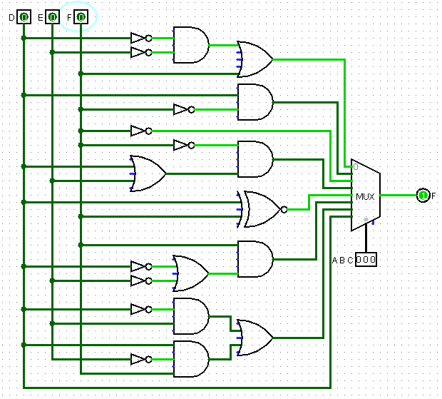

Bài 5:

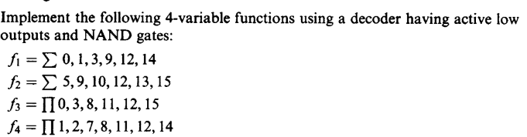

|  |  |  |  |  |  |  |  |  |  |  |  |  |  |  |  |  |  |  |  |  |
| --- | --- | --- | --- | --- | --- | --- | --- | --- | --- | --- | --- | --- | --- | --- | --- | --- | --- | --- | --- | --- |
| Enable | Input | | | | Output | | | | | | | | | | | | | | | |
| E | A | B | C | D | D15 | D14 | D13 | D12 | D11 | D10 | D9 | D8 | D7 | D6 | D5 | D4 | D3 | D2 | D1 | D0 |
| 0 | X | X | X | X | 1 | 1 | 1 | 1 | 1 | 1 | 1 | 1 | 1 | 1 | 1 | 1 | 1 | 1 | 1 | 1 |
| 1 | 0 | 0 | 0 | 0 | 1 | 1 | 1 | 1 | 1 | 1 | 1 | 1 | 1 | 1 | 1 | 1 | 1 | 1 | 1 | 0 |
| 1 | 0 | 0 | 0 | 1 | 1 | 1 | 1 | 1 | 1 | 1 | 1 | 1 | 1 | 1 | 1 | 1 | 1 | 1 | 0 | 1 |
| 1 | 0 | 0 | 1 | 0 | 1 | 1 | 1 | 1 | 1 | 1 | 1 | 1 | 1 | 1 | 1 | 1 | 1 | 0 | 1 | 1 |
| 1 | 0 | 0 | 1 | 1 | 1 | 1 | 1 | 1 | 1 | 1 | 1 | 1 | 1 | 1 | 1 | 1 | 0 | 1 | 1 | 1 |
| 1 | 0 | 1 | 0 | 0 | 1 | 1 | 1 | 1 | 1 | 1 | 1 | 1 | 1 | 1 | 1 | 0 | 1 | 1 | 1 | 1 |
| 1 | 0 | 1 | 0 | 1 | 1 | 1 | 1 | 1 | 1 | 1 | 1 | 1 | 1 | 1 | 0 | 1 | 1 | 1 | 1 | 1 |
| 1 | 0 | 1 | 1 | 0 | 1 | 1 | 1 | 1 | 1 | 1 | 1 | 1 | 1 | 0 | 1 | 1 | 1 | 1 | 1 | 1 |
| 1 | 0 | 1 | 1 | 1 | 1 | 1 | 1 | 1 | 1 | 1 | 1 | 1 | 0 | 1 | 1 | 1 | 1 | 1 | 1 | 1 |
| 1 | 1 | 0 | 0 | 0 | 1 | 1 | 1 | 1 | 1 | 1 | 1 | 0 | 1 | 1 | 1 | 1 | 1 | 1 | 1 | 1 |
| 1 | 1 | 0 | 0 | 1 | 1 | 1 | 1 | 1 | 1 | 1 | 0 | 1 | 1 | 1 | 1 | 1 | 1 | 1 | 1 | 1 |
| 1 | 1 | 0 | 1 | 0 | 1 | 1 | 1 | 1 | 1 | 0 | 1 | 1 | 1 | 1 | 1 | 1 | 1 | 1 | 1 | 1 |
| 1 | 1 | 0 | 1 | 1 | 1 | 1 | 1 | 1 | 0 | 1 | 1 | 1 | 1 | 1 | 1 | 1 | 1 | 1 | 1 | 1 |
| 1 | 1 | 1 | 0 | 0 | 1 | 1 | 1 | 0 | 1 | 1 | 1 | 1 | 1 | 1 | 1 | 1 | 1 | 1 | 1 | 1 |
| 1 | 1 | 1 | 0 | 1 | 1 | 1 | 0 | 1 | 1 | 1 | 1 | 1 | 1 | 1 | 1 | 1 | 1 | 1 | 1 | 1 |
| 1 | 1 | 1 | 1 | 0 | 1 | 0 | 1 | 1 | 1 | 1 | 1 | 1 | 1 | 1 | 1 | 1 | 1 | 1 | 1 | 1 |
| 1 | 1 | 1 | 1 | 1 | 0 | 1 | 1 | 1 | 1 | 1 | 1 | 1 | 1 | 1 | 1 | 1 | 1 | 1 | 1 | 1 |

1. F1 =

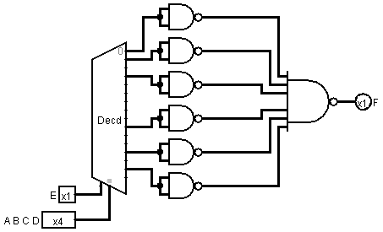

1. F2 =

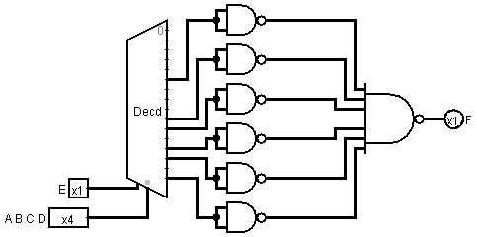

1. F3 =

= (A’+B’+C’+D’).(A’+B’+C+D).(A+B’+C’+D’).(A+B’+C+D).(A+B+C’+D’).(A+B+C+D)

F3’ = ABCD + ABC’D’+A’BCD+A’BC’D’+A’B’CD + A’B’C’D’

=

F3 =

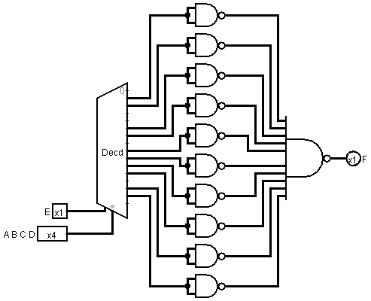

1. F4 =

= (A’+B’+C’+D).(A’+B’+C+D’).(A’+B+C+D).(A+B’+C’+D’).(A+B’+C+D).(A+B+C’+D’).(A+B+C+D’)

F4’ = ABCD’ + ABC’D + AB’C’D’ + A’BCD + A’BC’D’ + A’B’CD + A’B’C’D

=

F4 =

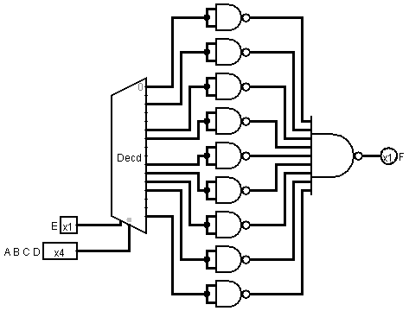

Bài 6:

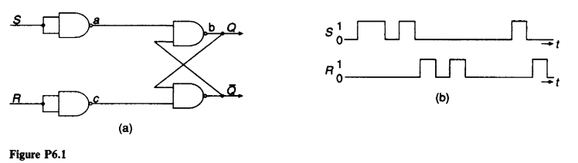

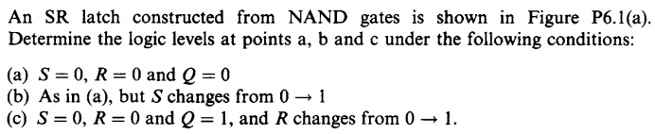

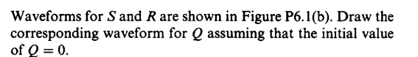

1. a=1,b=0,c=1
2. a=0,b=1,c=1
3. a=1,b=0,c=0

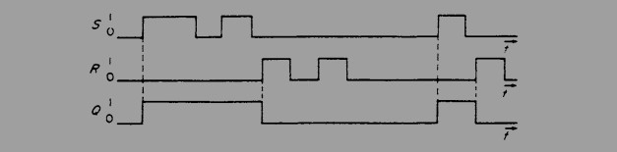

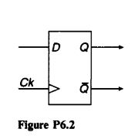Bài 7: 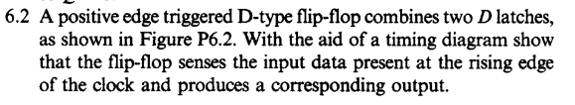

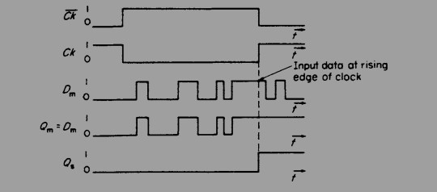

Bài 8: 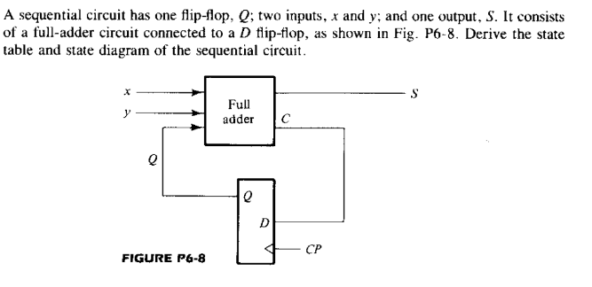

|  |  |  |  |  |
| --- | --- | --- | --- | --- |
| Present State | X | Y | Next State | Sum |
| 0 | 0 | 0 | 0 | 0 |
| 0 | 0 | 1 | 0 | 1 |
| 0 | 1 | 0 | 0 | 1 |
| 0 | 1 | 1 | 1 | 0 |
| 1 | 0 | 0 | 0 | 1 |
| 1 | 0 | 1 | 1 | 0 |
| 1 | 1 | 0 | 1 | 0 |
| 1 | 1 | 1 | 1 | 1 |

State diagram

00/0

01/1

10/1

0

1

01/0

10/0

11/1

11/0

00/1

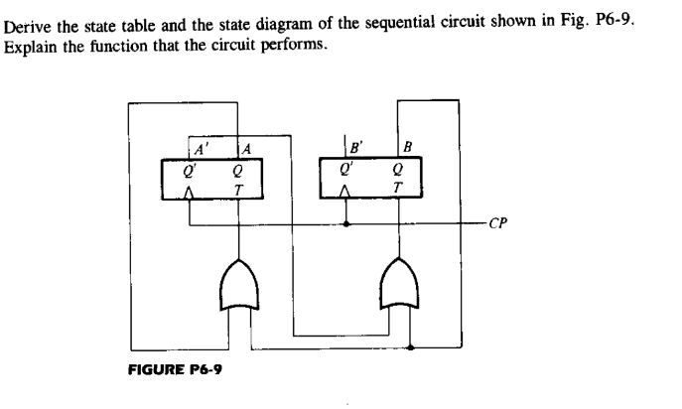Bài 9:

|  |  |  |  |  |  |
| --- | --- | --- | --- | --- | --- |
| Present state | | Next state | | Inputs | |
| A(t) | B(t) | A(t+1) | B(t+1) | TA | TB |
| 0 | 0 | 0 | 1 | 0 | 1 |
| 0 | 1 | 1 | 0 | 1 | 1 |
| 1 | 0 | 0 | 0 | 1 | 0 |
| 1 | 1 | 0 | 0 | 1 | 1 |

01

00

10

11