1. Cài đặt nginx ubuntu 20.04

- sudo apt udpate

- sudo apt install nginx

- Cấu hình file nginx:

+ sudo nano /etc/nginx/nginx.conf

+ Thêm phần này trong tag http để nginx điều hướng request đến backend

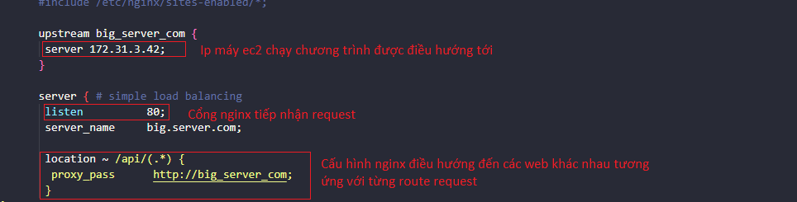

1. Cài đặt docker, docker compose
2. Docker

- sudo apt update

- sudo apt install docker.io -y

1. Docker-Compose

- sudo apt update

- sudp apt install docker-compose

1. Install database: sql server

* Install sql server on Ubuntu 20.04
  + Link: https://computingforgeeks.com/how-to-install-ms-sql-on-ubuntu/
  + Import public repository GPG keys
    - sudo wget -qO- https://packages.microsoft.com/keys/microsoft.asc | sudo apt-key add –
  + Add MSS 2019 ubuntu repository
    - sudo add-apt-repository "$(wget -qO- <https://packages.microsoft.com/config/ubuntu/20.04/mssql-server-2019.list>)"
  + Install ms sql server
    - sudo apt update
    - sudo apt install mssql-server
  + Setup sqlserver
    - sudo /opt/mssql/bin/mssql-conf setup
    - Chọn mode 2: develop
    - Nhập password đăng nhập sqlserver vs account: sa
  + Install MS SQL tools and unixODBC plugin
    - curl https://packages.microsoft.com/keys/microsoft.asc | sudo apt-key add -
    - curl https://packages.microsoft.com/config/ubuntu/20.04/prod.list | sudo tee /etc/apt/sources.list.d/msprod.list
    - sudo apt update
    - sudo ACCEPT_EULA=Y apt install mssql-tools unixodbc-dev
  + Configure PATH for MS SQL binaries
    - echo 'export PATH="$PATH:/opt/mssql-tools/bin"' >> ~/.bash_profile
    - source ~/.bash_profile
  + Test status
    - systemctl status mssql-server.service