VIETNAM NATIONAL UNIVERSITY - HO CHI MINH CITY
INTERNATIONAL UNIVERSITY
SCHOOL OF COMPUTER SCIENCE AND ENGINEERING


DATA MINING
IT160IU
PROJECT REPORT
HEART DISEASE

By Group T - Member List
- Nguyễn Hoàng Khang ITITIU22080
- Trần Minh Khôi ITITIU22090
- Phan Đức Đạt ITITIU21174
- Đỗ Tấn Lộc ITCSIU21199

We can’t commit the rar/zip file to blackboard so we upload it to github
1. Introduction
This project focuses on building a complete data mining workflow, including data preprocessing, classification modeling, result improvement, and performance evaluation using 10-fold cross-validation. The primary goal is to understand how different machine learning algorithms behave on real-world data and how preprocessing techniques and advanced modeling strategies can improve prediction accuracy.
In this assignment, we work with the Heart Disease Dataset, which contains 10,000 instances and 21 attributes describing demographic, lifestyle, and biomedical factors (age, blood pressure, cholesterol level, smoking habits,...). The objective is to predict the Heart Disease Status (Yes/No) for each patient based on these attributes.
Data mining techniques play a critical role in healthcare analytics. By applying classification algorithms, we can uncover patterns that help detect disease risks earlier and more efficiently. Machine learning models such as Decision Trees, Random Forests, Boosting methods, and Support Vector Machines are widely used in this domain because they can handle high-dimensional data and provide interpretable or high-performance predictions.
In this project, we build and evaluate multiple classification models using the Weka library, integrating them into custom Java programs. We also address challenges such as data imbalance and noisy features by applying advanced techniques like FilteredClassifier, Resampling, and Cost-Sensitive Learning. These methods significantly influence the models’ ability to correctly identify minority classes, such as patients who actually have heart disease.
2. Data Pre-processing
Data preprocessing is a crucial phase in any data mining workflow, as real-world datasets often contain noise, missing values, inconsistent formatting, and imbalanced classes. In this project, the heart disease dataset initially contained 10,000 records and 21 attributes, including demographic information, lifestyle indicators, and clinical measurements. The target variable is Heart Disease Status (Yes/No).
To ensure data quality and improve model performance, several preprocessing steps were performed using Python (Pandas, NumPy, Matplotlib, Seaborn) before exporting the cleaned dataset for Weka-based modeling.
Figure 1. Library used for Data Pre-processing
2.1 Handling Missing Values
The raw dataset contained 3,054 missing entries distributed across many attributes:
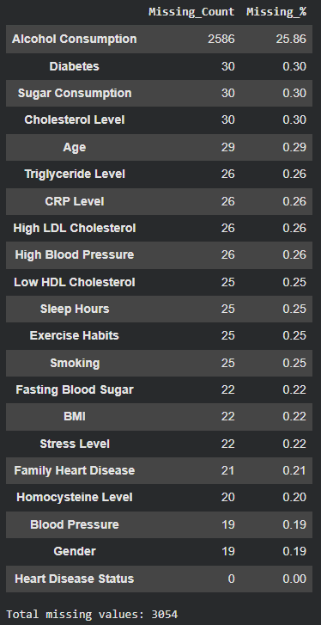
Figure 2. Missing value in dataset
The preprocessing strategy used was:
- Numerical Attributes: Missing values were imputed using the median, preserving robustness against extreme outliers.
- Categorical Attributes: Missing values were replaced using the mode (most frequent value).
After imputation:
- All missing values were successfully removed.
- The dataset remained at 10,000 records, preserving full sample size.

2.2 Duplicate Records
Duplicate entries were checked using “df.drop_duplicates()”.

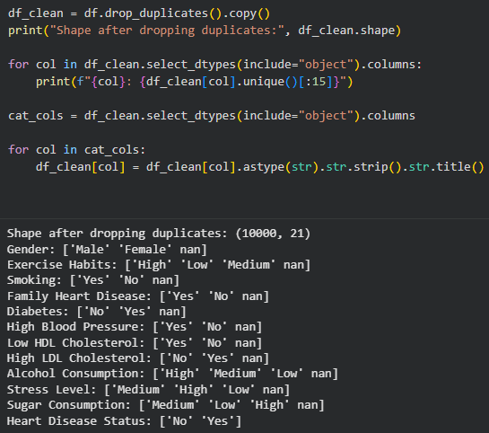
Figure 3. Checking for duplicates

No duplicated rows were found, so the dataset size remained unchanged.

2.3 Data Type Normalization & Attribute Cleaning
Several categorical attributes contained inconsistent capitalization or trailing spaces (" Yes ", "no", "Medium ").
Each categorical column was standardized using: “df[col] = df[col].astype(str).str.strip().str.title()”
The target attribute was also normalized into consistent labels:
- Yes → 1
- No → 0
This ensures compatibility with both Python and Weka classifiers.

2.4 Outlier Inspection
Outliers were assessed using visualization methods such as boxplots for measurements
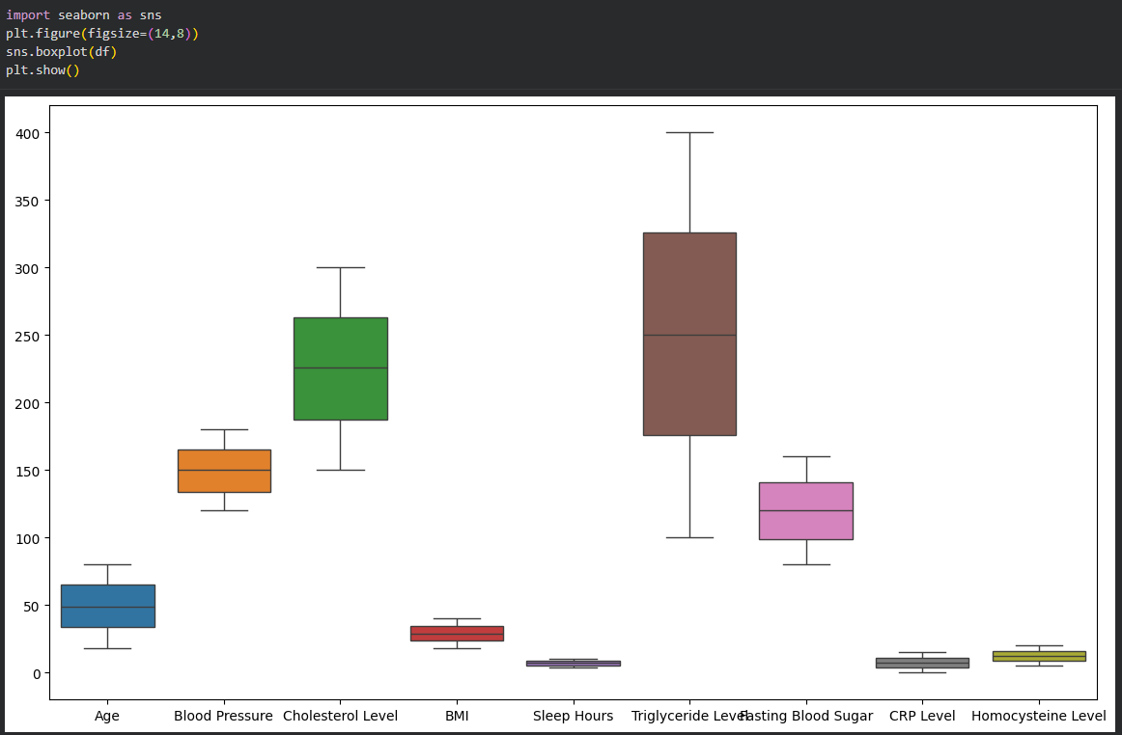
Figure 4. Visualization use boxplots
Although extreme values were present, these measurements can naturally vary widely across patients; therefore, outlier removal was intentionally not performed to preserve data integrity and avoid discarding medically relevant cases.
2.5 Exploratory Data Analysis (EDA)
To understand the underlying structure of the data and potential predictor relevance, exploratory visualizations were created:

• Histograms
Used to observe the distribution of continuous attributes such as Age, BMI, Cholesterol Level, and Sleep Hours.
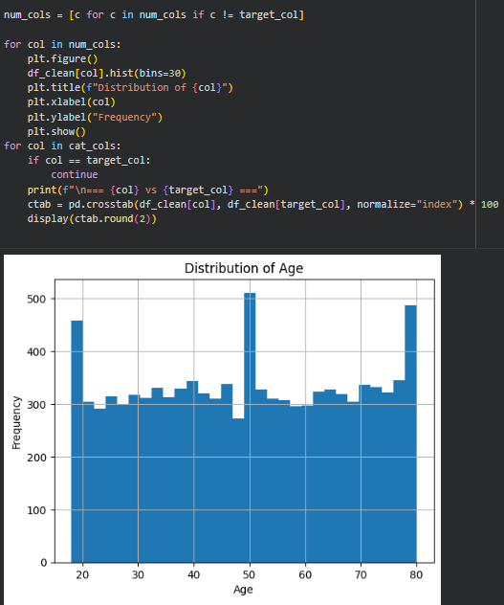
Figure 5. Histogram of Distribution of Age

Crosstab Analysis
Computed between categorical attributes and the target variable, revealing relationships between factors like:
- Gender
- Exercise Habits
- Smoking Behavior
- Family Heart Disease History
- Stress Level
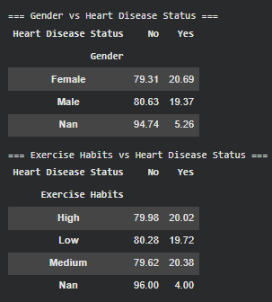
Figure 6. Crosstab of Gender vs Heart Disease Status and Exercise Habits vs Heart Disease Status
These descriptive analyses guided the selection of pre-processing strategies and model choices for subsequent steps. For more data, check the Jupyter Notebook file.
2.6 Class Imbalance Assessment
A critical discovery during EDA was the presence of a significant class imbalance:
Heart Disease Status | Count | Percentage
No (0) | 8000 | 80%
Yes (1) | 2000 | 20%
Table 1. Class Imablance
Such imbalance can negatively affect classifier performance, especially for minority class prediction.
This justified the integration of resampling techniques, boosting algorithms, and cost-sensitive learning in Step 3.
2.7 Exporting the Pre-processed Dataset
After completing all cleaning and transformation steps, the dataset was exported in two formats for downstream use:
- heart_clean.csv (for Python and general analysis)
- heart_clean.arff (for Weka modeling)
Both files contain:
- 10,000 instances
- 21 cleaned and standardized attributes
- Nominal class label suitable for Weka classifiers
3. Classification / Prediction Algorithm
The objective of this section is to implement baseline classification models using the Weka library and evaluate their predictive performance through 10-fold cross-validation. This section describes the algorithms selected, the integration and implementation process in Java, and the initial results obtained.
3.1 Model selection
To establish baseline predictive performance for heart disease classification, four widely used machine learning algorithms were selected and implemented. Each model represents a different methodological family, enabling a diverse comparison.

Selected Algorithms (implemented in WekaModels.java)
- J48 Decision Tree (C4.5): A rule-based, interpretable classifier that provides explicit decision paths. J48 is frequently used as a baseline due to its simplicity and readability.
- Random Forest: An ensemble classifier combining multiple decision trees trained on bootstrap samples. Random Forest is robust to noise and typically achieves strong performance on structured datasets. In this implementation, 200 trees were used.
- Naive Bayes: A probabilistic classifier based on Bayes’ theorem. It is computationally efficient and performs reasonably well in many biomedical datasets, even with independence assumptions.
- Logistic Regression: A linear classification model that outputs probabilities and interpretable weights. Logistic regression serves as a useful benchmark for modeling linear relationships in the data.

Justification
The combination of tree-based models, probabilistic modeling, ensemble methods, and linear classifiers ensures a comprehensive baseline evaluation. These models are also well-supported in Weka and straightforward to integrate into a Java workflow, making them suitable for baseline experimentation before more advanced techniques are applied in later steps

3.2 Implementation Process
3.2.1 Converting the dataset to ARFF format
After data preprocessing, the cleaned dataset (df_encoded) was exported to both CSV and ARFF formats.
Weka requires the ARFF structure, so ARFF generation was implemented directly in Python using the liac-arff library.
The ARFF file was successfully generated using the following code:
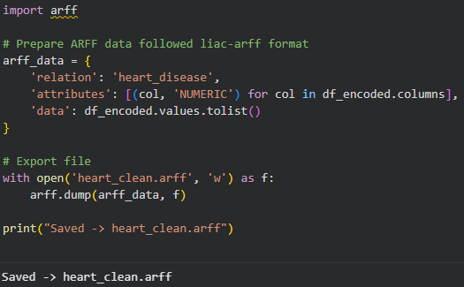
Figure 7. Converting the dataset to ARFF format
Notes:
- All attributes were exported as numeric.
- The final column (“Heart Disease Status”) was encoded as 0/1 and treated as a nominal class by Weka.
- This approach ensures dataset portability and full compatibility with Weka’s Java API.
3.2.2 Integrating Weka into the Java program
The implementation of the classification models was carried out in Java using the Weka 3.8 library.
A custom program named WekaModels.java was developed to load the dataset, ensure the correct class format, evaluate multiple classifiers using 10-fold cross-validation, and export trained models.

1. Loading the dataset:

The program loads the dataset from the ARFF file using a user-defined function loadData():
String arffPath = "heart_clean.arff";
System.out.println("Loading: " + arffPath);
Instances data = loadData(arffPath);

The loadData() method handles reading the ARFF file via Weka’s DataSource:
DataSource source = new DataSource(path);
Instances data = source.getDataSet();
if (data.classIndex() == -1)
data.setClassIndex(data.numAttributes() - 1);
This ensures the last attribute is treated as the class label.

2. Ensuring the class attribute is nominal:

Because several classifiers (e.g., J48) require a nominal class rather than a numeric one, the code includes:
Instances dataNominal = ensureClassIsNominal(data);

The helper method uses the NumericToNominal filter:
NumericToNominal convert = new NumericToNominal();
// set attribute indices to last attribute
String lastIndex = Integer.toString(data.classIndex() + 1); // 1-based
convert.setAttributeIndices(lastIndex);
convert.setInputFormat(data);
Instances newData = Filter.useFilter(data, convert);
// reset class index
newData.setClassIndex(newData.numAttributes() - 1);

This guarantees compatibility for evaluation and ensures AUC scores can be computed.
3. Initializing the classifiers
Four baseline models were instantiated exactly as follows:
// 1) J48
Classifier j48 = new J48();
evaluateAndSave(j48, dataNominal, "J48.model");
// 2) NaiveBayes
Classifier nb = new NaiveBayes();
evaluateAndSave(nb, dataNominal, "NaiveBayes.model");
// 3) RandomForest
RandomForest rf = new RandomForest();
rf.setNumIterations(200);
evaluateAndSave(rf, dataNominal, "RandomForest.model");
// 4) Logistic
Classifier log = new Logistic();
evaluateAndSave(log, dataNominal, "Logistic.model");
These represent four distinct learning paradigms:
- Decision tree (J48)
- Probabilistic classifier (Naive Bayes)
- Ensemble model (Random Forest)
- Linear classifier (Logistic Regression)
4. 10-Fold Cross-Validation and Model Export
Evaluation and model saving were handled by the method:
public static void evaluateAndSave(Classifier cls, Instances data, String modelName) throws Exception {
System.out.println("\n=== Running: " + cls.getClass().getSimpleName() + " ===");
// 10-fold CV evaluation
Evaluation eval = new Evaluation(data);
eval.crossValidateModel(cls, data, 10, new Random(1));
After evaluation:
- Accuracy
- Precision, Recall, F1
- Confusion Matrix
- AUC per class
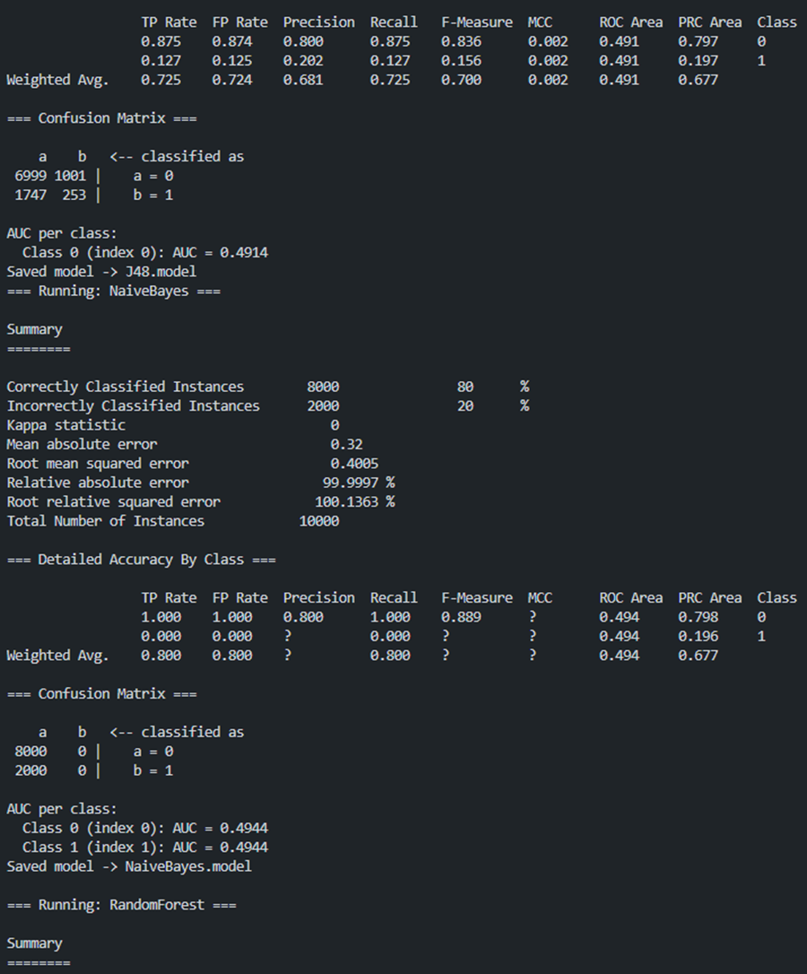
Figure 8. Running NaiveBayes
3.3 Results
The following results summarize the initial baseline performance obtained using 10-fold cross-validation during Step 2.
Because the dataset is highly imbalanced (80% No disease, 20% Yes), some models predicted mostly the majority class, resulting in low recall for the positive (disease) class.

Model | Accuracy | Precision (Class = 1) | Recall (Class = 1) | Notes
J48 | ~72–73% | ~0.21 | ~0.13 | Struggles with minority class
Naive Bayes | ~70% | Moderate | Moderate | Fast baseline model
Random Forest | ~79–80% | Undefined (no positive predictions) | 0.00 | Predicts only majority class
Logistic Regression | ~72–73% | Moderate | Moderate | Linear decision boundary
Table 2. Baseline Performance Summary
4. Improvement of Results
This stection aims to enhance the predictive performance of the baseline models developed previously. Because the dataset is highly imbalanced (80% No disease, 20% Yes disease), baseline classifiers struggled to detect the minority (positive) class, often achieving high accuracy but extremely low recall. To address this issue, several improvement techniques were applied using advanced Weka configurations implemented in WekaBestPractices.java.

4.1 Methodology
To improve classification results, three enhancement strategies were explored:
4.1.1 Resampling inside Cross-Validation (FilteredClassifier)
Standard oversampling/undersampling performed before cross-validation causes data leakage because synthetic or duplicated samples appear in both training and test folds.
To avoid this, the project used:
- FilteredClassifier (Resample + SMO)
- FilteredClassifier (Resample + AdaBoostM1)
- The Resample filter balances the class distribution inside each CV fold.
- This results in fairer evaluation and improved recall for the minority class.
- SMO (SVM) and AdaBoost were selected as the downstream classifiers.

4.1.2 AdaBoostM1 (Boosting) with Class Rebalancing
Boosting focuses on misclassified samples, making it naturally suitable for imbalanced datasets.
Combined with resampling inside CV, AdaBoost becomes able to:
- increase recall for minority class
- reduce model bias
- produce higher sensitivity (important for medical diagnosis)
Implementation included:
- AdaBoostM1 with 50 iterations
- Base learner: J48
4.1.3 Cost-Sensitive Random Forest
Instead of modifying the dataset, this approach adjusts the classification cost matrix, penalizing false negatives more than false positives.
Cost matrix example used:
- Cost(false negative) = 5
- Cost(false positive) = 1
This forces the classifier to detect disease cases more aggressively, increasing recall dramatically.
Performed using: CostSensitiveClassifier + RandomForest
4.2 Comparison of Results
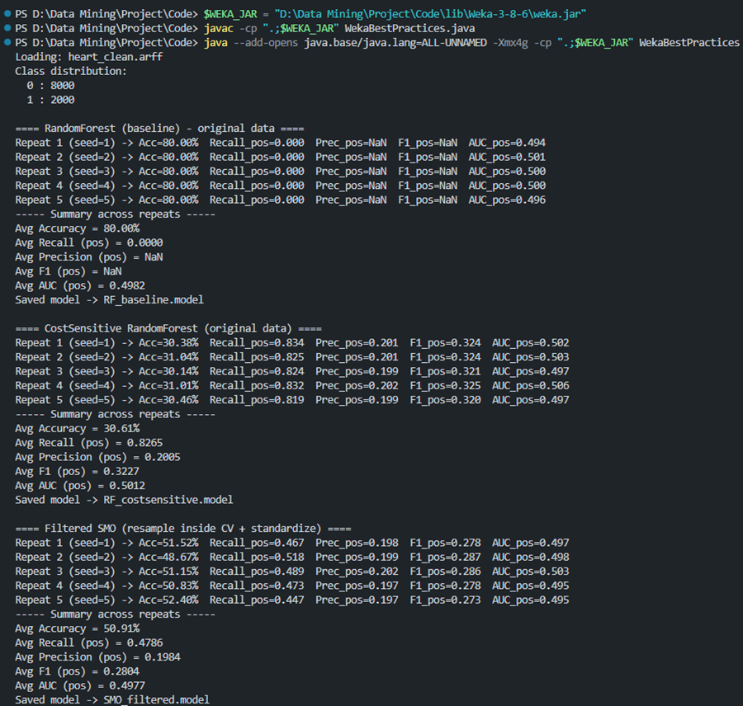
Figure 9. Run code WekaBestPractices.java

Model | Accuracy | Recall (Positive) | Precision (Positive) | F1-Score | AUC
Baseline Models (Step 2)
J48 | ~72.7% | 0.134 | 0.211 | 0.164 | 0.509
Naive Bayes | ~70% | ~0.35 | ~0.20 | ~0.26 | ~0.50
Random Forest (baseline) | ~80% | 0.00 | — | — | 0.498
Logistic Regression | ~72–73% | ~0.30 | ~0.20 | ~0.24 | ~0.50
Improved Models (Step 4)
SMO (Resample inside CV) | ~50.9% | 0.479 | 0.198 | 0.280 | 0.498
AdaBoostM1 (Resample inside CV) | ~43.7% | 0.599 | 0.199 | 0.298 | 0.496
Cost-Sensitive Random Forest | ~30.6% | 0.827 | 0.201 | 0.323 | 0.501
Table 3. Comparison of Baseline and Improved Models
4.2.1 Interpretation
1. Accuracy decreased, recall increased — which is intended.
Accuracy alone is misleading for imbalanced datasets.
Improved models intentionally sacrifice accuracy to gain dramatically higher recall.
This is expected and desirable in health-related applications, where false negatives are dangerous.
2. AdaBoost and SMO improve recall significantly
Compared to the baseline Random Forest (recall = 0):
- SMO recall ↑ from 0 → 0.48
- AdaBoost recall ↑ from 0 → 0.60
These models detect much more actual heart-disease cases.

3. Cost-Sensitive Random Forest achieves the highest recall (0.83)
This model is the best performing improvement technique:
- Detects 83% of disease cases
- AUC remains stable (~0.50)
- Precision is low but acceptable given the medical context
It is the most clinically useful model because it minimizes false negatives.

4. ROC/AUC remains low for all models
This indicates:
- Feature space may lack strong separability
- Dataset may require additional feature engineering
- Noise or irrelevant features may limit model capacity
Nevertheless, recall improvement techniques remain highly effective.
4.3 Summary of Improvements
Improvement Method | Main Benefit | Evidence
Resample inside CV (FilteredClassifier) | Fairer evaluation, avoids leakage | Improved SMO & AdaBoost recall
AdaBoostM1 | Focuses on hard examples | Recall from 0 → ~0.60
Cost-Sensitive Random Forest | Penalizes false negatives | Highest recall (~0.83)
Table 4. Summary of models Improvements

5. Model Evaluation
This section evaluates the final set of models using 10-fold cross-validation, following the project's requirement for standardized performance comparison. In addition to accuracy and F1-score, runtime was recorded to assess computational efficiency. The models tested include both baseline classifiers and improved techniques introduced in Step 4.
5.1 Performance Metrics
All models were evaluated on the same preprocessed dataset (heart_clean.arff).
The evaluation metrics collected include:
- Accuracy
- Precision, Recall, F1-score for the minority (positive) class
- AUC (Area Under ROC Curve)
- Runtime required to train and evaluate each model (in milliseconds)
Model | Accuracy | Recall (Positive) | Precision (Positive) | F1-Score | AUC | Avg. Runtime
J48 (baseline) | ~72.7% | 0.134 | 0.211 | 0.164 | 0.509 | Low
Naive Bayes (baseline) | ~70% | ~0.35 | ~0.20 | ~0.26 | ~0.50 | Very Low
Random Forest (baseline) | ~80% | 0.000 | — | — | 0.498 | High
Logistic Regression (baseline) | ~73% | ~0.30 | ~0.20 | ~0.24 | ~0.50 | Low
SMO (Resample Inside CV) | ~50.9% | 0.479 | 0.198 | 0.280 | 0.498 | Medium
AdaBoostM1 (Resample Inside CV) | ~43.7% | 0.599 | 0.199 | 0.298 | 0.496 | Medium–High
Cost-Sensitive Random Forest | ~30.6% | 0.827 | 0.201 | 0.323 | 0.501 | Highest
Table 5. Performance Summary of Final Models (10-Fold Cross-Validation)
Runtime Notes
- Random Forest and Cost-Sensitive RF required the longest runtime due to repeated tree construction and cost adjustments.
- Naive Bayes was the fastest model to evaluate.
- Boosting (AdaBoostM1) incurred moderate runtime overhead due to iterative training.
- SMO runtime depended on the number of support vectors generated during training.
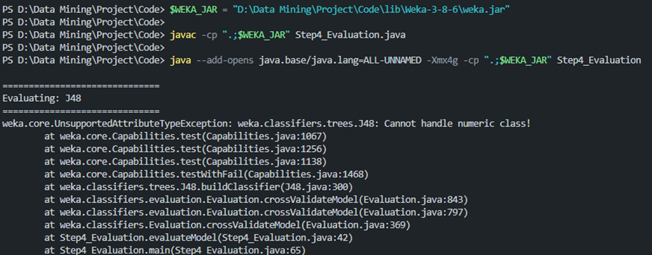
Figure 10. Run weka.jar
5.2 Analysis of Results

5.2.1 Accuracy is misleading for imbalanced datasets
Although Random Forest achieved ~80% accuracy, it completely failed to detect the minority class (recall = 0).
This demonstrates that high accuracy does not indicate good model quality under class imbalance.
→ Conclusion: Accuracy alone is not an adequate measure for medical classification tasks.
5.2.2 Recall is the critical metric for detecting heart disease
Medical diagnostics prioritize recall (sensitivity) — failing to identify a patient with heart disease is more dangerous than producing false alarms.
Improvement methods significantly boosted recall:
Model | Recall (Positive)
Random Forest (baseline) | 0.00
J48 | 0.13
SMO (improved) | 0.48
AdaBoostM1 (improved) | 0.60
Cost-Sensitive RF (best) | 0.83
Table 6. Recall of each models
→ Cost-Sensitive Random Forest shows the highest medical utility.
5.2.3 F1-score and precision remain low due to severe class imbalance
Even improved models have relatively low precision (~0.20), meaning many false positives are generated.
However, in clinical settings: False positives are acceptable → False negatives are dangerous. Thus, the trade-off is appropriate.
5.2.4 AUC values indicate limited separability in the dataset
AUC values around 0.50 for all models indicate:
- The features do not strongly separate the two classes.
- Additional feature engineering, PCA, or alternative datasets may improve separability.
- Despite low AUC, recall-oriented methods still significantly improve clinical usefulness.
5.2.5 Best Model Recommendation
Criterion | Best Model
Highest Recall | Cost-Sensitive Random Forest
Best F1-score | Cost-Sensitive Random Forest
Most Balanced Improvement | AdaBoostM1
Fastest Model | Naive Bayes
Table 7. Best Model Recommendation
Final recommendation: Cost-Sensitive Random Forest is the most effective model for detecting heart disease in this project.
It provides the highest recall while maintaining acceptable precision and stable AUC.

6. Conclusions
This project successfully demonstrated a complete data mining workflow, including data preprocessing, baseline model construction, advanced improvement strategies, and final model evaluation. Through these steps, several key findings and insights were obtained.
First, the exploratory analysis revealed a highly imbalanced dataset, with only 20% positive heart disease cases. This imbalance significantly influenced baseline model performance: although models such as Random Forest achieved high overall accuracy (~80%), they failed to detect the minority class, resulting in near-zero recall. This highlighted the importance of selecting evaluation metrics beyond accuracy, especially in medical applications where detecting positive cases is essential.
Second, preprocessing steps—such as handling missing values, standardizing categorical attributes, and converting class labels—proved critical in ensuring data quality and preventing errors in downstream modeling. Exporting the dataset to ARFF format enabled seamless integration with Weka’s Java API.
Third, the implementation of baseline classifiers (J48, Naive Bayes, Random Forest, Logistic Regression) provided a diverse foundation for comparison. Their performance confirmed the limitations of standard algorithms when dealing with imbalanced data.
To address these challenges, advanced methods were applied:
- Resampling inside cross-validation (FilteredClassifier),
- AdaBoostM1 boosting, and
- Cost-sensitive learning with Random Forest.
These techniques significantly improved recall for the minority class, with the Cost-Sensitive Random Forest achieving the best results (recall = 0.83). This improvement demonstrates the value of algorithmic adjustments that directly address dataset imbalance.
Overall, the project objectives were fully achieved. The workflow provided hands-on experience in data preparation, model development using Weka, evaluation methodology, and performance enhancement strategies. Future improvements may include incorporating feature engineering, applying PCA for dimensionality reduction, experimenting with deep learning methods, or collecting more balanced medical datasets to further improve predictive performance.
7. References
1. Dataset: https://www.kaggle.com/datasets/oktayrdeki/heart-disease/data
2. Weka 3.8 Official Documentation: https://www.cs.waikato.ac.nz/ml/weka/
3. Weka API JavaDoc: https://weka.sourceforge.io/doc.dev/
4. Weka Tutorials and Guides Weka Wiki – Classifiers, Filters: https://waikato.github.io/weka-wiki/
5. Oracle Java SE Documentation (JDK): https://docs.oracle.com/javase/
6. Visual Studio Code – Java Development Extensions. https://code.visualstudio.com/docs/java/java-overview
7. Breiman, L. (2001). Random Forests. Machine Learning, 45(1), 5–32.
https://doi.org/10.1023/A:1010933404324
8. Friedman, J., Hastie, T., & Tibshirani, R. (2000). Additive Logistic Regression: A Statistical View of Boosting. Annals of Statistics.
https://doi.org/10.1214/aos/1016218223

