PROJECT REPORT

Robustness of Object Detection Models to Noise and Environmental Distortions
  - Comparing YOLOv8n, YOLOv8s, and SSD-MobileNet; image recovery, fine-tuning, and demo application evaluation
Computer Vision • COCO val2017 • Open Images V7

Primary scope | Key evidence
5,000 COCO val2017 images, 80 classes | YOLOv8s reaches 61.12% mAP@0.5 at 640 px in the paired measurement
Three detectors under the shared 320 px protocol | YOLOv8s 49.12%; YOLOv8n 40.37%; SSD-MobileNet 33.86% on clean images
Synthetic distortions and preprocessing | Salt-and-Pepper 0.06 causes the largest drop; median filtering recovers the most
Fine-tuning and demo product | The tested fine-tuned checkpoints do not outperform the pretrained COCO baseline

Report date: 9 November 2026

Executive Summary
This project establishes a reproducible pipeline to measure how Gaussian noise, Salt-and-Pepper noise, fog, and low-light conditions affect pretrained object detectors. COCO val2017 is the primary benchmark, while Open Images V7 provides an external-dataset check. The study also compares image-recovery methods and fine-tuning. Larger models generally achieve higher mAP on COCO. Among the simulated distortions, Salt-and-Pepper noise causes the largest degradation, and a median filter restores most of the lost performance in this case.
- YOLOv8s pretrained is the strongest current choice for the demo: it reaches 61.12% mAP@0.5 on COCO val2017 at 640 px, compared with 51.85% for YOLOv8n. Measured median latency is 8.76 ms and 8.36 ms, respectively, on an RTX 3060.
- Under a shared 320 px input and evaluator, clean-image performance ranks YOLOv8s (49.12%), YOLOv8n (40.37%), and SSDLite320-MobileNetV3-Large (33.86%). SSD is usable and was evaluated, but scores lower on COCO under this protocol.
- Across 5,000 images, YOLOv8n mAP@0.5 falls from 51.85% on clean images to 24.59% under Salt-and-Pepper 0.06; median filtering raises it to 49.36%. This does not mean every distortion should be denoised: NLM reduces performance for mild-to-moderate Gaussian noise, and CLAHE can lower scores at some mild levels.
- Fine-tuning on 1,000 COCO-80 images lowers mAP for YOLOv8n, YOLOv8s, and SSD. YOLOv8n experiments on 5,000 images and noise-aware training also fail to outperform the clean-image baseline. Based on the evidence available at report time, retaining pretrained checkpoints and applying selective recovery is the better-supported decision.
- The 100-image Open Images result slightly changes the COCO ranking: YOLOv8n scores 65.77%, YOLOv8s 65.38%, and SSD 61.88% across eight classes. This is an Open Images pilot protocol and cannot be directly compared with COCO mAP.
Practical conclusion
Use YOLOv8s as the default for the COCO-80 demo; retain YOLOv8n as the lightweight option and SSD as an alternative architecture baseline. Apply median filtering to severe Salt-and-Pepper and CLAHE to severe fog/low-light according to the benchmarked policy; do not filter every image by default.

Contents
Executive Summary 2
Contents 3
Background and Research Question 4
Research Question 4
Objectives 4
Scope and Claims Not Made 4
Pipeline Architecture 4
Data and Evaluation Protocols 4
COCO val2017 4
Open Images V7 5
Distortion Condition Definitions 5
Metrics and Matching Rules 5
Image Recovery 5
Detector Comparison Results 5
Three-Model Comparison under the Shared 320 px Protocol 5
Model Comparison at 640 px 6
Individual Detector Assessment 8
YOLOv8n 8
YOLOv8s 8
SSD-MobileNet 8
Distortion Sensitivity and Recovery Effectiveness 9
Raw Distortion Curves on Full COCO val2017 9
Severe Distortions and Recovery at 640 px 10
Results by Seed and Image Composition 11
Small Objects and Class-Level Errors 12
Fine-Tuning and Checkpoint Selection 15
Fine-Tuning on 1,000 COCO-80 Images 15
YOLOv8n Experiments on 5,000 Images 16
Evaluation on Open Images V7 16
Demo Product and Application Pipeline 17
Desktop MVP 17
Local Website 17
Tiling Pilot 17
Limitations and Interpretation Risks 18
Conclusion and Recommendations 18
Next Steps 18
Appendix A: The 80 COCO Classes 19
Appendix B: Results and Reproduction Files 19
References 19

Background and Research Question
Object detectors may perform well on clean benchmark images but degrade when sensor noise, weather, or lighting changes. This project quantifies that relationship and tests whether image preprocessing before inference can recover performance.

Research Question
How do different levels of Gaussian noise, Salt-and-Pepper noise, simulated fog, and low-light affect mAP, precision/recall, and false-positive/false-negative counts for YOLOv8n, YOLOv8s, and SSD-MobileNet? How much performance can median filtering, Non-Local Means, bilateral filtering, and CLAHE recover?

Objectives
- Create distortion conditions with defined levels and seeds so experiments can be reproduced.
- Measure mAP@0.5 and mAP@0.5:0.95, and record TP/FP/FN counts at a separately specified confidence threshold.
- Compare detectors within protocols that use compatible input sizes and AP evaluators.
- Assess sensitivity to noise seeds, image selection, object size, and class.
- Test fine-tuning, retaining a checkpoint only if it improves results on an appropriate evaluation split.
- Package the results in a desktop demo and local website, clearly warning users when an image has no ground truth.

Scope and Claims Not Made
This is a robustness evaluation using synthetic distortions on COCO validation, not COCO test-dev or a real outdoor study. Fog is currently simulated as a nearly uniform veil without depth, while low-light is a pixel-level transformation. Conclusions therefore apply to the simulated changes and do not establish that a model is safe under all environmental conditions.

Pipeline Architecture
Stage | Description | Output
Labeled data | COCO val2017; Open Images V7 subset | Images and ground truth
Distortion | Gaussian, Salt-and-Pepper, fog, low-light | Raw images by level/seed
Recovery | NLM, bilateral, median, CLAHE | Corresponding recovered images
Inference | YOLOv8n, YOLOv8s, SSDLite-MobileNetV3 | Boxes, scores, labels
Assessment | mAP, precision/recall, TP/FP/FN, per-class, size recall | CSV, confusion matrices, charts
Application | Desktop MVP and local React/FastAPI website | Image demo, configuration, and results viewer

The clean, raw, and recovered branches use the same source images and original annotations. Gaussian and Salt-and-Pepper seeds are fixed so each model or preprocessing method receives the corresponding distortion.

Data and Evaluation Protocols

COCO val2017
The primary benchmark contains all 5,000 COCO val2017 images, 36,335 object instances, and all 80 COCO classes. COCO annotations were converted to YOLO format; crowd regions were excluded from measurements by the project script. Repeated analysis uses three disjoint 500-image subsets. The original subset contains 3,799 boxes and ground truth for 79 of 80 classes. The three subsets help separate variation caused by image composition from variation caused by noise seeds.

Open Images V7
The initial external pilot contains 100 validation images, 193 boxes, and eight classes cautiously mapped to semantically similar COCO classes. The expanded set contains 300 disjoint images, 782 boxes, and seven classes with positive boxes. Remote control has no boxes in this disjoint 300-image set and is therefore excluded from its mAP. Original Open Images annotations are retained, group-of instances are handled, and positive/negative labels follow a separate protocol.
Do not mix the mAP values
COCO and Open Images mAP use different class sets, ground-truth rules, and evaluators. Use Open Images to examine generalization beyond COCO, not to rank models directly against COCO mAP.

Distortion Condition Definitions
Condition | Simulation | Levels used
Gaussian | Additive Gaussian noise; sigma = level × 255 | 0.01; 0.03; 0.06
Salt-and-Pepper | Replace an equal share of pixels with black/white values | 0.01; 0.03; 0.06
Fog | Blend the image with a bright near-white veil using alpha intensity | 0.15; 0.30; 0.50
Low-light | Scale brightness by 0–1 and then apply gamma 1.15; lower factors are darker | 0.60; 0.40; 0.25

Metrics and Matching Rules
mAP@0.5 is the mean AP across classes at IoU 0.50; mAP@0.5:0.95 averages AP over IoU thresholds from 0.50 to 0.95. These are detection metrics, not the percentage of images classified correctly. TP/FP/FN are counted separately at confidence 0.25 and matching IoU 0.50; predictions below the threshold are excluded. Counts may therefore differ from a library's internal precision/recall values, and fewer false positives do not automatically mean a better model if false negatives increase.
At 640 px, YOLO models use the Ultralytics validator. The three-detector comparison at 320 px uses a shared 101-point interpolated AP evaluator on COCO images and retains each architecture's default post-processing. The 320 px protocol provides better normalization across models, although resizing and NMS still differ by framework. SSD is not compared at 640 px because SSD-MobileNetV3 is evaluated at its native 320 px input.

Image Recovery
Distortion | Method | Evaluation note
Gaussian | Fast NLM or bilateral filtering | NLM/bilateral depends on level and model; mild filtering is not always beneficial
Salt-and-Pepper | 3×3 median filter | mAP benefit increases clearly as impulse density rises
Fog / low-light | CLAHE on the Lab L channel | Most useful at severe fog/low-light levels

Detector Comparison Results

Three-Model Comparison under the Shared 320 px Protocol
This is the primary comparison of YOLOv8n, YOLOv8s, and SSD-MobileNet: the same 5,000 COCO val2017 images, the same 101-point AP evaluator, and the same target input size of 320 px. Recovered conditions use NLM for Gaussian noise, median filtering for Salt-and-Pepper, and CLAHE for fog/low-light.
Condition | YOLOv8n  mAP50 / 50:95 (%) | YOLOv8s  mAP50 / 50:95 (%) | SSDLite  mAP50 / 50:95 (%)
Clean | 40.37 / 27.84 | 49.12 / 35.00 | 33.86 / 21.04
Gaussian 0.06 raw | 37.66 / 25.76 | 46.40 / 32.72 | 31.84 / 19.71
Gaussian 0.06 recovered | 38.13 / 26.02 | 46.57 / 32.80 | 30.65 / 18.79
Salt-and-Pepper 0.06 raw | 26.12 / 17.45 | 32.17 / 22.03 | 22.54 / 13.70
Salt-and-Pepper + median | 39.51 / 27.26 | 48.12 / 34.26 | 32.98 / 20.57
Fog 0.50 raw | 35.76 / 24.68 | 44.23 / 31.40 | 30.05 / 18.66
Fog + CLAHE | 38.59 / 26.56 | 47.81 / 33.93 | 32.23 / 19.95
Low-light 0.25 raw | 34.82 / 23.90 | 43.80 / 31.03 | 28.72 / 17.80
Low-light + CLAHE | 37.28 / 25.75 | 46.25 / 32.76 | 30.50 / 18.93

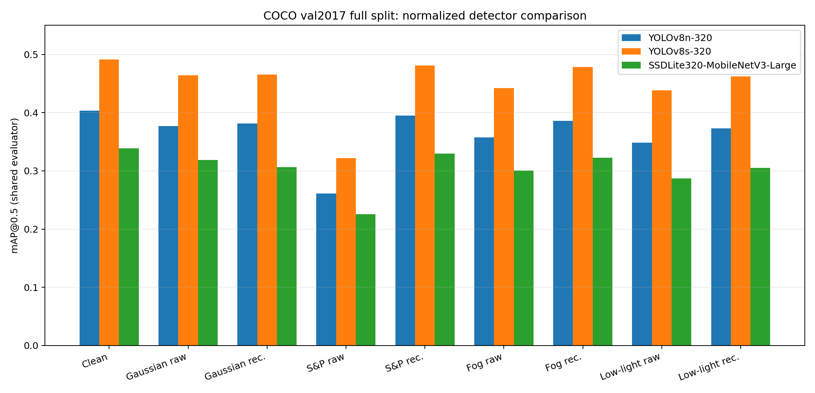
Figure 1. mAP@0.5 of the three detectors under the 320 px protocol. Source: runs/normalized_detector_comparison_fullval/metrics.csv.
YOLOv8s ranks first on clean images and in every condition in the 320 px table. YOLOv8n has fewer false positives on clean images (5,395 versus 7,121 for YOLOv8s), but also fewer true positives and more false negatives. SSD has the fewest TPs and most FNs in this baseline. Median filtering restores much of the severe Salt-and-Pepper degradation for all three architectures, while YOLOv8s still scores highest after recovery.

Model Comparison at 640 px
At 640 px, paired measurements for YOLOv8n and YOLOv8s use the same 5,000 images, the same Ultralytics model-family evaluator, and the same conditions. The project has no SSD 640 px result; SSD is reported at its native 320 px input.
Condition | YOLOv8n  mAP50 / 50:95 (%) | YOLOv8s  mAP50 / 50:95 (%)
Clean | 51.85 / 36.71 | 61.12 / 44.43
Gaussian 0.06 raw | 43.87 / 30.37 | 53.90 / 38.32
Gaussian 0.06 + bilateral | 48.17 / 33.66 | 57.24 / 40.87
Salt-and-Pepper 0.06 raw | 24.59 / 16.36 | 28.40 / 19.23
Salt-and-Pepper + median | 49.36 / 34.75 | 58.03 / 41.90
Fog 0.50 raw | 47.12 / 33.20 | 55.92 / 40.41
Fog + CLAHE | 49.98 / 35.27 | 59.48 / 43.07
Low-light 0.25 raw | 45.91 / 32.24 | 55.56 / 39.87
Low-light + CLAHE | 48.48 / 34.21 | 57.99 / 41.95

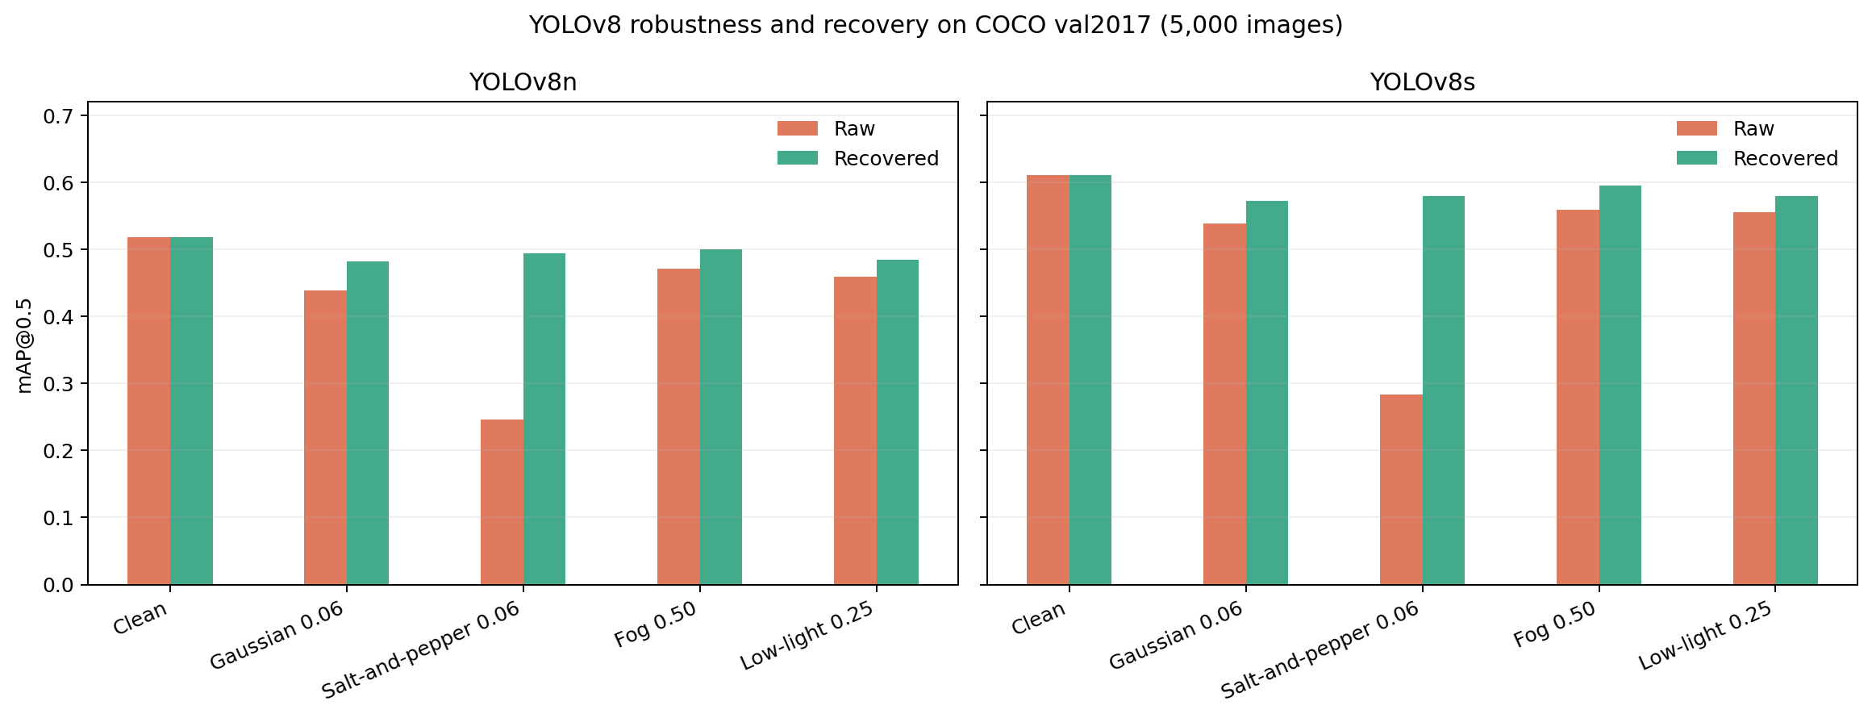
Figure 2. Robustness comparison of YOLOv8n and YOLOv8s on COCO val2017 at 640 px.
In the paired 640 px table, YOLOv8s exceeds YOLOv8n by 9.28 percentage points in clean-image mAP@0.5, while mean latency increases by about 0.58 ms/image in the RTX 3060 benchmark. The model-size comparison source reports a 60.96% clean score for YOLOv8s, whereas the paired robustness table reports 61.12%; these runs/aggregations do not match exactly. The report preserves each source value in its respective table rather than merging them.
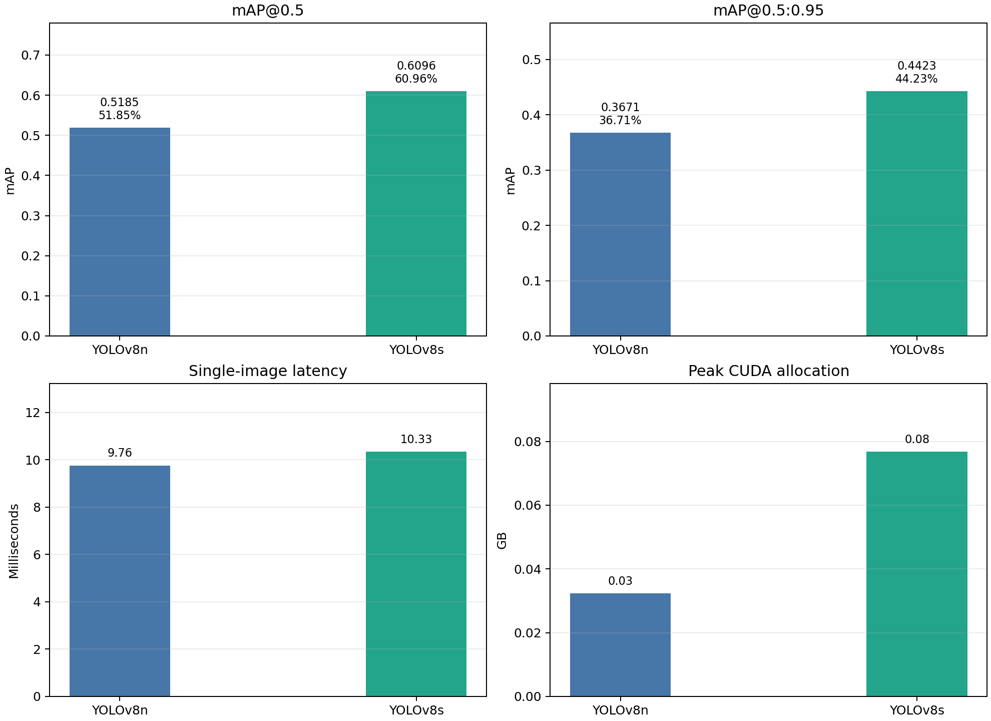
Figure 3. YOLOv8n and YOLOv8s model-size comparison on the full COCO val2017 set.
Model | mAP50 (640) | mAP50:0.95 | Mean latency | Median / P95 | Peak VRAM
YOLOv8n | 51.85% | 36.71% | 9.76 ms | 8.36 / 12.73 ms | 0.032 GB*
YOLOv8s | 60.96% | 44.23% | 10.33 ms | 8.76 / 15.26 ms | 0.077 GB*

*Peak VRAM is the CUDA-allocated value reported by the measurement, not the total VRAM reserved by the application. Latency was measured on 200 images per model in two orders after warm-up, with confidence 0.25 and NMS IoU 0.7 on an RTX 3060; it should not be treated as a universal hardware benchmark.

Individual Detector Assessment

YOLOv8n
YOLOv8n is a lightweight baseline and an option for faster inference. At 640 px, it reaches 51.85% mAP@0.5 / 36.71% mAP@0.5:0.95 on the full COCO val2017 set. Under the shared 320 px protocol, its clean scores are 40.37% / 27.84%.
YOLOv8n's strength is slightly lower inference cost than YOLOv8s; its baseline accuracy is clearly lower. Under severe Salt-and-Pepper 0.06, 640 px mAP50 falls from 51.85% to 24.59%, then recovers to 49.36% with median filtering. Fog 0.50 lowers it to 47.12%, and CLAHE raises it to 49.98%. Low-light 0.25 lowers it to 45.91%, and CLAHE raises it to 48.48%.

YOLOv8s
YOLOv8s has the strongest COCO performance in the current comparisons. It reaches 61.12% mAP50 / 44.43% mAP50:0.95 in the paired full-validation 640 px comparison and 49.12% / 35.00% under the shared 320 px protocol. Its measured RTX 3060 latency is only slightly higher than YOLOv8n, so it is selected as the default for the desktop MVP and live detection on the website.
At 640 px, YOLOv8s falls to 28.40% mAP50 under Salt-and-Pepper 0.06 and recovers to 58.03% with median filtering. Under severe fog it scores 55.92% raw and 59.48% after CLAHE; under severe low-light it scores 55.56% raw and 57.99% after CLAHE. On the expanded 300-image Open Images subset, YOLOv8s reaches 73.04% mAP50 under the Open Images evaluator across seven supported classes. YOLOv8n and SSD were not measured on the same 300-image run, so these results do not establish a three-model ranking.

SSD-MobileNet
SSDLite320-MobileNetV3-Large is a compact COCO-pretrained detector with a native 320 px input. It was evaluated on all 5,000 images under two protocols and uses Torchvision weights. Under the shared 320 px protocol, it reaches 33.86% mAP50 / 21.04% mAP50:0.95. This is the lowest clean score among the three models; on the 100-image Open Images set it reaches 61.88% across eight classes.
Salt-and-Pepper 0.06 lowers SSD to 22.54% at 320 px; median filtering raises it to 32.98%. CLAHE improves severe fog from 30.05% to 32.23% and severe low-light from 28.72% to 30.50%. Gaussian-NLM lowers SSD from 31.84% to 30.65%; bilateral filtering at level 0.06 reaches 32.48%, 0.64 points above raw and 1.84 points above NLM. At Gaussian levels 0.01 and 0.03, bilateral filtering instead lowers mAP.
Why was SSD previously unavailable on the website?
The API reports SSD as ready only when pretrained Torchvision weights are present in the local cache. SSD was not excluded from the benchmark; its weights simply need to be downloaded/cached locally before inference. The COCO comparison confirms that SSD runs, but its baseline mAP is below both YOLO models under the current protocol.

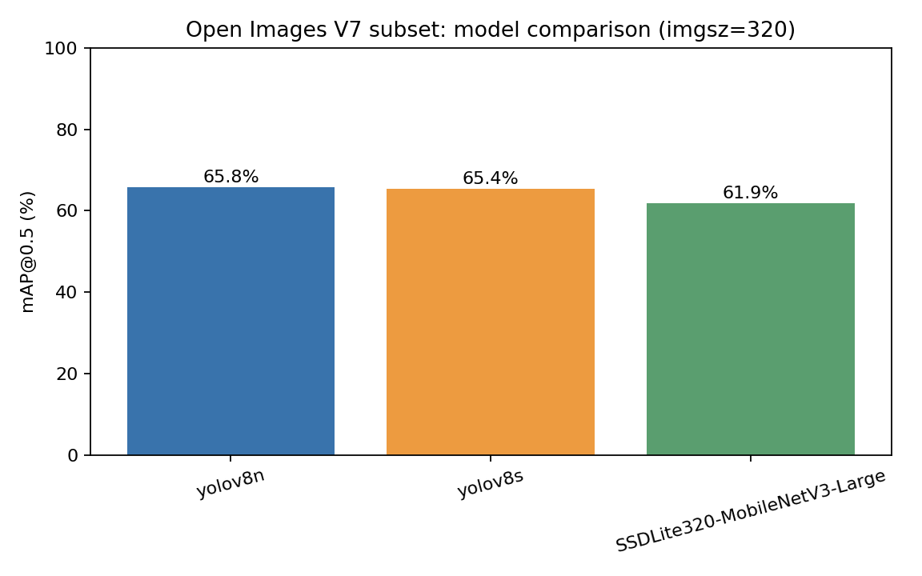
Figure 4. Three-detector comparison on the 100-image, eight-class Open Images validation subset; metrics use the separate Open Images evaluator.

Distortion Sensitivity and Recovery Effectiveness

Raw Distortion Curves on Full COCO val2017
The full raw sweep uses 5,000 images, 80 classes, YOLOv8n at imgsz 640, and seed 42. The clean baseline reaches 51.85% mAP50. Every distortion family lowers mAP as severity increases, with the largest drop from Salt-and-Pepper. The low-light factor is defined so that a lower value means a darker image; therefore, 0.25 is the most severe level.
Raw condition | mAP50 | mAP50:0.95 | mAP50 drop vs. clean
Clean | 51.85% | 36.71% | —
Gaussian 0.01 / 0.03 / 0.06 | 51.61 / 49.27 / 43.87% | 36.51 / 34.49 / 30.37% | 0.5 / 5.0 / 15.4% relative
S&P 0.01 / 0.03 / 0.06 | 43.37 / 34.64 / 24.59% | 30.21 / 23.44 / 16.36% | 16.3 / 33.2 / 52.6% relative
Fog 0.15 / 0.30 / 0.50 | 51.08 / 49.85 / 47.12% | 36.15 / 35.21 / 33.20% | 1.5 / 3.9 / 9.1% relative
Low-light 0.60 / 0.40 / 0.25 | 51.20 / 49.65 / 45.91% | 36.39 / 35.09 / 32.24% | 1.2 / 4.2 / 11.4% relative

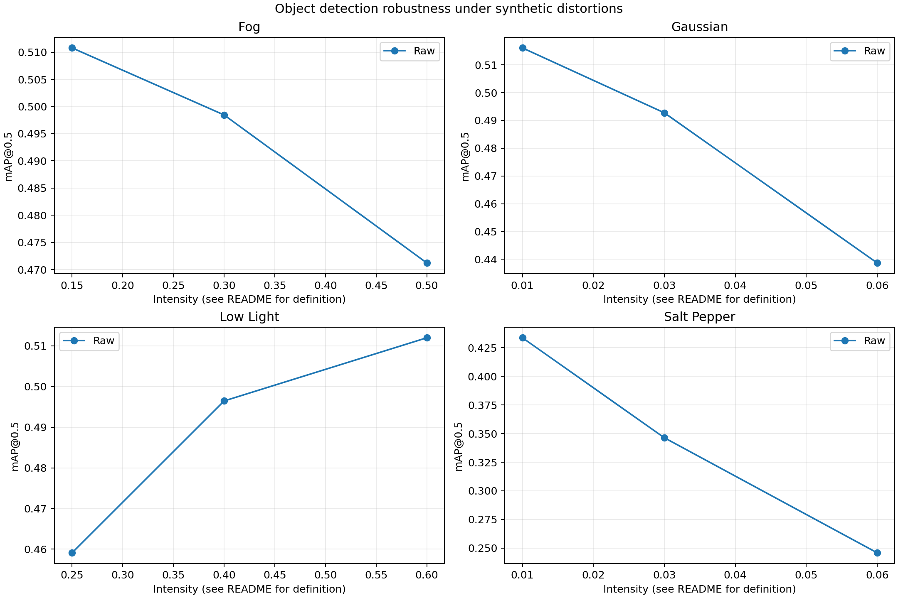
Figure 5. Raw mAP@0.5 by severity for YOLOv8n on 5,000 COCO val2017 images.
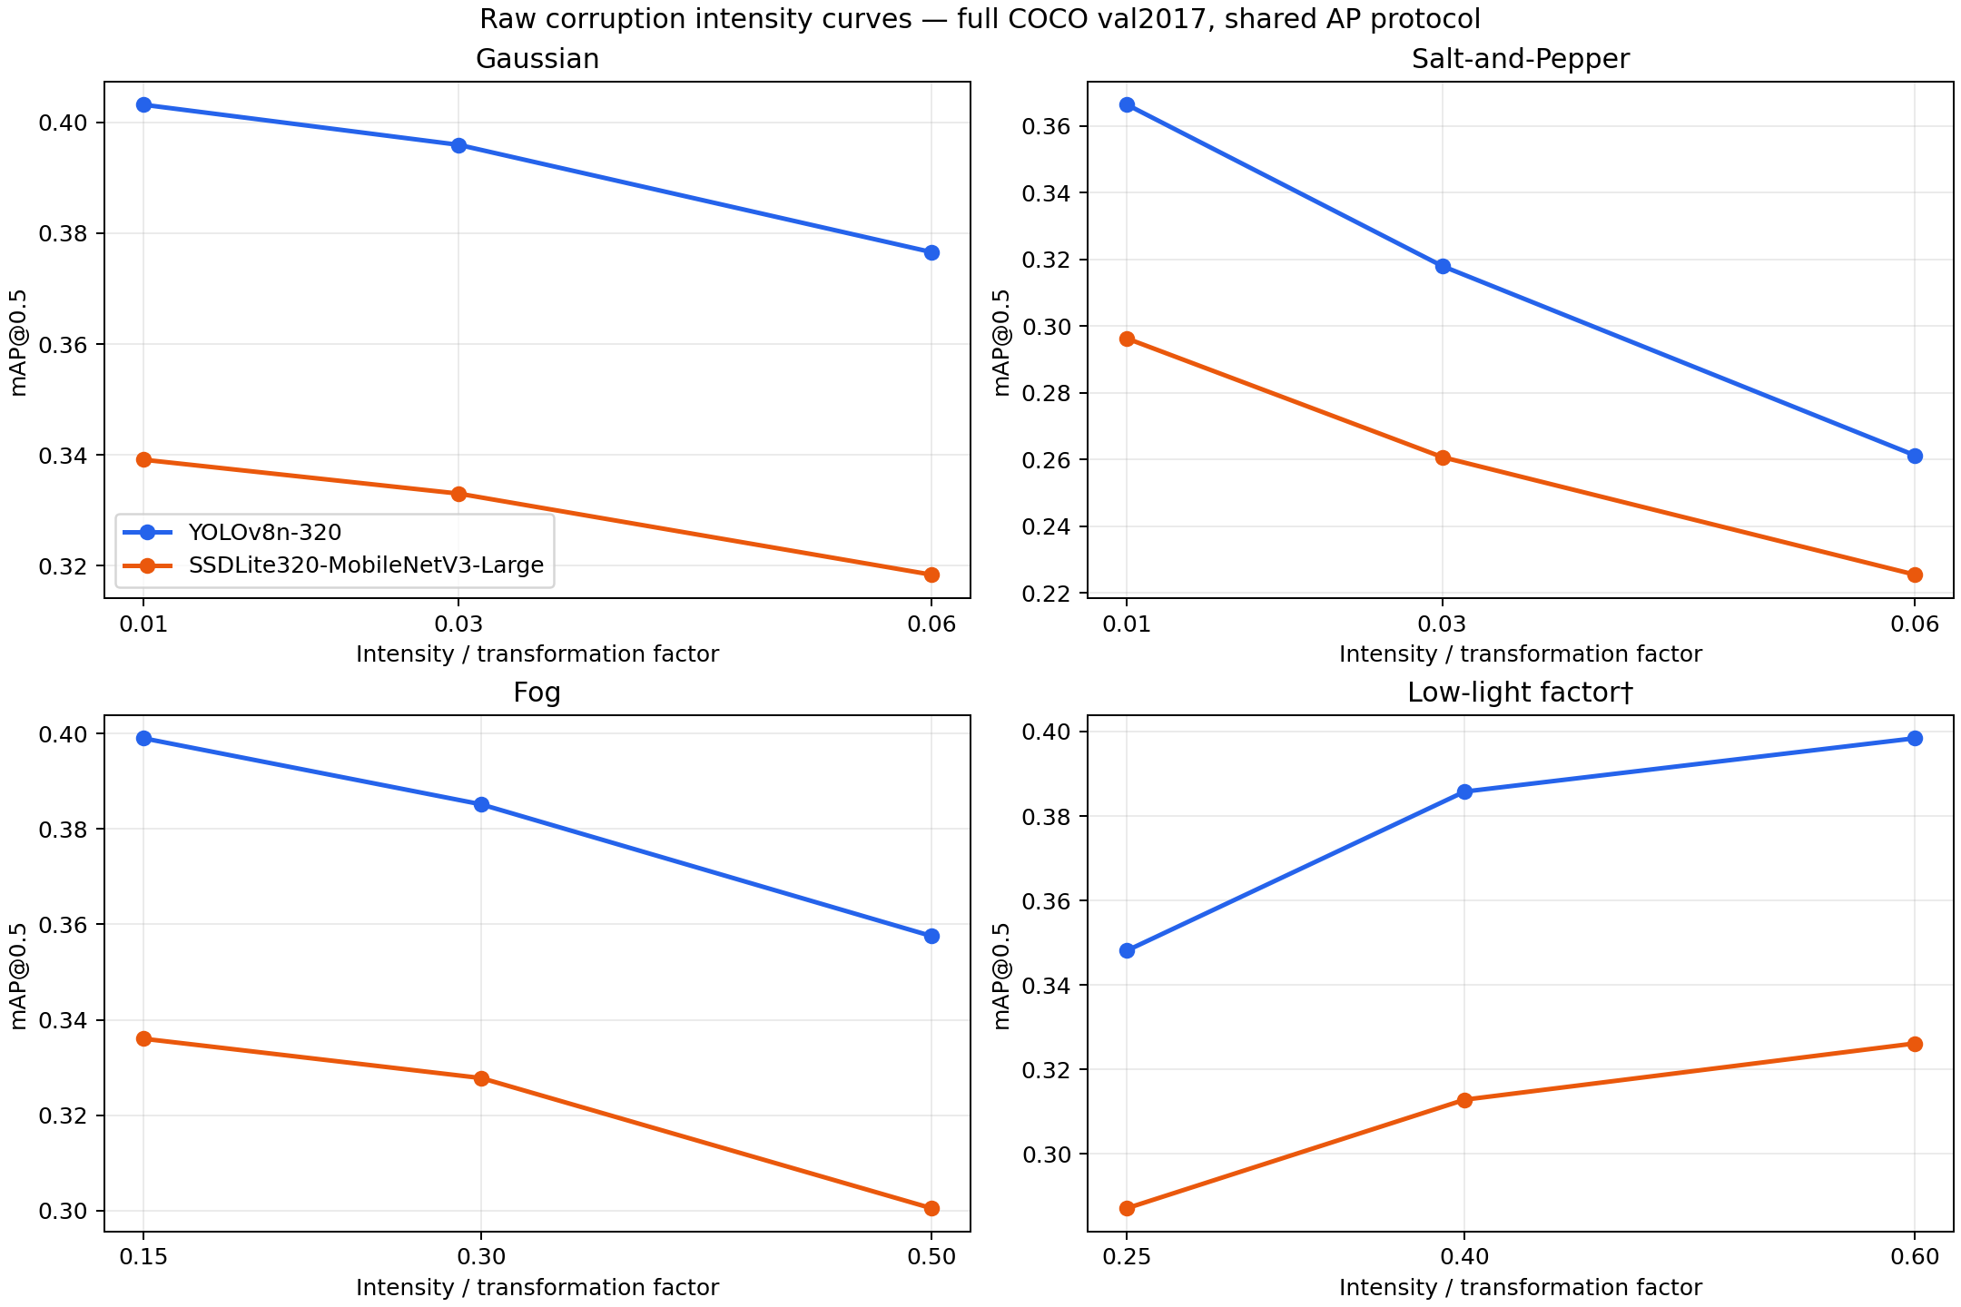
Figure 6. Raw curves across all distortion levels under the shared 320 px evaluator; the plot includes YOLOv8n and SSDLite.

Severe Distortions and Recovery at 640 px
Distortion | YOLOv8n raw → recovered | YOLOv8s raw → recovered | Interpretation
Gaussian 0.06 | 43.87 → 48.17% | 53.90 → 57.24% | The paired table uses bilateral filtering; NLM is from another protocol
Salt-and-Pepper 0.06 | 24.59 → 49.36% | 28.40 → 58.03% | Median filtering provides the strongest recovery
Fog 0.50 | 47.12 → 49.98% | 55.92 → 59.48% | CLAHE provides partial recovery
Low-light 0.25 | 45.91 → 48.48% | 55.56 → 57.99% | CLAHE provides partial recovery

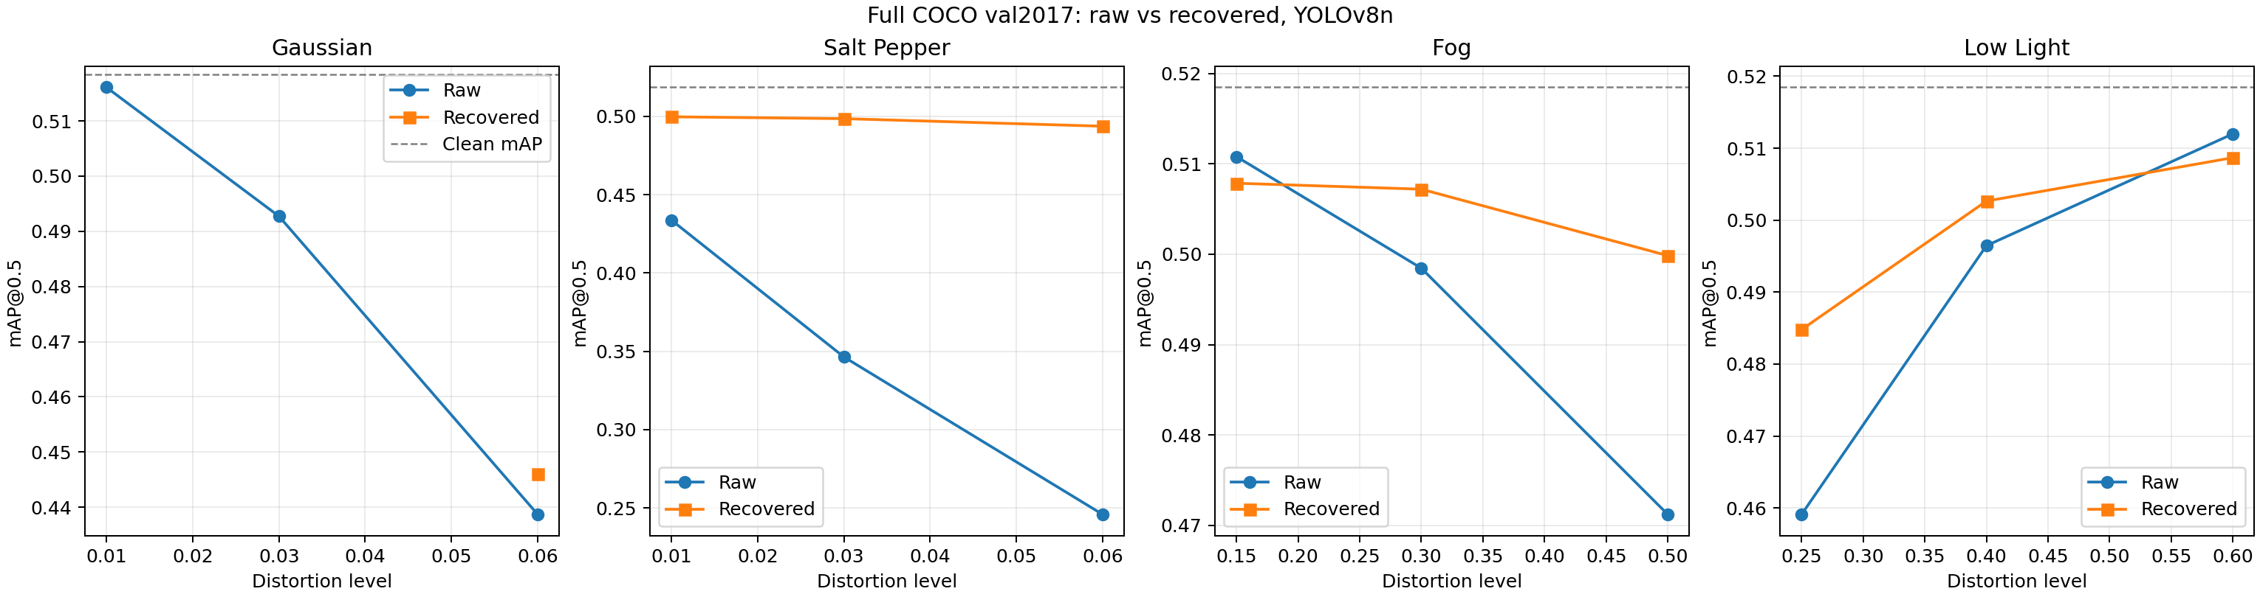
Figure 7. Raw and recovered results on full val2017 for YOLOv8n; Salt-and-Pepper is treated with median filtering.
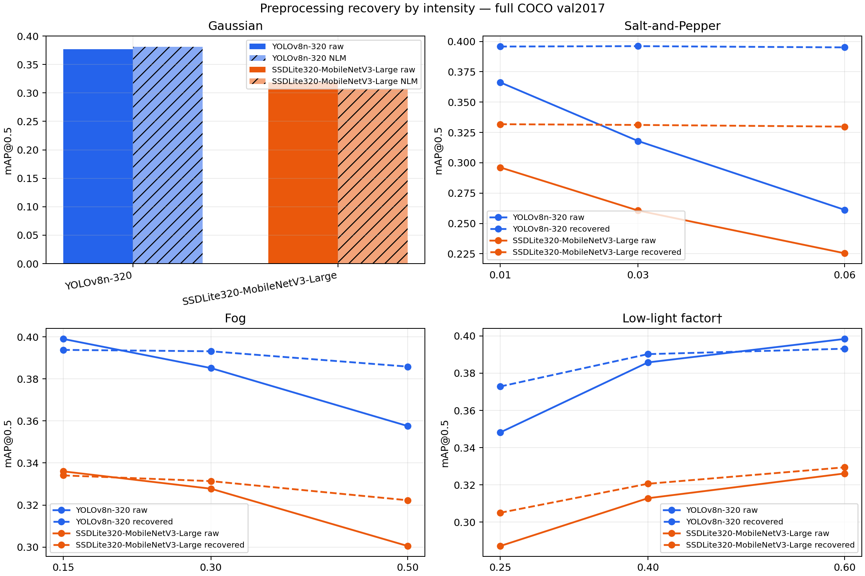
Figure 8. Recovered minus raw mAP by severity for YOLOv8n and SSDLite at 320 px.

Results by Seed and Image Composition
On a fixed 500-image subset, 25 conditions were run with noise seeds 42, 43, and 44. Clean mAP50 is 54.40%. Under Salt-and-Pepper 0.06, raw scores 26.92 ± 0.80%, while median filtering scores 51.69 ± 0.34%. Under Gaussian 0.06, raw scores 46.07 ± 0.23%, and NLM scores 46.72 ± 0.48%. NLM degrades performance for mild-to-moderate Gaussian noise. Fog/low-light transformations are deterministic, so zero SD across seeds does not mean results have no image-to-image variation.
Across three disjoint COCO subsets, Salt-and-Pepper 0.06 averages 26.74 ± 1.20% raw and 51.85 ± 2.83% after median filtering. Fog 0.50 scores 49.94 ± 1.93% raw and 52.49 ± 2.01% after CLAHE. Low-light 0.25 scores 48.12 ± 1.83% raw and 50.95 ± 2.30% after CLAHE. In some conditions, variation due to subset selection exceeds noise-seed SD; reporting only one decimal place may therefore imply excessive precision.
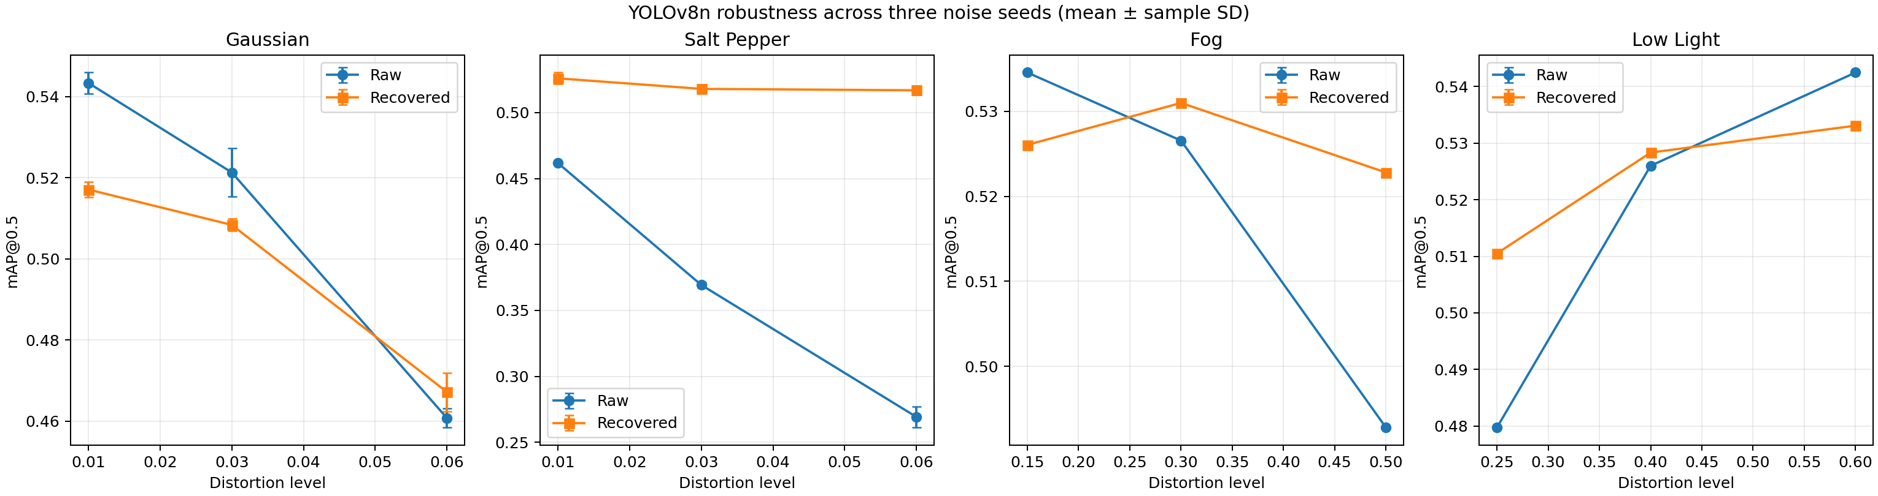
Figure 9. Mean mAP@0.5 ± sample SD across three seeds on the 500-image COCO subset.
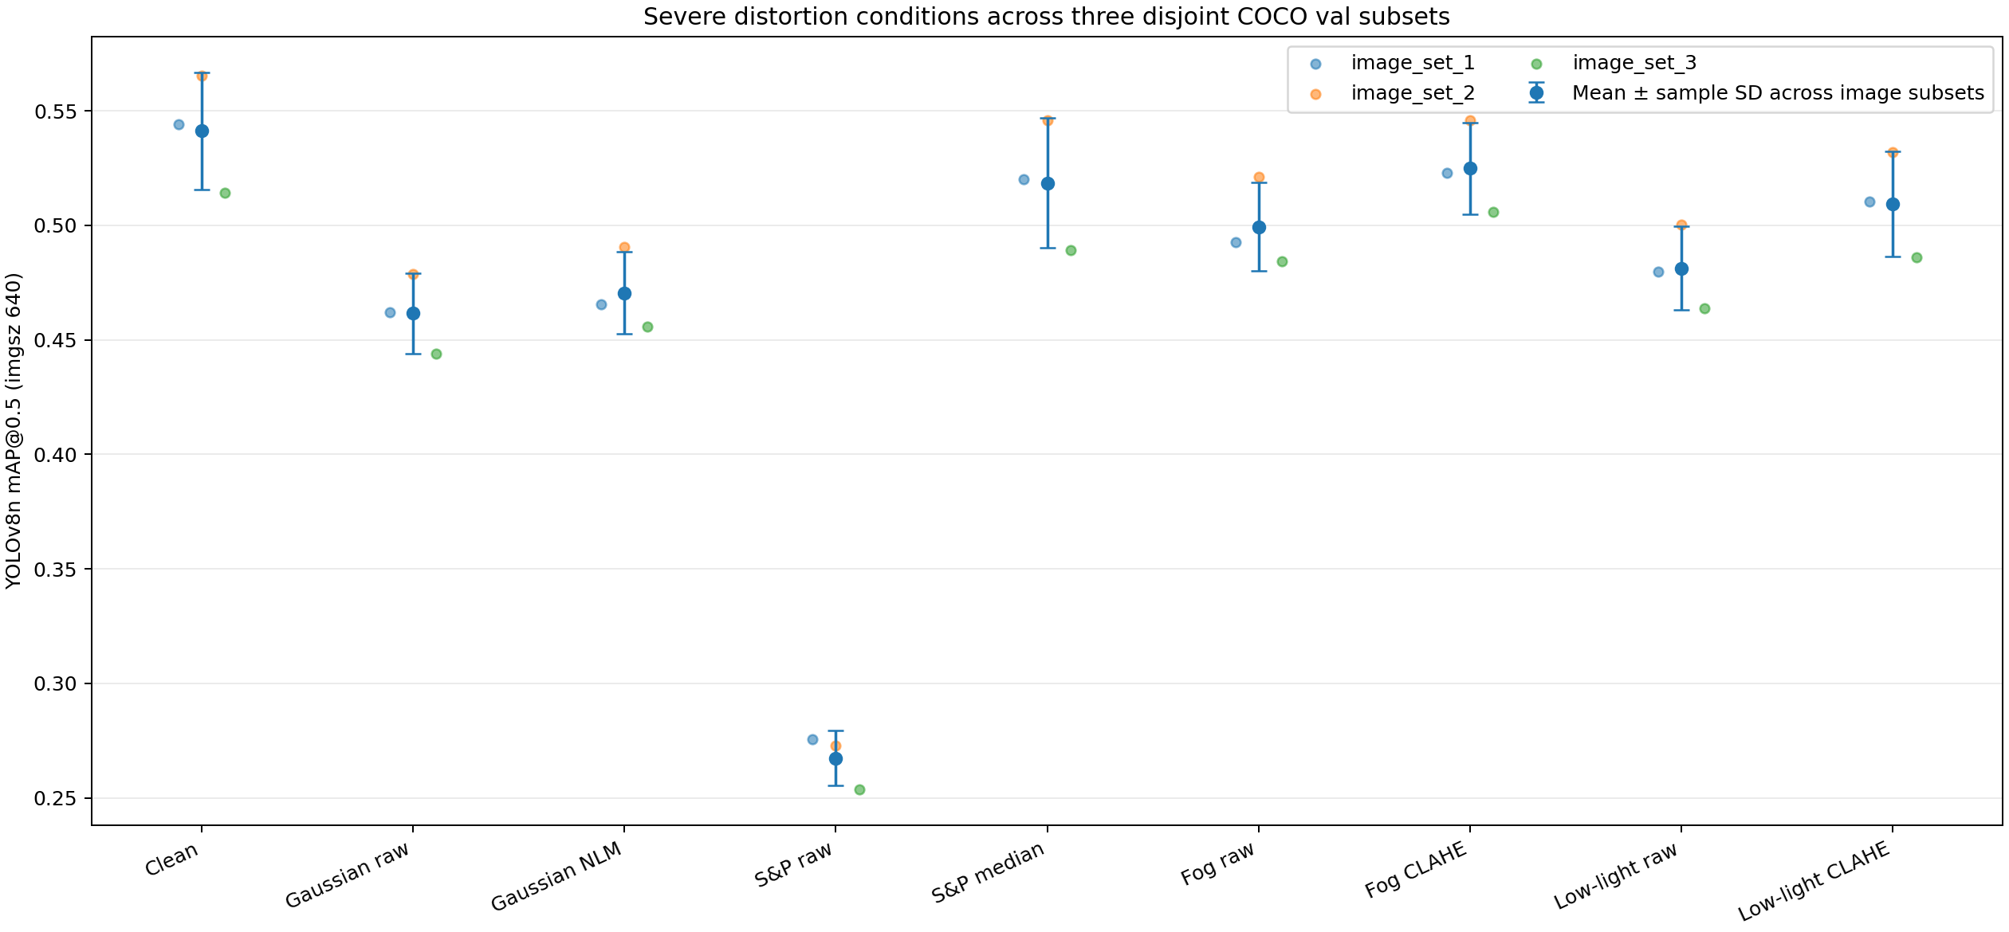
Figure 10. Sensitivity to image composition across three disjoint 500-image subsets.

Small Objects and Class-Level Errors
On the 500-image subset, clean recall is 22.39% for small, 53.54% for medium, and 73.25% for large objects. Raw Salt-and-Pepper 0.06 lowers recall to 11.32 / 27.34 / 38.46%; median filtering raises it to 16.77 / 48.20 / 73.09%. Small objects are the most difficult group under every condition. Across the three-subset repetition, small-object recall under raw Salt-and-Pepper is 9.8 ± 1.4%, versus 16.8 ± 0.9% after median filtering; median filtering does not fully restore clean small-object recall.
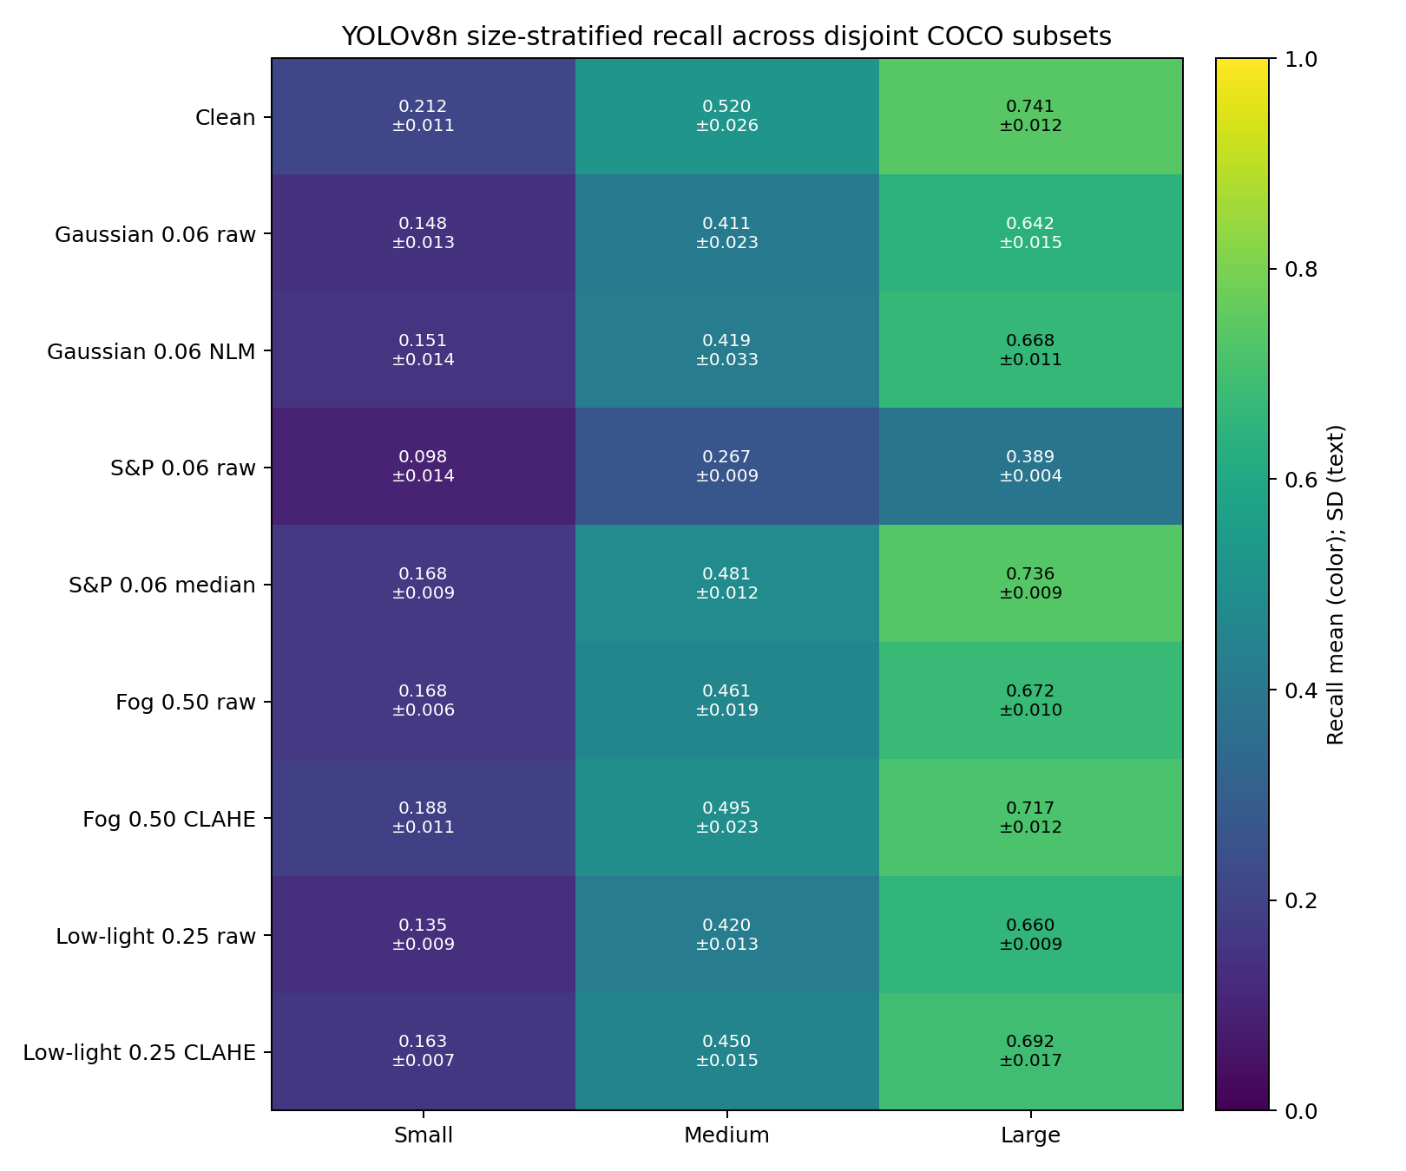
Figure 11. Recall by object size across three COCO subsets; confidence 0.25 and matching IoU 0.5.
Per-class analysis shows that effects vary by class and support. Across the three subsets, Salt-and-Pepper causes the largest recall drops for cat (−73.5 percentage points), mouse (−73.1), airplane (−70.7), and refrigerator (−67.1), among classes with at least 30 aggregate ground-truth boxes. Median filtering reduces those drops to −12.5, −5.4, −2.7, and −3.3 points, respectively. Low support still makes per-class statistics less stable.
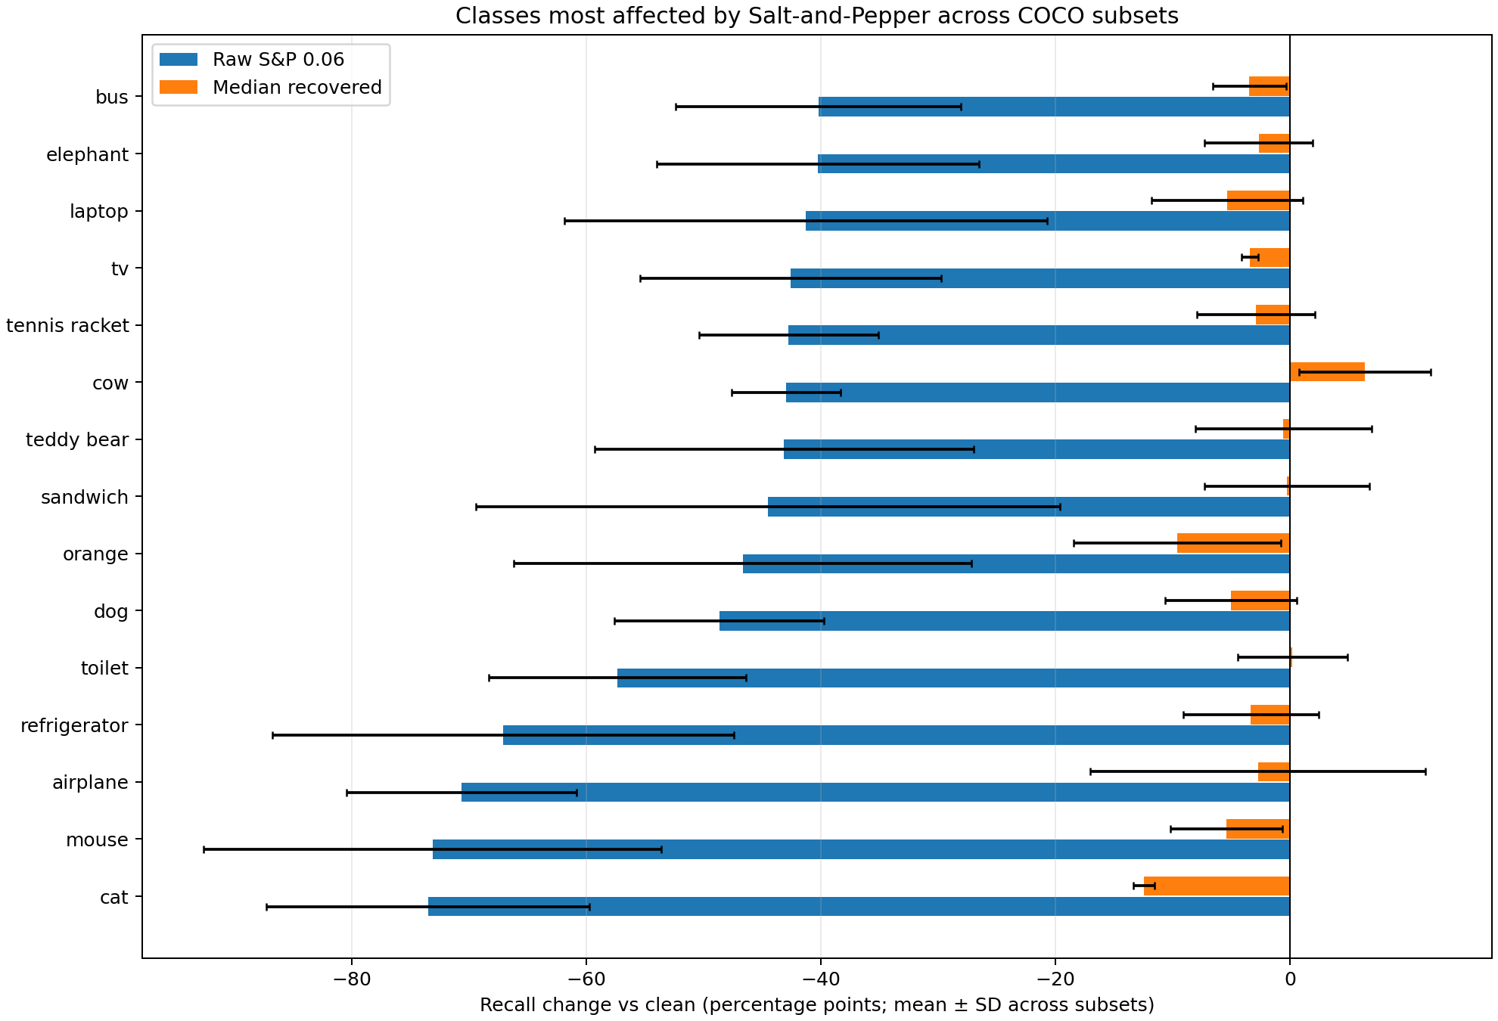
Figure 12. Per-class recall change under raw and median-filtered Salt-and-Pepper; averaged across three subsets.
Total FP does not increase monotonically with severity. Under Salt-and-Pepper 0.06, YOLOv8n fullval has 5,212 FPs, fewer than the 8,794 on clean images, but FNs increase from 18,414 to 27,102. The model misses more objects and therefore emits fewer detections. FP and FN must be considered alongside mAP/recall. Confusion counts use confidence 0.25 and IoU 0.5.
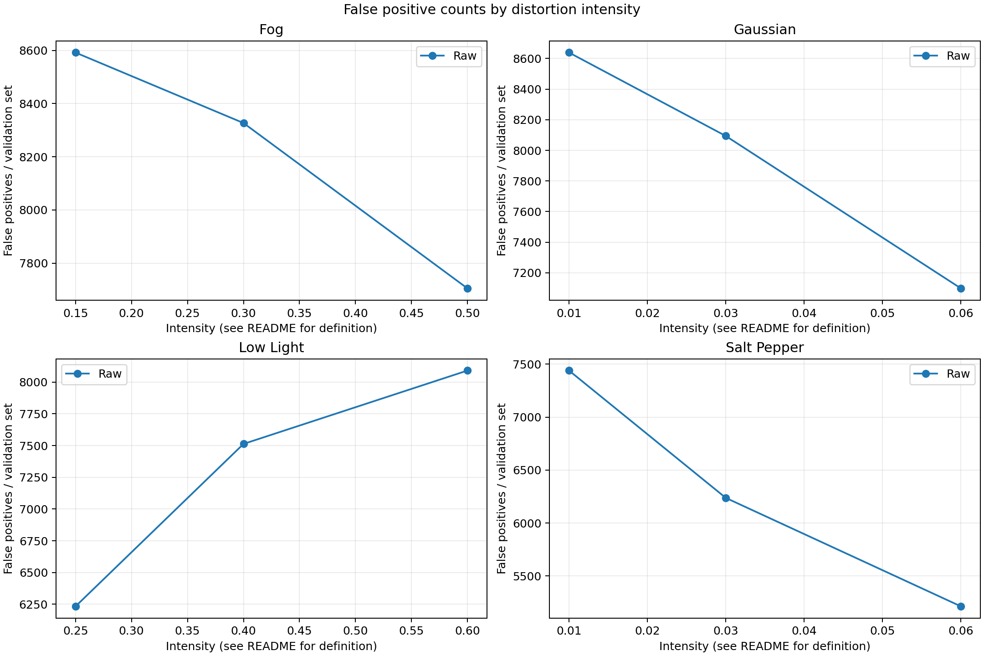
Figure 13. FP by severity on full COCO val2017; fewer counts do not imply higher accuracy when FN increases.
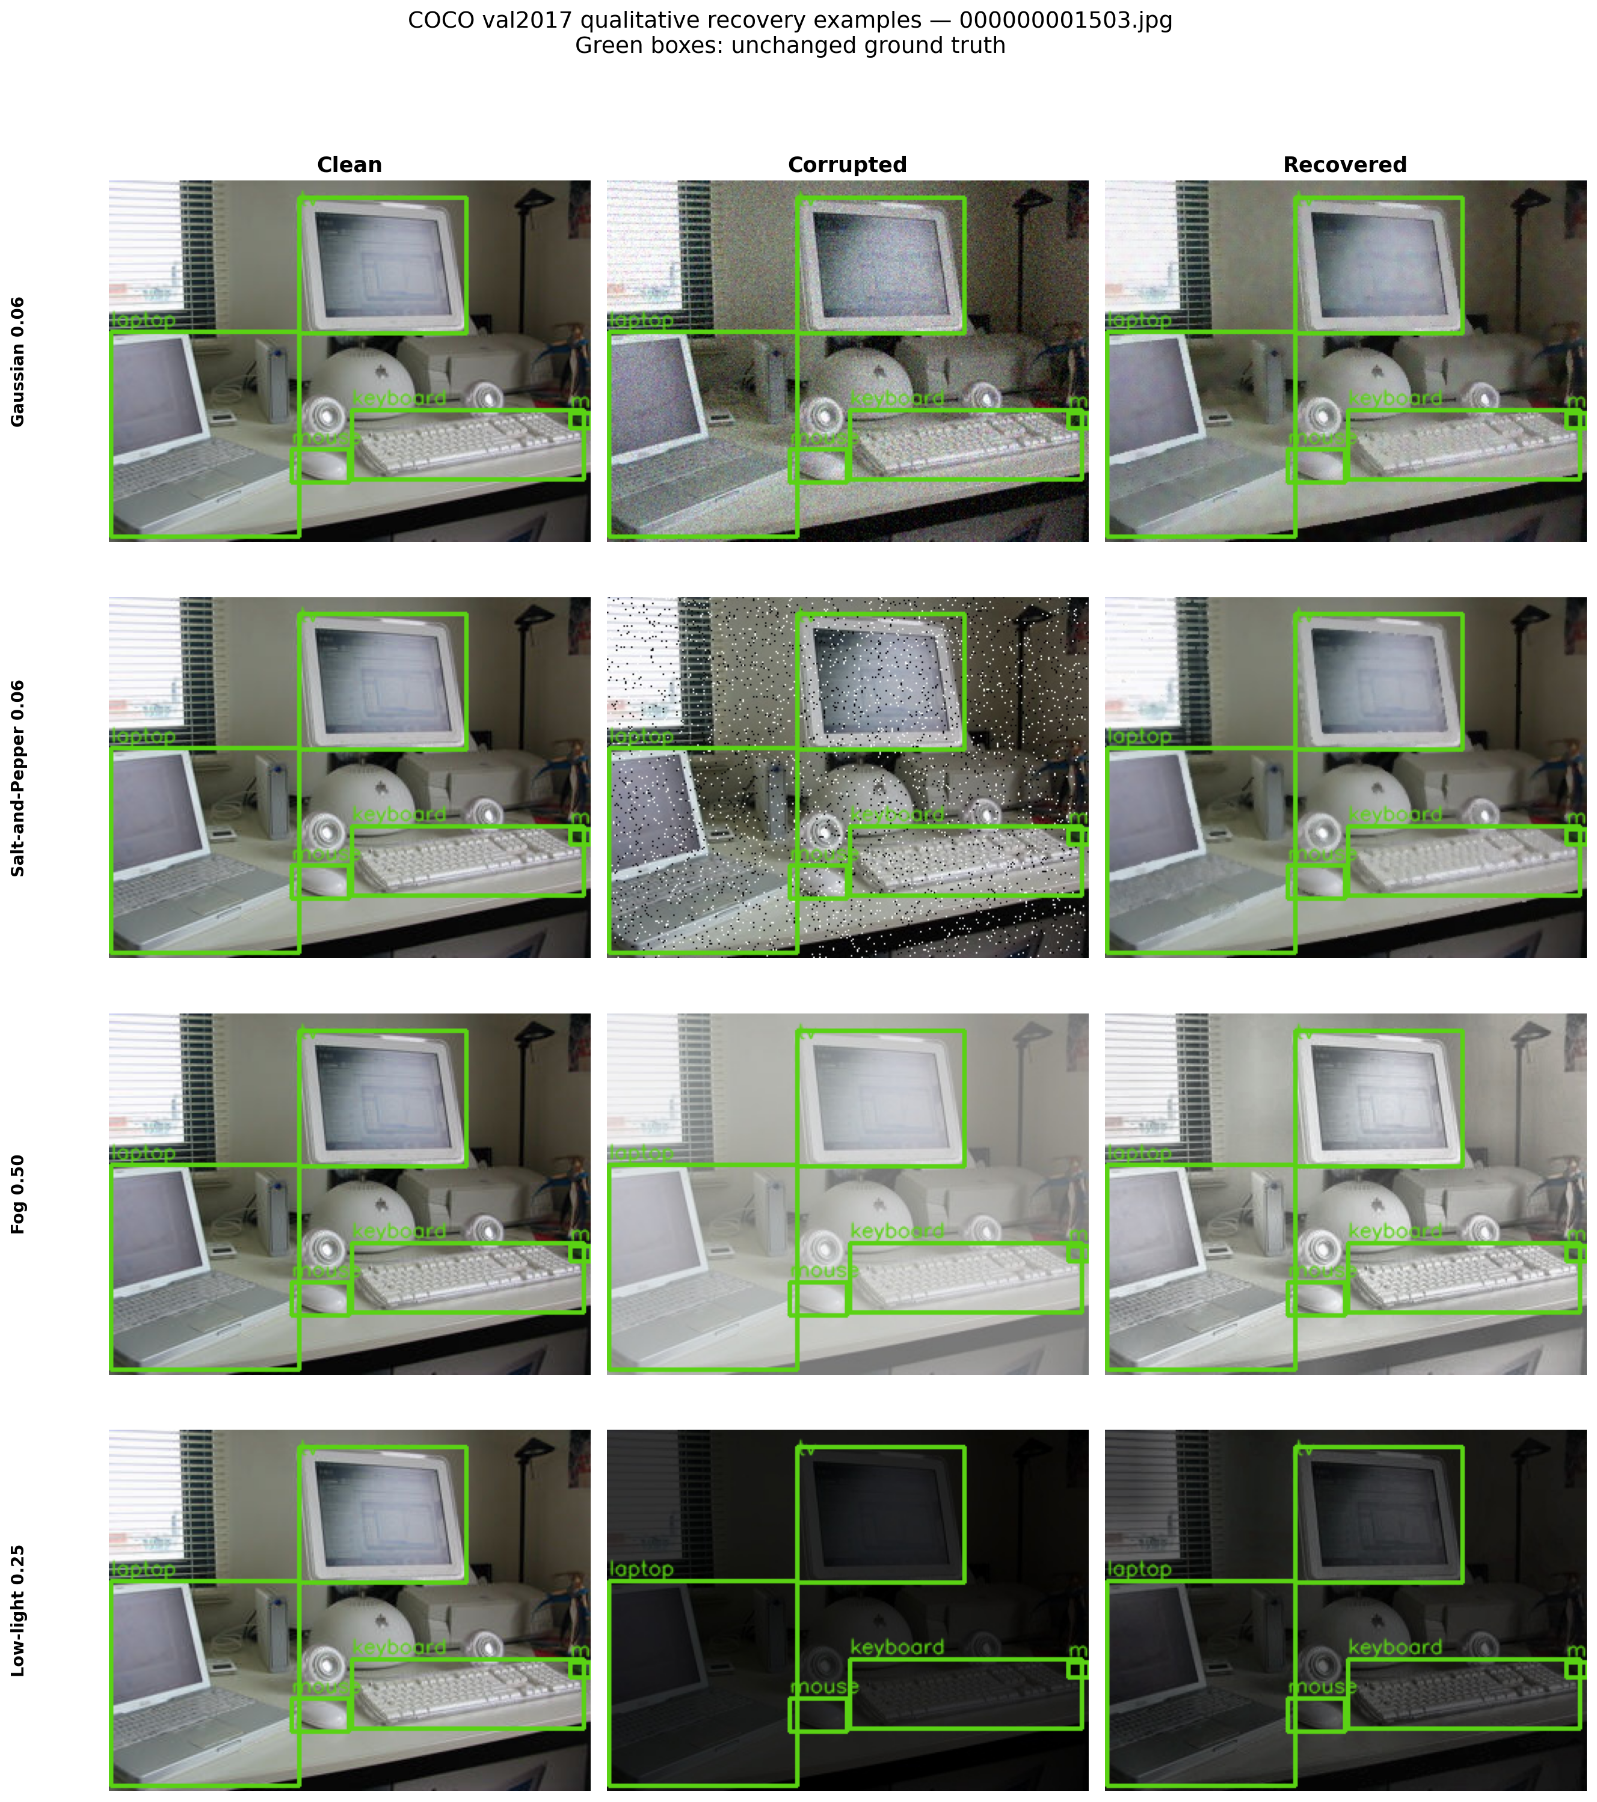
Figure 14. Qualitative example on the same COCO image under clean, raw corruption, and recovery; illustrative only and not a replacement for metrics.

Fine-Tuning and Checkpoint Selection

Fine-Tuning on 1,000 COCO-80 Images
The models were fine-tuned on a COCO training subset with complete COCO-80 labels and evaluated on the same 5,000 validation images. This fine-tuning lowers mAP for all three baselines and is therefore not selected for the product model.
Model | Baseline mAP50 / 50:95 | Fine-tuned on 1K: mAP50 / 50:95 | mAP50 change
YOLOv8n | 51.92 / 36.83% | 33.65 / 21.60% | −18.27 points
YOLOv8s | 60.96 / 44.23% | 26.76 / 16.84% | −34.20 points
SSD-MobileNet | 33.86 / 21.04% | 31.13 / 18.16% | −2.73 points

For SSD, FP increases from 6,933 to 10,917 in the logged comparison. The measurements show that continuing training on 1,000 COCO images alone does not guarantee improvement. The recipe, learning rate, epochs, initialization, split, and correctness of the data conversion may need to be checked.

YOLOv8n Experiments on 5,000 Images
Run | Configuration | Best validation mAP50 / 50:95 | Assessment
Pretrained baseline | COCO pretrained; 640 px | 51.92 / 36.83% | Reference baseline
Fine-tune for 5 epochs | 5K COCO training subset; AdamW; lr 0.0002 | 47.87 / 33.12% | Below baseline
Schedule up to 50 epochs | Early stopping at epoch 11; best epoch 3 | 43.30 / 29.09% | No improvement; not an isolated epoch ablation
Noise-aware 5K paired | Clean + corrupted; lr 0.0001; max 10 epochs | 47.30 / 32.69% clean | Clean score drops by 4.55 points

The noise-aware checkpoint improves mAP50 over the baseline under raw Salt-and-Pepper 0.06 (36.78% versus 24.59%), but clean mAP falls and false positives increase. Under Salt-and-Pepper 0.06, baseline raw TP/FP/FN are 9,233/5,212/27,102; noise-aware values are 13,778/9,401/22,557. Baseline plus median filtering reaches 16,897/8,168/19,438 and 49.36% mAP50. Thus, for the evaluated case, denoising the baseline outperforms the noise-aware model in AP and counts.
Checkpoint decision
Fine-tuning on 1K, 5K, the 50-epoch schedule, and noise-aware training have not replaced the baseline for the product objective. Keep pretrained YOLOv8s for the demo. Further fine-tuning requires reviewed labels, a separate validation set, and simultaneous clean/robustness reporting.

Evaluation on Open Images V7
Set | Model | Images / GT / classes | mAP50 | TP / FP / FN
100-image pilot | YOLOv8n | 100 / 193 / 8 | 65.77% | 114 / 50 / 79
100-image pilot | YOLOv8s | 100 / 193 / 8 | 65.38% | 119 / 69 / 74
100-image pilot | SSD-MobileNet | 100 / 193 / 8 | 61.88% | 105 / 62 / 88
300-image expansion | YOLOv8s | 300 / 782 / 7 | 73.04% | 415 / 171 / 367

On the 100-image Open Images subset, YOLOv8n exceeds YOLOv8s by 0.39 mAP50 points. YOLOv8s has more TPs and fewer FNs, but more FPs at confidence 0.25. This small mAP difference on a 100-image/193-box subset is insufficient to overturn the YOLOv8s choice based on COCO and the 300-image set. The COCO-80 application does not evaluate accuracy for object classes outside the mapped set.
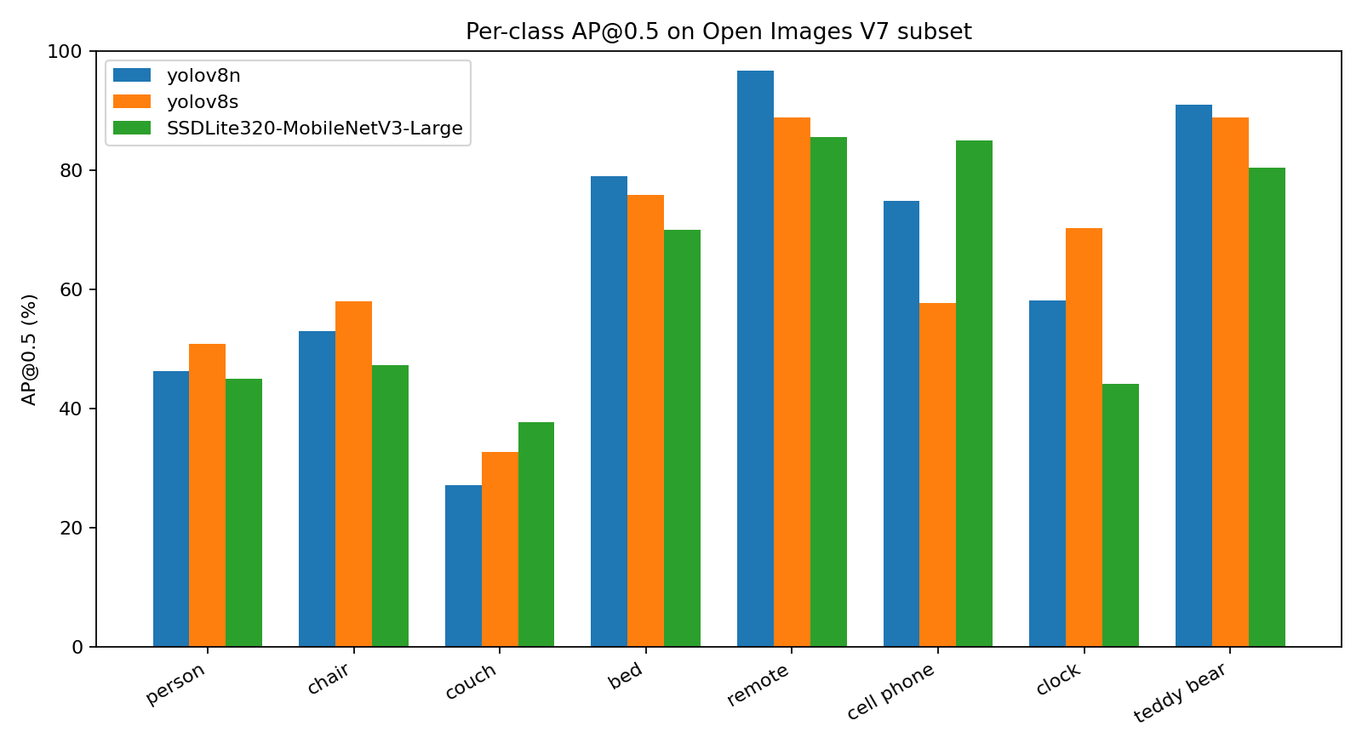
Figure 15. AP@0.5 by class on 100 Open Images images; the number of boxes per class is uneven.
The 300-image set is a disjoint expansion used for external evaluation and the website gallery. The YOLOv8s result of 73.04% is computed over only seven classes with ground truth; remote control is excluded from the average. Because the image and class sets differ from the 100-image subset, the percentage difference should not be interpreted as model improvement.

Demo Product and Application Pipeline

Desktop MVP
- Accept clean or corrupted images; select the default YOLOv8s model, noise family/level, and recovery policy.
- Display the original image, corrupted image with detections, and recovered image with detections; show confidence and input sizes of 640/960/1280.
- Tiling at 640 px with 25% overlap is an experimental option for small objects; it is off by default because increased small-object recall has not been demonstrated.
- Save result images and JSON metadata. Single-image inference reports boxes/confidence/latency; it does not calculate mAP without ground truth.

Local Website
The React/TypeScript website connects to FastAPI and includes Detection Lab, model comparison, research analytics, and a methodology/gallery. The API uses local model checkpoints and data. The comparison gallery uses recorded results from the 300-image Open Images set; changing the gallery threshold only filters displayed boxes and does not create new metrics. Under the current design, uploaded images are not written to disk by the local API.

Tiling Pilot
YOLOv8s 640 inference mode | mAP50 | mAP50:0.95 | TP / FP / FN | Small-object recall
Full frame | 59.79% | 43.75% | 21,317 / 10,576 / 15,018 | 31.69%
Tiled 640, 25% overlap | 60.26% | 43.23% | 21,188 / 9,350 / 15,147 | 31.40%

Tiling raises mAP50 by 0.47 points but lowers mAP50:0.95 by 0.53 points, reduces small-object recall by 0.29 points, and adds 129 FNs. This does not support enabling tiling by default when the goal is better small-object detection; it shows a different trade-off in detections/FN.

Limitations and Interpretation Risks
- Environmental distortions are synthetic: uniform fog does not model depth, low-light does not include sensor noise/white balance, and motion blur, rain, flare, and camera changes are not included.
- The full-validation raw sweep primarily uses seed 42; the complete three-seed repetition uses a 500-image subset. Some full-validation recovery runs cover only selected conditions and should not be generalized to unmeasured levels.
- All three disjoint subsets come from the same COCO val2017 set; they are not three independent benchmarks. An independent non-COCO test split is needed to establish generalization.
- The 320 px comparison uses a normalized evaluator, but model-specific resizing/NMS still differs. The 640 px comparison uses a separate Ultralytics protocol and does not include SSD at 640 px.
- The Open Images subsets are small and score only seven or eight mapped classes; low-support classes such as clock/teddy bear make per-class AP unstable.
- Previously tested user images without ground truth were removed; pseudo-labels are not used to report product-domain mAP. An earlier three-image pilot had labels that largely matched YOLOv8s pseudo-labels and therefore was not an independent evaluation.
- Fine-tuning runs use different learning-rate/epoch schedules; comparing five epochs with a 50-epoch schedule does not isolate the effect of epoch count alone. These results should not be used to conclude that fine-tuning is generally ineffective.
- FP/FN depend on confidence 0.25 and IoU 0.5. When a noisy image reduces recall, FP can fall at the same time; mAP, FN, and recall must be read alongside FP.

Conclusion and Recommendations
On COCO val2017, pretrained YOLOv8s is the strongest overall model in the available measurements. Under the shared 320 px protocol, it outperforms YOLOv8n and SSD-MobileNet on clean images and every severe condition in the table. At 640 px, YOLOv8s also has higher mAP than YOLOv8n, with a small latency difference on an RTX 3060. YOLOv8n remains suitable when a lightweight model is needed; SSD serves as an alternative compact baseline but has lower mAP on this benchmark.
Salt-and-Pepper causes the largest degradation. A 3×3 median filter restores mAP close to baseline, especially for YOLOv8s, while small-object recall remains below clean performance. CLAHE helps under severe fog/low-light, with small or negative effects at mild levels. No single Gaussian recovery method wins consistently: NLM lowers scores at mild-to-moderate levels, while bilateral filtering performs better at level 0.06 in the 320 px evaluator.
For the current product, retain pretrained YOLOv8s and use recovery policies according to the measured distortion type/level. Do not switch to the current fine-tuned checkpoints or enable tiling by default. To increase confidence, expand testing to an out-of-domain set with independently human-annotated labels, run multiple seeds on full validation for product-critical results, select recovery on validation, and evaluate it on a separate held-out test set.

Next Steps
- Collect target-camera images with human-annotated and reviewed ground truth; split train/validation/test by scene or time to avoid leakage.
- Evaluate YOLOv8s/YOLOv8n/SSD baselines under one protocol on clean and genuinely corrupted images; prioritize small-object recall, mAP50:0.95, and latency on the deployment machine.
- Optimize recovery on validation while keeping the final test set independent; report mean ± SD and uncertainty intervals.
- If fine-tuning, change one factor at a time, retain COCO replay or class balance, and compare both clean COCO and the target test. Release a checkpoint only if it improves target performance without an unacceptable clean-set regression.
- Package environment setup and model/dataset downloads separately from GitHub; document checksums/versions so others can reproduce the project.

Appendix A: The 80 COCO Classes
COCO ID / class | COCO ID / class | COCO ID / class | COCO ID / class
0: person | 1: bicycle | 2: car | 3: motorcycle
4: airplane | 5: bus | 6: train | 7: truck
8: boat | 9: traffic light | 10: fire hydrant | 11: stop sign
12: parking meter | 13: bench | 14: bird | 15: cat
16: dog | 17: horse | 18: sheep | 19: cow
20: elephant | 21: bear | 22: zebra | 23: giraffe
24: backpack | 25: umbrella | 26: handbag | 27: tie
28: suitcase | 29: frisbee | 30: skis | 31: snowboard
32: sports ball | 33: kite | 34: baseball bat | 35: baseball glove
36: skateboard | 37: surfboard | 38: tennis racket | 39: bottle
40: wine glass | 41: cup | 42: fork | 43: knife
44: spoon | 45: bowl | 46: banana | 47: apple
48: sandwich | 49: orange | 50: broccoli | 51: carrot
52: hot dog | 53: pizza | 54: donut | 55: cake
56: chair | 57: couch | 58: potted plant | 59: bed
60: dining table | 61: toilet | 62: tv | 63: laptop
64: mouse | 65: remote | 66: keyboard | 67: cell phone
68: microwave | 69: oven | 70: toaster | 71: sink
72: refrigerator | 73: book | 74: clock | 75: vase
76: scissors | 77: teddy bear | 78: hair drier | 79: toothbrush

Appendix B: Results and Reproduction Files
Description | Project source
Metrics, protocol, and interpretation reports | RESULTS_REPORT.md; EXPERIMENT_LOG.md
Three-detector comparison at 320 px | runs/normalized_detector_comparison_fullval/metrics.csv
YOLOv8n/s robustness at 640 px | runs/yolo_family_comparison_640_fullval/metrics.csv
Raw noise sweep and confusion counts | runs/full_val2017_raw_seed42/metrics.csv and confusion_*.csv
Full-validation recovery | runs/full_val2017_comparison_seed42/raw_vs_recovered.csv
Repeated seeds / subsets / object sizes | runs/repeat_analysis_seed42_43_44/; runs/image_subset_analysis/; runs/size_stratified_subsets/
Fine-tuning | runs/finetune_coco80/; runs/noiseaware_yolov8n_fullval_sweep_seed42/
Open Images | runs/open_images_v7_eval/; runs/open_images_v7_test_extra_eval/
Tiled inference | runs/tiled_inference_eval/summary.csv
Dataset preparation / evaluation | prepare_coco.py; robustness_eval.py; yolo_custom_eval.py; compare_detectors_normalized.py; evaluate_open_images_subset.py

References
1. Microsoft COCO dataset and download page.
2. Open Images V7 download and annotation information.
3. Ultralytics validation and metrics documentation.
4. Torchvision SSDLite320 MobileNetV3 Large model.
5. Project repository.
Metrics are from repository CSV/PNG artifacts (9 November 2026); see Appendix B.

