  L2 Spr25

Q1:

Software Requirements Specification

for

FU EXAM360
Version 1.0 approved
Prepared by
Tran Xuan Huy - HE180649
Hoa Lac Campus
03/04/2025

Q2:

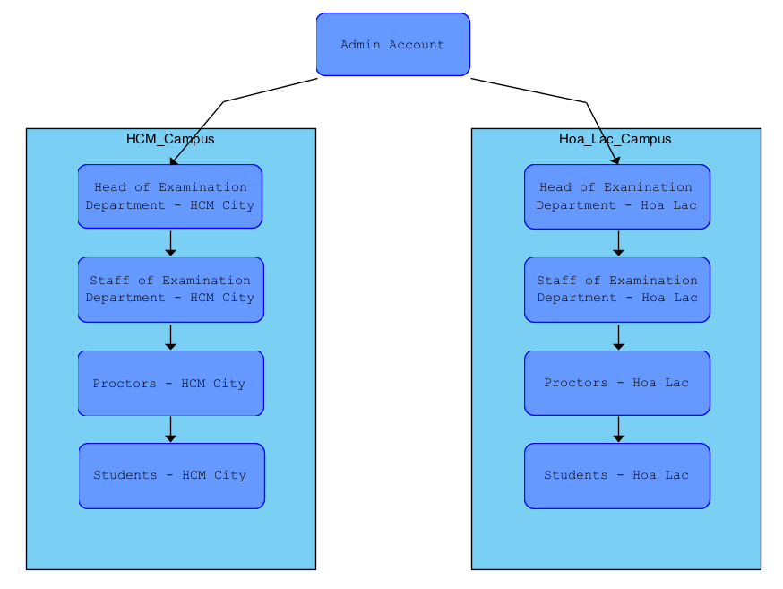

From this structure, the type of user with the largest number is likely the "Students." This is because each campus serves a large student body, and they represent the primary users of the FUE360 website for performing actions like check-in and check-out for exams.

Q3:

Q4:
UC ID and Name: | UC - 1 Add Exam Slot
Created By: | HuyTXHE180649 | Date Created: | 03/04/2025
Primary Actor: | Admin, Head of Examination Department | Secondary Actors: | Staff of Examination Department
Trigger: | - The Admin or Head of Examination Department initiates the process to add a new exam slot.  - The system validates input data and saves the new slot to the database.
Description: | This use case describes the process for adding a new exam slot to the FU Exam360 (FUE360) system.
Preconditions: | - The user must be logged into the system with an Admin or Head of Examination Department account.  - The user must have permission to manage exam slots.
Post conditions: | - The exam slot is successfully added and stored in the system.  - The slot is made visible to all authorized users, including staff and proctors.  - A confirmation message is shown to the user.
Normal Flow: | - The Admin/Head of Examination Department logs into FUE360.  - The user navigates to the "Exam Slot Management" section.  - The user selects the option to "Add Exam Slot."  - The system displays a form requiring details such as:  - Exam date and time  - Course name and code  - Exam room and capacity  - Assigned proctors  - The user fills in the required details and submits the form.  - The system validates the input and checks for conflicts with existing exam slots.  - If validation passes, the system saves the new exam slot to the database.  - A success message is displayed, and relevant staff are notified.
Alternative Flows: | - If the user enters incomplete or invalid data, the system displays an error message and requests corrections.  - If the selected time slot conflicts with an existing exam, the system prompts the user to choose a different time.  - If the user cancels the process before submission, no changes are made to the system.
Exceptions: | - If the system encounters a database error, the exam slot is not saved, and an error message is displayed.  - If the user session expires, they are redirected to the login page.  - If the internet connection is lost during submission, the system prompts the user to retry.  - If unauthorized users attempt to access this function, the system denies access and logs the attempt.
Priority: | High
Frequency of Use: | High
Business Rules: | - Only Admins and Heads of Examination Departments can add exam slots.  - Exam slots must not overlap in the same room.  - Exam slots must be created before a specified deadline.
Other Information: | - The system should provide an intuitive UI for adding exam slots.  - Notifications should be sent to relevant stakeholders upon successful slot creation.
Assumptions: | - The system has a predefined set of exam rooms and proctors available.  - Users follow proper protocols when scheduling exams.  - Data integrity is maintained in the database.

Q5:
a. Performance Requirements
- The FUE360 system must be able to handle at least 10,000 concurrent users accessing the platform during peak exam periods without any noticeable delay (response time must be under 2 seconds for 95% of requests).
- The system must process and confirm a check-in/check-out request within 1 second after submission to ensure smooth operations for students and staff.
b. Security Requirements
- Only users with an @fpt.edu.vn email can log in to the system, and all authentication processes must
- All exam-related data, including exam slots and student check-in/out records, must be encrypted using AES-256 both in transit and at rest to prevent unauthorized access

