Question 1:
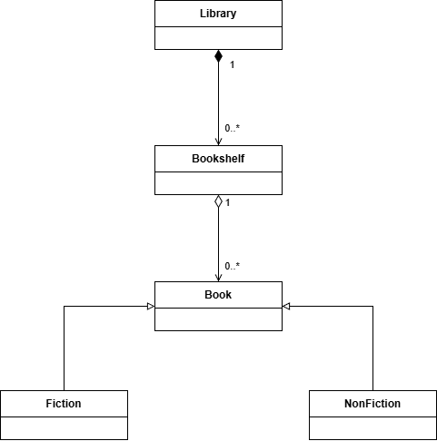

Question 2:
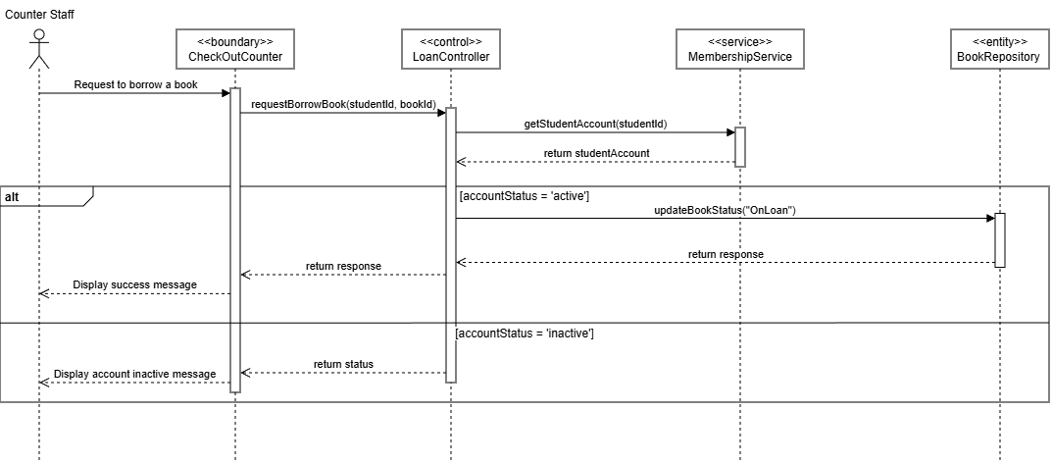

Question 3:
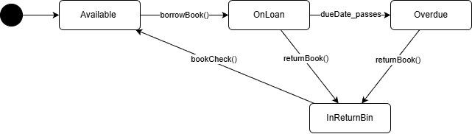
Question 4:
- Architecture Name: Layered Architecture (3-Tier)
- Explain:
+ Base on the question 1, 2, 3, the system has view, controller, service and entiry so it aim to implement the 3 layer presentation, bussiness, data access.
+ Database can be changed without having to rewrite user interface.
+ Changes in one layer have minimal impact on others. Updating the user interface does not require changing the backend data logic.
- Advantage: Development teams can work on different layers simultaneously (e.g., frontend designers on the presentation layer, backend engineers on the business logic), allowing for faster development cycles.
- Disadvantage: Data must pass through multiple layers, increasing network traffic and processing time, which can impact performance.

Question 5:
- Pattern Name: Strategy Pattern
- Explain: The Strategy Pattern is specifically designed to define a family of algorithms (Search by Title, Author, or ISBN), encapsulate each one, and make them interchangeable. This allows the SearchInterface to remain "unaware" of the specific logic inside each search type, satisfying the requirement perfectly.

