 

Q1:

Software Requirements Specification

for

**Koi Order System**

**Version 1.0 approved**

**Prepared by**

**Mai Thi Thanh Ngan – SEXXXXXX**

**FPTU_HO CHI MINH**

**22/07/2025**

Q3:

| **#** | **Actor** | **Description** |
| --- | --- | --- |
| 01 | Customer | Uses the system to search for Koi fish, View quote, confirm quote, view detailed information about the delivery date, make payment or top up the wallet in system, make Koi purchase reservation |
| 02 | Reservation staff | Used to review purchase reservations, sending quote or specific information to customer, also can recommends a suitable trip route through the farms |
| 03 | Consulting Staff | The user uses the Koi Order system to view the Koi purchase reservation, take attendance for customer, update customer’s fish purchase orders and the fish delivery date. |
| 04 | Delivery Staff | Uses the system to confirm the Koi purchase reservation has been delivered |
| 05 | Manager | The manager used the system to approve the quote, assign the consulting staff to be in charge of the Koi purchase reservation and also assign the delivery staff to deliver fish to customers. |

< Student must replace this line, **briefly describe** the use cases of the diagram by fill the content to below table>

| **#** | **Use Case** | **Actors** | **Description** |
| --- | --- | --- | --- |
| UC-01 | Search for Koi fish breeds | Customer | Customer search for Koi fish breads, farms, pricing |
| UC-02 | View quote | Customer | Customer view the quote approved by manager |
| UC-03 | Confirm quote | Customer | Customer can confirm the quote to proceed with the purchase |
| UC-04 | Make payment | Customer | Customer can make payment in the system to purchase the reservation |
| UC-05 | Top up the wallet | Customer | Customer can top up the wallet in case the amount of money in the wallet not enough |
| UC-06 | Cancel the Koi purchase reservation | Customer | Customer can cancel the purchase reservation 48 hours before the trip departure date |
| UC-07 | Make Koi purchase reservation | Customer | Customers make Koi purchase reservations to buy fish at Japanese farms with specific proposals. |
| UC-08 | View detailed information | Customer | Customers can view detailed information about the delivery date through the system |
| UC-09 | Approved quote | Manager | The manager can receive the quote from the reservation staff and approve the quote before the customer can view it. |
| UC-10 | Assign the consulting staff | Manager | Manager can assign the consulting staff to oversee the Koi purchase reservation |
| UC-11 | Assign the delivery staff | Manager | Manager can assign the delivery staff to deliver fish to the customer |
| UC-12 | View Koi purchase reservation | Consulting staff | Consulting staff can view the Koi purchase reservation assigned to him by the manager |
| UC-13 | Take attendance of the customer | Consulting staff | Consulting staff can take attendance of the customer on the trip to help manager can observation of the trip |
| UC-14 | Updates customer's fish purchase orders | Consulting staff | Consulting staff updates customer’s fish purchase orders after finalizing the purchase price with the farm owner into the system |
| UC-15 | Updates the fish delivery date | Consulting staff | Consulting staff updates the dish delivery date at the end of the trip |
| UC-16 | Reviews for the Koi purchase reservation | Reservation staff | Reservation staff can review Koi purchase reservation on the system |
| UC-17 | Recommends a suitable trip route | Reservation staff | Reservation staff can recommend suitable trip routes to help customer can search information easily |
| UC-18 | Send specific information to the customer | Reservation staff | Reservation staff can send specific information like airfare, hotel, etc., to customer |
| UC-19 | Send a quote to the customer | Reservation staff | Reservation staff can send a quote to customer |
| UC-20 | Confirm the Koi purchase reservation has been delivered | Delivery staff | Delivery staff can confirm the koi purchase reservation has been delivered to help customers manage their orders. |

Q4:

| **ID** | **Rule Definition** | **Use cases** |
| --- | --- | --- |
| BR-01 | A Koi purchase reservation is not considered accepted until the customer has confirmed the quote and made full payment through the CH Pay online payment system. | UC-03 |
| BR-02 | Customers can cancel their Koi purchase reservation up to 48 hours before the departure date of the trip. However, they must cover any non-refundable costs such as airfare and hotel fees. In cases where the customer refuses fish delivery due to poor quality or fault by NJS Koi Farm, the deposit will be refunded. | UC-09 |
| BR-03 | Customers can cancel their Koi purchase reservation up to 48 hours before the departure date of the trip. However, they must cover any non-refundable costs such as airfare and hotel fees. In cases where the customer refuses fish delivery due to poor quality or fault by NJS Koi Farm, the deposit will be refunded. | UC-06 |
| BR-04 | Consulting staff can only manage and view Koi purchase reservations that have been explicitly assigned to them by the manager. They are responsible for updating customer orders and delivery details during and after the trip. | UC-12, UC-14, UC-15 |
| BR-05 | All financial transactions and personally identifiable information (PII) transmitted through the system must be encrypted with 256-bit encryption. The system must comply with relevant data protection regulations. | UC-04 |

**Q5:**

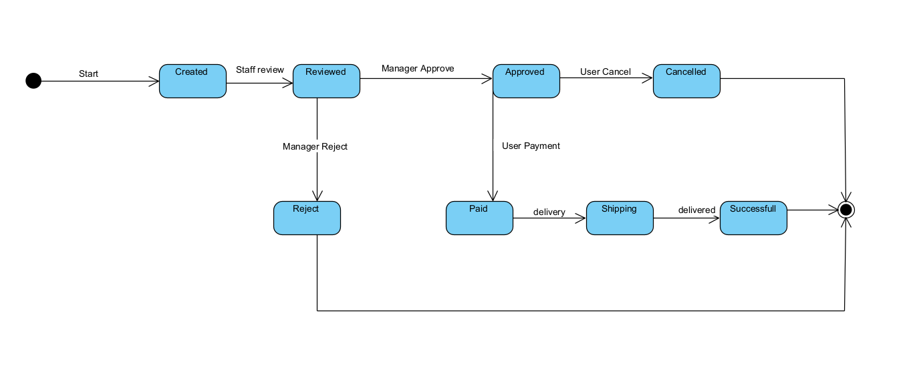

| **#** | **State** | **Description** |
| --- | --- | --- |
| 01 | Created | User submitted a new request (start of process). |
| 02 | Reviewed | Staff reviewed the request for validity and completeness. |
| 03 | Approved | Manager approved the request. |
| 04 | Cancelled | User cancelled the request after approval. |
| 05 | Paid | The user made a payment for the approved request. |
| 06 | Shipping | The product or service is in the delivery/shipping phase. |
| 07 | Successfull | The delivery is completed and marked as successful. |
| 08 | Reject | The manager rejected the request after staff review. |