In fact, when developing a new software, the software development team must describe the software requirements in software requirements specification before they do the design and coding. They describe the software requirements by using text, formulas, drawing models and table description. The software tools department at FPT University want to develop a new software tool named EduNext website to allow students to learn many courses in the constructivism way. Following the constructivism way, the students will build up their knowledge more actively by searching content on the internet, reading text books, interacting with other students in the same group or in the same class. The EduNext website need to have many functions which allow importing data about student list from FAP system, displaying the list of students, updating the list of students, adding questions, updating questions, listing questions, creating student groups in the same class by teacher, answering the questions by students, voting answers by students, voting answers by teacher, signing in EduNext by using @fpt.edu.vn email accounts of students or teachers. Besides, EduNext can record data of the interaction processes between students when students at FPT University post the answers of the questions, reply or comment the answers of other students, vote the answers of other students or even chat with other students. Use case approach is one of the most effective ways to describe the software requirements.

**All the answers must be in English and reflect this exam paper. If your answers of the questions in this exam paper have any keywords not related to this exam paper, the answers of the questions will get ZERO.**

**Question 1:** Complete all parts of the first page of the software requirements specification. (1 point)

Software Requirements Specification

for

EduNext website (0.25 point)

Version 1.0 approved

Prepared by Trần Ngọc Khiết (0.25 point)

FPT University (0.25 point)

July 3rd, 2025 (0.25 point)

**Question 2:**

Use case diagram is an effective way to visualize the interaction between actors and the software system. One Use case diagram need one rectangle which represents one system or one software application. One oval represents one use case. The name of the use case must begin with the verb and follow by an object.

1. In this exam paper, the name of the rectangle is: EduNext website( 0.1 point)
2. The actor may be human, other software systems or devices. In this exam paper, list the name of >= 3 actors is: student, teacher, FAP system, email system (0.6 point)
3. In this exam paper, list the name of >= 5 use cases are: importing data about student list, displaying the list of students, updating the list of students, adding questions, updating questions, listing questions, creating student groups in the same class (1 point)
4. The actors are inside or outside of the rectangle? outside (0.1 point)
5. The ovals represent the use cases are inside or outside of the rectangle? inside (0.1 point)
6. The primary actor of the use case **add new question** is: teacher(0.2 point)
7. The secondary actor of the use case **add new question** is: student (0.2 point)
8. Based on the fact you already used EduNext website. The use cases in this exam paper may have relationship.

8.a List the name of two use cases that have **extend** relationship: answering the questions, voting answers(0.3 point)

8.b The name of **base use case (in 8.a)** is: answering the questions (0.2 point)

8.c The name of **extend** **use case (in 8.a)** is: voting answers (0.2 point)

8.d The dashed line with an arrow that points to which use case? : answering the questions (student write the name of use case) (0.1 point)

1. Based on the fact you already used EduNext website, the use cases in this exam paper may have relationship.

9.a List the name of two use cases that have **include** relationship: listing questions, updating questions (0.3 point)

9.b The name of **based use case (in 9.a)** is: updating questions (0.2 point)

9.c The name of **include** **use case** **(in 9s.a)** is: listing questions (0.2 point)

9.d The dashed line with an arrow that points to which use case? listing questions (student write the name of use case) (0.2 point)

**Question 3:** Writing detail one use case, the use case **adds (+) new question** in the following format. (4 points)

1. UC ID and Name: UC-01 Add new question (0.1 point).
2. Created By: Trần Ngọc Khiết (0.1 point).
3. Date Created: July 3rd, 2025 (0.1 point).
4. Primary Actor: Teacher (0.2 point).
5. Secondary Actors: Student (0.2 point).
6. Trigger: Teacher indicate that he want to add a new question (0.3 point).
7. Description: Teacher add new question by importing question detail to a textbox and confirm. (0.1 point)
8. Preconditions: PRE-1. User’s identity has been authenticated.

PRE-2. User is authorized to add new question. (0.3 point).

1. Postconditions: POST-1 Question is stored on the website.

POST-2 Question is displayed to student. (0.3 point).

1. Normal Flow: 1.0 Add new question by teacher

1. Teacher request to add new question.

2. System display a textbox to fill in question.

3. Teacher import the question detail.

4. Teacher choose class(es) to add question.

5. Teacher confirm to create

6. System store the question in the website and notify student. (0.7 point).

1. Alternative Flows: 1.1 Add multiple questions

1. Teacher ask to add another question.

2. Return to step 1 of normal flow. (0.7 point).

1. Exceptions: 1.3.E1 Question length is out of limit.

1. System display a notification: Question length is out of limit.

2. Teacher re-enter the question with limit length.

3. System store the question in the website and notify student.

1.3.E2 Quesition content is empty

1. System display a notification: Question content must not be empty.

2. Teacher enter the question content.

3. System store the question in the website and notify student.

(0.3 point).

1. Priority: High (0.1 point).
2. Frequency of Use: Approximately 10 times per week by each teacher (0.1 point).
3. Business Rules: BR-1 Teacher must be assigned to class.

BR-2 Only teacher can add new question.

BR-3 Question must have content. (0.2 point).

1. Other Information: 1. Teacher shall be able to cancel adding question in any step of the use case.

2. Teacher shall be able to view previous created questions and copy them for other class. (0.1 point).

1. Assumptions: Teacher have been assigned to class

Teacher have stable internet connection while adding question (0.1 point).

**Question 4:** writing 2 non-functional requirements.

1. The term of the most important non-functional requirements and at least 2 statements. Should be specific in number, explain the number so that the tester can test the software and make conclusion the test is passed or failed. (0.5 point)

NFR-1: The system shall load the student list within 2 seconds for up to 1000 concurrent users.  
Explanation: The tester will simulate 1000 users accessing the student list concurrently. If the page loads within 2 seconds, the test passes.

NFR-2: The system shall allow submitting a question within 3 seconds, even under peak load like class hour.  
Explanation: A load testing tool will simulate peak traffic. If the system allows question submission within 3 seconds during this test, the test passes.

1. The term of the second important non-functional requirement and at least 2 statements. Should be specific in number, explain the number so that the tester can test the software and make conclusion the test is passed or failed. (0.5 point)

NFR-3: Only users with a valid @fpt.edu.vn email domain shall be able to log in to EduNext.  
Explanation: The tester attempts to log in using invalid domains (e.g., @gmail.com). If access is denied for all such attempts, the test passes.

NFR-4: The EduNext website shall automatically log out a user after 30 minutes of inactivity to protect session data.  
Explanation: Testers can log in, remain idle for 30 minutes, then attempt to use the system. If they are logged out, the test passes.

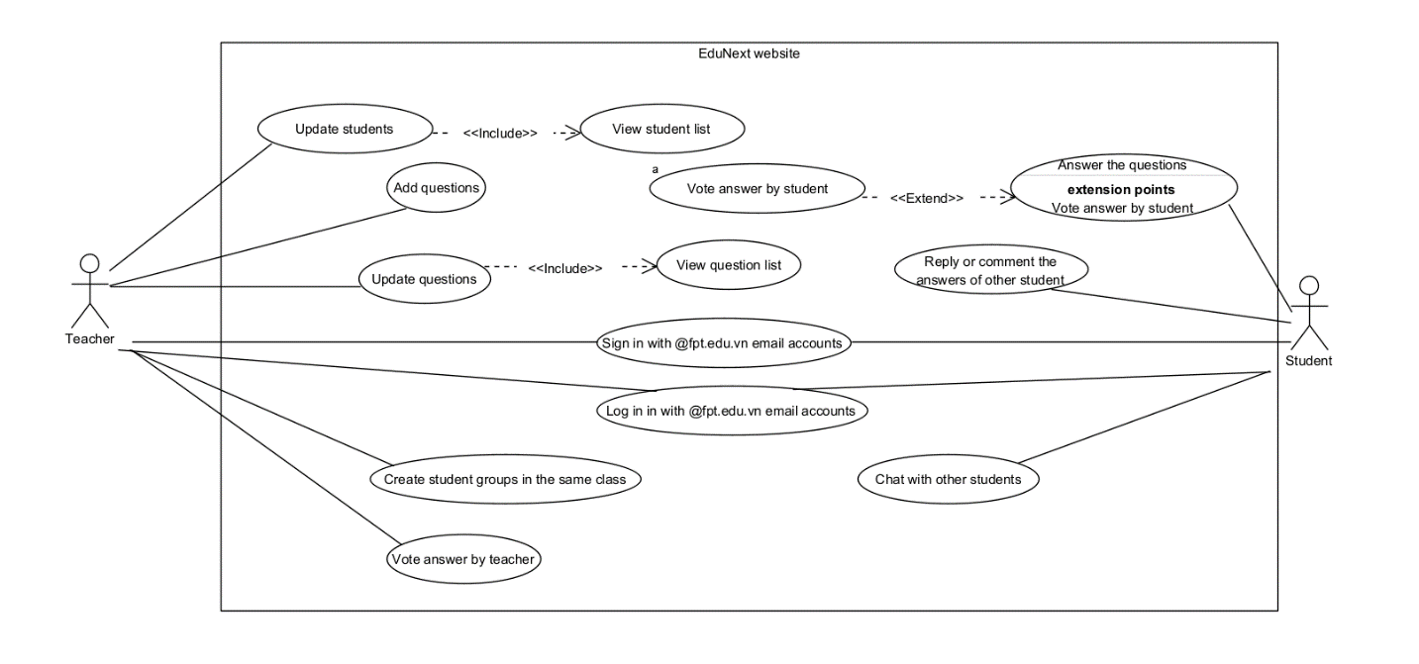Use Case Diagram of EduNext Website:

System Context Diagram of EduNext Website:

