

AWS First Cloud AI Journey – Project Plan

Skyscraper – FPTU HCM Campus – Smart Office

10/16/2025 – 12/09/2025
Table of Contents
1 BACKGROUND and motivation 3
1.1 executive summary 3
1.2 PROJECT SUCCESS CRITERIA 3
1.3 Assumptions 3
2 SOLUTION ARCHITECTURE / ARCHITECTURAL DIAGRAM 3
2.1 Technical Architecture Diagram 3
2.2 Technical Plan 4
2.3 Project Plan 4
2.4 Security Considerations 4
3 Activities AND Deliverables 5
3.1 Activities and deliverables 5
3.2 OUT OF SCOPE 5
3.3 PATH TO PRODUCTION 5
4 EXPECTED AWS COST BREAKDOWN BY SERVICES 5
5 TEAM 6
6 resources & cost estimates 6
7 Acceptance 7

BACKGROUND and motivation

executive summary
- Background & Motivation
Team Skyscraper from FPTU HCM Campus introduces the "Smart Office Management System" to modernize traditional office administration. Currently, managing office environments lacks real-time visibility into room conditions (temperature, humidity, light) and relies heavily on manual oversight. This project serves a dual purpose: to digitize office management for better decision-making and to act as a hands-on "First Cloud Journey" for the team to master AWS Serverless technologies.
- Proposed Solution
We are developing a centralized Management Console that allows administrators and managers to monitor room status and manage device configurations in real-time. By leveraging AWS IoT Core, Lambda, API Gateway, and DynamoDB, the system provides a secure and scalable platform for visualizing sensor data and managing user access via Amazon Cognito, replacing outdated manual tracking methods.

PROJECT SUCCESS CRITERIA
The success of the Smart Office Management System will be measured by the following key outcomes:
- Centralized Monitoring: The system successfully aggregates and visualizes real-time environmental data (temperature, humidity, light) from all connected rooms on a single dashboard, eliminating the need for manual checks.
- Remote Management: Administrators can successfully update room configurations and device settings remotely via the web console with immediate synchronization to the edge devices.
- Security & Access Control: The platform enforces strict access control using Amazon Cognito, ensuring that only authorized managers and administrators can view sensitive data or modify settings.
- System Reliability: The serverless backend maintains high availability, ensuring sensor data is processed and stored in DynamoDB without loss during standard operation.
- Educational Impact: The project team successfully demonstrates a working knowledge of AWS Cloud services by deploying a fully functional, production-ready serverless architecture.

Assumptions
The project plan relies on the following key assumptions and prerequisites:
- Hardware Availability: It is assumed that the necessary IoT sensor hubs and ESP32 controllers are already installed and operational within the office rooms. The project budget does not include provisions for procuring new hardware devices.
- Network Stability: The office network infrastructure is assumed to be stable and capable of supporting continuous MQTT data transmission from multiple devices to AWS IoT Core at 2-minute intervals without significant interruptions.
- Cost Estimates: The operational cost estimates assume usage remains within the AWS Free Tier limits for services like Lambda and DynamoDB. It is assumed there will be no unexpected surge in data traffic that would significantly exceed the projected $1.81/month budget.
- AWS Environment: It is assumed that the development team has full administrative access to the AWS account to provision necessary resources (IoT Core, Cognito, etc.) using AWS CDK/SDK without restriction.

SOLUTION ARCHITECTURE / ARCHITECTURAL DIAGRAM

Technical Architecture Diagram
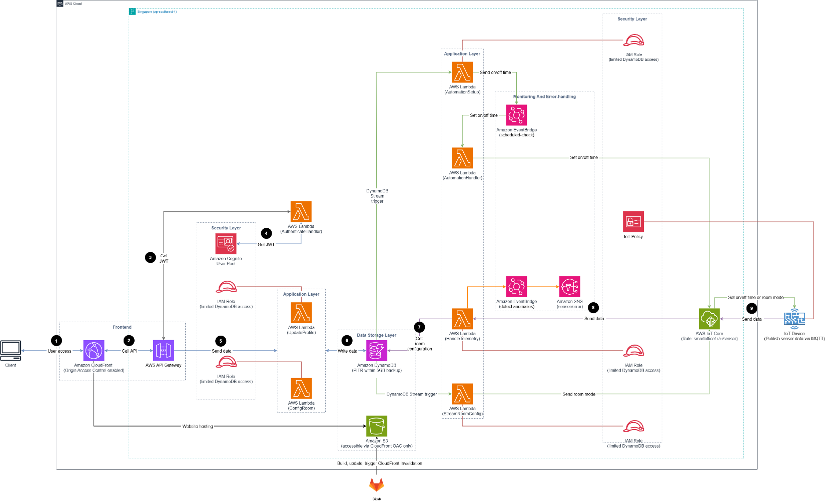
High-Level Architecture Description: The Smart Office Management System employs a robust AWS Serverless architecture, designed to provide real-time visibility and management capabilities with minimal operational overhead. The system ingests environmental data from room sensors via AWS IoT Core, processes it using AWS Lambda, and stores it in Amazon DynamoDB for persistence and quick retrieval. A user-friendly web dashboard, hosted on Amazon S3 and accelerated by Amazon CloudFront, serves as the central management console. Secure API access is facilitated by Amazon API Gateway, while Amazon Cognito ensures that only authorized personnel can access the system or modify configurations.
Core Components & Data Flow:
- Sensor Network: IoT Sensor Hubs deployed in each room collect telemetry data (temperature, humidity, light) and transmit it securely to AWS IoT Core via MQTT protocols every 2 minutes.
- Data Processing: The SensorProcessor Lambda function is triggered by IoT Core to validate incoming data and persist it into Amazon DynamoDB tables (Sensor Logs).
- Configuration Management: The RoomConfigHandler Lambda allows administrators to read and update room settings (e.g., thresholds, device states) stored in DynamoDB via the web dashboard.
- Alerting System: Amazon SNS is integrated to send notifications to managers when environmental conditions breach pre-defined safety thresholds, ensuring timely manual intervention.
- User Interface: The frontend dashboard connects to the backend via secure REST APIs exposed by Amazon API Gateway, allowing users to visualize real-time data and manage room statuses.

Technical Plan
Implementation Strategy: The project will follow a "Cloud-Native" development approach, utilizing AWS CloudFormation for Infrastructure as Code (IaC) to ensure reproducible and scalable deployments. The technical execution is divided into the following key phases:
- Foundation & Research: comprehensive study of core AWS services (IoT Core, Lambda, DynamoDB) and their interactions to build a solid theoretical base.
- System Design: Finalizing the serverless architecture for an 8-room office setup and performing detailed cost estimation using the AWS Pricing Calculator.
- Development:
  - Creating simulation scripts to generate realistic IoT sensor data for testing.
  - Developing backend Lambda functions for data ingestion and API logic.
  - Building the Next.js web dashboard and integrating it with the serverless backend.
- Integration & Deployment: Full stack deployment, end-to-end testing of data flows from sensor to dashboard, and final system validation.

Project Plan
The project is structured over a 12-week timeline to ensure systematic progress from learning to delivery:
- Weeks 1–7 (Research & Preparation): Deep dive into AWS services and architectural patterns. Understanding security best practices and resource constraints.
- Week 8 (Design & Estimation): Complete the architectural blueprint and finalize budget forecasts. Define database schemas and API specifications.
- Weeks 9–11 (Development): Execute the core coding phase. Implement data simulation, backend logic, database setup, and frontend dashboard creation.
- Week 12-13 (Testing & Go-Live): Perform system testing, debug issues, and deploy the solution to the production environment for final acceptance.

Security Considerations
Security is a primary focus of the architecture, implemented through a multi-layered approach:
- Identity & Access Management: Amazon Cognito handles all user authentication, enforcing strict login requirements for administrators. IAM roles are configured with least-privilege permissions for all Lambda functions and services.
- Data Security: All data in transit is encrypted via HTTPS (for web/API) and MQTTS (for IoT devices). The web dashboard is securely delivered via Amazon CloudFront to protect against common web attacks.
- API Protection: Amazon API Gateway acts as a secure front door for the backend, utilizing Cognito Authorizers to validate user tokens before processing any requests.
- Monitoring: Amazon CloudWatch is enabled to log all system activities and operational metrics, allowing for rapid detection and auditing of any unauthorized access attempts or system anomalies.

Activities AND Deliverables

Activities and deliverables\

Project Phase | Timeline | Activities | Deliverables/Milestones | Total man-day
Research & Foundation | Week 1-7 | - Study AWS core services (IoT Core, Lambda, DynamoDB)  - Analyze integration patterns for Serverless architecture | - Research Document  - Service Selection Report | [35 man-days]
Architecture Design | Week 8 | - Define database schema for Room, Logs  - Create detailed Serverless Architecture Diagram | - Solution Architecture Document (SAD)  - Cost Estimation Report | [5 man-days]
Backend Development | Week 9-10 | - Configure AWS IoT Core and MQTT topics  - Develop Lambda functions for data ingestion and config management  - Set up DynamoDB tables and API Gateway endpoints | - IoT Core Rules Engine  - Functional REST APIs  - Database Tables | [10 man-days]
Frontend & Integration | Week 11 | - Build Web Dashboard with React  - Integrate Frontend with API Gateway and Cognito  - Implement real-time data visualization  - Deploy CloudFormation templates | - Web Management Console  - Source Code Repository | [5 man-days]
Testing & Go-Live | Week 12-13 | - Perform end-to-end system testing  - Verify security rules and access controls  - Deploy to production environment. | - UAT Sign-off  - Live Production System | [5 man-days]
Handover | Week 14 | - Presentation | - Prepare documents | [5 man-days]

OUT OF SCOPE
The following items are explicitly excluded from the scope of this project:
- Hardware Procurement & Installation: The project assumes all sensors and IoT hubs are pre-installed. No new hardware will be purchased or mounted.
- AI/ML Forecasting: Advanced weather prediction models using Machine Learning are not part of this release; the system relies on real-time sensor data only.
- Mobile Application: The user interface is limited to a web-based dashboard; a native mobile app is not included.
- Physical Maintenance: Physical repair or maintenance of the office infrastructure (lights, AC units) is outside the team's responsibility.

PATH TO PRODUCTION
This project represents the "First Cloud Journey" and serves as a Proof of Concept (POC) and foundational platform. To transition to a full-scale enterprise production environment, the following steps would be required:
- Operational Excellence: Implement comprehensive CI/CD pipelines (using AWS CodePipeline) to automate testing and deployment, replacing manual deployments.
- Enhanced Observability: Configure advanced Amazon CloudWatch Alarms and AWS X-Ray for deep tracing of API requests and proactive incident response.
- Disaster Recovery: Establish backup strategies for DynamoDB and define a clear Disaster Recovery (DR) plan for regional failover.
- Scalability Testing: Conduct load testing to validate the system's ability to handle hundreds of rooms and higher data ingestion rates before scaling up.

EXPECTED AWS COST BREAKDOWN BY SERVICES
AWS Pricing Calculator Estimate: For a detailed breakdown of the infrastructure costs, please refer to the following AWS Pricing Calculator estimate: https://calculator.aws/#/estimate?id=0db12150c448b012356e475becefd549c37094d8
Monthly Cost Breakdown: The estimated monthly operating cost is approximately $1.81 USD (or $21.72 USD/year), leveraging the AWS Free Tier where applicable.
- Compute & API:
  - AWS Lambda: Free (within 119,000 requests/month).
  - Amazon API Gateway: Free (within 720 requests/month).
- IoT & Event Processing:
  - AWS IoT Core: $0.18 (based on 8 devices, ~13,000 messages).
  - Amazon EventBridge: Free (2,600 events/month).
  - Amazon SNS: $0.02 (2,100 requests/emails).
  - Amazon SQS: Free (2,600 requests/month).
- Storage & Database:
  - Amazon DynamoDB: Free (~0.002 GB storage).
  - Amazon S3: Free (~0.01 GB storage).
- Networking & Content Delivery:
  - Amazon CloudFront: $1.27 (based on 10,000 requests).
- Management & Security:
  - Amazon CloudWatch: $0.25 (Log storage with 3-day retention).
  - Amazon Cognito: Free (within 3 MAU).
Assumptions:
- Cost estimations assume the project remains within the usage limits of the AWS Free Tier for services like Lambda and DynamoDB.
- No additional hardware costs are incurred as existing sensors and hubs are used.

TEAM
Partner Project Team
Name | Title | Role | Email / Contact Info
Ngo Van Minh Tri | DevOps | IoT system manager, implements Lambda, alert system | ngovanminhtri05@gmail.com
Vo An Khang | DevOps | IoT system manager, implements Lambda, alert system | voankhangpt@gmail.com
Ly Hoang Son | Website design | Website UI designer, implements Lambda and Frontend | lyhoangson21102005@gmail.com
Tran Ngoc Khiet | DevOps | Design database,  Deployment, manages CI/CD and Security | tranngockhiet22062005@gmail.com

resources & cost estimates

Project Phase | DevOps | Website design | Other  (Please specify) | Total Hours
Research & Foundation | 200 hours | 200 hours |  | 400 hours
Architecture Design | 40 hours | 40 hours |  | 80 hours
Backend Development | 100 hours | 100 hours |  | 200 hours
Frontend & Integration | 150 hours | 150 hours |  | 300 hours
Testing & Go-Live | 40 hours | 40 hours |  | 80 hours
Total Hours | 530 hours | 530 hours |  | 1060 hours
Total Cost | 0 | 0 |  | 0

Cost Contribution distribution between Partner, Customer, AWS:
Party | Contribution (USD) | % Contribution of Total
Customer | 0 | 0%
Partner | 0 | 0%
AWS | 0 | 100%

Acceptance
Acceptance Process: To ensure the project meets the "Smart Office Management System" requirements, the following acceptance process will be followed:
- Deliverable Submission: Upon completion of the Testing & Go-Live phase, Team Skyscraper will submit the final Source Code, Architecture Documentation, and the workshop guide to the FCAJ mentor.
- Final Acceptance: The project is deemed accepted when the Dashboard successfully displays real-time data from all connected rooms and allows configuration changes via the web interface.

