**Assignment 03**

**Building a Post Management Website using Real-Time Communication with SignalR**

# Introduction

Imagine you are an employee of IT department of a media company. Your manager has asked you to develop a web application for post management. The post management system must follow the real-time communication application. When user makes the post, this post will automatically update for all connected clients.

The application has to support adding, viewing, modifying, and removing posts; standardized usage action verbs better known as Create, Read, Update, Delete (CRUD) and Search. This assignment explores creating an application using Real-Time Communication with SignalR .NET Core Web Application, C#, and Entity Framework Core. The MS SQL Server database will be created to persist the data and it will be used for reading and managing data.

# Assignment Objectives

In this assignment, you will:

* Use the Visual Studio.NET to create ASP.NET Core Web Application (Model-View-Controller) project.
* Perform CRUD actions using Entity Framework Core combined with Real-Time Communication with SignalR.
* Apply to validate data type for all fields.
* Run the project and test the ASP.NET Core Web Application actions.

# Database Design

# 

PostCategories (CategoryID, CategoryName, Description)

AppUsers (UserID, Fullname, Address, Email, Password)

Posts (PostID, AuthorID, CreatedDate, UpdatedDate, Title, Content, PublishStatus, CategoryID)

# Main Functions

* Create database using Entity Framework Core.
* Member management, post management, and registration management: Read, Create, Update and Delete actions.
* Search Post by ID , Title or Description
* Create a report statistics posts by the period from StartDate to EndDate, and sort post in descending order
* Member registration by Email and Password.

# Guidelines

# Activity 01: Build a solution [01 mark]

**Step 01**. Create Project/Solution named SignalRAssignment

**Step 02**. Choose the Project template: ASP.NET Core Web Application (Model-View-Controller)

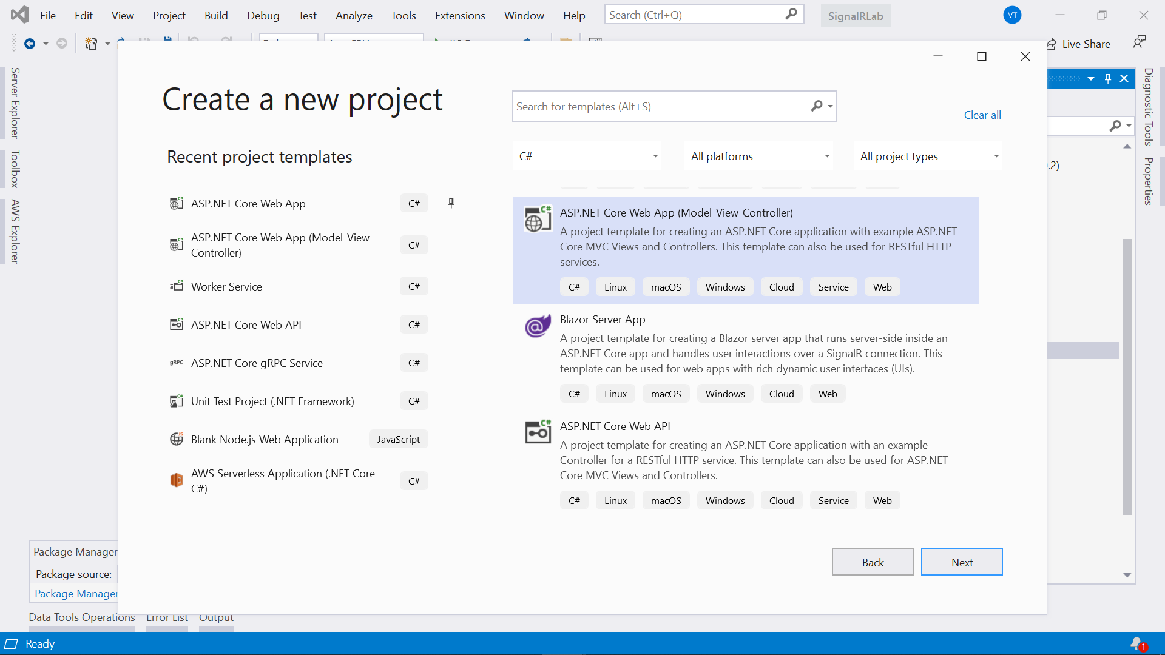

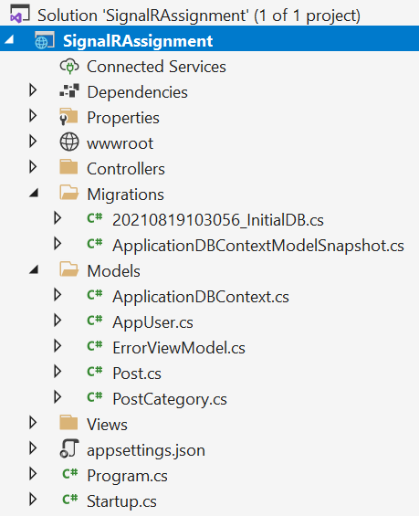

# Activity 02: Create database with Entity Framework [03 marks]

# 

# 

**Step 01**. Create Model

**Step 02**. Create database context with Entity Framework ApplicationDBContext

**Step 03**. Add-Migration and then Update Database

# Activity 03: CRUD post item using Real-Time Communication with SignalR [05 marks]

**Step 01**. Create Registration with the information

**Step 02**. Create a new post. When user create a new post, this information will automatically update with all other connected users using .NET Core SignalR.

**Step 03**. Update an existing post. When user update an existing post, this information will automatically notify with all other connected users using .NET Core SignalR.

**Step 04**. Delete an existing post. When user delete an existing post (owner), this information will automatically update with all other connected users using .NET Core SignalR.

**Step 05**. View detail of the post.

**Step 06**. View list of posts with paging.

# Activity 04: Run the project and test all actions [01 mark]