Omega

Tran Ngoc Tuan C4b

Content

Program Description 3

Architecture 3

Design Patterns 3

System requirements 3

Database 3

Program Usage 3

# Program Description

Task Management System is a program through which your employer will assign tasks.

# Architecture

The program is built on a Three Tier architecture that work together for proper functionality

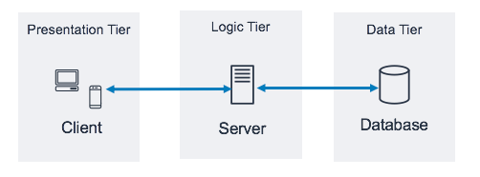of the program.

## Design Patterns

The program also has other design patters such as:

* Singleton to connect to a database server

# System requirements

The program requires the following:

* Windows
* .net core 6
* MSSQL Database Server

# Database

Database has following tables:

* Users
* Roles
* Teams
* Projects
* Comments
* Tasks

# 

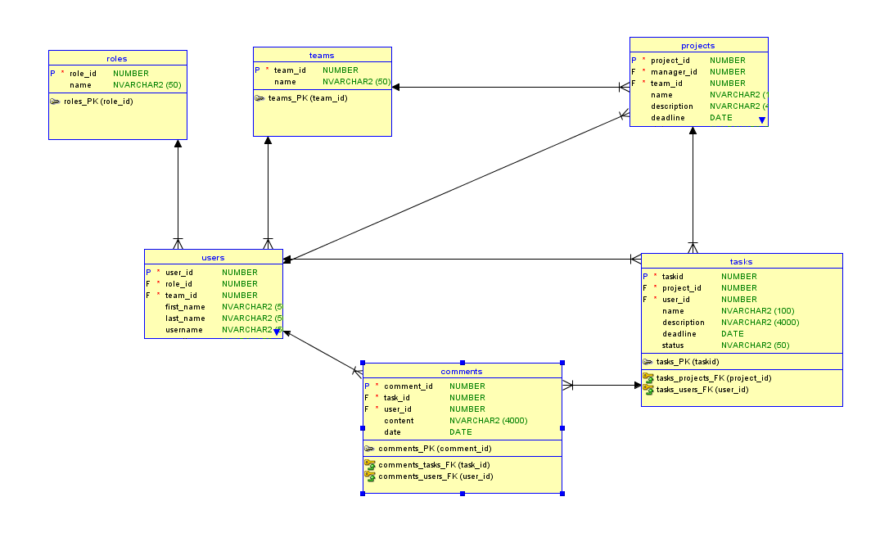

# Program Usage

After a successful log in the program has a menu on the left side.

