Energy-Accuracy Trade-offs of Spiking Neural Networks for SAR Flood Segmentation: A Systematic Benchmark
Tran Nhat Phi¹, Huong Bui² (advisor)
¹ ² [Affiliation / University] — {emails} [TODO điền cơ quan, email]
Abstract
Rapid flood-extent mapping from Sentinel-1 SAR is critical for disaster response, and on-board or edge deployment demands energy-efficient models. Spiking Neural Networks (SNNs) promise low-energy inference through sparse, event-driven computation, yet they have never been benchmarked for flood segmentation on SAR. We present the first systematic energy–accuracy benchmark of direct-trained SNNs against strong ANN baselines — CNNs, a Transformer, an ANN-to-SNN conversion, and an INT8-quantized CNN — for 3-class flood-on-land segmentation (background / permanent water / flood) on Sen1Floods11, where permanent water is separated from flood using the JRC Global Surface Water layer. Across 20+ configurations trained with multiple seeds, we find that (i) with pooled flood-IoU an INT8 MobileNet-UNet dominates the accuracy–energy Pareto front (0.490 IoU at 3.1 mJ), while (ii) with a per-chip paired metric the best direct-trained SNN is statistically indistinguishable from the INT8 CNN (Wilcoxon, p = 0.40; Cohen's d = 0.09) — the conclusion about SNN competitiveness is metric-dependent. We verify 13.6–23.8% spike sparsity supporting the energy estimate, show ANN-to-SNN conversion fails even at T = 128, analyse per-region geographic sensitivity, and give practical guidance for choosing SNN vs. quantized CNN.
Keywords: Spiking Neural Networks; SAR flood mapping; Sen1Floods11; energy-efficient segmentation; quantization; neuromorphic computing.
1. Introduction
1.1 Motivation
Floods are among the most frequent and damaging natural disasters, and timely flood-extent maps are essential for emergency response. Sentinel-1 SAR penetrates clouds and operates day and night, unlike optical imagery. Deep segmentation models achieve strong accuracy but are energetically expensive, limiting deployment on satellites, UAVs and edge stations. This motivates studying the energy–accuracy trade-off of candidate architectures, and whether SNNs — computing with sparse binary spikes and additions only — offer a favourable operating point.
1.2 Contributions
- First direct-trained SNN benchmark for 3-class flood-on-land segmentation on Sen1Floods11, with 20+ configurations and a full ablation over timesteps T, learning rate and encoding.
- Rigorous statistical comparison via Wilcoxon signed-rank on paired per-chip flood-IoU: a direct-trained SNN is statistically indistinguishable from an INT8 MobileNet-UNet (p > 0.05), whereas pooled IoU lets the quantized CNN dominate — metric choice determines the conclusion.
- Verified energy claim: measured spike sparsity 13.6–23.8% confirms the SynOps estimate; and ANN-to-SNN conversion fails to converge even at T = 128, so direct training is essential.
- Per-region analysis revealing geographic sensitivity (SNN relatively strong in Sri-Lanka/Ghana, weak in Mekong/Pakistan).
- Practical guidance: a decision procedure for SNN vs. quantized CNN given energy budget, accuracy floor and hardware target.
2. Related Work
2.1 SAR flood mapping. Sen1Floods11 [1] established a Sentinel-1 benchmark; later CNN and semi-supervised methods improved water IoU. Prior work targets binary water; we address a harder 3-class task separating permanent water via JRC [TODO cite].
2.2 Spiking neural networks for vision. Direct training via surrogate gradients and spiking segmenters have shown feasibility on frame/event benchmarks [TODO cite]; SNNs for SAR are nascent, and none benchmark flood segmentation.
2.3 Quantization for edge deployment. PTQ/QAT compress CNNs to INT8/INT4 with small accuracy loss, drastically cutting per-operation energy; INT8 is the strongest ANN energy competitor to SNNs and is a mandatory baseline here.
3. Method
3.1 Problem formulation. Per-pixel 3-class segmentation of 2-channel (VV, VH, dB) chips into background (0), permanent water (1) and flood (2); invalid pixels use ignore-index (−1).
3.2 Spiking U-Net. A 4-level U-Net (7.76 M params) with a LIF neuron (ATan surrogate, τ=2.0, detach-reset) after each conv block, multi-step mode (SpikingJelly); direct SAR encoding over T timesteps; final membrane potentials averaged to logits; tdBN-style BatchNorm over (T,B).
3.3 Energy modeling. At 45 nm [Horowitz 2014]: FP32 MAC = 4.6 pJ, INT8 MAC ≈ 0.23 pJ, SNN AC = 0.9 pJ. ANN energy = FLOPs × E_MAC (ptflops); SNN energy = SynOps × E_AC where SynOps = Σ_conv(MACs × input spike-rate) accumulated over T.
3.4 Statistical testing protocol. We report pooled and per-chip flood-IoU, and run Wilcoxon signed-rank on paired per-chip flood-IoU (seeds averaged), plus bootstrap 95% CIs and paired Cohen's d for key pairs.
4. Experimental Setup
4.1 Dataset. Sen1Floods11 hand-labeled subset: 446 chips of 512×512, 2 channels (VV/VH dB), across 11 flood events/regions. 3-class labels via JRC permanent-water.
4.2 Preprocessing & splits. dB clipped to [−50,0], normalized to [0,1]; NaN → ignore-index. Region-stratified split 70/20/10 → 312/88/45 chips (agreed protocol), fixed seed.
4.3 Baselines. Otsu; U-Net (vanilla / SMP-ResNet34 pretrained / U-Net++); DeepLabV3; MobileNet-UNet (3 LRs) and MobileNet-UNet INT8 (static PTQ); SegFormer-b2; SNN-Flood (T∈{1..8,10}, LR sweep); ANN2SNN (T∈{32,64,128}). Shared dataset/loss/metric/protocol.
4.4 Training. AdamW, gradient clipping (max-norm 5.0), early stopping on val flood-IoU; 3 seeds per config (T=6 with 5 seeds); Otsu deterministic. [TODO: epochs, batch size, lr từ base.yaml].
5. Results
5.1 Main comparison (Table 1)
Model | Group | Params | Energy(mJ) | Pooled IoU | Per-chip | Spike%
SegFormer-b2 | Transformer | 24.7M | 98.0 | 0.525±0.018 | 0.251 | —
U-Net (SMP) | CNN | 24.4M | 143.9 | 0.509±0.028 | 0.291 | —
U-Net++ | CNN | 26.1M | 339.1 | 0.500±0.026 | 0.264 | —
MobileNet-UNet | CNN | 6.6M | 62.7 | 0.498±0.007 | 0.272 | —
MobileNet-UNet INT8 | Quantized | 6.6M | 3.1 | 0.490±0.003 | 0.258 | —
U-Net (vanilla) | CNN | 7.8M | 223.2 | 0.482±0.019 | 0.306 | —
SNN-Flood T2 | SNN | 7.8M | 31.4 | 0.391±0.045 | 0.240 | 13.6
SNN-Flood T8 | SNN | 7.8M | 166.8 | 0.388±0.030 | 0.246 | 23.8
ANN2SNN (T=128) | SNN | 24.4M | 440.4 | 0.290±0.062 | 0.196 | 10.6
DeepLabV3 | CNN | 26.0M | 502.3 | 0.419±0.014 | 0.127 | —
Table 1. Selected models (full table in supplementary). Energy per 512×512 chip.
On pooled IoU the accuracy leaders are pretrained ANNs (SegFormer 0.525); MobileNet-UNet INT8 reaches 0.490 at only 3.1 mJ (≈ its FP32 parent at 20× lower energy). SNN-Flood tops out at ≈0.39 pooled IoU, below the quantized CNN.
5.2 Statistical significance
Under the per-chip metric: U-Net-SMP vs MobileNet-INT8 p = 0.015 (significant, Cohen's d = 0.35); MobileNet-INT8 vs SNN-T6 p = 0.397 (n.s., d = 0.09); SNN-T2 vs SNN-T6 p = 0.368 (n.s., d = −0.14). The best SNNs and INT8 form a statistically indistinguishable cluster — the headline conclusion is metric-dependent.
5.3 Energy & spike-rate analysis
The pooled Pareto frontier is Otsu (0 mJ, 0.13) → MobileNet-INT8 (3.1 mJ, 0.49) → SegFormer (98 mJ, 0.53); SNN-Flood is not Pareto-optimal under pooled IoU. Measured spike sparsity 13.6% (T2)–23.8% (T8) confirms energy is driven by genuine sparsity. Direct-trained SNNs (31–167 mJ) are far more efficient than ANN2SNN (94–440 mJ).
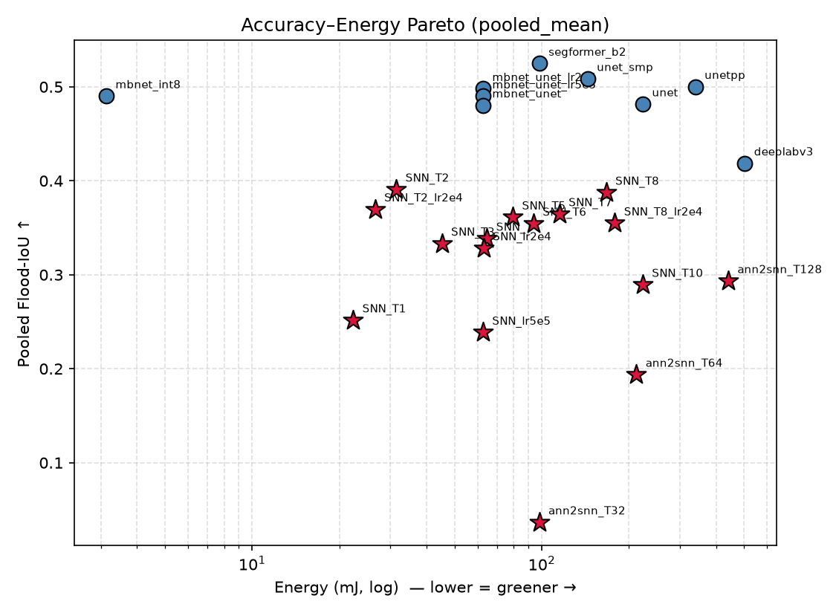
Figure 1. Accuracy–energy Pareto (pooled flood-IoU).
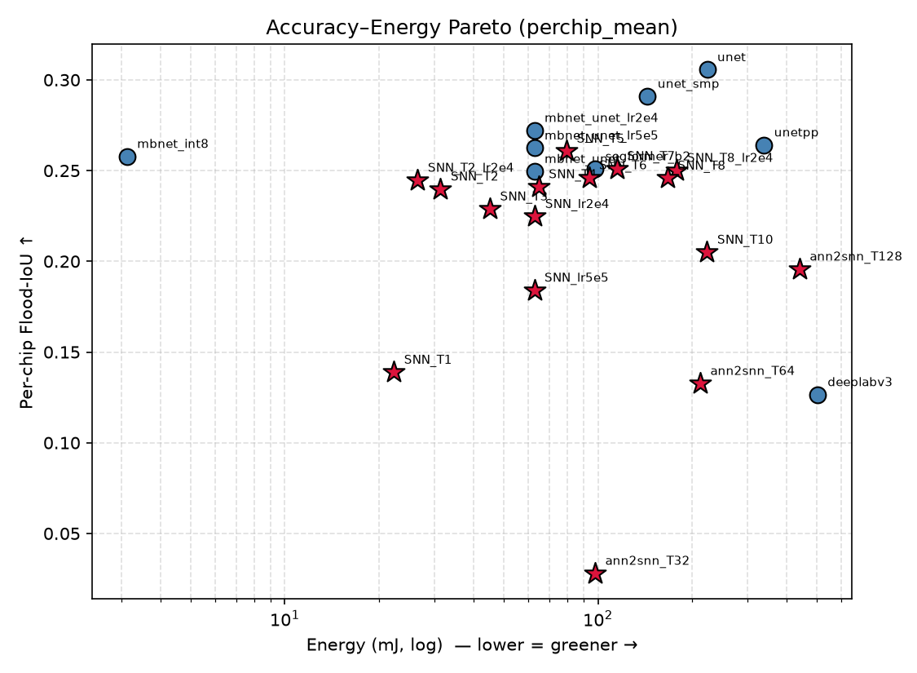
Figure 2. Accuracy–energy Pareto (per-chip flood-IoU).
5.4 Per-region breakdown
All models share the same regional difficulty ordering — easiest in Mekong/Ghana (≈0.4–0.5), hardest in Bolivia (≈0.04 for every model) — a property of the data, not the model. SNNs are comparatively stronger in Sri-Lanka/Ghana and weaker in Mekong/Pakistan.
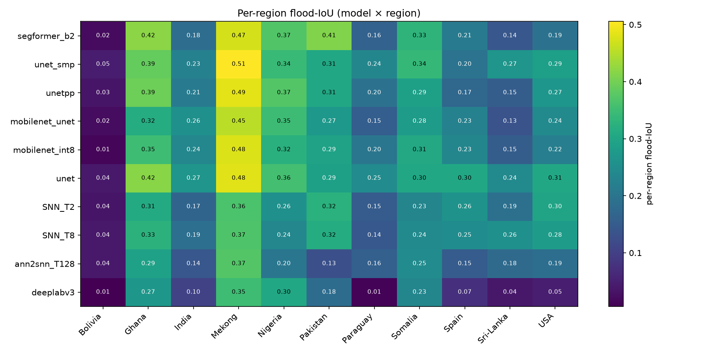
Figure 3. Per-region flood-IoU (model × region).
5.5 Ablations
Within T2–T8 accuracy is flat (T2 0.391 ≈ T8 0.388; SNN-T2 vs SNN-T6 n.s.), so larger T buys no accuracy but costs more energy. At extreme T (T1, T10) occasional seed-level training collapse appears (a seed drops to ≈0.08); re-running T6 with 5 seeds reduced std from 0.13 (n=3) to 0.022 (n=5), confirming a small-sample artifact, not a bimodal property. LR affects SNN stability more than mean accuracy. INT8 preserves accuracy (−0.008 IoU) at 20× energy; INT4 was inconclusive in our tooling (Conv2d unsupported).
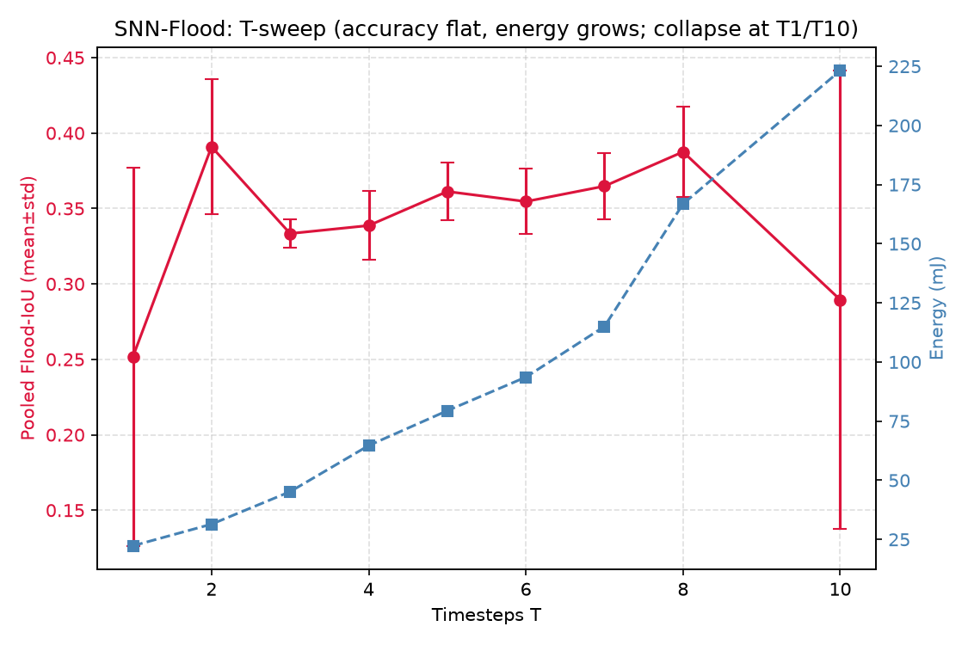
Figure 4. T-sweep: accuracy flat, energy grows; collapse at T1/T10.
6. Discussion
6.1 Why SNN does not dominate. Under a MAC/SynOps energy model, the SNN's sparse-spike advantage is outweighed by (i) using full convolutions on a vanilla U-Net vs. MobileNet's depthwise-separable convs, and (ii) INT8 making each MAC ~20× cheaper. The SNN's event-driven benefit is only partially captured on von-Neumann hardware.
6.2 When to use SNN vs quantized CNN. On standard edge hardware with INT8 kernels, a quantized MobileNet-UNet is best. Prefer an SNN when the target is neuromorphic hardware (e.g., Loihi), when INT8 MAC arrays are unavailable, or with native event-based sensing; under the per-chip metric the SNN is not statistically worse than INT8. [TODO: vẽ decision-tree figure]
6.3 Limitations. No deployment on real neuromorphic hardware (energy estimated, not on-chip); single dataset; modest absolute IoU (harder 3-class SAR-only); INT4 not conclusively evaluated.
7. Conclusion
We presented the first systematic energy–accuracy benchmark of direct-trained SNNs for SAR flood segmentation against CNN, Transformer, ANN2SNN and INT8 baselines under one protocol with multi-seed statistics. SNNs are competitive with an INT8 CNN under a paired per-chip metric but not under pooled IoU; ANN2SNN fails; quantized CNNs occupy the pooled Pareto front. Future work: neuromorphic deployment, multi-temporal SAR, event-native sensing.
References
[1] Bonafilia et al., Sen1Floods11: a georeferenced dataset for Sentinel-1 flood mapping, CVPRW 2020.
[2] Horowitz, Computing's energy problem (and what we can do about it), ISSCC 2014.
[3] Pekel et al., High-resolution mapping of global surface water (JRC), Nature 2016.
[TODO] SpikingJelly; SNN segmentation (Shi 2022, Su 2023); MobileNetV2; SegFormer; DeepLabV3; SAR-SNN works. Cần đủ 20–30 trích dẫn.

