Rethinking Embedded Feature Engineering in Gradient Boosting: A Static Cheap Rotation Rivals Ensemble and Adaptive Selection
Working draft — Empirical Study. Citations marked [verify] must be checked before submission.
Abstract
Embedding feature engineering (FE) into the boosting loop—rather than applying it once as preprocessing—has been shown to improve gradient-boosted trees. A recent method, Feat-XGBoost, rotates an ensemble of six FE transforms across boosting iterations. This design raises two unexamined questions: is the full six-transform ensemble necessary, and would adaptively selecting a transform per iteration (rather than blindly rotating) do better? We conduct a controlled empirical study on 15 high-dimensional UCI classification datasets (4-fold cross-validation, 3 seeds), comparing six selection strategies within a single boosting framework: no FE, one fixed transform, a 2-transform rotation, a cheap 5-transform rotation, the original 6-transform round-robin, and a contextual-bandit selector. We find that (i) FE diversity helps—round-robin significantly outperforms plain XGBoost (Δacc = +2.4 pts, paired t = 2.57) and single-transform variants; (ii) the most expensive transform (Autofeat) is nearly free of benefit—dropping it reduces peak feature-representation memory by 57% with no significant accuracy change (Δacc = −0.16 pts, t = −0.56); and (iii) online adaptive selection provides no advantage: a contextual bandit ties the cheap static rotation on accuracy (t = −0.37) while consuming as much memory as the full ensemble, because it must materialize every candidate transform. An oracle analysis explains the negative result: the per-iteration optimal transform is nearly uniform across boosting phases, so there is little exploitable structure. We recommend a static rotation over cheap transforms and release all code and data splits.
Keywords: gradient boosting, feature engineering, XGBoost, contextual bandit, empirical study, computational efficiency.
1. Introduction
Feature engineering (FE) frequently determines the effectiveness of tabular machine-learning models: even strong classifiers struggle when the input representation obscures class structure. In the gradient-boosting family (XGBoost, LightGBM), FE has traditionally been a preprocessing step applied once, decoupled from the learner. A recent line of work instead embeds FE inside the boosting loop: at each iteration a feature transform is applied to (a subsample of) the training data before the next tree is fit. Feat-XGBoost implements this idea, rotating six transforms—identity, Autofeat, random projection, a hard-thresholded SVD, robust scaling, and min–max scaling—across iterations, and reports accuracy gains over standard baselines on UCI benchmarks.
While effective, this design leaves two questions unanswered. First, is the full ensemble necessary? Rotating six transforms—some expensive (Autofeat expands the feature space several-fold)—incurs substantial cost, and each transform's contribution is unclear. Second, is blind rotation optimal? The transform is chosen by a fixed schedule (iteration index modulo six), ignoring the data state; adaptively choosing per iteration might be superior.
We answer these with a controlled empirical study rather than by proposing a new state-of-the-art method, organized around four research questions. RQ1: Does FE diversity in the boosting loop help, relative to no FE or a single transform? RQ2: Is the full six-transform ensemble needed, or does a cheaper subset suffice? RQ3: Does adaptive per-iteration selection (a contextual bandit) outperform fixed selection? RQ4: Does the optimal transform vary systematically across boosting iterations, and can this be exploited online?
Contributions: (1) a fair, single-framework comparison of six FE-selection strategies over 15 high-dimensional datasets with statistical testing; (2) evidence that the most expensive transform (Autofeat) can be removed with a 57% reduction in feature-representation memory and no significant accuracy loss; (3) a negative but well-supported result that online adaptive selection does not beat a cheap static rotation, with an oracle analysis explaining why; (4) a concrete practical recommendation and an open, reproducible codebase.
2. Related Work
[TO EXPAND] Feature engineering for boosting: automatic feature construction (e.g., Autofeat), dimensionality reduction (random projection, SVD-based denoising). Prior work largely treats FE as preprocessing; Feat-XGBoost is closest to ours in embedding FE within boosting.
Gradient-based one-side sampling (GOSS), from LightGBM, keeps large-gradient (hard) samples and subsamples small-gradient ones with re-weighting; we use it to focus each iteration on hard examples. Contextual bandits (e.g., LinUCB) select actions from context to maximize reward; we repurpose one to select an FE transform per boosting iteration.
3. Materials and Methods
All strategies share one boosting engine differing only in an interchangeable FE selector. At iteration t: (1) compute gradients of the multiclass log-loss on the training set; (2) apply GOSS (a = 0.4 large-gradient, b = 0.3 small-gradient, re-weighting (1−a)/b) to obtain a hard subset; (3) a selector picks one transform from a candidate set; (4) a single boosting round (multi:softprob) is fit on the transformed data and added to the additive margin. At inference, each stored tree is applied in its own transformed space. Candidate transforms follow Feat-XGBoost: identity, Autofeat (first-round only: 1/x, x^2, x^3, e^x), Gaussian random projection, hard-thresholded SVD (Gavish–Donoho threshold), robust scaling, min–max scaling.
The contextual bandit uses a low-dimensional summary of the hard subset as context (mean/std gradient magnitude, class coverage/entropy, dimensionality); its reward is validation-accuracy improvement minus a cost penalty. A 10-iteration warm-up forces round-robin so it observes every arm.
Data and protocol: 15 high-dimensional datasets from the standardized UCI benchmark (excluding one dataset with a train/test label mismatch), each evaluated with 4-fold cross-validation × 3 seeds; we report mean ± std accuracy. Because our claims are relative (strategy vs. strategy under identical conditions), we fix boosting hyperparameters (η = 0.3, max depth = 6, 100 iterations) across all strategies. Cost is measured on a single machine: wall-clock fit time (mean of 3 repeats) and the memory footprint of the precomputed feature representations. Each strategy precomputes only the transforms it can use; the bandit must precompute all six (its action menu), reflected in its measured cost.
4. Results
4.1 RQ1–RQ2: diversity helps, but the full ensemble is wasteful
Table 1 reports mean accuracy and cost across strategies of increasing FE diversity. Accuracy rises from plain XGBoost (0.757) to round-robin (0.781). Round-robin significantly beats plain XGBoost (Δ = +0.024, paired t = 2.57, 12/15 wins) and single-transform Fixed-HT-SVD (11/15 wins), confirming RQ1: FE diversity is beneficial. However, the gain saturates. Dropping Autofeat—the most expensive transform—moves from round-robin (6) to the cheap 5-transform rotation with no significant accuracy change (Δ = −0.0016, t = −0.56) while reducing precomputed-representation memory from 5.06 MB to 2.19 MB (57% reduction) and fit time by ~15%. This answers RQ2: the full ensemble is unnecessary.
Strategy | #FE | Accuracy | Fit time (s) | FE memory (MB)
Plain XGBoost | 0 | 0.757 | 1.04 | 1.02
Fixed-HT-SVD | 1 | 0.767 | 1.30 | 0.19
2-FE rotation | 2 | 0.771 | 1.27 | 0.47
Cheap rotation | 5 | 0.779 | 1.25 | 2.19
Round-robin (orig.) | 6 | 0.781 | 1.47 | 5.06
Contextual bandit | 6* | 0.778 | 1.33 | 5.06
Table 1. Mean accuracy and cost over 15 datasets (4-fold × 3 seeds; fixed hyperparameters). *The bandit chooses one transform per iteration but must materialize all six.
4.2 RQ3: adaptive selection does not help—and is dominated
The contextual bandit matches the cheap static rotation on accuracy (Δ = −0.0012, t = −0.37; no significant difference). It exceeds the impoverished 2-FE (t = 2.16) and single-FE (t = 2.04) baselines only because those are too narrow; it never beats the cheap rotation. On the accuracy–cost plane (Figure 1) the bandit is Pareto-dominated by the cheap rotation: it uses the same memory as the full round-robin (5.06 MB, since it must precompute Autofeat as a candidate) yet is less accurate than the cheaper rotation. This answers RQ3: online adaptive selection provides no benefit here and is strictly worse in cost than a fixed cheap rotation.
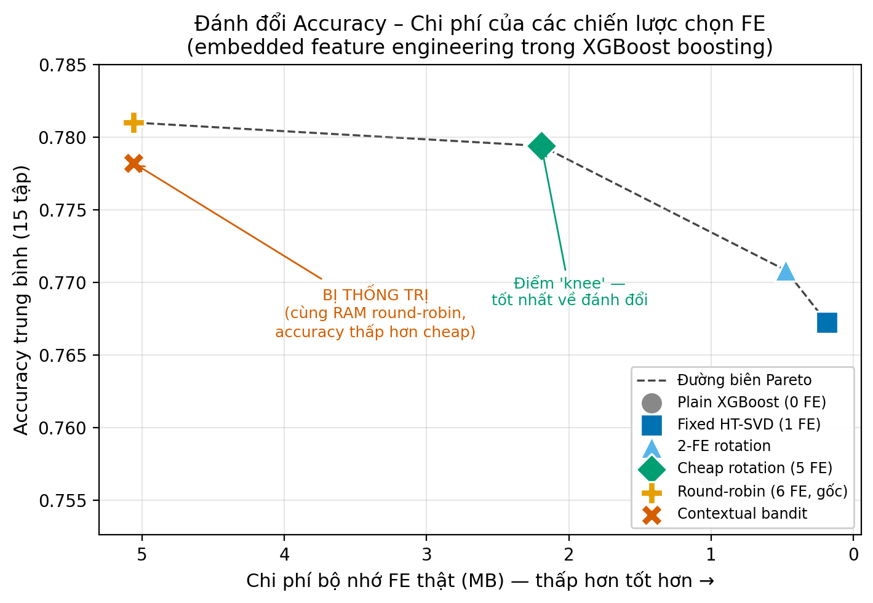
Figure 1. Accuracy vs. FE memory (Pareto frontier). The cheap rotation is the knee; the contextual bandit lies below the frontier (dominated).
4.3 RQ4: why adaptivity fails
To test whether any per-iteration selector could help, we compute a greedy oracle that, at each iteration, tries all six transforms and keeps the one minimizing validation loss. Aggregated over datasets, the oracle's transform distribution is nearly uniform across boosting phases (Figure 2), with only a mild monotone trend: Autofeat is modestly favored early (22%) and declines late (13%), while identity is common throughout (30–36%). The clean denoise-early/preserve-late pattern holds only for individual noisy datasets, not in aggregate. With no strong temporal structure and a noisy per-iteration reward, an online learner has little to exploit—explaining the RQ3 result.
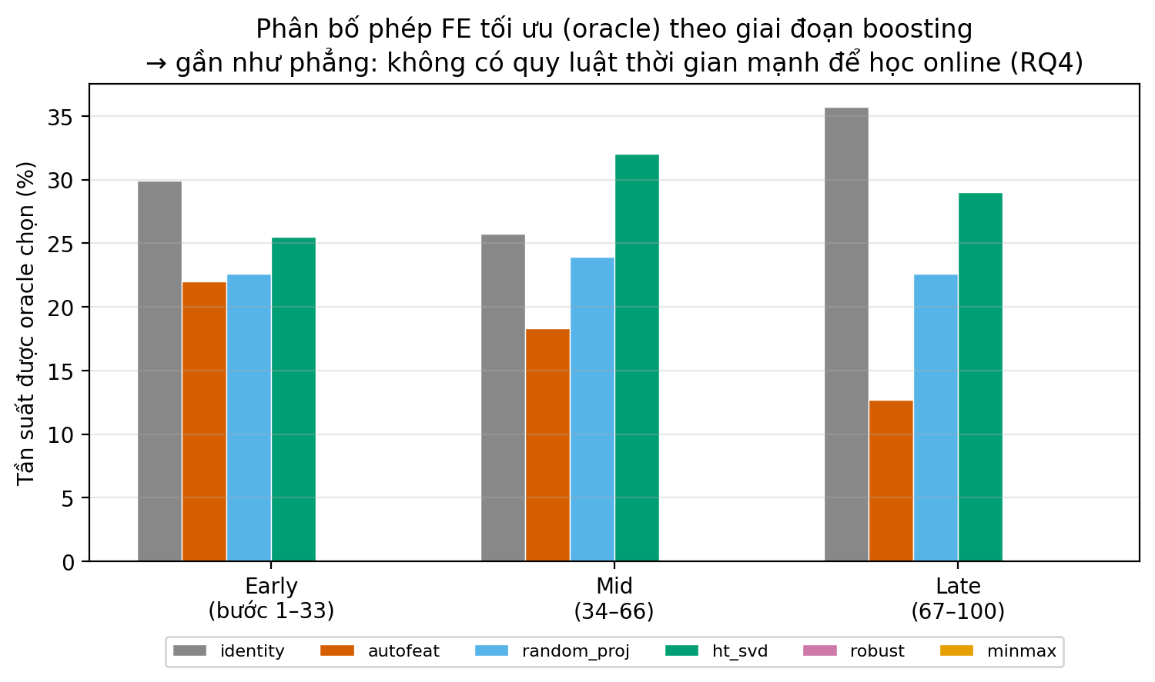
Figure 2. Oracle-optimal FE transform distribution by boosting phase. The distribution is near-uniform, indicating little exploitable temporal structure (RQ4).
5. Discussion
Practical recommendation. For embedding FE into gradient boosting, practitioners should use a static rotation over cheap transforms (dimensionality reducers and scalers), omitting expensive feature-expansion methods such as Autofeat. This retains the accuracy benefit of FE diversity at roughly one-third the memory of the full ensemble and requires no learned controller.
Why the bandit was worth testing—and why it lost. Blind rotation is an obvious target for improvement, and a cost-aware bandit can concentrate on cheap transforms. But two factors neutralize it: (a) it must precompute every candidate transform to keep them selectable, erasing its cost advantage; and (b) the per-iteration signal is too noisy and too weakly structured for the learned policy to beat a fixed schedule on accuracy. This delimits when adaptive FE selection is not worth its complexity.
Limitations. Our comparison is relative under fixed hyperparameters; absolute numbers would shift with per-configuration tuning (e.g., Optuna), which we did not run and leave as future work. We study 15 high-dimensional datasets and XGBoost only; base-learner generality (LightGBM, random forests) and larger datasets remain open. Timing was measured on small datasets where fit time is dominated by fixed overheads, so the runtime gap is modest; the memory gap is the more robust cost signal.
6. Conclusion
Embedding feature engineering into gradient boosting helps, but the popular six-transform ensemble is over-engineered: a cheap static rotation matches it at a fraction of the cost, and a learned online selector adds complexity without benefit. We recommend the simple cheap rotation and release code, data splits, and all experimental artifacts for reproducibility.
References (TO VERIFY — do not submit unchecked)
[1] Chen, T., Guestrin, C. XGBoost: A Scalable Tree Boosting System. KDD 2016. [verify]
[2] Ke, G. et al. LightGBM: A Highly Efficient Gradient Boosting Decision Tree. NeurIPS 2017. [verify]
[3] Li, L. et al. A Contextual-Bandit Approach to Personalized News Article Recommendation. WWW 2010. [verify]
[4] Fernández-Delgado, M. et al. Do we need hundreds of classifiers to solve real world classification problems? JMLR 2014. [verify]
[5] Horn, F., Pack, R., Rieger, M. The autofeat Python Library for Automated Feature Engineering and Selection. 2020. [verify]
[6] Gavish, M., Donoho, D. The Optimal Hard Threshold for Singular Values is 4/√3. IEEE TIT 2014. [verify]
[7] Feat-XGBoost (base paper). Pattern Recognition, 2026. DOI:10.1016/j.patcog.2026.113169. [verify authors/title]

