Read the below instructions carefully before you start.
- Software Requirement: Apache NetBeans 17, MS SQL Server 2008 R2+ or higher, Java SE Development Kit 17, Apache Tomcat 10.1.x.
- Download the given material then unzip.
- You receive folders: Q1_XXX (1) and Q2_XXX (2) … They are template for your corresponding exam questions. Q1_XXX used for question number 1 and Q2_XXX for question number 2 and so on. Open them as NetBeans project, replace XXX by [your student ID], e.g. Q1_SE1111, Q2_SE1111, Q3_SE1111. Change the context application to new name, e.g. /Q1_SE1111/Index.html instead of /Q1_XXX/Index.html. Your work will not be considered for grading if this condition is not satisfied.
- Template project already contains the DBContext.java (3) to source package (src\java\dal) under folder (2), (3).
- You MUST use DBContext.java for your database activities. Update your database connection string by filling values for instance variables in the constructor.
- All allowed libraries including jdbc 6.0 and jakarta jstl 2.0 are already added to your given NetBeans projects, you are NOT allowed to change or add more libraries.
On completion, read submission guide carefully.
Note: In case you cannot submit the exam due to your submission folder contains more than 10MB. Open Netbeans > right click on the project icon > Clean. It would help if you did it for all questions. Netbeans will delete the .class files and reduce the size of your projects.
Question 1:
(2.5 points)
You are given a NetBeans template project (read more detail in the first page). The given project already added index.html.
Your tasks
- Edit index.html to create a web page
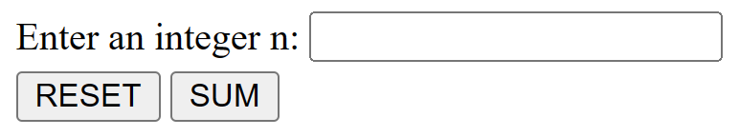
- Your tasks: Assume that users fill an integer into the textfield
1. When users click “RESET” button, set value of textfield is empty. (0.5 point)
2. When users click “SUM” button, the browser makes a request to /sum using Post method (The Servlet is configured in web.xml) (0.5 point):
a. Check input: If users input the number that is not an integer number>1, show the error message "You input wrong" to servlet. Otherwise, make the request b. (0.5 point)
b. Calculate the sum of the prime number from 1 to n-1 and output the result to servlet. (1.0 point)

Question 2:
(2.5 points)
You are given a NetBeans template project (read more detail in the first page).
Your tasks
- Add MyExam.jsp to create a web page (0.5 point)
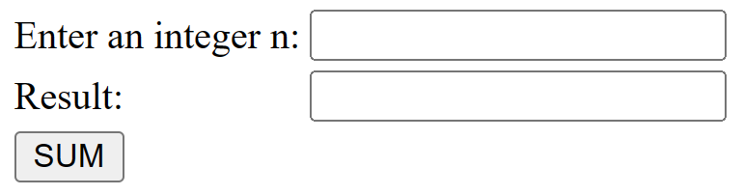
- Assume that users fill an integer into the textfield, when users click “SUM” button, the browser makes a request to /sum using Post method (The Servlet is configured in web.xml) (0.5 point):
a. Check input: If users input the number that is not an odd number > 0, show the error text "You must input an odd number > 0". (0.5 point)
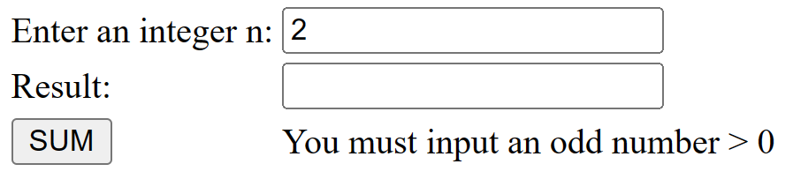
Otherwise, make the request b.
b. Calculate the sum of the prime number from 1 to n-1 and output the result to JSP file as following. (1.0 point)
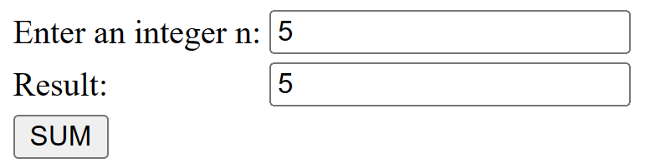

Question 3:

IMPORTANT – before you start doing your solution, MUST do the following steps:
- Create your MS SQL database named PE_Example by running code in script PE_Example.sql.
- You MUST use DBContext.java for your all database connection.

(5 points)
You are given a NetBeans template project (read more detail in the first page).
You are asked to build a web application using the given database.
User can type /show (/ represents your web application context path) to access Show Students Page (0.5 point).
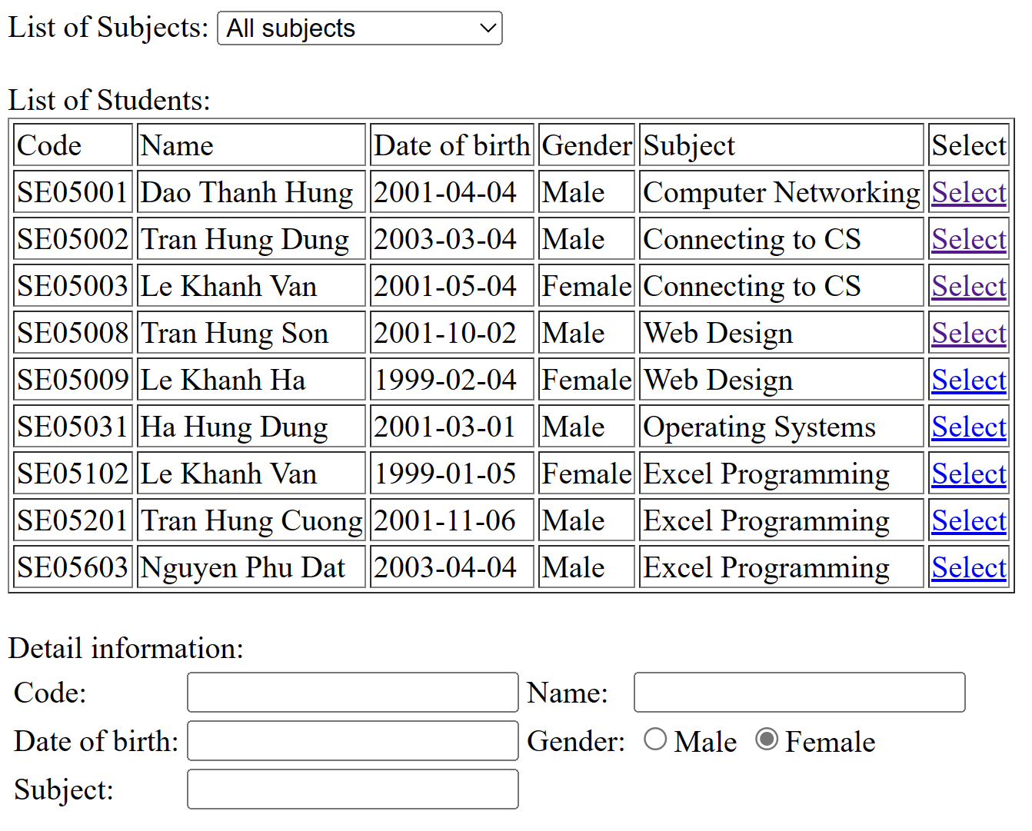
- The Subjects dropdown list must load data from [Subjects] table. (1 point)
Reduce 1 point if cannot display subjects (including All subjects option) to the dropdownlist.
- The table “List of Students” must load data from [Students] table. (1 point)
Reduce 1 point if cannot display students correctly to the table.
- When user selects a subject in [Subjects] dropdownlist, the list of Students that learn that subject will be displayed in the Table. (1 point)
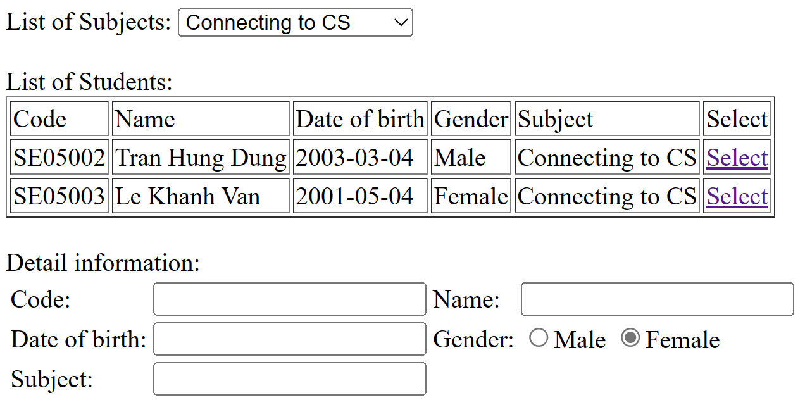
- When user clicks [Select] link, the Student information will be displayed in the Detail Information (1.5 point)
