|  |  |
| --- | --- |
|  | **EPITA International Programs** |
| Fundamental semester – MSc – 2019 |
| **JAVA Fundamental: OOA & UML & Java** |
| **TRAN Thi-Thuong-Hoai** [thithuonghoaitran@gmail.com](mailto:thithuonghoaitran@gmail.com) |

**QUIZ MANAGER USER GUIDE**

1. **Minimum Requirements**

The minimum requirements that you need to comply with before enjoying this Quiz

Windows:

* Windows 10, Window 8.x (Desktop)
* Windows 7 SP1
* Windows Vista SP2
* Windows Server 2008 R2 SP1 (64-bit)
* Windows Server 2012 and 2012 R2 (64-bit)

Mac OS X:

* Intel-based Mac running Mac OS X 10.8.3+, 10.9+

Linux:

* Oracle Linux 5.5+
* Oracle Linux 6.x (32-bit) and (64-bit)
* Oracle Linux 7.x (64-bit)
* Red Hat Enterprise Linux 5.5+1, 6.x (32-bit), 6.x (64-bit)
* Ret Hat Enterprise Linux 7.x (64-bit)
* Suse Linux Enterprise Server 10 SP2+, 11.x
* Suse Linux Enterprise Server 12.x (64-bit)
* Ubuntu Linux 12.04 LTS, 13.x
* Ubuntu Linux 14.x, 15.04. 15.10

1. **Installing and Starting**

In order to try this quiz, first of all, you should run the Launcher.java inside src/fr.epita.core.launcher

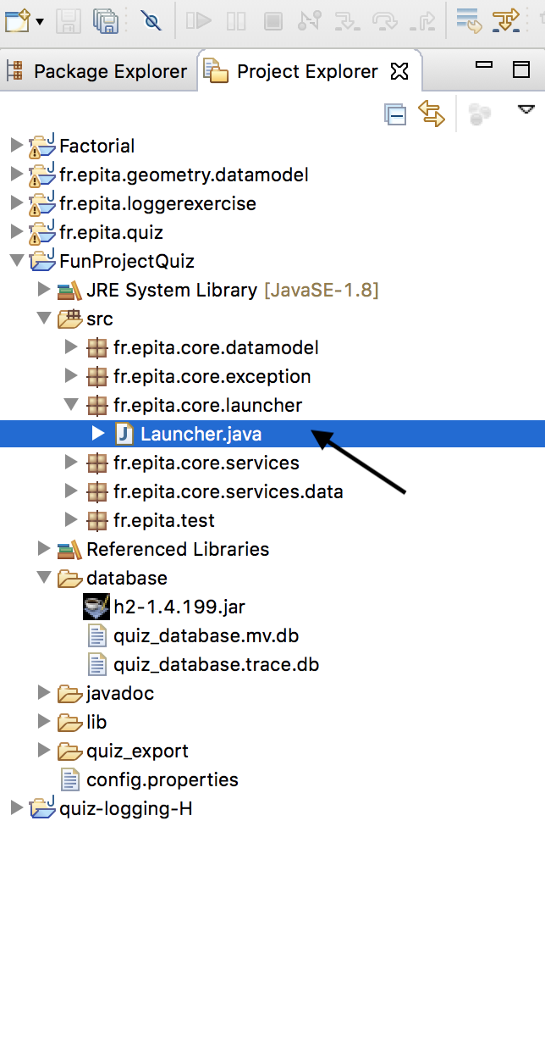

* 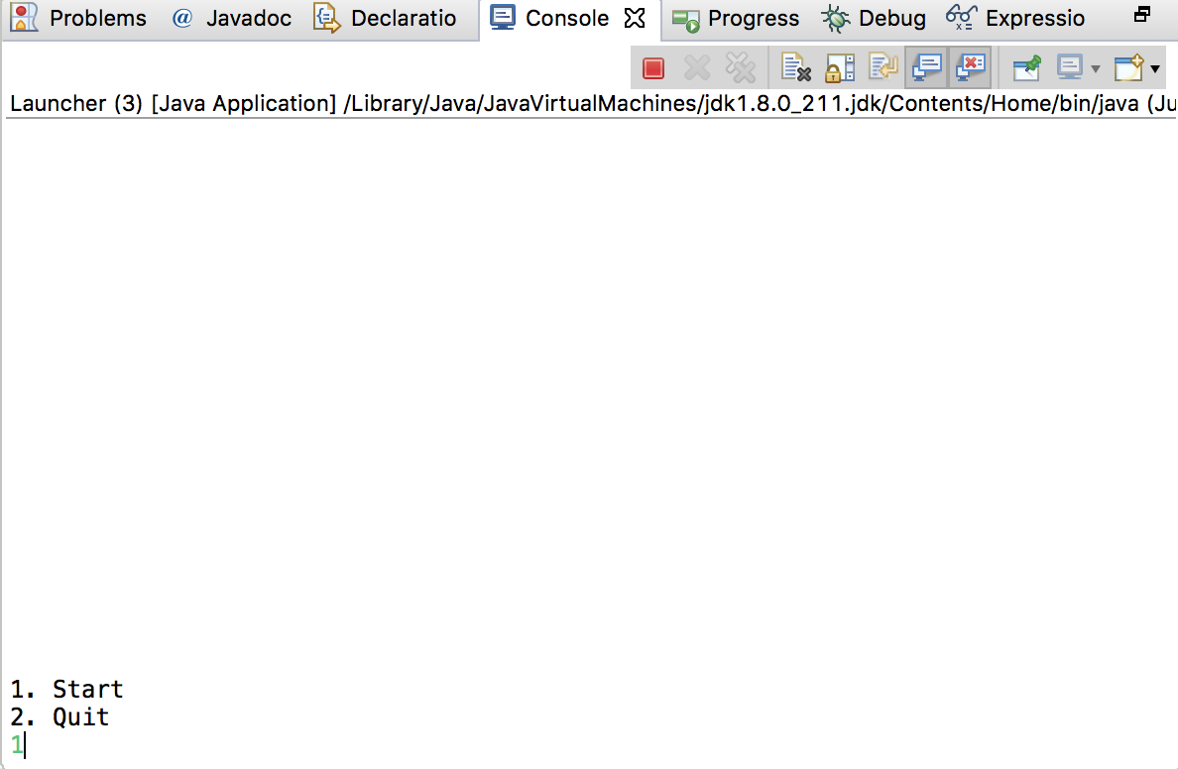Choose **“1”** to start this Quiz application
* Input your name and your ID
* 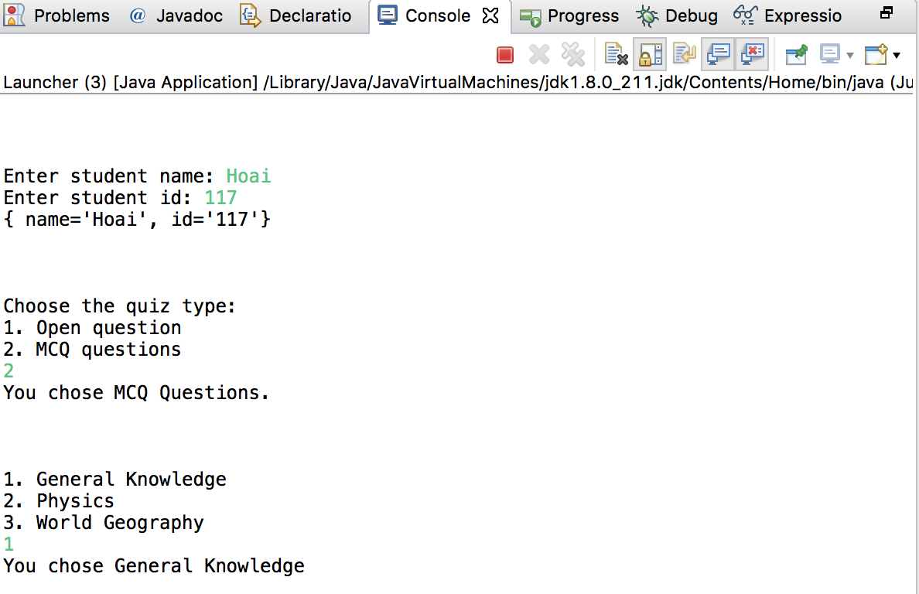Choose the topics, the type of the quiz and the level of difficulty you want to do the Quiz.

Then, Let’s do the quiz!

1. **Quiz**

You have two possible types of questions to do:

**Multiple Choice Questions**

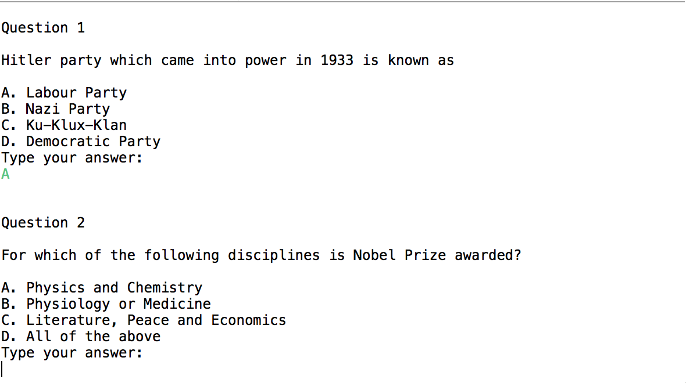After read the question, you have to choose the answer from “**A”, “B”, “C” or “D”.**

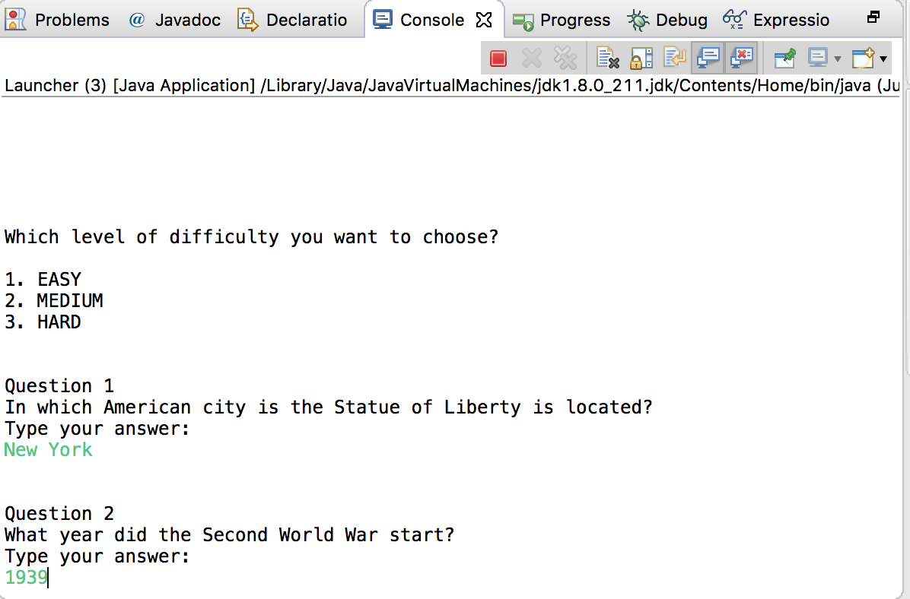**Open Questions**

You will answer your question by typing below the question. This type question will not be correct automatically, your professor will have read and evaluate your answer in order to give results to you later.

1. 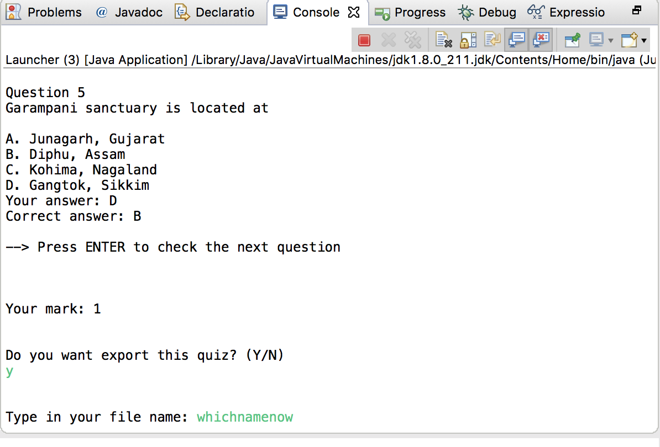**After Quiz**

After finishing your Quiz, you can get your result in the TXT file and keep it yourself by giving “Y” (Yes) or “N” (No). Don’t forget to terminate this app before you leave because it will close batabase and help this app run well for next time.