Coursework Report



|  |  |
| --- | --- |
| Team name: |  |
| Team members: |  |

URL of our site:

Password:

Table of Contents

1. Introduction 3

2. Evaluate 3

2.1. Product evaluate 3

2.2. Individual evaluate 3

2.3. Group evaluate 3

2.4. Methodology 3

3. Lessons learnt 3

4. Conclusion 3

5. References 3

6. Appendices 3

6.1. Requirements specification 3

6.2. Database design 3

6.3. Interface Design 3

6.4. Role-based security system 3

6.5. Validations implemented 3

6.6. Workflow implementation 3

6.7. Test plan and test log 3

6.8. Minutes of meetings 3

6.9. Scrum documentation 3

# Introduction

# Evaluate

## Product evaluate

## Individual evaluate

## Group evaluate

## Methodology

# Lessons learnt

# Conclusion

# References

# Appendices

## Requirements specification

## Database design

## Database diagram

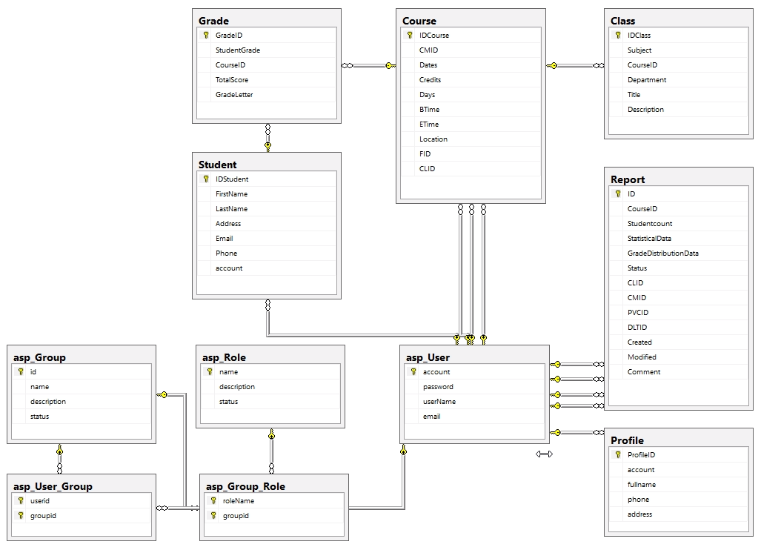

Figure 1 : Database Diagram

## Entity Relationship Diagrams

## Interface Design

## Role-based security system

The role-based security system was done using role-based authentication and identity management for an ASP.NET MVC 5 web application (Identity 2.0 Framework). ASP.NET MVC provides a controller, data models, and views that we can use to create function authentication, users register, log on and log off, and change password, management user role, groups, role of group. ASP.NET Identity uses Entity Framework Code-First approach to generate the table schema based on the user and role objects. That means for each piece of user profile a separate column is created in the database table. The following figure shows the tables created in a database.  
  
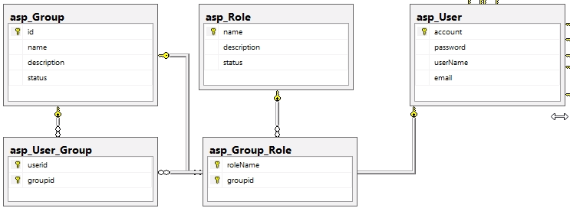

Figure 2: Diagram tables manage user and roles

In this project we divided into 3 main groups users:

|  |  |
| --- | --- |
| Administrator | As a user role with full rights, view reports, manage courses, classes, students, grades, manage employees, manage permissions |
| Staff | * Course Leader * Course Moderator * Pro-vice Chancellor * Director of Learning and Quality |
| Guest | A Faculty has a Guest account. This account is only allowed to view the report |

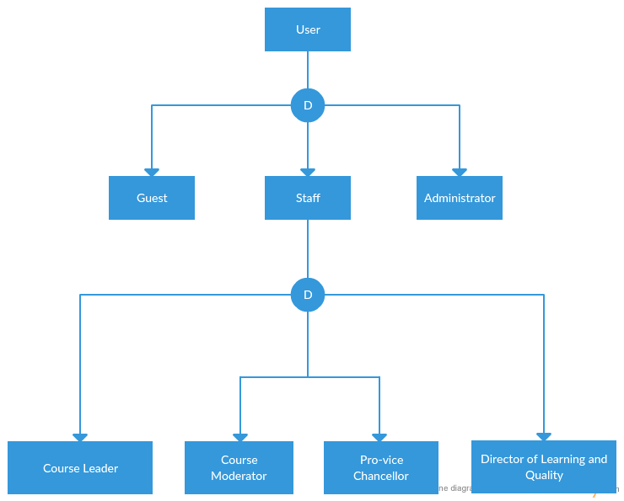

Figure 3: Diagram group users

## Validations implemented

## Workflow implementation

1. User Login Folow Chart

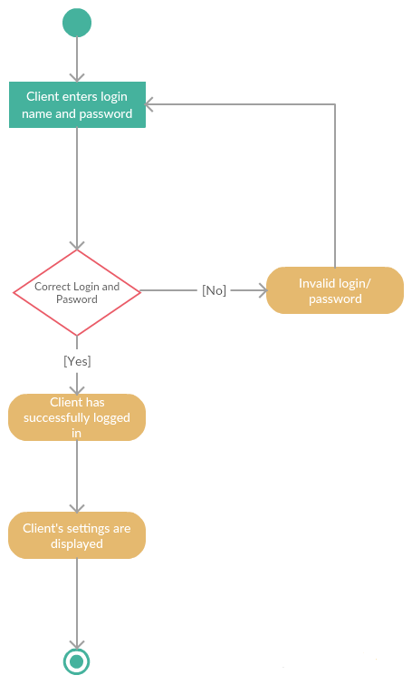

Figure 4: Activity Diagram Login to system

1. Administrator Charts

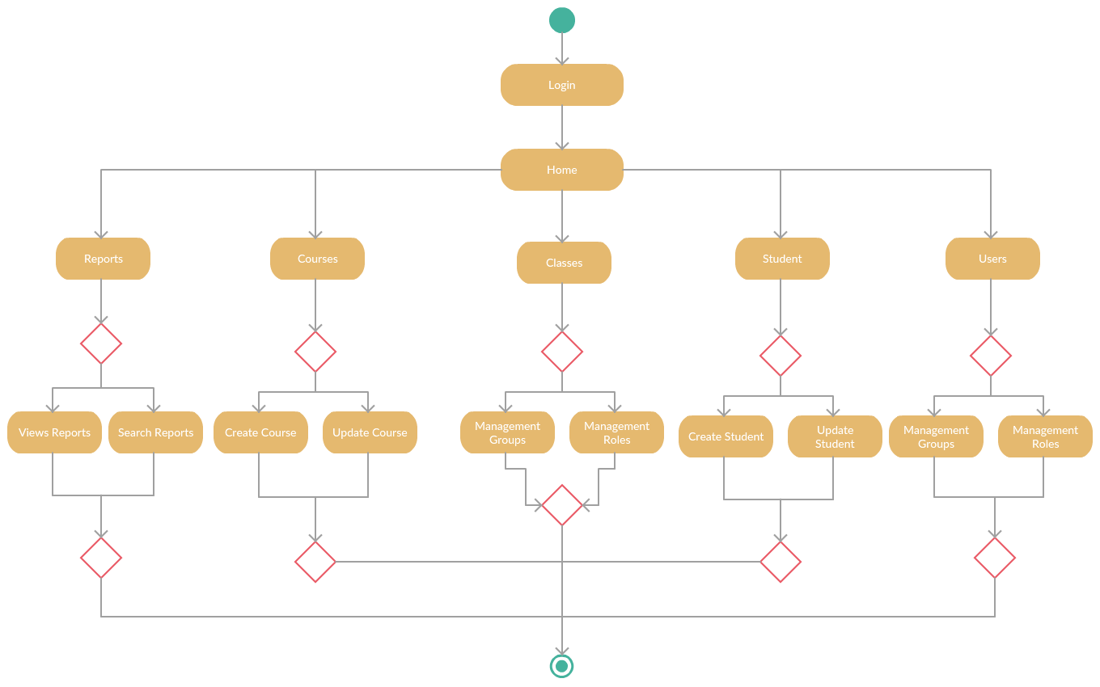

Figure 5: Diagram admin functions

1. Course Leader Flow Charts
2. Course Moderator Folow Chars
3. Director of Learning and Quality Charts
4. PVC Follow Charts
5. DLT Flow Chart
6. Guest Flow Chart

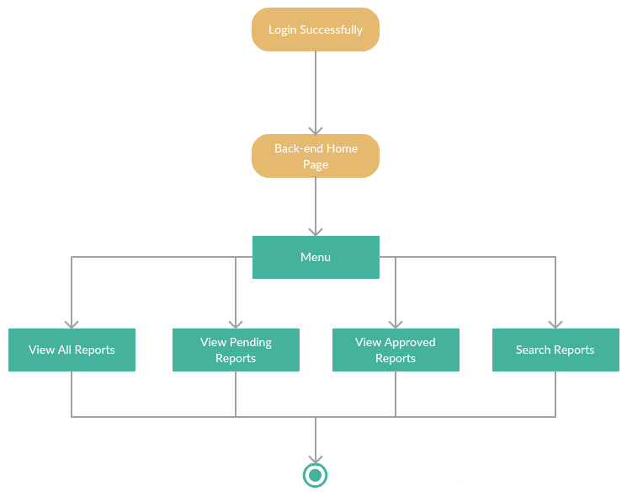

## Test plan and test log

## Minutes of meetings

## Scrum documentation