Exercise 2:

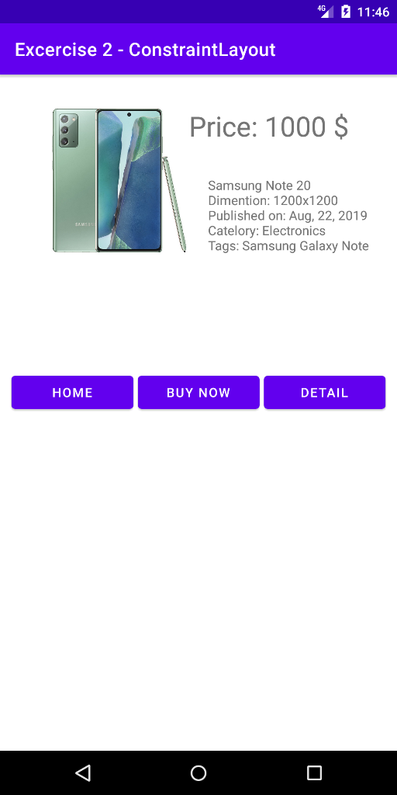

Activity_main.xml

|  |
| --- |
| *<?*xml version="1.0" encoding="utf-8"*?>* <androidx.constraintlayout.widget.ConstraintLayout xmlns:android="http://schemas.android.com/apk/res/android"  xmlns:app="http://schemas.android.com/apk/res-auto"  xmlns:tools="http://schemas.android.com/tools"  android:layout_width="match_parent"  android:layout_height="match_parent"  tools:context=".MainActivity"  android:layout_marginLeft="10dp"  android:layout_marginRight="10dp">   <ImageView  android:id="@+id/iv1"  android:layout_width="175dp"  android:layout_height="230dp"  android:src="@drawable/samsung_note_20"  app:layout_constraintRight_toLeftOf="@id/tv2"  app:layout_constraintLeft_toLeftOf="parent"  app:layout_constraintTop_toTopOf="parent"></ImageView>   <TextView  android:id="@+id/tv1"  android:layout_width="wrap_content"  android:layout_height="wrap_content"  android:text="Price: 1000 $"  android:textSize="30dp"  app:layout_constraintBottom_toTopOf="@id/tv2"  app:layout_constraintHorizontal_bias="0"  app:layout_constraintLeft_toRightOf="@+id/iv1"  app:layout_constraintRight_toRightOf="parent"  app:layout_constraintTop_toTopOf="parent"></TextView>   <TextView  android:id="@+id/tv2"  android:layout_width="wrap_content"  android:layout_height="wrap_content"  android:text="Samsung Note 20\nDimention: 1200x1200\nPublished on: Aug, 22, 2019\nCatelory: Electronics\nTags: Samsung Galaxy Note"  app:layout_constraintBottom_toBottomOf="@id/iv1"  app:layout_constraintLeft_toRightOf="@+id/iv1"  app:layout_constraintRight_toRightOf="parent"  app:layout_constraintTop_toBottomOf="@+id/tv1"></TextView>   <LinearLayout  android:layout_width="match_parent"  android:layout_height="wrap_content"  android:orientation="horizontal"  android:weightSum="3"  app:layout_constraintBottom_toBottomOf="parent"  app:layout_constraintLeft_toLeftOf="parent"  app:layout_constraintRight_toRightOf="parent"  app:layout_constraintTop_toBottomOf="@id/iv1"  app:layout_constraintVertical_bias="0.2">   <Button  android:id="@+id/bthome"  android:layout_width="match_parent"  android:layout_height="wrap_content"  android:layout_marginLeft="2.5dp"  android:layout_marginRight="2.5dp"  android:layout_weight="1"  android:text="HOME"  app:layout_constraintEnd_toStartOf="@id/btbuynow"  app:layout_constraintLeft_toLeftOf="parent"  app:layout_constraintRight_toLeftOf="@+id/btbuynow"  app:layout_constraintStart_toStartOf="parent"  app:layout_constraintTop_toBottomOf="@id/iv1"></Button>   <Button  android:id="@+id/btbuynow"  android:layout_width="match_parent"  android:layout_height="wrap_content"  android:layout_marginLeft="2.5dp"  android:layout_marginRight="2.5dp"  android:layout_weight="1"  android:text="BUY NOW"  app:layout_constraintEnd_toStartOf="@+id/btdetail"  app:layout_constraintLeft_toRightOf="@+id/bthome"  app:layout_constraintRight_toLeftOf="@+id/btdetail"  app:layout_constraintStart_toEndOf="@+id/bthome"  app:layout_constraintTop_toBottomOf="@id/iv1"></Button>   <Button  android:id="@+id/btdetail"  android:layout_width="match_parent"  android:layout_height="wrap_content"  android:layout_marginLeft="2.5dp"  android:layout_marginRight="2.5dp"  android:layout_weight="1"  android:text="DETAIL"  app:layout_constraintEnd_toEndOf="parent"  app:layout_constraintLeft_toRightOf="@+id/btbuynow"  app:layout_constraintRight_toRightOf="parent"  app:layout_constraintStart_toEndOf="@+id/btbuynow"  app:layout_constraintTop_toBottomOf="@id/iv1"></Button>  </LinearLayout> </androidx.constraintlayout.widget.ConstraintLayout> |

@drawable/Samsung-note-20.jpg

|  |
| --- |
|  |