

AWS First Cloud AI Journey – Metropolitano Railways

Project Team – FPT HCM University – Metropolitano Railway Systems (Client) [12/09/2025]
Table of Contents
1 BACKGROUND and motivation 3
1.1 executive summary 3
1.2 PROJECT SUCCESS CRITERIA 3
1.3 Assumptions 3
2 SOLUTION ARCHITECTURE / ARCHITECTURAL DIAGRAM 3
2.1 Technical Architecture Diagram 3
2.2 Technical Plan 4
2.3 Project Plan 4
2.4 Security Considerations 4
3 Activities AND Deliverables 5
3.1 Activities and deliverables 5
3.2 OUT OF SCOPE 5
3.3 PATH TO PRODUCTION 5
4 EXPECTED AWS COST BREAKDOWN BY SERVICES 5
5 TEAM 6
6 resources & cost estimates 6
7 Acceptance 7

BACKGROUND and motivation

Executive Summary
- Client background: Rapid urban expansion is increasing pressure on public transportation. Metropolitano Railway Systems (Client) is modernizing operations to improve reliability, passenger experience, and efficiency. The Client’s on-premises systems struggle with scalability, high availability, and real-time data processing.
- Business and Technical Objectives:
  - High availability and 24/7 uptime for mission-critical rail services
  - Elastic scalability to handle peak passenger loads and seasonal demand
  - Improved system reliability and disaster recovery capabilities
  - Real-time data processing for ticketing and payment transaction monitoring, including payment status tracking and reconciliation.
  - Stronger security and compliance, aligning with public-sector transportation standards
  - Reduced operational costs through cloud-native automation
  - Faster innovation cycles for new digital services such as mobile ticketing and predictive maintenance
- Use Cases:
  - Digital ticketing and fare collection (web/app booking, QR/IC card integration)
  - Train scheduling and dispatch management (contextual use case; not the primary focus of this POC).
  - Real-time payment/transaction event analytics through Amazon Kinesis (e.g., payment status updates, settlement events, anomaly detection)
  - BI dashboards for management decision-making using Amazon QuickSight
  - Incident response and alerting through centralized monitoring and logging
- Summary of Project Team Professional Services
  - AWS architecture design for a secure, scalable, and fault-tolerant solution based on Amazon EC2 and managed services
  - Migration of existing workloads from on-premises infrastructure to AWS
  - Implementation of real-time payment event pipelines using Amazon Kinesis, with storage and analytics datasets delivered to Amazon S3.
  - Deployment of analytics using QuickSight.
  - CI/CD setup using CodePipeline, CodeBuild, and CodeDeploy.
  - Knowledge transfer and training to ensure operational readiness for the Client’s technical team

PROJECT SUCCESS CRITERIA
      - Service Reliability & Availability:
  - The deployed system must achieve ≥ 99.9% uptime across all mission-critical services (ticketing, payment monitoring, analytics).
      - Scalability & Performance:
  - Platform must automatically scale to handle peak passenger traffic without performance degradation.
  - End-to-end response time for booking and payment APIs must remain under 300 ms during peak load tests.
      - Real-Time Data Processing:
  - Real-time payment and ticketing transaction events must be processed with a latency under 5 seconds using Amazon Kinesis.
  - Data ingestion pipelines must support at least 10,000 events per second with auto-scaling.
      - Analytics & Insights Delivery:
  - Management dashboards (QuickSight) must provide accurate, refreshed datasets within ≤ 5 minutes of data arrival in S3.
      - CI/CD & Operational Excellence:
  - All application deployments must be executed via automated CI/CD pipelines with rollback capability.
      - Cost Efficiency:
  - AWS cost optimization mechanisms (Auto Scaling, RI/Savings Plans, lifecycle policies) must reduce operational cost by at least 20% compared to on-premises operations.
  - Cost Explorer and Billing Alarms must be configured to prevent overruns.

Assumptions
- Prerequisites & Dependencies:
  - Metropolitano Railway Systems (Client) will provide timely access to all required environments, systems, and personnel.
  - Client will supply all necessary credentials, API documentation, and integration endpoints for on-premise or third-party systems.
  - Existing operational data (ticketing, scheduling, payment transactions) will be available and accessible for migration and integration.
  - Third-party vendors (e.g., payment gateways, fare systems, and transit card systems) will offer stable APIs and documentation.
  - Required AWS accounts, organizations, and billing structures must be set up prior to project start.
  - Client will identify Subject Matter Experts (SMEs) for each domain (operations, IT, ticketing, scheduling).
- Technical Constraints:
  - Some legacy systems may remain on-premises, requiring hybrid connectivity via VPN or Direct Connect.
  - Existing applications may have non-cloud-optimized architectures, limiting the degree of modernization possible within project scope.
  - Data quality issues in legacy systems may affect migration accuracy and analytics output.
  - Client’s operational networks and payment/ticketing systems must support secure and reliable cloud connectivity.
  - Performance of real-time analytics depends on the latency and stability of data ingestion from payment gateways and ticketing transaction sources.
- Business Constraints:
  - Project timelines may depend on internal Client approvals or procurement processes.
  - Client’s organizational readiness and staff availability may impact progress.
  - Budget limitations may restrict the scope of modernization or ML/AI adoption.
  - Some regulatory or compliance requirements may limit data residency or retention options.
- Assumptions:
  - Client agrees to follow AWS security best practices, including IAM least privilege and multi-account governance.
  - Client will participate actively in testing, UAT, and go-live validation.
  - Application owners will provide prompt feedback during iterative deployment cycles.
  - All third-party integrations will function as documented and will not require reverse engineering.
  - Client’s leadership supports cloud adoption and will provide the necessary resources for change management.
- External Dependencies:
  - Dependencies on third-party systems such as payment processors, ticketing machines, and transit card systems.
  - Availability of stable internet connectivity for branches, stations, trains, and back-office operations.
  - Engagement and timely support from external auditors or compliance assessors (if required).
  - Import/export of large datasets may rely on Client’s availability of storage or network throughput.
- Risks:
  - Integration risk: Legacy systems may have undocumented behaviors that delay integration.
  - Data migration risk: Inconsistent or incomplete legacy data may reduce analytics accuracy.
  - Operational risk: On-premise hardware failures during hybrid operations may impact cloud migration steps.
  - Security risk: Misconfigured third-party endpoints could expose vulnerabilities.
  - Timeline risk: Delays in Client approvals, vendor support, or resource allocation could impact project schedule.
  - Dependency risk: If third-party APIs (payment gateways / transit card systems) fail to support the required throughput, real-time analytics may be affected.

SOLUTION ARCHITECTURE / ARCHITECTURAL DIAGRAM

Technical Architecture Diagram
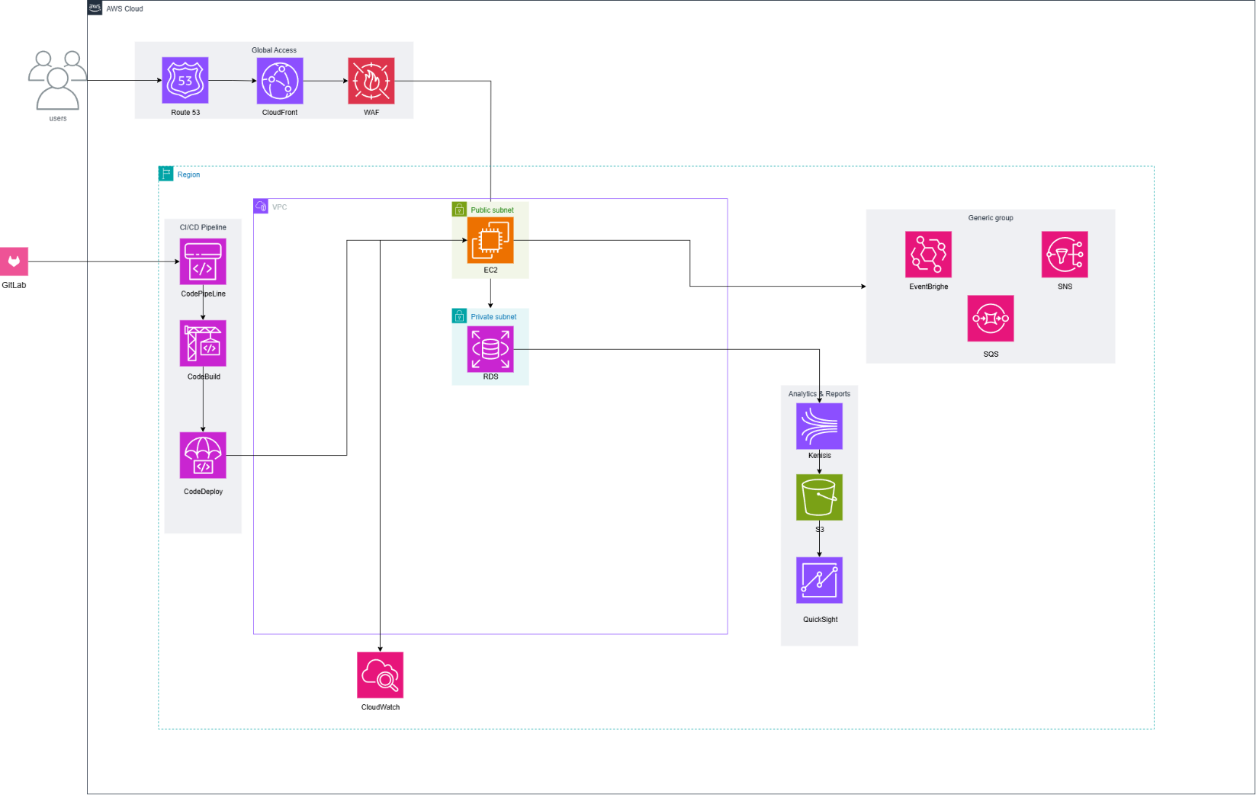
Figure 1. AWS Technical Architecture Diagram – Metropolitano Railways (POC)

      - Figure 1 (POC Outcome & Architecture Summary). The POC enables near real-time monitoring and reconciliation of ticketing/payment transactions. Payment status events are streamed into Amazon Kinesis and delivered to Amazon S3 (data lake) for analytics. Amazon QuickSight dashboards provide revenue insights (daily/monthly) and highlight unpaid/incomplete payments for follow-up. User traffic is routed via Route 53 → CloudFront → AWS WAF to the application on Amazon EC2, with transactional data stored in Amazon RDS (private subnet). Amazon CloudWatch supports monitoring/alerting. Asynchronous workflows are decoupled using SNS/SQS (and EventBridge where needed). Source control uses GitLab; CI/CD is implemented using CodePipeline/CodeBuild/CodeDeploy.
      - Production note: For production readiness, enable Multi-AZ, place workloads in private subnets behind an ALB, restrict egress using NAT Gateway/VPC Endpoints, enforce TLS (ACM) + least-privilege IAM + Secrets Manager/SSM, enable CloudTrail/Config, and use blue/green or canary deployments with rollback.

Technical Plan
- Key activities include:
  - Infrastructure provisioning using IaC templates to deploy:
    - Amazon EC2 clusters for application workloads
    - Amazon RDS for database services
    - Amazon S3 for static content and data lake storage
    - Amazon Route 53 for DNS routing
    - Amazon CloudFront and AWS WAF for secure global content delivery
    - Amazon Kinesis for real-time data ingestion
    - Amazon SQS/SNS for asynchronous messaging
    - Amazon EventBridge for event-driven workflows
    - Amazon CloudWatch for logging, monitoring, alarms, and dashboards
    - Amazon QuickSight for analytics and BI reporting
      - This POC does not include AWS Lambda; streaming consumers and asynchronous/background processing are implemented on EC2-based services (or containers) and integrated via SNS/SQS/EventBridge where applicable.
  - Application build and release processes will be automated using CodePipeline, CodeBuild, and CodeDeploy, enabling blue/green or rolling deployments with automated rollback.
  - Configuration items that require approvals (such as production DNS changes, WAF rule modifications, RDS parameter adjustments, security group updates) will follow the Client’s Change Management Process, including CAB approval and tracked deployment records.
- All critical paths (ticketing workflows, scheduling, payment integrations, real-time data ingestion, analytics refresh flows) will undergo extensive unit, integration, load, and failover testing. Test scenarios, acceptance criteria, and validation procedures are provided in Appendix X.

Project Plan
- Stakeholder Participation:
  - Client stakeholders (Operations, IT, Data, Security teams) are required for:
    - Sprint Reviews (demo and feedback)
    - Sprint Retrospectives (continuous improvement)
    - UAT and sign-off sessions
    - Technical design workshops
- Team Responsibilities
  - A high-level responsibility matrix is proposed as follows:
    - Project Team Cloud Architect – AWS solution design, security architecture, scalability & HA patterns
    - Project Team DevOps Engineer – CI/CD pipelines, IaC, automated deployments
    - Project Team Application Engineer – application refactoring and integration
    - Client IT Lead – access provisioning, governance alignment
    - Client Operations Team – process validation, UAT testing
    - Client Security Officer – review compliance and security controls
    - Project Team Data Engineer – Kinesis pipelines, SQS/SNS integration, data modeling
    - Analytics/BI Engineer – QuickSight dashboards and dataset automation
- Communication Cadence:
  - Daily: Standups with Project Team
  - Weekly: Project status updates to Client stakeholders
  - Bi-weekly: Sprint Review + Sprint Planning
  - Monthly: Steering Committee meeting (Project Team + Client Leadership)
  - Ad-hoc: Incident response, change approvals, design deep-dive sessions
- Knowledge Transfer:
  - Knowledge transfer sessions will be conducted by [Project Team] to the Client’s technical team covering:
    - AWS architecture overview
    - CI/CD pipeline management
    - Monitoring and incident response using CloudWatch
    - Data pipeline operations (Kinesis → S3 → QuickSight)
    - Infrastructure lifecycle & IaC updates
    - Security and IAM operations

Security Considerations
- Access Security
  - [Project Team] will implement secure IAM with least privilege, role-based access control, and IAM policies following AWS best practices.
  - MFA will be enabled for all privileged accounts.
  - CI/CD access will be restricted using IAM roles with scoped permissions.
  - Route53 DNS changes, CloudFront updates, and WAF rule modifications will require change approvals.
- Infrastructure Security
  - Amazon EC2 instances will be deployed in private subnets within the Multi-AZ VPC architecture.
  - AWS WAF will protect CloudFront distributions and application endpoints against common exploits.
  - Security Groups and NACLs will enforce traffic boundaries.
  - Amazon RDS will run in Multi-AZ mode with encrypted storage and automated backups.
  - EventBridge can be used for security-trigger automation (e.g., config rule violations), where applicable.
- Data Security:
  - All data at rest stored in S3, RDS, Kinesis, and SQS will be encrypted with AWS KMS CMKs.
  - Data in transit will be protected using TLS 1.2+ across all services.
  - S3 lifecycle policies and object versioning will be configured to ensure retention compliance.
  - Data lake structure will follow separation of raw, processed, curated layers.
- Detection & Monitoring:
  - AWS CloudTrail and AWS Config will be enabled for full API auditing and resource compliance tracking.
  - Amazon CloudWatch will collect logs, metrics, application traces, alarms, and dashboard visualizations.
  - WAF logs and CloudFront access logs will be delivered to S3 for security analytics.
- Incident Management:
  - [Project Team] will design incident response playbooks covering system failure, security breach, data exposure, or pipeline errors.
  - SNS and EventBridge will trigger automated alerts or notifications to the Client’s operations team.
  - Disaster recovery procedures will be implemented for critical EC2 and RDS workloads.
  - Backup snapshots will comply with Client-defined retention policies.
  - Operational alarms will be routed to the correct on-call teams for faster MTTR.

Activities AND Deliverables

Activities and deliverables

Project Phase | Timeline | Activities | Deliverables/Milestones | Total man-day
Assessment | Week x-y | - Requirements workshops (business, technical, security)  - Current-state architecture analysis  - Identify integration points (payments, ticketing, analytics).  - Environment readiness validation | - Assessment Report  - Architecture Blueprint v1  - Backlog & Sprint Plan | [X man-day]
Setup base infrastructure | Week x-y | - VPC, subnets, routing, SGs  - IAM baseline  - S3 data lake foundation  - CloudFront + WAF + Route53  - RDS setup  - CloudWatch | - Infrastructure Provisioned  - IaC templates delivered  - Networking & Security Baseline | [X man-day]
Setup component 1 | Week x-y | - EC2 Auto Scaling setup  - Deploy application backend  - Configure CI/CD (CodePipeline, CodeBuild, CodeDeploy)  - Observability dashboards | - Application Deployed  - CI/CD Pipelines Operational  - Monitoring Dashboard | [X man-day]
Setup component 2 | Week x-y | - Kinesis streaming pipelines  - SQS/SNS messaging  - ETL to S3 Data Lake  - QuickSight dashboards  - EventBridge workflows | - Data Pipeline Operational  - BI dashboard in QuickSight  - Event-driven Architecture  - Revenue dashboards (daily/monthly) in QuickSight  - Unpaid / incomplete payments report (with alerting thresholds) | [X man-day]
Testing & Golive | Week x-y | - Unit, Integration, Load testing  - Go-Live readiness review  - Production DNS cutover  - Monitoring & rollback plans | - UAT Sign-off  - Go-Live Checklist  - Production Launch | [X man-day]
Handover | Week x-y | - Final documentation  - Operations training  - Knowledge transfer sessions  - Transition to BAU | - Runbooks & SOPs  - Admin Training Completion  - Final Acceptance | [X man-day]

OUT OF SCOPE
- Custom application code development or feature enhancements not listed in the Scope of Work
- On-premise infrastructure upgrades, network redesign, or hardware procurement
- Performance tuning of third-party vendor systems
- Development of mobile apps or UI/UX redesign
- Machine Learning model development outside QuickSight & basic SageMaker patterns
- Penetration testing or third-party security audits
- Post go-live 24/7 operations unless contracted separately
- Support for legacy networks or non-cloud compatible components
- Migration of data sources not included in the initial assessment
- AWS Lambda–based serverless compute (event consumers/functions) is out of scope for this POC.

PATH TO PRODUCTION
The Proof of Concept (POC) environment will demonstrate selected use cases defined in Section 2.2.
The POC environment will not contain all production-grade capabilities.
- Key gaps requiring enhancements before production deployment include:
  - Full resilience design (multi-AZ, failover, scaling policies)
  - Complete observability coverage (CloudWatch metrics, distributed tracing, WAF logs)
  - Hardened security baselines (advance IAM controls, WAF tuning, encryption policies)
  - Comprehensive testing (integration, performance, DR simulation)
  - CI/CD hardening and automated rollback
  - Production-approved DNS, WAF, and network change processes
  - Enhanced error handling and exception flows for edge-cases

EXPECTED AWS COST BREAKDOWN BY SERVICES
- Costing Considerations:
  - EC2 estimated using a mix of On-Demand + Reserved Instances
  - Multi-AZ RDS with automatic backups
  - CloudFront cost includes WAF usage (rule groups + request filtering)
  - S3 includes storage tiers (Standard, Intelligent-Tiering)
  - Log storage and metrics in CloudWatch
  - Kinesis ingest & processing units
  - Data transfer cost between components
  - QuickSight Reader & Author licenses
  - Messaging (SQS, SNS) based on estimated throughput
  - Route53 DNS queries + health checks
- Assumptions:
  - Daily ingestion volume: X GB/day of payment/ticketing events via Kinesis
  - EC2 compute size based on projected user load for ticketing and payment workloads
  - S3 storage baseline calculated for 12 months retention
  - Moderate WAF rule usage and CloudFront regional edge charges
  - SQS/SNS/EventBridge traffic estimated from projected workflow processes
  - QuickSight usage includes 1 Author and X Readers

TEAM
Project Team Members
Name | Title | Description | Email / Contact Info
Tào Bảo Thành | Team Leader | Manage the project, configure the AWS services, and code Backend, write document, design architecture | taobaothanh365@gmail.com
Nguyễn Thị Nhã Uyên | Member | Design the UI and code Frontend | uyenntnse183774@fpt.edu.vn
Nguyễn Bảo Khánh | Member | Design the UI and code Frontend | baokhanhtcv2005@gmail.com
Trần Văn Quyết | Member | Code Backend | quyettvse181574@fpt.edu.vn
Nguyễn Văn Cường | Member | Code Backend | cuongnvse183645@fpt.edu.vn

