Đại học Đà Nẵng
TRƯỜNG ĐẠI HỌC SƯ PHẠM KỸ THUẬT



BÁO CÁO
NGÔN NGỮ LẬP TRÌNH c#

Tên đề tài: Bán điện thoại online

Sinh viên: Trần Văn Thanh
GVHD: Lê Thị Bích Tra

Đà Nẵng, năm 2021
- Cơ Sở Dữ Liệu
create database TranVanThanhDB
go
use TranVanThanhDB
go
create table UserAccount (
ID int not null primary key,
UserName varchar(50) not null,
Password varchar(16),
Status char(5)
)
insert into UserAccount
values (1,'ThanhTran','th123456','O'),
(2,'TranThanh','th123456','F')
create table Product(
Pr int not null primary key,
Name nvarchar(50),
UnitCost int,
Quantity int,
Image varchar,
Description nvarchar(50),
Status char(5)
)
insert into Product
values (1,N'Điện thoại','1600000','1',N'Mới nhập về','C'),
(2,N'Laptop','6600000','3',N'Hàng mới nguyên hộp','C')

Create table Category(
ID int not null primary key,
Name nvarchar(20),
Description nvarchar(50)
)
insert into Category
values (1,N'Điện thoại',N'Sản phẩm chính hãng mới'),
(2,N'Laptop',N'Sản phẩm mới')
- Code bài tập cuối kì
Câu 1.
  - Trang Login
<!DOCTYPE html>
<html lang="en">
<head>
<meta charset="utf-8">

<meta name="viewport" content="width=device-width, initial-scale=1.0">
<meta name="description" content="">
<meta name="author" content="ThemeBucket">
<link rel="shortcut icon" href="images/favicon.png">

<title>Login</title>

<!--Core CSS -->
<link href="bs3/css/bootstrap.min.css" rel="stylesheet">
<link href="css/bootstrap-reset.css" rel="stylesheet">
<link href="font-awesome/css/font-awesome.css" rel="stylesheet" />

<!-- Custom styles for this template -->
<link href="css/style.css" rel="stylesheet">
<link href="css/style-responsive.css" rel="stylesheet" />

<!-- Just for debugging purposes. Don't actually copy this line! -->
<!--[if lt IE 9]>
<script src="js/ie8-responsive-file-warning.js"></script><![endif]-->

<!-- HTML5 shim and Respond.js IE8 support of HTML5 elements and media queries -->
<!--[if lt IE 9]>
<script src="https://oss.maxcdn.com/libs/html5shiv/3.7.0/html5shiv.js"></script>
<script src="https://oss.maxcdn.com/libs/respond.js/1.3.0/respond.min.js"></script>
<![endif]-->
</head>

<body class="login-body">

<div class="container">

<form class="form-signin" action="index.html">
<h2 class="form-signin-heading">sign in now</h2>
<div class="login-wrap">
<div class="user-login-info">
<input type="text" class="form-control" placeholder="User ID" autofocus>
<input type="password" class="form-control" placeholder="Password">
</div>
<label class="checkbox">
<input type="checkbox" value="remember-me"> Remember me
<span class="pull-right">
<a data-toggle="modal" href="#myModal"> Forgot Password?</a>

</span>
</label>
<button class="btn btn-lg btn-login btn-block" type="submit">Sign in</button>

<div class="registration">
Don't have an account yet?
<a class="" href="registration.html">
Create an account
</a>
</div>

</div>

<!-- Modal -->
<div aria-hidden="true" aria-labelledby="myModalLabel" role="dialog" tabindex="-1" id="myModal" class="modal fade">
<div class="modal-dialog">
<div class="modal-content">
<div class="modal-header">
<button type="button" class="close" data-dismiss="modal" aria-hidden="true">&times;</button>
<h4 class="modal-title">Forgot Password ?</h4>
</div>
<div class="modal-body">
<p>Enter your e-mail address below to reset your password.</p>
<input type="text" name="email" placeholder="Email" autocomplete="off" class="form-control placeholder-no-fix">

</div>
<div class="modal-footer">
<button data-dismiss="modal" class="btn btn-default" type="button">Cancel</button>
<button class="btn btn-success" type="button">Submit</button>
</div>
</div>
</div>
</div>
<!-- modal -->

</form>

</div>

<!-- Placed js at the end of the document so the pages load faster -->

<!--Core js-->
<script src="js/jquery.js"></script>
<script src="bs3/js/bootstrap.min.js"></script>

</body>
</html>
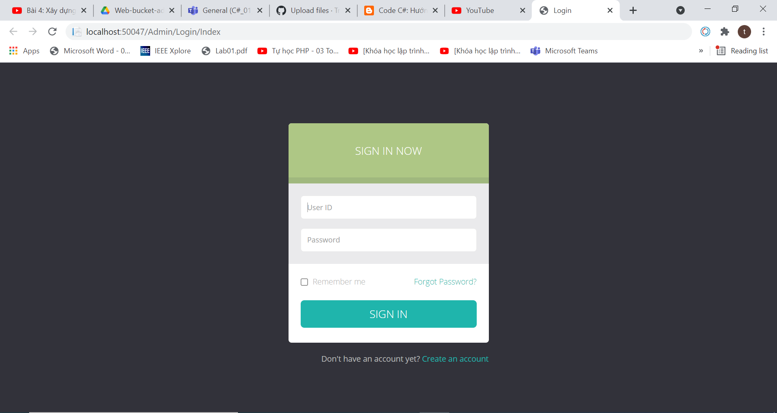
  - Thực hiện chức năng Kiểm tra đăng nhập
ModelEF.DAO
using System;
using System.Collections.Generic;
using System.Linq;
using System.Text;
using System.Threading.Tasks;

namespace ModelEF.DAO
{
class UserAcocount
{
private TranVanThanhContext db;
public UserAcocount(
db = new TranVanThanhContext();
)
public int Login(string UserName, password)
{
var result db.username.SingleOrDefault(x => x.UserName.Contains(UserName) && x.Password.Contians(password));

if(result==null){
reaturn 0;
}
else{ return 1;}
}
}
}
LoginModle
using System;
using System.Collections.Generic;
using System.Linq;
using System.Web;

namespace UngDung.Models
{
public class LoginModle
{
[Required]
public string UserName { get; set; }

public string Password { get; set; }
}
}
LoginController
using System;
using System.Collections.Generic;
using System.Linq;
using System.Web;
using System.Web.Mvc;

namespace UngDung.Areas.Admin.Models
{
public class LoginController : Controller
{
// GET: Admin/Login
public ActionResult Index()
{
return View();
}
[HttpPost]
public ActionResult Index(LoginModle login)
{
if (ModleState.IsValid)
{
var user = new userDAO();
var result = user.login(login.user, login.password);
}
if(result==1)
{
ModleState.AddModleError("", "Dang nhap thanh cong");
}
else { ModleState.AddModleError("", "Dang nhap that bai"); }
return View("Index");
}
}
}
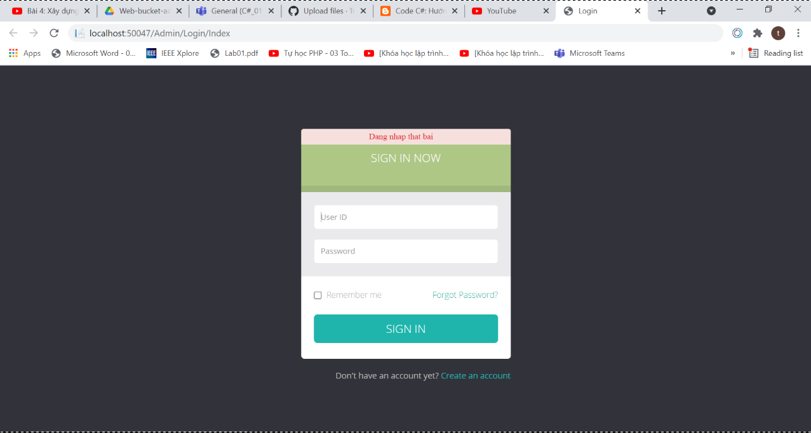

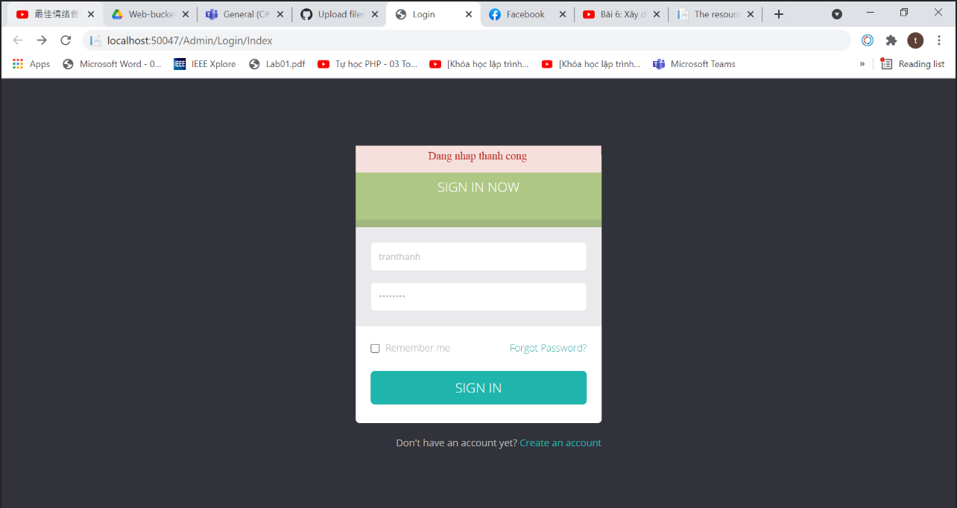
  - Trang hiển thị người dùng
UserController
using System;
using System.Collections.Generic;
using System.Linq;
using System.Web;
using System.Web.Mvc;

namespace UngDung.Areas.Admin.Controllers
{
public class UserController : Controller
{
// GET: Admin/User
public ActionResult Index()
{
var user = new userDAO();
var userList = user.ListAll();
return View(userList);
}
}
Câu 2:

