M A N A G I N G P E O P L E & T E A M W O R K

**S O F T W A R E P R O J E C T M A N A G E M E N T**

*10/2020*

1

# Contents

**Part 1: Managing people**

### Introduction

1. Motivating people
2. Personality types

**Part 2: Teamwork**

1. Introduction
2. A good group
3. Factors influence the effectiveness of a group

**Contents – Part 1: Managing people**

## Introduction

### Motivating people

1. Personality types

* The people working in a software organization are its greatest assets.
  + It costs a lot to recruit and retain good people.

### In successful companies and economies, this is achieved when people are:

* + respected by the organization and
  + assigned responsibilities that reflect their skills and experience.

### It is important that software project managers understand the technical issues that influence the work of software development.

* Unfortunately, however, good software engineers are not necessarily good people managers.
  + Software engineers often have strong technical skills but may lack the softer skills that enable them to motivate and lead a project development team.

### There are four critical factors in people management [Sommerville 2011]

* + Consistency
  + Respect
  + Inclusion
  + Honesty

## Consistency

* + People in a project team should all be treated in a comparable way.
  + No one expects all rewards to be identical but people should not feel that their contribution to the organization is undervalued.

### People management, in my view, is something that has to be based on experience, rather than learned from a book.

#### Sommerville

* **Respect**
  + Different people have different skills and managers should respect these differences.
  + All members of the team should be given an opportunity to make a contribution. In some cases, of course, you will find that people simply don’t fit into a team and they cannot continue, but it is important not to jump to conclusions about this at an early stage in the project.

## Inclusion

* + People contribute effectively when they feel that others listen to them and take account of their proposals.
  + It is important to develop a working environment where all views, even those of the most junior staff, are considered.

## Honesty

* + As a manager, you should always be honest about what is going well and what is going badly in the team.
  + You should also be honest about your level

of technical knowledge and willing to defer to staff with

more knowledge when necessary.

* + If you try to cover up ignorance or problems you will eventually be found out and will lose the respect of the group.

### Introduction

1. **Motivating people**
2. Personality types



**Motivating people**

* As a project manager, you need to motivate the people that work with you so that they contribute to the best of their abilities.
* Motivation means
  + organizing the work and the working environment …
  + to encourage people to work as effectively as possible.



If people are not motivated…

* They will not be interested in the work they are doing.
* They will work slowly, be more likely to make mistakes,
* and will not contribute to the broader goals of the team

or the organization.



**How to motivate your employees**

Image src: <https://www.trophiesplusmedals.co.uk/the-teachers-guide-to-keep-students-motivated-in-class/>

# Motivating people

### To provide this encouragement, you should understand a little about what motivates people.

* + Maslow (1954) suggests that people are motivated by satisfying their needs.

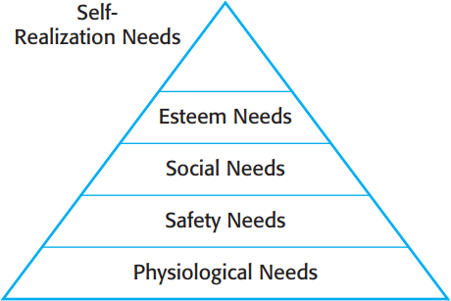

Concerned with personal development

The need to feel respected by others

The need to feel part of a social

grouping

The need to feel secure in an environment

Food, sleep...

Human needs hierarchy

(Maslow)

People need to satisfy lower-level needs like hunger before the more abstract, higher-level needs

* ***Physiological Needs***: thức ăn, nước uống, thở…
* ***Safety Needs:*** *a*n toàn khi tai nạn, chấn thương, an toàn tài chính, an toàn sức khỏe và tài sản.
* ***Social Needs:*** tình bạn, tình yêu đôi lứa, gia đình, các

hội/nhóm, các nhóm cộng đồng..

* ***Esteem Needs: n***hu cầu được kính trọng, quý mến.
* ***Self-realization needs***: nhu cầu được thể hiện/ chứng tỏ giá trị bản thân mình (đây là nhu cầu của con người muốn khai phá các tiềm năng và thể hiện đúng con người mình)

### People working in software development organizations are not usually hungry or thirsty or physically threatened by their environment.

* Therefore, making sure that people’s social, esteem, and self-realization needs are satisfied is most important from a management point of view.

###### **To satisfy social needs**, you need to give people time to meet their co-workers and provide places for them to meet.

* + This is relatively easy when all of the members of a development team work in the same place but, increasingly, team members are not located in the same building or even the same town or state. They may work for different organizations or from home most of the time.
  + Social networking systems and teleconferencing can be used to facilitate communications but my experience with electronic systems is that they are most effective once people know each other.
* **To satisfy social needs…**
  + You therefore need to arrange some face-to-face meetings **early** in the project so that people can directly interact with other members of the team.
  + Through this direct interaction, people become part of a social group and accept the goals and priorities of that group.
* **To satisfy esteem needs**, you need to show people that they are valued by the organization.
  + Public recognition of achievements is a simple yet effective way of doing this.
  + Obviously, people must also feel that they are paid at a

level that reflects their skills and experience.

### **To satisfy self-realization needs**, you need to give people responsibility for their work, assign them demanding (but not impossible) tasks, and provide a training programme where people can develop their skills.

* + Training is an important motivating influence as people like to gain new knowledge and learn new skills
* **Problem:**
  + A competent group member **loses interest** in the work and in the group. The **quality** of her work **falls** and becomes **unacceptable**.
  + This situation has to be dealt with quickly. If you don’t sort out the problem, the other group members will become dissatisfied and feel that they are doing an unfair share of the work.
  + Dorothy’s motivation problem is one that is quite common when projects develop in an unexpected direction.

### **Solution:** in those circumstances, you may decide that:

* + The team member should leave the team and find opportunities elsewhere.
  + In this example, however, Alice decides to try to convince Dorothy that broadening her experience is a positive career step.
    - She gives Dorothy more design **autonomy** and organizes **training courses** in software engineering that will give her more opportunities after her current project has finished.

**Contents – Part 1: Managing people**

### Introduction

1. Motivating people
2. **Personality types**

* Personality type also influences motivation. Bass and Dunteman (1963) classify professionals into three types:
  + **Task-oriented people**
  + **Self-oriented people**
  + **Interaction-oriented people**
* **Task-oriented people**
  + Who are motivated by the work they do. In software engineering, these are people who are motivated by the intellectual challenge of software development.
* **Self-oriented people**
  + Who are principally motivated by personal success and recognition. They are interested in software development as a means of achieving their own goals.
  + This does not mean that these people are selfish and think only of their own concerns. Rather, they often have longer- term goals, such as career progression, that motivate them and they wish to be successful in their work to help realize these goals.

## Interaction-oriented people

* + Who are motivated by the presence and actions of co-workers.
  + As software development becomes more user- centered, interaction-oriented individuals are becoming more involved in software engineering.

### Interaction-oriented personalities usually like to work as part of a group,

* Whereas task-oriented and self-oriented people usually prefer to act as individuals.
* Women are more likely to be interaction-oriented than men. They are often more effective communicators.
* **Individuals can change their motivation**:
  + For example, technical people who feel they are not being properly rewarded can become self-oriented and put personal interests before technical concerns.
  + If a group works particularly well, self-oriented people

can become more interaction-oriented.

**TEAMWORK**

**S O F T W A R E P R O J E C T M A N A G E M E N T**

*10/2020*

31

### Introduction

1. A good group
2. Factors influence the effectiveness of a group
3. **Introduction**
4. A good group
5. Factors influence the effectiveness of a group

* Most professional software is developed by project teams that range in size from two to several hundred people.
* Large teams are usually split into groups:
  + Each group is responsible for developing part of the overall system.
  + Groups should not have more than 10 members.

## Why we should split into small groups?

### When small groups are used, communication problems are reduced.

– Everyone knows everyone else and the whole group can get around a table for a meeting to discuss the project and the software that they are developing.

### Introduction

1. **A good group**
   * Benefits of a cohesive group
   * How to encourage group cohesiveness
   * Case study: Team spirit

### Factors influence the effectiveness of a group

* + A good group is cohesive and has a team spirit.
    - The people involved are motivated by the success of the group as well as by their own personal goals.



* + **In a cohesive group**, members think of the group as more important than the individuals
    - Members of a well-led, cohesive group are loyal to the group. They identify with group goals and other group members.
    - They attempt to protect the group from outside interference.

### This makes the group robust and able to cope with problems and unexpected situations.

* + **The benefits of creating a cohesive group are:**

1. **The group can establish its own quality standards:** Because these standards are established by consensus, they are more likely to be observed than external standards imposed on the group.
2. **Individuals learn from and support each other:** People in the group learn from each other. Inhibitions caused by ignorance are minimized as mutual learning is encouraged.

**Example: a rule of a team:**

when fixing bug, comment [who], date, reason of changing

// [SLV] 20/10/2019 Fix issue #123

## The benefits of creating a cohesive group are:

1. **Knowledge is shared:** Continuity can be maintained if a group member leaves. Others in the group can take over critical tasks and ensure that the project is not unduly disrupted.
2. **Refactoring and continual improvement is encouraged:** Group members work collectively to deliver high-quality results and fix problems, irrespective of the individuals who originally created the design or program.

### Good project managers should always try to

**encourage group cohesiveness**.

* + - They may organize social events for group members and their families.
    - Try to establish a sense of group identity by:
      * naming the group
      * establishing a group identity and territory
      * or they may get involved in explicit group-building activities

such as sports and games.

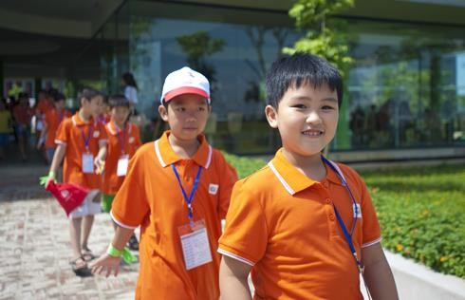

‘Working with parents’ Day (a FPT event)



TMA Parents’ Day

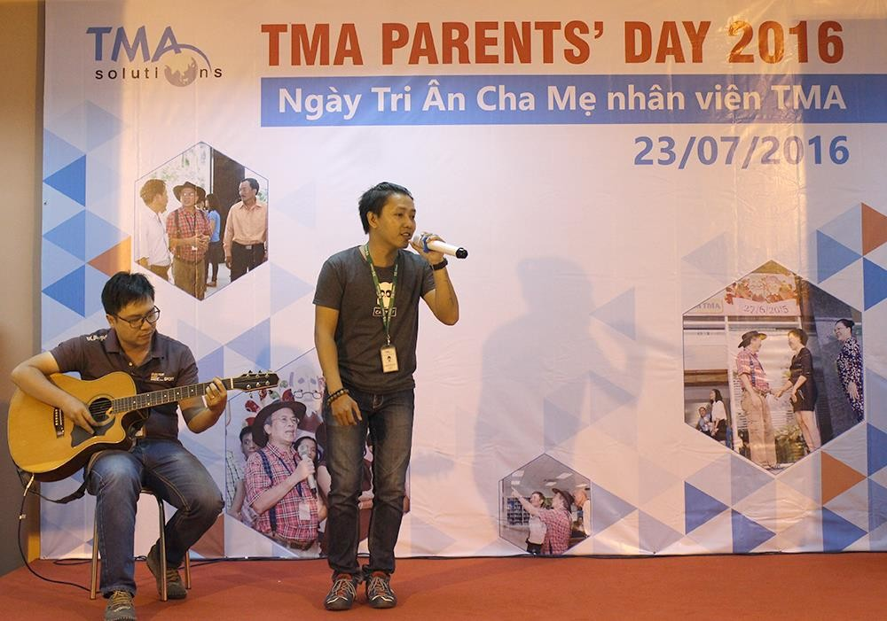

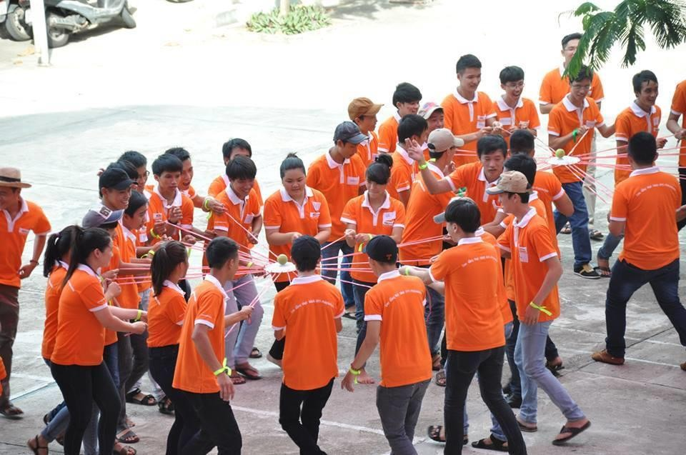

## Team building

**How to encourage group cohesiveness**

###### One of the most effective ways of promoting cohesion is to be inclusive.

* + This means that you should treat group members as responsible and trustworthy, and make information freely available.
    - Sometimes, managers feel that they cannot reveal certain information to everyone in the group. This invariably creates a climate of mistrust.
    - Simple information exchange is an effective way of making people feel valued and that they are part of a group.
  + Alice arranges regular informal meetings where she tells the other group members what is going on.
  + She makes a point of involving people in the product development by asking them to come up with new ideas derived from their own family experiences.
  + The ‘away days’ are also good ways of promoting cohesion — people relax together while they help each other learn about new technologies.

1. Introduction
2. A good group
3. **Factors influence the effectiveness of a group**
   * Group composition – Case study
   * Group organization
   * Group communications

### There are three generic factors that affect team working:

Group composition

Group organization



Group communications

* + There are three generic factors that affect team working:
    - **The people in the group:** You need a mix of people in a project group as software development involves diverse activities such as negotiating with clients, programming, testing, and documentation.
    - **The group organization:** A group should be organized so that individuals can contribute to the best of their abilities and tasks can be completed as expected.

###### There are three generic factors that affect team working:

* + - **Technical and managerial communications:** Good communications between group members, and between the software engineering team and other project stakeholders, is essential.

###### As with all management issues, getting the right team cannot guarantee project success.

* + However, if you don’t pay attention to group composition, organization, and communications, you increase the likelihood that your project will run into difficulties.

1. Introduction
2. A good group
3. Factors influence the effectiveness of a group
   * **Group composition**
   * Group organization
   * Group communications

### A manager or team leader’s job is to create a cohesive group and organize their group so that they can work together effectively.

* + This involves creating a group with the right balance of technical skills and personalities, and organizing that group so that the members work together effectively.
  + Sometimes, people are hired from outside the organization;
  + More often, however, software engineering groups are put together from current employees who have experience on other projects.
  + However, managers rarely have a completely free hand in team selection.
    - They often have to use the people who are available in the company, even when they may not be the ideal people for the job.

### Many software engineers are motivated primarily by their work. Software development groups, therefore, are often composed of people who have their own ideas about how technical problems should be solved.

* + This is reflected in regularly reported problems of:
    - interface standards being ignored,
    - systems being redesigned as they are coded,
    - unnecessary system embellishments, and so on.

### A group that has complementary personalities may work better than a group that is selected solely on technical ability.

* + - People who are motivated by the work are likely to be the **strongest technically**.
    - People who are self-oriented will probably be best at

**pushing the work** forward to finish the job.

* + - People who are interaction-oriented help **facilitate**

**communications** within the group.



### [Sommerville] think that it is particularly important to have interaction-oriented people in a group.

* + - They like to talk to people and can detect tensions and disagreements at an early stage, before these have a serious impact on the group.

However...

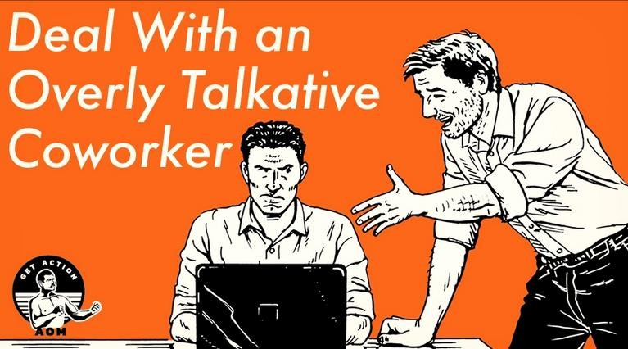

###### Alice has tried to create a group with complementary personalities. This particular group has a good mix of interaction- and task-oriented people.

* + - Alice — self-oriented
    - Brian — task-oriented
    - Bob — task-oriented
    - Carol — interaction-oriented
    - Dorothy — self-oriented
    - Ed — interaction-oriented
    - Fred — task-oriented

### However, there are some problems:

* + - Dorothy’s self-oriented personality has caused problems because she has not been doing the work that she expected.
    - Fred’s part-time role in the group as a domain expert might also be a problem. He is mostly interested in technical challenges, so he may not interact well with other group members. The fact that he is not always part of the team means that he may not relate well to the team’s goals.

## It is sometimes impossible to choose a group with complementary personalities.

* + - If this is the case, the project manager has to control the group so that individual goals do not take precedence over organizational and group objectives.
    - This control is easier to achieve if all group members participate in each stage of the project.
    - Individual initiative is most likely when group members are given instructions without being aware of the part that their task plays in the overall project.

###### For example, say a software engineer is given a program design for coding and notices what appears to be possible improvements that could be made to the design.

* + If he or she implements these improvements without understanding the rationale for the original design, any changes, though well intentioned, might have adverse implications for other parts of the system.
  + If all the members of the group are involved in the design from the start, they will understand why design decisions have been made. They may then identify with these decisions rather than oppose them.

1. Introduction
2. A good group
3. Factors influence the effectiveness of a group
   * Group composition
   * **Group organization**
   * Group communications
   * The way that a group is organized affects
     + the decisions that are made by that group,
     + the ways that information is exchanged, and
     + the interactions between the development group and external project stakeholders.

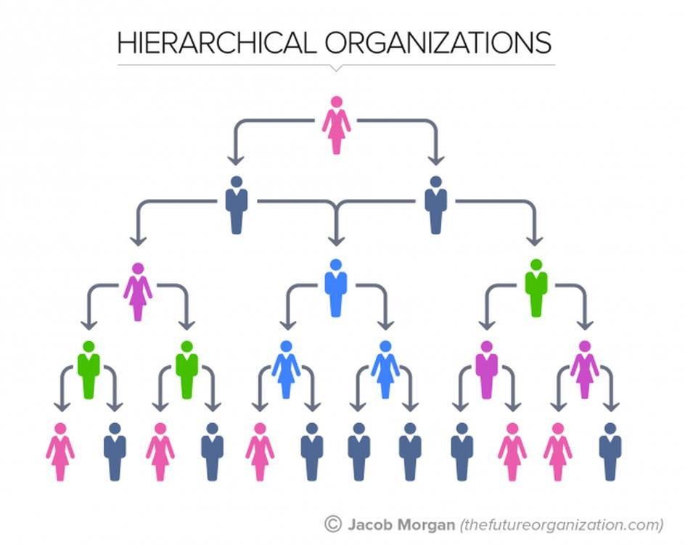**The 5 Types Of Organizational Structures by** [Jacob Morgan](https://www.forbes.com/sites/jacobmorgan/)

**at Forbes.com**

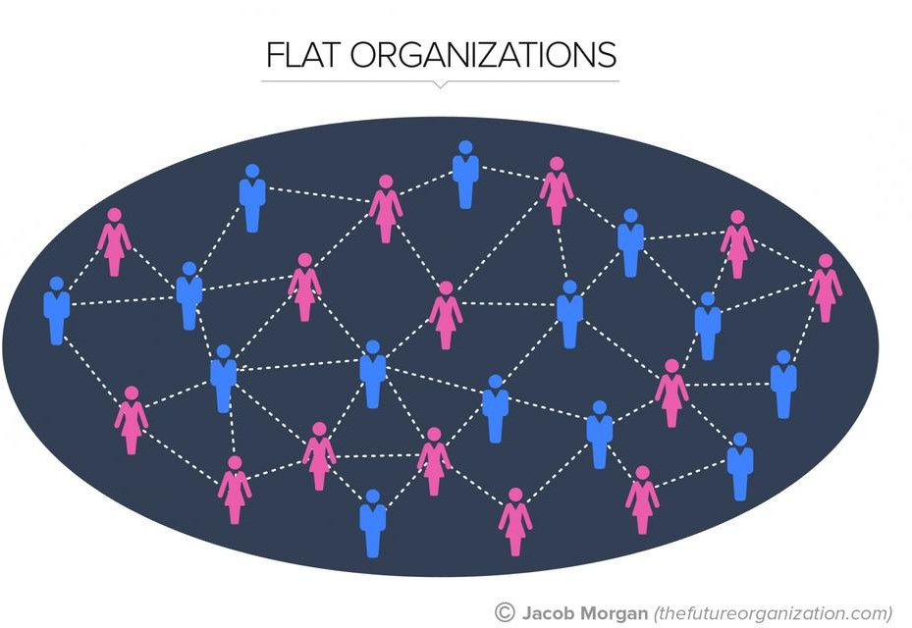

###### Important organizational questions for project managers include:

1. Should the project manager be the technical leader of the group?
2. Who will be involved in making critical technical decisions,

and how will these be made?

1. How will interactions with external stakeholders and senior company management be handled?
2. How can groups integrate people who are not colocated?
3. How can knowledge be shared across the group?

## Should the project manager be the technical leader of the group?

* + The technical leader or system architect is responsible for the critical technical decisions made during software development.
  + Sometimes, the project manager has the skill and experience to take on this role. However, for large projects, it is best to appoint a senior engineer to be the project architect, who will take responsibility for technical leadership.

## Who will be involved in making critical technical decisions, and how will these be made?

* + Will decisions be made by the system architect, the project manager, or by reaching consensus amongst a wider range of team members?

## How will interactions with external stakeholders and senior company management be handled?

* + In many cases, the project manager will be responsible for these interactions, assisted by the system architect if there is one.
  + However, an alternative organizational model is to create a dedicated role concerned with external liaison, and appoint someone with appropriate interaction skills to that role.

## How can groups integrate people who are not colocated?

* + It is now common for groups to include members from different organizations and people to work from home as well as in a shared office. This has to be taken into account in group decision-making processes.

## How can knowledge be shared across the group?

* + Group organization affects information sharing as certain methods of organization are better for sharing than others.
  + However, you should avoid too much information sharing as people become overloaded and excessive information distracts them from their work.

### Small programming groups are usually organized in a fairly informal way.

In an informal group, the work to be carried out is discussed by the group as a whole, and tasks are allocated according to ability and experience.

* + The group leader gets involved in the software development with the other group members.
  + More senior group members may be responsible for the architectural design.
  + However, detailed design and implementation is the responsibility of the team member who is allocated to a particular task.
  + Extreme programming groups (Beck, 2000) are always informal groups.
  + XP enthusiasts claim that formal structure inhibits information exchange.
  + In XP, many decisions that are usually seen as management decisions (such as decisions on schedule) are devolved to group members.
  + Programmers work together in pairs to develop code and take joint responsibility for the programs that are developed.

###### Informal groups can be very successful, particularly when most group members are experienced and competent.

* + Such a group makes decisions by consensus, which improves cohesiveness and performance.
  + However, if a group is composed mostly of inexperienced or incompetent members, informality can be a hindrance because no definite authority exists to direct the work, causing a lack of coordination between group members and, possibly, eventual project failure.



**Group organization - Hierarchical**

### **Hierarchical groups** are groups that have a hierarchical structure with the group leader at the top of the hierarchy.

The group leader has more formal authority than the group members and so can direct their work.

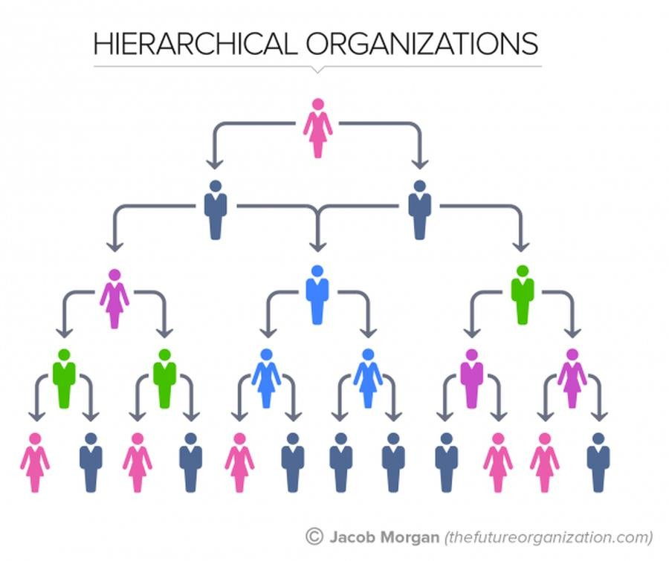There is a clear organizational structure and decisions are made towards the top of the hierarchy and implemented by people lower down the hierarchy.

Communications are primarily instructions from senior staff and there is relatively little ‘upward’ communication from the lower levels to the upper levels in the hierarchy.

### **This approach can work well** when a well- understood problem can be easily broken into subproblems with subproblem solutions developed in different parts of the hierarchy.

* + In those situations, relatively little communication across the hierarchy is required. However, such situations are relatively rare in software engineering for the following reasons:

###### Reasons:

* + - Changes to the software often require changes to several parts of the system and this requires discussion and negotiation at all levels in the hierarchy.
    - Software technologies change so fast that more junior staff often know more about the technology than experienced staff. Top-down communications may mean that the project manager does not find out about the opportunities of using new technologies. More junior staff may become frustrated because of what they see as old-fashioned technologies being used for development.

###### Democratic and hierarchic group organizations do not formally recognize that there may be very large differences in technical ability between group members.

* + The best programmers may be up to 25 times more productive as the worst programmers.
  + It makes sense to use the best people in the most effective way and to provide them with as much support as possible.
  + An early organizational model that was intended to provide this support was the chief programmer team.
  + 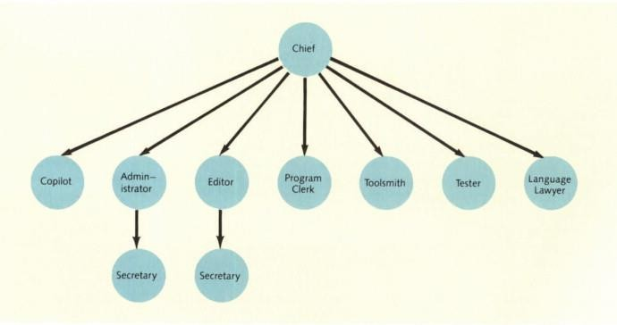To make the most effective use of highly skilled programmers, Baker (1972) and others (Aron, 1974; Brooks, 1975) suggested that teams should be built around an individual, highly skilled chief programmer.

### The underlying principle of the chief programmer team is that:

* + - The skilled and experienced staff should be responsible for all software development.
    - They should not be concerned with routine matters and should have good technical and administrative support for their work.
    - They should focus on the software to be developed

and not spend a lot of time in external meetings.



Read more in [**Structured Programming**](https://www.sciencedirect.com/science/article/pii/B9780122090059500151)**,** *HARVEY M. DEITEL, BARBARA DEITEL,*

##### The chief programmer:

* + - who does it all from problem definition to programming, testing, debugging, and even documentation.
    - In every sense, the chief must be a “super programmer,” most likely with 10 or more years'

experience in computing, plus considerable expertise in the area of the application being designed.

##### The copilot,

* + - The copilot is less experienced than the chief but is able to take over in the chief's absence.

### **The administrator**, a skilled person designated to handle administrative matters that the chief can't attend (tham dự) to because of limited time.

* + **The editor(người biên tập)**, who frees the chief from much of the tedium of the clerical work, proofreading, and edit corrections associated with producing the documentation. The chief writes or dictates the generalized versions of the documentation.

→ Two secretaries, one to serve the administrator and the other to serve the editor.

###### **The program clerk(thư kí)**, who handles all inputs, outputs, program files, backup files, and the like.

* + **The toolsmith(thợ công cụ)**, who constructs the special programs that support the chief's efforts. The toolsmith builds programs, called(được gọi) utilities(tiện ích) or software tools(công cụ), that make the chief's job easier.
  + **The tester**, who prepares(chuẩn bị) test cases and appropriate test data to ensure that the programs written by the chief run properly.

**(và dữ liệu thử nghiệm thích hợp để đảm bảo rằng)**

* + **The language lawyer**, an expert(chuyen gia) in the structured programming language being used in the project.
  + **Some disadvantages:**
    - Chief programmers are very hard to find.
    - The chief programmer team organization is overdependent(phụ thuộc quá nhiều ) on the chief programmer and their assistant.
    - Other team members who are not given sufficient responsibility

(K được giao đủ trách nhiệm)may become demotivated(mất động lực) because they feel their skills are underused(k được sử dụng). They do not have the information to cope(đối phó) if things go wrong(mọi việc k như ý muốn) and are not given the opportunity to participate in decision making.(họ k thể quyết định)

* + - There are significant project risks associated with this group organization and these may outweigh any benefits that this kind of organization might bring.

### Introduction

1. A good group
2. Factors influence the effectiveness of a group
   * Group composition
   * Group organization
   * **Group communications**
   * It is absolutely essential(hoàn toàn cần thiết) that group members communicate(giao tiếp) effectively(hiệu quả) and efficiently with each other and with other project stakeholders.(bên liên quan khác của dự án)
   * Group members must exchange(trao đổi) information on the status of their work(tình trạng công việc), the design decisions(quyết định thiết kế) that have been made, and changes to previous design decisions(thay đổi vs các quyết định thiết kế trước đó).
   * They have to resolve problems(v đề) that arise(p sinh) with other stakeholders and inform(t báo) these stakeholders of changes to the system, the group, and delivery plans.(kế hoạch phân phối)
   * Good communication(giao tiếp tốt) also helps strengthen(tăng cường) group cohesiveness(kết nối).
   * Group members come to understand the motivations(động cơ), strengths(điểm mạnh), and weaknesses(điểm yếu) of other people in the group.
   * The effectiveness(hiệu quả) and efficiency of communications(truyền thông) is influenced by(bị ảnh hưởng)
     + Group size(quy mô nhóm)
     + Group structure(cơ cấu nhóm)
     + Group composition (thành phần nhóm)
     + The physical work environment(Môi trường làm việc thực tế)
     + The available communication channels(các kênh liên lạc sẵn có)

### **Group size** As a group gets bigger(được lớn), it gets harder for members to communicate(giao tiếp) effectively.(hiệu quả)

* + - The number of one-way communication links is *n* * (*n - 1*), where *n* is the group size, so, with a group of eight members, there are 56 possible communication pathways. This means that it is quite possible that(hoàn toàn có khả năng) some people will rarely(hiếm) communicate with each other.
    - Managers and experienced engineers(kỹ sư giàu kinh nghiệm) tend(xu hướng) to dominate(thống trị) communications with less experienced staff(nhân viên ít kinh nghiệm), who may be reluctant(miễn cưỡng) to start a conversation(đối thoại) or make critical remarks.(hoặc đưa ra những phê bình)

### **Group structure(cơ cấu nhóm)** People in informally(k chính thức) structured groups communicate more effectively(hiệu quả hơn) than people in groups with a formal(có cấu trúc chính thức), hierarchical(phân cấp) structure.

* + - In hierarchical groups, communications(thông tin) tend(xu hướng) to flow up and down the hierarchy(lên và xuống theo hệ thống phân cấp). People at the same level(cùng cấp độ) may not talk(nói) to each other. This is a particular(đặc thù) problem(vấn đề) in a large(lớn) project with several development groups.(nhóm phát triển)
    - If people working(làm việc) on different(khác nhau) subsystems(hệ thống con) only

communicate through their managers.(giao tiếp thông qua người quản lí)

()

### **Group composition(thành phần nhóm)** People with the same(cùng) personality(tính cách) types may clash(xung đột) and, as a result, communications(thông tin) can be inhibited(hạn chế).

* + - Communication(giao tiếp) is also usually better(tốt hơn) in mixed-sex(giới tính hỗn hợp) groups (Marshall and Heslin, 1975) than in single-sex(đơn giới tính) groups.
    - Women(phụ nữ) are often more interaction(tương tác)-oriented(hướng) than men(nam) and may act(đóng vai trò) as interaction controllers(điều khiển) and facilitators(điều phối cho nhóm) for the group.

s

* + **The physical work environment(môi trường làm việc thể chất)** The organization of the workplace(nơi làm việc) is a major factor(yếu tố chính) in facilitating(tạo đk) or inhibiting(hạn chế) communications.

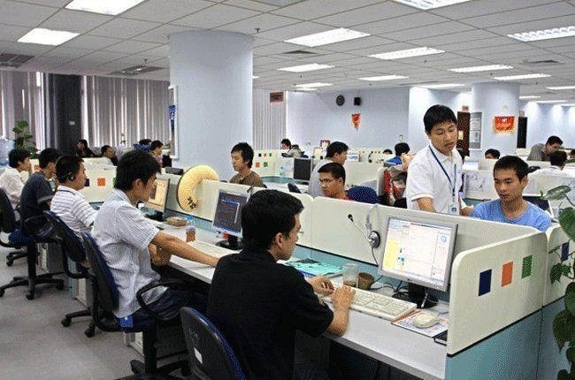





* + **The available communication channels(Các kênh liên lạc sẵn có)**
    - There are many different forms(hình thức) of communication — face-to-face(mặt đối mặt), e-mail messages, formal(chính thức) documents, telephone, and Web 2.0 technologies such as social(xã hội) networking(mạng) and wikis.
    - As project teams become(trở nên) increasingly(ngày càng) distributed(phân tán), with team members working remotely(từ xa), you need to make use of a range(dùng loạt) of technologies to facilitate(tạo đk) communications.

### Project managers usually work(làm) to tight deadlines(đúng thời hạn) and, consequently(do đó), they may try(cố gắng) to use communication(giao tiếp) channels that don’t take up too(quá) much(nhiều) of their time.

* + They may therefore(do đó) rely(đưa vào) on meetings and formal(chính) documents to pass(chuyển) on information to project staff(nhân viên) and stakeholders.
  + Although this may be an efficient(hiệu quả) approach(tiếp cận) to communication(giao tiếp) from(từ) a project manager’s perspective, it is not usually very effective(hiệu quả).
    - There are often(thường) good(chính đáng)reasons(lý do) why people can’t attend(góp mặt) meetings and so they don’t hear(k nghe) the presentation(trình bày).
    - Long(dài) documents are often never read because readers(người đọc) don’t know if the documents are relevant(liên quan không). When several versions of the same(cùng) document are produced(đc tạo ra), readers find it difficult(khó) to keep track(theo dõi) of the changes

###### **Effective communication** is achieved(đạt được) when communications are two way(chiều), and the people involved can discuss issues(thảo luận các vấn đề) and information and establish(thiết lập) a common(chung) understanding of proposals(đề xuất) and problems.(vấn đề)

* + This can be done through(thông qua) meetings, although these are often dominated(chi phối) by powerful(mạnh mẽ) personalities(tính cách). It is sometimes(đôi khi) impractical(k thực tế) to arrange(sắp xếp) meetings at short notice.(thời gian ngắn)
  + More and more project(ngày càng có nhiều) teams include remote members, which also makes meetings more difficult.(điều này làm cho các cuộc họp trở nên khó khăn hơn)

**→ How to counter these problems?**

* + To counter these problems(vấn đề), you may make use of web technologies such as wikis and blogs to support information exchange.
    - Wikis support the collaborative creation and editing(chỉnh sửa) of documents, and blogs support threaded(theo chuỗi) discussions(thảo luận) about questions and comments made by group members.
    - Wikis and blogs allow(cho phép) project members and external stakeholders to exchange(trao đổi) information, irrespective(bất kể) of their location. They(chúng ta) help manage information and keep track(theo dõi) of discussion(thảo luận) threads(chủ đề), which often become(trở nên) confusing(khó hiểu) when conducted(tiến hành) by e-mail.

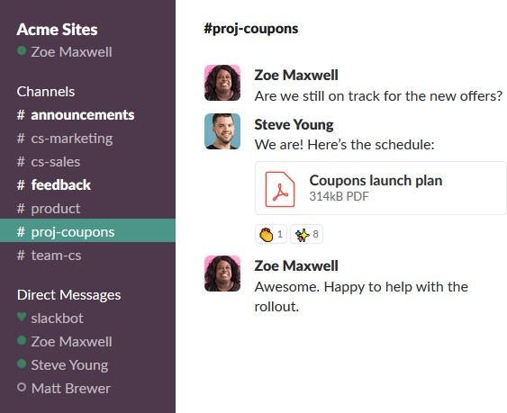

### You can also use instant messaging(nhắn tin tức thời) and teleconferences(tham khảo từ xa), which can be easily(dễ dàng) arranged(sắp xếp), to resolve issues(vấn đề) that need(cần) discussion(thảo luận).





###### Software development groups should be fairly(khá) small(nhỏ) and cohesive(gắn kết).

* + The key factors(yếu tố) that influence(ảnh hưởng) the effectiveness(hiệu quả) of a group are the people in that group(trong nhóm), the way that it(cách thức) is organized, and the communication between group members.
  + Communications within(trong) a group are influenced(ảnh hưởng) by factors(yếu tố) such as the status(trạng thái) of group members, the size(quy mô) of the group, the gender composition(thành phần giới tính) of the group, personalities(tính cách), and available(có sẵn) communication channels.

*As described in the Introduction slide.*