Step 5:

|  |  |  |
| --- | --- | --- |
| Pin 1 | Pin 2 | Output |
| 0 | 0 | 0 |
| 0 | 1 | 0 |
| 1 | 0 | 0 |
| 1 | 1 | 1 |

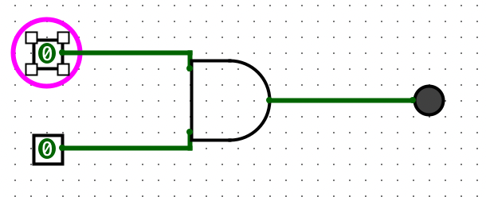

Step 8:

|  |  |
| --- | --- |
| Pin | Output |
| 0 | 1 |
| 1 | 0 |

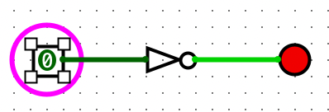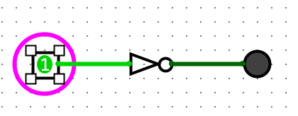

Step 10:

|  |  |  |
| --- | --- | --- |
| Pin 1 | Pin 2 | Output |
| 0 | 0 | 0 |
| 0 | 1 | 1 |
| 1 | 0 | 1 |
| 1 | 1 | 0 |

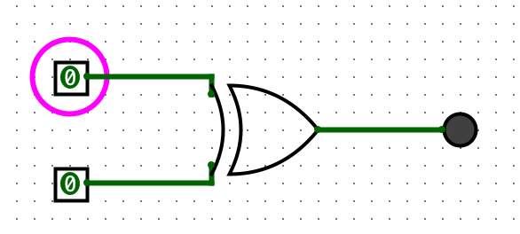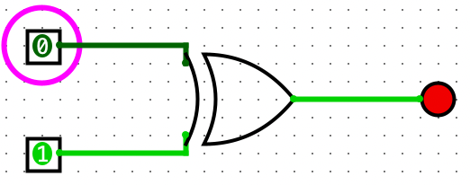

Step 12:

|  |  |  |
| --- | --- | --- |
| Pin 1 | Pin 2 | Output |
| 0 | 0 | 1 |
| 0 | 1 | 0 |
| 1 | 0 | 0 |
| 1 | 1 | 1 |

Y = NOT (A XOR B)

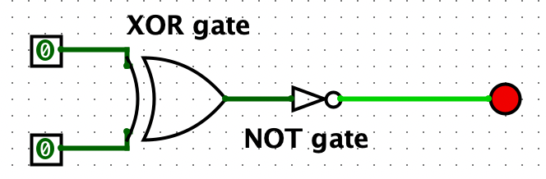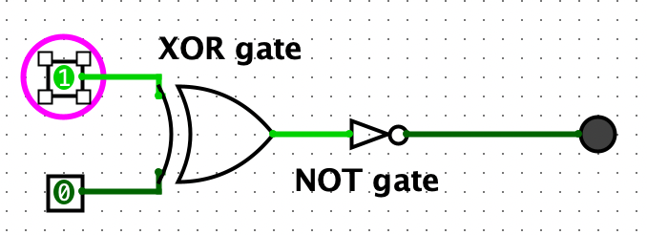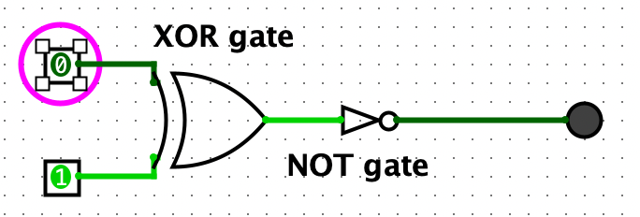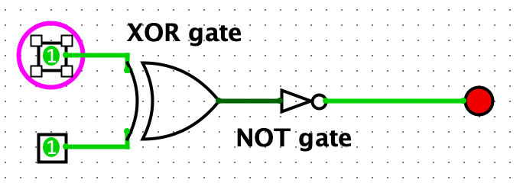

Step 15:

|  |  |  |  |
| --- | --- | --- | --- |
| Pin 1 | Pin 2 | Pin 3 | Output |
| 0 | 0 | 0 | 1 |
| 1 | 0 | 0 | 0 |
| 1 | 1 | 0 | 0 |
| 1 | 0 | 1 | 0 |
| 0 | 0 | 1 | 0 |
| 0 | 1 | 1 | 0 |
| 0 | 1 | 0 | 0 |
| 1 | 1 | 1 | 1 |

Y = (A XNOR B) AND (B XNOR C)

