Name: Vu Duc Tran

Student ID: 104175614

1. Big-endian 3-bit counter:

2. Big-endian 3-bit “count down” counter:

3. Common Clock big-endian 3-bit counter:

4. Common Clock big-endian 3-bit counter (MOD 6):

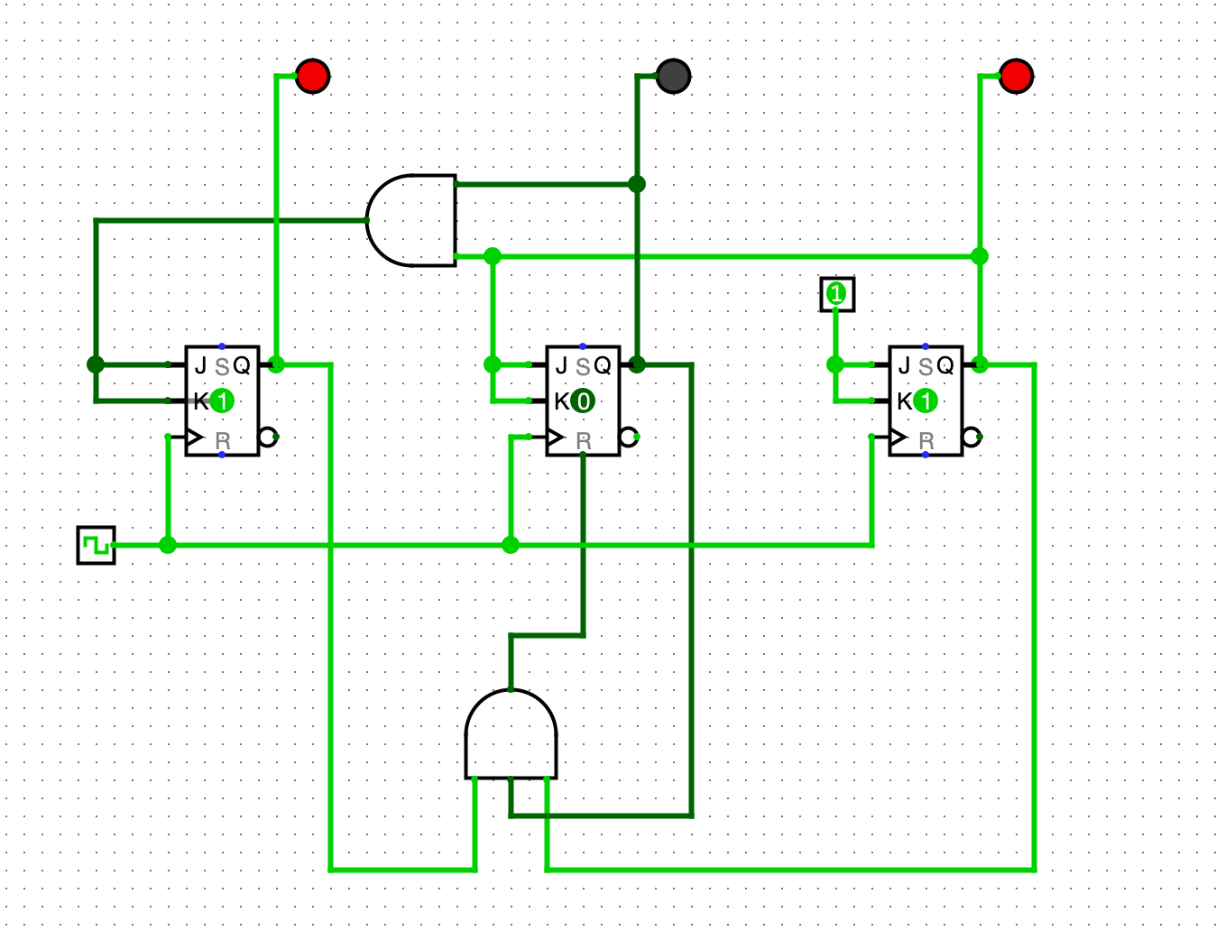

5.1. Common Clock big-endian 3-bit counter (MOD 5):

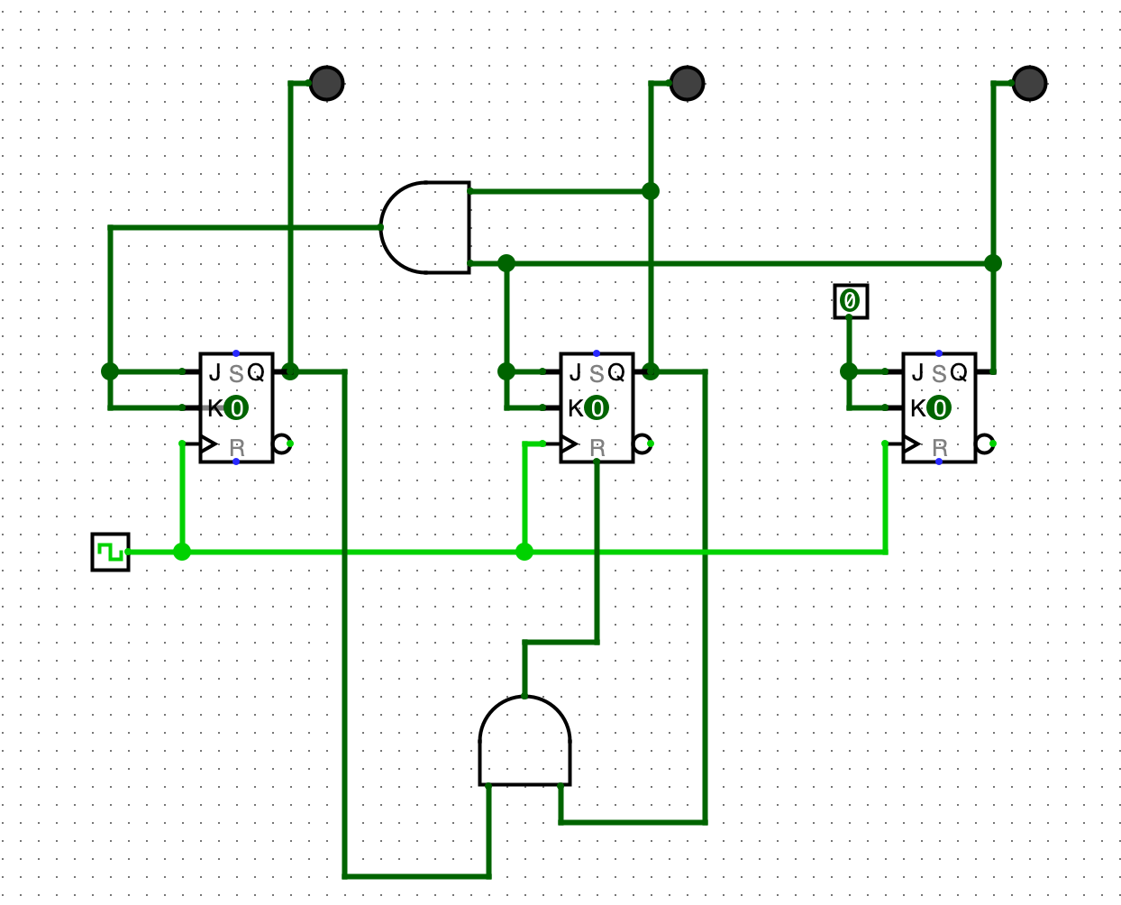

5.2. Why is handling such things important ?

In states where the counter values are not allowed, and they don't make sense, it can result in wrong data, make the system unstable, give users a bad experience, create security problems, and make troubleshooting difficult.

6. Big-endian 3-bit counter HEX display:

