1. Review the lecture slides on types of memory and provide a short answers to the following questions (using your own words):
   1. What is ROM and what is its primary purpose ?

* Read-only Memory is a type of computer storage. It stores data that can only be read and the data cannot be loss even if the electric goes off
  1. What is RAM and how is it different from ROM ?
* Random-access Memory is a type of computer storage. It stores the information which can be accessed quickly.
* It is different from ROM because when power goes off, the information that RAM store will be deleted.
  1. What is the difference between static RAM and dynamics RAM ?
* The difference:

+ Static Ram: keep information until power removed, fast, larger   
area of silicon per byte, modest power requirement.

+ Dynamics RAM: keep information as long as the contents are   
refreshed frequently enough, smaller area of silicon per byte, low   
power requirement.

* 1. What type of memory is typically used in USB thumb drives ? Why shouldn’t we rely on this for critical data storage ?
* EEPROM (Flash memory) is used in USB. We shouldn’t rely on this for critical data storage because it can be easily affected by electricity.

1. Consider a computer with 1GB RAM (1024 MB). Given memory addressing is for each byte, how many bits are needed to address all bytes in the system’s RAM ?

* We nees 2^30x8 to address all bytes in the system’s RAM.

1. Give a brief description of the Von Neumann and Harvard computing architectures. What are the fundamental differences between the two and for what is is each designed to achieve ?

* The fundamental defferences:

+ Von Neumann architecture: Control bits and data bits share a common memory space hardware

+ Harvard architecture: instructions and data are kept separate.

1. What is cache memory and what is its primary role ?

* Cache memory is used by CPU and store frequently accessed instructions/data in high-speed memory.

1. Explain the concept of an interrupt, and list four common types.

* Interrupt is a type of signal from hardware that tell the CPU they want priority.
  1. Polling is an alternative to interrupts ? Briefly explain polling and why it is not com­monly used
* Polling is an alternative approach to interrupt. It is not commonly used because:

+ Can waste time checking hardware which is doing nothing.   
+ Doesn't take advantage of the stack.   
+ If one device freezes, this can make the   
entire computer unresponsive.

1. Explain the general concept of a stack - how do they work, and what is their primary purpose.

* It is a row that can push data on and pop it out. A stack allows us to mothball/backup/hibernate a process/task at will on the receipt of an interrupt or code invocation.
  1. How are stacks useful for handling interrupts ?
* Stack help device to continue the work after interrupts happen instead of finding where have the data gone after interrupts happen.
  1. How are stacks useful in programming ?
* Programming can find the lastest data they used to continue their work.

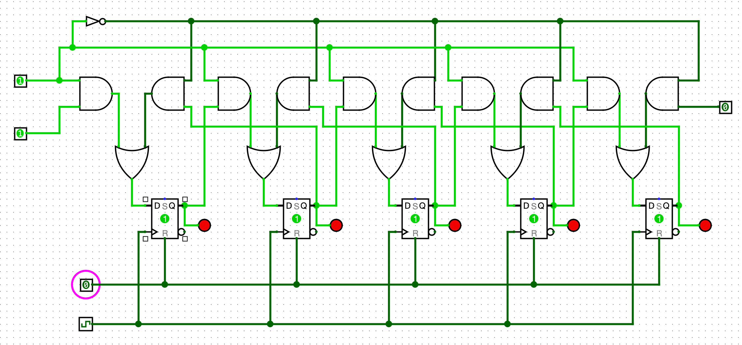

12.

