Introduction to Web Development

# Week1

Introduction to development tools

Libraries

Version control

Frameworks

CI/CD

Continuous Integration with Continuous Delivery or Continuous Deployment

Implement through build automation server

Build tools

Transfer source code into binaries for installation

From IDE

Package

In this module, you learned that:

Front-end developers work on the parts of the website or app that the user sees and interact with.

Back-end developers work on the logic and functionality that keeps the website or app running and responding to users’ inputs.

Full-stack developers have both sets of skills.

Front-end developers and back-end developers work closely together.

Frameworks and libraries extend the functionality of coding languages such as JavaScript and Python.

Common languages for front-end development include: HTML, CSS, and JavaScript.

Common languages and frameworks for back-end development include: Python, Django, and Flask.

Version control systems keep track of changes and resolve conflicts between them.

CI/CD (Continuous Integration with Continuous Delivery/Deployment) is a best practice developers use to deliver frequent changes reliably.

# Week2

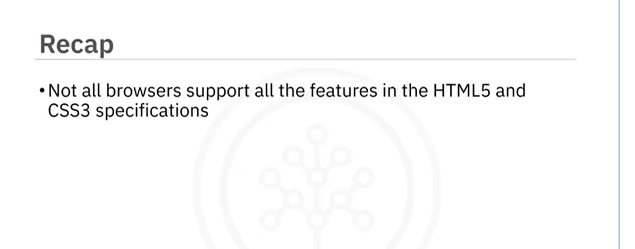

In this module, you learned that:

HTML provides the basic structure and content for a website using tags.

Tags represent the elements of an HTML page.

The HTML DOM Tree describes how a website is structured.

HTML uses APIs to enhance the user experience, providing features for advanced animation, audio, and video.

Scripting provides a more interactive user experience when browsing websites.

It is recommended to not rely on scripting as it can be disabled.

HTML5 sandboxes help manage iframe mashups.

HTML5 Browser Support Tables describe which browsers support which HTML5 features.

JavaScript is used to check if an element is supported by a browser.

CSS provides consistent style and design throughout the website.

There are two types of CSS layouts to design websites: fluid and fixed.

*There are some input type supported, but some browser may have different ways to implements that, you’d better use UI by yourself if necessary. Or you will stuck in specific browser like chrome or Firefox.*

In this module, you learned that:

CSS creates a uniform look throughout each element of each page of the website.

CSS is usually coded in external style sheets and creates base styles for a website.

CSS frameworks assists in implementing UI elements and creating dynamic web pages.

CSS has two types of frameworks:

Utility-first frameworks, which provide utility classes to help in building one's own styles and layouts.

Component frameworks, which provide a wide selection of pre-styled components and templates that can be implemented onto a website.

Plain (Vanilla) CSS lets developers write the styles and layouts of a website.

HTML5 elements provide structure and function to websites.

HTML5 uses the <input> tag to allow users to input information.

