TITLE TITLE TITLE TITLE TITLE TITLE TITLE TITLE TITLE TITLE TITLE TITLE TITLE
R. COSSU*, A.M. POLCARO**, M.C. LAVAGNOLO° AND S. PALMAS°°
* IMAGE, Department of Hydraulic, Maritime, Environmental and Geotechnical Engineering, University of Padua - Via Loredan, 35131, Italy
** Department of Chemical Engineering, University of Cagliari, Italy
° CISA, Environmental Sanitary Engineering Centre, Cagliari, Italy
°° CINSA, Chemical Engineering Research Centre, Cagliari, Italy
1. INTRODUCTION (should include problem statement and goal)
Text text text text text text text text text text text text text text text text text text text text text text text text text text text text text text text text text text text text text text text text text text text text text text text text text text text text text text text text text text text text text text text text text text text text text text text text text text text text text text text text text text text text.
Text text text text text text text text text text text text text text text text text text text text text text text text text text text text text text text text text text text text text text text text text text text
2. MATERIAL AND METHODS
Text text text text text text text text text text text text text text text text text text text text text text text text text text text text text text text text text text text text text text text text text text text
Table 1. Caption caption caption caption caption caption caption caption caption caption
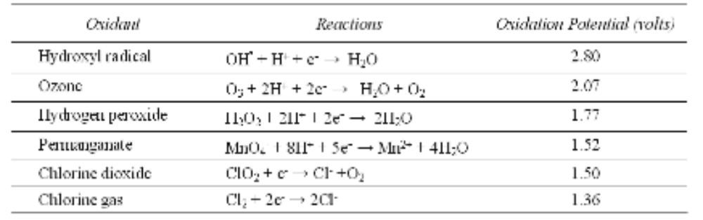
Text text text text text text text text text text text text text text text text text text text text text text text text text text text text text text text text text text text text text text text text text text text text text text text text text text text text text text text text text text text text text text text text text text text text text text text text text text text text text text text text text text text text text text text text text text text text text text text.
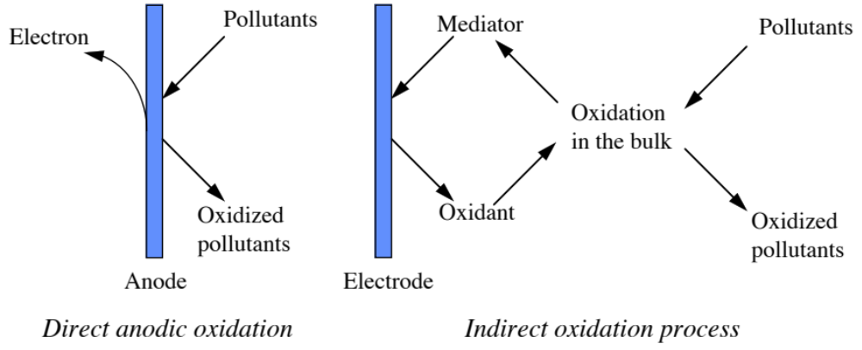
Figure 1. Caption caption caption caption caption caption caption caption caption caption caption caption.
4. RESULTS
Text text text text text text text text text text text text text text text text text text text text text text text text text text text text text text text text text text text text text text text text text text text text text text text text text text text text text text text text text text text text text text text text text text text text text text text text text text text text text text text text text text text text text text text.
Text text text text text text text text text text text text text text text text text text text text text text text text text text text text text text text text text text text text text text text text text text text
5. CONCLUSIONS
Text text text text text text text text text text text text text text text text text text text text text text text text text text text text text text text text text text text text text text text text text text text text text text text text text text text text text text text text text text text text text text text text text text text text text text text text text text text text text text text text text text text text text text text text text text text text text.
AKNOWLEDGEMENTS
Text text text text text text text text text text text text text text text text.
REFERENCES (unnumbered list)
Blakey N.C., Cossu R., Maris P.J. and Mosey F.E. (1992). Anaerobic lagoons and UASB reactors: Laboratory experiments. In Landfilling of waste: Leachate, Christensen, Cossu, Stegmann (Eds), Elsevier Applied Science Publisher, Amsterdam, 245-263.
Li-Choung Chiang, Juu-En Chang and Ten-Chin Wen (1995). Indirect oxidation effect in Electrochemical oxidation treatment of landfill leachate, Wat. Res., vol. 29, n. 2, 671-678.
For Journal Title Abbreviations see: http://www.efm.leeds.ac.uk/~mark/ISIabbr/A_abrvjt.html

