**An Introduction to Natural-language Processing**

By Trang Nguyen on April 7, 2018

Natural-language processing (NLP) is a computer science field that focus on programming computer to process natural language data. In a way, we can see NLP as continuous classes that teach computers human language. The goal for NLP is to help machines to understand human languages through oral or written communications.

**What types or processes does NLP has?**

NLP allows and encourages machines to perform automated speech and automated text writing[1].

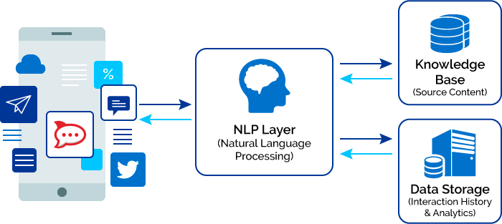[2]

When breaking down, NLP practices can be included in one of the following levels.[3]

1. Signal Processing: converts spoken words to texts
2. Semantic Analysis: delves into the meaning of words in the sentences
3. Syntactic Analysis: retrieves grammars or structures of the sentences
4. Pragmatics: look at the overall sentence meaning in larger contexts. Users will need to teach the machine how the sentences are used and in what contexts.

NLP usually involve in two process which are understanding and generation of natural languages. **Natural Language Understanding** is like it name, trying to understand human language. Challenges the understanding process face is ambiguity in words’ or sentences’ meanings. For example, the nail can be understood as fingernails or a sharp thin metal we use in construction. Besides from that, human’s tone can also alter a sentence meaning, especially when it comes to sarcasm. Imagine your best friend who can barely draw a line try to draw your portrait and ask you how it look. An answer such as “it looks so good I want to die” would most likely be interpreted by the computer that you like the painting. Human are complex, we sometimes say what we actual mean and sometimes we play around with our words. Such complexity will give machine difficulty in understanding and interpreting our sentences. These challenges can be overcome by time as the computer learn more about the way human talk. **Natural Language Generation** create readable and meaningful sentences and phrases from existing structured data. This process usually goes through a check list to ensure the quality of the produced text. As Gill explained in his article[4], the stages are text planning, sentence planning and realization. Text planning take out the words, phrases and form structured data; sentence planning combine sentences with structured data to create the flow of information. Realization will correct grammar of the sentence before present the final text.

Up to this point, we may question what the difference between NLP and Text Mining. Gill[5] has the shortest answer for us.

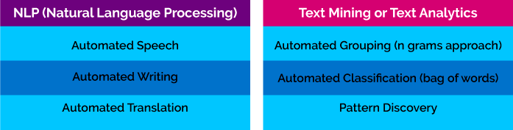

**What companies use NLP?**

Companies are utilizing NLP in building their applications, analyze their customers’ reviews, and so on. Some examples are Siri, Amazon Echo, and Google Home. Yes, when you talk to Siri, that is when NLP is helping her to understand what you are saying. Besides from that, various email systems also use NLP to detect spam mail and automatically include those emails in the spam folder. NLP is still growing, so we will see more of it in the future.

1. Gill, J. (2017) *Overview of Artificial Intelligence and Role of Natural Language Processing in Big Data.* Retrieved from https://www.xenonstack.com/blog/data-science/overview-of-artificial-intelligence-and-role-of-natural-language-processing-in-big-data
2. Gill, J. (2017) *Overview of Artificial Intelligence and Role of Natural Language Processing in Big Data.* Retrieved from https://www.xenonstack.com/blog/data-science/overview-of-artificial-intelligence-and-role-of-natural-language-processing-in-big-data
3. Phillips, W. (2006*) Introduction to Natural Language Processing.* Retrieved from URL http://www.mind.ilstu.edu/curriculum/protothinker/natural_language_processing.php
4. Gill, J. (2017) *Overview of Artificial Intelligence and Role of Natural Language Processing in Big Data.* Retrieved from https://www.xenonstack.com/blog/data-science/overview-of-artificial-intelligence-and-role-of-natural-language-processing-in-big-data
5. Gill, J. (2017) *Overview of Artificial Intelligence and Role of Natural Language Processing in Big Data.* Retrieved from https://www.xenonstack.com/blog/data-science/overview-of-artificial-intelligence-and-role-of-natural-language-processing-in-big-data