PART 1: SOCIAL INTERACTION

* I have used to ate at a lot of restaurant such as “highland coffee”, “Tyt tea” ,”garden beer”. However, I am very favourite “Hai Xom” restaurant. Because the food is here really very delicious(tasty) and price reasonable , the foods suitable for both old and young,
* In my opinion, the foods of foreign look very beautiful. However, I feel not suitable with myself , I still like more the foods of Vietnamese than. Because, it is hometown flavor where I was born.
* People like to eat out because foods diverse and bustling atmosphere there

Talk about relaxaion

-With me activities to make myself relaxation such as play sports ,meeting friends

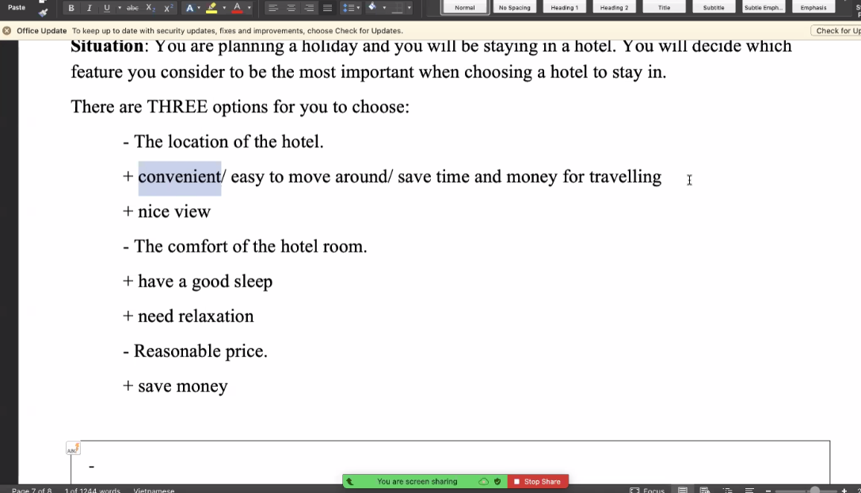

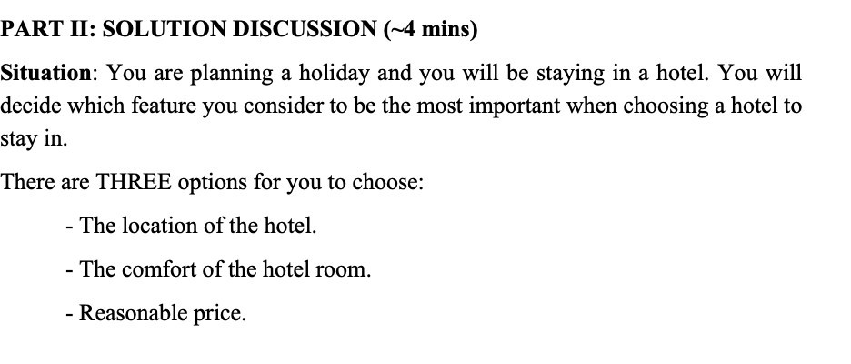

-Go for(đi theo)

-the comfort( tiện nghi)

-The location of the hotel

+convenient/easy to move around /save time and money for travelling

+nice view

-The comfort of the hotel room

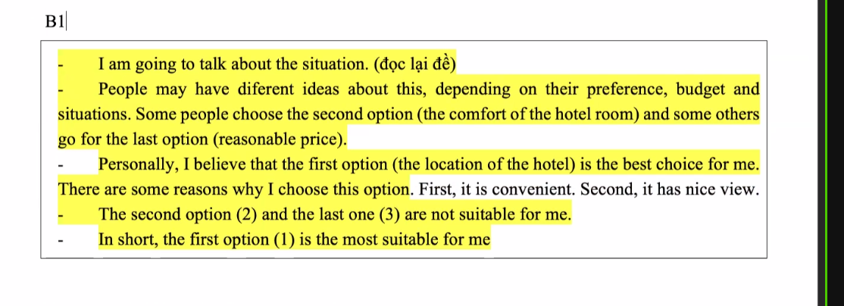

|  |
| --- |
| -I am going talk about the situation  -People may have diferent ideas about this , depending(tùy) on their preference(sự ưu thích), budget(ngân sách) and situation . Some people choose the second option(the comfort of the hotel room) and some other s go for the last option (reasonable price)  -Personally(cá nhân tôi), I believe that the first option (the location of the hotel) is best choice for me. There are some reasons why I choose this option . First , it is convenient,(thuận lợi) . second, it has nice vierw.  -The second option(2) and the last one (3) are not suitable for me  -In short , the first option (1) is the most suitable for me |

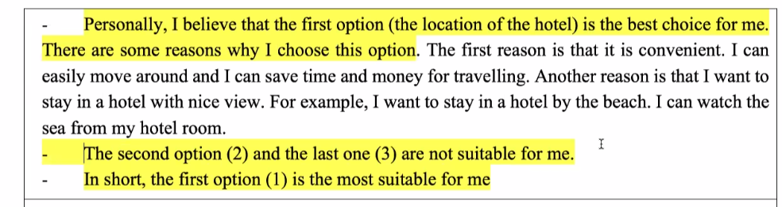

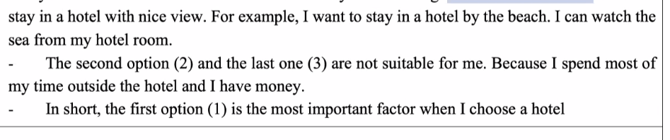

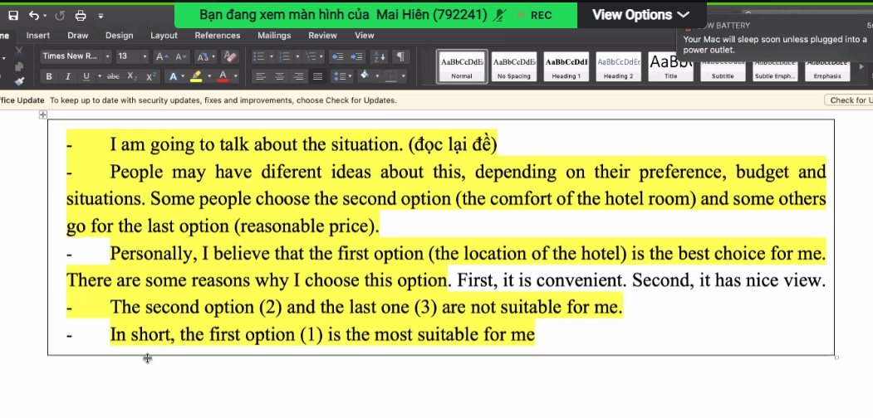

B2:

|  |
| --- |
| -I am going talk about the situation  -People may have different ideas about this, depending(tùy) on their preference(sự ưu thích), budget(ngân sách) and situation . Some people choose the second option (the comfort of the hotel room) and some others go for the last option (reasonable price)  -Personally(cá nhân tôi), I believe that the first option is best choice for me. The first reason is that it is convenient(thuận tiện_). I can easily move around and I can save time (tiết kiệm thời gian) and money for travelling. Another reason is that I want to stay in a hotel with nice view,. For example , I want to stay in a hotel by the beach . I can watch the sea from my hotel room |

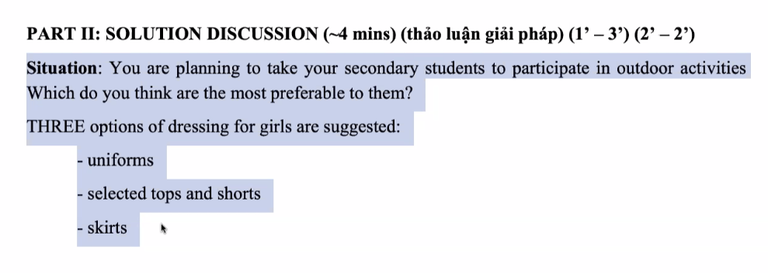

Kịch bản: Bạn đang lên kế hoạch đưa học sinh cấp 2 (secondaru student) to participate(tham gia ) in outdoor activities( hoạt động ngoài trời). Bạn nghĩ họ sẽ thích cái hoạt động nào nhất

-Dressing: sự mặc

-skirts chân váy

-suggest: gợi ý

-recognise: Nhận ra

Seclected top and shorts(like , comfortable thoải mái, beautiful and fashionale(thời trang)

Reason: -choose

There are some reason Why I choose this option. The first reason I want to mention here is that (reason1). Another reason is that (reason 2) . One more reason is that (Reason 3)

-preference: I like /love reading books(a book)

-Price: I choose it because it cheap(economical/affordable) so I can save money to do other things

-Old: it is suitable for children/teenagers/old people

-Benefit convenient /fast/comfortable/safe/delicious. It helps me ….

-I am going talk about the situation

-People may have different ideas about this , depending on their perference. Some people choose the first option (uniform) because it is easy so it is easy for the teachers to recognize their students

and some other go for the last option(skirt) as they are beautiful

-Personlly , I believe that the second option (selected tops and shorts) is the best choice for girls. There some reasons why I choose this option . The first reason is that girls like wearing tops and shorts. Another reason is that this out fit is beautiful and sporty. One more reason is that girls feel comfortable in this outfit

- the first option(uniform) and the last one (skirt) are not suitable for girls . Uniform are boring and skirts are not suitable for outdoor activities

Present for on their birthday: a book, a shirt, a pair of tickets

A book

-She likes reading books

-It is cheap

-It is useful-help her relax and reduce stress – broaden her mind

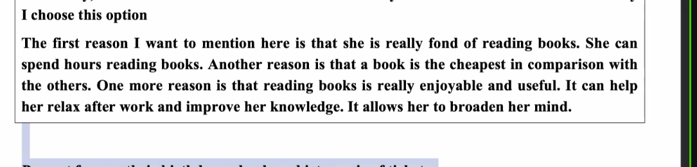

Pesonally , I believe that a book is best choice for my friend. There are some resons why I choose this option