-Typical: tiêu biểu, điển hình

-A my day always start from 6 pm , finished personal hygiene and breakfast at 7pm. I start come company and I start work at 8pm and end work at five AM

-Do you have any habits that annoy other people?

+I think noboby is perfect . each people will have habit difference good and bad, howervb

+Every day I get up at 6AM and do exercise, I have breakfast with my family and then I go to work at 7AM. I start my work at 8AM and finish at 5PM . I go home and have dinner at 8OM . I watch TV my family and go to bed at 10PM

+I have some habits that annoy other people .I listen to music and get up late .These annoy my family

+When I upset, I usually call for my mother , because mom always encourage me , that is also my motivation

Part II

-Train: tàu

-Boat: thuyền

-Coach: xe khách

I am going talk about situation (đọc lại đề)

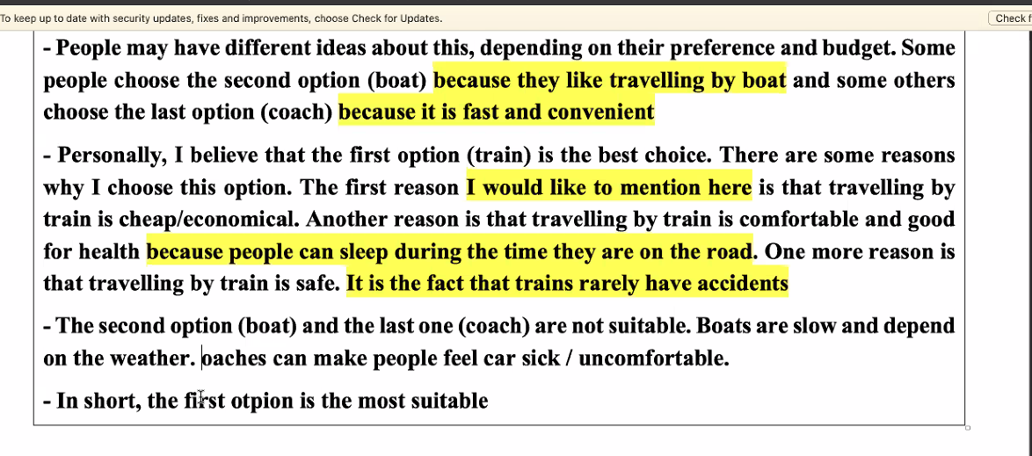

-People may have ideas about this, depending on their preference and budget (ngân sách) .Some people choose the second option(boat) and some others choose second option (boat) because they like travelling by boat and some others choose the last option( coach), because people can sleep

-People may have difference ideas , depending on their preference and budget. Some other people choose the second option because they like travelling by boat and some other option because it is fast and convenition

-Pesonally, I believe that the first option(train) is the best choice . There are reasons why I choose this option . The first