**Greeting**

-Dear Mr.David

Opening: khai mạnc

-induction: (name,age ,from,married,children,job)

**-purpose of writing**:

-I am writing this email to …(cho bạn biết một vài thông tin , cung cấp)

+ask you for some information about the course

+give you some information about the course

+thank you for your help

+give you feedback about your restaurant

+complain about service your restaurant

**Body:….**

**Ending :**

-if you have any questions or need further information , please contact me at 1231341 or via strang@123

-I am looking forward to hearing from you.

Best Regards.

**Ports:**

-when I will start the work

-Do I have to wear uniform

-what is the salary

Dear Mr.Bob

I am Trang. I am thirty one . Recently I am a 3rd year student at the cryptography engineering of academy. I will leave in 2026(leave Hn university –left graduate from HN university).From some my friends,I know your restaurant is looking for a manager and I interested in this position. I write this letter to ask you about this information.

-I am married and I have two little children

- I graduted from Hn university in 2012

-I would like to know about requirement of this position including qualification ,word experience or skill

-Please tell me when I will start the work. I am available from the beginning of next month

-I would like to know what the requirement for this position is?

-please tell me when I will start the work?

-Can you tell me if I have to wear uniform ?please let me know about the salary. I would be grateful if you could give me more information about this position

If you have any answer or need further information, please contact me at 1213 or via [susu@as.as](mailto:susu@as.as)

I am looking forward to hearing from you

-Please tell me about…

-I would like know requirement for this postion manager

-Can you tell me

Please let me know

Please tell me about what time is it?

Manager(n) người quản lý

Manag(v) quản lý

Management(n) quản lý

I majored (đã học)

i marjored in management

-such as: chang han nhu

-experience:

-

Candidate(n) Ứng viên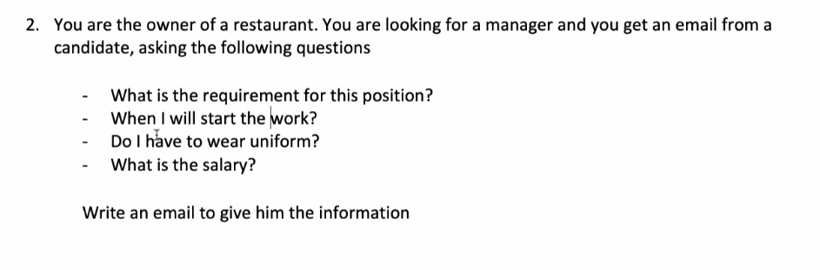

Dear Mrs.shella

My name is Trang, I am owner of Bien dong restaurant. I write to send for you some imformation about position manager( I am writing this email to inform for you about information of this position)

Major-manager

You must/need/should

My name is Trang, I am owner of BienDong Restaurant. I am writing this email to inform for some information about the position of a manager .You need graduated from Cryptography technology of academy in 2019 or you must have a bachelor and major(chuyên ngành) in management.It is beneficial for you if you can speak english You need to have three years of experience in management.You can start work from beginning of next month.You must wear uniform ;a white shirt, and black trousers. I desire have a salary of 1000 dollars. If you work well, you will get more.My restaurant is best in city,I think you will like this place

-Các cách nói học thức

You must have a bachelor(cử nhân,bằng)/university degree

You must graduted from a university