BAI 4: ON TAP CHUONG 1 – CAU TAO NGUYEN TU
Chuong I: Cau tao nguyen tu | Thoi gian thuc hien: 2 tiet (Tiet 11 – 12)
I. MUC TIEU
1. Ve kien thuc
- He thong hoa va tong ket duoc toan bo kien thuc Chuong 1: thanh phan nguyen tu (e, p, n); nguyen to hoa hoc; dong vi; NTKTTB; AO; lop, phan lop, so AO; cau hinh electron; lop ngoai cung.
- Giai duoc cac bai tap tong hop: tim Z, A, N tu tong so hat; tinh NTKTTB; viet cau hinh electron va du doan tinh chat hoa hoc tu bai toan mo ta cau hinh.
2. Ve nang luc
a) Nang luc chung
- Tu chu va tu hoc: Tu hoan thanh so do he thong hoa kien thuc Muc I SGK; tu giai bai tap truoc khi xem huong dan (HD1, HD2).
- Giao tiep va hop tac: Thao luan nhom giai thich each dat phuong trinh lap de tim p va n tu tong so hat (HD3).
- Giai quyet van de: Phan tich bai toan phuc hop (cau 10 SGK), lap he phuong trinh tuyen tinh hai an (HD3).
b) Nang luc dac thu mon Hoa hoc
- Nhan thuc hoa hoc: Tong hop kien thuc toan chuong, nhan ra moi lien he giua cac khai niem.
- Van dung kien thuc: Giai bai toan tong so hat, NTKTTB; viet cau hinh electron; du doan tinh chat tu cau hinh.
c) Nang luc so va nang luc AI (Phu luc 1)
- 3.1.NC1a - Tra cuu bang tuan hoan truc tuyen kiem tra ket qua bai tap (HD2, HD3).
- 5.2.NC1b - Lam bai trac nghiem on tap truc tuyen de tu danh gia kien thuc toan Chuong 1 (HD Cung co).
- 2.5.NC1a - Chia se bai giai cau 10 len Classroom; binh luan each giai cua ban (HD Cung co).
3. Ve pham chat
- Trung thuc: Tu danh gia dung kien thuc minh can on luyen them qua ket qua bai trac nghiem.
- Cham chi: Hoan thanh du cac cau luyen tap SGK; on luyen bang 20 nguyen to truoc khi kiem tra Chuong 1.
II. THIET BI DAY HOC VA HOC LIEU
1. Thiet bi truyen thong
- GV: SGK Hoa hoc 10 (KNTT), phieu luyen tap in san, bang tuan hoan, may tinh bo tui.
- HS: SGK, vo ghi, but, may tinh cam tay, bang 20 nguyen to da hoc.
- Bang phu: So do "He thong hoa kien thuc" (SGK tr.26) phong to de HS dien vao.
2. Cong cu so
Bai on tap truc tuyen: https://trangtu66.github.io/Taode_thi_online/hoa_cc_bai4_k10.html
- HS dung may tinh/dien thoai kiem tra bai toan phuong trinh (cau 5, 10) va tra cuu bang tuan hoan (cau 2, 8).
III. TIEN TRINH DAY HOC
Phan bo thoi gian
Hoat dong | Noi dung chinh | Thoi gian
HD1 - He thong hoa KT | Hoan thanh so do he thong hoa kien thuc Chuong 1 | 20 phut (Tiet 11)
HD2 - Luyen tap C1-6 | Bai tap nhan biet – thong hieu (Cau 1-6 SGK) | 25 phut (Tiet 11)
HD3 - Luyen tap C7-10 | Bai tap van dung cao (Cau 7-10 SGK) | 30 phut (Tiet 12)
HD4 - Van dung | Bai toan tong hop thuc tien; chia se loi giai | 10 phut (Tiet 12)
Tong | 2 tiet (Tiet 11 - 12) | 90 phut
--- TIET 11 ---
Hoat dong 1: He thong hoa kien thuc (20 phut)
Muc tieu hoat dong | Noi dung day hoc | San pham hoc tap | To chuc thuc hien
Tong ket va he thong hoa toan bo kien thuc Chuong 1.  Nhin ra moi lien he giua cac khai niem (nguyen to, AO, lop, phan lop, cau hinh). | He thong hoa kien thuc (SGK tr.26, Muc I):  HS hoan thanh so do tu duy voi cac o trong (GV phat phieu phong to):  1. Hat nhan: hat proton (m~1amu, dien tich +1), hat neutron (m~1amu, dien tich 0).  2. Vo nguyen tu: hat electron (m~0,00055amu, dien tich -1).  3. Kich thuoc NT: ~10^-10m; hat nhan ~10^-5pm; KL tap trung o HN.  4. Z = so p = so e = so don vi dien tich HN; A = Z + N.  5. AO s: hinh cau; AO p: 3 AO (px, py, pz) hinh so 8 noi.  6. Lop n: n phan lop (n<=4); so AO trong lop: n^2.  7. Thu tu nang luong: 1s 2s 2p 3s 3p 4s 3d 4p...  8. Quy tac Hund: e doc than toi da trong cung 1 phan lop.  9. Lop ngoai cung: 1-3e->KL; 5-7e->PK; 8e(He:2e)->khi hiem; 4e->KL/PK. | HS dien day du so do he thong hoa; trinh bay moi lien he chinh xac giua cac khai niem. | Giao nhiem vu: Phat phieu so do (phong to tu SGK tr.26); HS hoan thanh ca nhan (7 phut).  Thuc hien: Sau do trao doi nhom 4 nguoi kiem tra lai (3 phut).  Bao cao: GV chieu so do dap an; HS so sanh va sua.  Ket luan: GV nhan manh 3 moi lien he chinh: Z->nguyen to; A-Z=N; cau hinh->tinh chat.
Hoat dong 2: Luyen tap – Cau 1 den 6 (Nhan biet – Thong hieu) (25 phut)
Muc tieu hoat dong | Noi dung day hoc | San pham hoc tap | To chuc thuc hien
Van dung kien thuc giai bai tap nhan biet va thong hieu.  Ren luyen ki nang tinh toan p, n, e; viet cau hinh electron. | Cau 1 (SGK tr.27): ³⁹₁₉K: p=19, n=39-19=20, e=19.  -> Dap an C: 19, 20, 19.  Cau 2: 3e ngoai cung: Al(Z=13): 1s²2s²2p⁶3s²3p¹ -> 3e ngoai.  -> Dap an C: ²⁷₁₃Al.  Cau 3: K(Z=19): orbital chua e = 1(1s)+1(2s)+3(2p)+1(3s)+3(3p)+1(4s) = 10.  -> Dap an D: 10.  Cau 4: Na(Z=11): 1s²2s²2p⁶3s¹.  -> Dap an C.  Cau 5: Goi p la so p = so e; n la so n.  2p + n = 58 (tong hat)  2p - n = 18 (hat mang dien nhieu hon khong mang dien)  => 4p = 76 -> p = 19 (K/Potassium). -> Dap an C.  Cau 6: Cl(Z=17): 1s²2s²2p⁶3s²3p⁵.  - So lop electron: 3 (lop K, L, M).  - E ngoai cung: 3s²+3p⁵ = 7e.  - E doc than: 3p⁵ = [ud][ud][u] -> 1 electron doc than. | HS tra loi dung cau 1-6 SGK; trinh bay ro each dat phuong trinh Cau 5. | Giao nhiem vu: GV yeu cau HS giai 6 cau (ca nhan, 10 phut); ghi each giai ra giay.  Thuc hien: Cau 5 GV huong dan each dat he phuong trinh (khong chi doan).  Bao cao: Chia thanh 3 nhom - moi nhom trinh bay 2 cau len bang.  Ket luan: GV chot dap an; nhan manh each dat phuong trinh cau 5 (dung suy luan dai so, khong doan).
--- TIET 12 ---
Hoat dong 3: Luyen tap – Cau 7 den 10 (Van dung cao) (30 phut)
Muc tieu hoat dong | Noi dung day hoc | San pham hoc tap | To chuc thuc hien
Giai duoc bai tap tong hop: NTKTTB, cau hinh electron phuc hop, bai toan tong so hat 2 an.  Ren luyen ki nang tinh toan he phuong trinh. | Cau 7: V: A_TB=50,9975; dong vi ⁵⁰V(0,25%) va dong vi chua biet A.  Goi A la so khoi dong vi thu 2 (chiem 99,75%).  50×0,25 + A×99,75 = 50,9975×100  12,5 + 99,75A = 5099,75 -> A = 51.  -> Dong vi con lai la ⁵¹V.  Cau 8: X: 1s²2s²2p⁶3s²3p⁶4s¹; Y: 1s²2s²2p⁶3s²3p⁴.  a) X: 19e; Y: 16e.  b) Z(X)=19 (K/Potassium); Z(Y)=16 (S/Sulfur).  c) X: lop 4 (phan lop 4s) cao nhat; Y: lop 3 (phan lop 3p).  d) X: 4 lop, 6 phan lop (1s,2s,2p,3s,3p,4s); Y: 3 lop, 5 phan lop.  e) X: 1e ngoai -> kim loai; Y: 6e ngoai -> phi kim.  Cau 9: X ket thuc 3p¹ -> 1s²2s²2p⁶3s²3p¹ -> Z=13 (Al); 3e ngoai -> kim loai.  Y ket thuc 3p³ -> 1s²2s²2p⁶3s²3p³ -> Z=15 (P); 5e ngoai -> phi kim.  YO₄³⁻ la phosphate (PO₄³⁻), dong vai tro quan trong trong ADN, RNA, ATP.  Cau 10 (Bai toan 2 an):  Tong hat = 49; n = 53,125% x 2p = 1,0625p.  2p + n = 49 -> 2p + 1,0625p = 49 -> 3,0625p = 49.  p = 16; n = 17; A = 16+17 = 33.  Z=16 (Sulfur, S-33). Dien tich HN = +16.  -> p=e=16; n=17; A=33; DTHK = +16. | HS giai dung cau 7-10; trinh bay day du each giai cau 10 (lap phuong trinh, tinh p, n, A). | Giao nhiem vu: HS giai 4 cau (nhom doi, 15 phut); cau 10 GV goi y cach lap PT truoc.  Thuc hien: GV huong dan cau 10: dat 2 an p va n, lap he PT tu 2 dieu kien.  Bao cao: Dai dien nhom trinh bay cau 8 (toan bo) va cau 10.  Ket luan: GV chot each giai cau 10; luu y: n/2p = 53,125/100 (khong phai n/p).
Hoat dong 4: Van dung – Tong ket Chuong 1 (10 phut)
Muc tieu hoat dong | Noi dung day hoc | San pham hoc tap | To chuc thuc hien
Tu danh gia muc do nam vung kien thuc Chuong 1.  5.2.NC1b – Lam bai on tap truc tuyen. | Bai toan thuc te (GV neu):  "Nguyen to calcium (Ca, Z=20) rat quan trong cho su phat trien xuong va rang.  Nuoc suoi khoang tai dia phuong, Gia Lai co chua ion Ca²⁺.  a) Viet cau hinh electron cua Ca (Z=20).  b) Du doan Ca la kim loai hay phi kim? Tai sao?  c) Ion Ca²⁺ co bao nhieu electron?"  Dap an:  a) Ca: 1s²2s²2p⁶3s²3p⁶4s² (hoac [Ar]4s²).  b) Kim loai (2e ngoai cung; 1,2,3e ngoai cung -> KL).  c) Ca²⁺: mat 2e -> con 18e (cau hinh [Ar]).  Cung co online:  HS lam bai trac nghiem on tap Chuong 1:  https://trangtu66.github.io/Taode_thi_online/hoa_cc_bai4_k10.html | HS tra loi dung bai toan Ca; hoan thanh bai on tap truc tuyen dat >= 6/10. | Giao nhiem vu: GV neu bai toan Ca (3 phut); HS giai ca nhan.  Thuc hien: 1 HS len bang trinh bay; ca lop nhan xet.  Bao cao/Cung co: HS quay QR lam bai truc tuyen (5 phut).  Ket luan: GV thong bao bai kiem tra Chuong 1 (neu co); dan sang Chuong 2: "Lien ket hoa hoc".
5. Cung co – Dan do
- HS lam bai on tap truc tuyen Chuong 1 tai: https://trangtu66.github.io/Taode_thi_online/hoa_cc_bai4_k10.html
- Dan do: Doc Chuong 2 – Bai 5 "Lien ket ion" (SGK tr.28). Ghi truoc: ion duong, ion am la gi?
- On lai: Bang cau hinh electron 20 nguyen to dau tien (se kiem tra trong gio toi).
Bo cau hoi on tap Chuong 1 tham khao (dap an danh cho GV):
Cau | Noi dung | A | B | C | D | DA
1 | Nguyen tu ³⁹₁₉K co so proton, neutron, electron lan luot la: | A. 19, 20, 39 | B. 20, 19, 39 | C. 19, 20, 19 | D. 19, 19, 20 | C
2 | Nguyen tu cua nguyen to nao sau day co 3e o lop ngoai cung? | A. ²³₁₁Na | B. ¹⁴₇N | C. ²⁷₁₃Al | D. ¹²₆C | C
3 | K (Z=19) co so orbital chua electron la: | A. 8 | B. 9 | C. 11 | D. 10 | D
4 | Na (Z=11) co cau hinh electron la: | A. 1s²2s²2p⁶3s² | B. 1s²2s²2p⁶ | C. 1s²2s²2p⁶3s¹ | D. 1s²2s²2p⁵3s² | C
5 | Tong so hat p, n, e cua X la 58; hat mang dien nhieu hon khong mang dien la 18. X la: | A. Cl (Z=17) | B. Ca (Z=20) | C. K (Z=19) | D. S (Z=16) | C
6 | Cau hinh electron cua Ca (Z=20) la: | A. 1s²2s²2p⁶3s²3p⁶3d² | B. 1s²2s²2p⁶3s²3p⁶4s² | C. 1s²2s²2p⁶3s²3p⁸ | D. 1s²2s²2p⁶3s²3p⁶4p² | B
Cau dung/sai (on tap tong hop):
Cau DS: Nguyen to X co tong so hat co ban la 40, trong do so hat mang dien nhieu hon khong mang dien la 12. Xet cac phat bieu sau:
a) Nguyen to X co Z = 13. -> DUNG (2p-n=12; 2p+n=40 -> 4p=52 -> p=13)
b) Nguyen to X la Aluminum (Al, Z=13). -> DUNG
c) Cau hinh electron cua X la 1s²2s²2p⁶3s²3p¹. -> DUNG (Z=13)
d) X la phi kim vi co 3 electron o lop ngoai cung. -> SAI (1,2,3e ngoai -> KL; Al la kim loai tru H,He,B)
IV. KIEM TRA, DANH GIA
Hoat dong | Hinh thuc | Cong cu | Tieu chi
HD1 - He thong hoa | Ca nhan + nhom | Phieu so do | Dien day du so do; trinh bay moi lien he
HD2 - Luyen tap C1-6 | Ca nhan | Phieu giai bai tap | Giai dung >= 4/6 cau; each dat PT cau 5
HD3 - Luyen tap C7-10 | Nhom doi | Bai giai cau 7-10 | Giai dung cau 10 (lap PT, tim p,n,A)
Cung co | Ca nhan online | Trac nghiem hoa_cc_bai4_k10.html | Diem >= 6/10
PHU LUC
Phu luc 1: Huong dan giai bai tap 10 (day du cac buoc)
Bai 10: X co tong hat co ban = 49; so hat khong mang dien bang 53,125% so hat mang dien.
Dat: p = so proton = so electron; n = so neutron.
Dieu kien 1: 2p + n = 49.
Dieu kien 2: n = 53,125% x 2p = 0,53125 x 2p = 1,0625p.
The vao DK1: 2p + 1,0625p = 49 -> 3,0625p = 49 -> p = 16.
Tinh n: n = 1,0625 x 16 = 17. Tinh A: A = p + n = 16 + 17 = 33.
Ket luan: Z=16 (Sulfur), dien tich hat nhan = +16; p=16; e=16; n=17; A=33.
(Day la dong vi ³³₁₆S, ton tai trong tu nhien voi ti le 0,75%.)
Phu luc 2: Dap an Bai 4 SGK (cac bai tu giai)
Cau 1: C (19, 20, 19). Cau 2: C (Al). Cau 3: D (10). Cau 4: C.
Cau 5: C (K, Z=19). Cach: 2p+n=58; 2p-n=18 -> 4p=76 -> p=19.
Cau 6: Cl: 3 lop e; 7e ngoai cung; 1e doc than (3p⁵).
Cau 7: Dong vi con lai cua V la ⁵¹V (chiem 99,75%).
Cau 8: Z(X)=19(K), Z(Y)=16(S); X: kim loai; Y: phi kim.
Cau 9: X(Z=13, Al): kim loai; Y(Z=15, P): phi kim.
Cau 10: Z=16(S-33); p=e=16; n=17; A=33; DTHK=+16.

TO TRUONG/TO PHO | NGUOI SOAN | PHO HIEU TRUONG
Hua Van My Vuong | TTT | Bui Xuan Thanh
CỦNG CỐ CUỐI BÀI – SƠ ĐỒ TƯ DUY
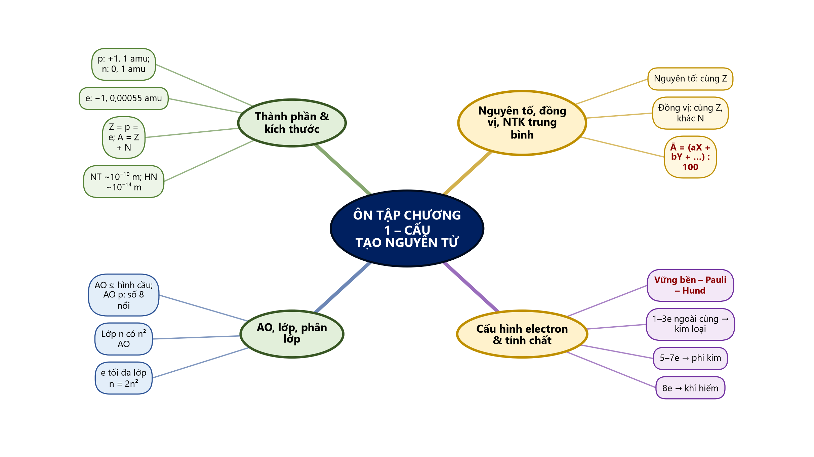
Sơ đồ tư duy – Ôn tập chương 1 – Cấu tạo nguyên tử (TTT biên soạn theo SGK)
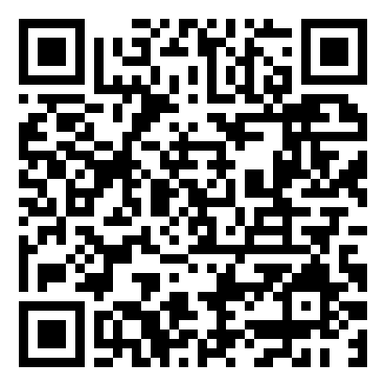
Bài tập củng cố trực tuyến (phòng thi bảo mật – đáp án niêm phong): https://trangtu66.github.io/Taode_thi_online/hoa_cc_bai4_k10.html

