TRUONG THPT VINH THANH
TO: LY – HOA - CONG NGHE-TB
KE HOACH BAI DAY MON HOA HOC LOP 10
Bai 8. DINH LUAT TUAN HOAN – Y NGHIA BANG TUAN HOAN CAC NGUYEN TO HOA HOC
Chuong 2: Bang tuan hoan cac nguyen to hoa hoc va Dinh luat tuan hoan
Thoi gian thuc hien: 1 tiet (Tiet 21)
GV: TRUONG TU TRANG | To chuyen mon: LY – HOA - CONG NGHE-TB

I. MUC TIEU
1. Ve kien thuc
– Phat bieu duoc noi dung Dinh luat tuan hoan (Mendeleev mo rong).
– Giai thich duoc moi lien he giua cau hinh e nguyen tu, vi tri trong BTH va tinh chat cua NT.
– Van dung y nghia BTH: biet vi tri → suy ra cau hinh e, tinh chat, CT oxide cao nhat, hydroxide.
2. Ve nang luc
a) Nang luc chung
– NL tu chu tu hoc: Phan tich Hinh 8.1 (SGK tr.43): cau hinh e ↔ vi tri ↔ tinh chat.
– NL GQVD sang tao: Bien so lieu vit tri (CK, nhom) sang cau hinh e va tinh chat va nguoc lai.
b) Nang luc dac thu
– Nhan thuc hoa hoc: Hieu the nao la quy luat tuan hoan, vi sao BTH la cong cu du bao tinh chat NT.
– Tim hieu tu nhien: Lien he giang day: biet Z cua N trong phan dam urea (CO(NH₂)₂) → suy ra vi tri, tinh chat N.
– Van dung: Giai dung hai vi du SGK (S va P) va tao ra cac vi du tuong tu (Ca, Na, Al).
c) Nang luc so va nang luc AI
– 5.2.NC1b (Chia se): Chia se ket qua bai tap cung co qua ma QR.
– 2.5.NC1a (Phan tich): Xem ket qua bai trac nghiem, phan tich cau sai va tu sua.
– 1.3.NC1a (Cong cu so): Tao bang Excel the hien moi lien he: vi tri BTH → cau hinh e → tinh chat.
3. Ve pham chat
– Cham chi: Rut ra quy luat tu nhieu vi du, khong chi hoc thuoc long.
– Tu duy he thong: Biet ket noi kien thuc cac bai 5-7 vao mot quy luat tong quat.

II. THIET BI DAY HOC VA HOC LIEU
– GV: BTH A0 (dung lam tham chieu trong ca bai); slide ton tat Chuong 2; so do tu duy; may tinh, man chieu.
– HS: SGK Hoa hoc 10 (tr.43-44); phieu hoc tap.
Link bai tap cung co: https://trangtu66.github.io/Taode_thi_online/hoa_cc_bai8_k10.html

III. TIEN TRINH DAY HOC
══════════════ TIET 21 ══════════════
Hoat dong 1. MO DAU (5 phut)
a) Muc tieu | b) Noi dung | c) San pham | d) To chuc
– Ket noi kien thuc Bai 5-7 vao mot quy luat tong quat.  – Dat van de: Lieu co quy luat nao chi phoi tat ca cac xu huong bien doi tuan hoan da hoc? | Cau hoi mo dau (SGK tr.43):  'Tinh chat cac nguyen to bien doi nhu the nao theo chieu dien tich hat nhan tang dan trong bang tuan hoan?'  GV re cap: 'Cac em da hoc xu huong bien doi ban kinh, do am dien, tinh KL-PK (bai 6), tinh acid-base oxide (bai 7). Lieu co mot DINH LUAT thong nhat giai thich tat ca khong?' | HS neu duoc 2-3 xu huong bien doi da hoc va nhan xet chung bien doi theo quy luat tuan hoan. | #Giao nhiem vu: GV chieu so do 4 xu huong (bai 6) + tinh acid-base (bai 7) len man.  #Thuc hien: HS nhac lai quy luat ca nhan 1 phut.  #Bao cao: GV goi 2 HS tom tat.  #Ket luan: 'Tat ca cac xu huong nay deu la bieu hien cua mot DINH LUAT chung.' → Vao bai moi.

Hoat dong 2.1. HINH THANH KIEN THUC: Dinh luat tuan hoan (12 phut)
a) Muc tieu | b) Noi dung | c) San pham | d) To chuc
– Phat bieu chinh xac noi dung Dinh luat tuan hoan.  – Lien he dinh luat voi cac xu huong bien doi da hoc (bai 6, bai 7). | I. DINH LUAT TUAN HOAN (SGK tr.43)  PHAT BIEU DINH LUAT:  'Tinh chat cua cac nguyen to va don chat, cung nhu thanh phan va tinh chat cua cac hop chat tao nen tu cac nguyen to do, bien doi tuan hoan theo chieu tang dan dien tich hat nhan nguyen tu.'  (Mendeleev 1869, mo rong 1871)  Giai thich: 'Bien doi tuan hoan' co nghia la sau moi chu ki, cau hinh e lop ngoai cung lap lai → cac tinh chat xet trong muc tieu lap lai.  Vi du: Li(1e ngoai), Na(1e ngoai), K(1e ngoai) – deu la KL kiem, tinh chat tuong tu → tinh chat TUAN HOAN.  HD (SGK tr.43):  HS doc dinh luat va liet ke 4 dac diem bien doi tuan hoan: (1) ban kinh NT; (2) do am dien; (3) tinh KL-PK; (4) tinh acid-base oxide/hydroxide. | HS phat bieu duoc Dinh luat tuan hoan dung (bien doi tuan hoan theo Z tang); liet ke 4 tinh chat bien doi tuan hoan. | #Giao nhiem vu: HS doc muc I SGK tr.43, viet phieu 1 phut.  #Thuc hien: 1 HS doc to to dinh luat; ca lop nhan xet.  #Ket luan: GV chot: 'Bien doi tuan hoan' la cot loi; lien he: tai sao cau hinh e lop ngoai cung quyet dinh tinh chat?

Hoat dong 2.2. HINH THANH KIEN THUC: Y nghia cua bang tuan hoan (20 phut)
a) Muc tieu | b) Noi dung | c) San pham | d) To chuc
– Giai thich moi lien he giua Cau hinh e ↔ Vi tri ↔ Tinh chat (Hinh 8.1 SGK).  – Van dung: Biet vi tri → suy ra cau hinh e, tinh chat, oxide, hydroxide va nguoc lai. | II. Y NGHIA CUA BANG TUAN HOAN (SGK tr.43-44)  Hinh 8.1 (SGK tr.43): So do 3 chieu:  VI TRI (CK, nhom A, so thu tu) ←→ CAU HINH ELECTRON ←→ TINH CHAT (KL/PK, do am dien, oxide, hydroxide)  Cach suy luan:  A. Biet VI TRI → Suy ra TINH CHAT:  – Chu ki → so lop e; Nhom A → so e ngoai cung (hoa tri).  – Nhom IA, IIA: KL; nhom VIIA: PK manh; nhom VIIIA: khi hiem.  – Hoat tinh KL/PK: theo xu huong bai 6.  – CT oxide, hydroxide: theo quy tac bai 7.  B. Biet CAU HINH E → Suy ra VI TRI:  – So lop e = so CK; so e ngoai cung = so thu tu nhom A.  – Loai NT (s/p/d/f) → thuoc nhom nao.  VI DU 1 (SGK tr.43-44): Sulfur (S, Z=16)  a) Xac dinh vi tri va tinh chat S:  Cau hinh: 1s²2s²2p⁶3s²3p⁴. So lop e=3 → CK3. So e ngoai=6 → nhom VIA.  S la phi kim (nhom VIA, CK3); do am dien cao (2,58); tính PK mạnh hon P.  b) CT oxide cao nhat SO₃; hydroxide H₂SO₄ (acid manh).  c) So sanh P (nhom VA, CK3) vs S (nhom VIA, CK3): cung CK3, Z(S)>Z(P) → do am dien S>P → tinh PK S>P.  So sanh S (nhom VIA, CK3) vs Se (nhom VIA, CK4): cung nhom VIA, Z(Se)>Z(S) → tinh PK Se<S.  VI DU 2 (SGK tr.44): Phosphorus (P, Z=15)  Cau hinh: 1s²2s²2p⁶3s²3p³. CK3 (3 lop e). Nhom VA (5e ngoai).  CT oxide cao nhat: P₂O₅. Hydroxide: H₃PO₄.  So sanh P vs N (nhom VA, CK2): cung nhom VA, N co it lop e hon → tinh PK N > P.  So sanh P vs S (cung CK3): S co Z lon hon → tinh PK S > P.  HD (SGK tr.44):  2. (a) X (Z=19): cau hinh 1s²2s²2p⁶3s²3p⁶4s¹ → CK4, nhom IA, KL kiem. CT oxide Na₂O; hydroxide NaOH (base manh).  (b) Y (CK4, nhom IIA, Z=20, Ca): cau hinh 1s²2s²2p⁶3s²3p⁶4s²; KL kiem tho; CT oxide CaO; Ca(OH)₂ base manh. | HS van dung Hinh 8.1: giai dung Vi du 1 (S) va Vi du 2 (P); lam dung HD2 (a) va (b). | #Nhiem vu 1: HS doc Vi du 1 + Vi du 2 SGK (5 phut), tim hieu so do Hinh 8.1.  #Nhiem vu 2: HS lam HD2(a) + HD2(b) ca nhan 5 phut.  #Bao cao: 2 HS len bang trinh bay HD2(a) va (b); ca lop chuan xac.  #Ket luan: GV chot 3 bai toan quan trong: (1) Biet Z → vi tri + tinh chat; (2) Biet vi tri → cau hinh e; (3) So sanh tinh chat 2 NT dua tren BTH.

Hoat dong 3. LUYEN TAP – VAN DUNG (8 phut)
a) Muc tieu | b) Noi dung | c) San pham | d) To chuc
– Van dung y nghia BTH giai cac bai toan suy luan tinh chat tu vi tri.  – Lien he voi thuc tien: Nitrogen trong phan dam urea tai dia phuong. | PHIEU LUYEN TAP BAI 8:  1. Bai 3 SGK tr.44: NT X thuoc chu ki 3, nhom IIA.  (a) Viet cau hinh electron X.  (b) X la kim loai hay phi kim? Co tinh chat gi dac trung?  (c) Viet CT oxide va hydroxide cua X.  2. Bai 2 SGK tr.44: Xet cac phat bieu sau ve Y (CK3, nhom VIIA):  (a) Y co 7 e o lop ngoai cung. (b) Y la phi kim. (c) Hydroxide cua Y la acid manh. (d) Y co Z=17.  3. VAN DUNG THUC TIEN (dia phuong):  Phan dam urea CO(NH₂)₂ – nguon N (Z=7) bao duong ca phe dia phuong.  Xac dinh vi tri N trong BTH va suy ra tinh chat co ban cua N (tinh PK, do am dien, so sanh voi P va O). | Dap an:  1. X(CK3, IIA): Z=12 (Mg). Cau hinh: 1s²2s²2p⁶3s². Kim loai (IIA). CT oxide MgO (base yeu). Mg(OH)₂ (base yeu).  2. Y(CK3, VIIA): Z=17 (Cl). (a) Dung (7e ngoai). (b) Dung (phi kim manh). (c) Dung (HClO₄ acid manh nhat). (d) Dung.  3. N(Z=7): CK2, VA, 5e ngoai, phi kim, do am dien 3,04. So sanh: tinh PK N>P (cung nhom VA, N CK2 co lop e it hon); tinh PK O>N (cung CK2, O co Z lon hon). | #Giao nhiem vu: HS lam phieu LT ca nhan (5 phut).  #Bao cao: GV chieu dap an; goi 1 HS neu ket qua bai 3 (N trong urea).  #Ket luan: 'Bai 8 la ket tinh cua ca Chuong 2 – biet vi tri → suy ra moi thu.' Chuan bi On tap Chuong 2.

5. CUNG CO – TONG KET BAI 8 VA CHUONG 2
KET LUAN BAI 8
DINH LUAT TUAN HOAN (Mendeleev mo rong)
'Tinh chat cua nguyen to, don chat, hop chat bien doi TUAN HOAN
theo chieu tang dan dien tich hat nhan Z.'
Y NGHIA BANG TUAN HOAN (So do 3 chieu – Hinh 8.1 SGK tr.43):
VI TRI (CK, Nhom A) ←→ CAU HINH ELECTRON ←→ TINH CHAT
Ung dung: Biet Z → Cau hinh → Vi tri → Tinh chat → CT oxide, hydroxide
Biet vi tri → Suy ra cau hinh + Tính KL/PK + Acid/Base oxide
VI DU: S(Z=16): CK3, VIA → SO₃ (oxide), H₂SO₄ (acid manh)
P(Z=15): CK3, VA → P₂O₅ (oxide), H₃PO₄ (acid trung binh)
BAI TAP CUNG CO TRUC TUYEN: https://trangtu66.github.io/Taode_thi_online/hoa_cc_bai8_k10.html
Chuan bi bai sau: Bai 9 – On tap Chuong 2 (Tiet 22-23). Hoc thuan thao 4 xu huong bien doi tinh chat; on tap vi du 1, 2 Bai 8.

IV. KIEM TRA, DANH GIA
Hoat dong | Hinh thuc | Cong cu | Tieu chi
HD1 (Mo dau) | Van dap | Cau hoi ket noi | HS neu 2 xu huong bien doi tuan hoan da hoc
HD2.1 | Phieu 1 phut | Phieu phat bieu DL | Phat bieu dung DL tuan hoan (co chu 'tuan hoan' va 'Z tang')
HD2.2 | Ca nhan + phieu | Phieu HD2 | Lam dung HD2(a,b); suy ra dung CT oxide, hydroxide
HD3 (LT+VD) | Phieu LT | Phieu 3 bai | Dung >=2/3 bai; bai 3 (N urea) neu dung vi tri va tinh PK

PHU LUC
Phu luc 1. PHIEU HOC TAP BAI 8
Ho ten: ................................................ Lop: ............ Ngay: ................

PHAN 1: DINH LUAT TUAN HOAN
Phat bieu dinh luat tuan hoan (bang loi cua em): .................................................................
Liet ke 4 tinh chat bien doi tuan hoan da hoc trong Chuong 2:
(1) ........................................
(2) ........................................
(3) ........................................
(4) ........................................

PHAN 2: VAN DUNG Y NGHIA BTH
Bai 1. NT Y thuoc chu ki 3, nhom IIA. (a) Viet cau hinh e. (b) La KL hay PK? (c) CT oxide, hydroxide?
(a) Cau hinh e: ..........................................
(b) Kim loai hay phi kim? Giai thich: ..................................................
(c) CT oxide: .............. Hydroxide: ..............

DAP AN (danh cho GV – khong in cho HS):
Phan 1: 4 tinh chat: ban kinh NT, do am dien, tinh KL-PK, tinh acid-base oxide/hydroxide.
Phan 2: Y(CK3, IIA): Z=12 (Mg). (a) 1s²2s²2p⁶3s². (b) Kim loai (nhom IIA, do am dien nho 1,31). (c) MgO; Mg(OH)₂.

TO PHO CHUYEN MON | NGUOI SOAN | PHO HIEU TRUONG
Hua Van My Vuong | TTT | Bui Xuan Thanh
CỦNG CỐ CUỐI BÀI – SƠ ĐỒ TƯ DUY
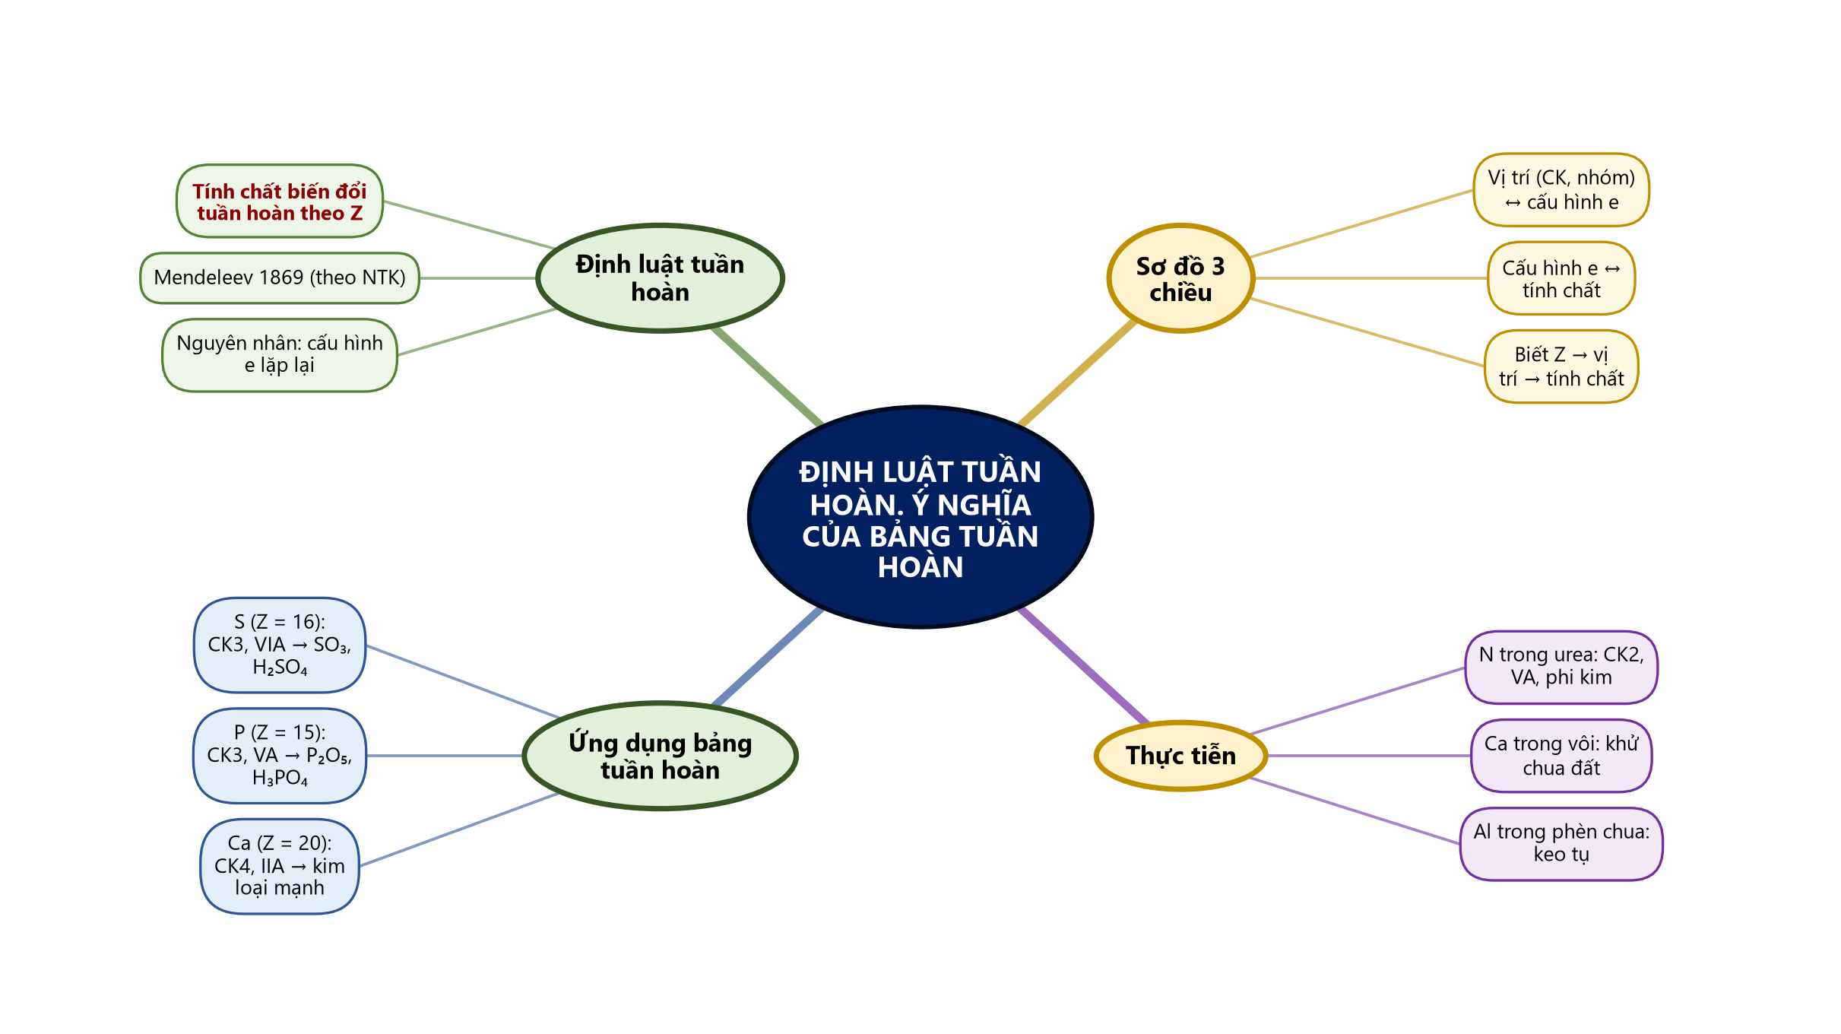
Sơ đồ tư duy – Định luật tuần hoàn. Ý nghĩa của bảng tuần hoàn (TTT biên soạn theo SGK)
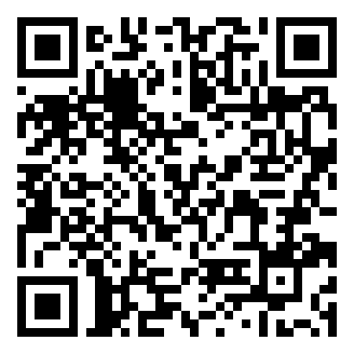
Bài tập củng cố trực tuyến (phòng thi bảo mật – đáp án niêm phong): https://trangtu66.github.io/Taode_thi_online/hoa_cc_bai8_k10.html

